Supporting Information for
Heat Flux Intensified Coastal Thermal Fronts in the East China Shelf Seas
Xueyang Chen¹, Lei Lin², Yiyang Ji¹, Qi Quan^{1*}, Dongyan Liu^{1, 3*}
Corresponding authors. Email: qquan@sklec.ecnu.edu.cn; dyliu@sklec.ecnu.edu.cn

Contents of this file

Supplementary Figs. 1 to 3

Introduction

We include three figures as supporting information to complement the main text. Supplementary Fig. 1 compares the MURSST and OFES2 fields, confirming their consistency in capturing sea surface temperature (SST) and gradient magnitude (GM) structures. As referenced in discussion, Fig. 2 presents the spatial ratios of wintertime heat-flux components to Qnet and their interannual variability in the Bohai–Yellow Seas and the East China Sea, respectively, providing additional physical context for the thermodynamic interpretation. Fig. 3 shows the seasonal climatology of GM derived from MUR SST (2003–2024), illustrating the persistence and seasonal evolution of the ten quasi-stationary fronts across the East China Shelf Seas and offering background context for the wintertime analyses. Fig. 3c displays the spatial trend of MUR SST anomalies, demonstrating how air-sea heat flux (Qnet) and oceanic advection (Qv) jointly influence SST changes across frontal zones and supporting the relative contribution framework of Equation (4).
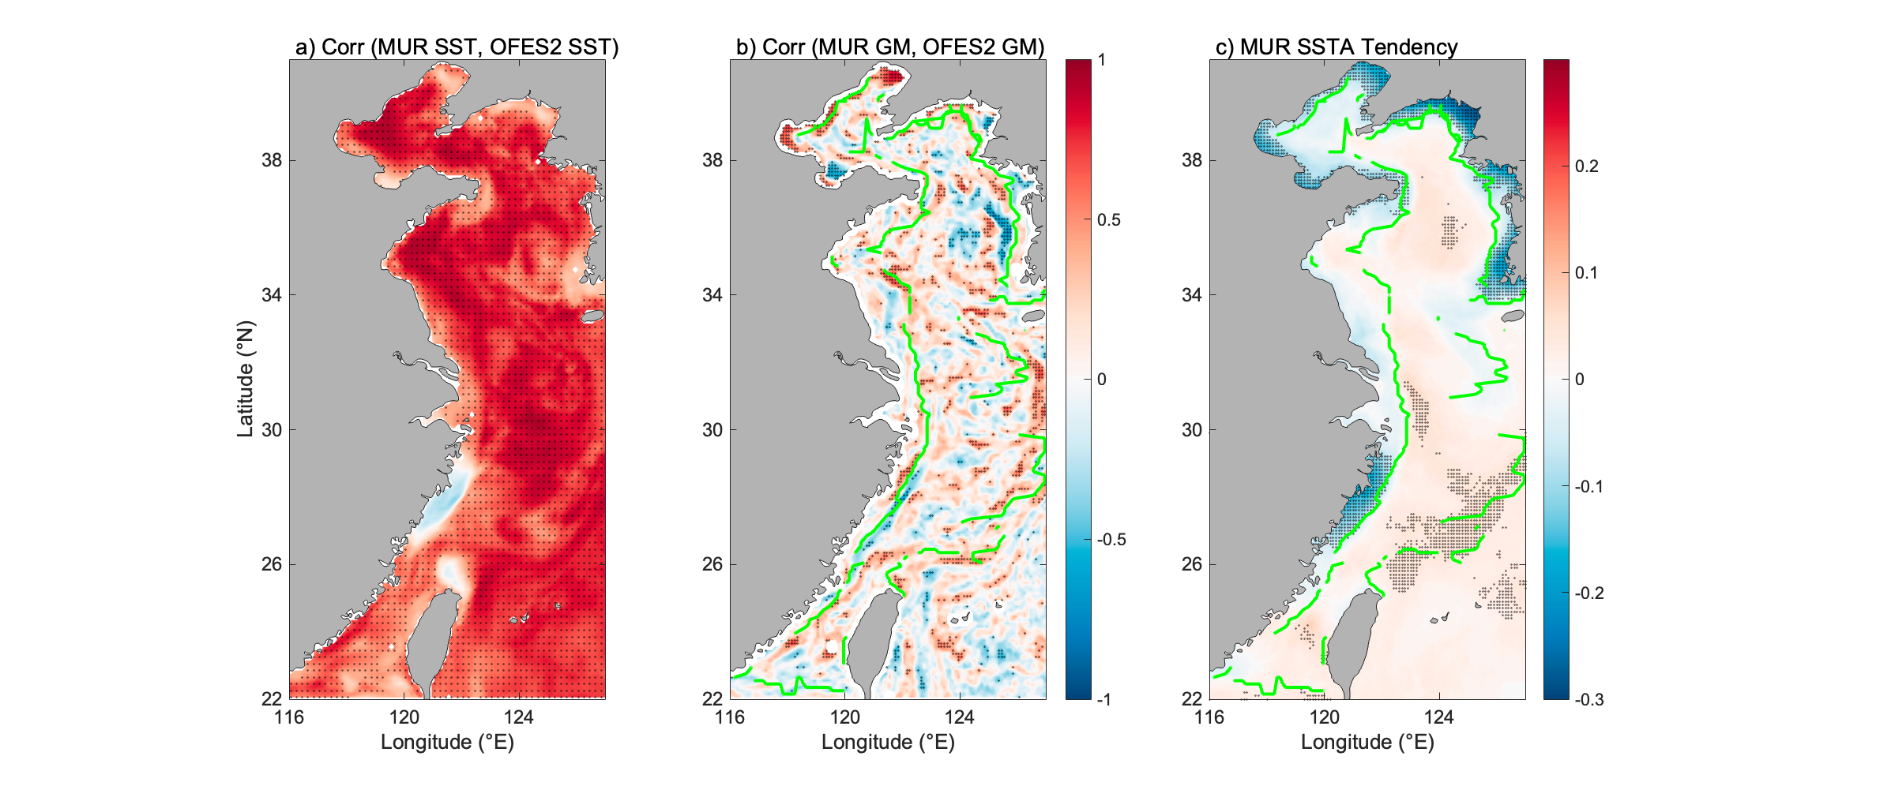
Fig. 1 | Spatial distribution of Pearson correlation coefficients for (a) SST and (b) GM fields between the MURSST and OFES2 datasets, and (c) the MUR SSTA tendency (units: °C yr⁻¹). Green lines indicate the frontal positions. Dotted areas pass the t-test at the 95% significance level.

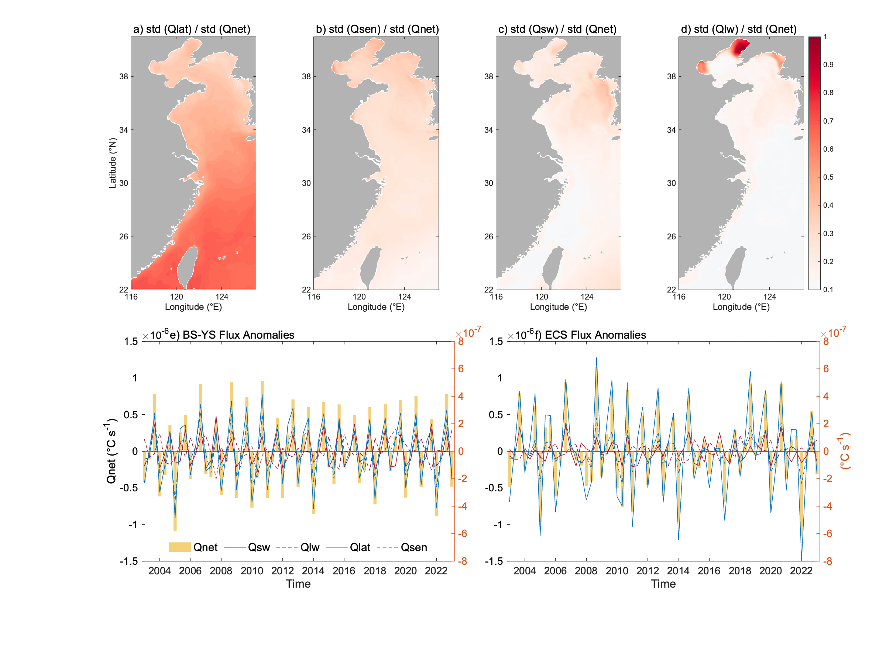
Fig. 2 | (a-d) Spatial distributions of the ratios of surface heat flux components to Qnet during winter for 2003-2023. Qlat, Qsen, Qsw, Qlw represent the latent and sensible heat flux, net downward shortwave and longwave heat flux, respectively, calculated used the same processing method as Qnet. And the time series of zonal anomalous heat flux variables for (e) the BS-YS and (f) the ECS. Yellow bars represent Qnet, while solid and dashed lines indicate the components of Qnet.
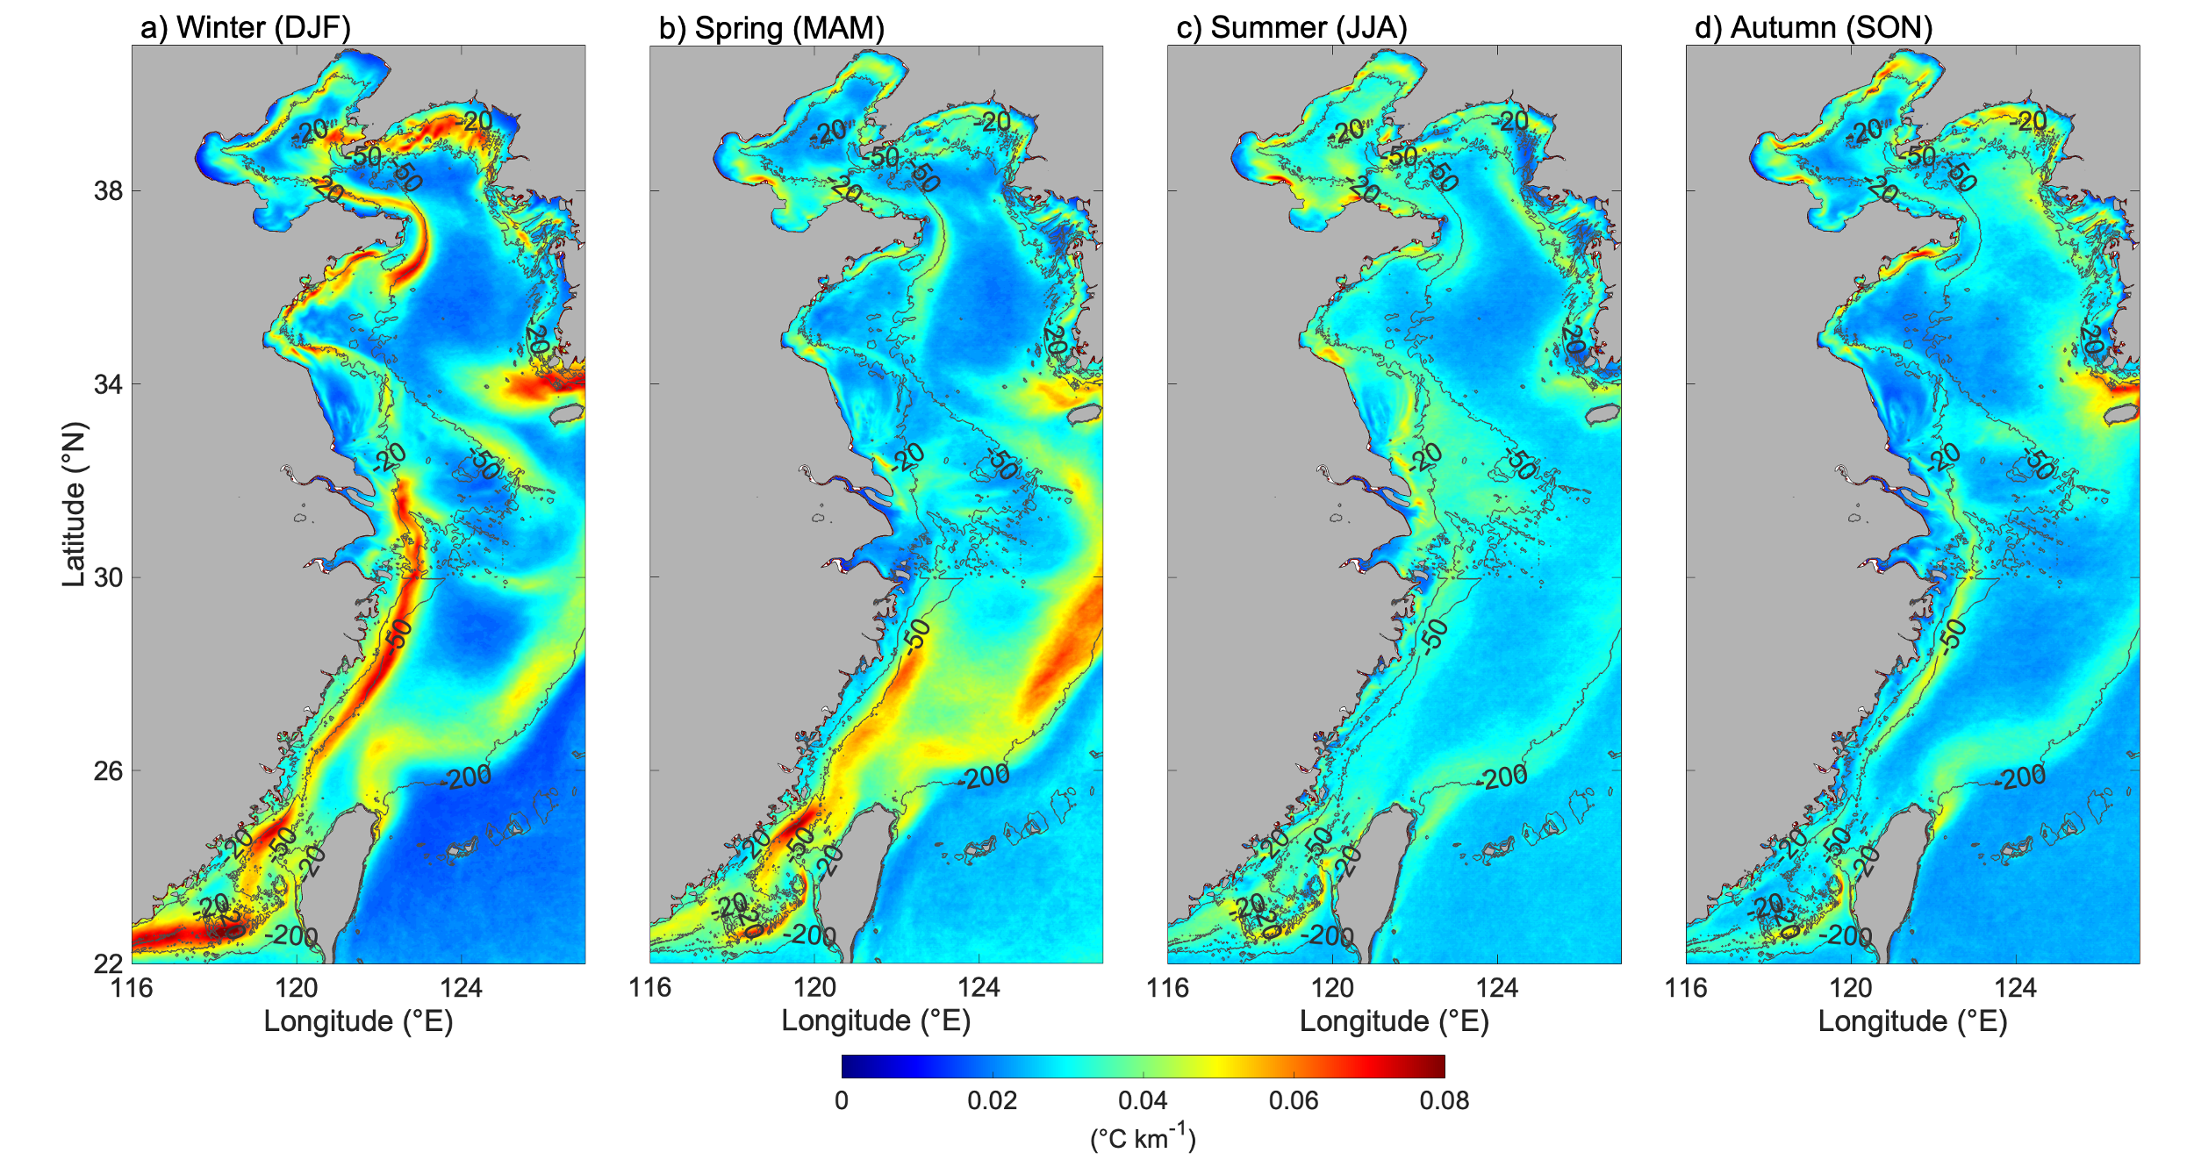Fig. 3 | Seasonal mean GM climatology (units: °C km⁻¹) derived from MUR SST (2003–2024). (a) Winter (Dec–Feb); (b) Spring (Mar–May); (c) Summer (Jun–Aug); (d) Autumn (Sep–Nov). Gray contours indicate bathymetry (units: m).

