Appendix A Calving videos
Video-1 shows drone recording of the first phase of the Hisinger calving, observed on the 25th of August 2023. This calving location coincides with the plume location. Video-2 shows a drone recording of the second phase of the calving with the distinct full depth bottom-out characteristic.

Appendix B Calving induced Chl-A changes

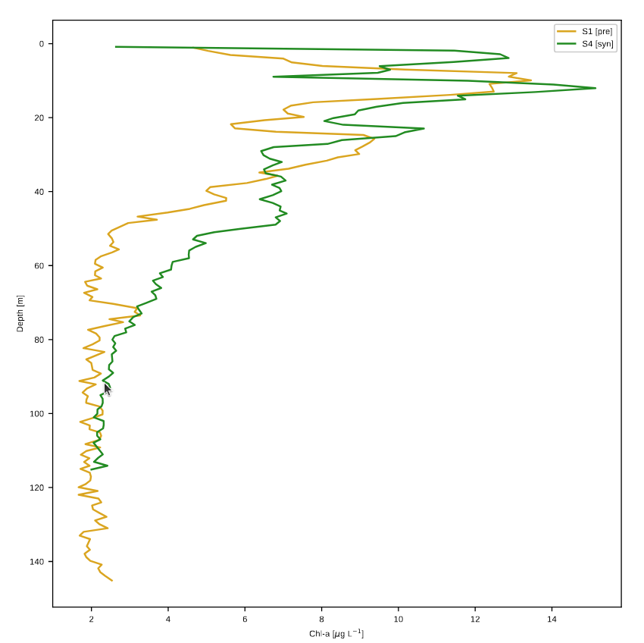
Fig. B1: Redistribution of Chl-A from measurements pre- and syn-calving. Notice how a Chl-A ”plateau” for the green syn-calving measurement appears at 30-50 m depth. The peak at ∼ 25 m for the yellow pre-calving Chl-A profile also appears to be shifted upwards in the green syn-calving profile.

Appendix C Conceptual schematic of water-mass structure in Dickson Fjord
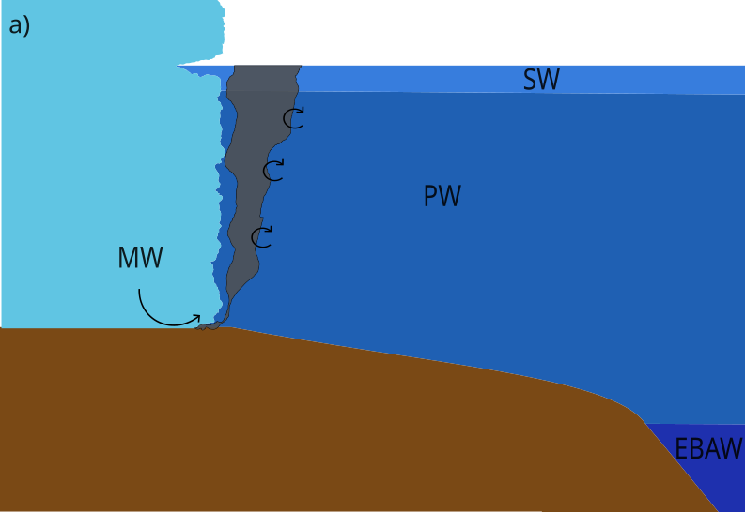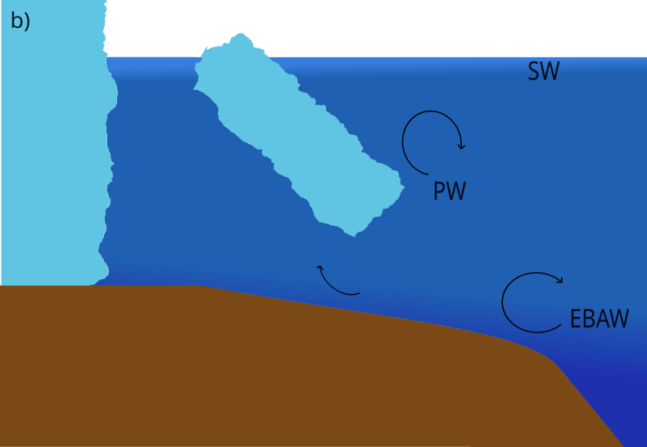
Fig. C2: a) Conceptual illustration of the mixing from subglacial discharge entraining PW near the terminus. b) Conceptual illustration of fjord wide mixing driven by full front “bottom-out” calving.

Appendix D Iceberg capsize animations
Two animations of the iceberg capsize simulations are available: ”capsize_animation_global.mp4” for a view of the entire computational domain and ”capsize_animation_nearfield.mp4” for a view of the near-iceberg water velocity mag nitudes. Both animations show the water velocity magnitudes in colors ranging from 0.01 m/s to 8 m/s on the ground and on the plane y = 0. The glacier wall is in white and the iceberg is shaded in gray so that the water flow under it remains visible. Particle tracers (black dots) are added to the simulations to show the particle trajectories evolving in time. Three streamlines are also displayed on the ground and on the plane y = 0. They highlight the presence of vortexes (spiral shapes) during the whole process.

Appendix E Iceberg capsize sketch
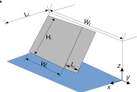
Fig. E3: Unscaled sketch of the iceberg capsize with notations from the text 4.9

