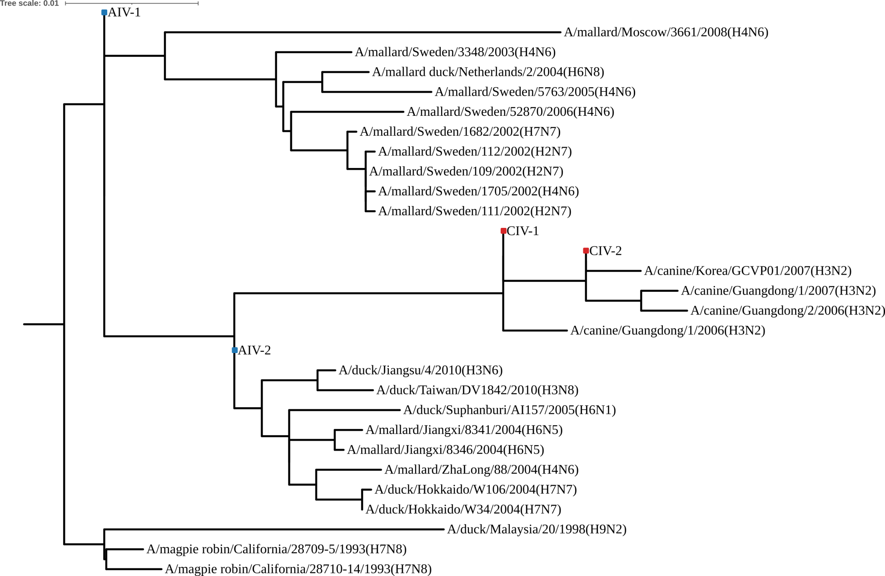
Figure S4. Topological validation of the reconstructed ancestral NP sequences.

