Supporting Information

Benchmarking protein sequence and structure search methods for remote homology detection

Yuan Liu¹, Yingquan Zhou¹, Yan Huang², Hongyi Xin³, Xiaoyong Pan¹, Hong-Bin Shen^{1, *}

¹ Institute of Image Processing and Pattern Recognition, Shanghai Jiao Tong University, and Key Laboratory of System Control and Information Processing, Ministry of Education of China, Shanghai, 200240, China
² State Key Laboratory of Infrared Physics, Shanghai Institute of Technical Physics, Chinese Academy of Sciences, 500 Yu Tian Road, Shanghai 200083, China
³ Global Institute of Future Technology, Shanghai Jiao Tong University, Shanghai, 200240, China
* Address correspondence to H.B. Shen at hbshen@sjtu.edu.cn
Tel: +86-21-34205320
Fax: +86-21-34204022

Contents
Supplementary Tables 3
Table S1. Area under curve of CATH hierarchy classification in Figure 2 3
Table S2. Mean GO semantic similarity of the top-10 retrieved hits for each method in Figure 3. 4
Table S3. Mean lDDT scores of the top-10 retrieved hits in Fig. 4 for multi-domain and corresponding single-domain proteins 5
Table S4. Mean GO semantic similarity of the top-10 retrieved hits for intrinsically disordered proteins across disorder content bins in Figure 5 6
Table S5. Mean GO semantic similarity of the top-10 retrieved hits across AlphaFold predicted structures stratified by pLDDT confidence levels, corresponding to Figure 6 7
Supplementary Figures 8
Figure S1. Pairwise comparison of residue-level alignment quality using lDDT 8
Figure S2. Distribution of intrinsic disorder content and predicted structure confidence for the DisProt benchmark dataset 9

Supplementary Tables

Table S1. Area under curve of CATH hierarchy classification in Figure 2.
Method | Class | Architecture | Topology | Homologous superfamily
GTalign | 1.73E-02 | 0.0608 | 0.282 | 0.5080
TMalign | 1.69E-02 | 0.0630 | 0.2854 | 0.5109
Dali | 2.47E-02 | 0.0588 | 0.2763 | 0.5027
Foldseek | 1.36E-02 | 0.0355 | 0.2212 | 0.4625
GraSR | 1.28E-02 | 0.0452 | 0.2019 | 0.3561
TMvec | 7.51E-03 | 0.0253 | 0.1568 | 0.3001
PLMSearch | 7.07E-03 | 0.0326 | 0.2154 | 0.4033
DHR | 3.41E-03 | 0.0206 | 0.1424 | 0.3317
FoldExplorer | 8.69E-03 | 0.0400 | 0.2259 | 0.4517
BLAST | 3.53E-04 | 0.0025 | 0.0402 | 0.1100
Diamond | 2.93E-05 | 0.0002 | 0.0066 | 0.0194
jackhmmer | 4.12E-04 | 0.0049 | 0.0524 | 0.1405
MMseqs | 3.22E-04 | 0.0024 | 0.0341 | 0.0940

Table S2. Mean GO semantic similarity of the top-10 retrieved hits for each method in Figure 3.
Method | Mean GO semantic similarity
GTalign | 0.497
TMalign | 0.515
Dali | 0.553
Foldseek | 0.551
GraSR | 0.468
TMvec | 0.516
PLMSearch | 0.513
DHR | 0.550
FoldExplorer | 0.539
BLAST | 0.424
Diamond | 0.268
jackhmmer | 0.438
MMseqs | 0.390

Table S3. Mean lDDT scores of the top-10 retrieved hits in Fig. 4 for multi-domain and corresponding single-domain proteins.
Method | Multi-domain mean lDDT | Single-domain mean lDDT
GTalign | 0.507 | 0.549
TMalign | 0.508 | 0.548
Dali | 0.556 | 0.604
Foldseek | 0.531 | 0.568
GraSR | 0.417 | 0.551
TMvec | 0.463 | 0.522
PLMSearch | 0.483 | 0.523
DHR | 0.475 | 0.494
FoldExplorer | 0.473 | 0.549
BLAST | 0.397 | 0.417
Diamond | 0.298 | 0.352
jackhmmer | 0.404 | 0.404
MMseqs | 0.376 | 0.398

Table S4. Mean GO semantic similarity of the top-10 retrieved hits for intrinsically disordered proteins across disorder content bins in Figure 5.
Method |  |  | bin
Method | 0-0.2 | 0.2-0.4 | 0.4-0.6 | 0.6-0.8 | 0.8-1
GTalign | 0.390 | 0.407 | 0.387 | 0.434 | 0.383
TMalign | 0.394 | 0.418 | 0.399 | 0.453 | 0.384
Dali | 0.430 | 0.443 | 0.419 | 0.457 | 0.397
Foldseek | 0.423 | 0.445 | 0.428 | 0.453 | 0.413
GraSR | 0.396 | 0.419 | 0.386 | 0.407 | 0.393
TMvec | 0.421 | 0.444 | 0.403 | 0.458 | 0.399
PLMSearch | 0.406 | 0.451 | 0.411 | 0.469 | 0.416
DHR | 0.429 | 0.440 | 0.435 | 0.465 | 0.438
FoldExplorer | 0.415 | 0.441 | 0.419 | 0.456 | 0.425
BLAST | 0.431 | 0.441 | 0.403 | 0.443 | 0.406
Diamond | 0.385 | 0.403 | 0.373 | 0.394 | 0.388
jackhmmer | 0.431 | 0.436 | 0.413 | 0.424 | 0.395
MMseqs | 0.426 | 0.434 | 0.398 | 0.449 | 0.399
Random | 0.365 | 0.381 | 0.354 | 0.387 | 0.379
Best | 0.823 | 0.831 | 0.823 | 0.849 | 0.831

Table S5. Mean GO semantic similarity of the top-10 retrieved hits across AlphaFold predicted structures stratified by pLDDT confidence levels, corresponding to Figure 6.
Method | ≥90 | 70~90 | <70
GTalign | 0.47 | 0.413 | 0.299
TMalign | 0.468 | 0.41 | 0.299
Dali | 0.516 | 0.488 | 0.398
Foldseek | 0.51 | 0.504 | 0.475
GraSR | 0.462 | 0.389 | 0.357
TMvec | 0.527 | 0.524 | 0.492
PLMSearch | 0.517 | 0.474 | 0.483
DHR | 0.554 | 0.54 | 0.525
FoldExplorer | 0.552 | 0.513 | 0.504
BLAST | 0.405 | 0.391 | 0.445
Diamond | 0.254 | 0.248 | 0.311
jackhmmer | 0.438 | 0.405 | 0.451
MMseqs | 0.347 | 0.35 | 0.415

Supplementary Figures

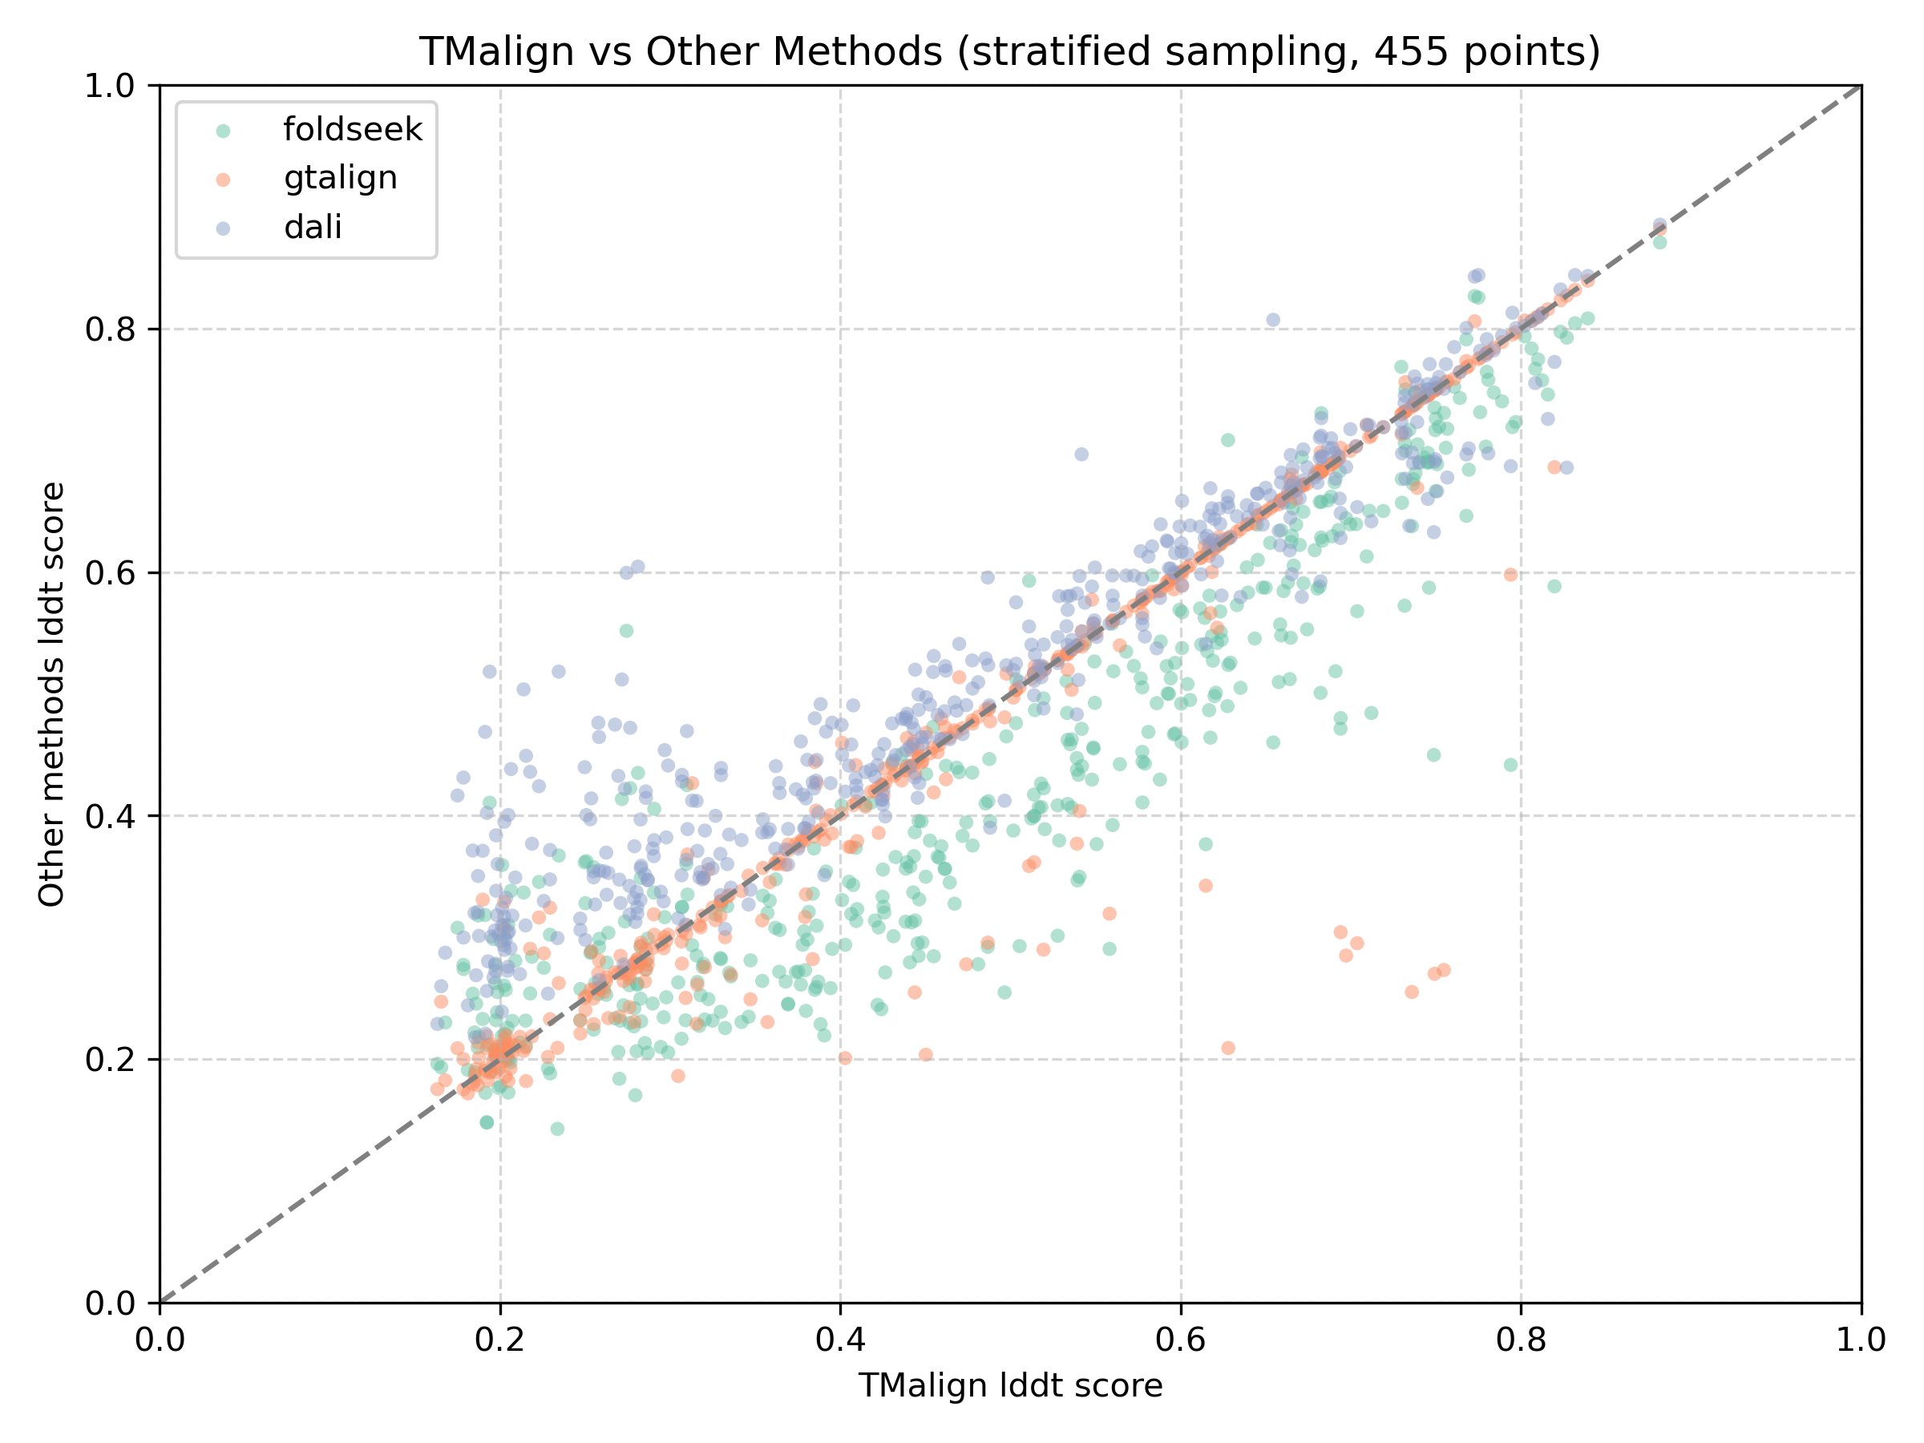
Figure S1. Pairwise comparison of residue-level alignment quality using lDDT. A total of 455 query-hit alignments were selected by stratified sampling over lDDT ranges. Each point represents one alignment. The x-axis shows the lDDT score obtained by TM-align, while the y-axis shows the corresponding lDDT score obtained by the other alignment methods (Dali, GTalign, and Foldseek). The diagonal line indicates y = x.

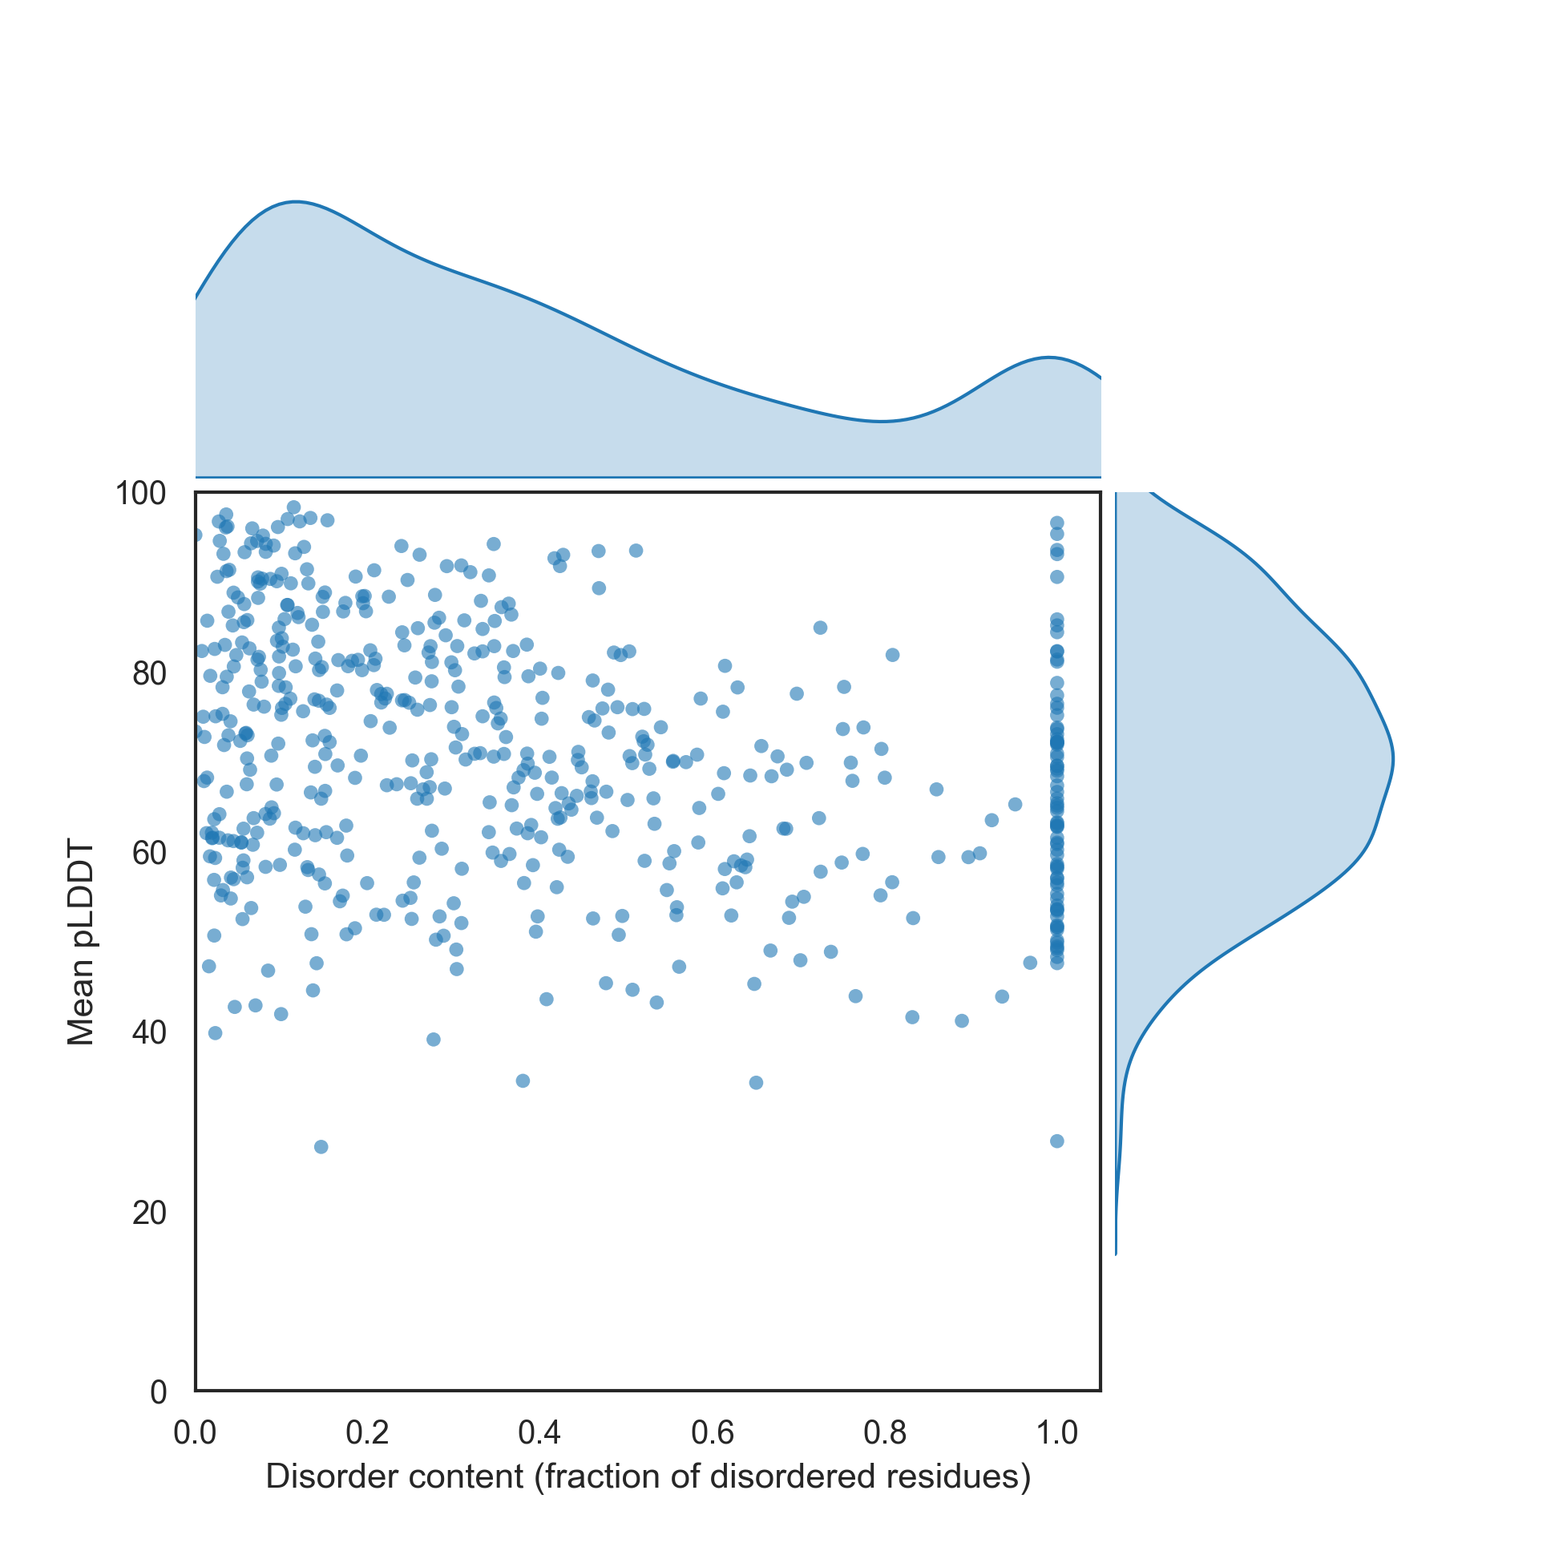
Figure S2. Distribution of intrinsic disorder content and predicted structure confidence for the DisProt benchmark dataset. Each point represents one protein, plotted by disorder content (x-axis) and mean pLDDT (y-axis). Marginal density estimates illustrate the overall distributions of disorder content and pLDDT scores, highlighting the prevalence of low-confidence predictions among highly disordered proteins.

