Supplementary information
Construction of Molecular Fans in Metal-Organic Framework to Overcome Diffusion Resistance in Molecular-size-matched Pores for Trace Benzene Capture
Zhaowei Huangª, Xi Yangª, Yi Luanª, Yuanbo Heª, Xiaotong Yunª, Daohui Linª, Kun Yang^{a,b}, Wenhao Wu^{a,*}

ª State Key Laboratory of Soil Pollution Control and Safety, Zhejiang Provincial Key Laboratory of Organic Pollution Process and Control, Key Laboratory of Environmental Pollution and Ecological Health of Ministry of Education, College of Environmental and Resource Sciences, Zhejiang University, Hangzhou 310058, China.
^{b} Zhejiang University-Hangzhou Global Scientific and Technological Innovation Center, Hangzhou 311200, China.

*Corresponding Author (Wenhao Wu)
Phone: 86-571-88982579, Fax: 86-571-88982590, Email: wenhaowu@zju.edu.cn

Contents
1. Preparation and Synthesis of Absorbents 3
2. Structural Characterization of MOFs 3
3. Gas and Vapor Adsorption 4
4. Theoretical Simulation 7
5. Adsorption Heat Calculation 9
6. In Situ Spectra 10
7. Additional Figures and Tables 11
8. References 81

Preparation and Synthesis of Absorbents
The commercially obtained activated carbon F400d and zeolite ZSM-5 were ground into a fine powder prior to further experimental procedures. MFM-300(Fe)¹, PCN-250(Fe₂Co)², MIL-125-Zn³, HKUST-1⁴, BUT-55⁵, and were synthesized following the reported procedures. ZJU-702 was synthesized with slight modifications to a previously established protocol⁶, while ZJU-703 was prepared under similar synthetic conditions to those of ZJU-702.

Structural Characterization of MOFs
The structure of ZJU-701 was successfully determined through single-crystal X-ray diffraction analysis^{7,8}. Crystallographic data reveal that ZJU-701 crystallizes in the P6₁ space group, with unit cell parameters of a = 48.53 Å, b = 48.53 Å, c = 27.46 Å (α = β = 90°, γ = 120°). Detailed crystallographic data for ZJU-701 are provided in Supplementary Table 1.
The structures of ZJU-702 and ZJU-703 were determined by Rietveld refinement^{9,10}. Detailed data are provided in Supplementary Table 2 and 3. Additionally, the pore sizes of ZJU-701, ZJU-702, and ZJU-703 are similar, suggesting that these materials are isostructural, with the only differences stemming from the substitution of molecular fans in the ligands.

Gas and Vapor Adsorption
- Nitrogen adsorption-desorption isotherm
The specific surface areas were calculated using the Brunauer–Emmett–Teller (BET) method^{11,12} (S1–S4) based on N₂ adsorption-desorption isotherms collected at 77 K. Pore-size distributions (S5) were determined using the Non-Local Density Functional Theory (NLDFT) method¹³.
$$\begin{aligned}\frac{\frac{P}{P_{0}}}{V\left(1-\frac{P}{P_{0}}\right)}=\frac{1}{V_{m}×C}+\frac{C-1}{V_{m}×C}×\frac{P}{P_{0}}\#(S1)\end{aligned}$$
$$\begin{aligned}V_{m}=\frac{1}{a+b}\#(S2)\end{aligned}$$
$$\begin{aligned}C=\frac{1}{V_{m}×b}\#(S3)\end{aligned}$$
$$\begin{aligned}S=N_{A}×\frac{a_{m}}{22414}×V_{m}\#\left(S4\right)\end{aligned}$$
where ${[(P}/{P_{0}})/V×(1-P/{P_{0})]}$ is the y-axis of the BET equation; $P_{0}$ is the saturated vapor pressure of the adsorbate at the adsorption temperature; $V_{m}$ is the single-layer saturated adsorption capacity of the adsorbent on the adsorbate, cm³·g⁻¹; $C$ is a constant related to the adsorption performance of the adsorbent; $S$ is the BET specific surface area, m²·g⁻¹; $a_{m}$ is the cross-sectional area of adsorbate molecules, m²; $22414$ is the volume occupied by 1 mol of gas under standard conditions, cm³; $P/{P_{0}}$ is the relative pressure; $P$ is the pressure after adsorption equilibrium, bar; $V$ is the adsorption capacity of the adsorbent on the adsorbate at the adsorption equilibrium pressure P, cm³·g⁻¹; $a$ is the slope of the fitted line; $b$ is the intercept of the fitted line; $N_{A}$ is Avogadro's constant, 6.02×10²³.
$$\begin{aligned}N_{exp}\left(P\right)=\int_{w_{min}}^{w_{max}}{f\left(w\right)ρ\left(P，w\right)dw}\#\left(S5\right)\end{aligned}$$
where $w$ is pore size of adsorbent, nm; $f\left(w\right)$ is the pore volume function corresponding to the aperture w; $N_{exp}\left(P\right)$ is the number of adsorbed moles of adsorbate at a relative pressure of P; $ρ\left(P，w\right)$ is the molar density of the adsorbate at pore size w and relative pressure P.
- Benzene vapor adsorption isotherm
Prior to adsorption measurements, the adsorbents were degassed under vacuum at 423 K for 6 h to remove solvent molecules from the pores. This same degassing procedure was applied to the benzene-saturated ZJU-701 during the subsequent regeneration experiments.
- Adsorption kinetics test
After measuring the benzene adsorption kinetic curves for each adsorbent, the pseudo-first-order rate constant (k₁) was calculated using the following equation¹⁴⁻¹⁶:
$$\begin{aligned}y=a(1-e^{-bt})\#\left(S7\right)\end{aligned}$$
where $a$ is the saturation benzene adsorption; $b$ is the pseudo-first-order rate constant k₁.
The diffusion coefficient was calculated using the following equation, where $D/r²$ serves as the metric for evaluating diffusion rates^{17,18}:
$$\begin{aligned}\frac{Q_{t}-Q_{0}}{Q_{∞}-Q_{0}}=1-\sum_{n=1}^{∞}{\frac{6}{n^{2}π^{2}}exp\left(\frac{-Dn^{2}π^{2}t}{r^{2}}\right)}\#\left(S8\right)\end{aligned}$$
where $Q_{∞}$ is the saturation benzene adsorption; $Q_{t}$ is the benzene adsorption at t second (s); $Q_{0}$ is the benzene adsorption at initial time, s; $D$ is the diffusion coefficient, m² s^{–1}; $r$ is the ball model radius.
For the convenience of calculation, the above equation can be approximated as:
$$\begin{aligned}\frac{Q_{t}-Q_{0}}{Q_{∞}-Q_{0}}=\left(\frac{6}{\sqrt{π}}×\sqrt{\frac{D}{r^{2}}}\right)×\sqrt{t}\#\left(S9\right)\end{aligned}$$
plot $\frac{Q_{t}-Q_{0}}{Q_{∞}-Q_{0}}$as y and$\sqrt{t}$ as x, perform linear fitting to obtain the slope k，k =$(\frac{6}{\sqrt{π}}×\sqrt{\frac{D}{r^{2}}})$.
Kinetic measurements were similarly conducted for ZJU-701, ZJU-702, ZJU-703 and MFM-300(Fe) using toluene (300 ppm)^{19,20}, m-xylene (300 ppm)²¹, NH₃ (300 ppm)²², SO₂ (2000 ppm)²³, and SF₆ (100,000 ppm)²⁴ as target gases at 298 K.
- Breakthrough experiment
Breakthrough curves were obtained by recording the concentration versus time profiles, from which the benzene breakthrough adsorption capacities at different flow rates were determined.
$$\begin{aligned}Q=\frac{V}{m}\int_{0}^{t}{\left(1-C\right)dt}\#\left(S10\right)\end{aligned}$$
where $Q$ is the breakthrough adsorption capacity, mmol·g⁻¹; $V$ is the benzene volumetric feed flow rate, cm³·min⁻¹; $m$ is the mass of the adsorbent, g; $t$ is the adsorption time, min; $C$ is the feed benzene concentration, mmol·cm⁻³.

Theoretical Simulation
To investigate the adsorption behavior of benzene in the adsorbents, Grand Canonical Monte Carlo (GCMC) simulations were performed using the Raspa software, with adsorption sites visualized²⁵. The simulation parameters were set as follows: a constant adsorption temperature of 298 K and benzene partial pressures of 0.0126 kPa, 0.126 kPa, 1.26 kPa, and 12.6 kPa. During the simulations, the atomic positions within the adsorbent framework were held fixed. The atomic potential parameters were described using the Universal Force Field²⁶, and partial atomic charges were calculated using the Qeq method²⁷. Long-range electrostatic interactions were handled using the Ewald and group summation techniques. Benzene molecules were allowed to undergo translation, rotation, insertion, and deletion operations within the framework, with a cutoff radius of 14 Å. Each simulation included 1×10⁶ equilibration cycles, followed by 1×10⁷ production cycles.
Density functional theory (DFT) calculations were performed using the CP2K program to carry out geometric optimization and energy computations for the benzene molecule adsorbed on the adsorbents. The Goedecker-Teter-Hutter (GTH) pseudopotential^{28,29} and DZVP-MOLOPT-SR basis³⁰ set were employed in the calculations. The Perdew-Burke-Ernzerhof (PBE) functional was used to evaluate the nonlocal exchange-correlation energy³¹, with the DFT-D3 dispersion correction scheme applied³². The energy cutoff was set to 400 Rydberg (Ry), with a relative cutoff of 50 Ry. The binding energies were calculated using the following formula:
$$\begin{aligned}∆Ebind = E\left[MOF \& Benzene\right]-E\left[MOF\right]-E\left[Benzene\right]\#\left(S11\right)\end{aligned}$$
where $E\left[MOF \& Benzene\right]$ is the total energy of the optimized MOF & benzene structure; $E\left[MOF\right]$, and $E\left[Benzene\right]$ are the total energy of the optimized ZJU-701, ZJU-702 and ZJU-703 and benzene molecules, respectively.

Adsorption Heat Calculation
To investigate the correlation between the isosteric heat of adsorption (Qₛₜ) and the amount of benzene adsorbed, adsorption data of benzene vapor at different temperatures were fitted. The Virial equation was used to describe the relationship between the amount adsorbed (n) and the equilibrium adsorption pressure (p):
$$\begin{aligned}ln(p)=ln(n)+\frac{1}{T}\sum_{i=0}^{m}{a_{i}}n^{i}+\sum_{i=0}^{k}{b_{i}}n^{i}\#\left(S12\right)\end{aligned}$$
where $p$ is the equilibrium pressure; $n$ is the amount adsorbed; $T$ is the absolute temperature, K; and $a_{i}$, $b_{i}$ are the Virial coefficients.
According to the thermodynamic derivation based on the Clausius–Clapeyron equation, the isosteric heat of adsorption can be calculated using the following expression²⁷:
$$\begin{aligned}Q_{st}=-R{\left[\frac{∂\ln\left(p\right)}{∂(1/{T)}}\right]}_{n}\#\left(S13\right)\end{aligned}$$
where $R$ is the universal gas constant.
By substituting the Virial equation, the relationship between $Q_{st}$ and the amount adsorbed n can be obtained as:
$$\begin{aligned}Q_{st}=-R\sum_{i=0}^{m}{a_{i}}n^{i}\#\left(S14\right)\end{aligned}$$

In Situ Spectra
- In situ low-frequency Raman spectra
ZJU-701, ZJU-702, and ZJU-703 (30 mg) were individually weighed and loaded into the sample chamber at 298 K. The nitrogen flow rate was gradually increased from 0 to 100 mL·min⁻¹. At each flow rate, the system was equilibrated for 5 minutes before recording the corresponding low-frequency spectrum. The excitation wavelength used was 532 nm^{33,34}.
- In situ infrared spectra
ZJU-701, ZJU-702, and ZJU-703 (30 mg) were individually weighed and loaded into the sample chamber at 298 K. The nitrogen flow rate was gradually increased from 0 to 30·mL min⁻¹. At each flow rate, the system was equilibrated for 5 minutes before recording the corresponding infrared spectrum.

Additional Figures and Tables
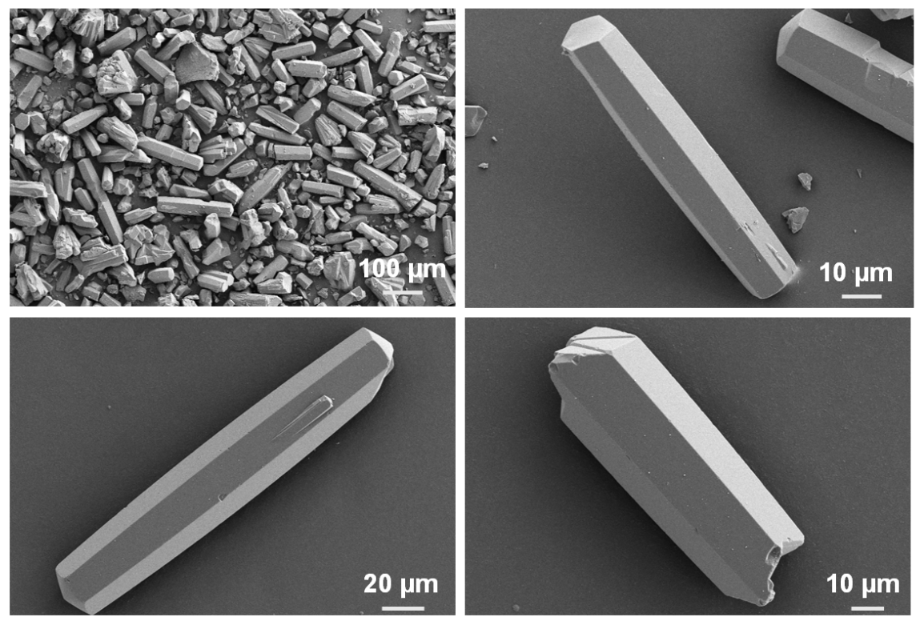
Figure S1. SEM images of ZJU-701.

Figure S2. PXRD patterns of ZJU-701.
Figure S3. (a) N₂ adsorption-desorption isotherms of ZJU-701 at 77 K; (b) pore size distribution profile of ZJU-701.

Figure S4. N₂ adsorption-desorption isotherms after (a) treatments with aqueous solution at pH 2~12 for 7 days; (b) 10 benzene vapor adsorption cycles, and (c) breakthrough experiment for ZJU-701.

Figure S5. PXRD patterns after (a) treatments with aqueous solution at pH 2~12 for 7 days, (b) N₂ adsorption, (c) 10 benzene vapor adsorption cycles, and (d) breakthrough experiment for ZJU-701.

Figure S6. TGA curve of ZJU-701.

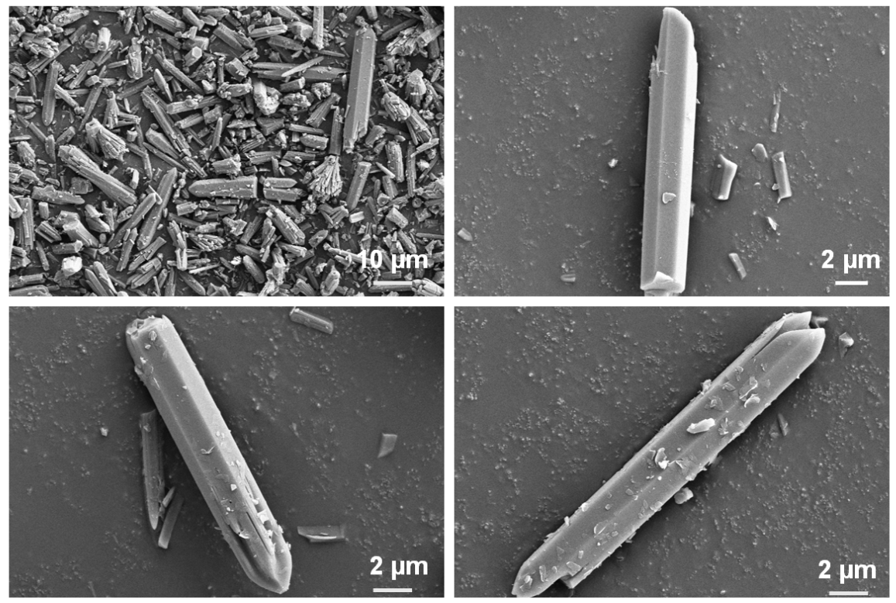
Figure S7. SEM images of ZJU-702.

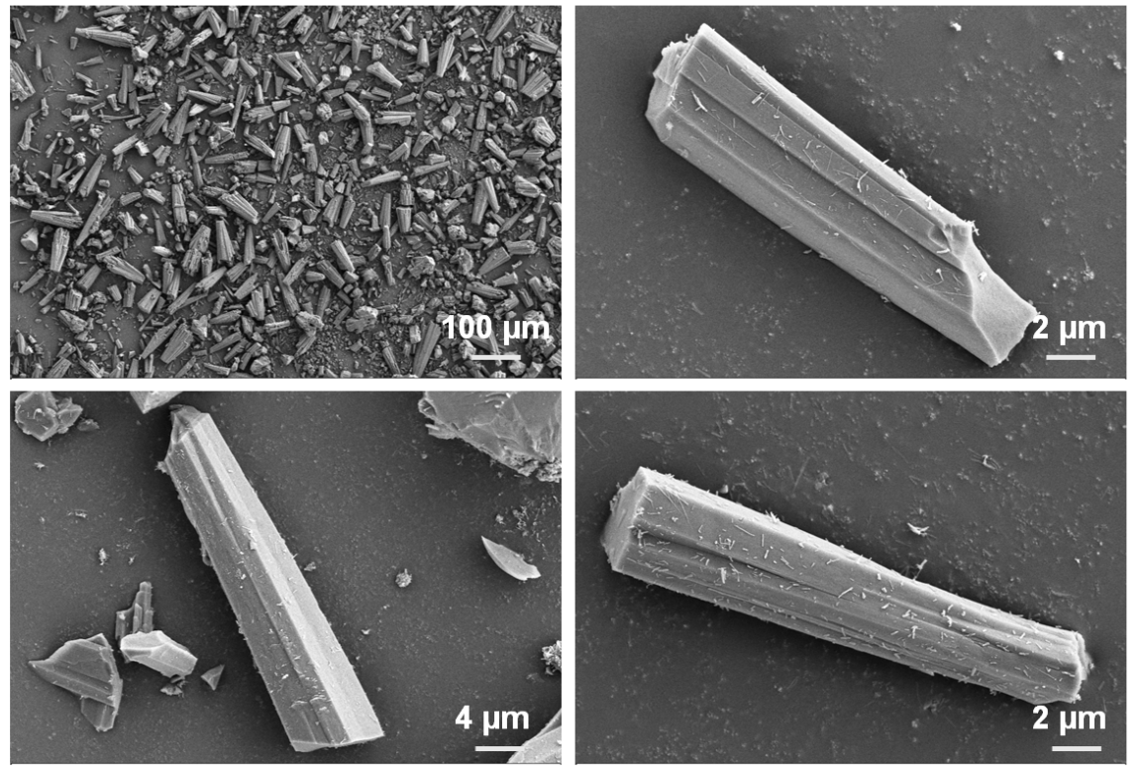
Figure S8. SEM images of ZJU-703.

Figure S9. Rietveld refinement of PXRD data for (a) ZJU-702 and (b) ZJU-703.

Figure S10. (a) N₂ adsorption-desorption isotherms of ZJU-702 and ZJU-703 at 77 K; pore size distribution profiles of (b) ZJU-702 and (c) ZJU-703.

Figure S11. TGA curves of (a) ZJU-702 and (b) ZJU-703.

Figure S12. (a) Brunauer-Emmett-Teller (BET) Rouquerol plot and (b) linear plot of ZJU-701.
Figure S13. (a) Brunauer-Emmett-Teller (BET) Rouquerol plot and (b) linear plot of ZJU-702.
Figure S14. (a) Brunauer-Emmett-Teller (BET) Rouquerol plot and (b) linear plot of ZJU-703.
Figure S15. (a) N₂ adsorption-desorption isotherm, (b) pore size distribution profile, (c) Brunauer-Emmett-Teller (BET) Rouquerol plot, and (d) linear plot of MFM-300(Fe).

Figure S16. (a) Benzene adsorption kinetics curve, instantaneous uptake, (b) pseudo-first-order kinetics fitting curve, and (c) diffusion coefficient fitting curve of ZJU-701.

Figure S17. (a) Benzene adsorption kinetics curve, instantaneous uptake, (b) pseudo-first-order kinetics fitting curve, and (c) diffusion coefficient fitting curve of ZJU-702.

Figure S18. (a) Benzene adsorption kinetics curve, instantaneous uptake, (b) pseudo-first-order kinetics fitting curve, and (c) diffusion coefficient fitting curve of ZJU-703.

Figure S19. (a) Benzene adsorption kinetics curve, instantaneous uptake, (b) pseudo-first-order kinetics fitting curve, and (c) diffusion coefficient fitting curve of MFM-300(Fe).

Figure S20. PXRD patterns of (a) MFM-300(Fe), (b) PCN-250(Fe₂Co), (c) MIL-125-Zn, (d) HKUST-1, and (e) BUT-55.

Figure S21. (a) N₂ adsorption-desorption isotherm, (b) pore size distribution profile, (c) Brunauer-Emmett-Teller (BET) Rouquerol plot, and (d) linear plot of PCN-250(Fe₂Co).

Figure S22. (a) N₂ adsorption-desorption isotherm, (b) pore size distribution profile, (c) Brunauer-Emmett-Teller (BET) Rouquerol plot, and (d) linear plot of MIL-125-Zn.

Figure S23. (a) N₂ adsorption-desorption isotherm, (b) pore size distribution profile, (c) Brunauer-Emmett-Teller (BET) Rouquerol plot, and (d) linear plot of HKUST-1.

Figure S24. (a) N₂ adsorption-desorption isotherm, (b) pore size distribution profile, (c) Brunauer-Emmett-Teller (BET) Rouquerol plot, and (d) linear plot of BUT-55.

Figure S25. (a) N₂ adsorption-desorption isotherm, (b) pore size distribution profile, (c) Brunauer-Emmett-Teller (BET) Rouquerol plot, and (d) linear plot of AC.

Figure S26. (a) N₂ adsorption-desorption isotherm, (b) pore size distribution profile, (c) Brunauer-Emmett-Teller (BET) Rouquerol plot, and (d) linear plot of ZSM-5.

Figure S27. (a) Benzene adsorption kinetics curve, instantaneous uptake, (b) pseudo-first-order kinetics fitting curve, and (c) diffusion coefficient fitting curve of PCN-250(Fe₂Co).

Figure S28. (a) Benzene adsorption kinetics curve, instantaneous uptake, (b) pseudo-first-order kinetics fitting curve, and (c) diffusion coefficient fitting curve of MIL-125-Zn.

Figure S29. (a) Benzene adsorption kinetics curve, instantaneous uptake, (b) pseudo-first-order kinetics fitting curve, and (c) diffusion coefficient fitting curve of HKUST-1.

Figure S30. (a) Benzene adsorption kinetics curve, instantaneous uptake, (b) pseudo-first-order kinetics fitting curve, and (c) diffusion coefficient fitting curve of BUT-55.

Figure S31. (a) Benzene adsorption kinetics curve, instantaneous uptake, (b) pseudo-first-order kinetics fitting curve, and (c) diffusion coefficient fitting curve of AC.

Figure S32. (a) Benzene adsorption kinetics curve, instantaneous uptake, (b) pseudo-first-order kinetics fitting curve, and (c) diffusion coefficient fitting curve of ZSM-5.

Figure S33. Benzene adsorption kinetics curves (0-500 min) at P/P₀ = 0.001 and 298 K.

Figure S34. Linear relationship between the diffusion coefficient and the pseudo-first-order rate constant k₁ for the benzene uptake.

Figure S35. Benzene breakthrough curves at different flow rates for (a) ZJU-701, (b)ZJU-702, (c) ZJU-703, and (d) MFM-300(Fe).

Figure S36. Benzene breakthrough curves at different flow rates for (a) PCN-250(Fe₂Co), (b)MIL-125-Zn, (c) HKUST-1, and (d) BUT-55.

Figure S37. Benzene breakthrough curves at different flow rates for (a) AC and (b) ZSM-5.

Figure S38. Benzene breakthrough curves under dry, 30% relative humidity (RH) and 60% RH conditions at a flow rate of 0.03 m·s⁻¹ for ZJU-701.

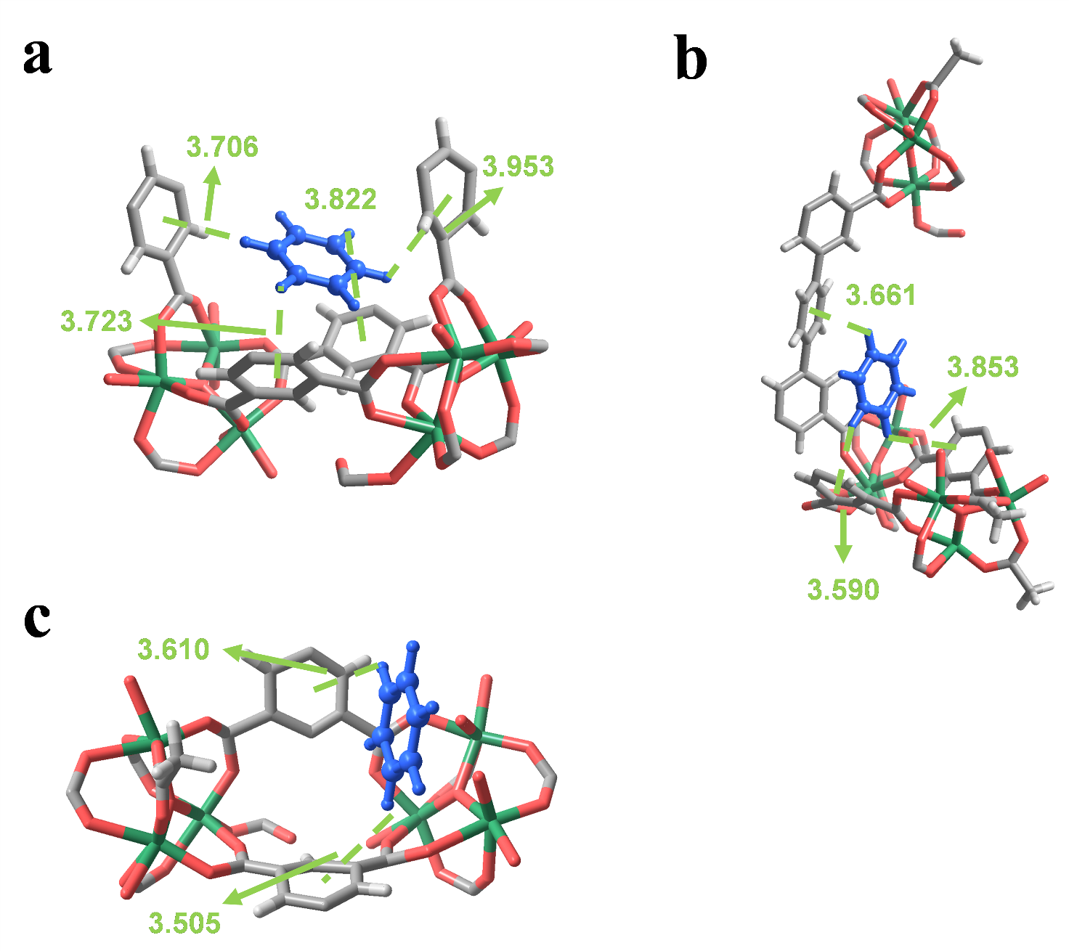
Figure S39. Views of benzene binding (a) site I, (b) site II, and (c) site Ⅲ in ZJU-702. Color code: H, white; C, grey; O, red; Fe, green; benzene, blue.

Figure S40. Views of benzene binding (a) site I, (b) site II, and (c) site Ⅲ in ZJU-703. Color code: H, white; C, grey; O, red; Fe, green; benzene, blue.

Figure S41. Adsorption energy of benzene molecules in ZJU-701, ZJU-702, and ZJU-703.

Figure S42. Benzene adsorption isotherms of (a) ZJU-701, (b) ZJU-702 , and (c) ZJU-703 at different temperatures.

Figure S43. Isosteric heat of adsorption curves of (a) ZJU-701, (b) ZJU-702, and (c) ZJU-703.

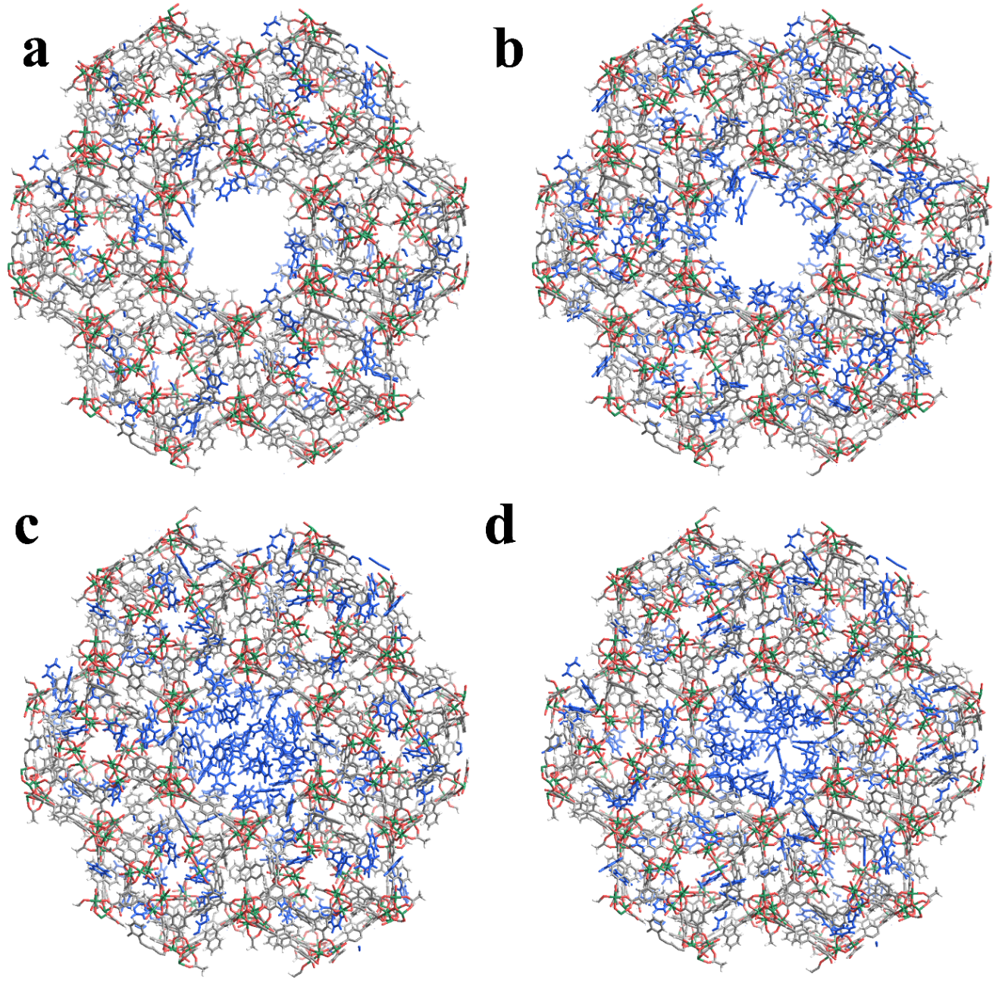
Figure S44. Slices through the calculated benzene adsorption sites in ZJU-701 at (a) P/P₀ = 0.001, (b) 0.01, (c) 0.10, and (d) 1.00, respectively. Color code: H, white; C, grey; O, red; Fe, green; benzene, blue.

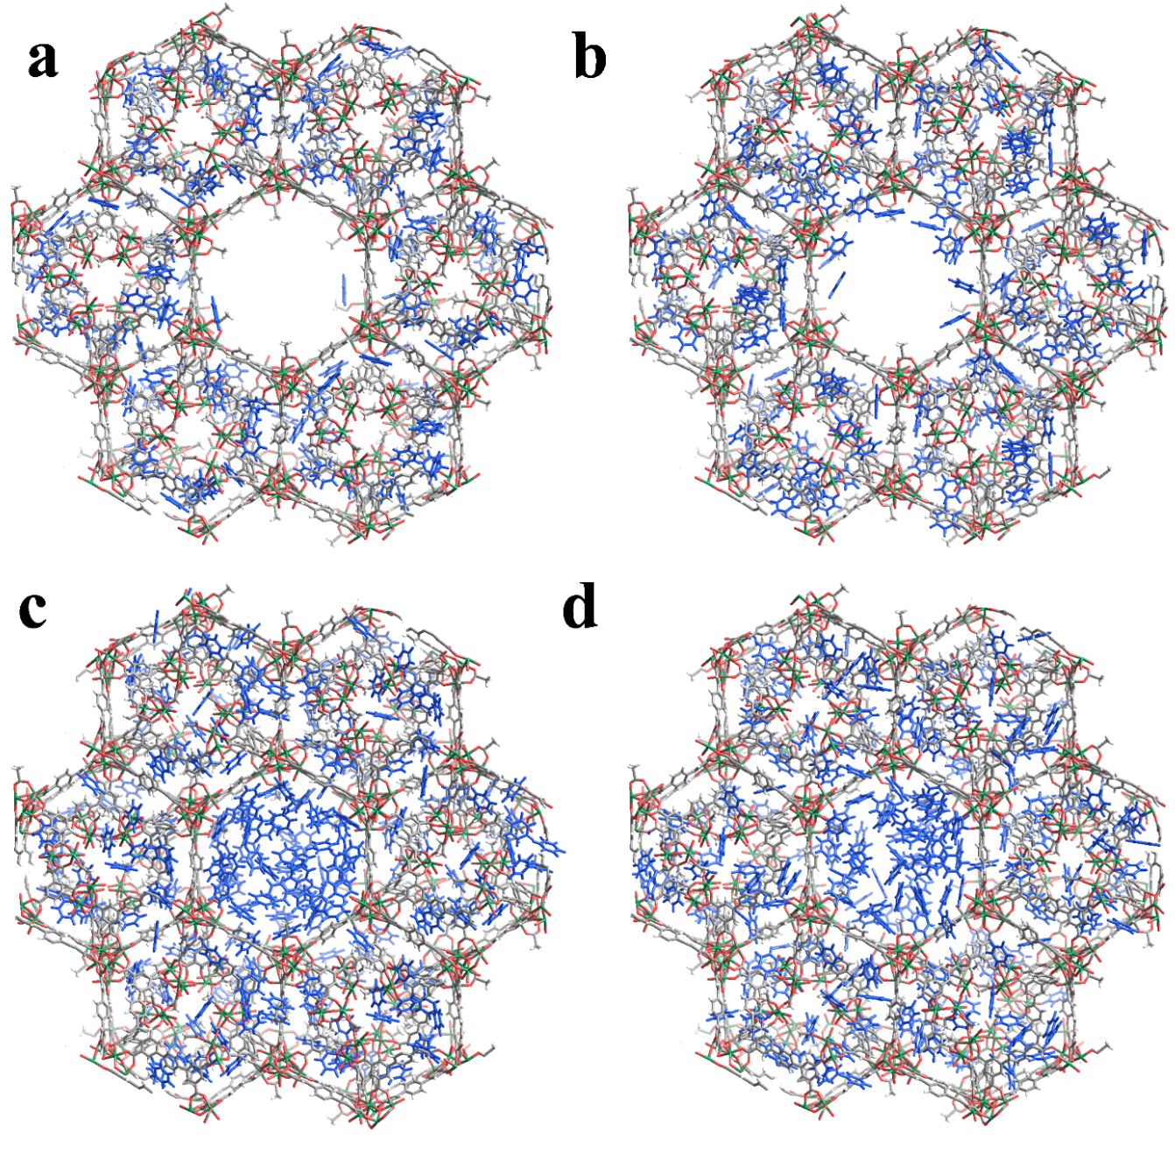
Figure S45. Slices through the calculated benzene adsorption sites in ZJU-702 at (a) P/P₀ = 0.001, (b) 0.01, (c) 0.10, and (d) 1.00, respectively. Color code: H, white; C, grey; O, red; Fe, green; benzene, blue.

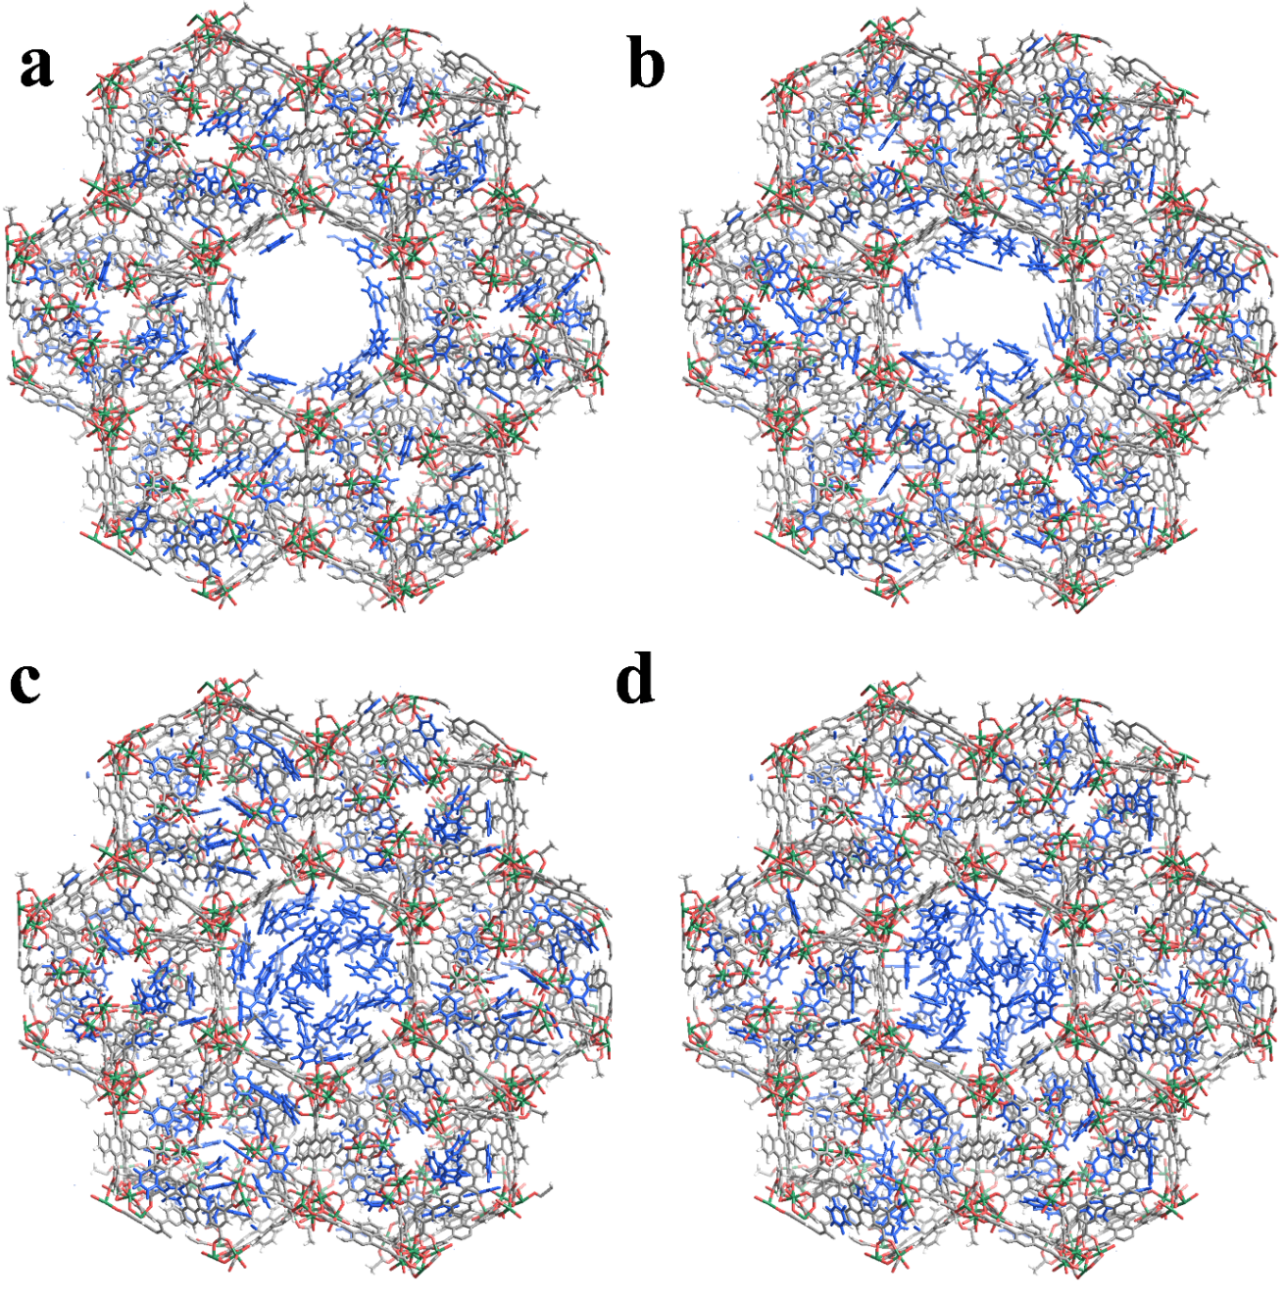
Figure S46. Slices through the calculated benzene adsorption sites in ZJU-703 at (a) P/P₀ = 0.001, (b) 0.01, (c) 0.10, and (d) 1.00, respectively. Color code: H, white; C, grey; O, red; Fe, green; benzene, blue.

Figure S47. Comparison of adsorption capacity and pseudo-first-order rate constant k₁ of (a) benzene (500 min, P/P₀ = 0.001), (b) toluene (600 min, P/P₀ = 0.008), (c) m-xylene (500 min, P/P₀ = 0.0285), (d) NH₃ (200 min, P/P₀ = 3.55 × 10⁻⁵), (e) SO₂ (60 min, P/P₀ = 6.25 × 10⁻⁴), and (f) SF₆ (7 min, P/P₀ = 0.00476) by ZJU-701, ZJU-702, ZJU-703, and MFM-300(Fe), respectively.

Figure S48. Toluene adsorption kinetics curves and instantaneous uptake for (a) ZJU-701, (b) ZJU-702, (c) ZJU-703, and (d) MFM-300(Fe).

Figure S49. Pseudo-first-order kinetics fitting curves of toluene uptake for (a) ZJU-701, (b) ZJU-702, (c) ZJU-703, and (d) MFM-300(Fe).

Figure S50. Diffusion coefficient fitting curves of toluene uptake for (a) ZJU-701, (b) ZJU-702, (c) ZJU-703, and (d) MFM-300(Fe).

Figure S51. m-Xylene adsorption kinetics curves and instantaneous uptake for (a) ZJU-701, (b) ZJU-702, (c) ZJU-703, and (d) MFM-300(Fe).

Figure S52. Pseudo-first-order kinetics fitting curves of m-Xylene uptake for (a) ZJU-701, (b) ZJU-702, (c) ZJU-703, and (d) MFM-300(Fe).

Figure S53. Diffusion coefficient fitting curves of m-Xylene uptake for (a) ZJU-701, (b) ZJU-702, (c) ZJU-703, and (d) MFM-300(Fe).

Figure S54. NH₃ adsorption kinetics curves and instantaneous uptake for (a) ZJU-701, (b) ZJU-702, (c) ZJU-703, and (d) MFM-300(Fe).

Figure S55. Pseudo-first-order kinetics fitting curves of NH₃ uptake for (a) ZJU-701, (b) ZJU-702, (c) ZJU-703, and (d) MFM-300(Fe).

Figure S56. Diffusion coefficient fitting curves of NH₃ uptake for (a) ZJU-701, (b) ZJU-702, (c) ZJU-703, and (d) MFM-300(Fe).

Figure S57. SO₂ adsorption kinetics curves and instantaneous uptake for (a) ZJU-701, (b) ZJU-702, (c) ZJU-703, and (d) MFM-300(Fe).

Figure S58. Pseudo-first-order kinetics fitting curves of SO₂ uptake for (a) ZJU-701, (b) ZJU-702, (c) ZJU-703, and (d) MFM-300(Fe).

Figure S59. Diffusion coefficient fitting curves of SO₂ uptake for (a) ZJU-701, (b) ZJU-702, (c) ZJU-703, and (d) MFM-300(Fe).

Figure S60. SF₆ adsorption kinetics curves and instantaneous uptake for (a) ZJU-701, (b) ZJU-702, (c) ZJU-703, and (d) MFM-300(Fe).

Figure S61. Pseudo-first-order kinetics fitting curves of SF₆ uptake for (a) ZJU-701, (b) ZJU-702, (c) ZJU-703, and (d) MFM-300(Fe).

Figure S62. Diffusion coefficient fitting curves of SF₆ uptake for (a) ZJU-701, (b) ZJU-702, (c) ZJU-703, and (d) MFM-300(Fe).

Table S1. Crystallographic data of ZJU-701 determined by SCXRD.
Parameter | ZJU-701
Empirical formula | C₁₆₇H₁₂₂Fe₁₅O₈₂
Formula weight | 4278.39
Temperature/K | 170.00
Crystal system | hexagonal
Space group | P6₁
a/Å | 46.5328(18)
b/Å | 46.5328(18)
c/Å | 27.4628(15)
α/° | 90
β/° | 90
γ/° | 120
Volume/Å³ | 51498(5)
Z | 6
ρ_{calc}/g/cm³ | 0.821
μ/mm⁻¹ | 3.696
F(000) | 12804.0
Crystal size/mm³ | 0.12 × 0.05 × 0.04
Radiation | GaKα (λ = 1.34139)
2θ range for data collection/° | 3.388 to 108.116
Index ranges | -56 ≤ h ≤ 56, -56 ≤ k ≤ 56, -33 ≤ l ≤ 33
Reflections collected | 706623
Independent reflections | 62663 [R_{int} = 0.0932, R_{sigma} = 0.0619]
Data/restraints/parameters | 62663/1217/2225
Goodness-of-fit on F² | 1.101
Final R indexes [I>=2σ (I)] | R₁ = 0.0665, wR₂ = 0.1786
Final R indexes [all data] | R₁ = 0.0734, wR₂ = 0.1841
Largest diff. peak/hole / e Å⁻³ | 0.89/－0.88
Flack parameter | 0.367(4)

Table S2. Crystallographic data and Rietveld refinement results of ZJU-702.
Parameter | ZJU-702
Empirical formula | C₁₄₄H₁₁₀Fe₁₅O₈₂
Formula weight | 3990.07
Crystal system | hexagonal
Space group | P6₁
a/Å | 46.301(6)
b/Å | 46.568(7)
c/Å | 27.264(5)
α/° | 90.430(16)
β/° | 90.173(11)
γ/° | 119.819(6)
Volume/Å³ | 50998(14)
2θ/° | 1.705-69.989
R_{p} | 9.13%
R_{wp} | 13.98%
R_{exp} | 5.13%

Table S3. Crystallographic data and Rietveld refinement results of ZJU-703.
Parameter | ZJU-703
Empirical formula | C₁₉₂H₁₃₄Fe₁₅O₈₂
Formula weight | 4590.74
Crystal system | hexagonal
Space group | P6₁
a/Å | 46.189(3)
b/Å | 46.186(3)
c/Å | 27.298(3)
α/° | 89.736(7)
β/° | 89.682(7)
γ/° | 119.969(6)
Volume/Å³ | 50447(9)
2θ/° | 2.994-69.989
R_{p} | 9.88%
R_{wp} | 12.80%
R_{exp} | 4.38%

Table S4. Benzene uptake for ZJU-701 over ten cycles at P/P₀ = 0.001 and 1.
Cycle Number | 1 | 2 | 3 | 4 | 5
Benzene Uptake at P/P₀ = 0.001 and 1 (mmol·g⁻¹) | 2.03 & 10.92 | 1.99 & 11.03 | 2.03 &10.97 | 2.03 & 10.92 | 2.05 & 11.06
Cycle Number | 6 | 7 | 8 | 9 | 10
Benzene Uptake at P/P₀ = 0.001 and 1 (mmol·g⁻¹) | 2.01 & 10.92 | 2.00 & 10.93 | 2.02 & 10.93 | 2.02 & 10.91 | 1.98 & 11.05

Table S5. BET specific surface area and micropore volume of adsorbents.
Adsorbents | S_{BET} (m²·g⁻¹) | Micropore volume (cm³·g⁻¹)
ZJU-701 | 1497 | 0.5346
ZJU-702 | 1641 | 0.5713
ZJU-703 | 1170 | 0.4199
MFM-300(Fe) | 1437 | 0.4025
PCN-250(Fe₂Co) | 1437 | 0.4493
MIL-125-Zn | 1130 | 0.4648
HKUST-1 | 2046 | 0.6377
BUT-55 | 891 | 0.2415
AC | 1064 | 0.3380
ZSM-5 | 711 | 0.1811

Table S6. Benzene adsorption capacities when ZJU-701 reached adsorption equilibrium, pseudo-first-order rate constant and diffusion coefficient of each adsorbent.
Adsorbents | Benzene uptake (mmol·g⁻¹) | Pseudo-first-order kinetic constant k₁ (10⁻³ min⁻¹) | Diffusion coefficient (10⁻⁶ s⁻¹)
ZJU-701 | 2.0450 | 6.00 | 5.416
ZJU-702 | 0.8505 | 3.21 | 3.285
ZJU-703 | 0.8696 | 2.03 | 1.828
MFM-300(Fe) | 0.9323 | 1.25 | 1.396
PCN-250(Fe₂Co) | 1.6637 | 2.91 | 2.050
MIL-125-Zn | 1.1321 | 2.97 | 2.305
HKUST-1 | 1.5111 | 1.58 | 1.754
BUT-55 | 0.8497 | 2.03 | 1.931
AC | 0.5123 | 3.46 | 3.354
ZSM-5 | 0.1885 | 1.49 | 0.713

Table S7. Benzene breakthrough uptake at different flow rates of each absorbent.
Adsorbents | Benzene uptake at different gas flow rate (m·s⁻¹)
Adsorbents | 0.03 | 0.05 | 0.06 | 0.08 | 0.10 | 0.12
ZJU-701 | 3.99774 | 3.87271 | 3.83542 | 3.80334 | 3.67936 | 3.66941
ZJU-702 | 1.17306 | 1.13293 | 0.79356 | 0.69462 | 0.66698 | 0.59204
ZJU-703 | 0.59302 | 0.39691 | 0.3239 | 0.23374 | 0.17429 | 0.11110
MFM-300(Fe) | 1.14974 | 0.40123 | 0.33173 | 0.27021 | 0.23342 | 0.19494
PCN-250(Fe₂Co) | 1.86808 | 1.78291 | 1.71455 | 1.6197 | 1.53587 | 1.43293
MIL-125-Zn | 2.64722 | 2.50255 | 2.31197 | 2.25743 | 2.06516 | 1.49305
HKUST-1 | 2.61469 | 2.331 | 1.84359 | 1.51963 | 1.40421 | 1.30217
BUT-55 | 0.78419 | 0.69232 | 0.59179 | 0.48177 | 0.37462 | 0.29388
AC | 1.69109 | 1.44664 | 1.39238 | 1.31064 | 1.25746 | 1.18068
ZSM-5 | 0.05596 | 0.04705 | 0.03502 | 0.02712 | 0.01901 | 0.01287

Table S8. Adsorption capacities of absorbents when ZJU-701 reached adsorption equilibrium.
Adsorbents | Gas uptake (mg·g⁻¹)
Adsorbents | Toluene | m-Xylene | NH₃ | SO₂ | SF₆
ZJU-701 | 253.62 | 243.57 | 41.04 | 48.60 | 131.74
ZJU-702 | 187.49 | 170.06 | 19.97 | 28.00 | 112.86
ZJU-703 | 53.21 | 57.13 | 15.25 | 27.34 | 57.43
MFM-300(Fe) | 129.14 | 50.42 | 10.03 | 37.35 | 19.09

Table S9. The pseudo-first-order rate constant k₁ of five gases.
Adsorbents | Pseudo-first-order rate constant k₁ (min⁻¹)
Adsorbents | Toluene | m-Xylene | NH₃ | SO₂ | SF₆
ZJU-701 | 5.60E-3 | 6.00E-3 | 1.31E-2 | 6.68E-2 | 8.07E-1
ZJU-702 | 4.77E-3 | 5.84E-3 | 8.20E-3 | 4.88E-2 | 4.91E-1
ZJU-703 | 3.68E-3 | 5.71E-3 | 5.30E-3 | 3.32E-2 | 3.70E-2
MFM-300(Fe) | 2.20E-3 | 1.27E-3 | 6.10E-3 | 3.89E-2 | 1.16E-2

Table S10. The diffusion coefficients of five gases.
Adsorbents | Diffusion coefficient (s⁻¹)
Adsorbents | Toluene | m-Xylene | NH₃ | SO₂ | SF₆
ZJU-701 | 4.61E-6 | 5.22E-6 | 1.01E-5 | 7.20E-5 | 1.19E-4
ZJU-702 | 4.07E-6 | 4.92E-6 | 7.75E-6 | 5.26E-5 | 6.84E-5
ZJU-703 | 3.13E-6 | 4.85E-6 | 4.08E-6 | 3.87E-5 | 5.28E-5
MFM-300(Fe) | 2.25E-6 | 1.38E-6 | 5.79E-6 | 4.61E-5 | 2.18E-5

References
1. Han, Y. et al. Control of the pore chemistry in metal-organic frameworks for efficient adsorption of benzene and separation of benzene/cyclohexane. Chem. 9, 738-754 (2023).
2. Dong, C. et al. Catalytic ozone decomposition and adsorptive VOCs removal in bimetallic metal-organic frameworks. Nat. Commun. 13, 4991 (2022).
3. Han, Y. et al. Trace benzene capture by decoration of structural defects in metal-organic framework materials. Nat. Mater. 23, 1531-1538 (2024).
4. Zhao, Y. L. et al. Enabling C₂H₂/CO₂ separation under humid conditions with a methylated copper MOF. Adv. Sci. 11 (2024).
5. He, T. et al. Trace removal of benzene vapour using double-walled metal-dipyrazolate frameworks. Nat. Mater. 21, 689-695 (2022).
6. Jiang, Z.-H. et al. A quinary metal-organic framework composed of one metal and one linker with ethane-selective property. Cryst. Growth Des. 23, 7026-7030 (2023).
7. Parmar, B. et al. Cycloaddition of CO₂ with an epoxide-bearing oxindole scaffold by a metal–organic framework-based heterogeneous catalyst under ambient conditions. Inorg. Chem. 58, 10084-10096 (2019).
8. Pei, X. et al. Coordinative alignment in the pores of MOFs for the structural determination of N-, S-, and P-containing organic compounds including complex chiral molecules. J. Am. Chem. Soc. 141, 18862-18869 (2019).
9. Li, R. L. et al. Two-dimensional covalent organic framework solid solutions. J. Am. Chem. Soc. 143, 7081-7087 (2021).
10. Kang, C. et al. Tunable interlayer shifting in two-dimensional covalent organic frameworks triggered by CO₂ sorption. J. Am. Chem. Soc. 144, 20363-20371 (2022).
11. Wang, Q. et al. One-pot synthesis of ultramicroporous multiple interpenetration COF-300 for efficient separation of C₂H₄/CH₄. J. Environ. Chem. Eng. 13, 117457 (2025).
12. Gang, S.-Q. et al. A stable Zr(IV)-MOF for efficient removal of trace SO₂ from flue gas in dry and humid conditions. J. Hazard. Mater. 470, 134180 (2024).
13. Li, Y. et al. Polymers of intrinsic microporosity containing [2.2] paracyclophane moieties: synthesis and gas sorption properties. Adv. Funct. Mater. 34, 2401957 (2024).
14. Liang, R.-R. et al. Exceptionally high perfluorooctanoic acid uptake in water by a zirconium-based metal–organic framework through synergistic chemical and physical adsorption. J. Am. Chem. Soc. 146, 9811-9818 (2024).
15. He, Y. et al. Fluorinated nonporous adaptive cages for the efficient removal of perfluorooctanoic acid from aqueous source phases. J. Am. Chem. Soc. 146, 6225-6230 (2024).
16. Zimmermann, R. T. et al. Optimal catalyst particle design for flexible fixed-bed CO₂ methanation reactors. Chem. Eng. J. 387 (2020).
17. Zhang, T. et al. High‐throughput computational screening‐driven porous material discovery for benchmark propylene/propane separation. Adv. Funct. Mater. 35, 2412457 (2024).
18. Sun, C. et al. 2D covalent organic framework for water harvesting with fast kinetics and low regeneration temperature. Angew. Chem. Int. Ed. 62, No. e202217103 (2023).
19. Cao, J. et al. Directed grafting engineering of MIL-101 for enhanced toluene adsorption: experimental and simulation analysis. Chem. Eng. J. 518, 164724 (2025).
20. He, X. et al. Constructing multi-active sites of LDH-derived MnCoFe layered mixed oxide catalysts for simultaneous removal of NO and toluene. App. Catal. B: Environ. 377, 125469 (2025).
21. Yu, Q. et al. Tackling the challenge of efficient VOCs removal across varied molecular sizes over zeolite adsorbent under humid conditions. Chem. Eng. J. 490, 151816 (2024).
22. Si, G. R. et al. Ammonia hydration in a Cu(II)‐pyrazolate framework for efficient trace capture. Angew. Chem. Int. Ed. 64, e202507356 (2025).
23. Suo, X. et al. Tailoring the pore size and chemistry of ionic ultramicroporous polymers for trace sulfur dioxide capture with high capacity and selectivity. Angew. Chem. Int. Ed. 60, 6986-6991 (2021).
24. Wang, S. M. et al. Pore‐structure control in metal–organic frameworks (MOFs) for capture of the greenhouse gas SF₆ with record separation. Angew. Chem. Int. Ed. 61, No. e202207066 (2022).
25. Parashar, S. & Neimark, A. V. Understanding the origins of reversible and hysteretic pathways of adsorption phase transitions in metal-organic frameworks. J. Colloid Interface Sci. 673, 700-710 (2024).
26. Sengupta, P. et al. Environmental friendly multifunctional energy harvester and energy storage: a strain engineered perovskite oxide composite. Chem. Eng. J. 503, 158486 (2025).
27. Si, G.-R. et al. Simultaneous capture of trace benzene and SO₂ in a robust Ni(II)-pyrazolate framework. Nat. Commun. 15, 7220 (2024).
28. Jiang, Z. et al. Filling metal–organic framework mesopores with TiO₂ for CO₂ photoreduction. Nature. 586, 549-554 (2020).
29. Gonzalez-Nelson, A. et al. Emergence of coupled rotor dynamics in metal–organic frameworks via tuned steric interactions. J. Am. Chem. Soc. 143, 12053-12062 (2021).
30. Han, J. et al. Simultaneous evaluation of reaction and diffusion over molecular sieves for shape-selective catalysis. ACS Catal. 10, 8727-8735 (2020).
31. Cui, J. et al. A molecular sieve with ultrafast adsorption kinetics for propylene separation. Science. 383, 179-183 (2024).
32. Humby, J. D. et al. Host–guest selectivity in a series of isoreticular metal–organic frameworks: observation of acetylene-to-alkyne and carbon dioxide-to-amide interactions. Chem. Sci. 10, 1098-1106 (2019).
33. Boehmke Amoruso, A. et al. Uncovering low-frequency vibrations in surface-enhanced Raman of organic molecules. Nat. Commun. 15, 6733 (2024).
34. Gao, J. & Sato, H. Study on the Brill transition of polyamide 6 with different crystal forms using low- and high-frequency Raman spectroscopy. RSC Adv. 15, 2224-2230 (2025).

