Table 1: Compounds present in the ethanolic extract of moringa oleifera whose percentage area maximum was greater than 1.

Name of compound | Structure | Retention time (min) | Molecular weight | Chemical formula | M/Z | Peak area (%) | Analysis mode
trans-3-Indoleacrylic acid | 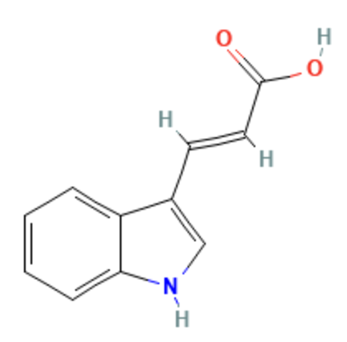 | 4.809 | 188.0704 | C11 H9 N O2 | 188.0704 | 6.209150344 | [M+H]+1
(R)-Prunasin | 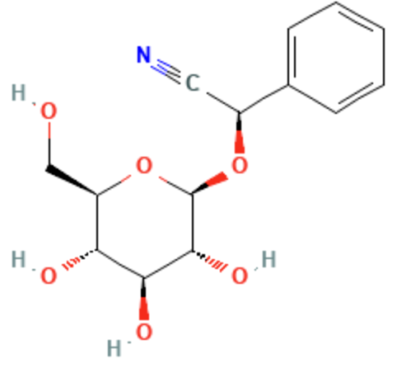 | 7.905 | 295.106 | C14 H17 N O6 | 294.0987 | 5.954894729 | [M-H]-1
4-(Methoxymethyl)-6-methyl-5-nitro-2-  3,4,5-trimethoxybenzyl)amino]nicotinonitrile | 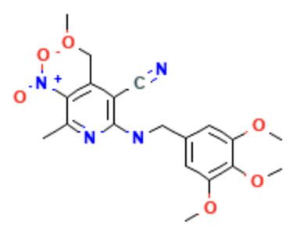 | 8.912 | 402.1529 | C19 H22 N4 O6 | 447.1512 | 2.281021368 | [M+FA-H]-1
1-{4-[3-(2-Methyl-2-propanyl)-1,2,4-oxadiazol-5-yl]-2-pyridinyl}-1H-imidazole-4-carboxylic acid | 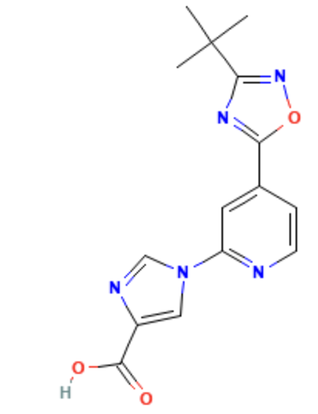 | 3.695 | 313.1163 | C15 H15 N5 O3 | 312.1093 | 1.937812581 | [M-H]-1
(2E)-3-{3-[(2-Hydroxyethyl)(methyl)sulfamoyl]-4,5-dimethoxyphenyl}acrylic acid | 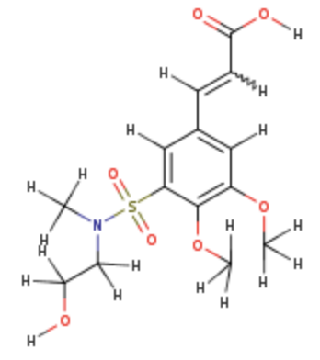 | 1.077 | 345.0878 | C14 H19 N O7 S | 346.095 | 1.77836382 | [M+H]+1
Pestalotiopyrone L | 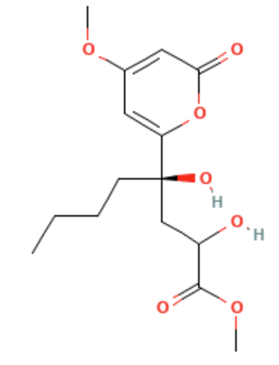 | 12.137 | 314.1373 | C15 H22 O7 | 313.13 | 1.697588162 | [M-H]-1
1-phenylpropane-1_2-dione | 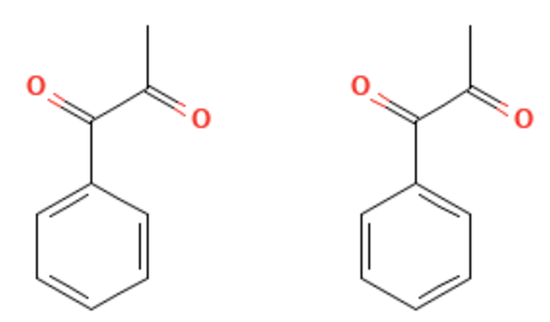 | 2.612 | 148.0523 | C9 H8 O2 | 166.0861 | 1.587107046 | [M+NH4]+1
pyridoxal isonicotinoyl hydrazone | 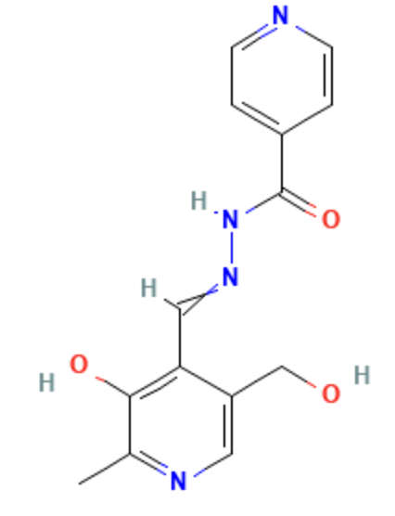 | 4.841 | 286.1055 | C14 H14 N4 O3 | 285.0982 | 1.572704395 | [M-H]-1
(S)-4-Hydroxymandelonitrile | 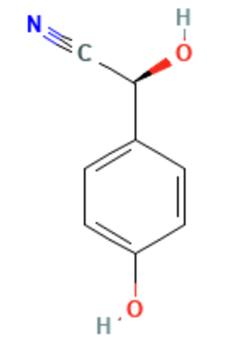 | 7.905 | 149.0479 | C8 H7 N O2 | 148.0406 | 1.495219512 | [M-H]-1
Adenosine | 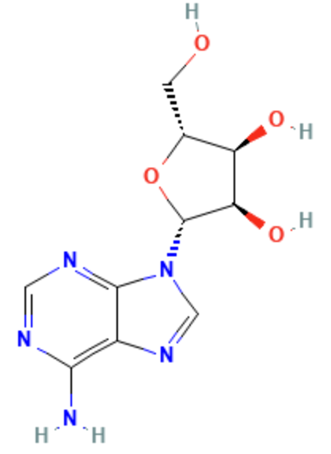 | 1.271 | 267.0965 | C10 H13 N5 O4 | 268.1038 | 1.428717368 | [M+H]+1
4-methylthiobutanaldoxime | 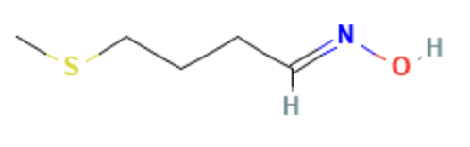 | 1.677 | 133.0561 | C5 H11 N O S | 134.0633 | 1.211793908 | [M+H]+1
(9S_10S)-9_10-Dihydroxyoctadecanoate | 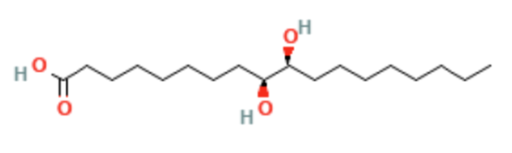 | 21.634 | 316.2617 | C18 H36 O4 | 315.2548 | 1.16117134 | [M-H]-1
5-(4-Morpholinyl)pyrazolo[1,5-a]quinazoline-3-carbonitrile | 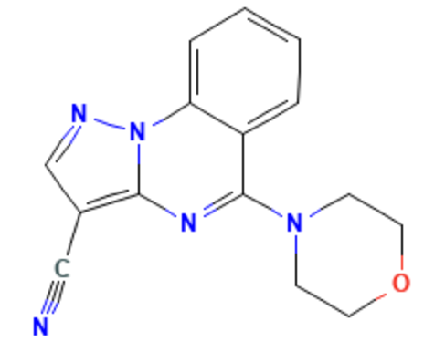 | 8.874 | 279.111 | C15 H13 N5 O | 324.1092 | 1.14777516 | [M+FA-H]-1
5-[4-(Allyloxy)-3-methoxyphenyl]-2-amino-5,8-dihydropyrido[2,3-d]pyrimidine-4,7(1H,6H)-dione | 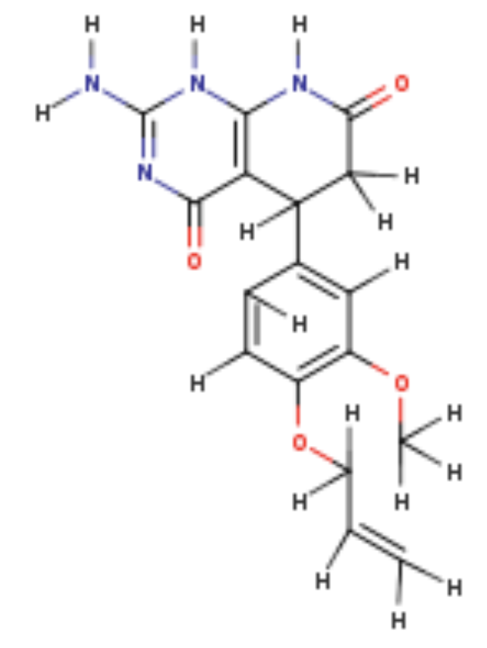 | 12.781 | 342.1323 | C17 H18 N4 O4 | 341.125 | 1.078186407 | [M-H]-1

