Supplementary 1: PGT-M Survey in English

Purpose of the Study
In Japan, Preimplantation Genetic Testing for Monogenic disorders (PGT-M) has long been restricted by the Japan Society of Obstetrics and Gynecology (JSOG) to only severe or serious genetic diseases. However, in 2022, the guidelines were revised, and now the scope has expanded to include diseases that were previously excluded. This survey aims to understand your opinions, concerns, and thoughts regarding PGT-M. Your responses will be used solely for research purposes and will remain completely anonymous. We sincerely hope you will share your honest opinions.
In this questionnaire, anyone affected by genetic disorders, including carriers, is referred to as a 'person concerned'.
Each person may respond only once. It takes approximately 15 minutes to complete. Participation is entirely voluntary, and you may withdraw at any time without penalty.

Consent to Participate
If you understand and agree to the above, please select “I agree” to begin the survey.

What is PGT-M?
Preimplantation Genetic Testing (PGT) is a procedure in which cells are taken from an embryo (fertilized egg) and tested for genetic conditions. One type of this procedure, which screens for specific diseases caused by single-gene changes, is called PGT-M (Preimplantation Genetic Testing for Monogenic Disorders). PGT-M is different from prenatal testing, which is done during pregnancy. For example, NIPT (Non-Invasive Prenatal Testing) analyzes fetal DNA from the mother’s blood to estimate the risk of chromosomal abnormalities and is performed after conception. In contrast, PGT-M requires in-vitro fertilisation (IVF)—specifically, intracytoplasmic sperm injection (ICSI), a technique in which a single sperm is injected into an egg. ICSI is usually used for infertility treatment and is considered an advanced assisted reproductive technology (ART). Therefore, even for individuals or couples who are not infertile, choosing PGT-M involves significant physical, psychological, and financial burdens.
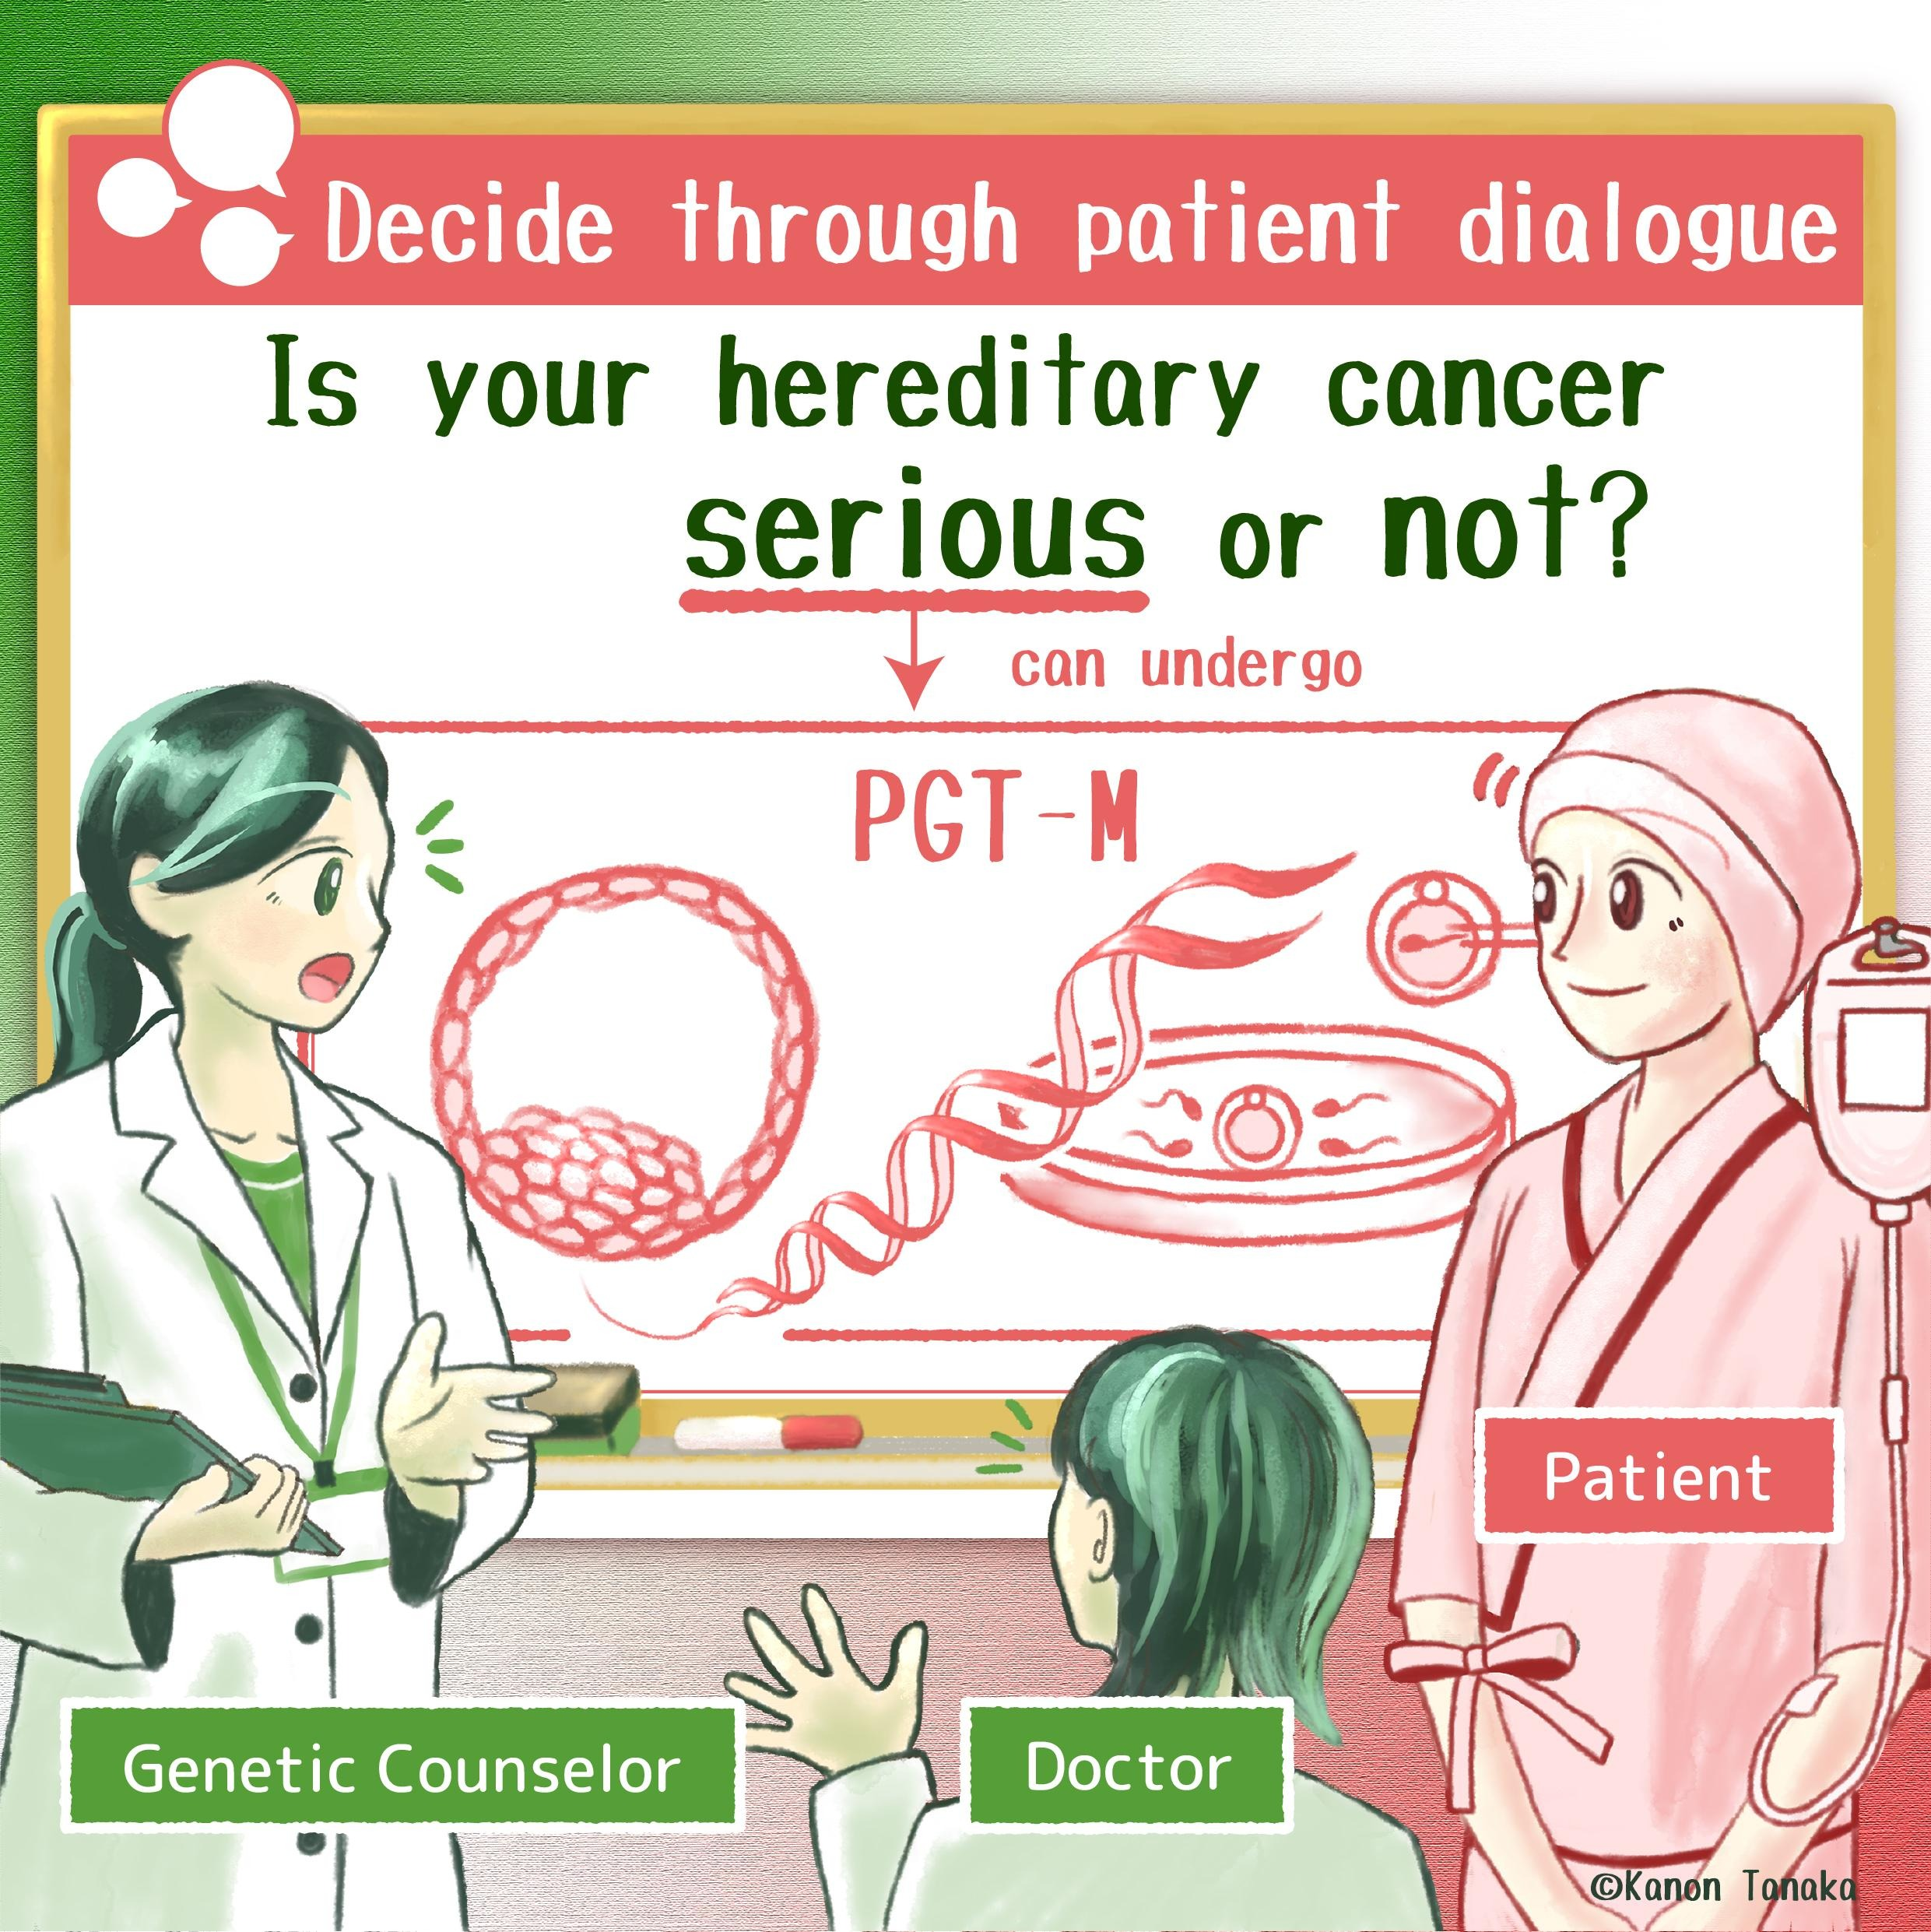

Q1. Before participating in this study, have you ever heard of PGT-M?
- Yes, I have
- No, I have not

Q2. Have you heard the term “genetic selection of embryo”?
- Yes, I have
- No, I have not

Q3. Would you want to undergo PGT-M? If you are not personally affected, please answer hypothetically as if you were.
- Definitely yes
- Probably yes
- Not sure
- Probably no
- Definitely no

Q4. What impression do you have when you hear the term “genetic selection of embryo”? (Select all that apply)
- Ranking the value of lives
- Unfair treatment of lives
- Ethically problematic
- Inevitable because of scientific advancements
- Personal issue
- No impression
- Other (please specify)

Q5. In current fertility treatments, embryos are graded (e.g., A–C) based on their appearance. Do you think choosing embryos that look more likely to result in pregnancy, based on their appearance, is ethically acceptable “selection of life”?
- Strongly disagree
- Disagree
- Cannot say
- Agree
- Strongly agree

Q6. Do you think that selecting embryos without the genetic changes (mutations) that make the parents susceptible to certain diseases—based on the results of PGT-M—is ethically acceptable “selection of life”?
- Strongly disagree
- Somewhat disagree
- Neither agree nor disagree
- Somewhat agree
- Strongly agree

Q7. If you were to undergo PGT-M yourself, for what purposes would you want to use it? (Select all that apply)
- To have a child without disease
- To have a child without disability
- To have a healthy child
- To have a child with enhanced abilities (e.g., intelligent, athletic, good-natured)
- To have a child who shares similar traits with me (e.g., deafness, blindness, short stature)
- PGT-M should not be permitted for any reason (please explain why you think so. If you have no opinion, you may answer “None”.)

Q8. If others were to undergo PGT-M, for what purposes would you permit its use? (Select all that apply)
- To have a child without disease
- To have a child without disability
- To have a healthy child
- To have a child with enhanced abilities (e.g., intelligent, athletic, good-natured)
- To have a child who shares similar traits with me (e.g., deafness, blindness, short stature)
- PGT-M should not be permitted for any reason (please explain why you think so. If you have no opinion, you may answer “None”.)

Q9 – 13. In the next questions, we ask what kinds of conditions you think PGT-M should be allowed for. In Singapore, professional and regulatory guidance typically prioritises conditions that are life-threatening or very severe. In this survey, however, we would like to know any conditions that you personally consider “serious” or “severe,” not only those that are life-threatening.

Q9 [Likelihood of Developing Disease] Even if we carry a genetic change (mutation) that increases the risk of disease, we do not always develop the condition. For example, people who carry a breast cancer–associated gene are estimated to have a 50–70% lifetime risk of developing breast cancer—about 5 to 7 times higher than those without the mutation. At what level of likelihood would you begin to feel that a genetic condition is “serious”? Please choose the single option that comes closest to when you would start considering the condition to be serious.
- 0–24%
- 25–49%
- 50–74%
- 75–100%

Q10. [Lethality] Some genetic conditions are life-threatening in infancy, while others cause severe symptoms from childhood and may lead to death before adulthood. The expected age of survival varies depending on the disease. Up to what age would you consider a disease to be “serious” if it limits survival? Please select the option that is closest to your opinion from the list below.
- Infancy (0–under 1 year)
- Early childhood (1–5 years)
- School age to adolescence (6–20 years)
- Adulthood (21–60 years)
- Older age (61 years and above)

Q11. [Impact on Daily Life] Some genetic conditions are not fatal but still affect the patient’s daily life. From what level of impact on daily life would you start to consider a condition “serious”? Please select only the lowest level that applies (meaning that you would consider the disease serious if it causes this level of impact or greater).
- No impact: No interference with daily life at all
- Mild: Some minor difficulties, but daily life is mostly unaffected
- Moderate: Certain activities are clearly limited, but the person can remain independent
- Severe: Independence is affected, and assistance is sometimes needed
- Very severe: Assistance is needed for many daily activities, and freedom in daily life is greatly reduced

Q12. [Factors Influencing Perception of Seriousness] To what extent do the following experiences affect how serious you perceive a disease to be? For each experience, please indicate how strongly it influences your judgment. Select “Very strong influence” if it affects your perception greatly, or “No influence at all” if it does not affect your perception.

Factor | No influence at all | Small influence | Moderate influence | Strong influence | Very strong influence
Physical burden of the illness or its treatment (e.g., side effects, pain, fatigue)
Psychological burden of the illness or its treatment (e.g., anxiety, depression, hopelessness, fear of the future)
Financial burden of treatment
Impact of the illness or treatment on daily life (e.g., work, household tasks, hobbies)
Changes in physical appearance caused by the illness or treatment
Discrimination or stigma related to the illness

Q13. [Availability of Support] To what extent would the lack of the following types of support affect how serious you perceive a disease to be? Select “Very strong influence” if it greatly affects your perception of seriousness, or “No influence at all” if it does not affect your perception.

Factor | No influence at all | Small influence | Moderate influence | Strong influence | Very strong influence
Emotional support and social connections (e.g., support from family or friends, counseling, community resources – having someone or somewhere to turn to when in distress
Accessible systems and services (e.g., medical cost subsidies, consultation hotlines, easily accessible hospitals – having mechanisms to receive needed support)
Financial stability and security in daily life (e.g., ability to afford treatment costs, impact on work or life).

Q14. If it were possible to test embryos for the following genetic predispositions, which ones do you think it would be acceptable to test for? (Select all that apply.)
- Hearing impairment
- Visual impairment
- Early-onset mental or intellectual disability e.g., autism
- Late-onset mental or intellectual disability e.g., dementia
- Neurodevelopmental disorders e.g., ADHD or other hyperactivity disorders
- Mental illness e.g., depression
- Physical disability e.g., dwarfism
- Conditions affecting appearance e.g., neurofibromatosis, which causes nodules and spots on skin
- Metabolic disorders e.g., familial hypercholesterolemia, which causes high cholesterol
- Cancer (malignant tumors)(e.g., hereditary breast cancer or colon cancer)
- Improving intelligence (for non-treatment purposes)
- I would not want to test for any of these predispositions

Q15. Do you think that using PGT-M would encourage people with hereditary conditions, or their children, to be more positive about marriage, pregnancy, and childbirth?
- Strongly disagree
- Somewhat disagree
- Neutral
- Somewhat agree
- Strongly agree

Q16. If you were to undergo PGT-M, what challenges or difficulties would you expect to face? (Select all that apply.)
- Feeling guilty about ‘selecting’ children
- Concern about violating a child’s “right not to know” their genetic information
- Pressure from family or society not to undergo PGT-M
- Pressure from family or society to undergo PGT-M
- Concerns about the financial burden
- Worry about value differences with one’s partner

Q17. What kind of impact do you think the wider use of PGT-M would have on society? (If you have no opinion, you may answer “None.”) [Free Text)

Q18. Regarding the cost of PGT-M, who do you think should bear the cost, and in what way?

- Entirely self-paid (out-of-pocket)
- Partial coverage through medical insurance (e.g., 30% co-pay as in Japan’s system)
- Government partial subsidy (e.g., advanced medical care assistance)
- Fully covered by public funds (no cost to the individual)
- Individuals should be financially rewarded for undergoing testing

Demographic Information

What is your age?
- Under 17
- 18–24
- 25–34
- 35–44
- 45–54
- 55–64
- 65 or older

What is your gender identity?
- Male
- Female
- Non-binary / Third gender
- Prefer not to answer

Do you have children?
- Yes
- No

What is your current marital status?
- Married
- Living with a partner
- Widowed
- Divorced / Separated
- Single (never married)

Do you or your family members have a genetic condition?
- I or a family member is affected
- Not affected
- Other (please specify)

Have you ever received fertility treatment?
- Yes
- No

What is your highest level of education?
- No formal education
- Completed primary education
- Some secondary education
- Completed secondary education
- Vocational or technical training
- Some university
- Completed university (bachelor’s degree)
- Postgraduate or professional degree (e.g., MA, MS, MBA, PhD, JD, MD, DDS)
- Prefer not to answer

Which best describes your employment status over the past 3 months?
- Full-time employment
- Part-time employment
- Unemployed and looking for work
- Homemaker
- Student
- Retired
- Other

What was your total household income (before taxes) in the past 12 months?
- Less than ¥2,000,000
- ¥2,000,000–¥3,990,000
- ¥4,000,000–¥5,990,000
- ¥6,000,000–¥7,990,000
- ¥8,000,000–¥9,990,000
- ¥10,000,000 or more
- Prefer not to answer

What is your religion?
- Christianity (Catholic, Protestant, or other Christian denomination)
- Buddhism
- Hinduism
- Islam
- Judaism
- Sikhism
- No religion
- Other (please specify)

