Supplementary Information
Electric field control of field-free spin-orbit torque switching via laterally modulated Rashba effect in Pt/Co/AlO_{x} structures

Min-Gu Kang^{1†}, Jong-Guk Choi^{1†}, Jimin Jeong¹, Jae Yeol Park¹, Hyeon-Jong Park², Jong Min Yuk¹, Kyung-Jin Lee³, and Byong-Guk Park^{1★}
¹Department of Materials Science and Engineering, KAIST, Daejeon 34141, Korea
²KU-KIST Graduate School of Converging Science and Technology, Korea University, Seoul 02841, Korea
³Department of Physics, KAIST, Daejeon 34141, Korea

† These two authors equally contributed to this work.
★ Correspondence to: bgpark@kaist.ac.kr (B.-G.P.)

Supplementary Note 1. Electron energy loss spectroscopy analysis of Pt/Co/AlO_{x}/TiO₂ structure.
To investigate the effect of the gate voltage on oxygen concentration in Pt (5nm)/Co (1.4nm)/AlO_{x} (2 nm)/TiO₂ (40 nm) samples, we perform scanning transmission electron microscopy (STEM) and electron energy loss spectroscopy (EELS) measurements, which provides a hint for the lateral asymmetry caused by the gate voltage. Before preparing a cross-sectional sample using focused ion beam (FIB) technique, we applied an asymmetric gate voltage (V_{G,L} = 0V, V_{G,R} = +8V), ΔV_{G} < 0. Figure S1a shows the STEM image and elemental maps of the oxygen obtained from EELS, in which the position A (B) represents the region of the gate oxide located just below the edge of the gate electrode V_{G,L} (V_{G,R}). This demonstrates that the oxygen concentration is increased at the position B where a V_{G,R} of +8V was applied as compared to the position A. This indicates that the ΔV_{G} induces the oxygen ion redistribution depending on its polarity, resulting in the oxygen concentration gradient (Fig. S1b). Moreover, Figure S1c shows the EELS spectra of the Ti L edges measured at the positions A and B, indicating that a positive V_{G} causes a valence change of the Ti ion into a higher oxidation state, and thus Ti L_{3,2} peaks move toward higher energy [1]. From the oxygen EELS intensity, the stoichiometries are qualitatively estimated as TiO_{1.84} on the left and TiO_{2.16} on the right.

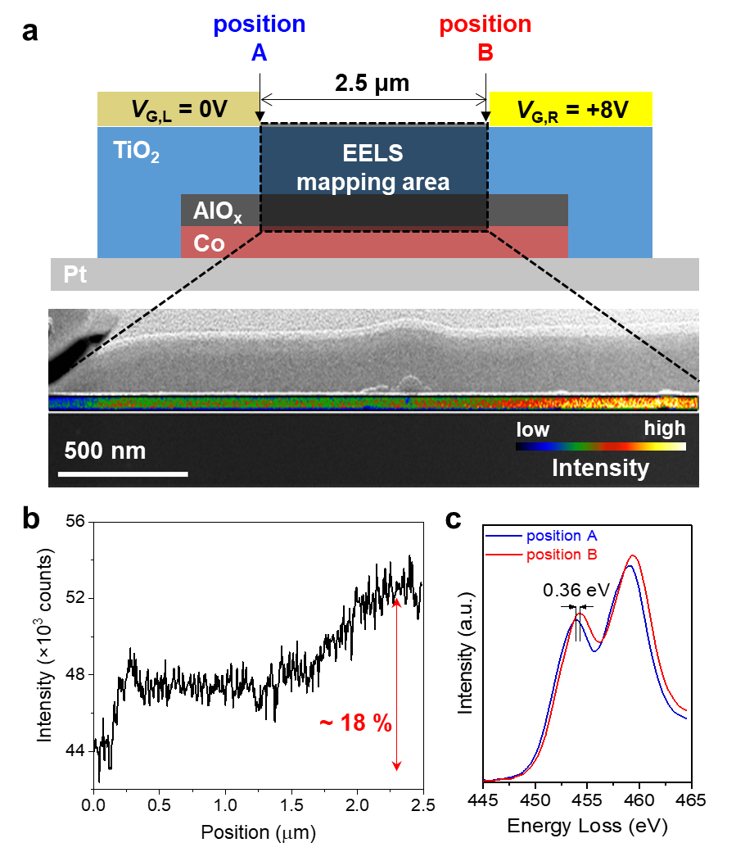
Figure S1. Electron energy loss spectroscopy analysis. a, STEM image and EELS mapping of oxygen in the TiO₂ layer of a Pt(5nm)/Co(1.4nm)/AlO_{x}(2 nm)/TiO₂(40 nm) structure. b, EELS intensity of oxygen in TiO₂ as a function of the position indicated in Fig. S1a. c, EELS spectra of the of Ti L_{3,2} edges at the positions A and B.

Supplementary Note 2. In-plane harmonic Hall voltage analysis of the spin-orbit torque
Landau-Lifshitz-Gilbert equation including out-of-plane spin-orbit torque (SOT) terms is given as [2-4]
$\frac{∂m}{∂t}=-γm×\left(B_{eff}+B_{DLT}^{y}\left(m×y\right)+B_{FLT}^{y}y+B_{DLT}^{z}\left(m×z\right)+B_{FLT}^{z}z\right)+αm×\frac{∂m}{∂t}$ (S1),
where $B_{eff}$ includes the anisotropy (B_{ani}), demagnetization (B_{dem}), exchange, and external fields; $α$ is the damping constant; $γ$ is the gyromagnetic ratio; $B_{DLT}^{y}$ ($B_{FLT}^{y}$) and $B_{DLT}^{z}$ ($B_{FLT}^{z}$) are the damping-like (field-like) SOT effective field from y-SOT and z-SOT, respectively. Here, we define the unit vector x as the current direction and z as the direction perpendicular to the film plane. We assume that inversion symmetry is broken in both the z- and y-directions, generating y-SOT and z-SOT, respectively. Figure S2a shows the effective fields due to y-SOT and z-SOT acting on the magnetization.
The current-induced effective field $(∆B)$ due to the inversion asymmetry along the z- and y-directions is given by [5]
$∆B=\left(∆B_{x},∆B_{y},∆B_{z}\right)=(-B_{DLT}^{y}\cos{θ_{0}}+B_{DLT}^{z}\sin{θ_{0}}\sin{φ_{0}}, B_{FLT}^{y}+B_{Oe}-B_{DLT}^{z}\sin{θ_{0}}\cos{φ_{0}},B_{DLT}^{y}\sin{θ_{0}}\cos{φ_{0}}+B_{FLT}^{z})$ (S2),
where $B_{Oe}$ is the Oersted field, $θ$ and $φ$ are the polar and azimuthal angles of the magnetization direction, respectively. The subscript “0” denotes the equilibrium state of magnetization.
When applying a sinusoidal oscillating current ($I=∆I\sin{ωt}$) with frequency $ω$, the Hall voltage $V_{xy}$ is expressed as,
$V_{xy}=R_{xy}I=\left(R_{xy,0}+\frac{dR_{xy}}{dI}∆I\sin{ωt}\right)∆I\sin{ωt}$ (S3),
where $R_{xy}$ is the Hall resistance. In normal-metal/ferromagnet/oxide structure, the $R_{xy}$ is
$R_{xy}=R_{AHE}\cos{θ}+R_{PHE}\sin^{2}{θ}\sin{2φ}$ (S4),
where R_{AHE} (R_{PHE}) is the anomalous Hall resistance (planar Hall resistance). The spin torque from $∆I\sin{ωt}$ induces the perturbation of magnetization in polar angle ($∆θ\sin{ωt}$) and azimuthal angle ($∆φ\sin{ωt}$). Therefore, the R_{xy} can be expanded as,
$R_{xy}=R_{xy,0}+\frac{dR_{xy}}{dI}∆I\sin{ωt}≈R_{AHE}\left(\cos{θ_{0}}-∆θ\sin{ωt}\sin{θ_{0}}\right)+R_{PHE}(\sin^{2}{θ_{0}}\sin{2φ_{0}}+∆θ\sin{ωt}\sin{2θ_{0}}\sin{2φ_{0}}+2∆φ\sin{ωt}\sin^{2}{θ_{0}}\cos{2φ_{0}})$ (S5).
When in-plane component of an external magnetic field ($B_{ext}$) with polar angle $θ_{B}$ and azimuthal angle $φ_{B}$ is sufficiently larger than the demagnetization field $B_{dem}$ ($\left|B_{dem}\right|≪\left|B_{ext}\right|\sin{θ_{B}}$ and $φ_{0}≈φ_{B}$), the perturbation angles become [5]
$∆θ=\frac{\cos{θ_{0}}\left(∆B_{x}\cos{φ_{B}}+∆B_{y}\sin{φ_{B}}\right)-\sin{θ_{0}}∆B_{z}}{\left(B_{ani}-B_{dem}\sin^{2}{φ_{B}}\right)cos2θ_{0}+B_{ext}cos(θ_{B}-θ_{0})}$ (S6)
$∆φ=\frac{-∆B_{x}\sin{φ_{B}}+∆B_{y}\cos{φ_{B}}}{-B_{dem}\sin{θ_{0}}\cos{2φ_{B}}+B_{ext}\sin{θ_{B}}}$ (S7).
By substituting the Eq.(S2) and Eqs. (S5-S7) into Eq.(S3), the Hall voltage and each harmonic Hall resistance ($R_{xy}^{0ω}$, $R_{xy}^{1ω}$, and $R_{xy}^{2ω}$) can be rewritten as
$V_{xy}=(\frac{1}{2}R_{xy}^{0ω}+R_{xy}^{1ω}\sin{ωt}-\frac{1}{2}R_{xy}^{2ω}\cos{2ωt}$)$∆I$ (S8).
$R_{xy}^{0ω}=A+B$ (S9).
$R_{xy}^{1ω}=R_{xy,0}$ (S10).
$R_{xy}^{2ω}=A+B$ (S11).
$$A=\left(-R_{AHE}\sin{θ_{0}}+2R_{PHE}\sin{2θ_{0}}\sin{2φ_{H}}\right)×\frac{\left(-B_{FLT}^{z}\sin{θ_{0}}-B_{DLT}^{y}\cos{φ_{H}}+(B_{FLT}^{y}+B_{Oe})\cos{θ_{0}}\sin{φ_{B}}\right)}{\left(B_{ani}-B_{dem}\sin^{2}{φ_{B}}\right)cos2θ_{0}+B_{ext}cos(θ_{B}-θ_{0})}$$
$$B=2R_{PHE}\sin^{2}{θ_{0}}\cos{2φ_{H}}\frac{B_{DLT}^{y}\cos{θ_{0}}\sin{φ_{B}}+(B_{FLT}^{y}+B_{Oe})\cos{φ_{B}}-B_{DLT}^{z}\sin{θ_{0}}}{-B_{dem}\sin{θ_{0}}\cos{2φ_{B}}+B_{ext}\sin{θ_{B}}}$$
In particular, when applying an in-plane magnetic field ($θ_{B}=\frac{π}{2}$) sufficient to make the magnetization direction aligned in the plane ($θ_{0}≈\frac{π}{2}$), $B_{FLT}^{y}$ and $B_{DLT}^{z}$ ($B_{DLT}^{y}$ and $B_{FLT}^{z}$) only changes the azimuthal (polar) angle of magnetization, as shown in Fig. S2b. In such condition, the second harmonic Hall resistance $R_{xy}^{2ω}$ becomes
$R_{xy}^{2ω}\left(φ_{B}\right)=\left(R_{AHE}\frac{B_{DLT}^{y}}{B_{eff}}+R_{∇T}^{2ω}\right)cosφ_{B}+2R_{PHE}\frac{B_{FLT}^{y}+B_{Oe}}{B_{ext}}\left(2\cos^{3}φ_{B}-cosφ_{B}\right)-2R_{PHE}\frac{B_{DLT}^{z}}{B_{ext}}cos2φ_{B}+R_{AHE}\frac{B_{FLT}^{z}}{B_{eff}}$ (S12),
Where thermal contribution ($R_{∇T}^{2ω}$) to $R_{xy}^{2ω}$ is included. Equation (S12) is the same as Eq. (1) in the main text.
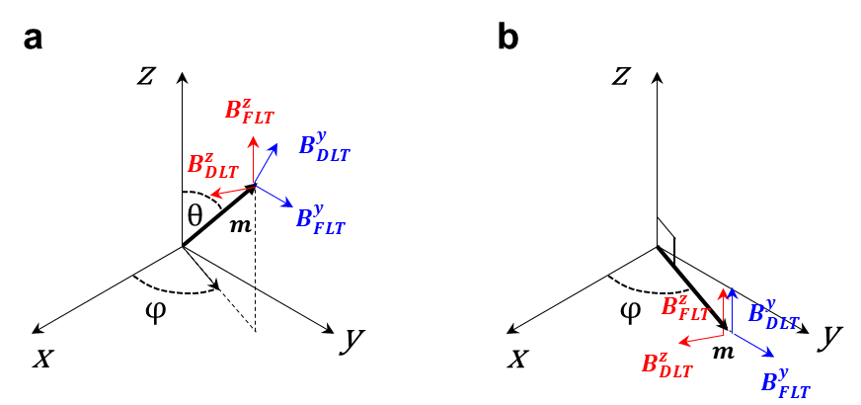
Figure S2. Effective fields due to y-SOT and z-SOT. a-b, The effective field directions acting on the arbitrary magnetization direction (a) and $θ=\frac{π}{2}$ (b).
Supplementary Note 3. Hysteresis loops shift of anomalous Hall resistance
We measure the anomalous Hall resistance R_{xy} with a d.c. current J_{d.c} as a function of the out-of-plane magnetic field B_{z}. The R_{xy} vs. B_{z} hysteresis loop will shift when z-SOT is present [3,6]. Figures S3a shows the hysteresis loop in Pt/Co/AlO_{x}/TiO₂ structures (TiO₂ sample) depending on the ΔV_{G}. When ΔV_{G} > 0 (V_{G,L} = +8V, V_{G,R} = -8V), the hysteresis loop shifts to the positive B_{z} direction for a positive J_{d.c}, while it is opposite for ΔV_{G} < 0. Figure S3b shows that the Δ$B_{S}$ gradually increases with J_{d.c} without a threshold current. Here, Δ$B_{S}$ is the amount of the hysteresis loop shift, defined Δ$B_{S}\left(I_{d.c.}\right)= \left[\left|B_{C}^{+}\left(I_{d.c.}\right)\right|-\left|B_{C}^{-}\left(I_{d.c.}\right)\right|\right]/2$, where $B_{C}^{}$ are positive and negative coercive fields. Figures S3c,d show the results of the ZrO₂ sample, demonstrating the hysteresis shift direction of the ZrO₂ sample is opposite to that of the TiO₂ sample. This is consistent with the SOT switching and harmonic measurement results in the main text.

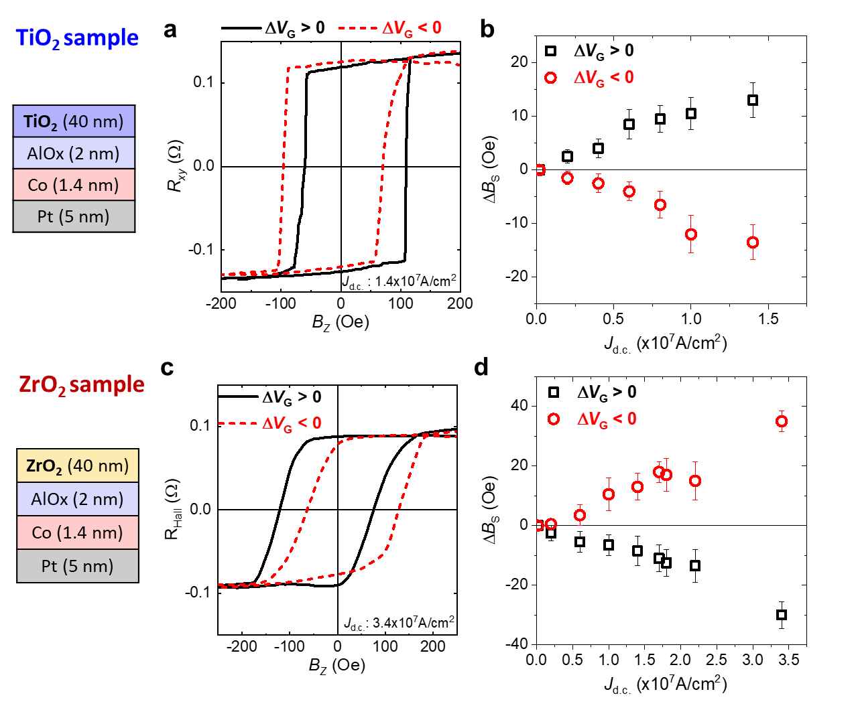
Figure S3. Hysteresis loop shift of R_{xy} in Pt/Co/AlO_{x}/gate oxide structure a, R_{xy} versus B_{z} curves in the TiO₂ sample for ΔV_{G} > 0 (V_{G,L} = +8 V, V_{G,R} = -8 V) (black line) and ΔV_{G} < 0 (V_{G,L} = -8 V, V_{G,R} = +8 V) (red dash line). b, Δ$B_{S}$ versus I_{d.c.} curves in the TiO₂ sample for ΔV_{G} > 0 (black square) and ΔV_{G} < 0 (red circle). c, R_{xy} versus B_{z} curves in the ZrO₂ sample for ΔV_{G} > 0 (V_{G,L} = +10 V, V_{G,R} = -10 V) (black line) and ΔV_{G} < 0 (V_{G,L} = -10 V, V_{G,R} = +10 V) (red dash line). d, Δ$B_{S}$ versus I_{d.c.} curves in the ZrO₂ sample for ΔV_{G} > 0 (black square) and ΔV_{G} < 0 (red circle). The error bars indicate single-standard-deviation uncertainties.

Supplementary Note 4. Spin-orbit torque measurements in Pt/Co/AlO_{x}/ZrO₂ sample
We perform the in-plane harmonic Hall measurements [7] for a Pt/Co/AlO_{x}/ZrO₂ structure (ZrO₂ sample). Figures S4a-c show the $cosφ$, $2\cos^{3}φ-cosφ$, and $cos2φ$ components of the $R_{xy}^{2ω}$ as a function of the B_{eff} or B_{ext}, which correspond to $B_{DLT}^{y}$, $B_{FLT}^{y}$ and $B_{DLT}^{z}$, respectively. For the ZrO₂ sample, the $cos2φ$ component or $B_{DLT}^{z}$ only appears when an asymmetric V_{G} is applied, similar to the TiO₂ sample (Fig. 3 of the main text). However, the sign of $B_{DLT}^{z}$ in the ZrO₂ sample is opposite to that of the TiO₂ sample, which is consistent with field-free switching results shown in Fig. 3 of the main text. The estimated SOT-induced effective SOT fields according to the gate voltage conditions are summarized in Table S1.

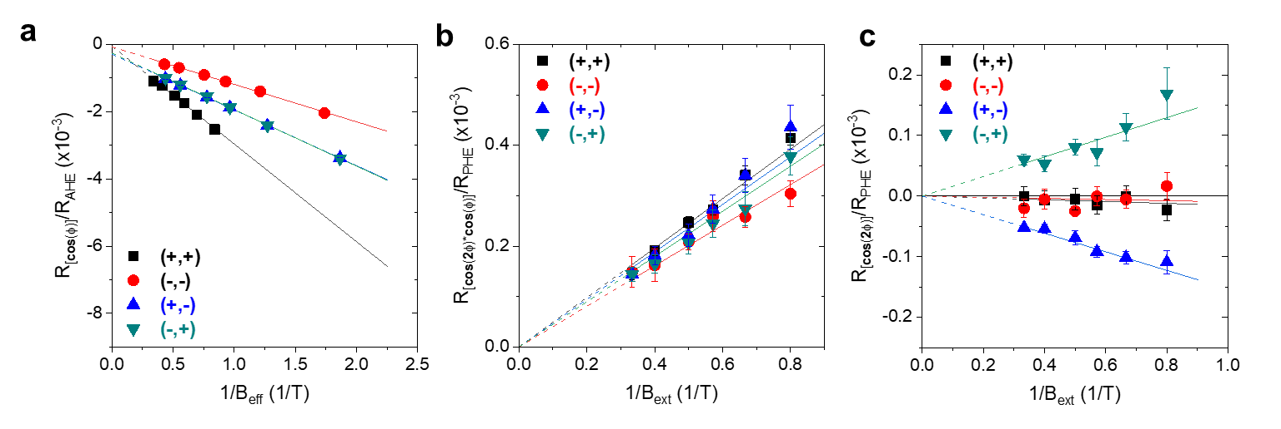
Figure S4. Harmonic spin-orbit torque measurements in Pt/Co/AlO_{x}/ZrO₂. a, $cosφ$ component of ${\text{R}}_{\text{xy}}^{\text{2ω}}$ versus 1/B_{eff}. b, ($2\cos^{3}φ-cosφ)$ component of ${\text{R}}_{\text{xy}}^{\text{2ω}}$ versus 1/B_{ext}. c, $cos2φ$ component of ${\text{R}}_{\text{xy}}^{\text{2ω}}$ versus 1/B_{ext}.

Table S1. SOT effective fields depending on gate voltage conditions.
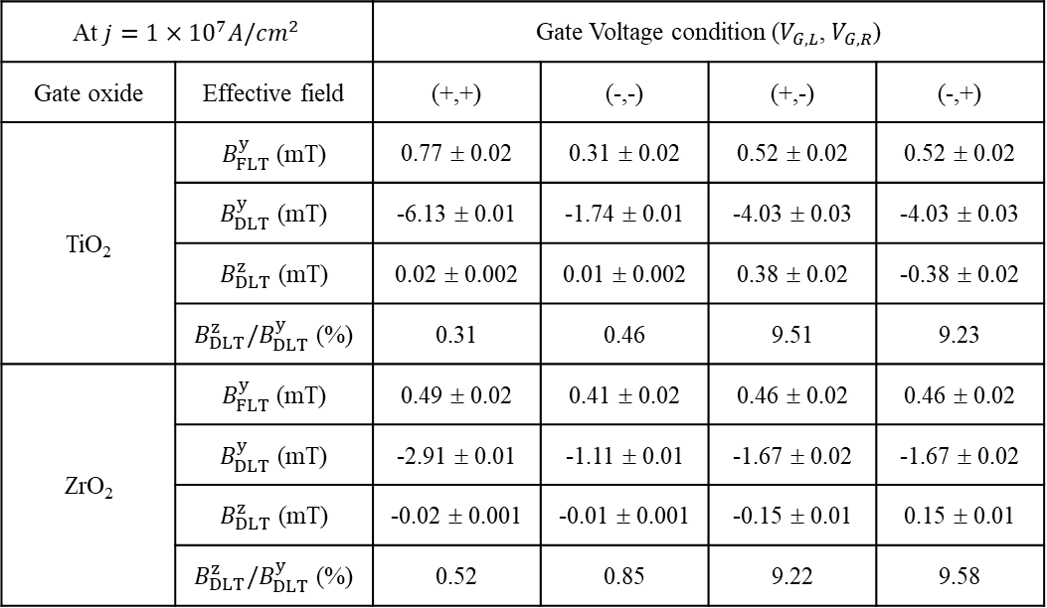

Supplementary Note 5. Voltage-controlled magnetic anisotropy (VCMA) effect
We investigate voltage-controlled magnetic anisotropy (VCMA) effect of the Pt (5 nm)/Co (1.4 nm)/AlO_{x} (2 nm) structures with different gate oxides of TiO₂ (40 nm) or ZrO₂ (40 nm), in which FM Co is fully covered by a single gate. We measure the anomalous Hall resistance (R_{xy}) as a function of an in-plane magnetic field (B_{x}), allowing us to evaluate the perpendicular magnetic anisotropy field (H_{K}) and its variation with gate voltage (V_{G}) [8-10]. Figures S5a,b show that the H_{K} decreases when applying a positive gate voltage (V_{G}) for both samples regardless of the gate oxide. We further investigate the VCMA effect of the same samples that are used for the SOT switching measurements in the main text with four different gate conditions of V_{G}^{(+,+)}, V_{G}^{(-,-)}, V_{G}^{(+,-)}, and V_{G}^{(-,+)}. Figures S5c-5f show the changes in the coercivity H_{C} and H_{K} with V_{G}, demonstrating that the H_{C} and H_{K} increase (decrease) when applying negative (positive) voltages to both left and right gate electrodes simultaneously: V_{G}^{(-,-)} (V_{G}^{(+,+)}). On the other hand, for the asymmetric voltages V_{G}^{(+,-)} and V_{G}^{(-,+)}, the H_{C} and H_{K} exhibit intermediate values. Moreover, the VCMA effect exhibits the same sign for both samples regardless of the gate oxides.

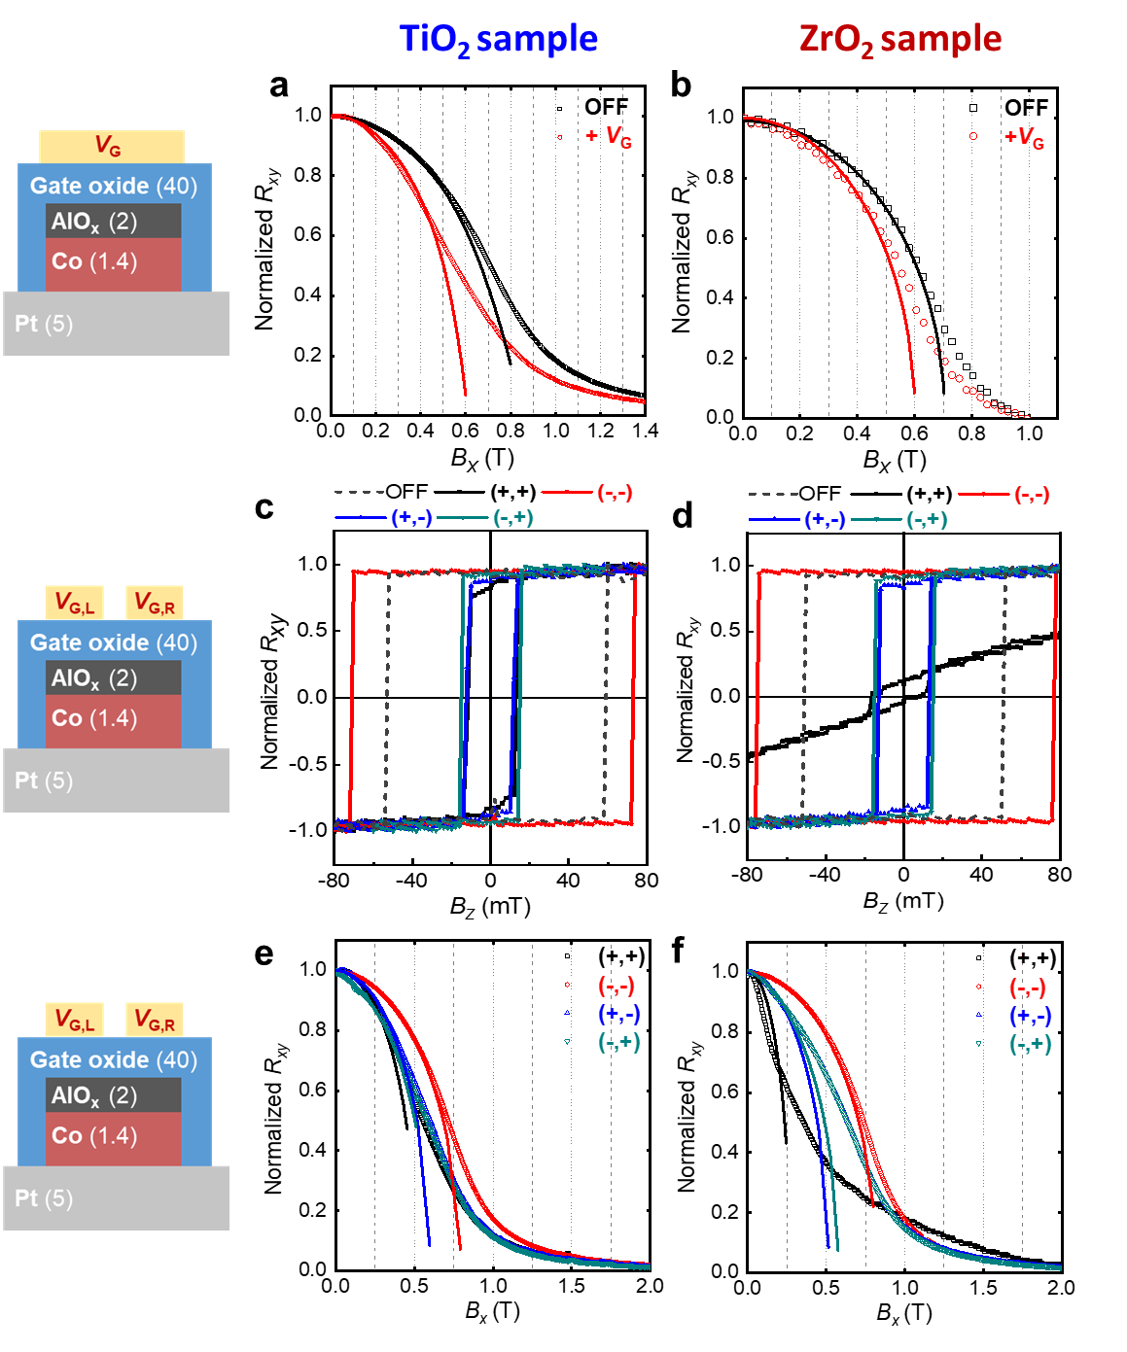
Figure S5. Voltage-controlled magnetic anisotropy measurements. a-b, Normalized anomalous Hall resistance (R_{xy}) as a function of in-plane magnetic field (B_{x}) under V_{G} = +8 V for the TiO₂ sample (a) and V_{G} = +10 V for ZrO₂ samples (b) with a single gate. c-d, Normalized R_{xy} as a function of an out-of-plane magnetic field (B_{z}) under different gate voltages of V_{G}^{(+,+)}, V_{G}^{(-,-)}, V_{G}^{(+,-)}, and V_{G}^{(-,+)} for the TiO₂ sample (c) and ZrO₂ sample (d). e-f, Normalized R_{xy} as a function of B_{x} under different gate voltages of V_{G}^{(+,+)}, V_{G}^{(-,-)}, V_{G}^{(+,-)}, and V_{G}^{(-,+)} for the TiO₂ sample (e) and ZrO₂ sample (f).

Supplementary Note 6. Variation of damping-like spin-orbit torque with gate voltage
Figure S6 shows the $cosφ$ component of $R_{xy}^{2ω}$ as a function of 1/B_{eff} depending on V_{G} in Pt (0.5 nm)/Co (2 nm)/AlO_{x} (2 nm)/gate oxide (40 nm) samples, which corresponds to the change in $B_{DLT}^{y}$ with V_{G}. Unlike the $B_{FLT}^{y}$ (Figs. 4c-d in the main text), the $B_{DLT}^{y}$ and its gate voltage dependence is negligible for the samples regardless of the gate oxide material.

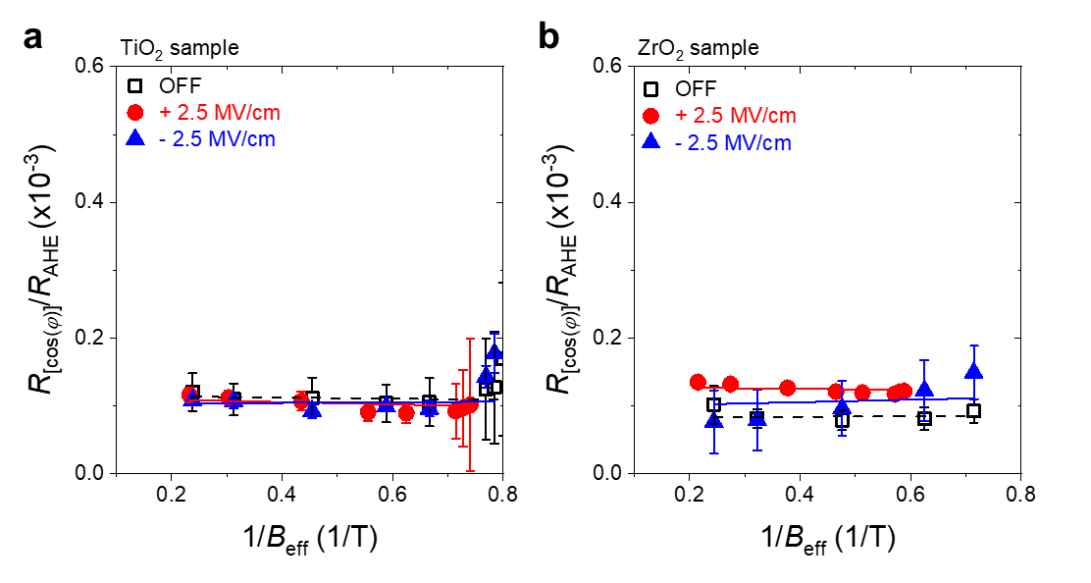
Figure S6. Gate voltage dependence of damping-like SOT. a-b, Damping-like SOT component of $R_{xy}^{2ω}$ depending on pre-biased gate voltage V_{G} of ±2.5 MV/cm for Pt(0.5 nm)/Co (2 nm)/AlO_{x} (2 nm)/TiO₂ (40 nm) (a) and Pt (0.5 nm)/Co (2 nm)/AlO_{x} (2 nm)/ZrO₂ (40 nm) (b) samples.
Supplementary Note 7. Reconfigurable logic operation using a single device
Figures 1 and 3 in the main text show the electrical control of spin-orbit torque switching polarity in a reversible and non-volatile manner. This allows us to demonstrate reconfigurable logic operations using a single device, where a gate voltage (V_{G,L} or V_{G,R}) and input current (I_{IN}) are used as two input parameters (Fig. S7a). Figure S7b shows the device performance; the magnetization switching occurs at a current of ±10 mA, and the switching polarity is reversed by changing the sign of ΔV_{G}. Based on the device, we construct a truth table, as shown in Figs. S7c,d, demonstrating that two logic operations are possible depending on the input parameters; first, the device operates the XOR function with input parameters of I_{IN} and V_{G,L} (Fig. S7c). Here, we define the positive values of the inputs (I_{IN} = +15 mA, V_{G,L} = +10 V) as digital input ‘1’, and their negative values (I_{IN} = -15 mA, V_{G,L} = -10 V) as digital input ‘0’. They determine the digital output of the device, the magnetization direction; UP [DOWN] magnetization (R_{xy} > 0) [(R_{xy} < 0)] corresponds to digital output ‘1’ [‘0’]. Second, it operates the AND function with input parameters of I_{IN} and V_{G,R} when the device is initialized as the ‘0’ state (Fig. S7d). For a AND gate, we define the inputs of I_{IN} = +15 mA, V_{G,L} = +10 V as digital input ‘1’, and those of I_{IN} = +5 mA, V_{G,L} = -10 V as digital input ‘0’. The different logic operations can be achieved by changing one input parameter, demonstrating a programmable logic operation in the SOT device with two side gates.
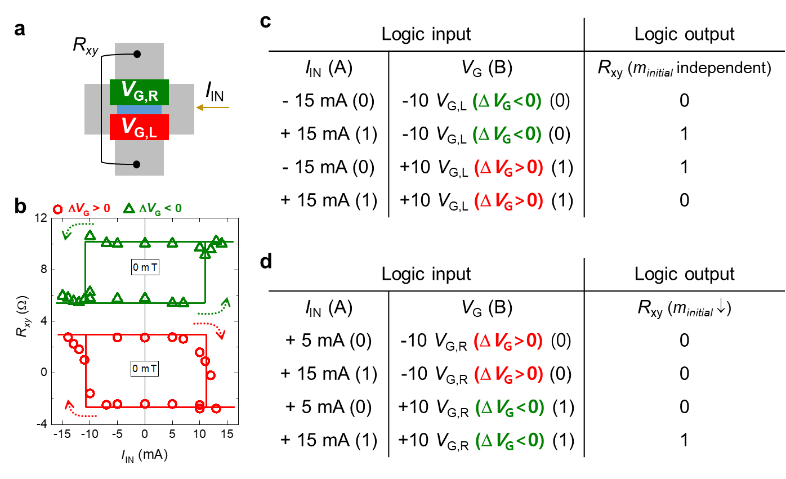
Figure S7. Reconfigurable logic operations of a single SOT device. a, Schematic of the device, in which gate voltage (V_{G,L} or V_{G,R}) and input current I_{IN} are used as two input parameters. b, Current-induced switching of the device according to ΔV_{G} under +10 V of V_{G,L} (ΔV_{G} > 0, red) or V_{G,R} (ΔV_{G} < 0, green). c-d, Logic truth tables constructed using the results in Fig. S7b. XOR function (c) and AND function (d).

References
- Tan, H., Verbeeck, J., Abakumov, A. & Van Tendeloo, G. Oxidation state and chemical shift investigation in transition metal oxides by EELS. Ultramicroscopy 116, 24–33 (2012).
- Garello, K. et al. Symmetry and magnitude of spin-orbit torques in ferromagnetic heterostructures. Nat. Nanotechnol. 8, 587–593 (2013).
- Yu, G. et al. Switching of perpendicular magnetization by spin-orbit torques in the absence of external magnetic fields. Nat. Nanotechnol. 9, 548 (2014).
- Lee, D.-K. & Lee, K.-J. Spin-orbit torque switching of perpendicular magnetization in ferromagnetic trilayers. Sci. Rep. 10, 1772 (2020)
- Hayashi, M., Kim, J., Yamanouchi, M. & Ohno, H. Quantitative characterization of the spin-orbit torque using harmonic Hall voltage measurements. Phys. Rev. B 89, 144425 (2014).
- Baek, S. C. et al.Spin currents and spin-orbit torques in ferromagnetic trilayers. Nat. Mater. 17, 509–513 (2018).
- Avci, C. O. et al. Interplay of spin-orbit torque and thermoelectric effects in ferromagnet/normal-metal bilayers. Phys. Rev. B 90, 224427 (2014).
- Maruyama, T. et al. Large voltage-induced magnetic anisotropy change in a few atomic layers of iron. Nat. Nanotechnol. 4, 158–161 (2009).
- Bauer, U. et al. Magneto-ionic control of interfacial magnetism. Nat. Mater. 14, 174–181 (2015).
- Park, K. W. et al. Electric field control of magnetic anisotropy in the easy cone state of Ta/Pt/CoFeB/MgO structures. Appl. Phys. Lett. 109, 012405 (2016).

