Visualizing Gas-Generating Catalysis at the Single-Nanoparticle Level via Multimodal Dark-Field Microscopy
Yi Wang*, Zhengzhuo Li, Yanhui Gao, Fengjv Shen, Yamin Wang, Le Sun, Xinlong Cai, Jingjing Shen, Quli Fan, Lei Zhang*
State Key Laboratory of Flexible Electronics (LoFE) & Institute of Advanced Materials (IAM), Nanjing University of Posts & Telecommunications, 9 Wenyuan Road, Nanjing 210023, China
Corresponding Author: *iamyiwang@njupt.edu.cn; *iamlzhang@njupt.edu.cn

Table of Contents
S1. Characterization results of MnO₂
S2. DFM imaging for single MnO₂ nanoparticle analysis
S3. Control experiments
S4. Statistical analysis for nanobubble generation on individual MnO₂ nanoparticles
S5. Active and non-active fraction of nanoparticles
S6. Statistical analysis of ON and OFF states duration time for a single MnO₂ nanoparticles with different H₂O₂ concentrations
S7. Tracking the center of single nanobubble with DFM imaging
S8. Trajectory of single MnO₂ particles along X and Y directions in different solutions
S9. Measurement of catalytic reaction in ensemble reaction
S10. Statistical analysis of high-velocity duration times

S1. Characterization results of MnO₂
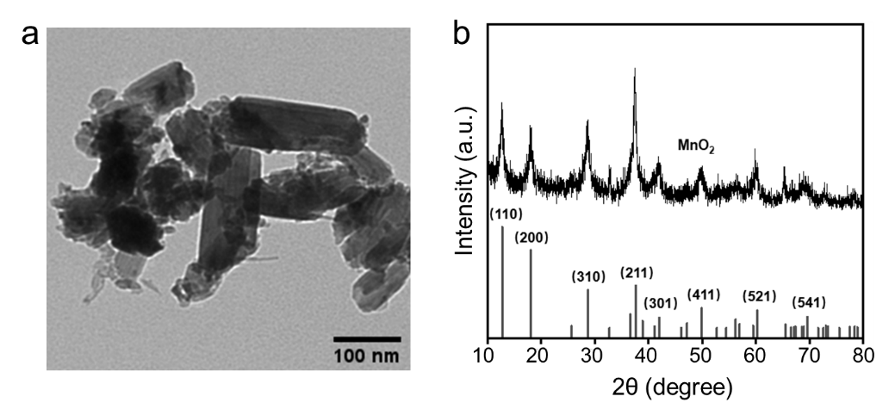
Figure S1. Transmission electron microscopy (TEM) image (a) of MnO₂. (b) XRD pattern of MnO₂, showing characteristic diffraction peaks of α-MnO2 indexed to the tetragonal phase (PDF #44-0141).

S2. DFM imaging for single MnO₂ nanoparticle analysis
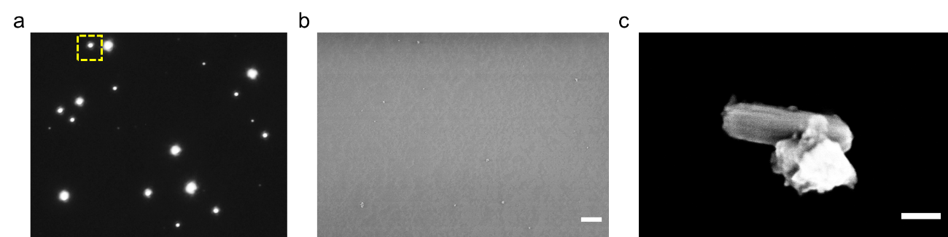
Figure S2. Dark-field image of MnO₂ particles immobilized on the glass slide, and (b) its corresponding SEM image. Scale bars: 5 μm. (c) SEM image of MnO₂ particle labeled in (a). Scale bar: 100 nm.
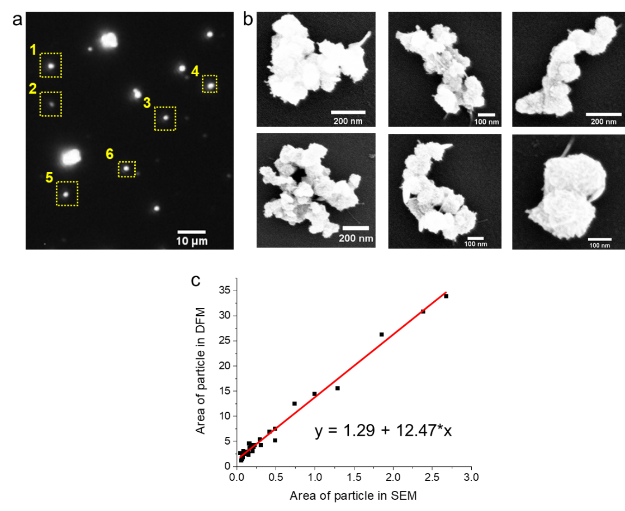
Figure S3. (a) The DFM image of MnO₂ particles. (b) The corresponding SEM of MnO₂ particles in the DFM image. (c) The bright spot variations with different sizes of individual MnO₂ particles in DFM image. Solid line represents the linear fitting curve of particle areas in DFM and SEM images.
Based on the local DFM and SEM characterization, it revealed the heterogeneity of MnO₂ in the size. In this study, we chose the MnO₂ nanoparticles with nm level to study the catalytic reaction.

S3. Control experiments
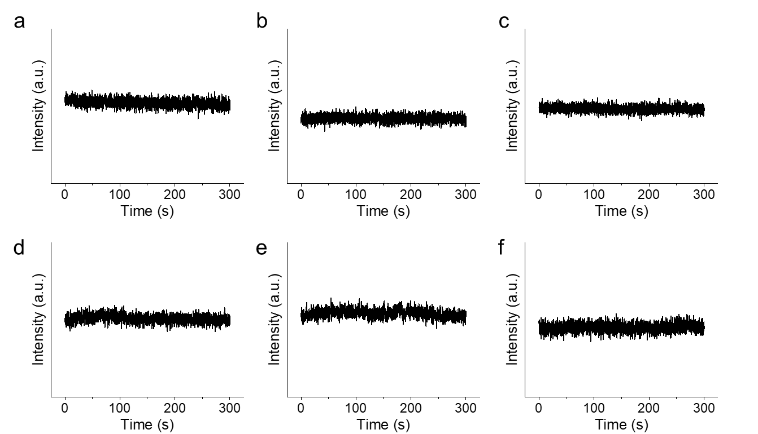
Figure S4. The scattering intensity over time of individual MnO₂ in DI water. No nanobubble was detected. Therefore, H₂O₂ is necessary for the formation of nanobubbles.
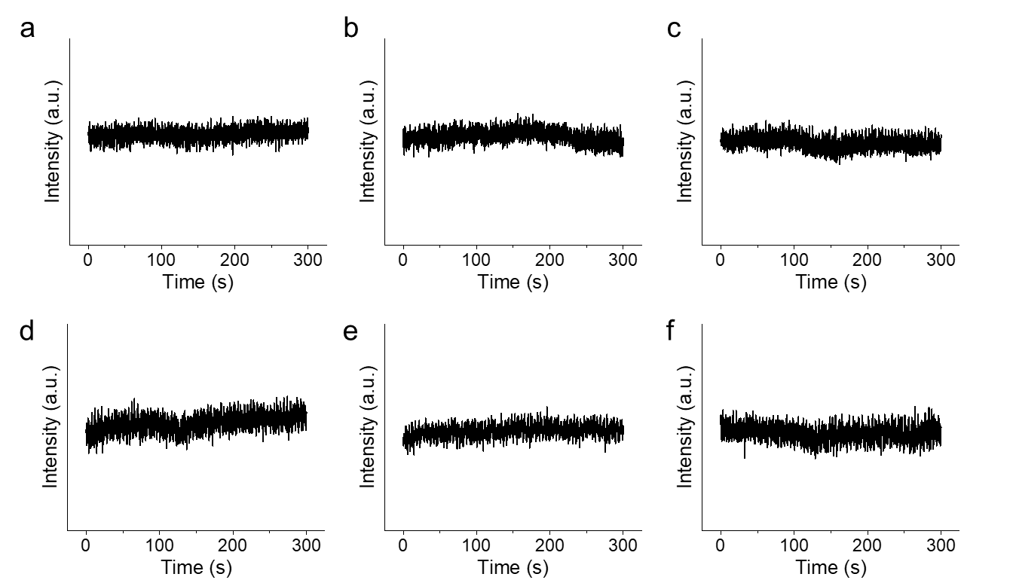
Figure S5. The scattering intensity over time of individual MnO₂ in 0.01 mM H₂O₂ and without SDS. No nanobubble was detected. Therefore, H₂O₂ is necessary for the formation of nanobubbles.

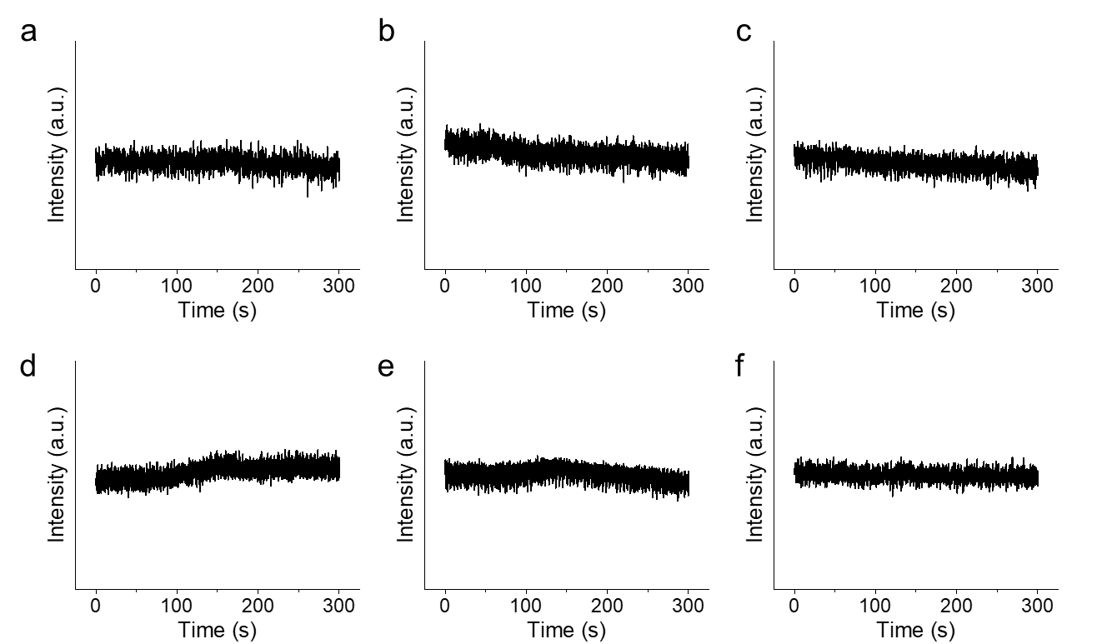
Figure S6. The scattering intensity over time of individual MnO₂ in 100 mM SDS and without H₂O₂. No nanobubble was detected. Therefore, SDS is necessary for the formation of nanobubbles.
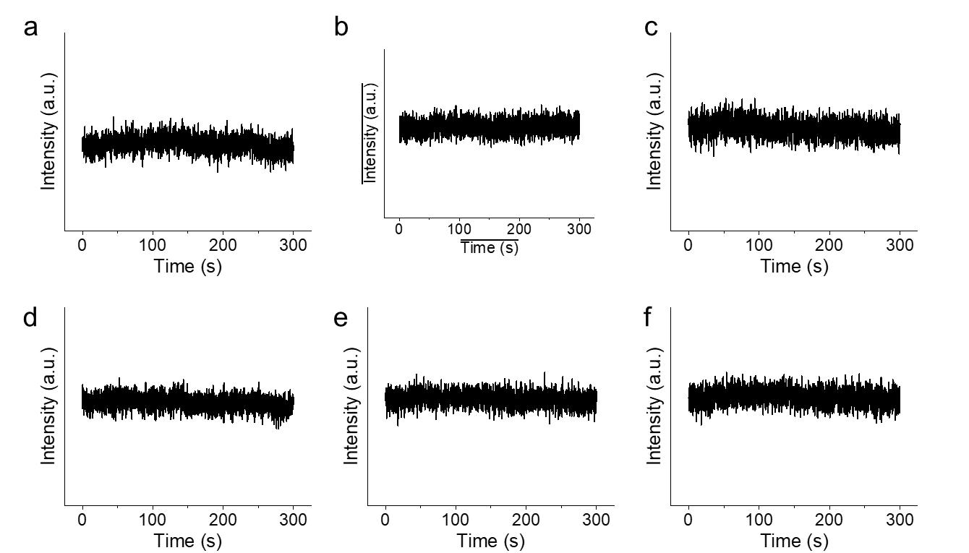
Figure S7. The scattering intensity over time of blank area without MnO₂ in 50 μM H₂O₂ and 100 mM SDS. No nanobubble was detected.

S4. Statistical analysis for nanobubble generation on individual MnO₂ nanoparticles
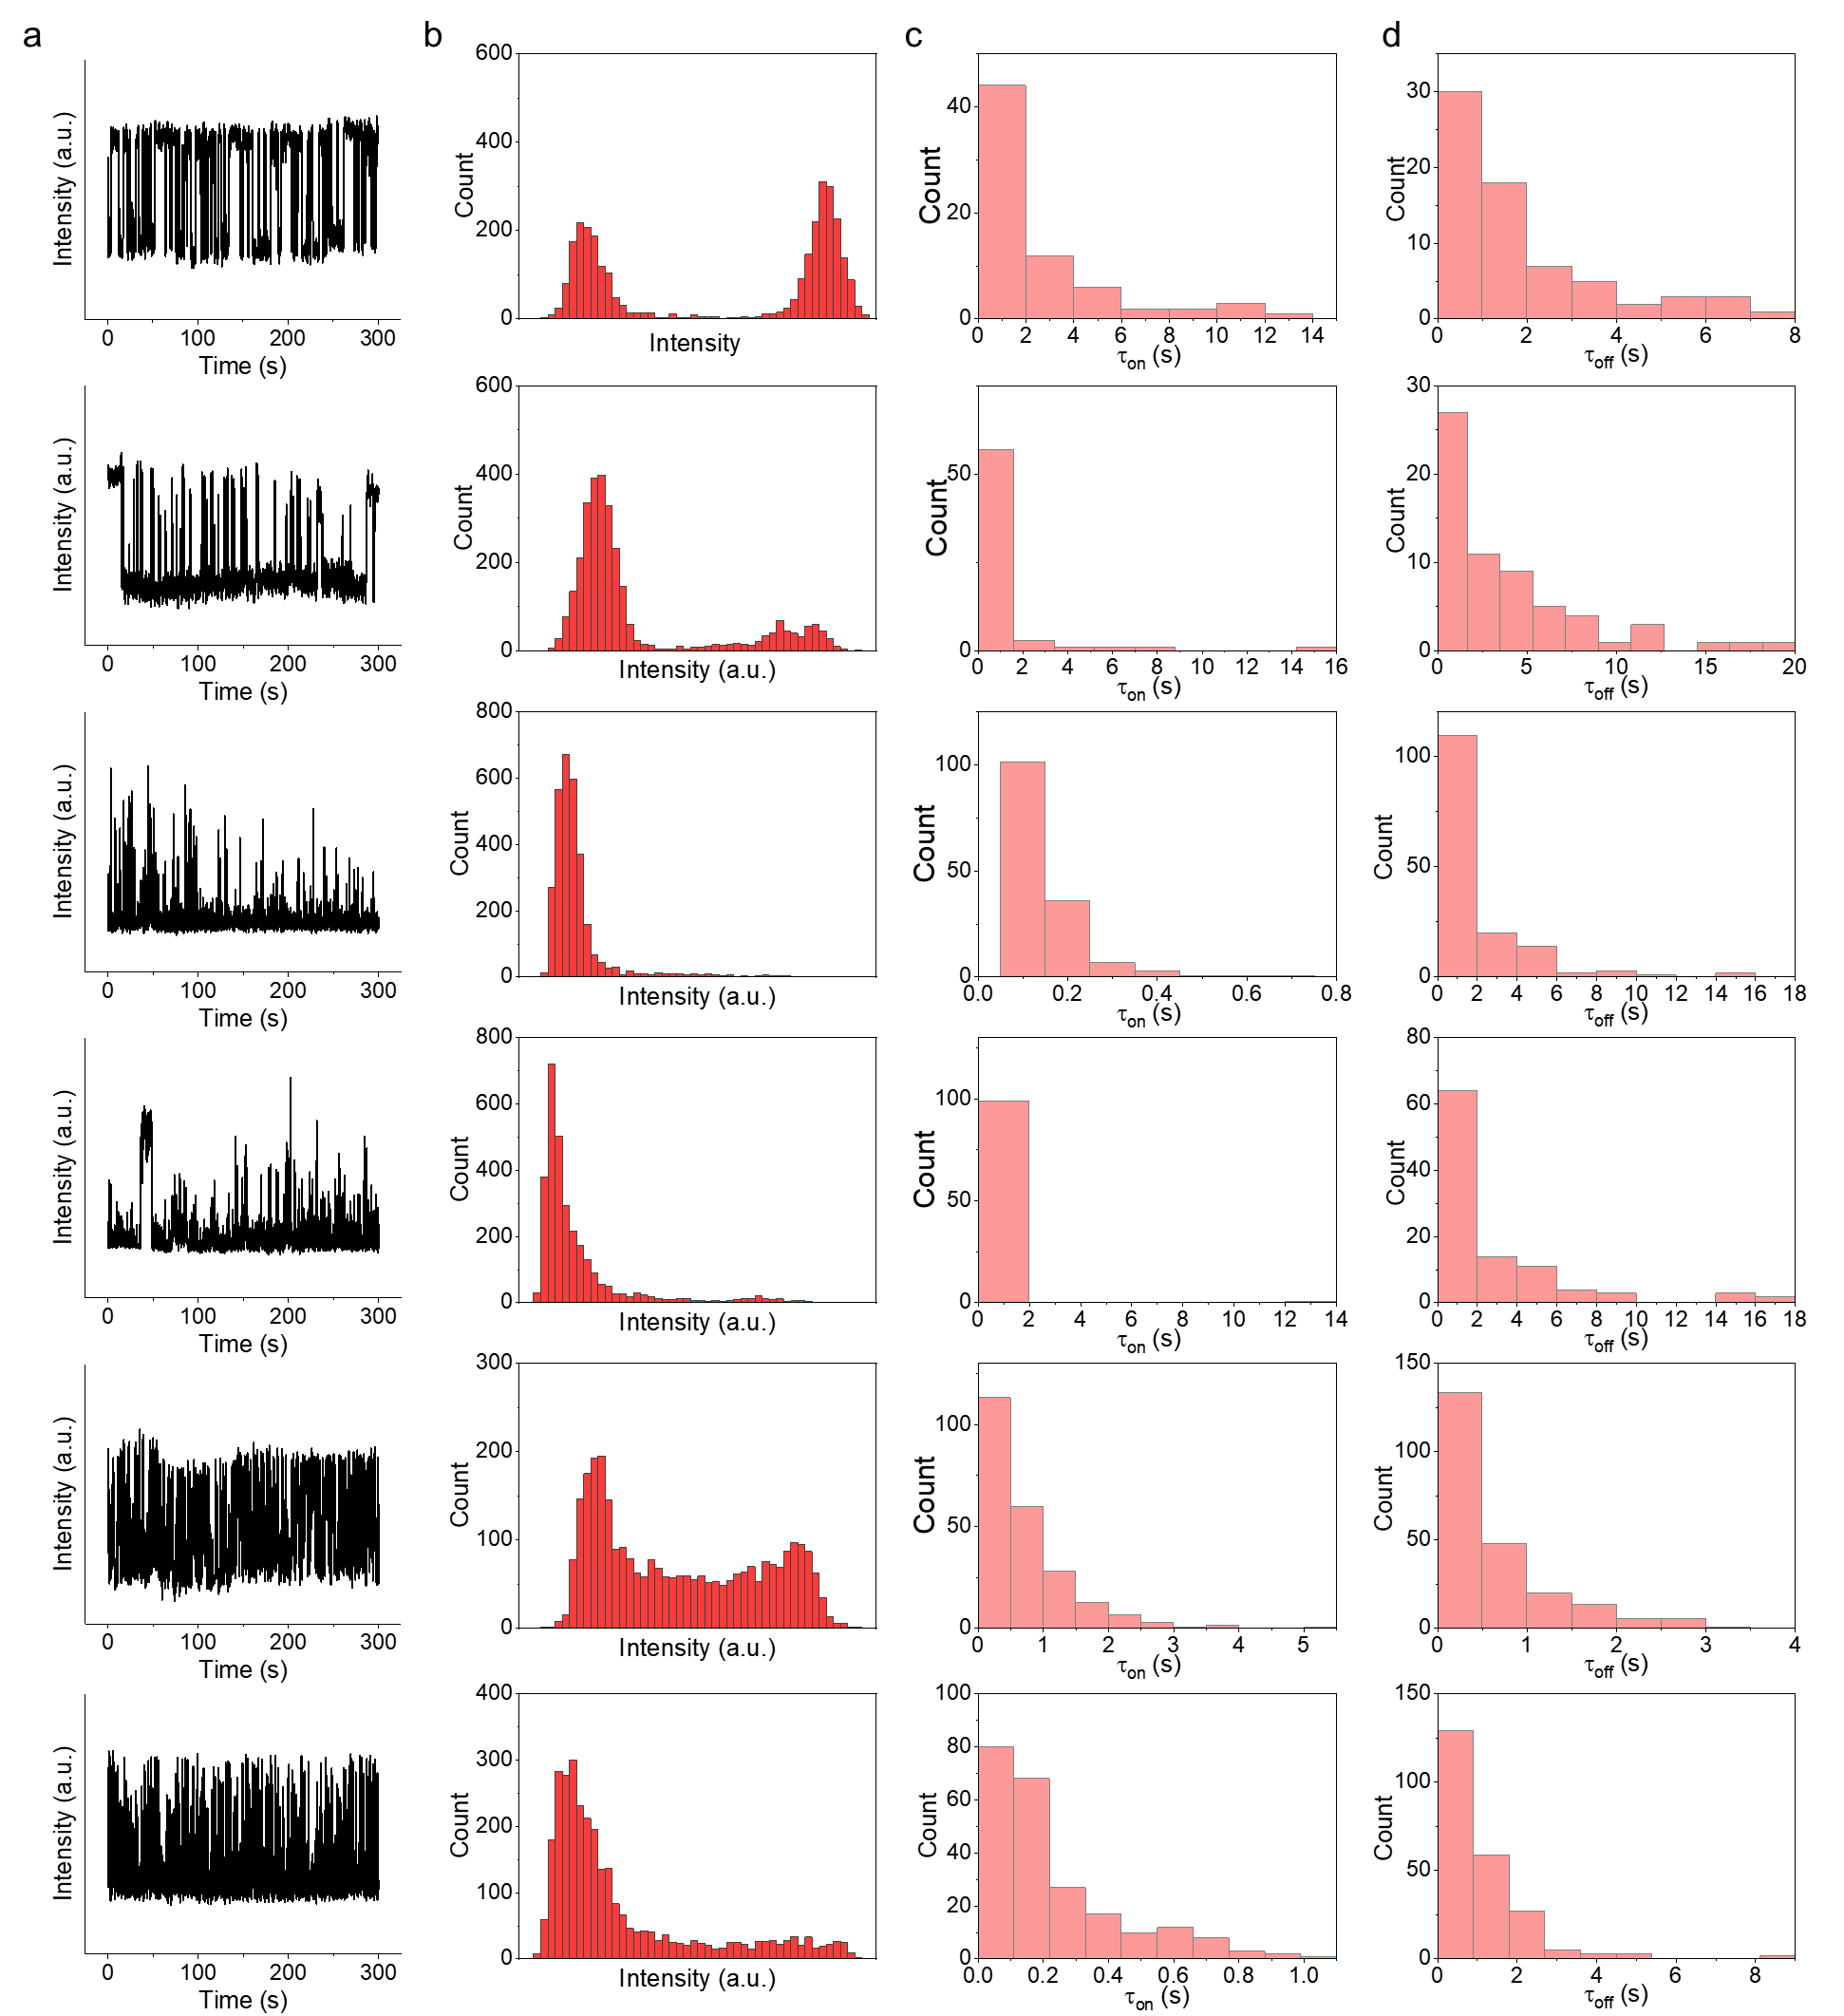
Figure S8. (a) The scattering intensity trajectories over time of individual MnO₂ nanoparticles in 100 mM SDS and 0.01 mM H₂O₂. (b) The histograms of the corresponding scattering intensity trajectories. (c) and (d) The histograms of corresponding duration time of ON and OFF states.
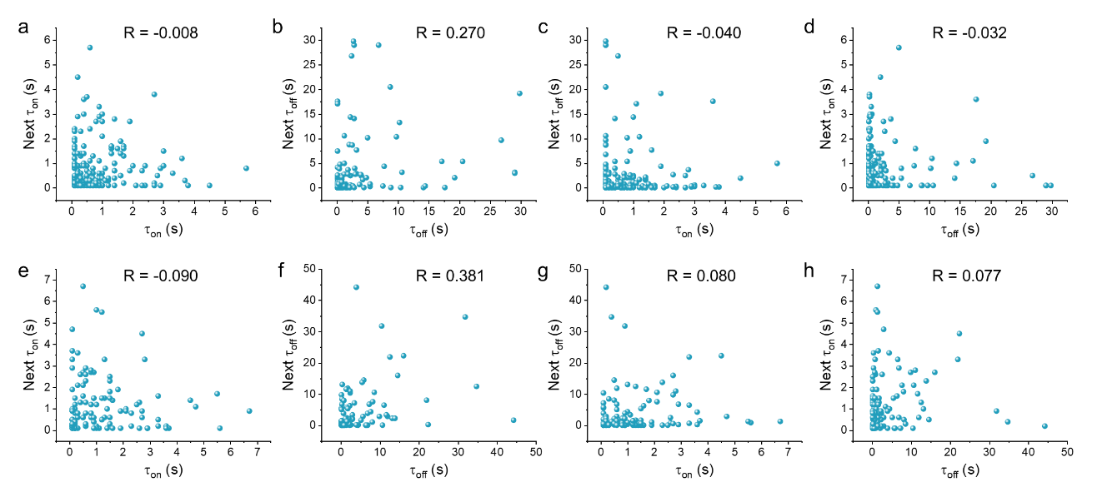
Figure S9. Correlations of adjacent on-on, off-off, on-off and off-on duration. The Pearson correlation coefficients R are shown in the corresponding graphs with a linear timescale, respectively.

S5. Active and non-active fraction of nanoparticles
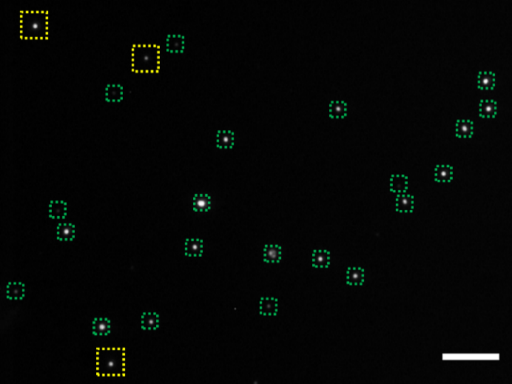
Figure S10. The active and non-active fractions of MnO₂ nanoparticles marked by different colors. Yellow color marks the active part and green color marks the non-active part. Scale bar: 10 μm.

S6. Statistical analysis of ON and OFF states duration time for a single MnO₂ nanoparticles with different H₂O₂ concentrations
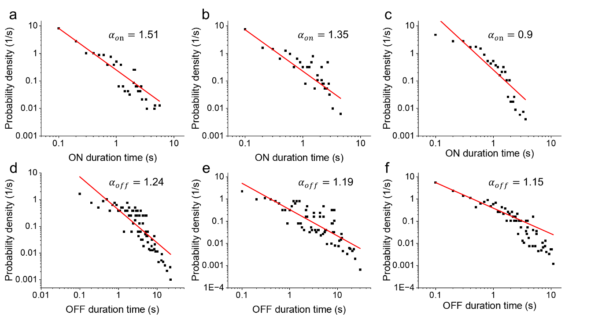
Figure S11. Statistical analysis of ON and OFF states duration time for a single MnO₂ nanoparticle with different H₂O₂ concentrations, (a, d) 1 mM, (b, e) 0.5 mM and (c, f) 0.01 mM.
S7. Tracking the center of single nanobubble with DFM imaging
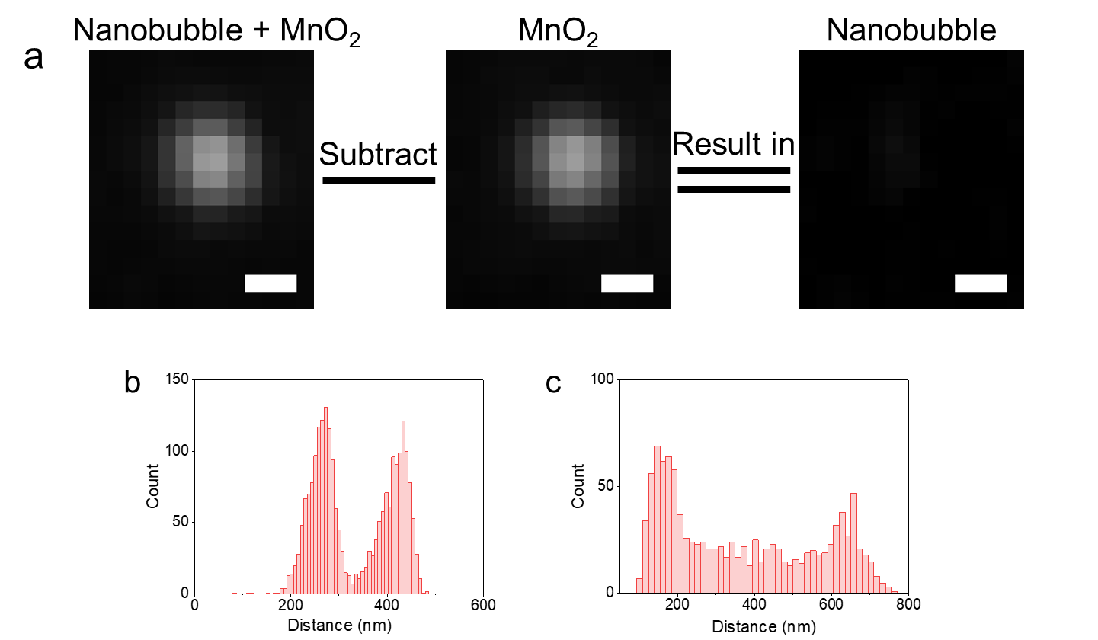
Figure S12. (a) Dark-field images of individual MnO₂ particle at ON and OFF states. The emission of the nanobubble by subtracting MnO₂ particle from the combination of nanobubble and MnO₂. (b) (c) Histograms of the distance distributions of individual MnO₂ particles.
To obtain the scattering image of nanobubble only, we subtracted the scattering signal of the MnO₂ nanoparticle from the combined signal of MnO₂ nanoparticle and nanobubbles as shown in Figure S14a. After separation of the scattering images, the images for both MnO₂ nanoparticle and the nanobubble are fitted with 2D Gaussian function. The centers of the fitting results are as the geometric centers of MnO₂ nanoparticles and nanobubbles, separately. The geometric center of MnO₂ nanoparticle is as the initial location, and the relative location of the nanobubble to the MnO₂ nanoparticle is identified clearly.

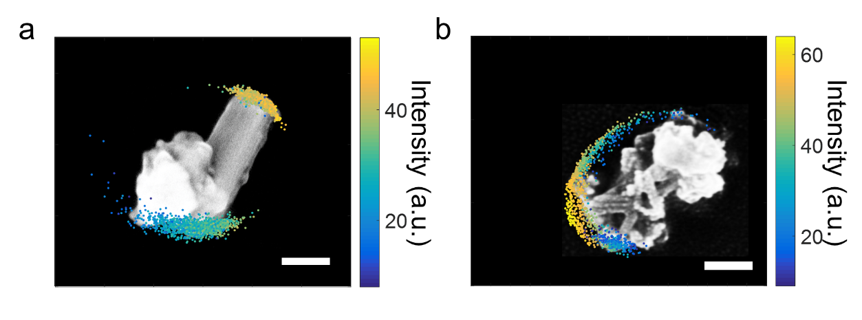
Figure S13. Diagrams of nanobubble distributions on the individual MnO₂ particles showing different intensities at different locations.

S8. Trajectory of single MnO₂ particles along X and Y directions under different concentration of H₂O₂ in different surfactant solutions
To quantify the motion dynamics of individual nanoparticles, we calculated their instantaneous velocities by analyzing sequential dark-field microscopy frames. The position of each nanoparticle in consecutive frames was determined with Trackmate Command of ImageJ. As illustrated in Figure 4a, with the initial particle location at time t₀ set as the origin, the displacement between frames was then divided by the interframe time interval to obtain the instantaneous velocity.
The displacement between consecutive time points, referred to as the movement distance (MD), was calculated as:
$$MD (t=∆t)=\sqrt{{[x\left(t_{k}\right)-x\left(t_{k-1}\right)]}^{2}+{[y\left(t_{k}\right)-y\left(t_{k-1}\right)]}^{2}}$$
Where $x\left(t_{k}\right)$ and $y\left(t_{k}\right)$ denote the coordinates of the particle on the two-dimensional substrate at time $t_{k}$. The instantaneous velocity $V_{t}$ was then derived as:
$$V_{t}=\frac{MD}{∆t}​$$
Here, $Δt$ corresponds to the inter-frame time interval, which was 0.1 s under the current imaging conditions
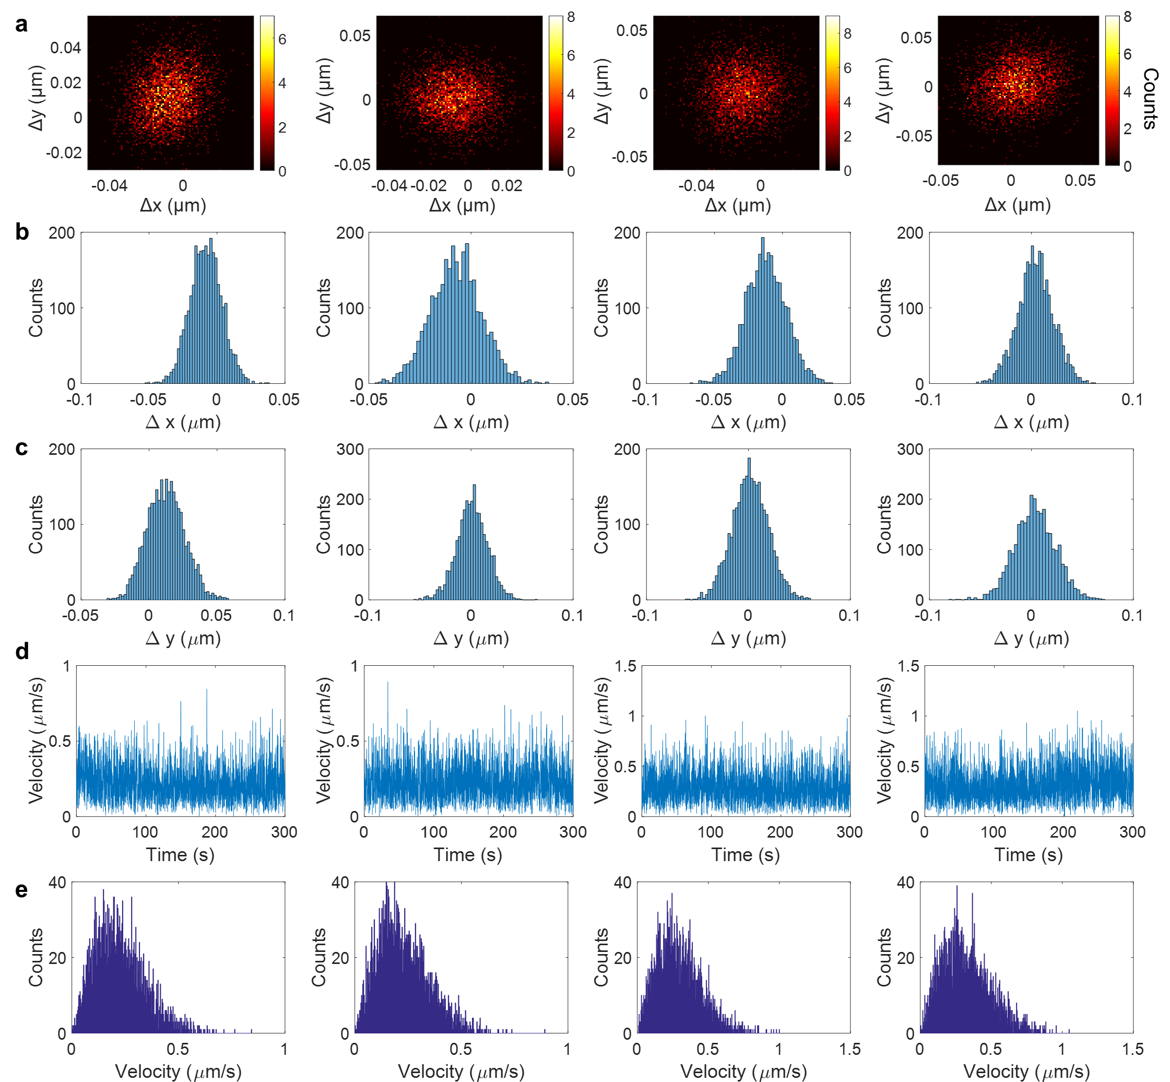
Figure S14. (a) Trajectory of single MnO₂ particle on the glass slide surface along X and Y directions over 300 s in the absence of H₂O₂. The corresponding probability distributions of the X displacements (b) and Y displacements (c) with single peaks. (d) The calculated time-lapsed velocity of the attached MnO₂ particle from the 2D displacements. (e) The corresponding probability distribution of the velocity.

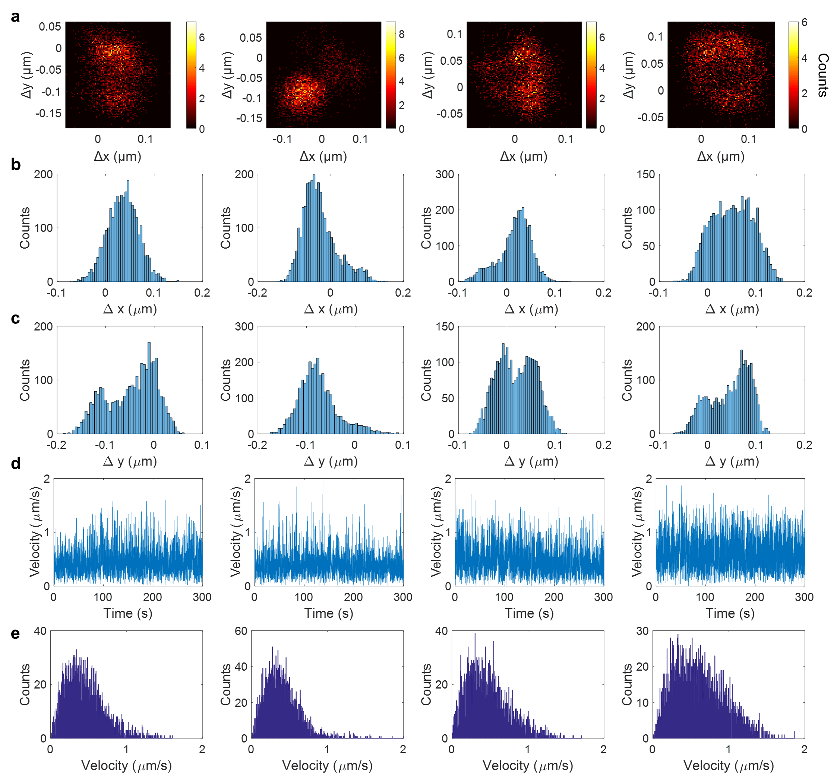
Figure S15. (a) Trajectory of single MnO₂ particle on the glass slide surface along X and Y directions over 300 s in the presence of 0.01 mM H₂O₂ and SDS solution. The corresponding probability distributions of the X displacements (b) and Y displacements (c) with single peaks. (d) The calculated time-lapsed velocity of the attached MnO₂ particle from the 2D displacements. (e) The corresponding probability distribution of the velocity.

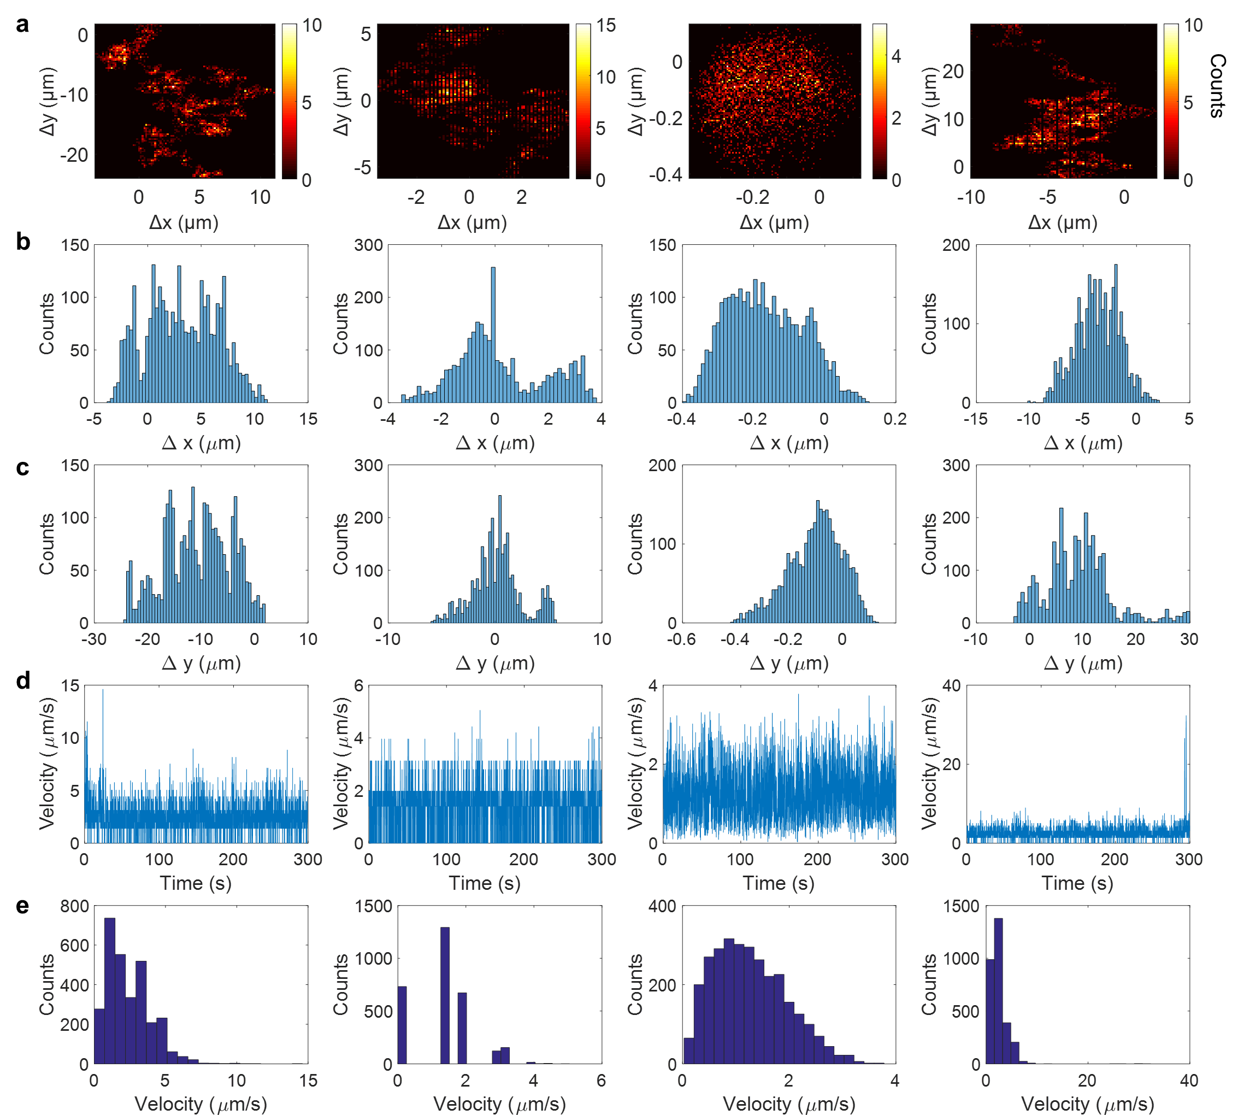
Figure S16. (a) Trajectory of single MnO₂ particle on the glass slide surface along X and Y directions over 300 s in the presence of 0.1 mM H₂O₂ and SDS solution. The corresponding probability distributions of the X displacements (b) and Y displacements (c) with single peaks. (d) The calculated time-lapsed velocity of the attached MnO₂ particle from the 2D displacements. (e) The corresponding probability distribution of the velocity.

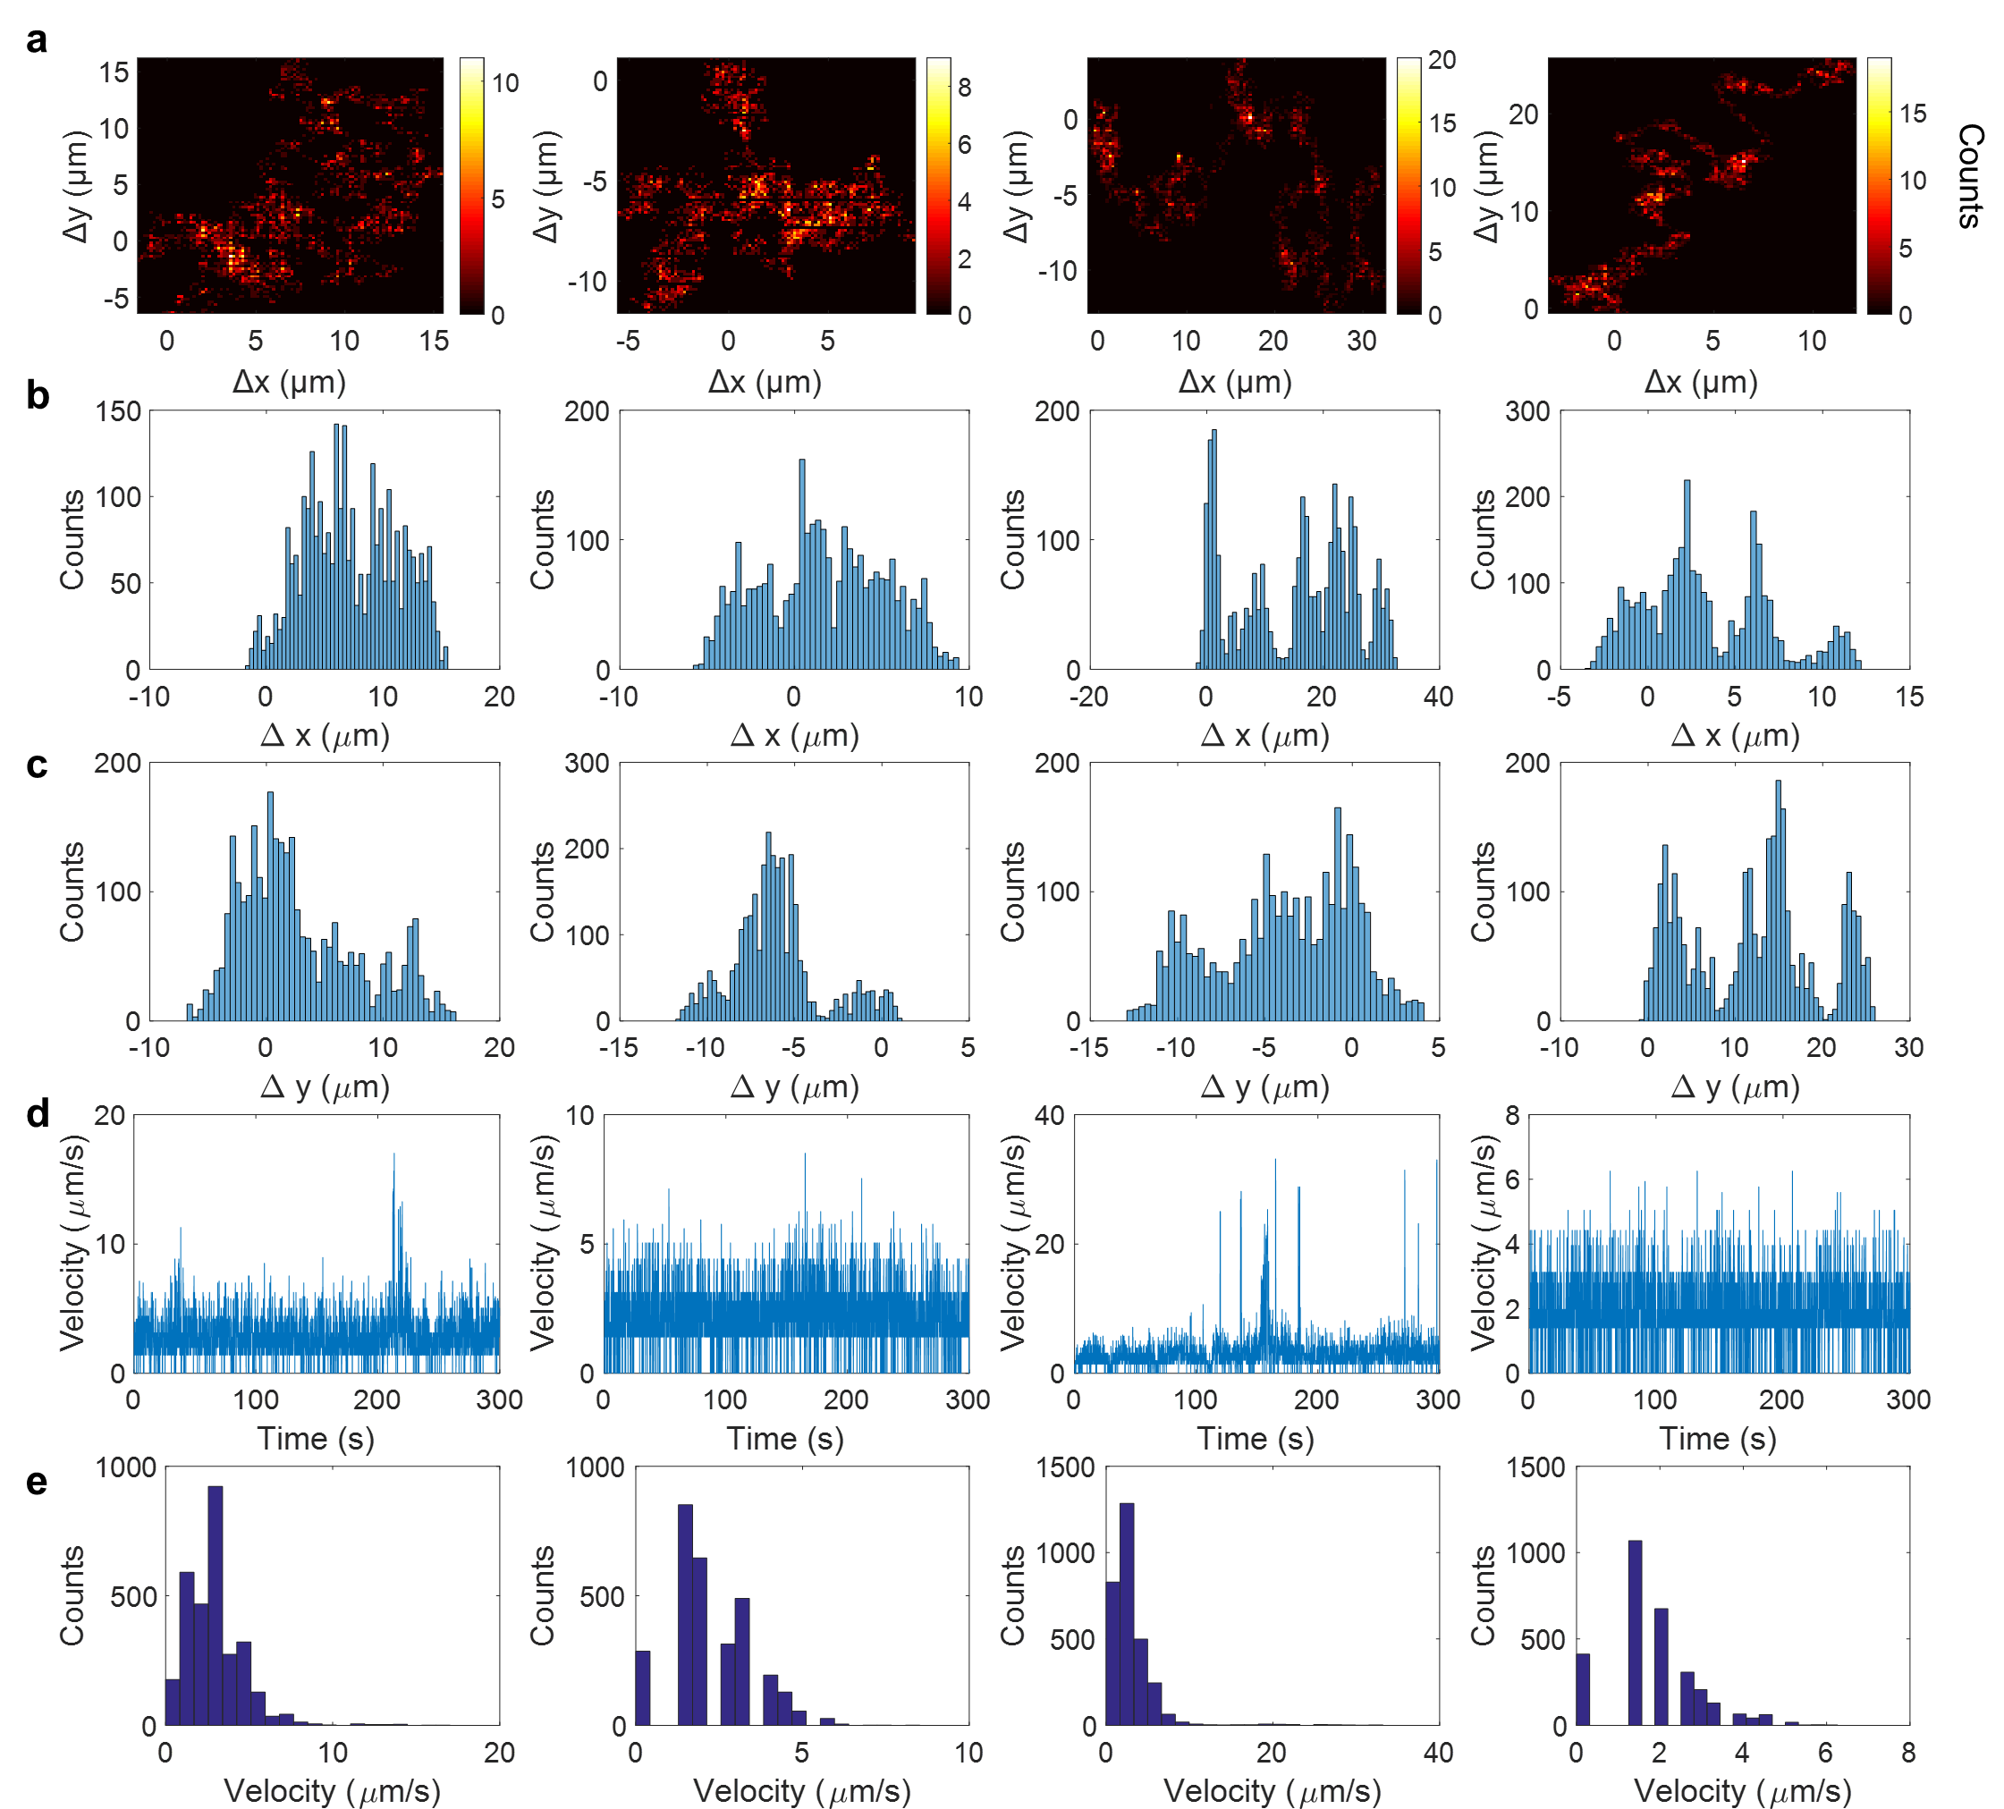
Figure S17. (a) Trajectory of single MnO₂ particle on the glass slide surface along X and Y directions over 300 s in the presence of 1 mM H₂O₂ and SDS solution. The corresponding probability distributions of the X displacements (b) and Y displacements (c) with single peaks. (d) The calculated time-lapsed velocity of the attached MnO₂ particle from the 2D displacements. (e) The corresponding probability distribution of the velocity.

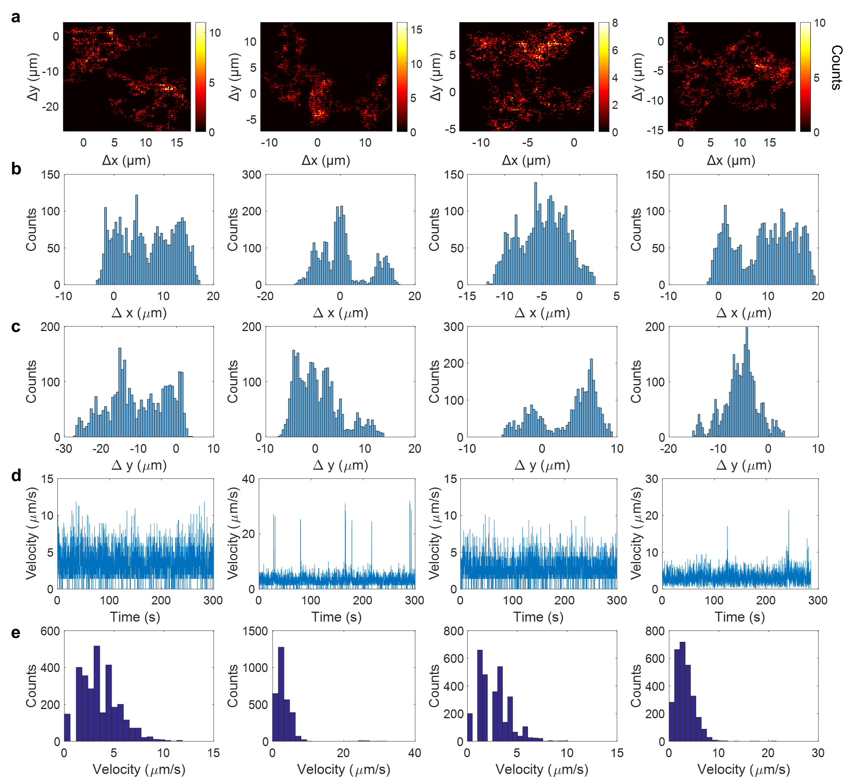
Figure S18. (a) Trajectory of single MnO₂ particle on the glass slide surface along X and Y directions over 300 s in the presence of 10 mM H₂O₂ and SDS solution. The corresponding probability distributions of the X displacements (b) and Y displacements (c) with single peaks. (d) The calculated time-lapsed velocity of the attached MnO₂ particle from the 2D displacements. (e) The corresponding probability distribution of the velocity.
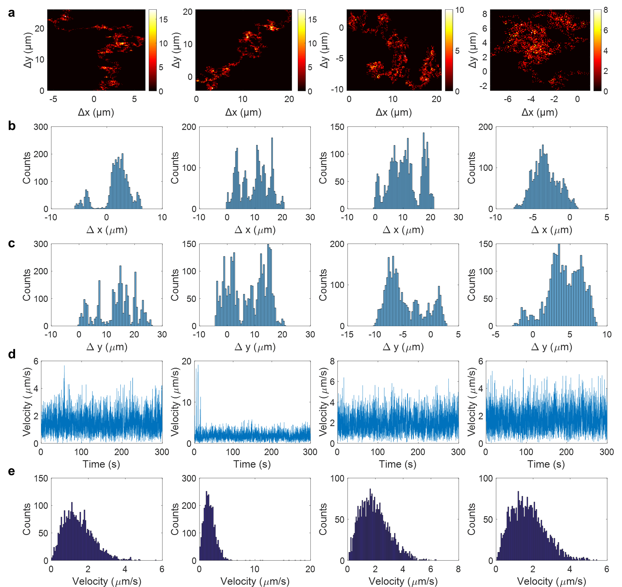
Figure S19. (a) Trajectory of single MnO₂ particle on the glass slide surface along X and Y directions over 300 s in the presence of 0.01 mM H₂O₂ and CTAB solution. The corresponding probability distributions of the X displacements (b) and Y displacements (c) with single peaks. (d) The calculated time-lapsed velocity of the attached MnO₂ particle from the 2D displacements. (e) The corresponding probability distribution of the velocity.

.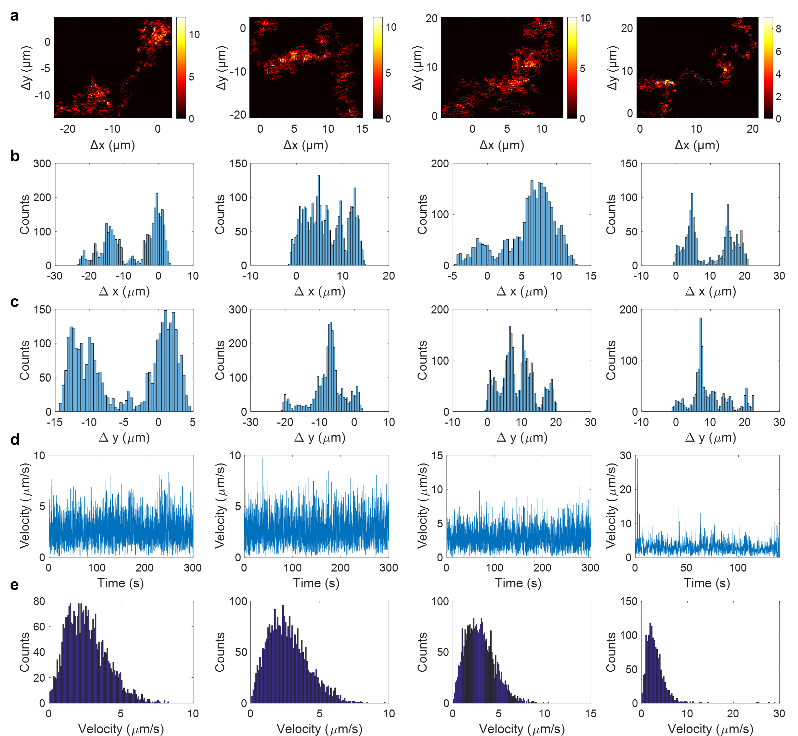
Figure S20. (a) Trajectory of single MnO₂ particle on the glass slide surface along X and Y directions over 300 s in the presence of 0.1 mM H₂O₂ and CTAB solution. The corresponding probability distributions of the X displacements (b) and Y displacements (c) with single peaks. (d) The calculated time-lapsed velocity of the attached MnO₂ particle from the 2D displacements. (e) The corresponding probability distribution of the velocity.

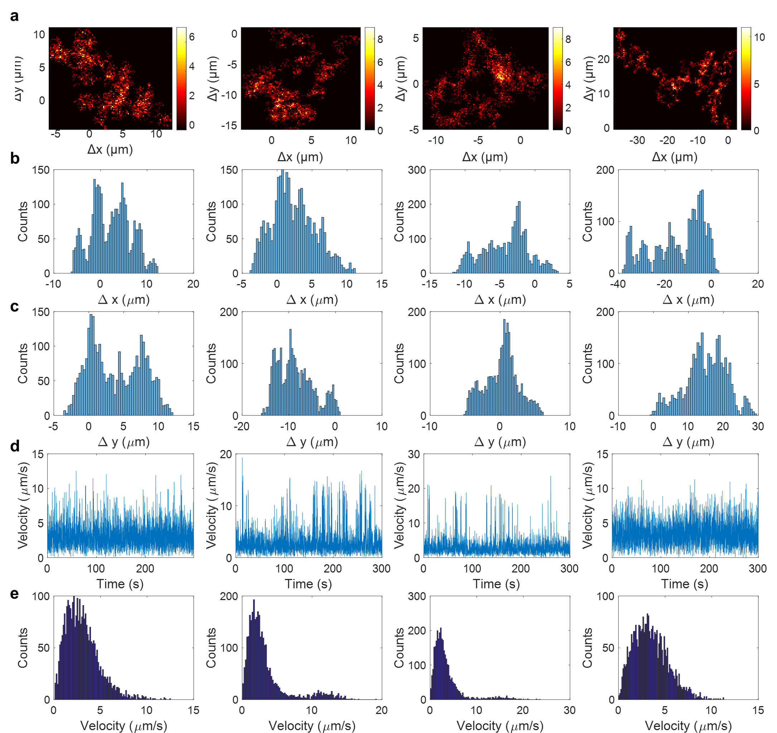
Figure S21. (a) Trajectory of single MnO₂ particle on the glass slide surface along X and Y directions over 300 s in the presence of 1 mM H₂O₂ and CTAB solution. The corresponding probability distributions of the X displacements (b) and Y displacements (c) with single peaks. (d) The calculated time-lapsed velocity of the attached MnO₂ particle from the 2D displacements. (e) The corresponding probability distribution of the velocity.

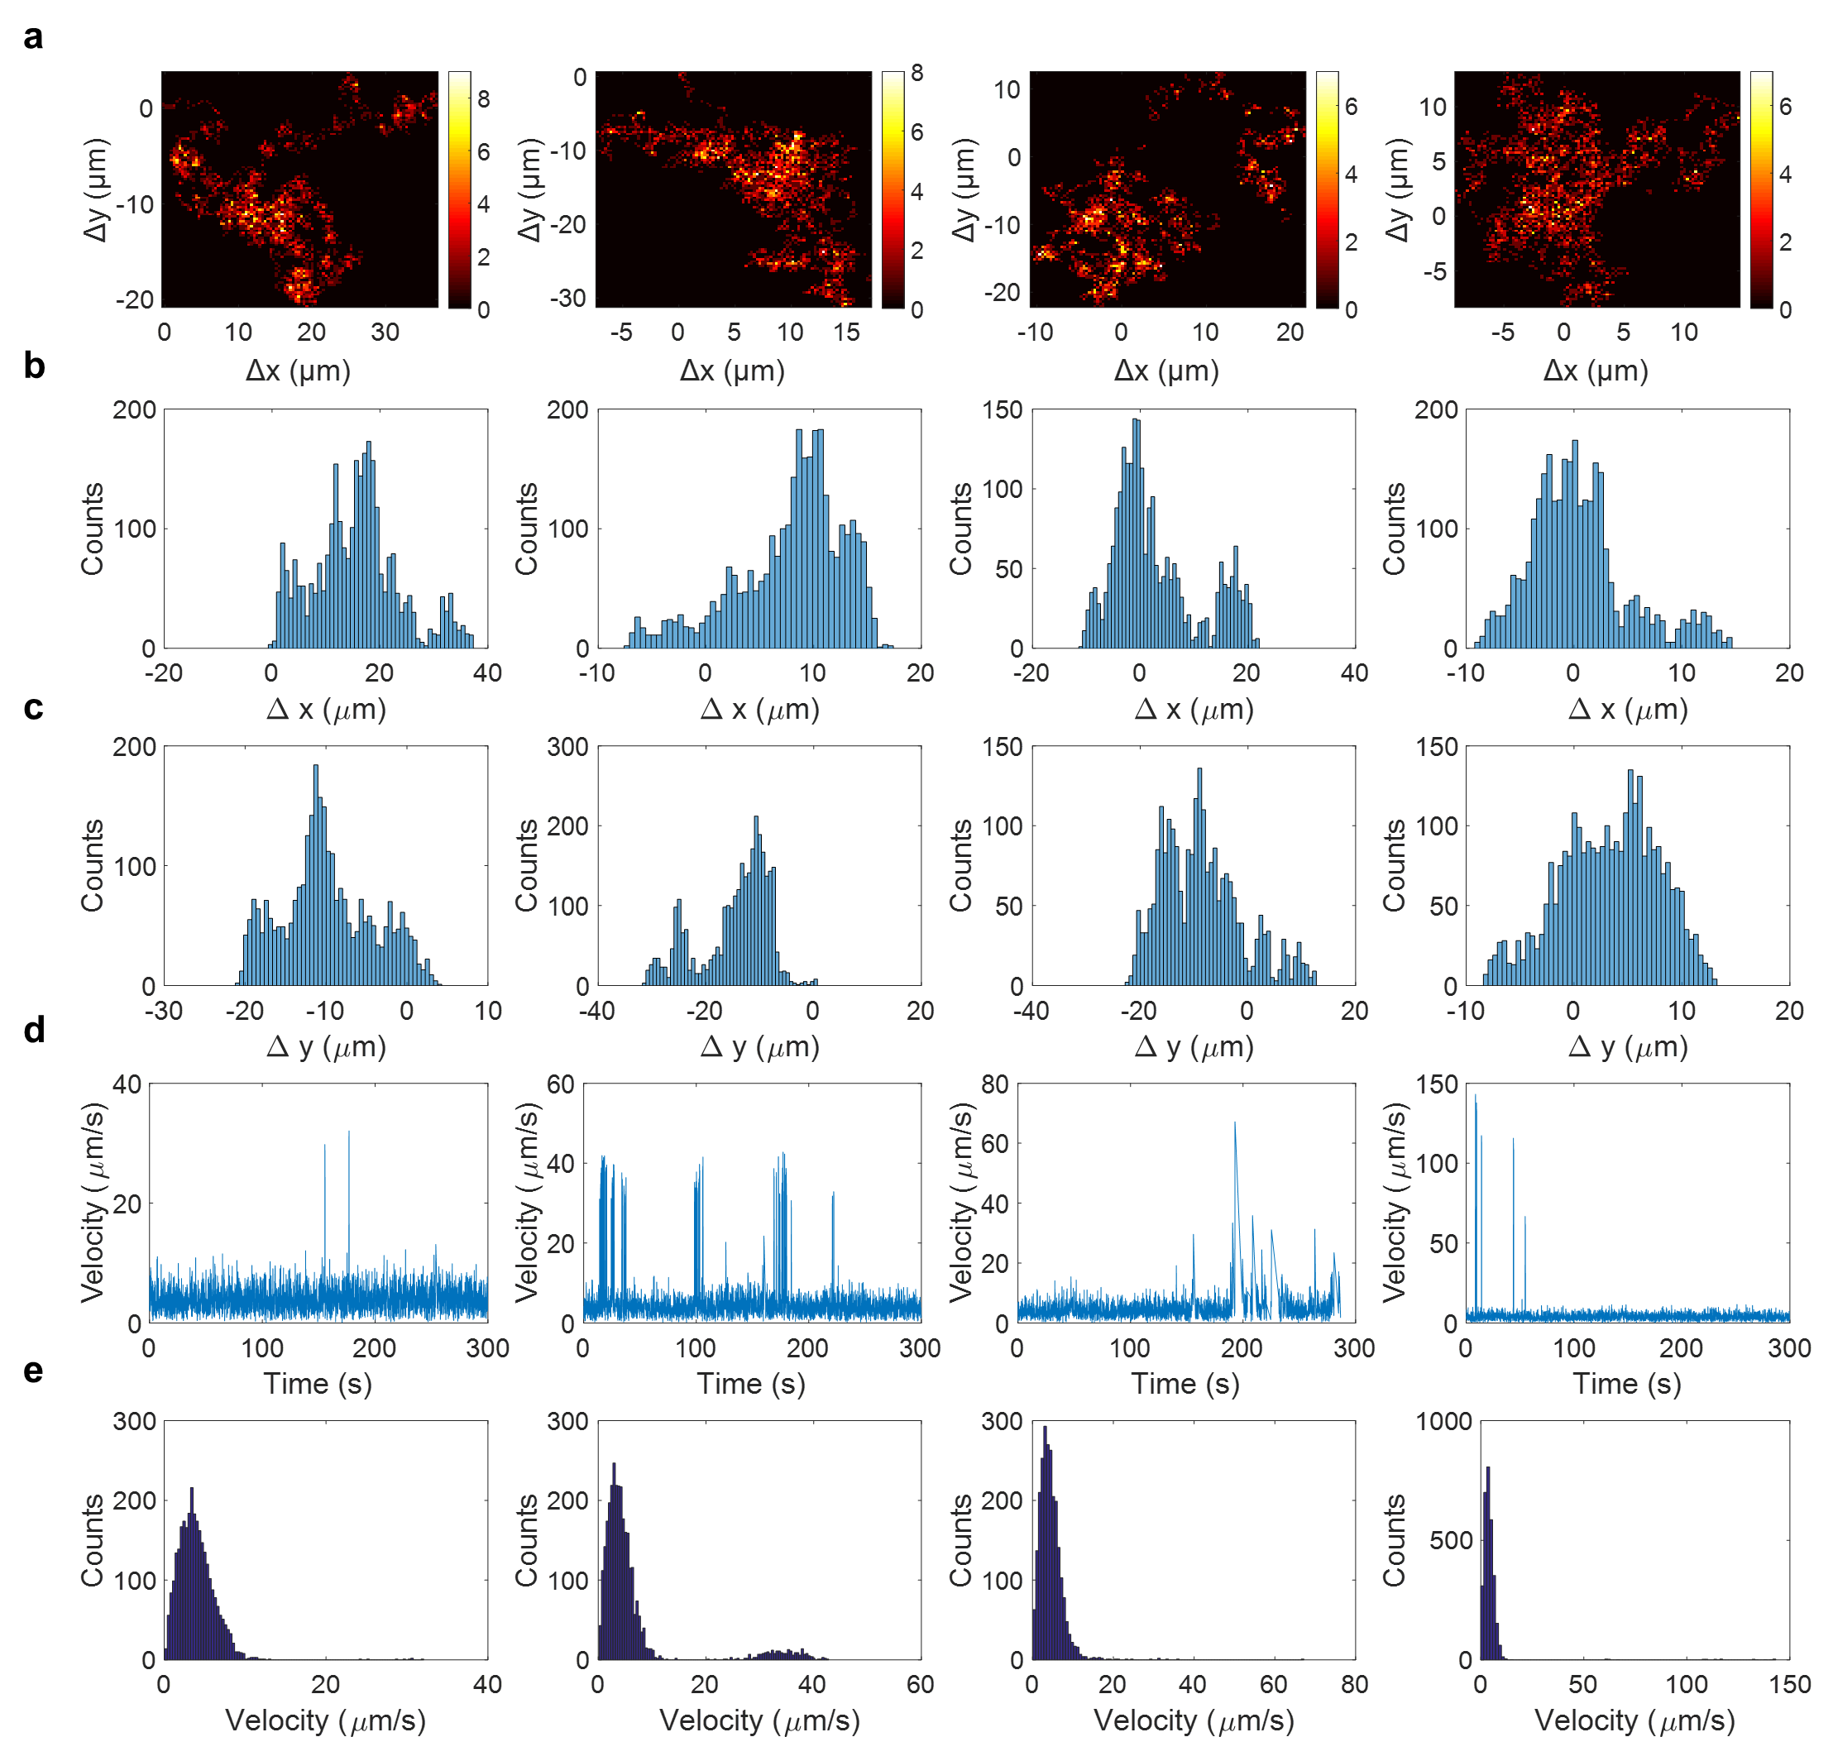
Figure S22. (a) Trajectory of single MnO₂ particle on the glass slide surface along X and Y directions over 300 s in the presence of 10 mM H₂O₂ and CTAB solution. The corresponding probability distributions of the X displacements (b) and Y displacements (c) with single peaks. (d) The calculated time-lapsed velocity of the attached MnO₂ particle from the 2D displacements. (e) The corresponding probability distribution of the velocity.

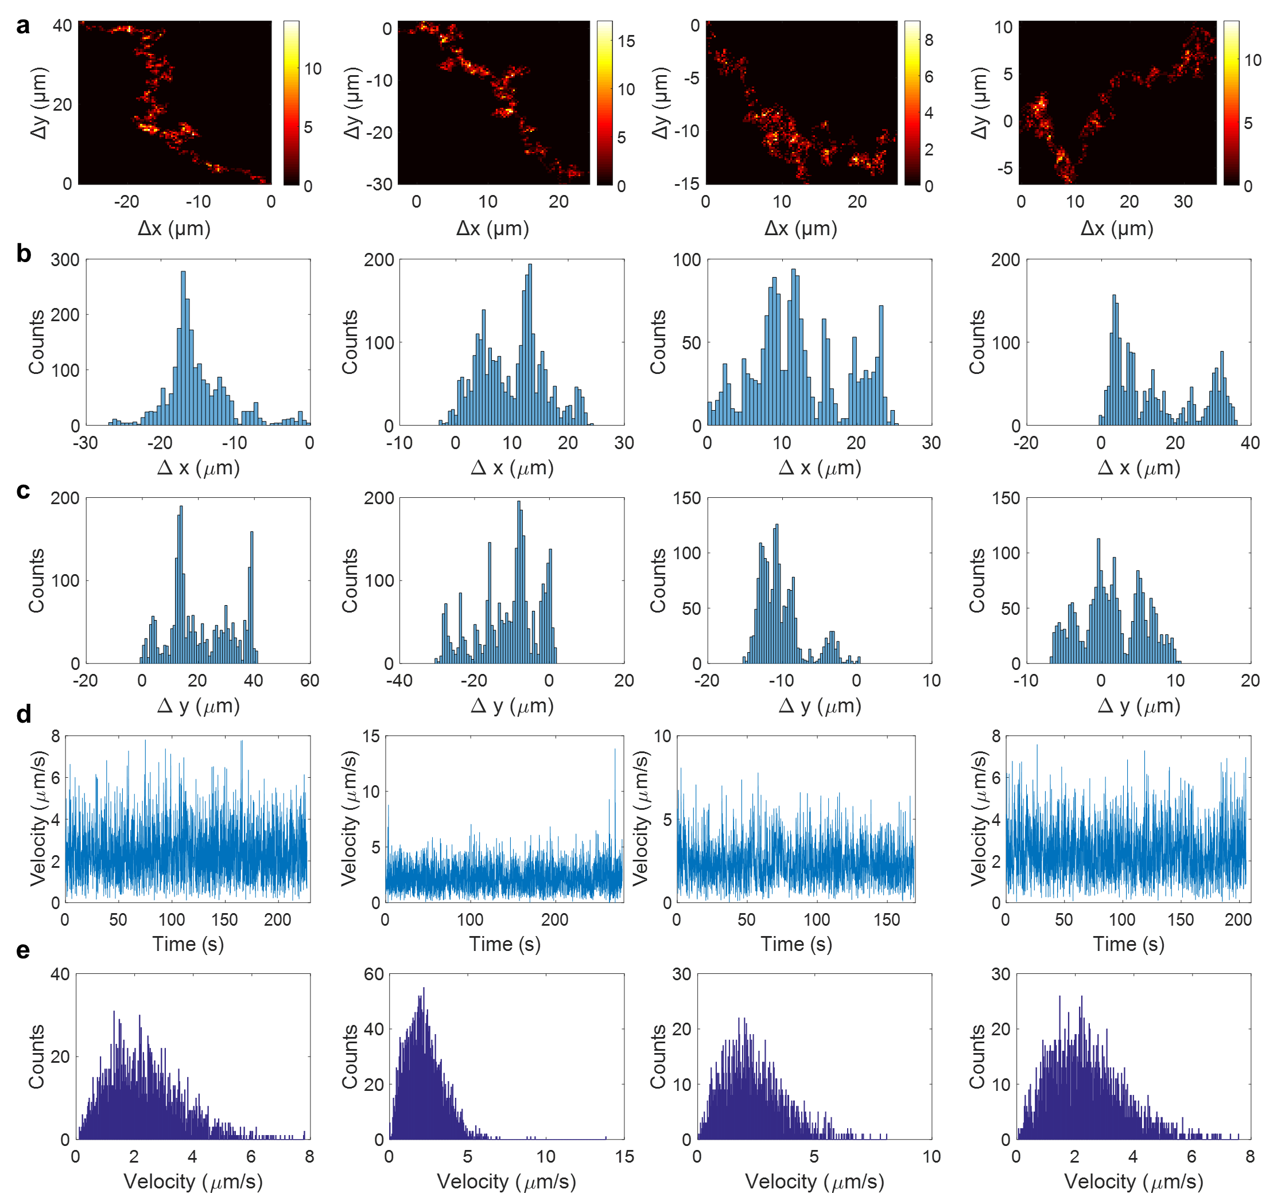
Figure S23. (a) Trajectory of single MnO₂ particle on the glass slide surface along X and Y directions over 300 s in the presence of 0.01 mM H₂O₂ and Tween-20 solution. The corresponding probability distributions of the X displacements (b) and Y displacements (c) with single peaks. (d) The calculated time-lapsed velocity of the attached MnO₂ particle from the 2D displacements. (e) The corresponding probability distribution of the velocity.

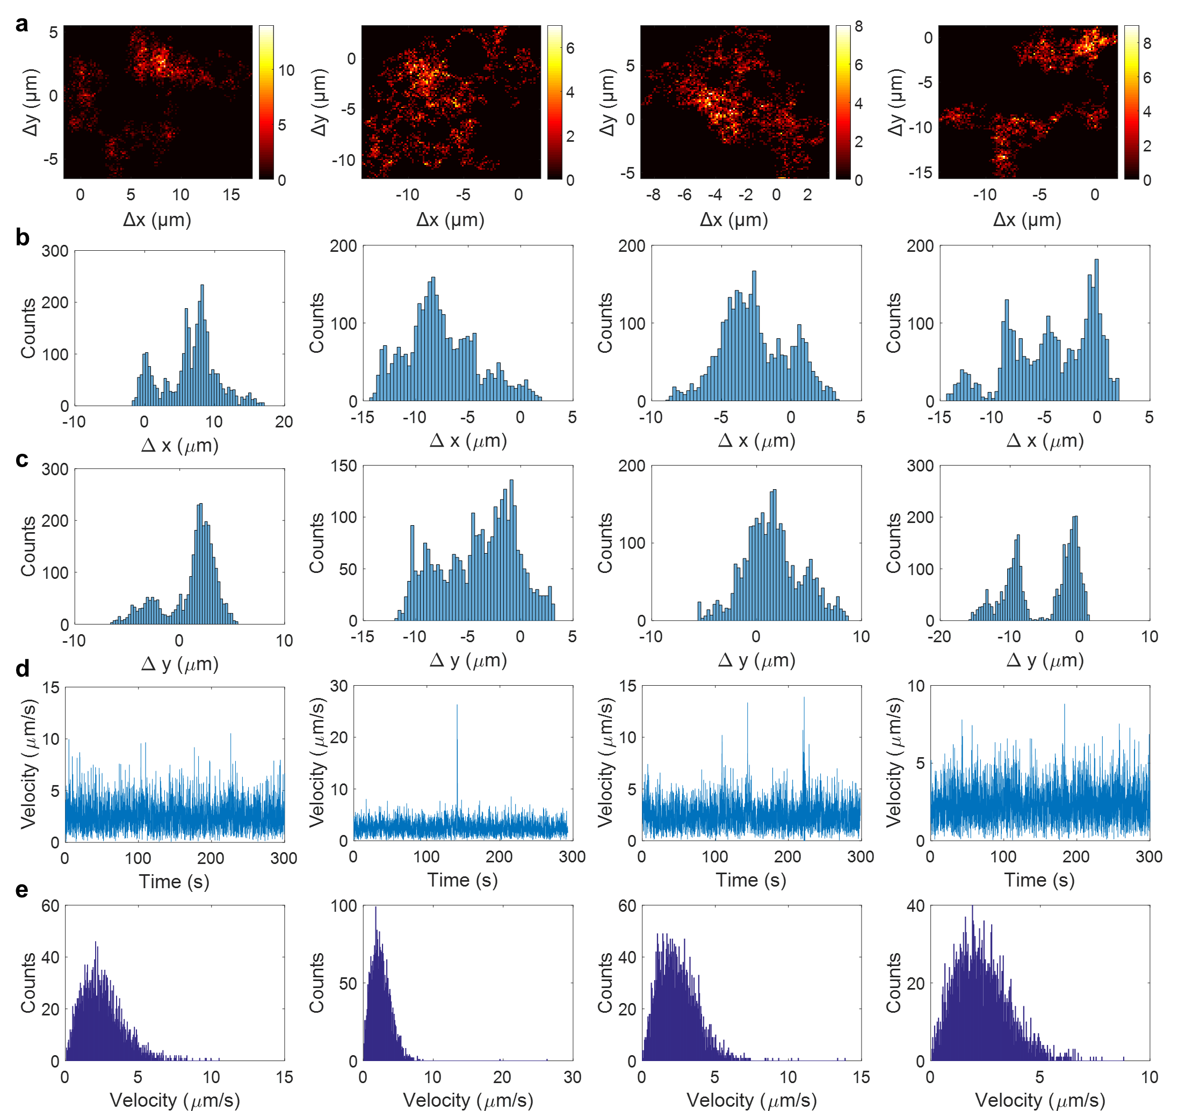
Figure S24. (a) Trajectory of single MnO₂ particle on the glass slide surface along X and Y directions over 300 s in the presence of 0.1 mM H₂O₂ and Tween-20 solution. The corresponding probability distributions of the X displacements (b) and Y displacements (c) with single peaks. (d) The calculated time-lapsed velocity of the attached MnO₂ particle from the 2D displacements. (e) The corresponding probability distribution of the velocity.

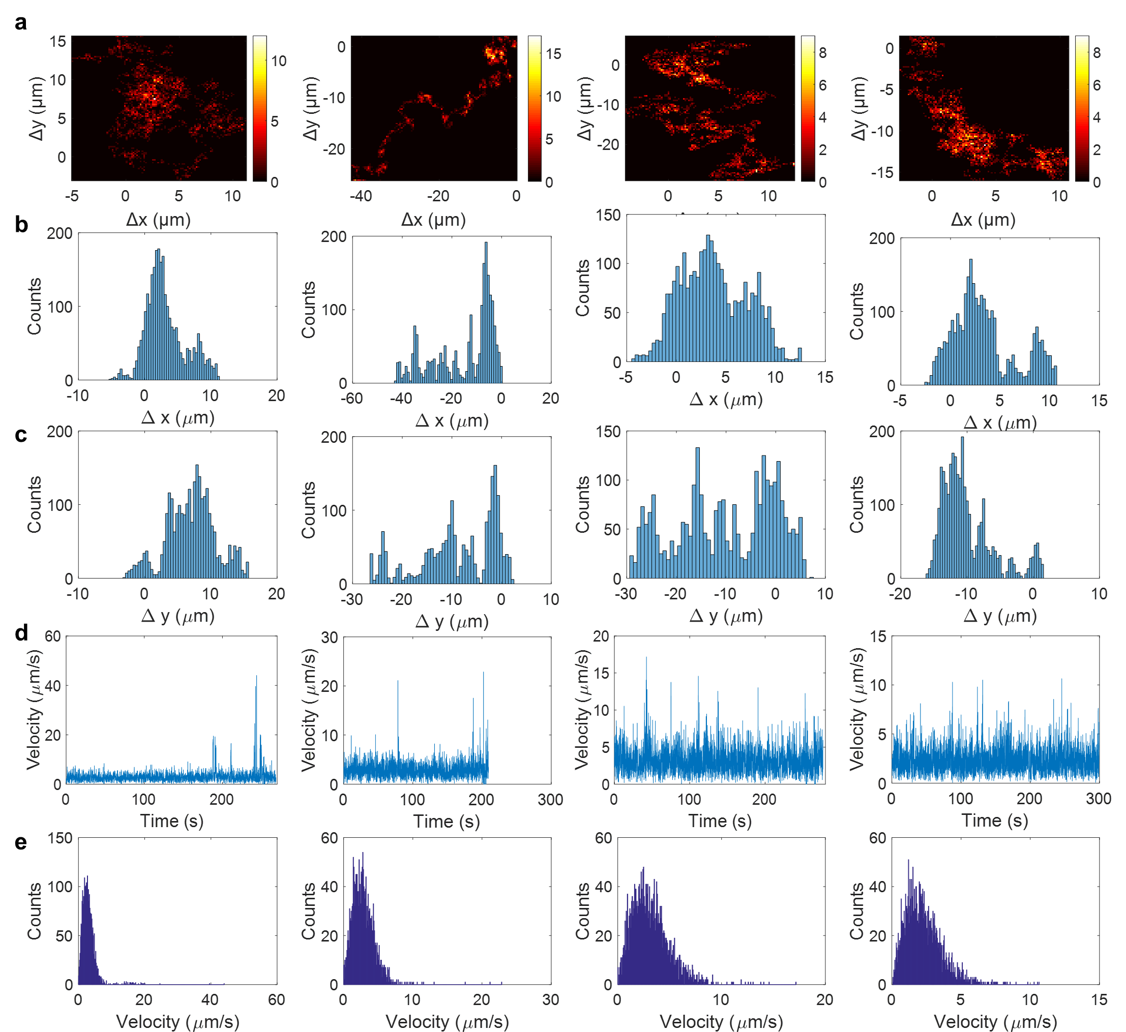
Figure S25. (a) Trajectory of single MnO₂ particle on the glass slide surface along X and Y directions over 300 s in the presence of 1 mM H₂O₂ and Tween-20 solution. The corresponding probability distributions of the X displacements (b) and Y displacements (c) with single peaks. (d) The calculated time-lapsed velocity of the attached MnO₂ particle from the 2D displacements. (e) The corresponding probability distribution of the velocity.

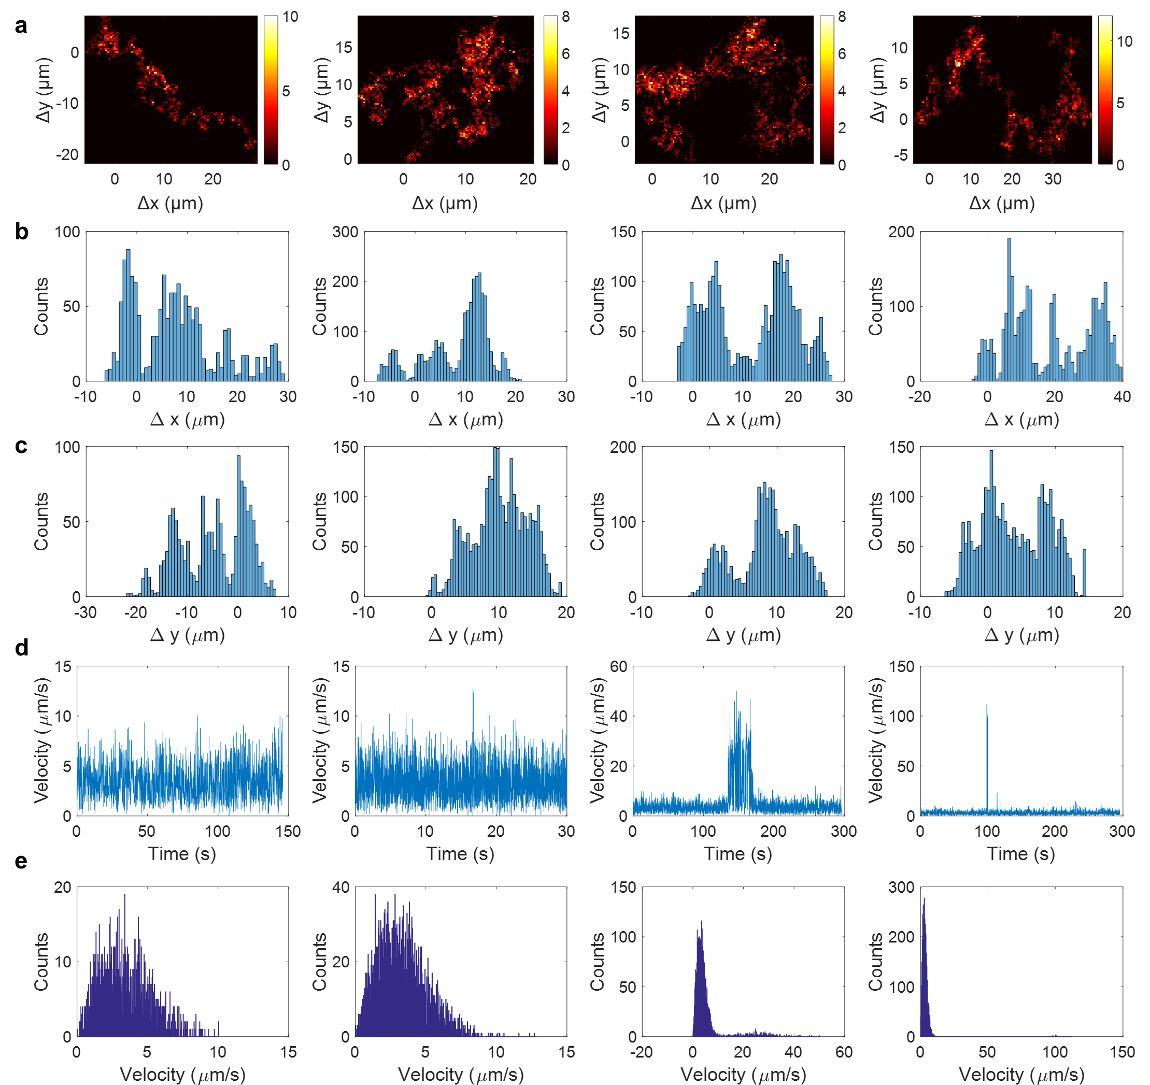
Figure S26. (a) Trajectory of single MnO₂ particle on the glass slide surface along X and Y directions over 300 s in the presence of 10 mM H₂O₂ and Tween-20 solution. The corresponding probability distributions of the X displacements (b) and Y displacements (c) with single peaks. (d) The calculated time-lapsed velocity of the attached MnO₂ particle from the 2D displacements. (e) The corresponding probability distribution of the velocity.

S9. Measurement of catalytic reaction in ensemble reaction
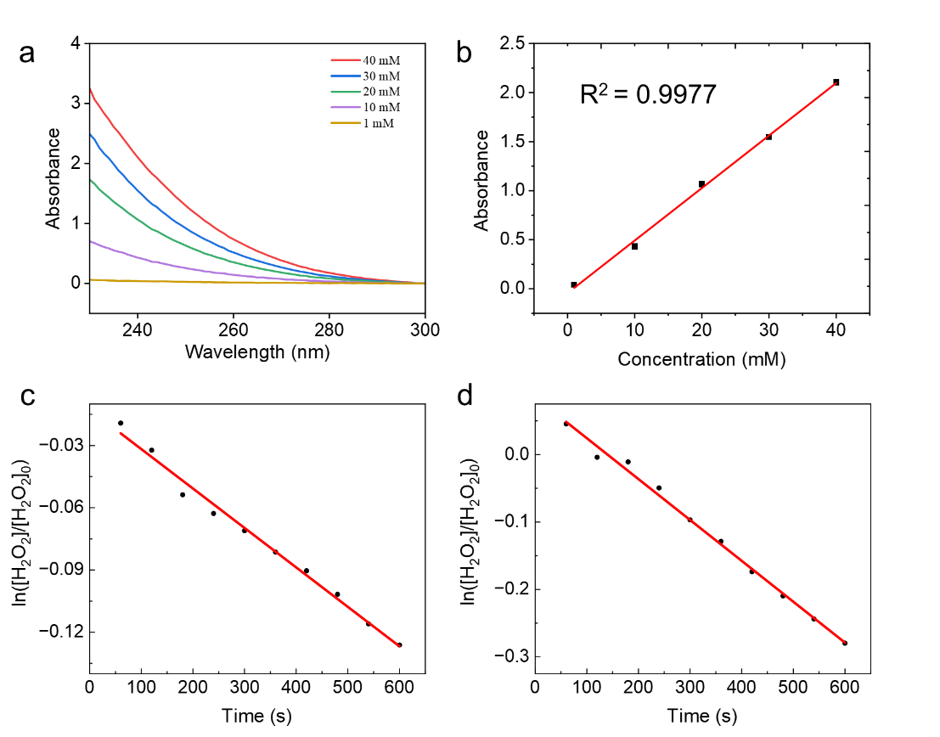
Figure S27. The rate of H₂O₂ decomposition at MnO₂ nanoparticles. (a) The absorbance spectra of H₂O₂ at various concentrations. (b) The calibration curve for H₂O₂ concentration and absorbance. Decomposition of 10 mM H₂O₂ catalyzed by MnO₂ in the presence of (c) SDS and (d) CTAB.
The concentration of H₂O₂ in the solution was determined by the spectrophotometric method based on Beer-Lambert law in previous work:
$A = εLC$ (S1)
Where A is the measured absorbance, $ε$ is the molar extinction coefficient ($ε_{H_{2}O_{2}}$ = 43.6 $M^{-1}∙{cm}^{-1}$ at 240 nm), L is the pass length and C is the concentration of H₂O₂. For quantitative analysis, H₂O₂ was diluted to 1-40 mM using ultrapure water to achieve measurable absorbance levels. A characteristic broad peak at 240 nm was observed in the corresponding UV-Vis spectra (Figure S27a). The high linearity of the resulting calibration curve (R² = 0.9977) indicates that the absorbance at this wavelength can be effectively used to quantify H₂O₂ concentration (Figure S27b).
As is shown in Figure S27c-d, $ln⁡({\left[H_{2}O_{2}\right]}/{{\left[H_{2}O_{2}\right]}_{0}})$ is linearly related to decomposition time over 600 s, indicating the decompositions of H₂O₂ at 0.01 mM of MnO₂ nanoparticles in the presence of SDS and CTAB were fitted well based on the first-order kinetics. The reaction rate is faster in the CTAB than in the SDS, which is consistent with the results of single nanoparticles.

S10. Statistical analysis of high-velocity duration times
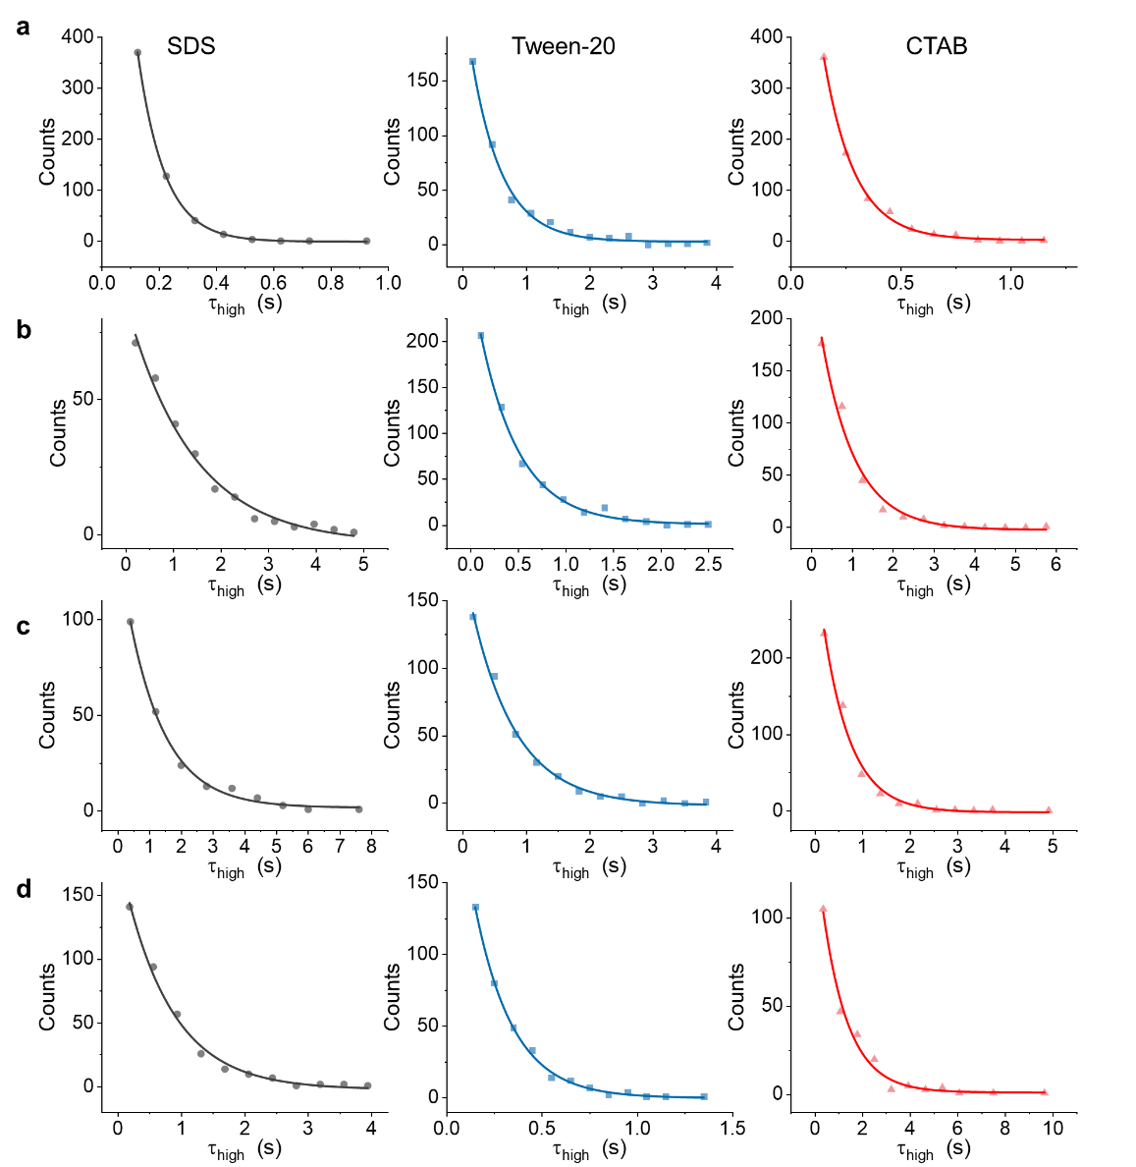
Figure S28. The distribution of high-velocity duration times fit with an exponential decay function of individual MnO₂ nanoparticles at different concentrations of H₂O₂ of (a) 0.01 mM, (b) 0.1 mM, (c) 1 mM and (d) 10 mM in the presence of SDS, Tween-20 and CTSB.
The velocities of individual MnO₂ nanoparticles in the absence of H₂O₂ indicate the background noise level. The threshold is set to 10 times the standard deviation of the background noise to distinguish the high state in the velocity trajectory. The distribution of high-velocity duration can be expressed as
$${Count}_{high}=a-b× {C_{high}}^{τ_{high}}$$
where ${Count}_{high}$ represents the frequency of high-velocity duration time observed in the trajectory of individual MnO₂ nanoparticles, a is a constant that represents the baseline value of the count. $C_{high}$ is the fitting parameter representing the characteristics of the high-velocity events, where higher values indicate a greater frequency of high-velocity events. $τ_{high}$ represents the duration time of high-velocity events.

