Extended data Table 1. Comparison of the haemagglutination test antibody endpoint titres against the Wuhan-like virus to the neutralisation and binding antibodies in the WHO anti-SARS-CoV-2 international standards
 | WHO antibody standards*
Antibody test | High | Mid | Low S, high N | Low S
HAT | 5120 | 640 | 5 | 5
MN titre (IC₅₀) | 2298 | 240 | 55 | 21
Neutralisation antibodies (IU/mL)# | 1473 | 210 | 58 | 44
Anti-RBD (BAU/mL) | 817 | 205 | 66 | 45
IgG anti-S1 (BAU/mL)# | 766 | 246 | 50 | 46
IgG anti-Spike IgG (BAU/mL)# | 832 | 241 | 83 | 53
Anti-N IgG (BAU/mL)# | 713 | 295 | 146 | 12

*The WHO anti-SARS-CoV-2 international standards (20/268 NIBSC, UK) contained high (20/150), mid (20/148), low S and high N (20/144) and low S (20/140) human antibodies. The HAT endpoint titres are compared MN titres and #neutralisation titres (IU/ml), and antibody binding (BAU/mL) as reported by NIBSC. Negative HAT tests are given a value of 5 for consistency.

Extended data Figure 1. Flow chart showing the cohorts included in the study.

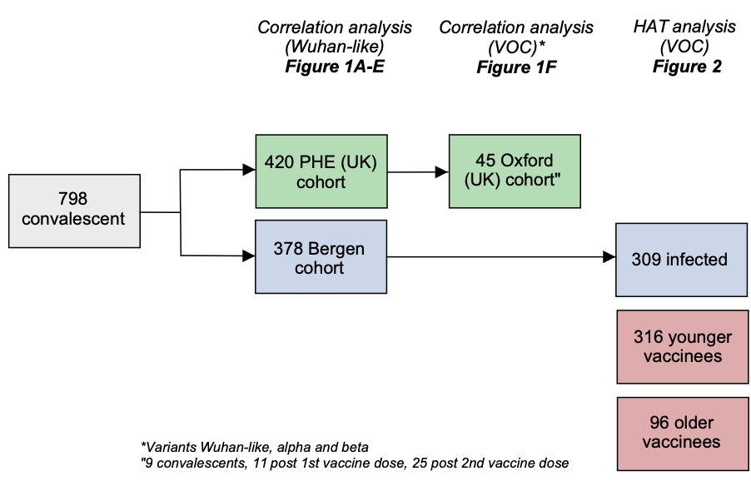
A schematic figure showing the number of individuals used in the Bergen, Public Health England (PHE) and Oxford cohorts used in this study in different analysis and figures.

Extended data Figure 2. Correlations between haemagglutination test antibody endpoint titres and binding antibodies (anti-IgG spike and anti-IgG RBD)
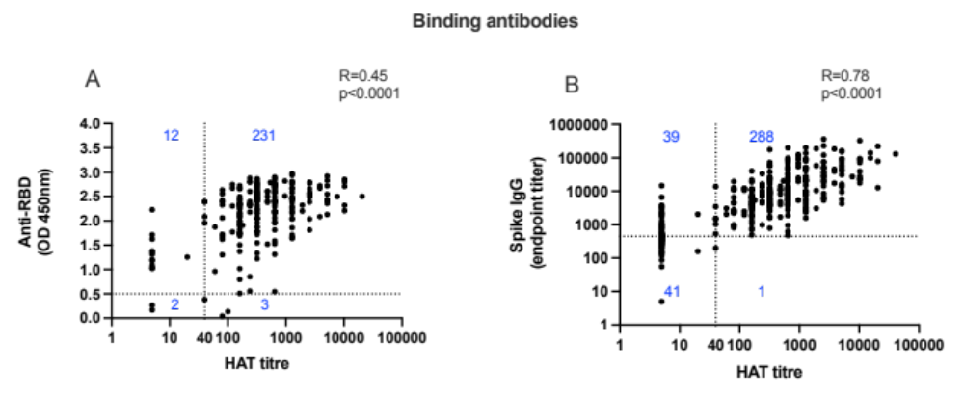
Correlation of endpoint HAT titres with binding antibody titres from a cohort of infected individuals from the first pandemic wave (diagnosis by PCR from nasopharyngeal swabs or serology in Bergen) (A-D, G). Wuhan antibodies were measured by ELISA; A: receptor binding domain (RBD) and B: spike endpoint titres. The dotted lines show the lowest detectable titre in each assay and the numbers in blue are the number of samples in each quadrant

