Graphical Abstract

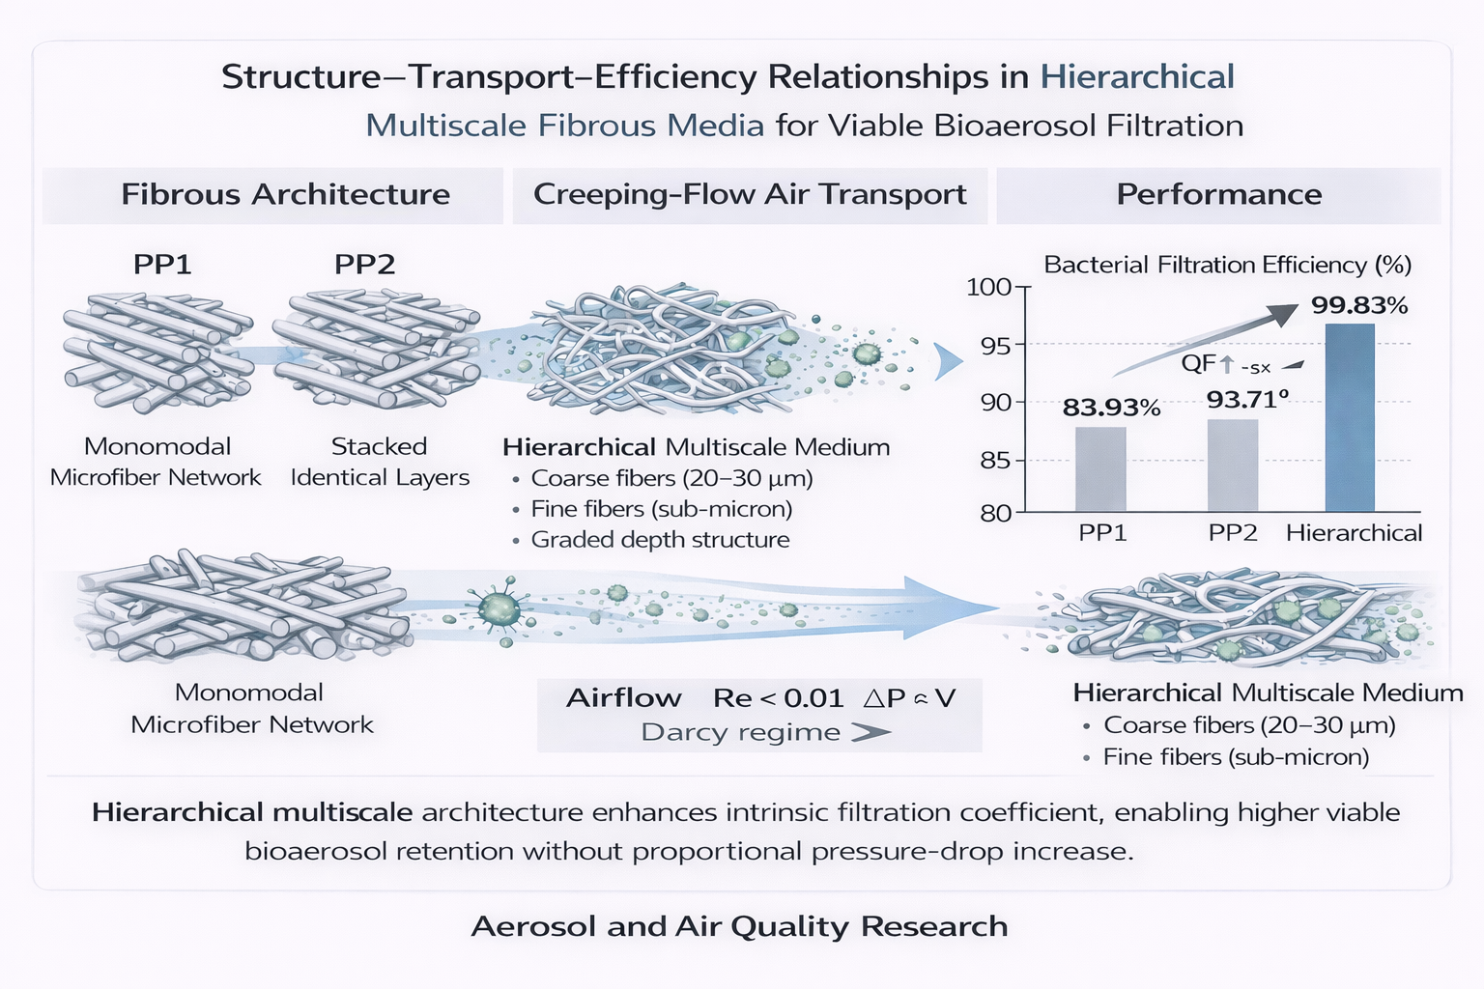

Description: Hierarchical multiscale fibrous architecture modifies airflow transport and particle–fiber interactions under creeping-flow conditions (Re < 0.01), enhancing viable bioaerosol capture without proportional increases in pressure drop. Compared with single-layer and stacked polypropylene media, the graded distribution of coarse and sub-micron fibers improves pore connectivity and intrinsic filtration efficiency, resulting in superior efficiency–resistance performance.

