Appendix

Appendix Table 1. Mitkof Island SBTD used in RADseq analysis for SNP discovery.
Field ID | Sex | Age Class | Notes
MD002 | Female | Adult
MD003 | Female | Adult
MD004 | Female | Adult
MD005 | Female | Adult | High missing data, not used for SNP discovery
MD006 | Female | Adult | Low reads, not used for SNP discovery
MD008 | Female | Yearling
MD009 | Female | Adult | High missing data, not used for SNP discovery
MD010 | Female | Yearling
MD011 | Female | Adult
MD012 | Female | Adult
MD013 | Female | Adult
MD014 | Female | Yearling
MD015 | Female | Adult
MD016 | Female | Adult | High missing data, not used for SNP discovery
MD018 | Female | Yearling

Appendix Table 2. Sample distribution by population and specific region or island.
Region | Populations | Region | Number of samples
Alaska, USA | Kodiak | Kodiak Island | 21
Alaska, USA | Kodiak | Afognak Island | 14
Alaska, USA | Kodiak | Sitkalidak Island | 5
Alaska, USA | Kodiak | Uganik Island | 1
Alaska, USA | Kodiak | Whale Island | 1
Alaska, USA | SCAK | Hinchinbrook Island | 14
Alaska, USA | SCAK | Hawkins Island | 6
Alaska, USA | NSEAK | Baranof Island | 24
Alaska, USA | NSEAK | Admiralty Island | 23
Alaska, USA | NSEAK | Chichagof Island | 13
Alaska, USA | NSEAK | Kruzof Island | 5
Alaska, USA | NSEAK | Douglas Island | 4
Alaska, USA | NSEAK | Shelter Island | 3
Alaska, USA | NSEAK | Mainland Juneau | 2
Alaska, USA | NSEAK | Krestof Island | 1
Alaska, USA | NSEAK | Partofshikof Island | 1
Alaska, USA | CSEAK | Mitkof Island | 28
Alaska, USA | CSEAK | Kupreanof Island | 21
Alaska, USA | SSEAK | Revillagigedo Island | 14
Alaska, USA | SSEAK | Gravina Island | 3
Alaska, USA | SSEAK | Cleveland Peninsula | 2
Alaska, USA | P. of Wales Is. | Prince of Wales Island | 20
Alaska, USA | Unknown | NA | 2
British Columbia, CAN | Haida Gwaii | Graham Island | 10

Appendix Figure 1. Sitka black-tailed deer SNP panel PCA by proportion sample missingness, showing the level of influence of missing data on sample clustering.
Appendix Figure 1. Sitka black-tailed deer SNP panel PCA by proportion sample missingness, showing the level of influence of missing data on sample clustering.

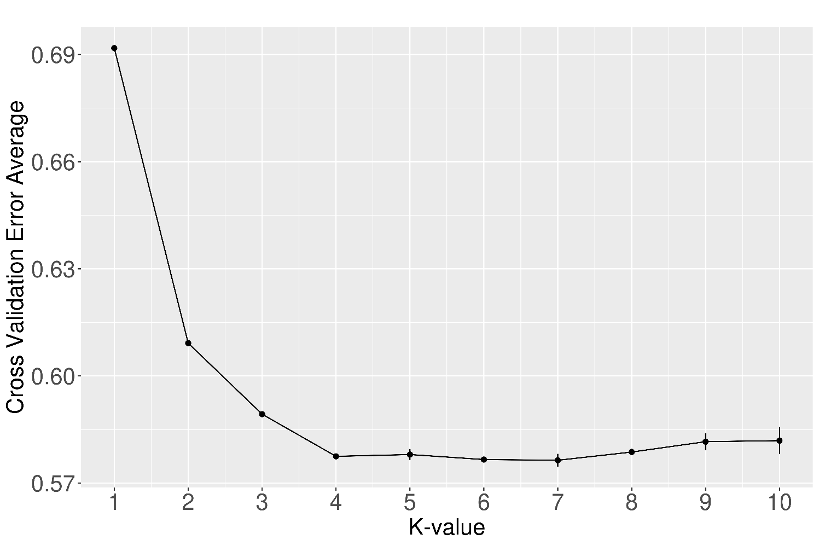
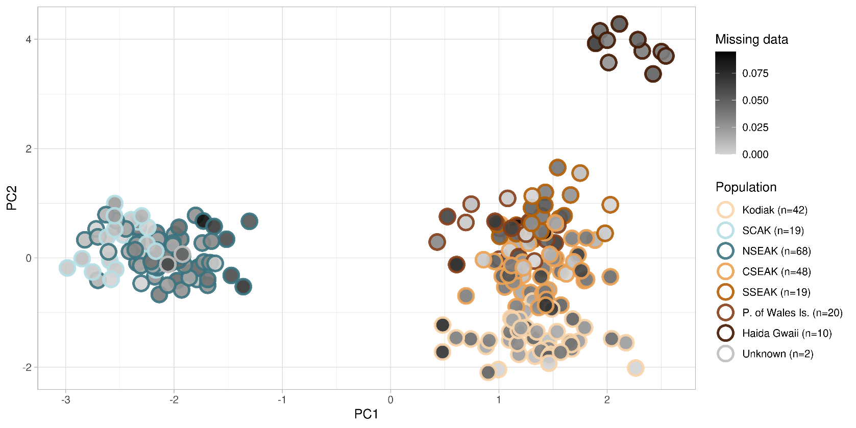
Appendix Figure 1. Sitka black-tailed deer SNP panel PCA by proportion sample missingness, showing the level of influence of missing data on sample clustering.
Appendix Figure 2. Sitka black-tailed deer SNP panel Admixture cross validation error. K=6 had the lowest CV error with lowest replicate variance.

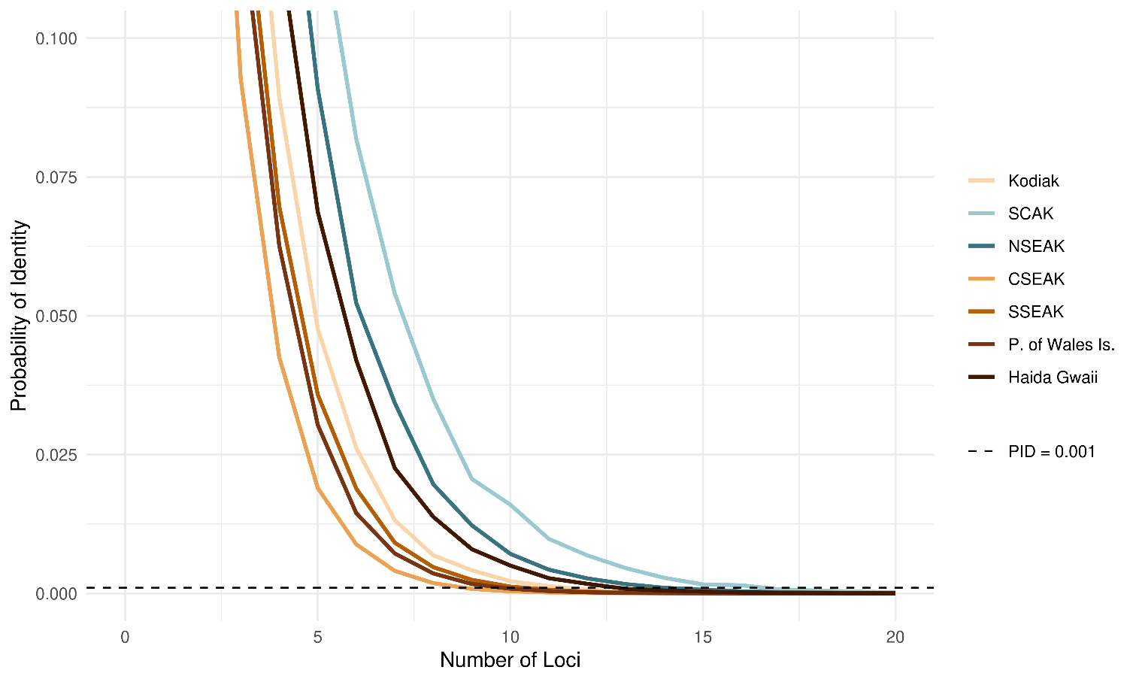
Appendix Figure 3. Sitka black-tailed deer SNP panel PID of unrelated individuals.

Supplemental Table 1 (excel file): Sitka black-tailed deer SNP panel recommended loci by region, including only high variability loci that are in Hardy-Weinberg Equilibrium by region and below 0.7 observed heterozygosity.

