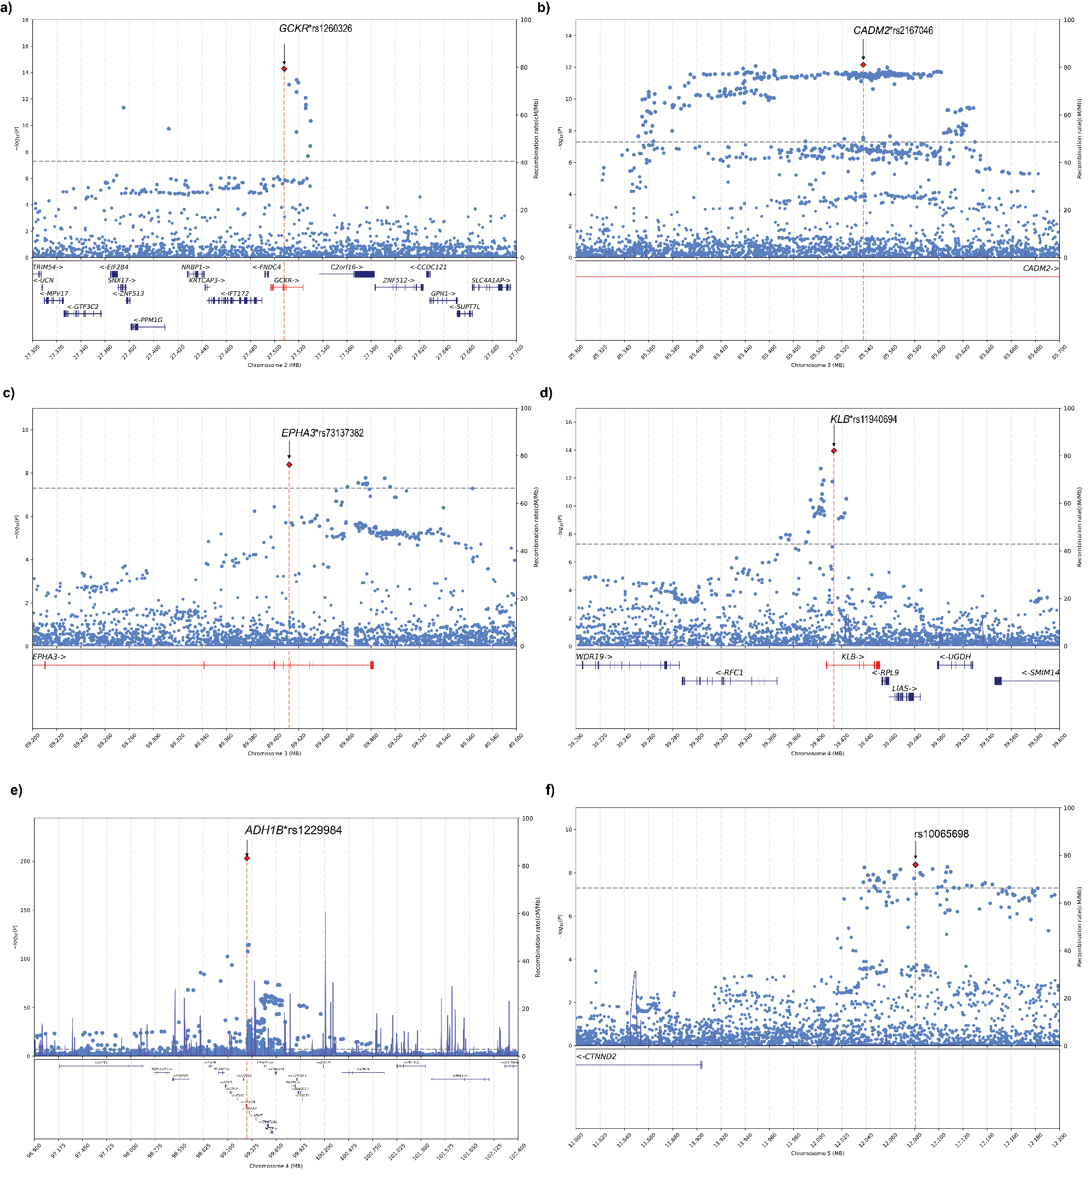
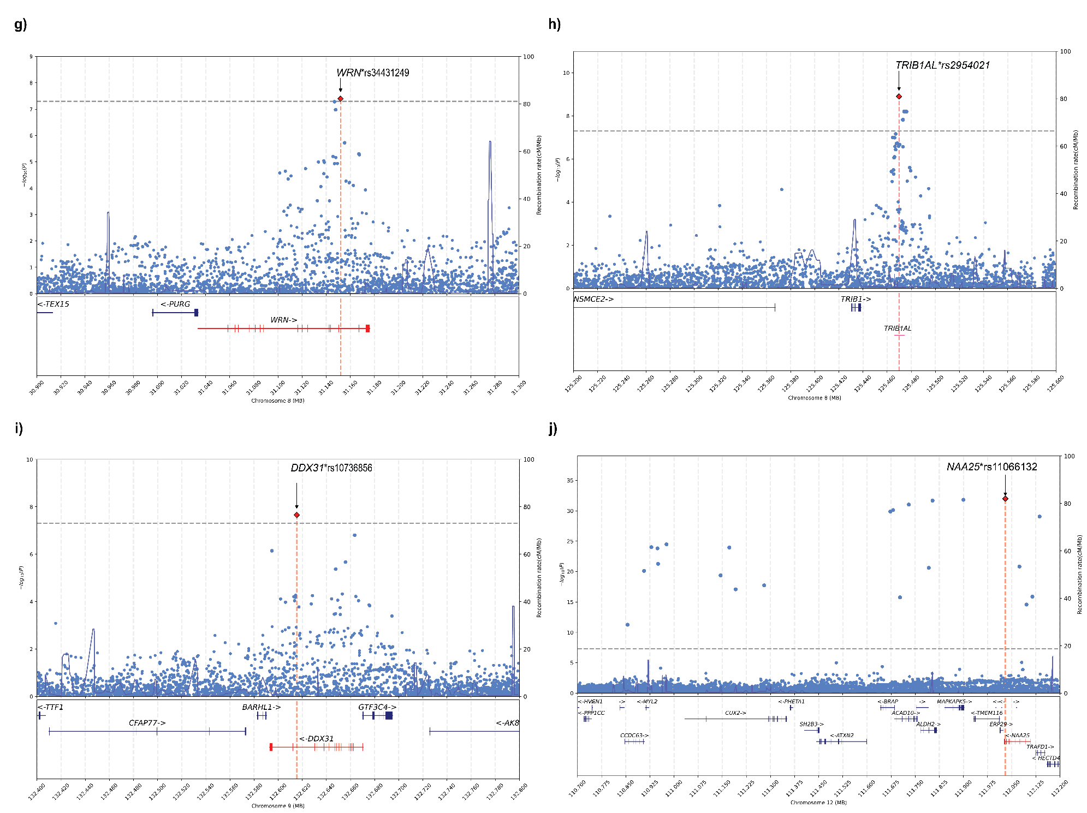

Supplementary Figure 1. Regional plots of the associated loci.

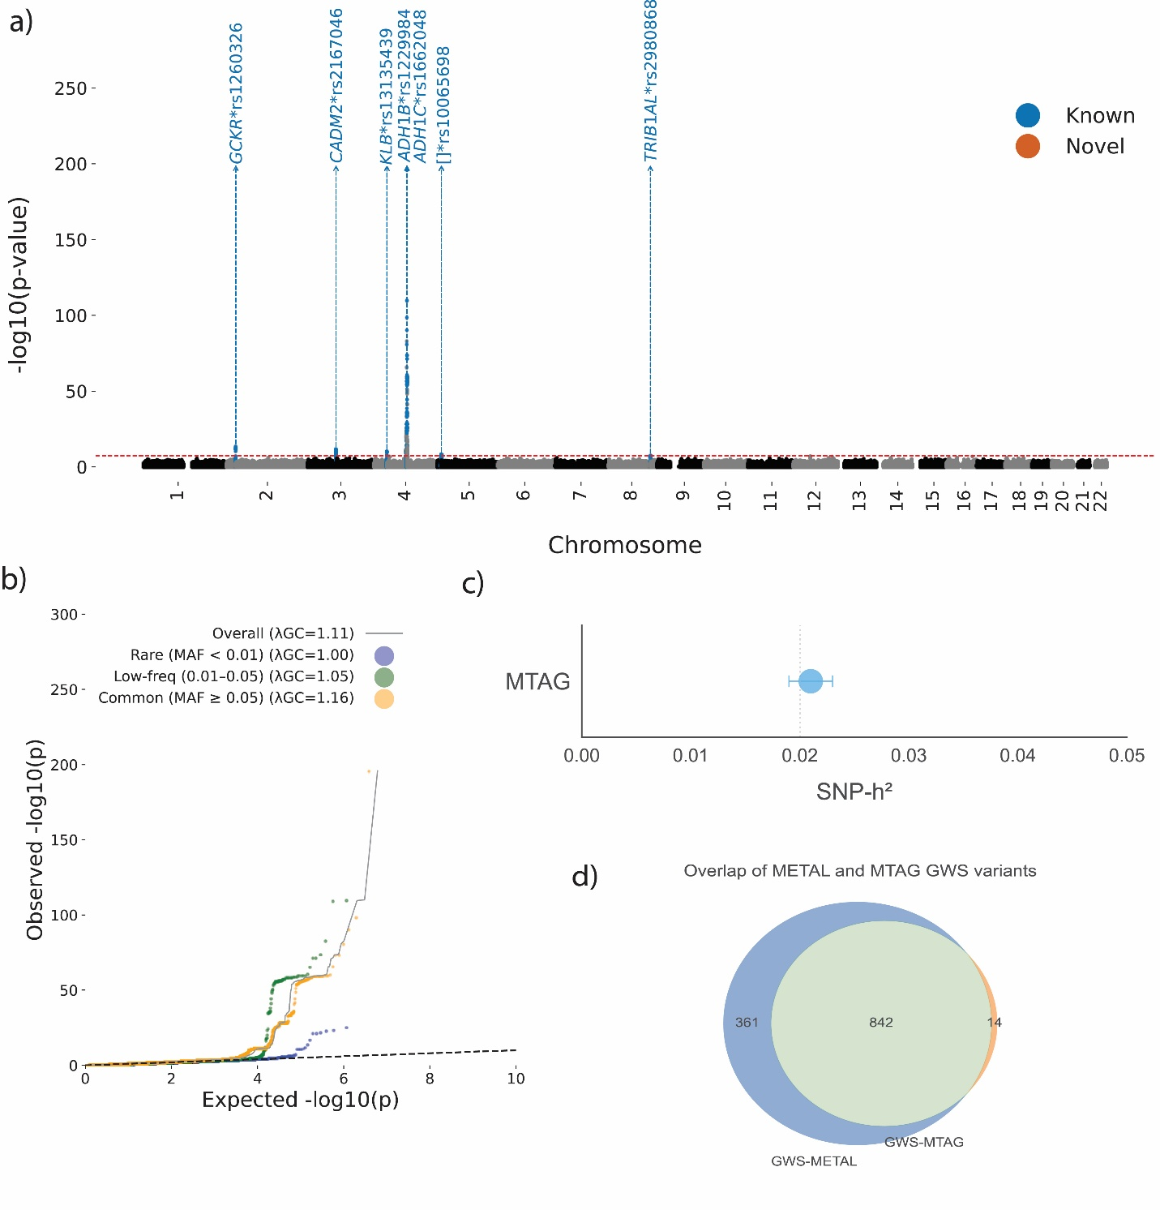
Supplementary Figure 2. Genetic architecture of alcohol consumption in Latin American populations. a) Genome-wide association results for alcohol consumption in the meta-analysis (N = 465,516) using METAL. The red line is the significance threshold of 5.0e−8. Red represents novel loci and blue represents previous known associations with alcohol consumption. b) Minor allele frequency (MAF)-stratified QQ plot for the meta-analysis using METAL; lambda GC =1.11, and the LDSC intercept = 1.0358 (s.e. 0.0085). c) Relationship between sample size and number of lead variants identified. Kranzler et al., 2019: alcohol consumption using the Alcohol Use Disorders Identification Test-Consumption (AUDIT-C) score; Kember et al., 2023: using AUDIT-C score; Saunders et al., 2022: drinks per week. d) Observed-scale SNP-based heritability (h²) in the sample size-weighted fixed-effects meta-analyses using METAL.

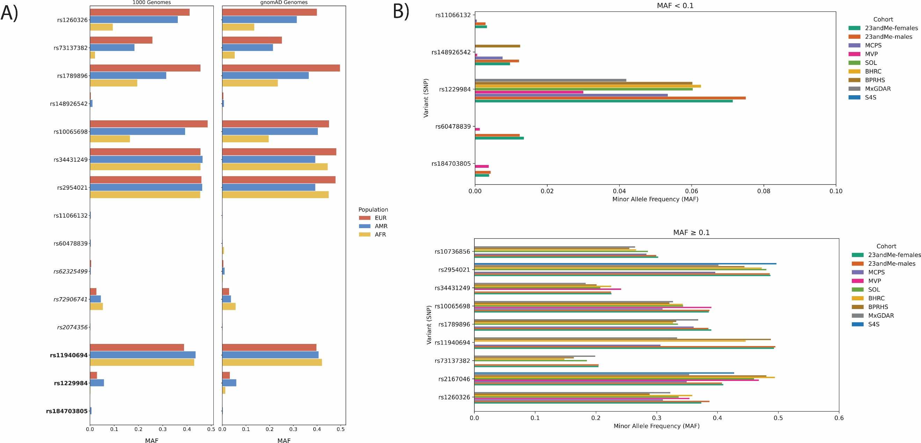
Supplementary Figure 3. Allelic frequency of the independent genome-wide significant variants. A) Ancestry stratified minor allelic frequency (MAF) in Europeans (EUR), Admixed Americans (AMR), and African (AFR) of the independent and causal variants using the 1000 Genomes and GnomAD reference panel. In bold are the independent variants that also were identified as causal by fine-mapping. B) MAF of the independent genome-wide significant variants by analyzed cohort.

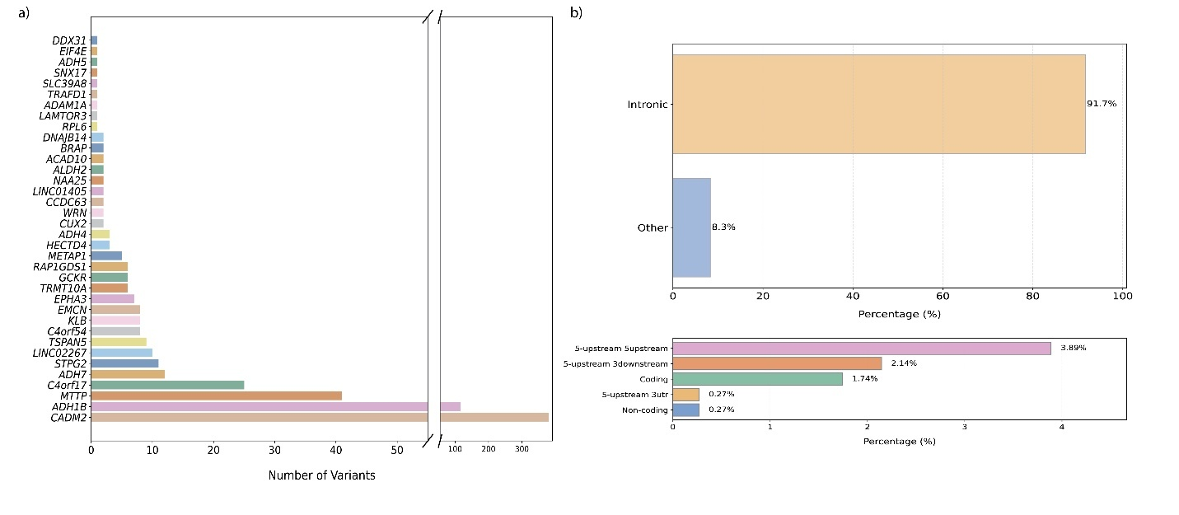
Supplementary Figure 4. Annotation of Genome-wide significant SNPs. a) Number of genome-wide significant SNPs mapping to each gene. b) Percentage of variants that mapped to the gene elements, most the variants, 91.7% mapped to intron positions. The annotation was performed using SNPnexus web platform.

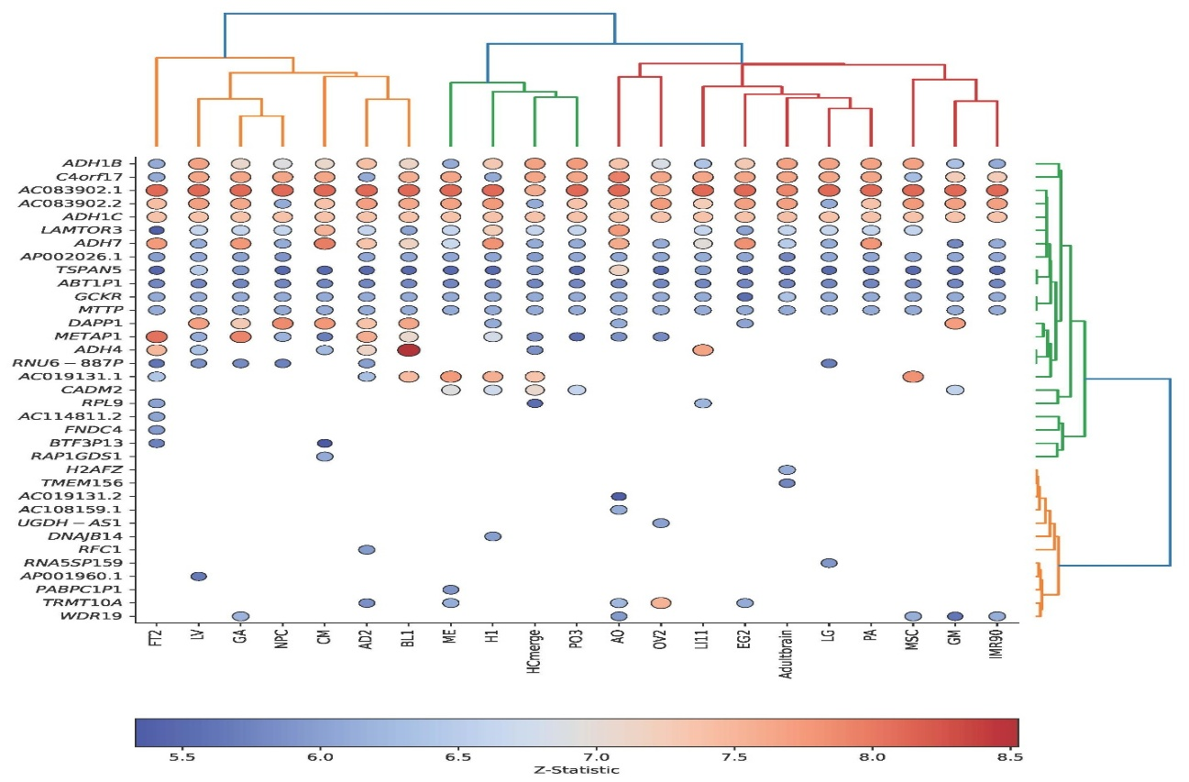
Supplementary Figure 5. H-MAGMA multi-tissue and cell lines analysis. Association of chromatin accessibility with alcohol consumption across multiple tissues and cell lines using H-MAGMA. The genes were clustered using hierarchical clustering for genes and tissues/cell lines.

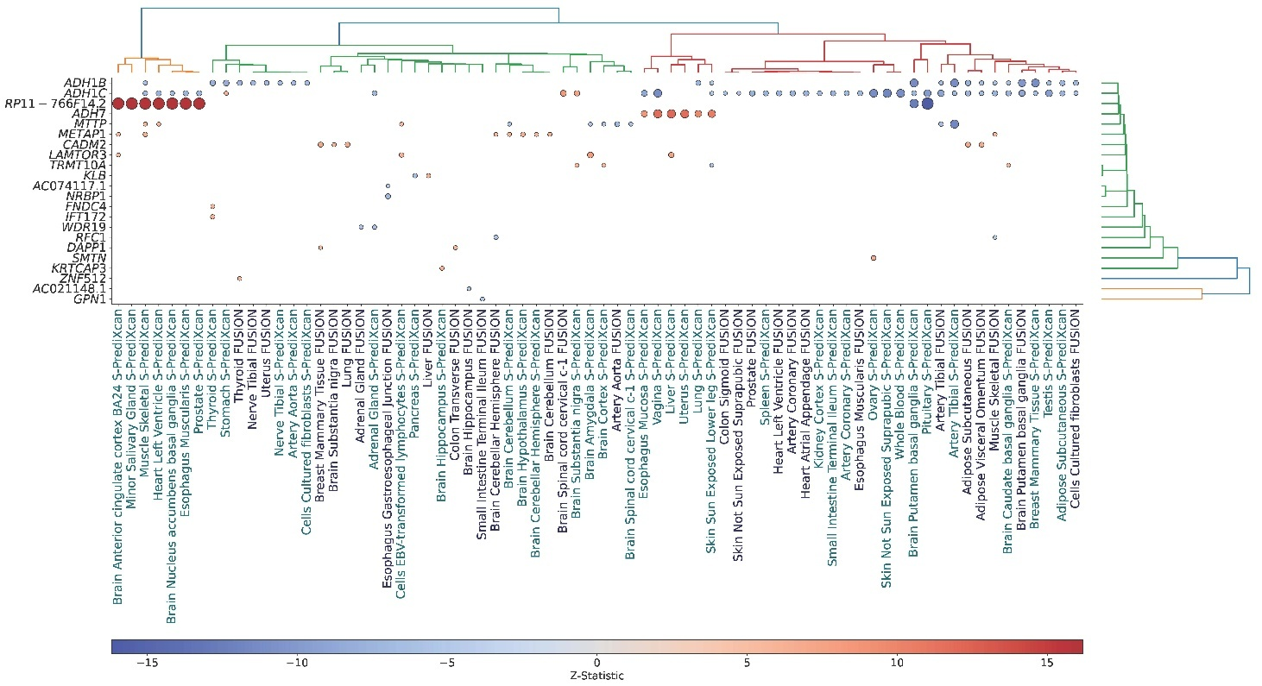

Supplementary Figure 6. Single tissue TWAS using Fusion and S-PredicXcan. Association of gene expression with alcohol consumption across multiple tissues. The genes were clustered using hierarchical clustering for genes and tissues/cell lines. Dark blue are the genes identified by Fusion and in light blue those identified by S-PredicXcan.

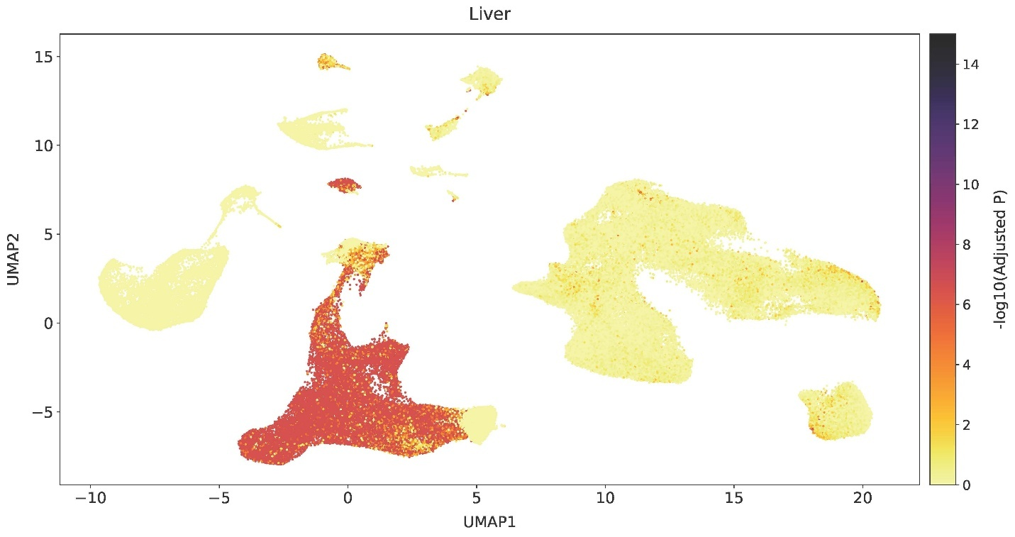
Supplementary Figure 7. Cell prioritization using scPagwas in the liver includes genetic variants with low minor allelic frequency.

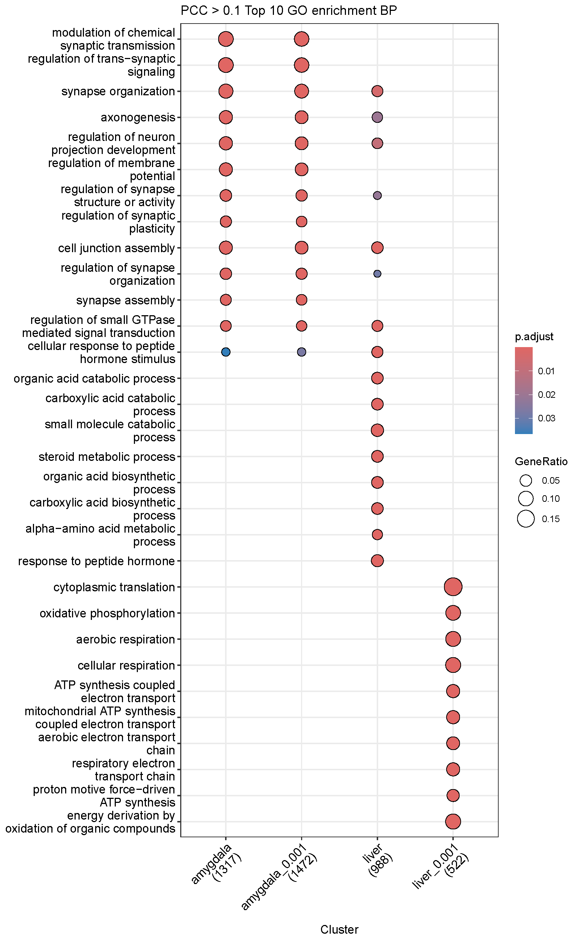
Supplementary Figure 8. GO enrichment analysis of the genes correlated with the genetic liability of alcohol consumption using scPagwas.

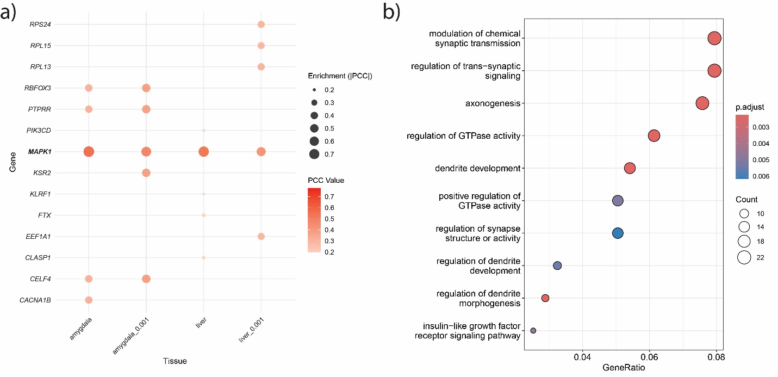
Supplementary Figure 9. Overlapping analysis of the genes identified by scPagwas in liver and amygdala. a) Genes that overlapped across the tissues with significant associations using scPagwas. b) GO enrichment analysis of the genes that overlapped across the tissues with significant associations using scPagwas

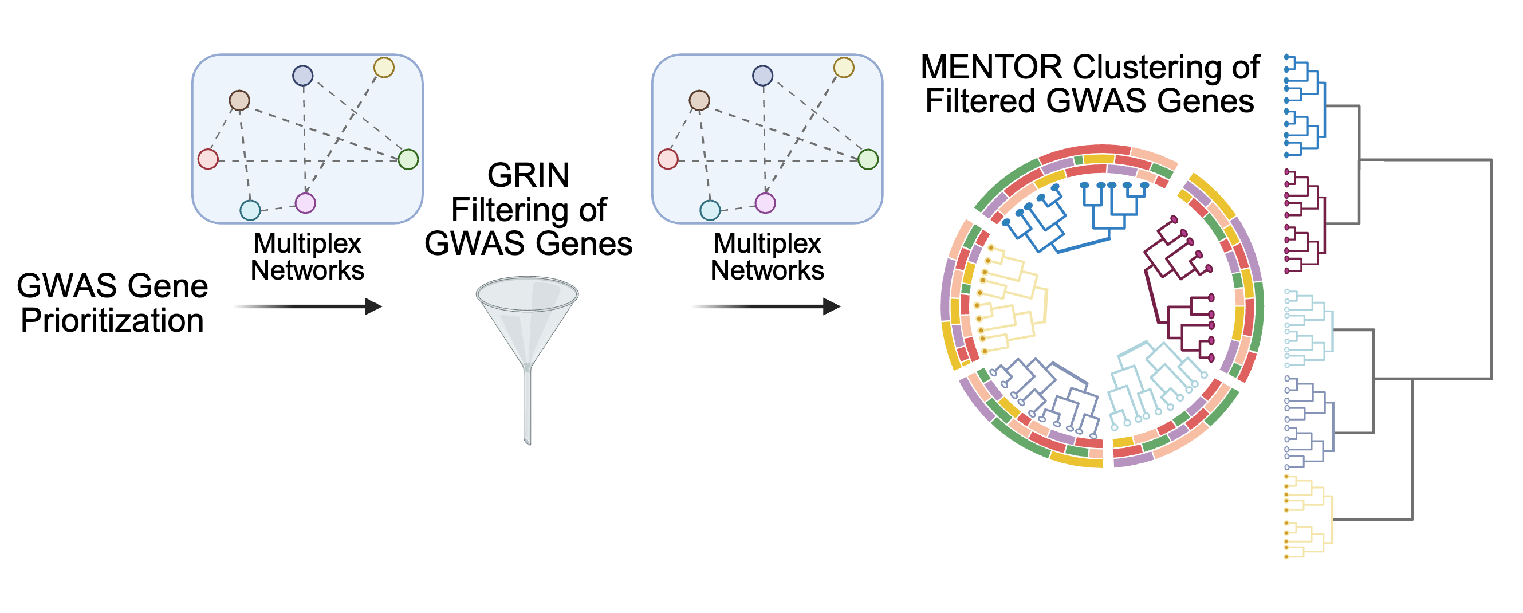
Supplementary Figure 10. Workflow diagram for network-based GRIN filtering and MENTOR clustering of alcohol consumption GWAS genes. Figure made with BioRender.com.
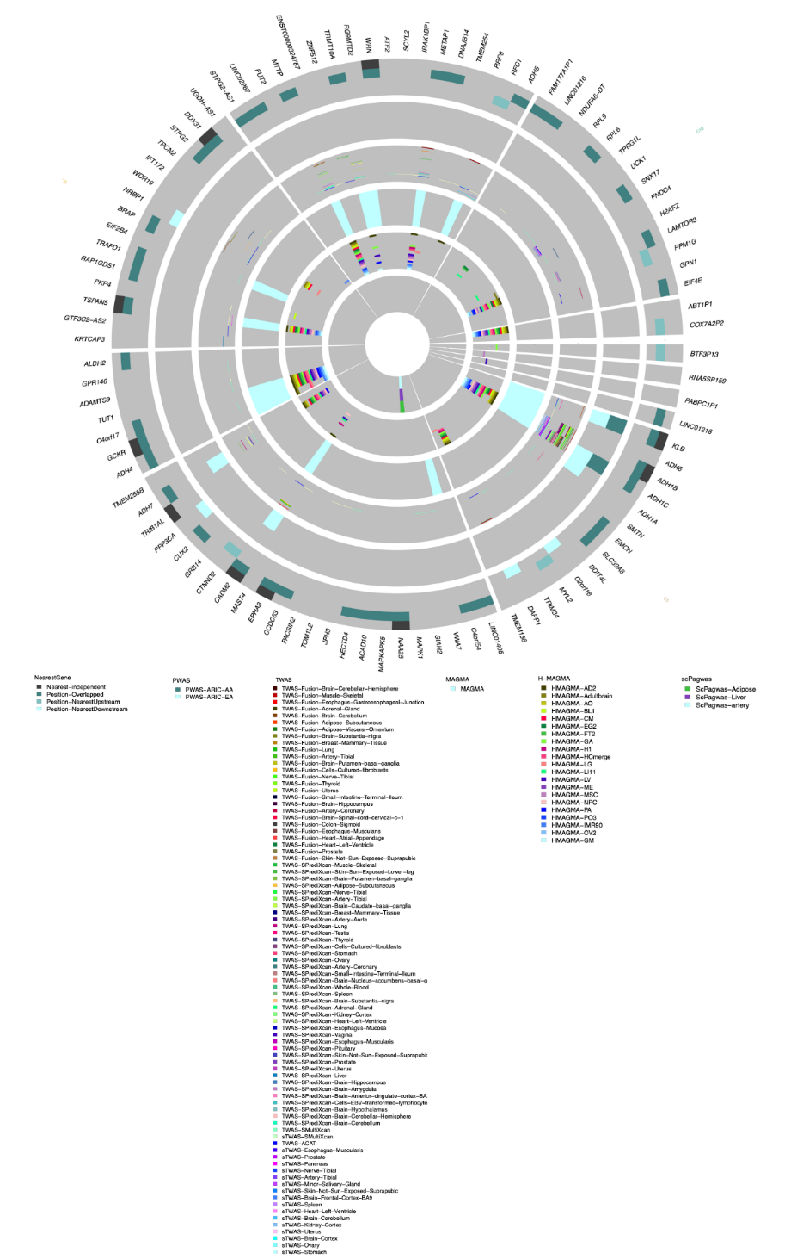

Supplementary Figure 11. MENTOR network embedding functional connections among full alcohol consumption GWAS gene list. Top: MENTOR network clustering of 96 alcohol consumption GWAS-associated genes prior to GRIN filtering. Bottom: Legend of GWAS gene prioritization methods used to identify alcohol consumption GWAS-associated genes.

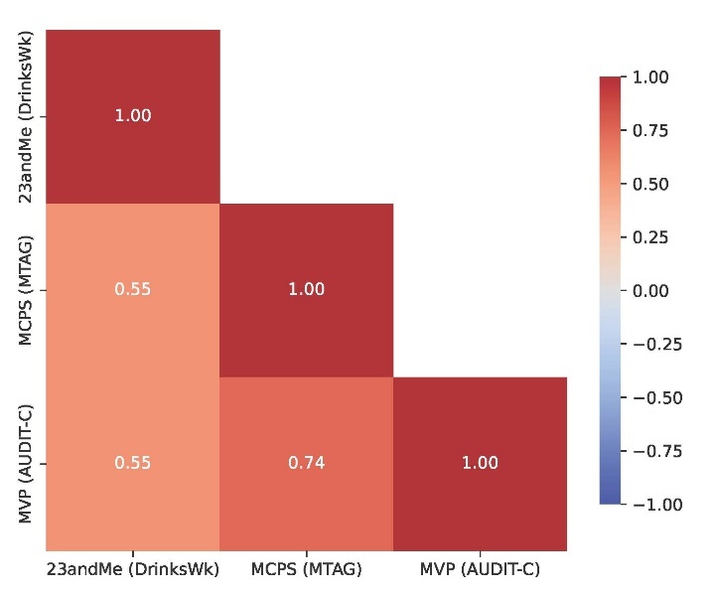
Supplementary Figure 12. Genetic correlations of alcohol consumption in the larger cohorts (23andMe, MCPS, and MVP).
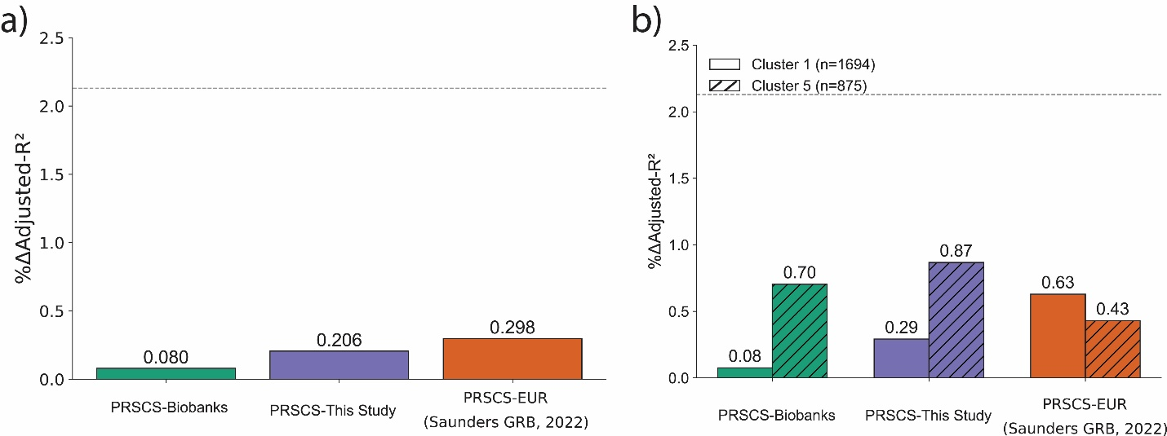

Supplementary Figure 13. Variance explained for alcohol consumed per week (DrinksWk) by the PRS in the HCHS/SOL. The PRS was computed using PRSCs, the variance was estimated by subtracting the Adjusted-R2 of the null model (using age, sex and 10 genetic principal components of genetic ancestry) of the model adding the PRS to the null model.

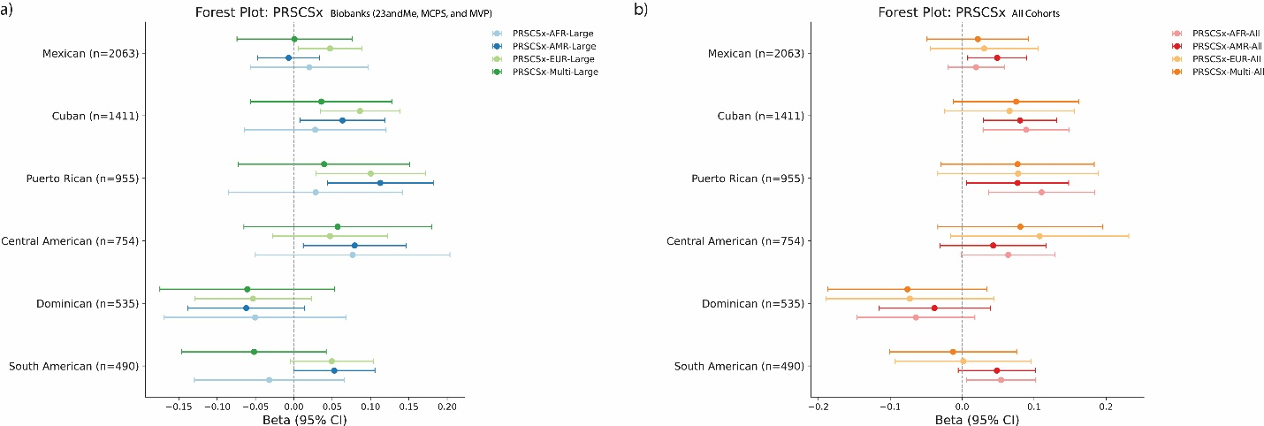
Supplementary Figure 14. Association alcohol consumed per week (DrinksWk) with the PRS in the HCHS/SOL stratified by geographical origin. The PRS was computed using PRSCsx, using the summary statistics from this study and the summary statistics from Saunders GRB et, al., 2022 for Europeans and African Americans; and the LD reference panels from 1000 Genomes. a) PRS was built using the summary statistics from Biobanks only, and b) PRS was built using the summary statistics when all the cohorts were included in the meta-analysis.

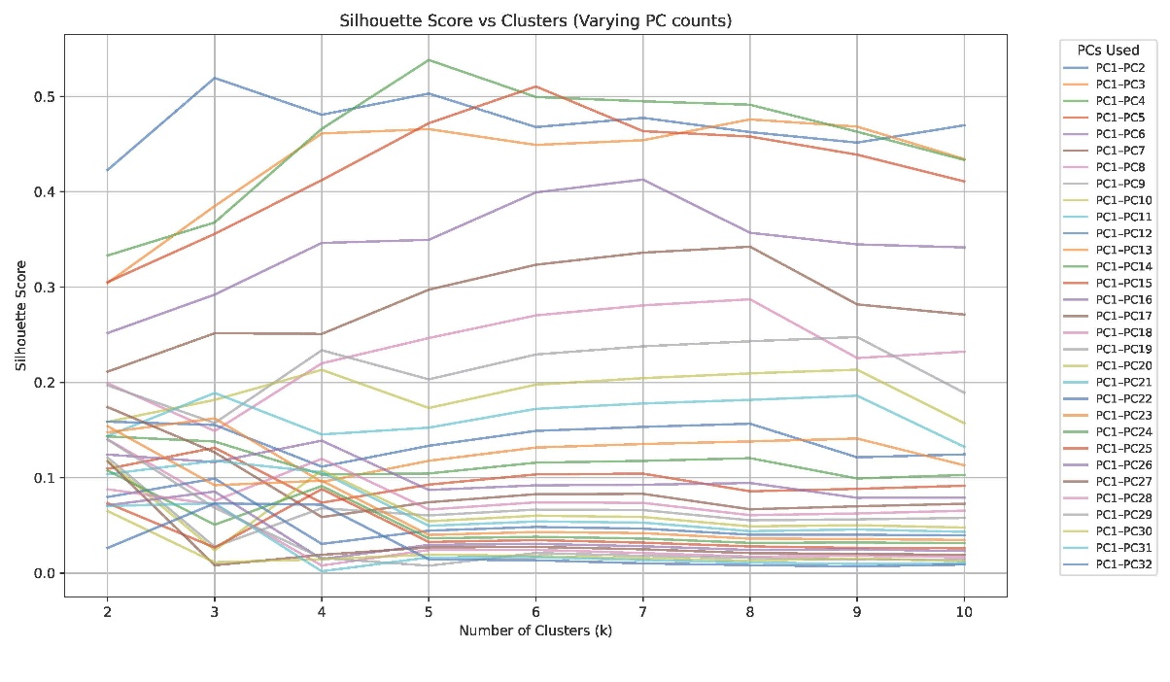
Supplementary Figure 15. Silhouette scores for the K-means clustering algorithm in the HCHS/SOL cohort. We varied the number for clusters from 1 to 10; and the number of genetic PCs included in each analysis starting from PC1 and PC2 and increasing the number until PC32. Each line represents the Silhouette scores with fixed number of PCs and varying the number of clusters.

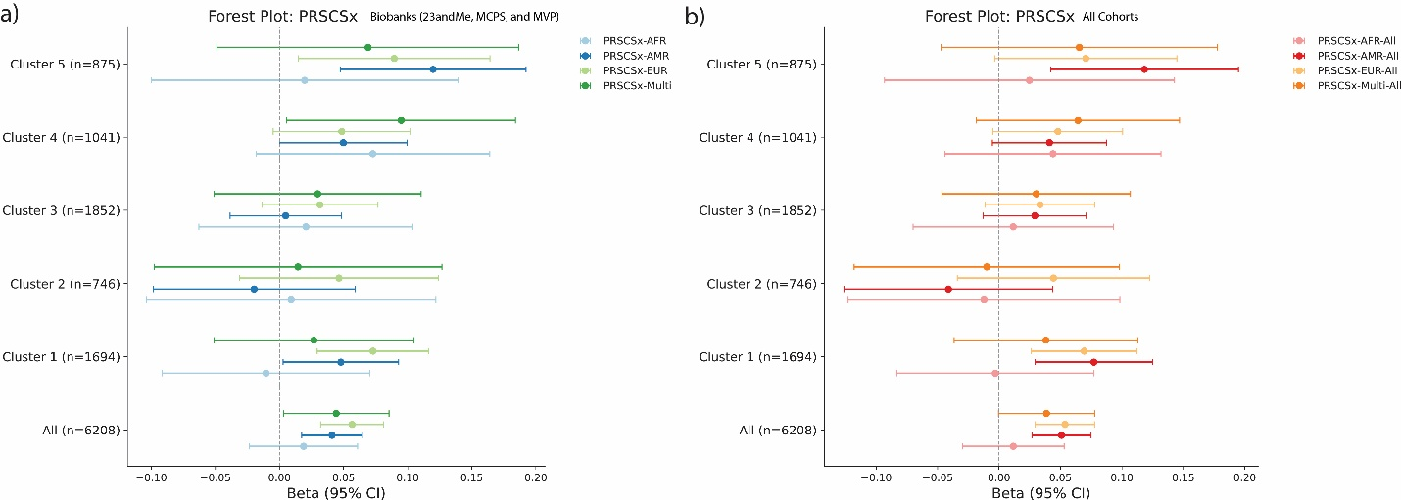
Supplementary Figure 16. Association alcohol consumed per week (DrinksWk) with the PRS in the HCHS/SOL stratified by the machine learning algorithm. The PRS was computed using PRSCsx, using the summary statistics from this study and the summary statistics from Saunders GRB et, al., 2022 for Europeans and African Americans; and the LD reference panels from 1000 Genomes. a) PRS was built using the summary statistics from Biobanks only, and b) PRS was built using the summary statistics when all the cohorts were included in the meta-analysis.

