Supplementary material

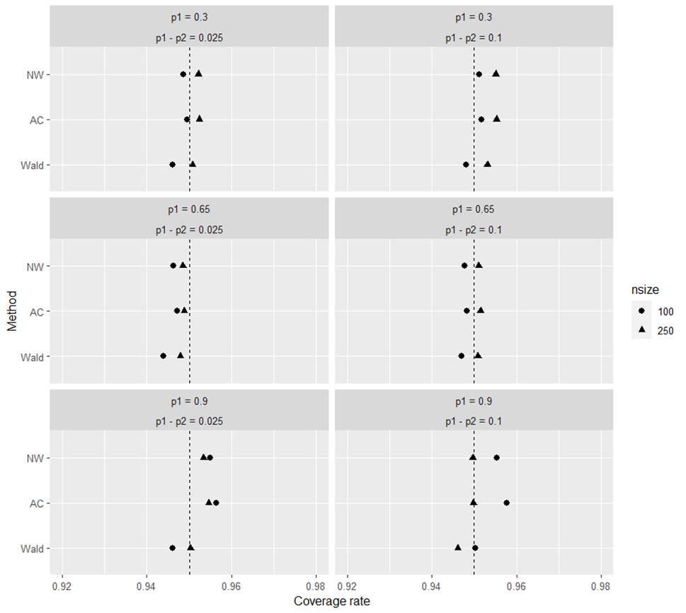

Figure S1. Coveage rate of the confidence intervals for the difference between proportions according to methods Newcombe-Wilson (NW), Agresti-Caffo (AC) and Wald. The dashed line is the desired coverage rate of 0.95.

Table 1. Length of confidence intervals for the difference between proportions of the Wald, Agresti-Caffo and Newcombe-Wilson methods in complete data and after Multiple Imputation of 10% and 30% missing MCAR data.
 | Wald^{*a} | AC^{*b} | NW^{*c} | MI-Wald^{†a} | MI-AC^{†b} | MI-NW^{†c}
n100; p1-p2=0.025, 30% missing
p1 = 0.3 | 0.249 | 0.248 | 0.247 | 0.264 | 0.262 | 0.261
p1 = 0.65 | 0.265 | 0.263 | 0.261 | 0.281 | 0.278 | 0.276
p1 = 0.9 | 0.173 | 0.177 | 0.180 | 0.184 | 0.187 | 0.192
n250; p1-p2=0.025, 30% missing
p1 = 0.3 | 0.158 | 0.158 | 0.158 | 0.168 | 0.167 | 0.167
p1 = 0.65 | 0.168 | 0.168 | 0.167 | 0.178 | 0.178 | 0.177
p1 = 0.9 | 0.110 | 0.111 | 0.112 | 0.117 | 0.118 | 0.119
n100; p1-p2=0.025, 10% missing
p1 = 0.3 | 0.249 | 0.248 | 0.247 | 0.305 | 0.302 | 0.301
p1 = 0.65 | 0.265 | 0.263 | 0.261 | 0.324 | 0.320 | 0.317
p1 = 0.9 | 0.174 | 0.177 | 0.180 | 0.215 | 0.216 | 0.227
n250; p1-p2=0.025, 10% missing
p1 = 0.3 | 0.158 | 0.158 | 0.158 | 0.194 | 0.193 | 0.193
p1 = 0.65 | 0.168 | 0.168 | 0.167 | 0.206 | 0.205 | 0.204
p1 = 0.9 | 0.110 | 0.111 | 0.112 | 0.136 | 0.136 | 0.139
n100; p1-p2=0.1, 30% missing
p1 = 0.3 | 0.237 | 0.236 | 0.236 | 0.251 | 0.250 | 0.250
p1 = 0.65 | 0.269 | 0.266 | 0.264 | 0.285 | 0.282 | 0.280
p1 = 0.9 | 0.194 | 0.196 | 0.198 | 0.206 | 0.208 | 0.211
n250; p1-p2=0.1, 30% missing
16. p1 = 0.3 | 0.150 | 0.150 | 0.150 | 0.160 | 0.159 | 0.159
17. p1 = 0.65 | 0.171 | 0.170 | 0.169 | 0.181 | 0.180 | 0.179
18. p1 = 0.9 | 0.124 | 0.124 | 0.124 | 0.131 | 0.131 | 0.132
n100; p1-p2=0.1, 10% missing
p1 = 0.3 | 0.237 | 0.236 | 0.236 | 0.290 | 0.288 | 0.289
p1 = 0.65 | 0.269 | 0.266 | 0.264 | 0.328 | 0.324 | 0.321
p1 = 0.9 | 0.194 | 0.196 | 0.198 | 0.239 | 0.239 | 0.247
n250; p1-p2=0.1, 10% missing
p1 = 0.3 | 0.150 | 0.150 | 0.150 | 0.184 | 0.184 | 0.184
p1 = 0.65 | 0.171 | 0.170 | 0.169 | 0.209 | 0.208 | 0.207
p1 = 0.9 | 0.124 | 0.124 | 0.125 | 0.152 | 0.152 | 0.154
ª Wald ^{b} Agresti-Caffo ^{c} Newcombe-Wilson; * Complete data † Multiple Imputation

Table 2. Length of confidence intervals for the difference between proportions of the Wald, Agresti-Caffo and Newcombe-Wilson methods in complete data and after Multiple Imputation of 10% and 30% missing MAR data when x and Y have a weak correlation.

 | Wald^{*a} | AC^{*b} |  | NW^{*c} | MI-Wald^{†a} | MI-AC^{†b} | MI-NW^{†c}
n100; p1-p2=0.025, 30% missing
p1 = 0.3 | 0.249 | 0.248 | 0.247 |  | 0.265 | 0.263 | 0.262
p1 = 0.65 | 0.265 | 0.263 | 0.261 |  | 0.281 | 0.279 | 0.277
p1 = 0.9 | 0.168 | 0.168 | 0.167 |  | 0.179 | 0.178 | 0.178
n250; p1-p2=0.025, 30% missing
p1 = 0.3 | 0.158 | 0.158 | 0.158 |  | 0.168 | 0.168 | 0.168
p1 = 0.65 | 0.168 | 0.168 | 0.167 |  | 0.179 | 0.178 | 0.178
p1 = 0.9 | 0.110 | 0.111 | 0.112 |  | 0.118 | 0.119 | 0.120
n100; p1-p2=0.025, 10% missing
7. p1 = 0.3 | 0.249 | 0.248 | 0.247 |  | 0.315 | 0.311 | 0.310
8. p1 = 0.65 | 0.265 | 0.263 | 0.261 |  | 0.332 | 0.328 | 0.325
9. p1 = 0.9 | 0.168 | 0.168 | 0.167 |  | 0.212 | 0.211 | 0.210
n250; p1-p2=0.025, 10% missing
p1 = 0.3 | 0.158 | 0.158 | 0.158 |  | 0.200 | 0.199 | 0.199
p1 = 0.65 | 0.168 | 0.168 | 0.167 |  | 0.212 | 0.211 | 0.210
p1 = 0.9 | 0.110 | 0.111 | 0.112 |  | 0.143 | 0.143 | 0.147
n100; p1-p2=0.1, 30% missing
p1 = 0.3 | 0.237 | 0.236 | 0.236 |  | 0.252 | 0.251 | 0.251
p1 = 0.65 | 0.269 | 0.266 | 0.264 |  | 0.285 | 0.283 | 0.280
p1 = 0.9 | 0.195 | 0.197 | 0.198 |  | 0.209 | 0.210 | 0.213
n250; p1-p2=0.1, 30% missing
p1 = 0.3 | 0.150 | 0.150 | 0.150 |  | 0.160 | 0.160 | 0.160
p1 = 0.65 | 0.171 | 0.170 | 0.169 |  | 0.181 | 0.180 | 0.180
p1 = 0.9 | 0.124 | 0.124 | 0.125 |  | 0.132 | 0.132 | 0.133
n100; p1-p2=0.1, 10% missing
p1 = 0.3 | 0.237 | 0.236 | 0.236 |  | 0.301 | 0.298 | 0.299
p1 = 0.65 | 0.269 | 0.266 | 0.264 |  | 0.336 | 0.332 | 0.328
p1 = 0.9 | 0.150 | 0.150 | 0.150 |  | 0.190 | 0.189 | 0.190
n250; p1-p2=0.1, 10% missing
p1 = 0.3 | 0.150 | 0.150 | 0.150 |  | 0.190 | 0.189 | 0.190
p1 = 0.65 | 0.170 | 0.170 | 0.169 |  | 0.215 | 0.214 | 0.213
p1 = 0.9 | 0.124 | 0.124 | 0.124 |  | 0.158 | 0.158 | 0.161
ª Wald ^{b} Agresti-Caffo ^{c} Newcombe-Wilson; * Complete data † Multiple Imputation

Table 3. Length of confidence intervals for the difference between proportions of the Wald, Agresti-Caffo and Newcombe-Wilson methods in complete data and after Multiple Imputation of 10% and 30% missing MAR data when x and Y have a strong correlation.

 | Wald^{*a} | AC^{*b} | NW^{*c} | MI-Wald^{†a} | MI-AC^{†b} | MI-NW^{†c}
n100; p1-p2=0.025, 30% missing
p1 = 0.3 | 0.249 | 0.248 | 0.247 | 0.261 | 0.260 | 0.259
p1 = 0.65 | 0.265 | 0.263 | 0.261 | 0.278 | 0.276 | 0.274
p1 = 0.9 | 0.174 | 0.177 | 0.180 | 0.185 | 0.188 | 0.193
n250; p1-p2=0.025, 30% missing
p1 = 0.3 | 0.158 | 0.158 | 0.158 | 0.166 | 0.165 | 0.165
p1 = 0.65 | 0.168 | 0.168 | 0.167 | 0.177 | 0.176 | 0.176
p1 = 0.9 | 0.110 | 0.111 | 0.112 | 0.117 | 0.118 | 0.120
n100; p1-p2=0.025, 10% missing
p1 = 0.3 | 0.249 | 0.248 | 0.247 | 0.293 | 0.290 | 0.289
p1 = 0.65 | 0.265 | 0.263 | 0.261 | 0.313 | 0.310 | 0.307
p1 = 0.9 | 0.173 | 0.177 | 0.180 | 0.217 | 0.218 | 0.229
n250; p1-p2=0.025, 10% missing
p1 = 0.3 | 0.158 | 0.158 | 0.158 | 0.185 | 0.184 | 0.184
p1 = 0.65 | 0.168 | 0.168 | 0.167 | 0.199 | 0.199 | 0.198
p1 = 0.9 | 0.110 | 0.111 | 0.112 | 0.136 | 0.136 | 0.139
n100; p1-p2=0.1, 30% missing
p1 = 0.3 | 0.237 | 0.236 | 0.236 | 0.248 | 0.247 | 0.247
p1 = 0.65 | 0.269 | 0.266 | 0.264 | 0.282 | 0.279 | 0.277
p1 = 0.9 | 0.195 | 0.197 | 0.198 | 0.207 | 0.208 | 0.211
n250; p1-p2=0.1, 30% missing
p1 = 0.3 | 0.150 | 0.150 | 0.150 | 0.158 | 0.157 | 0.157
p1 = 0.65 | 0.170 | 0.170 | 0.169 | 0.179 | 0.178 | 0.178
p1 = 0.9 | 0.124 | 0.124 | 0.125 | 0.131 | 0.131 | 0.132
n100; p1-p2=0.1, 10% missing
p1 = 0.3 | 0.237 | 0.236 | 0.236 | 0.279 | 0.277 | 0.277
p1 = 0.65 | 0.269 | 0.266 | 0.264 | 0.317 | 0.313 | 0.310
p1 = 0.9 | 0.195 | 0.197 | 0.198 | 0.239 | 0.239 | 0.246
n250; p1-p2=0.1, 10% missing
p1 = 0.3 | 0.151 | 0.150 | 0.150 | 0.176 | 0.176 | 0.176
p1 = 0.65 | 0.170 | 0.170 | 0.169 | 0.201 | 0.200 | 0.200
p1 = 0.9 | 0.124 | 0.124 | 0.125 | 0.150 | 0.150 | 0.152
ª Wald ^{b} Agresti-Caffo ^{c} Newcombe-Wilson; * Complete data † Multiple Imputation

