Supplementary Information

Guide to the code
Since the databases we used are from third parties, we do not publish the data directly, but offer all scripts and explanations required to reproduce them. The databases can be obtained from their respective sources and integrated into the code structure as described below. The mentioned ‘raw_data’ folder is in the data_and_skripts folder available in the Code Availability section, on the path: data_and_skripts/data/raw_data.
- Red List¹⁶: The data can be downloaded from the website https://www.iucnredlist.org/resources/spatial-data-download. Then, it must be added to the ‘raw_data’ folder with the name "IUCN_trees".
- GBIF⁵⁸: The data can be downloaded from the website https://www.gbif.org/occurrence/search?country=BO. Then, it must be added to the ‘raw_data’ folder with the name "GBIF_bo”.
- BBON³²: The data was provided by the authors and then added it to the ‘raw_data’ folder as "GEO_BON".
- Bolivian borders: Global border data can be downloaded from naturaldata.com. Then, it must be added to the ‘raw_data’ folder with the name "global_boundaries".
- IPL: The data from INRA³⁸ that can be accessed via a WMS service (link: https://geo.gob.bo/geoserver/ows) and downloaded using GIS software. Then, it must be added to the ‘raw_data’ folder with the name "INRA".
- PA: The data from UNEP-WCMC and IUCN⁵⁹ can be downloaded from the website https://www.protectedplanet.net/en/search-areas?geo_type=site. Then, it must be added to the ‘raw_data’ folder with the name "WDPA".
- Ecoregions: The data comes from Ibisch et al.³¹. Similar data from Dinerstein et al.⁶⁰ can be downloaded from the website https://ecoregions.appspot.com. Then, it must be added to the ‘raw_data’ folder with the name "ecoregions".
- Tree List: The data comes from Keppel et al.²¹ It can be accessed to their study’s Appendix S3. To integrate it into the code structure, the data can be copied from the row 'Species,GBIF,TRY1,TRY3,...' to the end. Then, add a folder called "Keppel" in the ‘raw_data’ folder, insert a txt-file called "treelist.txt", and paste the information by Keppel et al²¹.

Once the databases are added to the folder, the scripts preparing the data for the analyses can be run (See Figure S1, ‘data providers’). Then, we recommend running the ‘rasters’ and ‘reproject_rasters’ skripts. Based on this, all scripts can be run to reproduce the Figures and results of the study.

Figure S1: Scheme representing the structure of the codes used for the article. All data providers need to run one time to prepare the data, and to make the scripts work.
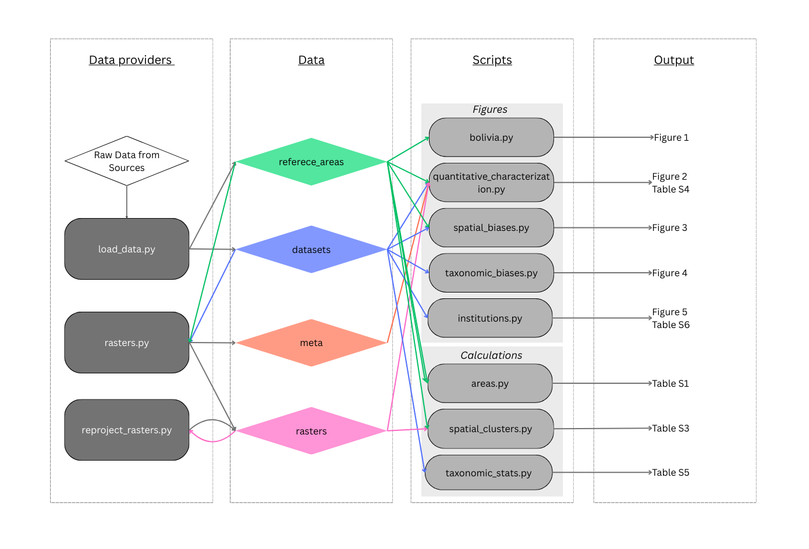

Detailed data
Table S1: Bolivian ecoregions and the proportions in percent of different area types within them. The bottom row shows the overall distribution of area types across Bolivia. Percentages exceed 100% because areas where IPL and PA overlap (IPL–PA) are counted in both categories. Accordingly, the total is equal to 100% plus twice the share of IPL–PA areas.
No. | Name | IPL | IPL-PA | PA | OA
1 | Southwestern Amazon | 23.64 | 7.32 | 23.36 | 60.32
1.1. | Amazonian Flooded Forests | 13.08 | 0.13 | 9.35 | 77.69
1.2. | Sub-Andean Amazonian Forests | 19.18 | 0.89 | 11 | 70.7
1.3. | Pre-Andean Amazonian Forests | 27.02 | 8.47 | 38.53 | 42.92
1.4. | Pando Amazonian Forests | 50.82 | 40.07 | 70.84 | 18.4
1.5. | Beni and Santa Cruz Amazonian Forests | 26.51 | 8.31 | 18.46 | 63.35
2 | Cerrado | 12.51 | 1.01 | 17.94 | 70.56
2.1. | La Paz Cerrado | 20.88 | 6.14 | 17.18 | 68.08
2.2. | Beni Cerrado | 7.97 | 0.14 | 33.23 | 58.94
2.3. | Chiquitano Cerrado | 8.42 | 4.84 | 43.96 | 52.46
2.4. | Chaco Cerrado | 3.55 | 0 | 16.04 | 80.41
3 | Flooded Savannas | 6.36 | 2.97 | 17.69 | 78.9
3.1. | Flooded Savannas of the Llanos de Moxos | 18.49 | 0.24 | 10.61 | 71.14
3.2. | Flooded Savannas of the Pantanal | 2.82 | 0 | 5.88 | 91.3
4 | Chiquitano Dry Forest | 15.89 | 0 | 0 | 84.11
5 | Gran Chaco | 4.8 | 3.77 | 29.51 | 69.46
6 | Yungas | 1.56 | 0 | 0.09 | 98.31
7 | Tucumano–Bolivian Forest | 25.96 | 0.67 | 7.07 | 67.64
8 | Montane Chaco | 28.94 | 0 | 1.03 | 70.02
9 | Inter-Andean Dry Forests | 56.85 | 7.03 | 8.22 | 41.96
10 | Prepuna | 22.21 | 0 | 0.02 | 77.77
11 | Northern Puna | 21.49 | 0.89 | 8.39 | 71
11.1. | Humid Puna | 10.36 | 3.62 | 39.26 | 54
11.2. | Semihumid Puna | 8.1 | 0.07 | 19.75 | 72.21
11.3. | High Andean Vegetation of the Eastern Cordillera with Nival and Subnival Zones | 5.63 | 0 | 16.57 | 77.8
12 | Southern Puna | 49.39 | 5.15 | 6.3 | 49.46
12.1. | Dry Puna | 7.22 | 2.66 | 9.88 | 85.56
12.2. | Desert Puna with Nival and Subnival Zones of the Western Cordillera | 3.86 | 3.86 | 40.39 | 59.56
 | Bolivia | 19.37 | 3.83 | 18.94 | 65.52

Table S2: Relation of the vector data by Dinerstein et al.⁶⁰ and the corresponding estimations by Ibisch et al.³¹. The derived numbers were separated in three categories of similar sizes. With low <200, middle 200-450, and high >450.
No. | Tree species richness estimation | Expected tree species richness assigned
1.1 | >800 | High
1.2 | >1000 | High
1.3 | >800 | High
1.4 | >800 | High
1.5 | 650-800 | High
2.1 | 150-300 | Middle
2.2 | 150-300 | Middle
2.3 | <400 | Middle
2.4 | <50 | Low
3.1 | 200-400 | Middle
3.2 | 150-200 | Low
4 | 200-400 | Middle
5 | 50-100 | Low
6 | > 500 | High
7 | <300 | Middle
8 | 100-200 | Low
9 | 100-200 | Low
10 | <20 | Low
11 | - | No Info
12 | - | No Info

Table S3: Number of grid cells with more total observations than the 99th percentile (i.e., distribution of the one percent of grid cells with most observations) across the different area types. The percentages add up to more than 100% because some grid cells intersect with more than one area type.
 | Total | IPL | IPL-PA | PA | OA
GBIF | 112 (100%) | 17 (15%) | 10 (9%) | 53 (47%) | 53 (47%)
BBON | 112 (100%) | 21 (19%) | 13 (12%) | 56 (50%) | 49 (44%)

Table S4: Average number of observations per 10³ sq. km in GBIF and BBON
 | IPL | IPL-PA | PA | OA
GBIF | 215 | 650 | 541 | 180
BBON | 207 | 609 | 390 | 141

Table S5: Average difference in species shares in the families, considering only families that are present in both datasets of each pair.
 | Red List | GBIF | BBON
Red List | — | 268% | 304%
GBIF | 268% | — | 19%
BBON | 304% | 19% | —

Table S6: Sources of the GBIF database, separated by Institution, Collection, and Record type. MGB is the Missouri Botanical Garden, US; AAU is the University of Aarhus Herbarium, Denmark; LPB is the Herbario Nacional de Bolivia – Universidad Mayor de San Andrés, La Paz, Bolivia; USZ Herbario – Universidad Gabriel René Moreno in Santa Cruz, Bolivia; RJB is the Real Jardín Botánico, Madrid, Spain; NYBG is the New York Botanical Garden Herbarium, US; F is the Field Museum of Natural History, Chicago, US; US is the United States National Herbarium, Smithsonian Institution, US; K is the Royal Botanic Gardens, Kew, United Kingdom; HSB is the Herbario de la Universidad Mayor de San Andrés, La Paz, Bolivia; CTES is the Instituto de Botánica del Nordeste, Corrientes, Argentina; and “other” comprises all combinations with less than 1000 entries. We could not identify what BOLV refers to. iNaturalist is a citizen science platform for biodiversity observations.
 | Institution | Collection | Record type | Number
1 | MGB | Tropicos | Preserved specimen | 57801
2 | AAU | PalmTransect | Human observation | 49667
3 | LPB | Tropicos | Preserved specimen | 34277
4 | USZ | Tropicos | Preserved specimen | 21042
5 | RJB | Tropicos | Preserved specimen | 11476
6 | NYBG | Tropicos | Preserved specimen | 9422
7 | NYBG | NYBG | Preserved specimen | 7040
8 | BOLV | Tropicos | Preserved specimen | 5561
9 | iNaturalist | Observations | Human observation | 5208
10 | RJB | RJB | Preserved specimen | 5080
11 | F | Botany | Preserved specimen | 4992
12 | US | US | Preserved specimen | 4859
13 | K | Herbarium | Preserved specimen | 4668
14 | HSB | Tropicos | Preserved specimen | 3335
15 | K | Tropicos | Preserved specimen | 1771
16 | CTES | Tropicos | Preserved specimen | 1504
17 | F | Tropicos | Preserved specimen | 1470
18 | other |  |  | 20424

