Fishing management as an agent for recovery of fish diversity. Lessons from Amazonian floodplain lakes

Supplementary Material S1
Life story strategy
In the life history strategy, the characteristics that can influence organisms in relation to the response to temporal and spatial variability of the environment are taken into account, such as maximum body length, length at the time of maturation, fecundity and parental care (Tedesco et al., 2017; Winemiller, 1989; Winemiller & Rose, 1992). Considering the listed functional attributes, the species were classified following Röpke et al. (2017): small equilibrium strategists -with maturation at under <12 cm standard length (SL); low fecundity of the spawning batch (<3,000); large oocytes (diameter greater than 1.5 mm); developed parental care and maximum size of the individual up to 30 cm (SL). Large equilibrium strategists - with maturation at over >17 cm (SL); with low fecundity of the spawning batch (<3,000); large oocytes (diameter greater than 1.5 mm), well-developed parental care and maximum size greater than 40 cm (SL). Small periodic strategists - with maturation up to 15 mm (SL), with moderate to high fecundity of the spawning batch; small oocytes (diameter of 0.5-1.3 mm); maximum size up to 30 cm (SL). Large periodic strategists - with maturation at >16 cm (SL), with high fecundity of the spawning batch; small oocytes (diameter 0.7-1.6 mm), no parental care and maximum size greater than 30 cm (SL). Intermediate strategists, between equilibrium and periodic - with low to moderate fecundity of the spawning batch (<9,000); relatively large oocytes (diameter 1.4-2.0 mm) and moderate development of parental care, with a period of care ending with the hatching of eggs or limits the choice of spawning habitats for hiding eggs.

Trophic strategy
The food classification of the species was carried out on the basis of information published in the literature and in the FishBase database (https://www.fishbase.se/search.php). In the context of this study, the species were classified as follows: herbivores - feed on superior vegetables such as leaves, seeds, filamentous algae and fruits of aquatic and terrestrial plants (Augustine et al., 1999; Arantes et al., 2018). Omnivorous - feed on items of animal and vegetable origin in similar proportions, with a mixed diet profile and few specialized structures. They often consume small invertebrates, plants and fruits (Augustine et al., 1999; Arantes et al., 2018; Rotta, 2003). Detritivores - consumers of detritus in the form of partially degraded organic matter of different types of plant and animal tissue, microorganisms and mineral fractions (Agostinho et al., 1999; Amadeu Santana et al., 2015; Arantes et al., 2018). Invertivores - ingest variable fractions of aquatic and terrestrial insects, benthic or water column microcrustaceans, spiders, shrimps and mollusks (Arantes et al., 2018). Planktivores - ingest phytoplankton, zooplankton and occasionally small amounts of plant material and debris, by oral-gill filtration (Agostinho et al., 1999; Arantes et al., 2018). Piscivorous - feed predominantly on fish, either whole or in pieces, including body structures of individuals such as scales, vertebrae and fins (Agostinho et al., 1999; Arantes et al., 2018). Carnivores - feed on items of animal origin such as larger invertebrates and fish, and are able to specialize in some particular types. These preferences may change with seasonal food availability (Augustine et al., 1999; Arantes et al., 2018).
Migration strategy
Species dispersal behavior is often associated with aspects of reproductive ecology and/or feeding. This behavior can be divided between sedentary species, which inhabit lakes and areas seasonally flooded by rivers, and migratory species, which are those that carry out seasonal synchronized movements between different habitats, ranging from small distances to hundreds of kilometers (Duponchelle et al., 2021). Sedentary fish are relative to resident species that eventually perform movements of short distances. They are species that exhibit territorial behavior, and are known to be strongly associated with substrates or complex structured habitats such as those with herbaceous plants (Arantes et al., 2018). Species that perform local migration comprise a diverse group of fish that migrate laterally between floodplain lakes or fluvial channels following seasonal fluctuations (Carolsfeld, 2003; Fernandes, 1997; Junk et al., 1989). Species that perform regional migration will migrate to floodplain habitats during the high-water period, but also perform longitudinal migrations (often hundreds of kilometers) along river channels to spawn (Barthem & Fabré, 2004; de Brito Ribeiro & Junior, 1990; Goulding, 1980). Long-distance migrants are species that migrate thousands of kilometers along river channels, although their juveniles often inhabit floodplain lakes (Arantes et al., 2018; Barthem et al., 2017; Borges Barthem et al., 1991).
Body shape
Fish body shapes play a crucial role in understanding how they move and adapt in different aquatic environments. Therefore, their characteristics may vary depending on the species. In the study, the classifications used by Baumgartner et al. (2012), de Azevedo Bemvenuti and Fischer (2010) and Froese; Pauly (2010) were adopted.
Fusiform: this is a torpedo-shaped body, with a tapered head and an elongated and narrow body (e.g., Curimata vittata Kner, 1858). Compressed and elongated: this body shape is characterized by being more laterally compressed and elongated (e.g., Rhaphiodon vulpinus Spix & Agassiz, 1829). Anguilliform: this is an elongated body with compressed head and body, absence of dorsal fin and more extensive and thin caudal region (e.g., Eigenmannia limbata Schreiner & Miranda Ribeiro, 1903). Rhomboid: this is characterized by having the tallest body, slightly compressed, wide in the lateral direction and truncated (e.g., Colossoma macropomum). Elliptical: disc-shaped or oval body, compressed laterally and high (e.g., Mylossoma aureum Spix & Agassiz, 1829). Moderately depressed: this has an elongated body, high at the base of the dorsal fin, inclined dorsal region and slightly concave from the tip of the muzzle to the origin of the dorsal fin, slightly flattened dorsum ventrally, and depressed in the head region (e.g., Pimelodina flavipinnis Steindachner, 1876). Depressed: these are dorso-ventrally flattened fish, they have a flattened body from top to bottom, an elongated skull and a depressed caudal pendulum. Depressed-bodied fish preferentially inhabit regions close to the sediment (e.g., Hypoptopoma gulare Cope, 1878). Cylindrical: these are fish that have an elongated and rounded body, with a circular (or almost circular) cross section, slightly depressed with a wide head and depressed in the posterior region (e.g., Hoplias malabaricus Bloch, 1794). Cylindrical and elongated: they are fish that have an elongated and rounded body and with compression in the posterior region (e.g., Lepidosiren paradoxa Fitzinger, 1837).
Mouth position
The position of the mouth in a species is closely related to its feeding strategy (de Azevedo Bemvenuti; Fischer, 2010). The classifications adopted were those proposed by Baumgartner et al. (2012), de Azevedo Bemvenuti; Fischer (2010) and Froese; Pauly (2010). Superior mouth: whose opening is facing the upper region of the head, above/behind the transverse plane that passes through the most anterior end of the head. These feed on what is above the individual. Terminal mouth: whose opening is located in the most anterior region of the head, in general they feed in the water column. Inferior mouth: located ventrally, i.e., in the lower region of the head, these usually feed on what is below them, at the bottom.
Classification of species
The species were classified according to five life history strategies: equilibrium strategists with small maturation (17 species) and with large maturation (8 species), periodic strategists with maturation at a small size (53 species) and with maturation at a large size (33 species), and intermediate strategists (28 species). The species were classified according to six feeding strategies: herbivores (14 species), omnivores (36 species), detritivores (23 species), invertivores (17 species), planktivores (8 species) and piscivores (41 species). The species were classified according to three migratory behaviors: sedentary (39 species), local migrants (93 species) and regional migrants (7 species). The species were classified according to eight body shapes: compressed and elongated (6 species), anguilliform (5 species), cylindrical (2 species), depressed (19 species), elliptical (26 species), fusiform (52 species), moderately depressed (23 species) and species with a rhomboid body (6 species). Finally, the species were classified according to three mouth positions: inferior (60 species), superior (21 species) and fish with a terminal mouth (58 species).
References
Agostinho, A. A., Júlio, H. F., & Lowe-McConnel, R. H. (1999). Estudos de comunidades de peixes tropicais.
Amadeu Santana, A. R., Werth, M., & Benedito-Cecilio, E. (2015). Use of food resources by detritivorous fish in floodplains: a synthesis. Acta Biológica Colombiana, 20(1), 5–14.
Arantes, C. C., Winemiller, K. O., Petrere, M., Castello, L., Hess, L. L., & Freitas, C. E. C. (2018). Relationships between forest cover and fish diversity in the Amazon River floodplain. Journal of Applied Ecology, 55(1), 386–395. https://doi.org/10.1111/1365-2664.12967
Barthem, R. B., & Fabré, N. N. (2004). Biologia e diversidade dos recursos pesqueiros da Amazônia. A Pesca e Os Recursos Pesqueiros Na Amazônia Brasileira, 1, 17–62.
Barthem, R. B., Goulding, M., Leite, R. G., Cañas, C., Forsberg, B., Venticinque, E., Petry, P., Ribeiro, M. L. D. B., Chuctaya, J., & Mercado, A. (2017). Goliath catfish spawning in the far western Amazon confirmed by the distribution of mature adults, drifting larvae and migrating juveniles. Scientific Reports, 7. https://doi.org/10.1038/srep41784
Baumgartner, G., Pavanelli, C. S., Baumgartner, D., Bifi, A. G., Debona, T., & Frana, V. A. (2012). Peixes do baixo rio Iguaçu. Eduem.
Borges Barthem, R., C6sar, M., De, L., Ribeiro, B., & Petrere, M. (1991). Life Strategies of some Long-Distance Migratory Catfish in Relation to Hydroelectric Dams in the Amazon Basin. In Biological Conservation (Vol. 55). https://doi.org/10.1016/0006-3207(91)90037-A
Carolsfeld, J. (2003). Migratory fishes of South America: biology, fisheries and conservation status. Idrc.
de Azevedo BEMVENUTI, M., & FISCHER, L. G. (2010). Peixes: morfologia e adaptações. Cadernos de Ecologia Aquática, 5(2), 31–54.
de Brito Ribeiro, M. C. L., & Junior, M. P. (1990). Fisheries ecololgy and management of the Jaraqui (Semaprochilodus Taeniurus, S. Insignis) in central Amazonia. Regulated Rivers: Research & Management, 5(3), 195–215. https://doi.org/10.1002/rrr.3450050302
Duponchelle, F., Isaac, V. J., Doria, C., Van Damme, P. A., Herrera-R, G. A., Anderson, E. P., Cruz, R. E. A., Hauser, M., Hermann, T. W., Agudelo, E., Bonilla-Castillo, C., Barthem, R., Freitas, C. E. C., García-Dávila, C., García-Vasquez, A., Renno, J. F., & Castello, L. (2021). Conservation of migratory fishes in the Amazon basin. Aquatic Conservation: Marine and Freshwater Ecosystems. https://doi.org/10.1002/aqc.3550
Fernandes, C. C. (1997). Lateral migration of fishes in Amazon floodplains. Ecology of Freshwater Fish, 6(1), 36–44. https://doi.org/10.1111/j.1600-0633.1997.tb00140.x
Froese, R., & Pauly, D. (2010). FishBase. Fisheries Centre, University of British Columbia Vancouver, BC, Canada.
Goulding, M. (1980). The fishes and the forest: explorations in Amazonian natural history. Univ of California Press.
Junk, W. J., Bayley, P. B., & Sparks, R. E. (1989). The flood pulse concept in river-floodplain systems. Canadian Special Publication of Fisheries and Aquatic Sciences, 106(1), 110–127.
ROTTA, M. A. (2003). Aspectos gerais da fisiologia e estrutura do sistema digestivo dos peixes relacionados à piscicultura.
Tedesco, P. A., Beauchard, O., Bigorne, R., Blanchet, S., Buisson, L., Conti, L., Cornu, J. F., Dias, M. S., Grenouillet, G., Hugueny, B., Jézéquel, C., Leprieur, F., Brosse, S., & Oberdorff, T. (2017). Data Descriptor: A global database on freshwater fish species occurrence in drainage basins. Scientific Data, 4. https://doi.org/10.1038/sdata.2017.141
Winemiller, K. O. (1989). Patterns of variation in life history among South American fishes in seasonal environments. Oecologia, 81(2), 225–241. https://doi.org/10.1007/BF00379810
Winemiller, K. O., & Rose, K. A. (1992). Patterns of Life-History Diversification in North American Fishes: implications for Population Regulation. Canadian Journal of Fisheries and Aquatic Sciences, 49(10), 2196–2218. https://doi.org/10.1139/f92-24
Supplementary Material S2
Table 1. Characteristics of fish species sampled in lakes with unrestricted and restricted access for fishing.
SPECIES | Acronym | Trophic strategy | Life history | Migration strategy | Body shape | Mouth position
Osteoglossiformes
Osteoglossidae
Osteoglossum bicirrhosum | OB | Invertivore^{1, 2} | Large equilibrium^{1,2} | Local¹ | Compressed and elongated³ | Superior³
Clupeiformes
Pristigasteridae
Ilisha amazonica | IA | Invertivore² | Small periodic^{1,2} | Local¹ | Fusiform³ | Terminal³
Pellona castelnaeana | PC | Piscivore^{1,2} | Large periodic^{1,2} | Local¹ | Fusiform³ | Superior³
Pellona flavipinnis | PF | Piscivore^{1, 2} | Small periodic^{1,2} | Local¹ | Fusiform³ | Superior³
Pristigaster cayana | PCA | Invertivore¹ | Small periodic¹ | Local¹ | Fusiform³ | Superior³
Engraulidae
Jurengraulis juruensis | JJ | Planktivore^{1, 2} | Small periodic^{1, 2} | Local¹ | Fusiform³ | Inferior³
Lycengraulis batesii | LB | Invertivore^{1, 2} | Small periodic^{1, 2} | Local¹ | Fusiform³ | Inferior³
Characiformes
Hemiodontidae
Anodus elongatus | AE | Planktivore^{1, 2} | Small periodic^{1, 2} | Local¹ | Fusiform³ | Inferior³
Hemiodus argenteus | HA | Omnivore¹ | Small periodic¹ | Local¹ | Fusiform³ | Terminal³
Hemiodus atranalis | HAT | Omnivore⁵ | Small periodic^{1,2} | Local¹ | Fusiform³ | Terminal³
Hemiodus immaculatus | HI | Omnivore^{1,2} | Small periodic^{1,2} | Local¹ | Fusiform³ | Terminal³
Hemiodus unimaculatus | HU | Omnivore¹ | Small periodic¹ | Local¹ | Fusiform³ | Terminal³
Curimatidae
Curimata inornata | CI | Detritivore¹ | Small periodic¹ | Local¹ | Fusiform³ | Inferior³
Curimata knerii | CK | Detritivore¹ | Small periodic¹ | Local¹ | Fusiform³ | Inferior³
Curimata ocellata | CO | Detritivore² | Small periodic² | Local⁴ | Fusiform³ | Inferior³
Curimata vittata | CV | Detritivore^{1,2} | Small periodic^{1,2} | Local¹ | Fusiform³ | Inferior³
Curimatella alburna | CA | Detritivore¹ | Small periodic¹ | Local¹ | Fusiform³ | Inferior³
Curimatella meyeri | CM | Detritivore^{1,2} | Small periodic^{1,2} | Local¹ | Fusiform³ | Inferior³
Cyphocharax spiluropsis | CSP | Detritivore¹ | Small periodic¹ | Local¹ | Fusiform³ | Inferior³
Potamorhina altamazonica | PA | Detritivore^{1,2} | Small periodic^{1,2} | Local¹ | Fusiform³ | Inferior³
Potamorhina latior | PL | Detritivore^{1,2} | Small periodic^{1,2} | Local¹ | Fusiform³ | Inferior³
Psectrogaster amazonica | PAM | Detritivore^{1,2} | Small periodic^{1,2} | Local¹ | Rhomboid³ | Inferior³
Psectrogaster rutiloides | PRU | Detritivore^{1,2} | Small periodic^{1,2} | Local¹ | Fusiform³ | Inferior³
Steindachnerina bimaculata | SB | Detritivore¹ | Small periodic¹ | Local¹ | Fusiform¹ | Inferior³
Prochilodontidae
Prochilodus nigricans | PN | Detritivore^{1,2} | Large periodic^{1,2} | Regional¹ | Fusiform³ | Inferior³
Semaprochilodus insignis | SI | Detritivore^{1,2} | Large periodic^{1,2} | Regional¹ | Fusiform³ | Inferior³
Semaprochilodus taeniurus | ST | Detritivore^{1,2} | Large periodic^{1,2} | Regional¹ | Fusiform³ | Inferior³
Anostomidae
Leporinus amazonicus | LA | Omnivore¹ | Small periodic¹ | Local¹ | Fusiform³ | Terminal³
Laemolyta proxima | LP | Herbivore⁶ | Small periodic¹ | Local¹ | Fusiform³ | Terminal³
Leporinus fasciatus | LF | Omnivore¹ | Large periodic¹ | Local¹ | Fusiform³ | Terminal³
Leporinus friderici | LFR | Omnivore¹ | Large periodic¹ | Local¹ | Fusiform³ | Terminal³
Megaleporinus trifasciatus | MT | Piscivore¹ | Large periodic¹ | Local¹ | Fusiform³ | Terminal³
Rhytiodus argenteofuscus | RA | Herbivore¹ | Small periodic¹ | Local¹ | Fusiform³ | Terminal³
Rhytiodus microlepis | RM | Herbivore¹ | Small periodic¹ | Local¹ | Fusiform³ | Terminal³
Schizodon fasciatus | SF | Herbivore¹ | Small periodic¹ | Local¹ | Fusiform³ | Terminal³
Erythrinidae
Hoplerythrinus unitaeniatus | HUN | Piscivore⁷ | Intermediate¹ | Sedentary⁸ | Cylindrical³ | Terminal³
Hoplias malabaricus | HM | Piscivore¹ | Intermediate¹ | Sedentary¹ | Cylindrical³ | Terminal³
Acestrorhynchidae
Acestrorhynchus abbreviatus | AA | Piscivore¹ | Small periodic¹ | Local¹ | Fusiform³ | Terminal³
Acestrorhynchus falcirostris | AFA | Piscivore^{1,2} | Small periodic^{1,2} | Local¹ | Fusiform³ | Terminal³
Acestrorhynchus microlepis | AM | Piscivore² | Small periodic² | Local¹ | Fusiform³ | Terminal³
Cynodontidae
Cynodon gibbus | CG | Piscivore¹ | Large periodic¹ | Local¹ | Compressed and elongated³ | Superior³
Hydrolycus scomberoides | HS | Piscivore¹ | Large periodic¹ | Local¹ | Compressed and elongated³ | Superior³
Rhaphiodon vulpinus | RV | Piscivore¹ | Large periodic¹ | Local¹ | Compressed and elongated³ | Superior³
Bryconidae
Brycon amazonicus | BA | Omnivore⁹ | Large periodic¹ | Regional¹ | Fusiform³ | Terminal³
Brycon melanopterus | BM | Omnivore⁹ | Large periodic¹ | Regional¹ | Fusiform³ | Terminal³
Iguanodectidae
Bryconops melanurus | BME | Omnivore¹⁰ | Small periodic¹⁰ | Local¹ | Fusiform³ | Terminal³
Serrasalmidae
Colossoma macropomum | CMA | Herbivore¹ | Large periodic¹ | Regional¹ | Rhomboid³ | Superior³
Metynnis argenteus | MA | Herbivore¹ | Intermediate¹ | Local¹ | Elliptical³ | Terminal³
Metynnis hypsauchen | MH | Herbivore¹ | Intermediate¹ | Local¹ | Elliptical³ | Terminal³
Myloplus asterias | MAS | Herbivore¹ | Large periodic¹ | Local¹ | Elliptical³ | Terminal³
Myloplus rubripinnis | MR | Herbivore¹ | Large periodic¹ | Local¹ | Elliptical³ | Terminal³
Mylossoma albiscopum | MAL | Herbivore¹ | Small periodic¹ | Local¹ | Elliptical³ | Terminal³
Mylossoma aureum | MAU | Herbivore¹ | Small periodic¹ | Local¹ | Elliptical³ | Terminal³
Piaractus brachypomus | PB | Herbivore¹ | Large periodic¹ | Regional¹ | Rhomboid³ | Superior³
Pygocentrus nattereri | PNA | Piscivore¹ | Intermediate¹ | Local¹ | Rhomboid³ | Superior³
Serrasalmus altispinis | SA | Piscivore¹ | Intermediate¹ | Local¹ | Elliptical³ | Superior³
Serrasalmus compressus | SC | Piscivore¹ | Intermediate¹ | Local¹ | Elliptical³ | Superior³
Serrasalmus elongatus | SE | Piscivore¹ | Intermediate¹ | Local¹ | Fusiform³ | Superior³
Serrasalmus hollandi | SH | Piscivore¹ | Intermediate¹ | Local¹ | Elliptical³ | Superior³
Serrasalmus maculatus | SM | Piscivore¹ | Intermediate¹ | Local¹ | Rhomboid³ | Superior³
Serrasalmus rhombeus | SR | Piscivore¹ | Intermediate¹ | Local¹ | Rhomboid³ | Superior³
Chalceidae
Chalceus erythrurus | CE | Omnivore¹¹ | Small periodic¹¹ | Local¹¹ | Fusiform³ | Terminal³
Chalceus macrolepidotus | CML | Omnivore¹¹ | Small periodic¹¹ | Local¹¹ | Fusiform³ | Terminal³
Characidae
Roeboides myersii | RMY | Piscivore¹ | Small periodic¹ | Local¹ | Fusiform³ | Superior³
Tetragonopterus argenteus | TA | Omnivore¹ | Small periodic¹ | Local¹ | Elliptical³ | Terminal³
Triportheidae
Agoniates anchovia | AAN | Piscivore^{1,2} | Small periodic^{1,2} | Local¹ | Compressed and elongated³ | Superior³
Triportheus albus | TAL | Omnivore^{1,2} | Small periodic^{1,2} | Local¹ | Fusiform³ | Superior³
Triportheus angulatus | TAN | Omnivore^{1,2} | Small periodic^{1,2} | Local¹ | Fusiform³ | Superior³
Triportheus auritus | TAU¹ | Omnivore¹ | Small periodic¹ | Local¹ | Fusiform ³ | Superior³
Siluriformes
Doradidae
Amblydoras affinis | AAF | Omnivore¹ | Small periodic¹ | Sedentary¹ | Depressed³ | Inferior³
Anadoras grypus | AGR | Omnivore¹ | Small periodic¹ | Sedentary¹ | Depressed³ | Inferior³
Nemadoras elongatus | NE | Omnivore² | Small periodic² | Local³ | Depressed³ | Inferior³
Nemadoras hemipeltis | NH | Omnivore² | Small periodic² | Local³ | Depressed³ | Inferior³
Nemadoras humeralis | NHU | Omnivore² | Small periodic² | Local² | Depressed³ | Inferior³
Opsodoras boulengeri | OB | Invertivore¹ | Small periodic¹ | Local¹ | Depressed³ | Inferior³
Ossancora asterophysa | OA | Invertivore¹ | Intermediate¹ | Sedentary¹ | Moderately depressed³ | Inferior₃
Ossancora punctata | OP | Invertivore¹ | Intermediate¹ | Sedentary¹ | Moderately depressed³ | Inferior³
Oxydoras niger | ON | Omnivore¹ | Large periodic¹ | Local¹ | Depressed³ | Inferior³
Pterodoras granulosus | PG | Herbivore¹ | Large periodic¹ | Local¹ | Depressed³ | Inferior³
Auchenipteridae
Auchenipterichthys coracoideus | AC | Omnivore² | Intermediate² | Sedentary¹ | Depressed³ | Inferior³
Ageneiosus dentatus | AD | Piscivore¹ | Intermediate¹ | Sedentary¹ | Moderately depressed³ | Inferior³
Ageneiosus inermis | AI | Piscivore¹ | Large periodic¹ | Local¹ | Moderately depressed³ | Inferior³
Ageneiosus ucayalensis | AU | Piscivore¹ | Intermediate¹ | Local¹ | Moderately depressed³ | Inferior³
Auchenipterus britskii | AB | Invertivore¹ | Intermediate¹ | Sedentary⁴ | Moderately depressed³ | Inferior³
Auchenipterus nuchalis | AN | Invertivore¹ | Intermediate¹ | Sedentary¹ | Moderately depressed³ | Inferior³
Centromochlus heckelii | CH | Omnivore¹ | Intermediate¹ | Local¹ | Moderately depressed³ | Inferior³
Trachelyopterus galeatus | TG | Omnivore¹ | Intermediate¹ | Sedentary¹ | Moderately depressed³ | Inferior³
Trachelyopterus porosus | TP | Invertivore² | Intermediate² | Sedentary¹ | Moderately depressed³ | Inferior³
Tympanopleura brevis | TB | Piscivore¹ | Intermediate¹ | Local¹ | Moderately depressed³ | Inferior³
Tympanopleura rondoni | TR | Piscivore¹ | Intermediate¹ | Local¹ | Moderately depressed³ | Inferior³
Pimelodidae
Calophysus macropterus | CMR | Piscivore¹ | Large periodic¹ | Local¹ | Moderately depressed³ | Inferior³
Hemisorubim platyrhynchos | HP | Piscivore¹ | Large periodic¹ | Local¹ | Moderately depressed³ | Inferior³
Hypophthalmus edentatus | HE | Planktivore¹ | Large periodic¹ | Local¹ | Fusiform³ | Terminal³
Hypophthalmus fimbriatus | HF | Planktivore¹ | Large periodic¹ | Local¹ | Fusiform³ | Terminal³
Hypophthalmus oremaculatus | HO | Planktivore¹ | Large periodic¹ | Local¹ | Fusiform³ | Terminal³
Phractocephalus hemioliopterus | PHE | Piscivore¹ | Large periodic¹ | Local¹ | Depressed³ | Inferior³
Pimelodina flavipinnis | PFL | Piscivore¹ | Large periodic¹ | Local¹ | Moderately depressed³ | Inferior³
Pimelodus blochii | PBL | Omnivore¹ | Small periodic¹ | Local¹ | Moderately depressed³ | Inferior³
Pimelodus maculatus | PM | Omnivore¹ | Small periodic¹ | Local¹ | Moderately depressed³ | Inferior³
Pinirampus pirinampu | PP | Piscivore¹ | Large periodic¹ | Local¹ | Moderately depressed³ | Inferior³
Pseudoplatystoma punctifer | PPU | Piscivore¹ | Large periodic¹ | Local¹ | Moderately depressed³ | Inferior³
Pseudoplatystoma tigrinum | PT | Piscivore¹ | Large periodic¹ | Local¹ | Moderately depressed³ | Inferior³
Sorubim lima | SL | Piscivore¹ | Large periodic¹ | Local¹ | Moderately depressed³ | Inferior³
Sorubim maniradii | SMA | Piscivore¹ | Large periodic¹ | Local¹ | Moderately depressed³ | Inferior³
Callichthyidae
Hoplosternum littorale | HL | Invertivore¹² | Intermediate¹ | Sedentary¹² | Moderately depressed³ | Inferior³
Megalechis picta | MP | Invertivore¹² | Intermediate¹ | Sedentary¹² | Moderately depressed³ | Inferior³
Loricariidae
Ancistrus dolichopterus | ADO | Detritivore² | Small equilibrium² | Sedentary⁴ | Depressed³ | Inferior³
Dekeyseria amazonica | DA | Detritivore¹ | Small equilibrium¹ | Sedentary¹ | Depressed³ | Inferior³
Hypoptopoma gulare | HG | Detritivore¹ | Intermediate¹ | Sedentary¹ | Depressed³ | Inferior³
Hypoptopoma incognitum | HIN | Detritivore³ | Intermediate¹ | Sedentary⁴ | Depressed³ | Inferior³
Loricaria cataphracta | LC | Detritivore¹ | Small equilibrium¹ | Sedentary¹ | Depressed³ | Inferior³
Loricariichthys maculatus | LM | Detritivore¹ | Small equilibrium¹ | Sedentary¹ | Depressed³ | Inferior³
Loricariichthys nudirostris | LN | Detritivore¹ | Small equilibrium¹ | Sedentary¹ | Depressed³ | Inferior³
Pterygoplichthys pardalis | PPA | Detritivore¹ | Large equilibrium¹ | Sedentary¹ | Depressed³ | Inferior³
Gymnotiformes
Apteronotidae
Parapteronotus hasemani | PHA | Invertivore¹ | Small periodic¹ | Local¹ | Anguilliform³ | Terminal³
Sternarchella schotti | SS | Invertivore¹ | Small periodic¹ | Local¹ | Anguilliform³ | Terminal3
Rhamphichthyidae
Rhamphichthys rostratus | RR | Invertivore^{13,14} | Small periodic³ | Local³ | Anguilliform³ | Terminal³
Sternopygidae
Eigenmannia limbata | EL | Invertivore¹ | Small periodic¹ | Local¹ | Anguilliform³ | Terminal³
Sternopygus macrurus | SMC | Invertivore¹⁵ | Large equilibrium³ | Local³ | Anguilliform³ | Terminal³
Perciformes
Sciaenidae
Plagioscion montei | PMO | Piscivore² | Large periodic² | Local¹ | Fusiform³ | Terminal³
Plagioscion squamosissimus | PS | Piscivore¹ | Large periodic¹ | Local¹ | Fusiform³ | Terminal³
Cichlidae
Acaronia nassa | ANA | Piscivore¹ | Small equilibrium¹ | Sedentary¹ | Elliptical³ | Terminal³
Acarichthys heckelii | AH | Omnivore¹ | Small equilibrium¹ | Local¹ | Elliptical³ | Terminal³
Astronotus crassipinnis | ACR | Piscivore³ | Large equilibrium³ | Sedentary³ | Elliptical³ | Terminal³
Astronotus ocellatus | AO | Piscivore¹ | Large equilibrium¹ | Sedentary¹ | Elliptical³ | Terminal³
Chaetobranchopsis orbicularis | COR | Planktivore¹ | Small equilibrium¹ | Sedentary¹ | Elliptical³ | Terminal³
Chaetobranchus flavescens | CF | Planktivore¹ | Small equilibrium¹ | Sedentary¹ | Elliptical³ | Terminal³
Chaetobranchus semifasciatus | CS | Planktivore³ | Small equilibrium³ | Sedentary³ | Elliptical³ | Terminal³
Cichla monoculus | CMO | Piscivore¹ | Large equilibrium¹ | Sedentary¹ | Fusiform³ | Terminal³
Cichlasoma amazonarum | CAM | Omnivore¹ | Small equilibrium¹ | Sedentary¹ | Elliptical³ | Terminal³
Crenicichla reticulata | CR | Piscivore¹ | Large equilibrium¹ | Sedentary¹ | Elliptical³ | Terminal³
Geophagus proximus | GP | Omnivore¹ | Small equilibrium¹ | Sedentary¹ | Elliptical³ | Terminal³
Heros notatus | HN | Omnivore¹ | Small equilibrium¹ | Sedentary¹ | Elliptical³ | Terminal³
Heros severus | HSE | Herbivore³ | Intermediate³ | Sedentary³ | Elliptical³ | Terminal³
Mesonauta festivus | MF | Omnivore¹ | Small equilibrium¹ | Sedentary¹ | Elliptical³ | Terminal³
Pterophyllum scalare | PSC | Omnivore¹ | Small equilibrium¹ | Sedentary¹ | Elliptical³ | Terminal³
Satanoperca acuticeps | SAC | Omnivore¹² | Small equilibrium¹² | Sedentary¹² | Elliptical³ | Terminal³
Satanoperca jurupari | SJ | Omnivore¹² | Small equilibrium¹² | Sedentary¹² | Elliptical³ | Terminal³
Ceratodontiformes
Lepidosiren paradoxa | LPA | Omnivore¹⁶ | Large equilibrium³ | Sedentary¹⁶ | Cylindrical and elongated³ | Terminal³

- Arantes, C. C., Winemiller, K. O., Petrere, M., Castello, L., Hess, L. L., & Freitas, C. E. C. (2018). Relationships between forest cover and fish diversity in the Amazon River floodplain. Journal of Applied Ecology, 55(1), 386–395. https://doi.org/10.1111/1365-2664.12967
- Röpke, C. P., Amadio, S., Zuanon, J., Ferreira, E. J. G., De Deus, C. P., Pires, T. H. S., & Winemiller, K. O. (2017). Simultaneous abrupt shifts in hydrology and fish assemblage structure in a floodplain lake in the central Amazon. Scientific Reports, 7. https://doi.org/10.1038/srep40170
- Froese, R., & Pauly, D. (2010). FishBase. Fi9sheries Centre, University of British Columbia Vancouver, BC, Canada.
- Freitas, C. E. C., Laurenson, L., Yamamoto, K. C., Forsberg, B. R., Jr, M. P., Arantes, C., & Siqueira-Souza, F. K. (2018). Fish species richness is associated with the availability of landscape components across seasons in the Amazonian floodplain. PeerJ, 2018(6). https://doi.org/10.7717/peerj.5080
- Silva, C. C. da, Ferreira, E. J. G., & Deus, C. P. de. (2008). Dieta de cinco espécies de Hemiodontidae (Teleostei, Characiformes) na área de influência do reservatório de Balbina, rio Uatumã, Amazonas, Brasil. Iheringia. Série Zoologia, 98, 465–468. https://doi.org/10.1590/S0073-47212008000400008
- Marinelli, C. E., Ferreira, K. M., Vieira, D. L. M., Jurinitz, C. F., Guerra, B. R., & Aguiar, A. J. C. (2001). Atributos ecomorfológicos para determinação de guildas tróficas da ictiofauna de igapó no arquipélago das Anavilhanas, Amazônia Central. Curso de Campo Ecologia Da Floresta Amazônica–2001. Livro Do Curso De, 59–62.
- Leal, M. E., Klein, G. F., Schulz, U. H., & Albornoz, P. L. (2010). Primeiro registro e aspectos ecológicos de Hoplerythrinus unitaeniatus (Agassiz, 1829)(Characiformes, Erythrinidae) como espécie introduzida na Bacia do Rio dos Sinos, RS, Brasil. Biota Neotropica, 10, 33–37. https://doi.org/10.1590/S1676-06032010000300002
- Sato, Y. (2003). Padrões reprodutivos de peixes da bacia do São Francisco. Águas, Peixes e Pescadores Do São Francisco Das Minas Gerais, 229–274.
- Arias, J. A. (2006). Estado actual del conocimiento sobre el yamú, Brycon amazonicus. Revista Colombiana de Ciencias Pecuarias, 19(2), 125–133.
- Silva, C. C. da, Ferreira, E. J. G., & Deus, C. P. de. (2008). Diet of Bryconops alburnoides and B. caudomaculatus (Osteichthyes: Characiformes) in the region affected by Balbina Hydroelectric Dam (Amazon drainage, Brazil). Neotropical Ichthyology, 6, 237–242. https://doi.org/10.1590/S1679-62252008000200011
- Hercos, A. P., Queiroz, H. L. de, & Almeida, H. L. de. (2009). Peixes ornamentais do Amanã. Instituto de Desenvolvimento Sustentável Mamirauá.
- Santos, G. M. dos., Ferreira, E. J. G., & Zuanon, J. A. S. (2009). Peixes comerciais de Manaus. Editora INPA.
- LUIZ, E. A., AGOSTINHO, A. A., Gomes, L. C., & Hahn, N. S. (2018). Ecologia trófica de peixes em dois riachos da bacia do rio Paraná.
- Olaya-Nieto, C., Soto-Fernández, P., & Barrera-Chica, J. (2009). Feeding habits of Mayupa (Sternopygus macrurus Bloch & Schneider, 1801) in the Sinu River, Colombia. Revista MVZ Córdoba, 14(3), 1787–1795.
- Montenegro, L. A., Damasceno, D. N. F., Almeida, R. G., & Chellappa, S. (2011). Biologia alimentar do mussum, Synbranchus marmoratus (Bloch, 1795)(Osteichthyes: Synbranchidae) no açude Marechal Dutra localizado no semi-árido brasileiro. Biota Amazônia, 1(2), 52–60. http://dx.doi.org/10.18561/2179-5746/biotaamazonia.v1n2p45-52
- Bemis, W. E., & Lauder, G. V. (1986). Morphology and function of the feeding apparatus of the lungfish, Lepidosiren paradoxa (Dipnoi). Journal of Morphology, 187(1), 81–108. https://doi.org/10.1002/jmor.1051870108
Supplementary Material S3
Taxonomic richness (S)
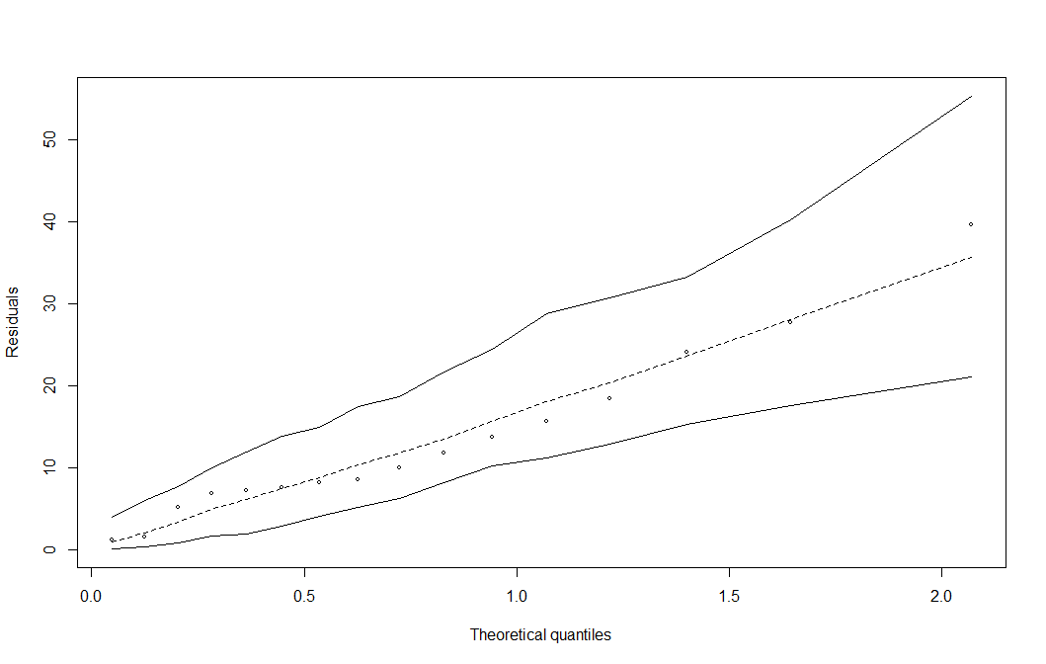
Figure 1. Quantile-quantile plot with simulated envelopes at 99% of the final model adjusted to taxonomic richness data.
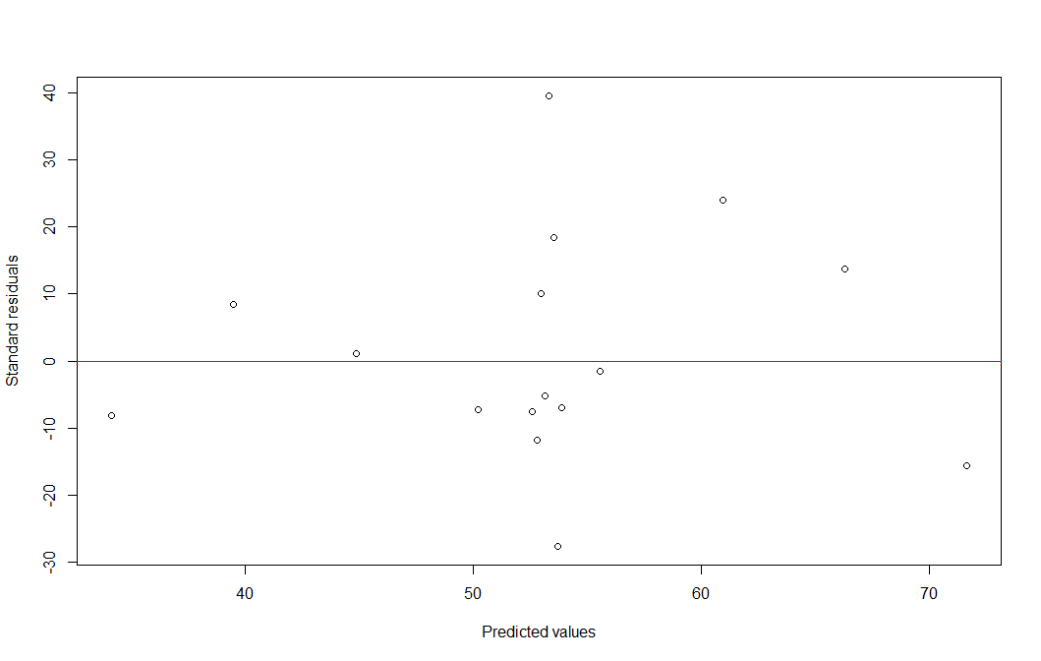
Figure 2. Scatter plot of normalized residuals in relation to the predicted values for the final model adjusted to taxonomic richness data.

Shannon diversity (H’)
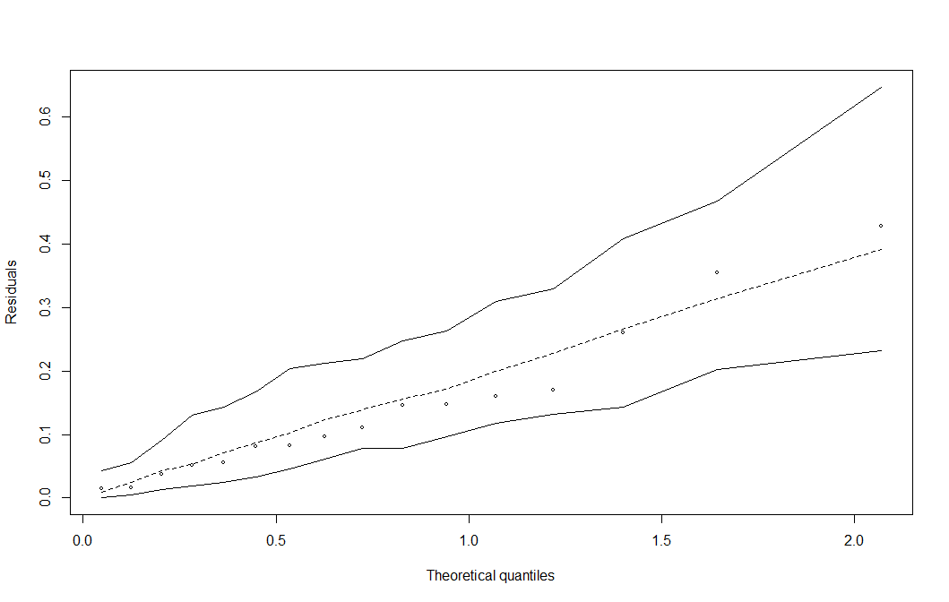
Figure 3. Quantile-quantile plot with envelopes simulated to 99% of the final model fitted to Shannon diversity data.
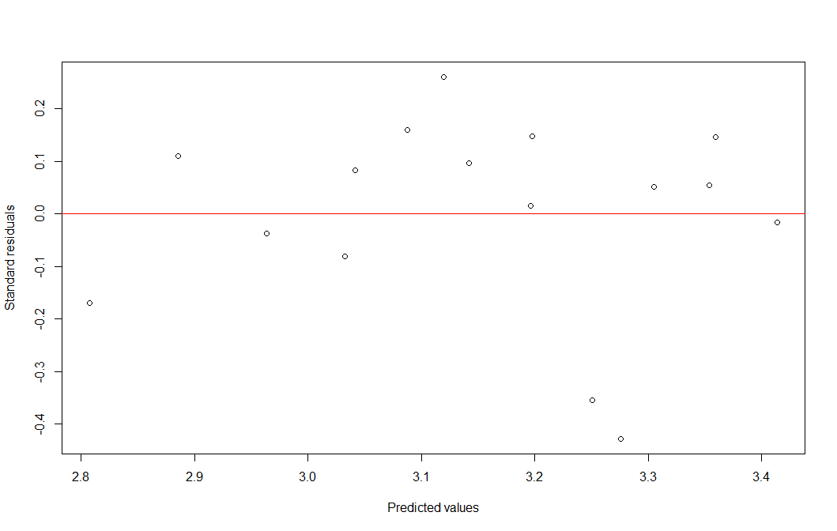
Figure 4. Scatter plot of normalized residuals against predicted values for the final model adjusted to Shannon diversity data.

Pielou equitability (J’)
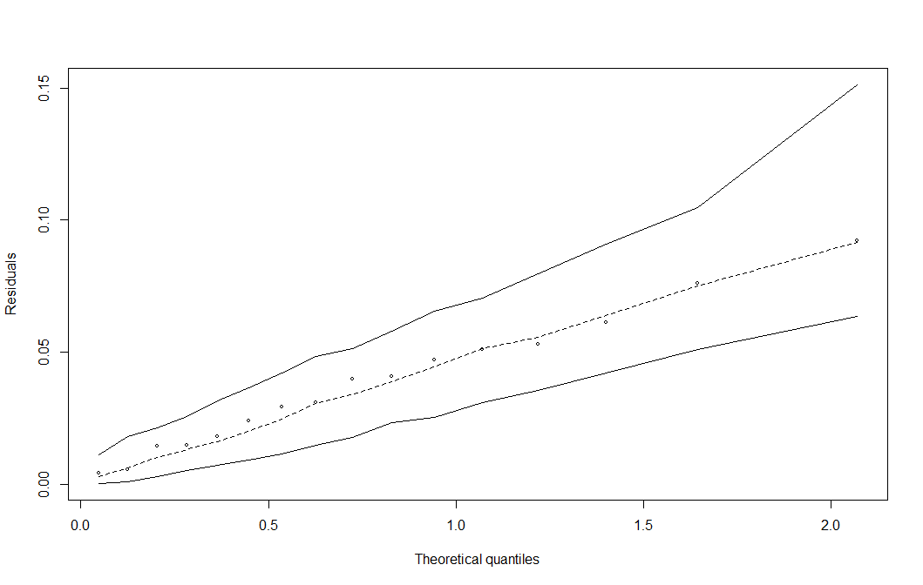
Figure 5. Quantile-quantile graph with envelopes simulated to 99% of the final model adjusted to Pielou equitability data.
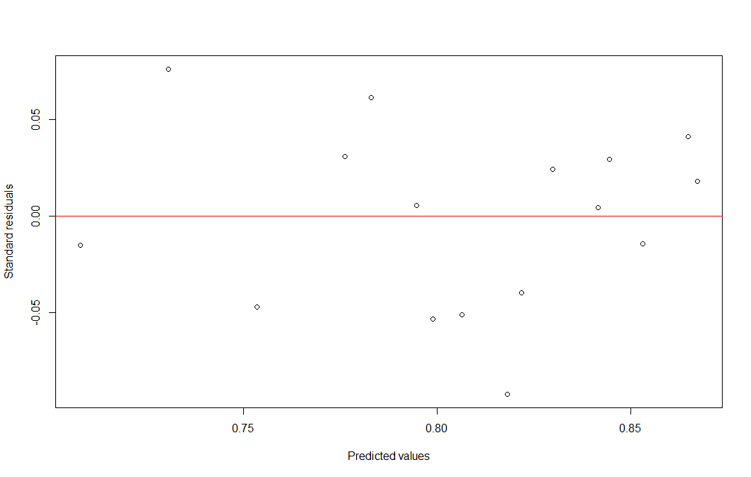
Figure 6. Scatter plot of the normalized residuals in relation to the predicted values for the final model adjusted to the Pielou equitability data.

Functional richness (FRIc)
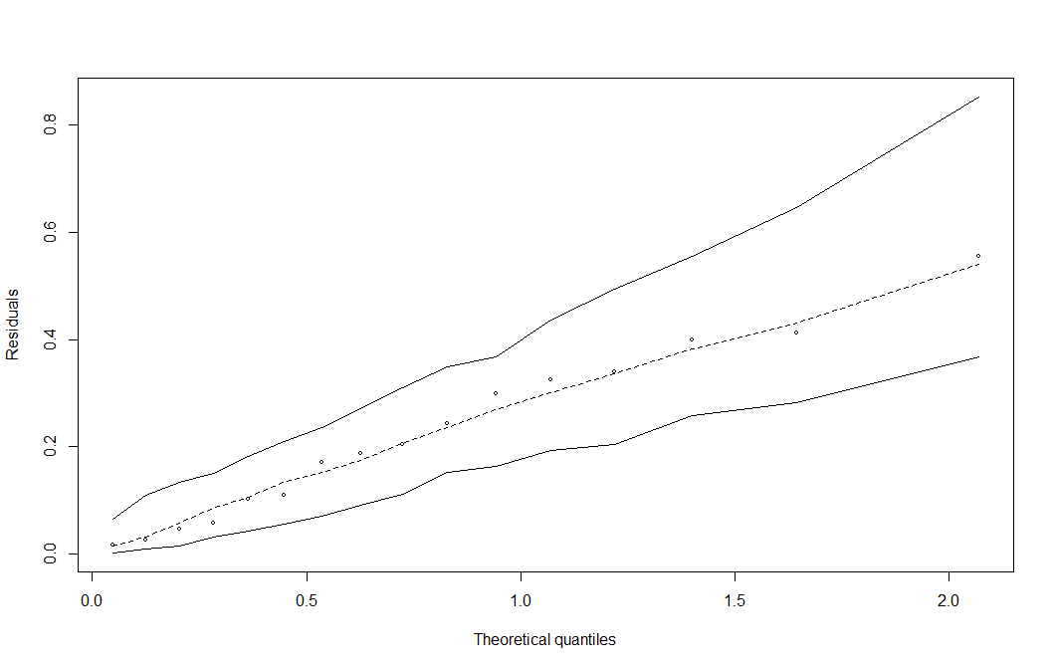

Figure 7. Quantile-quantile graph with envelopes simulated to 99% of the final model adjusted to functional richness data.
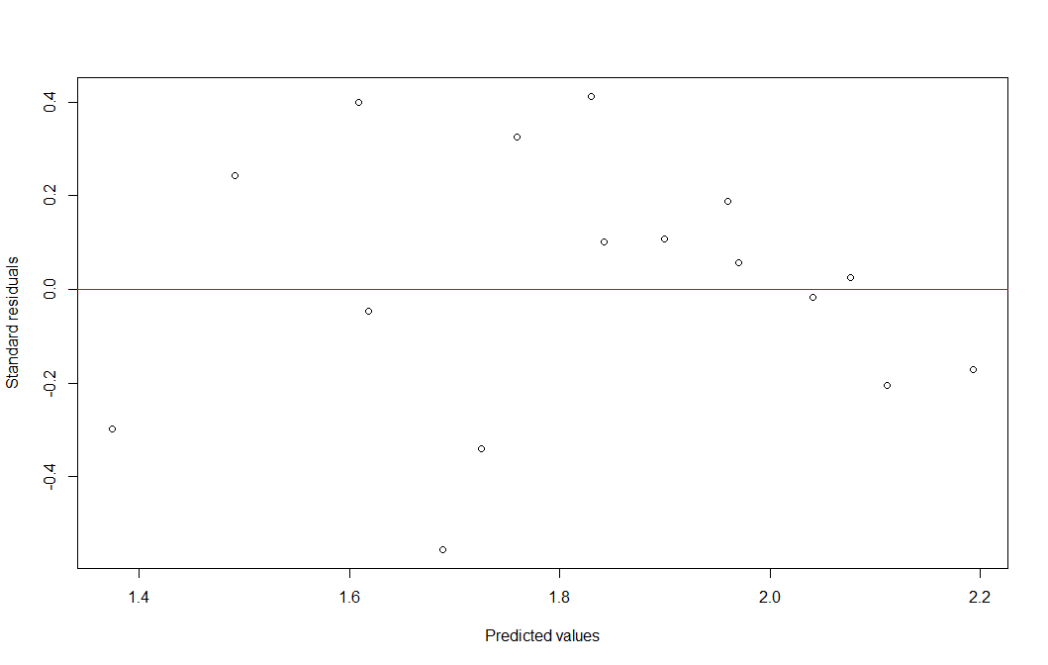
Figure 8. Scatter plot of the normalized residuals in relation to the predicted values for the final model adjusted to the functional richness data.

Functional divergence (FDiv)
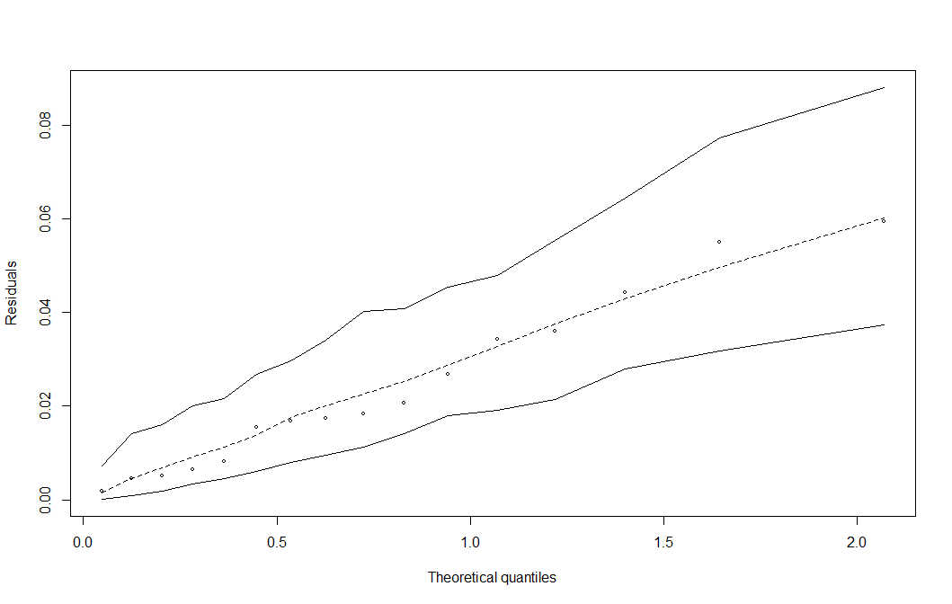
Figure 9. Quantile-quantile plot with envelopes simulated to 99% of the final model adjusted to functional divergence data.

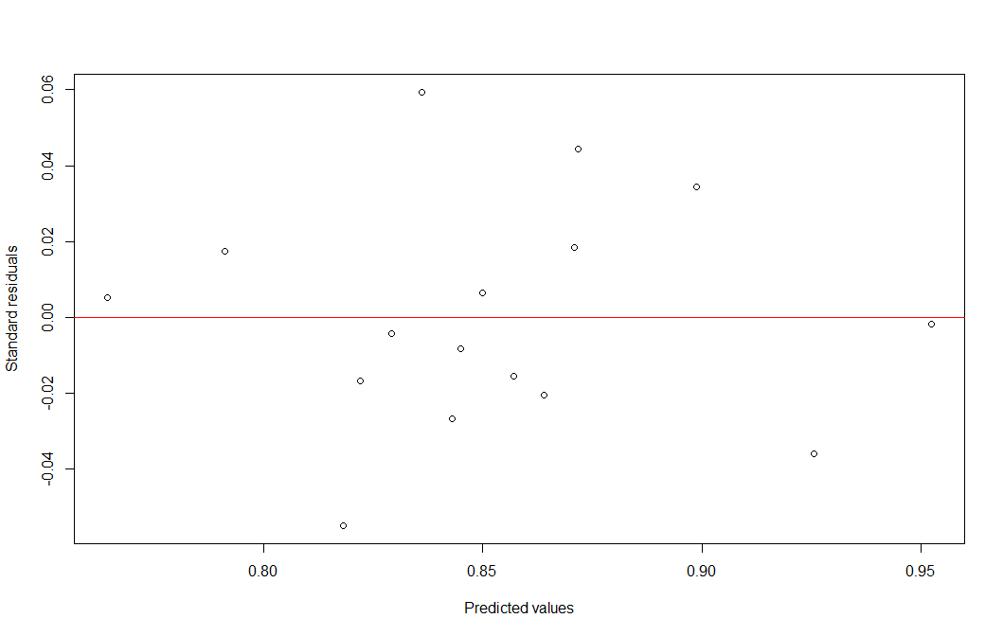
Figure 10. Scatter plot of normalized residuals against predicted values for the final model adjusted for functional divergence data.

Functional dispersion (FDis)
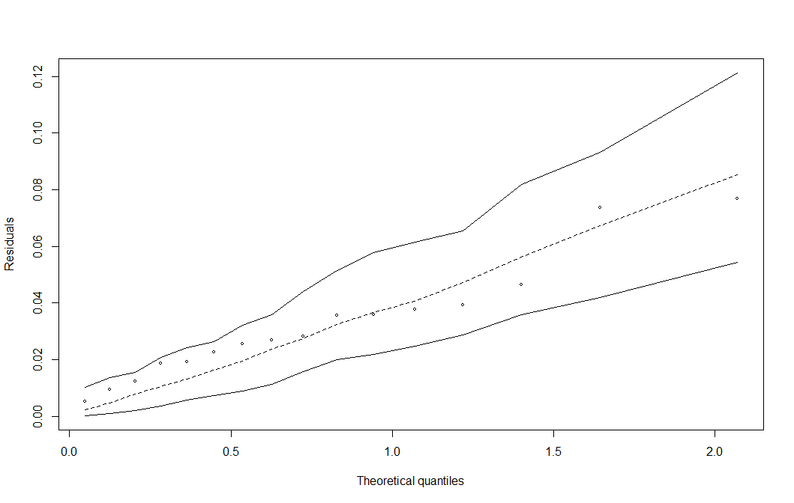
Figure 11. Quantile-quantile plot with envelopes simulated to 99% of the final model adjusted to functional dispersion data.

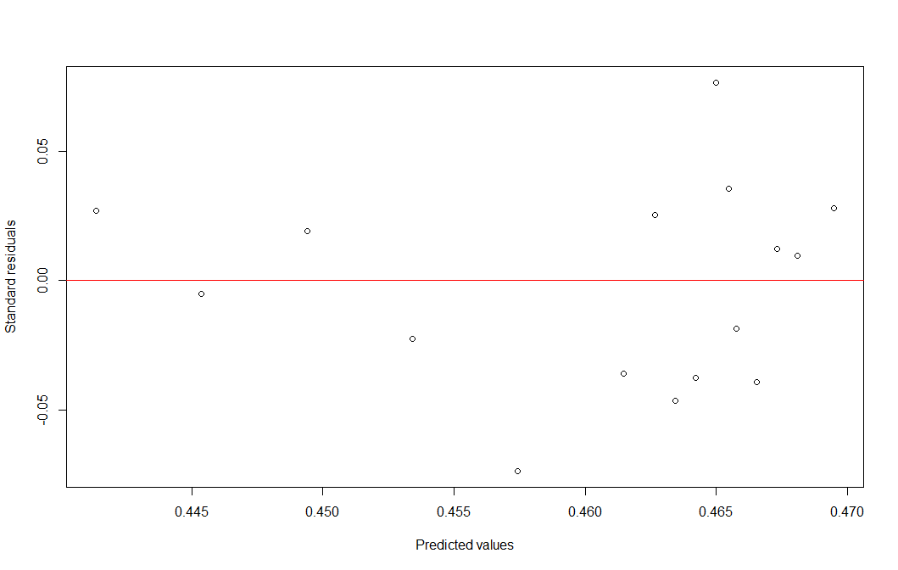
Figure 12. Scatter plot of the normalized residuals in relation to the predicted values for the final model adjusted to the functional dispersion data.

Functional equity (FEve)
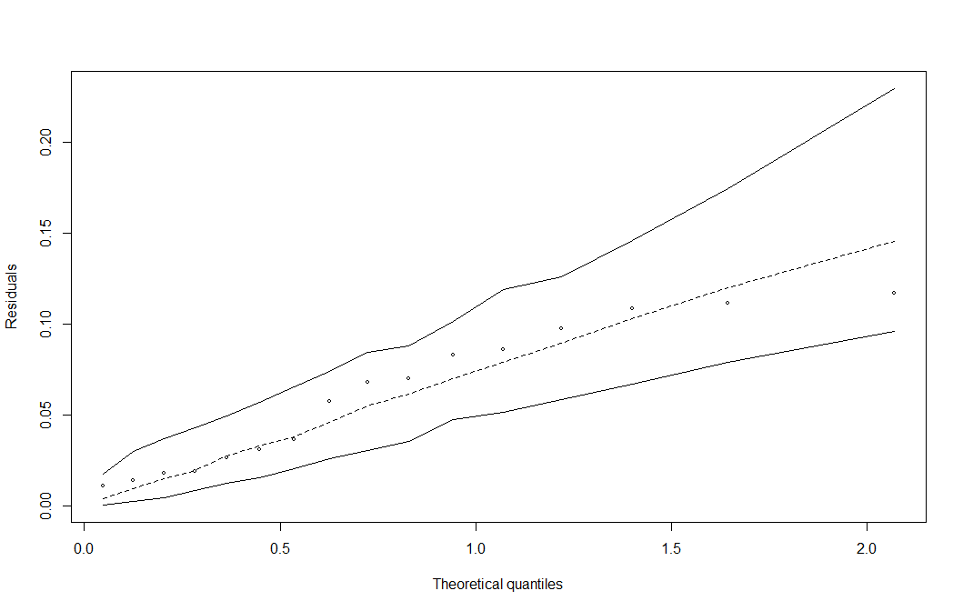
Figure 13. Quantile-quantile graph with envelopes simulated to 99% of the final model adjusted to functional equitability data.
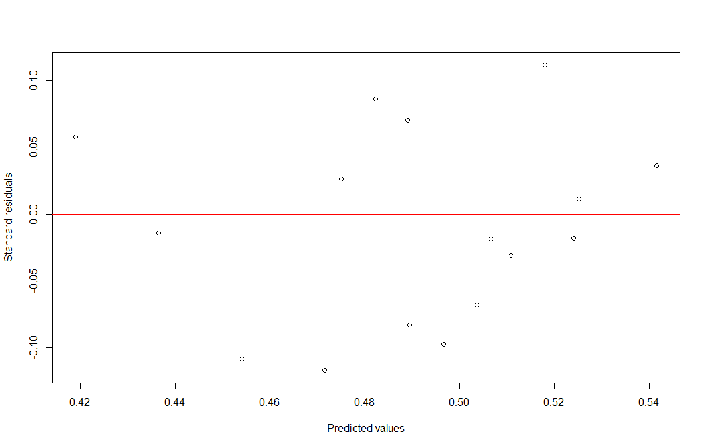
Figure 14. Scatter plot of the normalized residuals in relation to the predicted values for the final model adjusted to the functional equitability data.

Functional redundancy (FR)
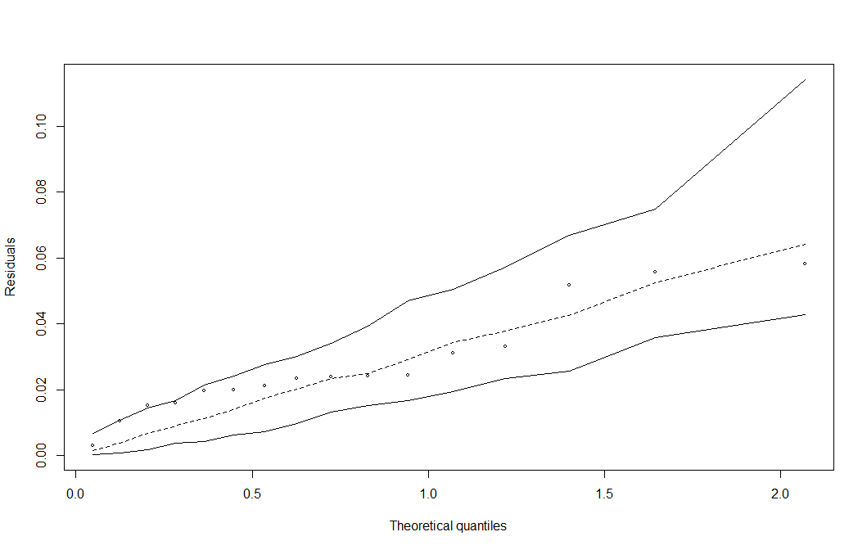
Figure 15. Quantile-quantile graph with envelopes simulated to 99% of the final model adjusted to functional redundancy data.
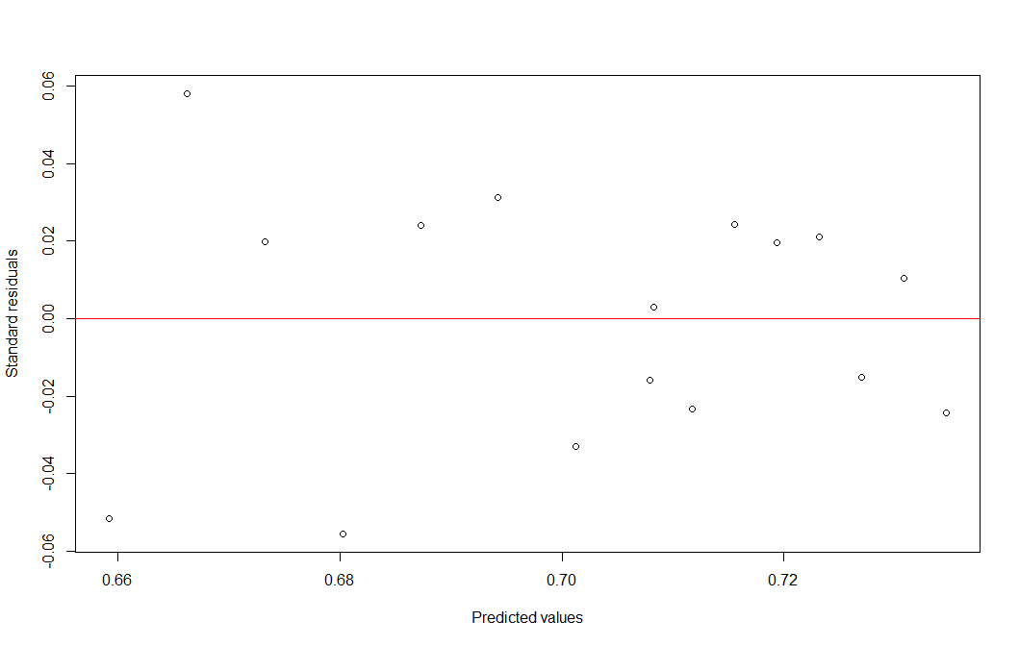
Figure 16. Scatter plot of the normalized residuals in relation to the predicted values for the final model adjusted to the functional equitability data.

Supplementary Material S4
Table 1. Abundance of fish species sampled in lakes with unrestricted and restricted access for fishing. O1=Unrestricted 2011, O2=Unrestricted 2013; O3=Unrestricted 2014; O4=Unrestricted 2015; O5=Unrestricted 2016; O6=Unrestricted 2017; O7=Unrestricted 2018; O8=Unrestricted 2019; R1= Restricted 2011, R2= Restricted 2013; R3= Restricted 2014; R4= Restricted 2015; R5= Restricted 2016; R6= Restricted 2017; R7= Restricted 2018; R8= Restricted 2019.
 | O1 | O2 | O3 | O4 | O5 | O6 | O7 | O8 | R1 | R2 | R3 | R4 | R5 | R6 | R7 | R8
Osteoglossum bicirrhosum | 1 | 0 | 2 | 3 | 1 | 1 | 6 | 2 | 0 | 0 | 2 | 0 | 11 | 6 | 13 | 2
Ilisha amazonica | 0 | 0 | 2 | 2 | 0 | 0 | 0 | 0 | 1 | 0 | 0 | 0 | 0 | 0 | 0 | 1
Pellona castelnaeana | 7 | 0 | 2 | 4 | 0 | 6 | 0 | 10 | 1 | 17 | 6 | 27 | 6 | 2 | 6 | 3
Pellona flavipinnis | 11 | 10 | 73 | 70 | 4 | 11 | 2 | 5 | 0 | 31 | 4 | 19 | 15 | 23 | 48 | 3
Pristigaster cayana | 0 | 0 | 0 | 1 | 0 | 0 | 0 | 0 | 0 | 0 | 0 | 4 | 91 | 0 | 26 | 0
Jurengraulis juruensis | 0 | 0 | 9 | 2 | 0 | 0 | 0 | 0 | 0 | 0 | 0 | 0 | 0 | 0 | 0 | 0
Lycengraulis batesii | 1 | 0 | 0 | 8 | 0 | 0 | 0 | 0 | 0 | 0 | 2 | 0 | 0 | 0 | 0 | 0
Anodus elongatus | 14 | 5 | 106 | 72 | 0 | 0 | 0 | 5 | 0 | 0 | 0 | 0 | 0 | 0 | 17 | 12
Hemiodus argenteus | 1 | 0 | 2 | 4 | 0 | 5 | 0 | 0 | 0 | 0 | 0 | 0 | 0 | 0 | 0 | 0
Hemiodus atranalis | 0 | 0 | 0 | 6 | 1 | 0 | 0 | 0 | 0 | 0 | 0 | 0 | 0 | 0 | 0 | 0
Hemiodus immaculatus | 0 | 0 | 4 | 11 | 0 | 0 | 0 | 0 | 0 | 0 | 3 | 1 | 0 | 2 | 18 | 0
Hemiodus unimaculatus | 0 | 0 | 0 | 0 | 0 | 0 | 0 | 0 | 0 | 0 | 0 | 0 | 1 | 1 | 0 | 0
Curimata inornata | 0 | 0 | 0 | 0 | 0 | 0 | 0 | 0 | 1 | 0 | 0 | 0 | 0 | 1 | 3 | 4
Curimata knerii | 0 | 0 | 4 | 6 | 1 | 0 | 0 | 1 | 0 | 0 | 0 | 0 | 0 | 0 | 0 | 0
Curimata ocellata | 0 | 0 | 0 | 0 | 0 | 0 | 0 | 0 | 0 | 0 | 0 | 0 | 0 | 8 | 0 | 0
Curimata vittata | 0 | 0 | 1 | 5 | 0 | 0 | 0 | 0 | 0 | 0 | 0 | 0 | 1 | 7 | 4 | 5
Curimatella alburna | 0 | 0 | 0 | 7 | 1 | 1 | 0 | 0 | 0 | 0 | 0 | 0 | 0 | 0 | 0 | 0
Curimatella meyeri | 0 | 0 | 20 | 45 | 0 | 7 | 2 | 0 | 0 | 0 | 0 | 0 | 22 | 10 | 5 | 27
Cyphocharax spiluropsis | 0 | 0 | 0 | 0 | 1 | 0 | 0 | 0 | 0 | 0 | 0 | 0 | 0 | 0 | 0 | 0
Potamorhina altamazonica | 2 | 0 | 5 | 2 | 0 | 14 | 0 | 7 | 0 | 30 | 0 | 4 | 199 | 144 | 82 | 34
Potamorhina latior | 5 | 0 | 2 | 20 | 1 | 91 | 17 | 1 | 1 | 23 | 3 | 3 | 9 | 212 | 32 | 34
Psectrogaster amazonica | 0 | 0 | 7 | 9 | 0 | 10 | 2 | 1 | 1 | 1 | 0 | 2 | 0 | 56 | 36 | 28
Psectrogaster rutiloides | 2 | 0 | 33 | 72 | 7 | 118 | 47 | 114 | 0 | 13 | 0 | 0 | 6 | 4 | 149 | 34
Steindachnerina bimaculata | 0 | 0 | 0 | 2 | 0 | 1 | 0 | 0 | 0 | 0 | 0 | 0 | 0 | 1 | 0 | 0
Prochilodus nigricans | 1 | 1 | 2 | 3 | 2 | 11 | 1 | 8 | 0 | 0 | 3 | 0 | 18 | 43 | 66 | 16
Semaprochilodus insignis | 2 | 1 | 5 | 2 | 26 | 1 | 2 | 13 | 0 | 1 | 1 | 0 | 10 | 32 | 43 | 56
Semaprochilodus taeniurus | 2 | 1 | 10 | 11 | 10 | 2 | 1 | 3 | 0 | 13 | 0 | 6 | 36 | 9 | 39 | 28
Leporinus amazonicus | 2 | 0 | 0 | 0 | 0 | 0 | 0 | 0 | 0 | 0 | 0 | 0 | 0 | 0 | 0 | 0
Laemolyta proxima | 0 | 0 | 0 | 11 | 3 | 0 | 1 | 0 | 0 | 0 | 0 | 0 | 0 | 0 | 0 | 0
Leporinus fasciatus | 0 | 0 | 0 | 0 | 0 | 0 | 0 | 0 | 0 | 1 | 0 | 6 | 4 | 1 | 6 | 0
Leporinus friderici | 1 | 0 | 0 | 2 | 0 | 8 | 0 | 0 | 0 | 1 | 0 | 5 | 0 | 14 | 3 | 2
Megaleporinus trifasciatus | 2 | 0 | 3 | 5 | 4 | 5 | 1 | 1 | 0 | 2 | 0 | 0 | 3 | 6 | 0 | 0
Rhytiodus argenteofuscus | 0 | 0 | 2 | 0 | 0 | 0 | 0 | 0 | 0 | 12 | 0 | 0 | 0 | 0 | 0 | 0
Rhytiodus microlepis | 6 | 6 | 29 | 93 | 3 | 8 | 7 | 2 | 2 | 2 | 16 | 12 | 60 | 28 | 44 | 9
Schizodon fasciatus | 0 | 0 | 10 | 50 | 0 | 4 | 14 | 1 | 0 | 6 | 1 | 0 | 19 | 26 | 45 | 1
Schizodon vittatus | 0 | 0 | 0 | 0 | 0 | 0 | 0 | 0 | 0 | 6 | 0 | 0 | 23 | 22 | 5 | 0
Hoplerythrinus unitaeniatus | 0 | 0 | 0 | 1 | 0 | 0 | 0 | 2 | 0 | 0 | 3 | 0 | 0 | 13 | 0 | 0
Hoplias malabaricus | 3 | 0 | 0 | 52 | 1 | 10 | 5 | 1 | 0 | 1 | 1 | 1 | 4 | 13 | 38 | 7
Acestrorhynchus abbreviatus | 0 | 0 | 0 | 1 | 0 | 1 | 0 | 0 | 0 | 0 | 0 | 0 | 0 | 0 | 0 | 0
Acestrorhynchus falcatus | 0 | 0 | 0 | 0 | 0 | 0 | 0 | 0 | 0 | 0 | 0 | 0 | 8 | 6 | 9 | 2
Acestrorhynchus falcirostris | 20 | 2 | 17 | 288 | 21 | 12 | 17 | 2 | 3 | 21 | 1 | 10 | 58 | 69 | 45 | 7
Acestrorhynchus microlepis | 1 | 1 | 0 | 4 | 1 | 0 | 0 | 0 | 0 | 0 | 0 | 0 | 0 | 0 | 0 | 0
Cynodon gibbus | 0 | 0 | 1 | 1 | 0 | 0 | 0 | 0 | 0 | 0 | 0 | 0 | 0 | 0 | 1 | 0
Hydrolycus scomberoides | 1 | 0 | 1 | 2 | 0 | 4 | 0 | 0 | 1 | 2 | 1 | 2 | 2 | 1 | 0 | 0
Rhaphiodon vulpinus | 7 | 1 | 13 | 11 | 0 | 9 | 1 | 1 | 4 | 56 | 7 | 15 | 0 | 2 | 32 | 13
Brycon amazonicus | 1 | 1 | 1 | 2 | 2 | 0 | 0 | 0 | 0 | 33 | 0 | 0 | 18 | 7 | 6 | 5
Brycon melanopterus | 12 | 0 | 2 | 0 | 0 | 3 | 2 | 1 | 0 | 0 | 0 | 0 | 0 | 0 | 0 | 0
Bryconops melanurus | 0 | 0 | 0 | 0 | 0 | 0 | 0 | 0 | 0 | 0 | 0 | 0 | 0 | 1 | 0 | 0
Colossoma macropomum | 0 | 1 | 2 | 14 | 0 | 2 | 0 | 0 | 0 | 3 | 4 | 2 | 1 | 34 | 119 | 7
Metynnis argenteus | 0 | 0 | 0 | 0 | 0 | 0 | 0 | 0 | 0 | 19 | 0 | 3 | 3 | 2 | 0 | 0
Metynnis hypsauchen | 0 | 0 | 0 | 0 | 0 | 0 | 0 | 0 | 0 | 0 | 1 | 2 | 6 | 22 | 2 | 3
Myloplus asterias | 0 | 0 | 0 | 0 | 0 | 0 | 0 | 0 | 0 | 0 | 0 | 0 | 0 | 0 | 1 | 0
Myloplus rubripinnis | 0 | 0 | 0 | 0 | 0 | 0 | 0 | 0 | 0 | 0 | 1 | 0 | 0 | 1 | 0 | 0
Mylossoma albiscopum | 13 | 1 | 3 | 6 | 0 | 1 | 3 | 1 | 9 | 65 | 5 | 27 | 72 | 98 | 109 | 29
Mylossoma aureum | 0 | 0 | 1 | 5 | 0 | 1 | 0 | 0 | 6 | 56 | 1 | 52 | 21 | 5 | 35 | 1
Piaractus brachypomus | 0 | 0 | 0 | 0 | 0 | 0 | 0 | 0 | 0 | 1 | 0 | 2 | 1 | 16 | 7 | 1
Pygocentrus nattereri | 6 | 2 | 3 | 6 | 8 | 1 | 0 | 1 | 7 | 17 | 17 | 10 | 32 | 62 | 80 | 22
Serrasalmus altispinis | 0 | 0 | 0 | 0 | 0 | 0 | 0 | 0 | 0 | 4 | 3 | 15 | 84 | 38 | 19 | 3
Serrasalmus compressus | 0 | 0 | 0 | 0 | 0 | 0 | 0 | 0 | 0 | 0 | 0 | 0 | 0 | 4 | 19 | 0
Serrasalmus elongatus | 6 | 1 | 3 | 3 | 0 | 1 | 1 | 5 | 1 | 10 | 5 | 7 | 17 | 10 | 7 | 10
Serrasalmus hollandi | 0 | 0 | 0 | 1 | 0 | 0 | 0 | 0 | 0 | 0 | 0 | 0 | 0 | 1 | 3 | 0
Serrasalmus maculatus | 1 | 0 | 2 | 5 | 9 | 7 | 3 | 1 | 0 | 0 | 0 | 0 | 0 | 1 | 78 | 7
Serrasalmus rhombeus | 0 | 0 | 1 | 5 | 7 | 3 | 1 | 3 | 1 | 36 | 11 | 3 | 7 | 14 | 7 | 3
Serrasalmus spilopleura | 0 | 0 | 0 | 0 | 0 | 0 | 0 | 0 | 0 | 5 | 2 | 1 | 74 | 72 | 0 | 0
Chalceus erythrurus | 0 | 1 | 1 | 7 | 1 | 1 | 4 | 0 | 0 | 0 | 1 | 11 | 1 | 0 | 0 | 0
Chalceus macrolepidotus | 0 | 0 | 0 | 0 | 0 | 0 | 0 | 0 | 0 | 10 | 0 | 0 | 7 | 45 | 0 | 0
Roeboides myersii | 0 | 0 | 2 | 3 | 0 | 4 | 1 | 1 | 0 | 3 | 0 | 1 | 11 | 15 | 7 | 1
Tetragonopterus argenteus | 0 | 0 | 0 | 0 | 0 | 0 | 0 | 0 | 0 | 0 | 0 | 0 | 0 | 2 | 2 | 0
Agoniates anchovia | 0 | 0 | 1 | 1 | 0 | 0 | 0 | 0 | 0 | 0 | 0 | 0 | 0 | 0 | 3 | 0
Triportheus albus | 15 | 0 | 38 | 252 | 59 | 104 | 4 | 22 | 5 | 13 | 23 | 7 | 386 | 290 | 290 | 11
Triportheus angulatus | 5 | 6 | 12 | 84 | 4 | 83 | 29 | 45 | 2 | 99 | 8 | 30 | 149 | 156 | 174 | 21
Triportheus auritus | 1 | 13 | 18 | 19 | 7 | 1 | 6 | 0 | 0 | 0 | 0 | 0 | 0 | 0 | 28 | 10
Triportheus elongatus | 0 | 0 | 0 | 0 | 0 | 0 | 0 | 0 | 2 | 43 | 8 | 34 | 70 | 24 | 2 | 0
Amblydoras affinis | 0 | 0 | 0 | 0 | 0 | 0 | 0 | 0 | 0 | 0 | 0 | 0 | 0 | 1 | 0 | 3
Anadoras grypus | 0 | 0 | 8 | 33 | 2 | 3 | 0 | 1 | 0 | 0 | 0 | 0 | 0 | 0 | 0 | 0
Nemadoras elongatus | 0 | 0 | 1 | 0 | 0 | 0 | 0 | 0 | 0 | 0 | 0 | 0 | 0 | 0 | 2 | 0
Nemadoras hemipeltis | 0 | 0 | 0 | 0 | 0 | 2 | 0 | 1 | 0 | 0 | 0 | 0 | 0 | 0 | 0 | 0
Nemadoras humeralis | 2 | 0 | 1 | 2 | 0 | 0 | 34 | 3 | 0 | 0 | 0 | 0 | 0 | 0 | 3 | 0
Opsodoras boulengeri | 0 | 0 | 0 | 0 | 0 | 0 | 0 | 1 | 0 | 0 | 0 | 0 | 0 | 0 | 0 | 0
Ossancora asterophysa | 0 | 0 | 0 | 2 | 1 | 1 | 0 | 0 | 0 | 0 | 0 | 0 | 0 | 0 | 0 | 0
Ossancora punctata | 0 | 0 | 0 | 7 | 0 | 5 | 0 | 0 | 0 | 0 | 0 | 0 | 0 | 0 | 0 | 0
Oxydoras niger | 0 | 0 | 0 | 2 | 0 | 0 | 1 | 0 | 4 | 3 | 2 | 0 | 0 | 3 | 21 | 1
Pterodoras granulosus | 1 | 0 | 2 | 12 | 0 | 1 | 0 | 1 | 0 | 0 | 0 | 0 | 0 | 0 | 0 | 0
Pterodoras lentiginosus | 0 | 0 | 0 | 0 | 0 | 0 | 0 | 0 | 0 | 0 | 0 | 0 | 0 | 8 | 13 | 5
Auchenipterichthys coracoideus | 8 | 0 | 0 | 40 | 2 | 0 | 0 | 0 | 0 | 0 | 0 | 0 | 0 | 0 | 0 | 0
Ageneiosus dentatus | 0 | 0 | 13 | 22 | 2 | 0 | 5 | 0 | 0 | 0 | 0 | 0 | 0 | 0 | 0 | 0
Ageneiosus inermis | 0 | 0 | 1 | 2 | 1 | 0 | 0 | 0 | 3 | 6 | 2 | 2 | 1 | 2 | 0 | 0
Ageneiosus ucayalensis | 0 | 0 | 3 | 2 | 1 | 3 | 0 | 0 | 7 | 0 | 23 | 17 | 0 | 29 | 0 | 0
Auchenipterus britskii | 0 | 0 | 8 | 5 | 0 | 0 | 0 | 0 | 0 | 0 | 0 | 0 | 0 | 0 | 0 | 0
Auchenipterus nuchalis | 0 | 4 | 10 | 21 | 5 | 5 | 5 | 2 | 0 | 6 | 0 | 6 | 0 | 3 | 1 | 2
Centromochlus heckelii | 0 | 0 | 0 | 0 | 0 | 0 | 0 | 0 | 0 | 0 | 0 | 2 | 0 | 2 | 0 | 0
Trachelyopterus galeatus | 5 | 0 | 1 | 5 | 5 | 1 | 4 | 0 | 9 | 26 | 15 | 8 | 0 | 0 | 24 | 54
Trachelyopterus porosus | 1 | 5 | 6 | 67 | 10 | 20 | 0 | 4 | 0 | 0 | 0 | 0 | 0 | 0 | 0 | 0
Tympanopleura brevis | 0 | 0 | 0 | 0 | 0 | 1 | 6 | 0 | 0 | 0 | 0 | 0 | 0 | 0 | 5 | 2
Tympanopleura rondoni | 0 | 0 | 1 | 1 | 0 | 0 | 0 | 0 | 0 | 0 | 0 | 0 | 0 | 0 | 0 | 0
Calophysus macropterus | 0 | 0 | 0 | 0 | 0 | 0 | 0 | 2 | 5 | 0 | 25 | 0 | 0 | 0 | 1 | 0
Hemisorubim platyrhynchos | 0 | 0 | 0 | 0 | 0 | 0 | 0 | 1 | 0 | 0 | 0 | 0 | 0 | 0 | 1 | 0
Hypophthalmus edentatus | 1 | 1 | 6 | 10 | 0 | 1 | 0 | 4 | 0 | 6 | 1 | 5 | 0 | 3 | 37 | 0
Hypophthalmus fimbriatus | 0 | 0 | 4 | 5 | 0 | 0 | 0 | 2 | 0 | 0 | 0 | 0 | 0 | 1 | 0 | 0
Hypophthalmus marginatus | 0 | 0 | 0 | 0 | 0 | 0 | 0 | 0 | 1 | 0 | 1 | 3 | 0 | 1 | 2 | 0
Hypophthalmus oremaculatus | 2 | 1 | 1 | 5 | 0 | 0 | 0 | 0 | 0 | 0 | 0 | 0 | 0 | 0 | 0 | 0
Phractocephalus hemioliopterus | 0 | 0 | 0 | 0 | 0 | 0 | 0 | 0 | 0 | 0 | 0 | 0 | 0 | 0 | 3 | 0
Pimelodina flavipinnis | 0 | 0 | 0 | 0 | 0 | 0 | 0 | 0 | 0 | 0 | 0 | 0 | 1 | 0 | 0 | 0
Pimelodus blochii | 4 | 0 | 4 | 20 | 0 | 5 | 3 | 3 | 2 | 1 | 2 | 4 | 3 | 21 | 201 | 26
Pimelodus maculatus | 0 | 0 | 0 | 0 | 0 | 0 | 0 | 0 | 0 | 0 | 0 | 0 | 0 | 0 | 1 | 0
Pinirampus pirinampu | 0 | 0 | 1 | 4 | 0 | 0 | 0 | 0 | 0 | 0 | 1 | 0 | 0 | 4 | 1 | 1
Pseudoplatystoma punctifer | 0 | 0 | 0 | 2 | 0 | 1 | 0 | 0 | 0 | 2 | 0 | 0 | 0 | 0 | 1 | 0
Pseudoplatystoma tigrinum | 0 | 2 | 1 | 2 | 0 | 0 | 0 | 0 | 0 | 2 | 0 | 0 | 0 | 1 | 0 | 0
Sorubim lima | 0 | 0 | 2 | 1 | 1 | 1 | 2 | 0 | 0 | 11 | 1 | 1 | 0 | 7 | 0 | 8
Sorubim maniradii | 2 | 0 | 2 | 2 | 2 | 4 | 0 | 0 | 0 | 0 | 0 | 0 | 0 | 0 | 0 | 1
Hoplosternum littorale | 4 | 2 | 8 | 41 | 42 | 31 | 0 | 46 | 0 | 0 | 1 | 0 | 10 | 24 | 95 | 40
Megalechis picta | 2 | 0 | 0 | 0 | 0 | 0 | 0 | 0 | 0 | 0 | 0 | 0 | 0 | 0 | 0 | 0
Ancistrus dolichopterus | 3 | 0 | 0 | 0 | 0 | 2 | 0 | 0 | 0 | 0 | 0 | 0 | 0 | 1 | 0 | 0
Dekeyseria amazonica | 3 | 0 | 5 | 4 | 2 | 5 | 4 | 0 | 0 | 0 | 2 | 2 | 0 | 2 | 0 | 0
Hypoptopoma gulare | 1 | 0 | 0 | 0 | 0 | 0 | 0 | 0 | 0 | 0 | 0 | 1 | 0 | 0 | 2 | 0
Hypoptopoma incognitum | 0 | 0 | 0 | 12 | 0 | 0 | 1 | 1 | 0 | 0 | 0 | 0 | 0 | 1 | 0 | 0
Loricaria cataphracta | 0 | 0 | 0 | 0 | 0 | 0 | 0 | 0 | 0 | 0 | 0 | 0 | 1 | 3 | 36 | 1
Loricariichthys maculatus | 0 | 0 | 0 | 3 | 0 | 0 | 0 | 11 | 0 | 0 | 0 | 0 | 0 | 0 | 0 | 0
Loricariichthys nudirostris | 0 | 0 | 0 | 0 | 0 | 1 | 0 | 0 | 0 | 0 | 0 | 0 | 0 | 0 | 0 | 0
Pterygoplichthys pardalis | 0 | 0 | 2 | 7 | 0 | 4 | 1 | 34 | 0 | 1 | 6 | 0 | 1 | 3 | 89 | 4
Parapteronotus hasemani | 0 | 0 | 0 | 0 | 0 | 0 | 0 | 0 | 0 | 0 | 0 | 0 | 0 | 0 | 0 | 1
Sternarchella schotti | 0 | 0 | 0 | 0 | 0 | 0 | 0 | 0 | 0 | 0 | 0 | 0 | 0 | 0 | 1 | 0
Rhamphichthys rostratus | 0 | 0 | 0 | 0 | 0 | 0 | 0 | 0 | 0 | 0 | 0 | 0 | 0 | 1 | 0 | 0
Eigenmannia limbata | 0 | 0 | 0 | 1 | 0 | 1 | 0 | 0 | 0 | 0 | 0 | 0 | 0 | 0 | 0 | 1
Sternopygus macrurus | 0 | 0 | 0 | 0 | 0 | 1 | 0 | 0 | 0 | 0 | 0 | 0 | 0 | 0 | 0 | 0
Plagioscion montei | 0 | 0 | 1 | 0 | 0 | 1 | 0 | 0 | 0 | 0 | 0 | 0 | 0 | 0 | 0 | 0
Plagioscion squamosissimus | 1 | 0 | 6 | 10 | 4 | 1 | 0 | 0 | 1 | 42 | 0 | 3 | 4 | 7 | 2 | 2
Acaronia nassa | 1 | 0 | 0 | 2 | 0 | 0 | 1 | 0 | 0 | 0 | 0 | 0 | 0 | 3 | 0 | 0
Acarichthys heckelii | 0 | 1 | 0 | 2 | 7 | 0 | 9 | 0 | 0 | 0 | 0 | 0 | 25 | 36 | 7 | 0
Astronotus crassipinnis | 0 | 0 | 0 | 1 | 1 | 0 | 0 | 0 | 0 | 0 | 0 | 0 | 1 | 1 | 1 | 0
Astronotus ocellatus | 0 | 0 | 0 | 2 | 0 | 0 | 0 | 0 | 0 | 0 | 1 | 0 | 0 | 0 | 0 | 1
Chaetobranchopsis orbicularis | 0 | 0 | 2 | 0 | 0 | 0 | 0 | 0 | 0 | 0 | 0 | 0 | 0 | 0 | 0 | 0
Chaetobranchus flavescens | 0 | 0 | 0 | 1 | 7 | 0 | 0 | 0 | 0 | 0 | 1 | 0 | 0 | 1 | 0 | 0
Chaetobranchus semifasciatus | 0 | 0 | 0 | 0 | 0 | 0 | 0 | 0 | 0 | 0 | 0 | 0 | 0 | 0 | 2 | 0
Cichla monoculus | 2 | 0 | 4 | 23 | 2 | 1 | 0 | 0 | 0 | 5 | 1 | 0 | 3 | 7 | 12 | 0
Cichlasoma amazonarum | 0 | 0 | 0 | 0 | 0 | 0 | 0 | 0 | 0 | 0 | 0 | 0 | 0 | 0 | 2 | 0
Crenicichla reticulata | 0 | 0 | 0 | 0 | 0 | 0 | 1 | 0 | 0 | 0 | 0 | 0 | 0 | 0 | 0 | 0
Geophagus proximus | 0 | 0 | 1 | 5 | 2 | 0 | 0 | 0 | 0 | 0 | 0 | 0 | 2 | 3 | 3 | 0
Heros notatus | 0 | 2 | 1 | 7 | 9 | 0 | 0 | 0 | 0 | 0 | 0 | 0 | 0 | 1 | 0 | 0
Heros severus | 0 | 0 | 0 | 0 | 0 | 0 | 0 | 0 | 0 | 0 | 0 | 0 | 1 | 5 | 5 | 1
Mesonauta festivus | 0 | 0 | 1 | 9 | 10 | 3 | 0 | 0 | 0 | 4 | 1 | 0 | 0 | 4 | 14 | 3
Pterophyllum scalare | 0 | 0 | 0 | 2 | 1 | 1 | 0 | 1 | 1 | 0 | 0 | 0 | 1 | 0 | 0 | 0
Satanoperca acuticeps | 0 | 0 | 0 | 0 | 0 | 0 | 0 | 0 | 0 | 0 | 0 | 0 | 0 | 1 | 5 | 0
Satanoperca jurupari | 0 | 2 | 5 | 4 | 4 | 0 | 2 | 0 | 0 | 0 | 0 | 0 | 1 | 6 | 8 | 0
Lepidosiren paradoxa | 0 | 0 | 0 | 0 | 0 | 0 | 0 | 0 | 0 | 0 | 0 | 0 | 0 | 0 | 3 | 0

Supplementary Material S5
Table 1. Scores of the PCA objects
Access | PC1 | PC2 | PC3 | PC4 | PC5 | PC6 | PC7 | PC8 | PC9 | PC10 | PC11 | PC12 | PC13 | PC14 | PC15 | PC16
Unrestricted | 0.213 | -1.103 | 0.535 | 1.662 | 0.566 | 0.338 | -0.357 | -1.235 | 1.345 | -0.618 | 0.658 | 0.493 | -0.242 | -0.235 | -0.172 | 0.000
Unrestricted | -0.200 | 0.002 | -3.697 | 0.476 | 1.034 | 0.238 | 0.449 | -0.051 | -0.555 | -0.297 | 0.112 | 0.307 | 0.139 | 0.455 | -0.176 | 0.000
Unrestricted | 1.230 | 0.909 | 0.101 | 3.269 | 2.780 | 1.615 | 0.348 | -0.249 | -0.566 | 1.073 | 0.138 | -0.291 | -0.079 | -0.074 | 0.112 | 0.000
Unrestricted | 1.913 | 0.259 | -0.120 | 2.432 | -0.882 | -0.978 | 1.467 | -0.948 | 0.401 | -0.814 | -1.181 | -0.128 | 0.338 | -0.075 | 0.062 | 0.000
Unrestricted | 1.855 | -3.690 | -4.052 | -2.066 | 0.274 | -0.773 | -1.072 | -0.637 | 0.267 | 0.206 | 0.004 | -0.416 | -0.082 | -0.176 | 0.106 | 0.000
Unrestricted | 2.493 | 2.461 | 0.588 | -0.974 | 0.412 | -1.562 | 1.407 | 0.751 | -0.908 | -0.893 | 0.846 | -0.460 | -0.204 | -0.123 | -0.063 | 0.000
Unrestricted | 2.399 | 1.569 | 1.265 | 1.460 | -2.118 | -1.543 | -1.735 | -1.005 | -0.245 | 0.522 | 0.452 | 0.112 | -0.123 | 0.294 | 0.100 | 0.000
Unrestricted | 4.854 | -1.081 | 0.631 | 0.593 | -0.684 | 1.079 | -1.414 | 2.660 | 0.205 | -0.162 | -0.374 | 0.054 | 0.098 | -0.040 | -0.079 | 0.000
Restricted | -4.346 | -3.022 | 0.984 | 0.897 | -0.347 | -1.185 | -0.615 | 0.162 | -1.588 | 0.396 | -0.023 | 0.220 | 0.233 | -0.248 | -0.097 | 0.000
Restricted | -3.613 | 1.302 | 1.315 | -0.758 | 1.172 | 0.411 | -1.359 | 0.013 | 0.779 | -0.748 | 0.575 | -0.506 | 0.465 | 0.101 | 0.060 | 0.000
Restricted | -3.134 | -3.727 | 0.386 | 0.866 | -1.542 | -0.003 | 1.928 | 1.274 | 0.884 | 0.409 | 0.484 | -0.150 | -0.156 | 0.181 | 0.091 | 0.000
Restricted | -4.293 | 1.536 | 0.077 | -0.073 | 0.601 | -0.034 | -0.936 | 0.433 | -0.133 | -0.694 | -1.151 | -0.066 | -0.547 | 0.068 | 0.036 | 0.000
Restricted | -1.439 | 4.450 | -2.078 | -1.010 | -0.575 | 0.003 | 0.398 | 0.848 | 0.279 | 0.358 | 0.232 | 0.752 | 0.126 | -0.219 | 0.158 | 0.000
Restricted | -0.424 | 2.508 | 0.596 | -1.805 | -0.431 | -0.330 | 0.403 | -0.358 | 0.781 | 1.545 | -0.512 | -0.377 | 0.031 | -0.018 | -0.236 | 0.000
Restricted | 0.179 | -0.120 | 0.460 | -1.774 | -2.475 | 3.094 | 0.417 | -1.261 | -0.902 | -0.389 | 0.067 | -0.089 | -0.027 | -0.032 | 0.007 | 0.000
Restricted | 2.313 | -2.254 | 3.007 | -3.196 | 2.216 | -0.372 | 0.671 | -0.396 | -0.044 | 0.106 | -0.328 | 0.544 | 0.030 | 0.142 | 0.090 | 0.000

Table 2. Scores of the atributes of the PCA. DET, detritivore; HERB, herbivore; INV, invertivore; OMN, omnivore, PIS, piscivore; PLAN, planktivore; LEL, large equilibrium strategist; LES, small equilibrium strategist; LIN, intermediate; LPL, large periodic; LPS, small periodic; LOM, local migrant; REM, regional migrant; SEM, sedentary; BAN, anguilliform body; CIB, cylindrical body; CLB, cylindrical and elongated body; COAB, compressed and elongated body; DEB, depressed body; ELB, elliptical body; FUB, fusiform body; FCLB, fusiform and laterally compressed body; MDB, moderately depressed body; ROB, rhomboid body; INM, lower mouth; SUM, upper mouth; TEM, terminal mouth.
Traits | PC1 | PC2 | PC3 | PC4 | PC5 | PC6 | PC7 | PC8 | PC9 | PC10 | PC11 | PC12 | PC13 | PC14 | PC15 | PC16
DET | 0.280 | 0.061 | 0.216 | -0.209 | -0.029 | 0.005 | -0.049 | 0.275 | -0.079 | 0.123 | 0.064 | -0.010 | -0.114 | -0.174 | -0.115 | -0.164
HERB | -0.320 | 0.068 | 0.130 | 0.003 | -0.028 | 0.093 | -0.125 | -0.159 | -0.087 | -0.123 | -0.447 | 0.083 | 0.145 | 0.470 | -0.081 | -0.065
INV | 0.241 | -0.092 | -0.355 | -0.074 | 0.088 | -0.017 | -0.030 | 0.140 | -0.117 | -0.252 | -0.122 | 0.008 | 0.155 | 0.091 | 0.140 | -0.437
OMN | -0.069 | 0.134 | -0.279 | -0.169 | -0.344 | -0.283 | -0.063 | -0.286 | -0.058 | -0.079 | 0.368 | 0.242 | 0.244 | -0.073 | -0.001 | 0.113
PIS | -0.286 | -0.153 | 0.010 | 0.233 | 0.008 | -0.075 | 0.134 | -0.070 | 0.285 | -0.039 | 0.026 | -0.147 | -0.038 | -0.091 | 0.132 | -0.443
PLAN | 0.077 | -0.006 | -0.095 | 0.336 | 0.388 | 0.347 | 0.116 | -0.191 | -0.072 | 0.228 | 0.037 | -0.063 | -0.222 | 0.046 | 0.011 | 0.130
LEL | 0.182 | -0.094 | 0.106 | 0.061 | -0.340 | 0.344 | -0.105 | 0.445 | 0.166 | -0.032 | -0.020 | -0.104 | 0.087 | 0.125 | 0.325 | 0.071
LES | 0.136 | -0.126 | -0.389 | -0.058 | -0.074 | -0.103 | -0.264 | -0.265 | 0.056 | 0.229 | 0.190 | -0.406 | -0.369 | 0.286 | 0.036 | -0.110
LIN | -0.137 | -0.349 | -0.056 | -0.113 | -0.065 | -0.191 | 0.127 | 0.155 | 0.094 | 0.106 | -0.101 | 0.144 | -0.173 | -0.204 | 0.291 | -0.159
LPL | -0.200 | -0.257 | 0.153 | -0.129 | 0.208 | 0.160 | -0.079 | 0.018 | 0.166 | -0.261 | 0.187 | -0.008 | -0.068 | -0.014 | -0.518 | -0.121
LPS | 0.116 | 0.378 | 0.025 | 0.134 | 0.005 | -0.020 | 0.058 | -0.111 | -0.186 | 0.032 | -0.089 | 0.045 | 0.206 | 0.025 | 0.051 | -0.285
LOM | -0.223 | 0.270 | 0.143 | 0.153 | -0.097 | -0.092 | 0.044 | 0.111 | -0.118 | 0.181 | 0.107 | -0.012 | -0.183 | 0.049 | 0.071 | -0.346
REM | 0.122 | -0.129 | 0.002 | -0.385 | 0.178 | 0.265 | -0.022 | -0.260 | 0.297 | 0.019 | 0.032 | 0.487 | -0.014 | 0.244 | 0.246 | -0.149
SEM | 0.225 | -0.283 | -0.188 | 0.010 | 0.030 | -0.024 | -0.045 | -0.003 | -0.008 | -0.247 | -0.157 | -0.250 | 0.247 | -0.197 | -0.227 | 0.007
ANB | 0.136 | 0.019 | 0.229 | -0.273 | 0.204 | -0.237 | 0.394 | -0.016 | -0.276 | -0.278 | 0.105 | 0.021 | -0.342 | 0.027 | 0.058 | -0.022
CIB | 0.138 | -0.004 | 0.185 | 0.082 | -0.369 | -0.164 | 0.379 | -0.285 | 0.368 | -0.254 | -0.229 | -0.213 | -0.144 | 0.141 | -0.001 | 0.093
CLB | 0.006 | -0.006 | 0.037 | -0.151 | -0.321 | 0.570 | 0.090 | -0.316 | -0.400 | -0.208 | 0.051 | -0.164 | -0.121 | -0.221 | 0.122 | -0.111
COAB | -0.250 | -0.077 | 0.249 | 0.131 | 0.135 | -0.004 | -0.213 | -0.033 | -0.021 | -0.329 | 0.487 | -0.206 | 0.206 | 0.049 | 0.320 | -0.031
DEB | 0.186 | -0.070 | 0.188 | 0.235 | -0.357 | 0.015 | -0.325 | 0.004 | 0.023 | -0.040 | 0.134 | 0.340 | -0.307 | 0.067 | -0.294 | -0.188
ELB | -0.295 | 0.023 | -0.050 | -0.162 | 0.030 | -0.049 | -0.373 | -0.089 | -0.066 | -0.049 | -0.402 | -0.009 | -0.253 | -0.392 | 0.166 | 0.019
FCLB | -0.070 | 0.268 | -0.364 | 0.004 | 0.022 | 0.102 | 0.159 | 0.220 | 0.049 | -0.222 | 0.012 | -0.014 | -0.073 | 0.107 | -0.221 | -0.265
FUB | 0.294 | 0.146 | 0.123 | 0.094 | 0.197 | 0.003 | 0.047 | -0.164 | 0.253 | 0.045 | 0.067 | 0.001 | 0.166 | -0.162 | 0.149 | -0.109
MDB | -0.056 | -0.376 | 0.006 | -0.002 | -0.036 | -0.132 | 0.136 | 0.153 | -0.410 | 0.079 | 0.030 | 0.000 | 0.032 | 0.415 | 0.078 | 0.078
ROB | -0.180 | -0.133 | 0.097 | -0.315 | -0.170 | 0.142 | 0.261 | -0.069 | 0.035 | 0.502 | 0.060 | -0.179 | 0.311 | -0.055 | -0.223 | -0.206
INM | 0.091 | -0.302 | 0.021 | 0.337 | -0.029 | -0.047 | 0.061 | -0.174 | -0.184 | 0.046 | -0.058 | 0.217 | 0.101 | -0.137 | -0.031 | -0.214
SUM | -0.226 | 0.189 | -0.253 | -0.099 | -0.059 | 0.180 | 0.187 | 0.217 | 0.179 | -0.089 | 0.129 | 0.039 | -0.145 | 0.020 | 0.028 | 0.096
TEM | 0.144 | 0.161 | 0.262 | -0.308 | 0.103 | -0.147 | -0.290 | -0.030 | 0.025 | 0.044 | -0.075 | -0.315 | 0.040 | 0.148 | 0.007 | -0.167

