The dialectic of sustainability: the case of the post-conflict Colombia

Antonio Bodini
Supplementary material

Appendix A: Variables
In what follows, the variables included in the model are described. Time series of proxy indicators were available for six out of the nine variables. Although we performed a qualitative analysis, when qualitative predictions indicate an increase or a decrease in a variable’s level it is useful showing the physical quantities involved. This procedure helps defining the meaning of the interactions between the variables.

F, forest. Extension of forest cover in ha. A dataset with annual hectares of forest cover has been exploited in the analysis (source of data: https://ourworldindata.org/grapher/forest).

EF, ecological function. It accounts for ecological processes that maintain ecosystem’s activity and provide ecosystem services. It is strictly dependent on biodiversity. We used the Red List Index (Butchart et al. 2007, 2010) as a proxy. This index is biased towards large plants and animals although many of the critical ecosystem functions are provided by microscopic organisms. Nevertheless, it is currently used in the assessment of the Sustainable Development Goals (SDGs), precisely for the 15th objective). It does not directly evaluate the ecosystem functions, but biodiversity at the upper trophic levels depends on mechanisms at the lower levels (such as nutrient cycling). Also the characterization of this micro-biodiversity (taxonomical diversity, functional diversity or community structure of bacteria, fungi) is scant and not available across the Colombian territory for the entire time frame we considered (source of data: https://stats.oecd.org/Index.aspx?DataSetCode=RED_LIST).

AL, available land. It is an ancillary variable rather than a true component of the system. It has been conceived as the reservoir of land that may become available to LP and SP for exploitation and F for regrowth. It has been included because competition for land use between SP and LP (see below) does not occur directly on forests, but on areas that were once covered by forests. Furthermore, forced displacement of rural people frees land that thus become available. This is recognized as a fundamental mechanism in the Colombian conflict-mediated socio-ecological system. If we considered simply small (rural) properties and large properties relying directly on forests for their land requirement, we could not make the models showing this mechanism in the model (see Appendix E for details). No proxy for this variable was available.

LP, large property. In Colombia restricted groups of families possess vast extensions of the territory so that a very large portion of arable land is concentrated in few hands. The extension of agricultural land has been considered as a proxy for this variable (source of data:
https://data.worldbank.org/indicator/AG.LND.AGRI.K2?view=chart).

CB, capital business. It represents all capital-intensive activities that are possible on large extensions of land such as oil palm cultivars and banana plantations. The extension of oil palm cultivar has been selected as a proxy indicator. It is one of the activities through which capital business is rapidly penetrating the economic tissue of the country. This is the reason why we included it as a proxy for CB, which also comprises other activities. Oil palm extension more effectively represents this rapid transformation of the Colombian economic system, which was largely rural until few years ago, and it is turning into a capital-intensive economy. Also Goebertus (2008) posits that the switch from banana plantations to oil palm cultivars has inflated forced displacement; as such, this type of activity is important in the creation of conflict-related dynamics (source of data:
https://data.worldbank.org/indicator/AG.LND.AGRI.K2?view=chart).

SP, small property. It refers to the extension of land where local rural activities are carried out for food security and small business. Rural people farm their plots and keep small livestock, guaranteeing their food security. They were also able to sell the small surplus that they produced to buy other items. The small property variable is strongly linked to the so-called “collective properties”. We used rural population (number of individuals) as proxy indicator for this variable. According to OECD (2022), Colombia is characterized by an atomized agricultural production made of family farming in small land plots. As much as 65% of agricultural production units operate in less than four hectares. Also, it is difficult to discern the fraction of small owners and the farmworkers because many owners lack legal documentation (source of data:
https://data.worldbank.org/indicator/SP.RUR.TOTL?end=2021&locations=CO&start=2001&view=chart).

V, violence. It is a central element of the societal configuration under the conflict constraints. In Colombia, there have been many insurgent groups (Villamizar 2017) but three main actors can be identified in this galaxy: the FARC (Fuerzas Armadas Revolucionaria de Colombia), the ELN (Ejercito de Liberación Nacional) as representative of the lefty insurgents, while the several right- wing guerrilla groups are united in the AUC (Autodefensas Unidas de Colombia). After the signature of the peace agreement (year 2016) between the Government and the FARC, parts of these groups remained covered and have become deeply involved in coca production and trafficking. We recognize that differences exist among the various groups as for motivation for violence and targets, so that we modelled interactions involving V taking into account two different mechanisms: one that more closely describes the role played by the left-wing guerrillas; the other reflecting more the attitude of criminal bands and right-wing groups. We reiterate here that despite the attempt to represent different behaviours, the two scenarios we conceived are in fact general, as the dynamics of violent phenomena in Colombia is far more complex than described in this paper. We did not consider any proxy for this variable.

DP, displaced people. Displacement has affected nearly every department in the country. It has occurred when various illegal groups either have been fighting for territorial control or have directly attacked population for land grabbing. We had no proxy for this variable.

IB, illegal business. This component mostly refers to business associated with coca cultivation and we used the extension of coca cropland as a proxy for this variable (source of data:
https://colombiapeace.org/category/infographics/).

References
Butchart, S. H., Walpole, M., Collen, B., Van Strien, A., Scharlemann, J. P., Almond, R. E., et al. (2010). Global biodiversity: indicators of recent declines. Science, 328(5982), 1164-1168.
Butchart SH, Resit Akçakaya H, Chanson J, Baillie JE, Collen B, Quader S, et al. (2007) Improvements to the Red List Index. PLoS ONE 2(1): e140. https://doi.org/10.1371/journal.pone.0000140
Goebertus J. (2008). Palma de aceitey desplazamiento forzado en zona Bananera:"trayectorias" entre recursosnaturales y conflicto. Colombia Internacional, 67: 152-175. ISSN: 0121-5612. Disponible en: https://www.redalyc.org/articulo.oa?id=81206708
OECD (2022). Rural Policy Review: Colombia. https://www.oecd.org/regional/rural-development/Rural-Policy-Review-Colombia-PH-EN.pdf
Villamizar D. (2017). Las guerillas en Colombia. Una historia desde los origenes hasta los confines. Debate, Bogotà, Colombia. 828 pp.

Appendix B: Data sets and correlations
Table B1. Data sets of the proxies for six out of the nine variables that compose the models. Their sources are provided in the main body of the paper (Table 1) as well as in the Appendix A.
 | Forest cover | Rural Pop. | Oil palm | Ecosystem Function | Agriculture | Illicit crops
Unit | (million ha) | (individuals) | (tons) | (RLI as proxy) | (sq.km) | (ha)
Year
2002 | 62.35 | 1.020E+07 | 528400.00 | 0.759 | 416,070.00 | 102,000.00
2003 | 62.16 | 1.018E+07 | 526634.00 | 0.758 | 420,510.00 | 86,000.00
2004 | 61.96 | 1.015E+07 | 630400.00 | 0.757 | 423,910.00 | 80,000.00
2005 | 61.77 | 1.012E+07 | 672576.00 | 0.756 | 425,570.00 | 86,000.00
2006 | 61.58 | 1.008E+07 | 711000.00 | 0.754 | 421,740.00 | 78,000.00
2007 | 61.39 | 1.004E+07 | 780000.00 | 0.753 | 424,360.00 | 99,000.00
2008 | 61.19 | 9.988E+06 | 777800.00 | 0.752 | 426,140.00 | 81,000.00
2009 | 61.00 | 9.932E+06 | 804838.00 | 0.752 | 425,400.00 | 73,000.00
2010 | 60.81 | 9.876E+06 | 753039.00 | 0.750 | 425,030.00 | 62,000.00
2011 | 60.67 | 9.816E+06 | 804838.00 | 0.750 | 417,210.00 | 64,000.00
2012 | 60.54 | 9.751E+06 | 973039.00 | 0.747 | 426,176.00 | 48,000.00
2013 | 60.40 | 9.682E+06 | 1040835.00 | 0.746 | 448,156.00 | 48,000.00
2014 | 60.27 | 9.609E+06 | 1109586.00 | 0.745 | 447,847.00 | 69,000.00
2015 | 60.13 | 9.535E+06 | 1275000.00 | 0.743 | 447,539.00 | 96,000.00
2016 | 59.94 | 9.474E+06 | 1146000.00 | 0.742 | 447,230.00 | 146,000.00
2017 | 59.74 | 9.455E+06 | 1627552.00 | 0.741 | 494,990.00 | 171,000.00
2018 | 59.54 | 9.472E+06 | 1631506.40 | 0.740 | 494,920.00 | 169,000.00
2019 | 59.34 | 9.483E+06 | 1527548.90 | 0.739 | 496,090.00 | 154,000.00
2020 | 59.14 | 9.460E+06 | 1557994.90 | 0.737 | 482,428.00 | 143,000.00

Pairwise correlations were computed using Pearson and Spearman’s tests. Results of the two tests are in Table B2.
Table B2. Correlation between the proxies associated to model variables. In bold, positive correlations. Asterisks identify the level of statistical significance as follows: p <0.001 ‘***’; 0.001 ‘**’; 0.01 ‘*’; 0.05 ‘.’; 0.1 ‘ ’, not significant.
Correlation | Pearson | p-value | Spearman | p-value
Oil Palm - Forest | -0.9411547 | 1.972e-09  (***) | -0.9688461 | 9.733e-12  (***)
Oil Palm - Agriculture | 0.955291 | 2.003e-10  (***) | 0.877578 | 7.995e-07  (***)
Oil Palm - Illicit Crops | 0.7243739 | 0.00045  (***) | 0.4110672 | 0.08039  .
Agriculture - Forest | -0.843685 | 5.658e-06  (***) | -0.8754386 | 9.194e-07  (***)
Agriculture - Illicit Crops | 0.8068749 | 2.989e-05  (***) | 0.3880599 | 0.1006
Illicit Crops - Forest | -0.5522935 | 0.014 (*) | -0.3520633 | 0.1393
Rural Population-Illicit Crops | -0.5609896 | 0.012 (*) | -0.3643548 | 0.1251
Rural Population-Agriculture | -0.8296039 | 1.12e-05 (***) | -0.8631579 | 1.957e-06  (***)
Rural Population-Oil Palm | -0.9364862 | 3.713e-09  (***) | -0.9741115 | 2.054e-12  (***)
Rural Population-Forest | 0.9759306 | 1.112e-12  (***) | 0.9824561 | 7.736e-14  (***)
Ecosystem function-Forest | 0.9955009 | 2.2e-16  (***) | 0.9995613 | < 2.2e-16  (***)
Ecosystem functions-Rural Population | 0.9852355 | 1.802e-14  (***) | 0.9820097 | 9.563e-14  (***)
Ecosystem function -Oil Palm | -0.9492884 | 5.726e-10  (***) | -0.9670764 | 1.547e-11  (***)
Ecosystem function - Agriculture | -0.8485435 | 4.402e-06  (***) | -0.877578 | 7.995e-07  (***)
Ecosystem function – Illicit Crops | -0.5741708 | 0.01014 (*) | -0.3548 | 0.136

Appendix C: Loop analysis and simulations
Loop analysis
Loop analysis is a qualitative technique that represents networks of interacting variables by means of signed digraphs (Puccia and Levins, 1985, Levins, 1974). Variables are nodes in a graph and might represent a single species or groups of species. This approach focuses exclusively on the quality nature of interactions, which are categorized into three types: positive, negative and no interaction. The former takes the shape of an arrowhead link connecting the variables; the second is represented by a circle-head link. Every signed diagraph is a graphical representation of the community matrix (Levins 1968) in which the positive interactions are represented by +1 coefficients, negative interactions by -1 and no interactions by 0; the self-effects of variables on their own growth rate are described in the elements along the main diagonal of the matrix. In Fig. C1 the correspondence between a community matrix and the related signed digraph is given for a simple predator-prey system.
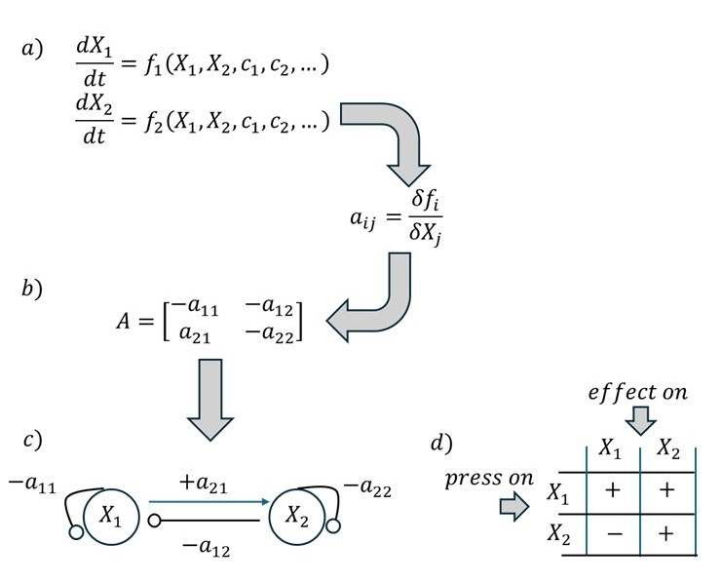
Figure C1. Synthesis of the formal derivation of a signed digraph for a predator-prey system. Coefficients of the community matrix A (b) are obtained from the dynamical equations (a) of the two populations by calculating the partial derivatives of each two equations in respect to each variable. The graph (c) translates the signs of the coefficients of A according to the graphical language of loop analysis. The table of predictions (d) summarizes the changes expected in the level of each column variables when positive inputs enter the system through any row variable.

Levins (1975) introduced an algorithm to predict the responses of model components to external perturbations—so-called press perturbations (Bender et al. 1984)—which alter their rates of change by modifying one or more parameters in the growth equations. Effects of these parameter changes, referred to by Levins as inputs, can propagate beyond the directly affected variable through the network of interactions that functio3nally links the system components. The algorithm identifies, within the signed digraph, the interaction pathways through which effects are transmitted, as well as the associated feedback loops that may either amplify or buffer these effects. This framework allows predicting whether the level of any system variable is expected to increase (+), decrease (–), or remain unchanged (0) in response to a perturbation. These predicted responses are summarized in a table of predictions that accompanies any model. For simplicity, the table of predictions denotes variations in response to positive parameter inputs (i.e., perturbations that increase the rate of change of the target variables); predictions for negative inputs can be obtained by simply reversing the signs in the table. Fig. C1-d shows an example of a prediction table for a simple predator-prey model.
The Levins algorithm conceptually mirrors the matrix inversion method (Bender et al. 1984; Montoya et al. 2009) but relies on graph topology to track direct and indirect effects. In this work, we present our models according to the loop analysis language (e.g. food webs as signed digraphs) while the computational analyses of stability and predictions were carried out using the matrix inversion algorithms. Accordingly, predictions of species response to perturbations are calculated from the negative inverse of the community matrix A:

$A^{-1}=\frac{adj(A)}{det⁡(A)}$ (1)

in which $A^{-1}$ is the inverse of the community matrix and the adjugated of the community matrix A is scaled to its inverse by its determinant (Dambacher et al. 2002; Novak et al. 2016). Then $A^{-1}$ summarizes the net steady-state changes in the abundance of each $i^{th}$ species resulting from all the direct and indirect interactions between it and the $j^{th}$species. The matrix determinant, in turn, provides a measure of the community’s overall sensitivity to perturbations (Levins 1998).
For small networks with few components and/or limited number of connections, expected changes can be traced directly by examining the graph’s structure (Bodini 1998, 2000). However, as the number of variables and connections increases, multiple interaction pathways emerge, and their effects may oppose one another (i.e., some paths exert positive effects while others have negative effects). This can lead to ambiguous predictions, where the net effect of a perturbation cannot be resolved (Puccia and Levins 1985). To overcome this limitation, we used the software LevinsAnalysis (Scotti et al. 2020; Pereira et al. 2023). This tool performs numerical simulations by assigning random values to the coefficients of the community matrix A, drawn from a uniform distribution within the interval (0, 1]. Each simulation run allows the calculation of path strengths, ensuring that even when multiple positive and negative pathways exist, their cumulative effect never becomes ambiguous. After the simulations, the algorithm returns the direction of change (increase, +; decrease, -; and no change, 0) for the level of any variable on a percentage base. The Supplementary material describes in detail the simulation process. In addition, LevinsAnalysis (Scotti et al. 2020; Pereira et al. 2023) conducts a stability analysis over the entire set of simulated matrices. It evaluates whether all eigenvalues of A have negative real parts, a condition required for system stability. The subset of matrices identified as stable is then used to generate the final tables of predictions.
Reλ_i (A)<0,i=1,2,3,…n (2)

Simulations
In the case of multiple pathways with opposite effects, a signed digraph yields ambiguous predictions and question marks appear instead of signs. To overcome this problem, instead of exploring the graph anatomy as we have shown in the section above, we obtained the tables of predictions using a numerical simulation based on a routine that randomly assigns numerical values to the coefficients of the community matrix (i.e. the coefficients of the links in the digraph). Loop analysis, in fact, is based on the equivalence between signed digraphs and matrices of constant coefficients. Figure C2 here below shows how a tri-trophic linear chain graph gives rise to an equivalent matrix A.

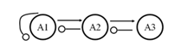
$$A=\left(\begin{matrix}-1 & 1 & 0 \\ -1 & 0 & 1 \\ 0 & -1 & 0\end{matrix}\right)$$
Figure C2. Signed digraph of a three-trophic linear chain system and its corresponding community matrix.

Inverting the community matrix, one obtains a matrix ${\left(A\right)}^{-1}$; each coefficient $-{\left(a_{ij}\right)}^{-1}$of this inverted matrix yields the net effect of a press perturbation acting on species j over species i, according to the following relations:

(2)

(3)

in which $\vec{x}$ is the vector of the variables, A is the community matrix, $\vec{F}$ is the vector of growth functions of the variables, and c is the parameter that undergoes a variation due to a sustained perturbation. This relation implies that A must have a non-zero determinant and must admit an inverse matrix ${\left(A\right)}^{-1}$ whose eigenvalues must satisfy the Lyapunov conditions of stability. The vector is for simplicity taken equal to one because no information about the power (i.e. quantification) of the press perturbation is available. This net effect is due to direct interactions with species i (i.e. predation or intraspecific competition) plus, eventually, one or more indirect interactions (i.e. paths) through which species i and j are connected via intermediate species (Bender et al. 1984, Levins 1975). For each simulated matrix, a table of predictions is produced; in it the response of the variables is given as the percentage of the signs predicted in the simulation. Each model yields z tables of predictions (i.e. considering the z stable matrices over the $[n × 1,000]$ community matrices that the software simulates; n = number of variables in the model). An overall table of predictions is then constructed combining on a percentage base the predictions of the z tables. For a given prediction, if all the z matrices (100% of the cases) yield the same sign (+ or -), the direction of change (i.e. the prediction) is easily assigned (+/-). However, there are cases in which a certain quota of the matrices yields a given sign (e.g. +) and another part renders the opposite sign (-). Overall, this prediction, whether it is a + or a -, depends on the percentage of matrices that return a sign in respect to those that yield the opposite outcome. We defined a set of rules for decision that are shown in Table C1. The rules convert percentages of signs obtained from the simulations (% of + and % of –) in signs for the predicted effects. More specifically, when more than 50% of the z stable matrices return sign - ([-100, -50]) or sign + ([50, 100]) for a given prediction, than this sign is retained in the final table of predictions. When the (either + or -) sign appears as the prediction outcome in a percentage between 20% and 50% then the prediction takes that sign but with a question mark, indicating a tendency to change in that direction. 0* is not a real null change in the variable’s level, but a neutral result due to a balanced amount of negative and positive effects (i.e. quasi-compensation.

Table C1. Rules to deduce signs from simulations. The rules convert percentages of signs obtained through simulations (% of + and % of –) in signs for the predicted effects. The round parenthesis stands for extreme values excluded; 0* is not a real zero, meaning no change in the variable, but a neutral result due to a balanced amount of negative and positive effects (i.e. quasi-compensation).
(% of + and % of -) | Overall prediction
[-100, -50] | -
(-50, -20) | ?- (tendency to -)
[-20, +20] | 0*
(+20, +50) | ?+ (tendency to +)
[+50, +100] | +

Appendix D: Predictions and correlations
The following example considers a simple resource (P)-consumer (H) model and shows that the correlation between them depends on the source of variation (e.g. the entry point of the input). The table below the model tells that a positive input to P is expected to increase the abundance of H but not to have effect on P itself. These outcomes can be easily obtained using the example of calculation in Figure D1 as a guide. The positive effect on H depends on the path from P to H, that is positive (arrow), multiplied by the sign of its complementary feedback that is negative (-1). Further, the product of these two terms has to be multiplied by the sign of the input (assumed to be positive) and divided by the sign of the overall feedback, which is the negative loop formed by P and H. This product yields the positive prediction (+). P itself would not be changing because the path from P to itself is positive (+1, no matter whether there is a negative self-effect on the variable; Puccia and Levins 1985) but the complementary feedback is null because H is not involved in any loop. Because H is increasing and P is not changing, a zero correlation will result for inputs entering through P. A positive input to H is predicted to augment H itself and reduce P: thus H and P are negatively correlated. Correlations for negative inputs are obviously the same because only the sign of the input is changing. Correlations between any two variables thus depends on the entry point of the input.
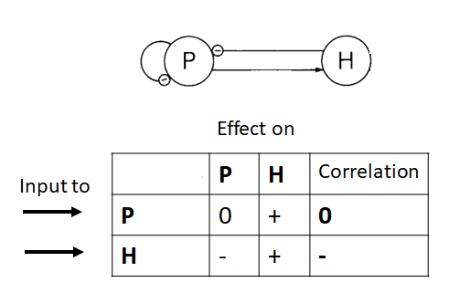
Figure D1. Simple resource-consumer model, its table of predictions, and expected correlations.

In the model below (Fig. D2), the table of predictions can be used as a diagnostic tool. For example, if observations revealed that only variable E changed, likely an input entered the system through variable C, because this is the only case in which all the variables remain unchanged but E. Also, the model predicts an overall positive correlation between H and E. This overall correlation can be deduced by looking down the columns for H and E. For three out of the four inputs (on P, H and E) these two components change in the same direction so that we expect a general positive correlation between them. The input to C leaves these two variables uncorrelated so it does not contribute to the overall correlation between H and E. Variables P and H tend to be negatively correlated: in two cases (input on H and C) they change in opposite directions, and in the other two cases no correlation would be expected. According to this example, the overall correlation between two variables can be obtained by scrolling down the columns of their expected changes and observing their covariations.
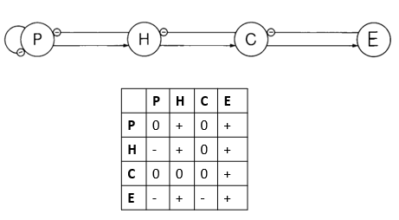
Figure D2. A four-variable linear chain model and its table of predictions.

In the absence of any information about whether a parameter input affected one or more variables we can assume (Puccia and Levins 1985) that over a sufficient time interval (or spatial scale) there may be variations causing parameter changes at one or more nodes in the graph. Therefore, variations eventually detected in their trends may be the overall effect of several (unknown) parameter inputs that may have affected one or more variables. In this case, to compare predicted and observed correlations, one must be looking down any two columns in the table of predictions to obtain overall pairwise expected correlations (Puccia and Levins 1985). However, a well-defined correlation pattern between any two variables emerges from the table of predictions only if all inputs produce coherent variations in their level, that is either they change in opposite directions (negative correlation) or they do in the same direction (positive correlations). If at least one input yields a different correlation (i.e. the two variables rise and fall together following all inputs but one, which instead produces opposite variations in the two variables, one rise and the other fall, so that they appear negatively correlated for that input) the correlation would be indeterminate. To overcome this problem, we simulated multiple inputs over each and every node and computed for each variable an overall prediction in response to these multiple inputs. An example output is given here below (Table D1):

Table D1. Simulation output, accounting for concurrent inputs across all model variables.
F EF AL SP LP V DP IB CB
+F 95.96 95.96 -75.75 -5.05 -75.75 -23.23 5.05 5.05 -75.76
+EF 95.96 97.98 -75.75 -5.05 -75.76 -23.23 5.05 5.05 -75.76
+AL -75.76 -75.76 75.76 5.05 75.76 23.23 -5.05 -5.05 75.76
+SP 100 100 -100 89.9 -100 -97.98 -89.9 -89.9 -100
+LP -100 -100 57.57 -73.74 100 85.86 73.74 73.737 100
+V -100 -100 100 -89.9 100 100 89.9 89.9 100
+DP -98.99 -100 100 -89.9 100 100 100 100 100
+IB -100 -100 100 -89.9 100 100 89.9 100 100
+CB -97.98 -97.98 91.91 -49.49 91.92 71.72 49.5 49.5 97.98
mean -31.20 -31.09 30.41 -34.23 35.13 37.37 35.35 36.47 35.8
signs - - + - + + + + +

In Table D1 the first column lists all the inputs that are simulated and their sign (+F means a positive input on F). Along each row one reads the fraction (on a -100/+100 scale) of the runs that yielded a given prediction for the column variable. For example, the number shown at the intersection between column (F) and the row (+AL) is -75.76. It indicates that about 76% of the runs yielded a negative prediction for F in response to a positive input targeting AL. To obtain an overall response of the variables to concurrent inputs, the numbers that compose that variable’s column are averaged, and the result is stored in the row “mean”. The sign of this “mean” value gives the overall direction of change for that column’s variable. Expected pairwise correlations are then obtained by comparing the “signs” of any two variables. For example, in Table D1 the row “sign” (last row of the Table) indicates that F and EF are expected to decrease their level in response to the concurrent inputs. Accordingly, the expectation is that they are positively correlated. For the sake of simplicity, all the simulated inputs in this example were positive (+ in the first column). In our analysis, however, for every model we simulated 1000 times concurrent inputs, with negative and positive inputs assigned randomly at each run. Every simulation yielded a table like Table D1. We registered expected correlations between the variables in each of the 1000 simulated matrices. Then, we counted how many times, over the 1000 runs, the expected correlations matched with the observed correlations that are given in Table B2. Finally, to identify the model that exhibits the highest correspondence with the observed correlations, we counted the number of times the matching between expected and observed correlations occurred concurrently for all the pairs of variables. Table D2 shows for each of the 36 models analyzed (rows from C1 to C36) the fraction over the 1000 executed runs in which the matching between predicted and observed correlations holds concomitantly for the 15 pairwise correlations. Next to this outcome Table D2 also shows the percentage of stable matrices that each model yielded in resulted from the simulation. Model selection for a better description of the system has been conducted on the basis of the best aggregate performance in terms of matching correlation patterns and stability, with priority given to the latter.

Table D2. Number of times over the 1000 simulation runs that each model yielded the concomitant matching between predicted and observed correlations for all the 15 pairs of variables (first column, Match/1000). The second column indicates the percentages of stable matrices for each model (details are in Appendix C). Grey shading denotes the best-performing model (Figure 1, main paper).

Model | Match/1000 |  | % Stability |  | Model |  | Match/1000 | % Stability
C1 |  | 278 |  | 27.61 | C19 | 483 |  |  | 8.37
C2 |  | 360 |  | 22.84 | C20 | 440 |  |  | 8.59
C3 |  | 439 |  | 14.31 | C21 | 173 |  |  | 36.04
C4 |  | 224 |  | 15.49 | C22 | 54 |  |  | 35.58
C5 |  | 280 |  | 11.79 | C23 | 81 |  |  | 33.99
C6 |  | 455 |  | 7.43 | C24 | 38 |  |  | 31.10
C7 |  | 580 |  | 20.11 | C25 | 93 |  |  | 23.44
C8 |  | 482 |  | 13.03 | C26 | 27 |  |  | 21.91
C9 |  | 427 |  | 8.30 | C27 | 266 |  |  | 20.08
C10 |  | 219 |  | 11.21 | C28 | 26 |  |  | 42
C11 |  | 346 |  | 7.34 | C29 | 44 |  |  | 39
C12 |  | 170 |  | 26.22 | C30 | 31 |  |  | 29
C13 |  | 204 |  | 19.71 | C31 | 12 |  |  | 32
C14 |  | 227 |  | 20.42 | C32 | 40 |  |  | 29
C15 |  | 290 |  | 11.77 | C33 | 51 |  |  | 20
C16 |  | 448 |  | 11.60 | C34 | 43 |  |  | 38
C17 |  | 475 |  | 6.59 | C35 | 80 |  |  | 29
C18 |  | 370 |  | 28.08 | C36 | 36 |  |  | 20

Appendix E: Interaction links
Interaction links
Forests (F) and ecosystem functions (EF) affect each other positively: the former and the biodiversity they host sustain ecological functions; these latter, in turn, maintain forest and its biodiversity (Table E1a, Brockerhoff et al. 2017). AL is the reservoir of land that both small property (SP) and large property (LP) exploit. The former farms for food security and small business, whereas the latter do it for cattle ranching and large-scale agricultural production. Graphs in Table E1b-c illustrate these interactions. Available land, if unused, may also be colonized by vegetation and forest regrowth may occur (Sanchez-Cuervo et al. 2012, Rubiano et al. 2017); thus, forest regrowth is favoured by land availability while the areas that host regrown forests reduce land availability. Accordingly, the interaction between AL and F corresponds to a resource-consumer type (Table E1d). Violence (V) is targeted mostly to small property (Carrillo 2009; see also section 5, FARC and Paramilitary scenarios, in the main body of the paper); we represented this action with a negative link from V to SP (Table E1e). Small property increases community cohesion; as such, it favours settling and thus counteracts displacement (Ramos-Vidal et al. 2019): a negative link from SP to DP is thus considered in the models (Table E1f). Together, the relationships depicted in Table E1e-f highlight the path through which violence makes land available: the two negative links $V-oSP-oAL$ form a path that carries an overall positive effect; this representation highlights the mechanism of land abandonment due to violence (Carrillo 2009).

Large property has been a major cause of deforestation. The lack of a regulative framework due to conflict conditions fuelled forest clearing for cattle ranching purposes (Sanchez-Cuervo and Aide 2013, Murillo-Sandoval et al. 2023). This is represented here with a negative link from LP to F (Table E1g). This negative link combined with the negative effect by F over AL (Table E1d) makes a path that show how large property creates available land through deforestation:
$LP-oF-oAL$. Illicit business has been described as a foremost driver of deforestation (Davalos et al. 2011, Negret et al. 2019). A negative link is thus depicted from IB to F (Table E1h); at the same time, IB thrives when remains covered, which we translated into a positive link from F to IB (Table E1h).

Illicit business expands also because of land grabbing (Murillo-Sandoval et al. 2023, Davalos et al. 2011, Negret et al. 2019). The following series of links represent this mechanism. First, illicit business inflates violence (Holmes et al. 2006, Andreas and Wallman 2009), which translates into a positive link from IB to V (Table E1i). Combined with the negative effect that violence exerts over small property (Table E1e) and the negative link from SP to AL (Table E1b), one obtains a path through which illicit business increases land availability $IB→V-oSP-oAL$. This land can be now exploited by illegal activities so that we inserted this exploitative action as a resource-consumer interaction between IB and AL (Table E1l). Thus, the mechanism of land grabbing by illicit business is associated to the positive feedback: $IB→V-oSP-oAL→IB.$

Illicit business inhibits ecological functions: pesticides are applied and reagents used for processing coca contaminate the environment (Armstead 1992): a negative link between IB and EF describes this relationship (Table E1m). Illicit business may offer a shortcut to displaced people as alternative for employment, so displaced people may become a workforce for illicit business which, in turn, provides opportunity for settling (Rincón-Ruiz et al. 2016). A positive link from DP to IB and a negative link from IB to DP are depicted (Table E1n). Large property stimulates capital business because this latter requires vast extensions of land to be profitable and landowners may be attracted by this opportunity (Castiblanco et al. 2015): an arrow from LP to CB is added here (Table E1o). Capital business exerts a negative effect on small property because of its powerful lobbying and financial capacity that easily expropriates land and deprives rural people (Boron et al. 2016); a negative link from CB to SP describes this relationship (Table E1p). This link combined with the negative effect of small property on displaced people yields a paths, ($CB-oSP-oDP$) which increases the rate of people displacement (Maher 2015). This path highlights the role that capital business might have on the rural environment within the conflict framework (Boron et al. 2016). Large property inflates violence. This effect occurs both as a reaction to unequal land distribution (motivation for lefty guerrilla groups) and because paramilitaries were paid for protection against insurgent groups or to force small owners to abandon their land (Lopez-Uribe and Sanchez-Torres 2024). A positive effect has been inserted from LP and V (Table E1q). The graphic description in Table E1r shows a positive link from CB to LP. This link considers that capital business becomes profitable on large areas, so it may favour land concentration (Castiblanco et al. 2015). Small farming (SP), basically relies upon natural mechanisms (i.e. ecological functions; Boron et al. 2016) to sustain their productivity; we thus added a positive link from EF to SP (Table E1s). Two further interactions complete this list and are depicted in Table E1t-u. They take into account the aggression that capital business operates over forest cover and the attractiveness that this latter exerts over capital business (Potter 2020, IUCN-NL 2023).

References
Andreas P., Wallman J. (2009). Illicit markets and violence: what is the relationship? Crime Law Soc Change, 52: 225–229. https://doi.org/10.1007/s10611-009-9200-6.
Armstead L. (1992). Illicit narcotics cultivation and processing: the ignored environmental drama. UN-ODCCP Bulletin on Narcotics, 2: 9–20.
Boron V., Payán E., MacMillan D., Tzanopoulos J. (2016). Achieving sustainable development in rural areas in Colombia: Future scenarios for biodiversity conservation under land use change, Land Use Policy, 59: 27-37, ISSN 0264-8377, https://doi.org/10.1016/j.landusepol.2016.08.017
Brockerhoff E.G., Barbaro L., Castagneyrol B. et al. (2017). Forest biodiversity, ecosystem functioning and the provision of ecosystem services. Biodivers Conserv, 26: 3005–3035. https://doi.org/10.1007/s10531-017-1453-2.
Carrillo A.C. (2009). Internal displacement in Colombia: Humanitarian, economic and social consequences in urban settings and current challenges. International Review of the Red Cross, 91:527 – 546. DOI: 10.1017/S1816383109990427.
Castiblanco C., Etter A., Ramirez A. (2015). Impacts of oil palm expansion in Colombia: what do socioeconomic indicators show? Land Use Policy, 44:31–43.
http://dx.doi.org/10.1016/j.landusepol.2014.10.007
Davalos L.M., Bejarano A.C., Hall M.A., Correa H.L., Corthals A.P., Espejo O.J. (2011). Forests and drugs: coca-driven deforestation in tropical biodiversity hotspots. Environ Sci Technol, 45: 1219–1227
Holmes J. S., de Piñeres S. A. G. (2006). The Illegal Drug Industry, Violence and the Colombian Economy: A Department Level Analysis. Bulletin of Latin American Research, 25: 104–118. http://www.jstor.org/stable/27733823.
IUCN-NL (2023). Insights in the supply chain. Palm oil from Colombia to EU. IUCN-The Netherlands, 74pp.
Lopez-Uribe M., Sanchez-Torres F. (2024). Ideology and Rifles: The Agrarian Origins of Civil Conflict in Colombia, World Development, 173: 106387. ISSN 0305-750X,
https://doi.org/10.1016/j.worlddev.2023.106387
Maher D. (2015). Rooted in Violence: Civil War, International Trade and the Expansion of Palm Oil in Colombia, New Political Economy, 20: 299-330.
https://doi.org/10.1080/13563467.2014.923825
Murillo-Sandoval P.J., Kilbride J., Tellman E. et al. (2023). The post-conflict expansion of coca farming and illicit cattle ranching in Colombia. Sci Rep 13, 1965 https://doi.org/10.1038/s41598-023-28918-0

Negret P.J., Sonter L., Watson J.E.M., Possingham H.J., Jones K.R., Suarez C., Ochoa-Quintero J.M., Maron M. (2019). Emerging evidence that armed conflict and coca cultivation influence deforestation patterns. Biological Conservation, 239: 108176. ISSN 0006-3207, https://doi.org/10.1016/j.biocon.2019.07.021.
Potter L. (2020). Colombia’s oil palm development in times of war and ‘peace’: Myths, enablers and the disparate realities of land control. Journal of Rural Studies, 78: 491-502. ISSN 0743-0167,
https://doi.org/10.1016/j.jrurstud.2019.10.035.
Ramos-Vidal I, Villamil I, Uribe A. (2019). Underlying Dimensions of Social Cohesion in a Rural Community Affected by Wartime Violence in Colombia. Int. J. Environ Res Public Health, 16(2):195. https://doi.org/10.3390/ijerph16020195
Rincón-Ruiz A., Correa H.L., León D.O., Williams S. (2016). Coca cultivation and crop eradication in Colombia: The challenges of integrating rural reality into effective anti-drug policy. International Journal of Drug Policy,33: 56-65,ISSN 0955-3959,https://doi.org/10.1016/j.drugpo.2016.06.011.
Rubiano, K., Clerici, N., Norden, N., Etter, A. (2017). Secondary Forest and Shrubland Dynamics in a Highly Transformed Landscape in the Northern Andes of Colombia (1985–2015). Forests 8: 216. https://doi.org/10.3390/f8060216.
Sánchez-Cuervo A.M., Aide T.M., Clark M.L., Etter A. (2012). Land cover change in Colombia: Surprising Forest recovery trends between 2001 and 2010. PLoS One 7: e43943. https://doi.org/10.1371/journal.pone.0043943.
Sanchez-Cuervo A.M., Aide, T.M. (2013). Consequences of the Armed Conflict, Forced Human Displacement, and Land Abandonment on Forest Cover Change in Colombia: A Multi-scaled Analysis. Ecosystems 16: 1052–1070. DOI: 10.1007/s10021-013-9667-y.

Table E1. Interactions between the models’ components as deduced from the elicitation-based information and the literature. Interactions are shown according to loop analysis symbolism (left column) and briefly described (right column).
Core interactions | Description and meaning
a) 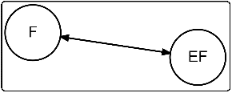 | Ecological functions sustain forests and the biodiversity they host; forest and biodiversity in turn foster ecological functions
b) 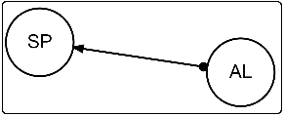 | Small property exploits available land for food security and small business
c) 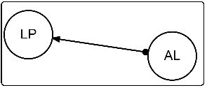 | Large property exploits available land for cattle ranching and large-scale agriculture
d) 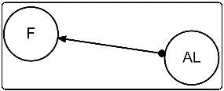 | Forest regrowth takes over on land that is not used and reduces available land
e) 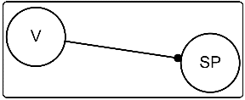 | Violence targets small property to force rural people leaving their land
f) 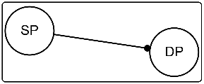 | Small property counteracts displacement as it promotes social cohesion and settling
g) 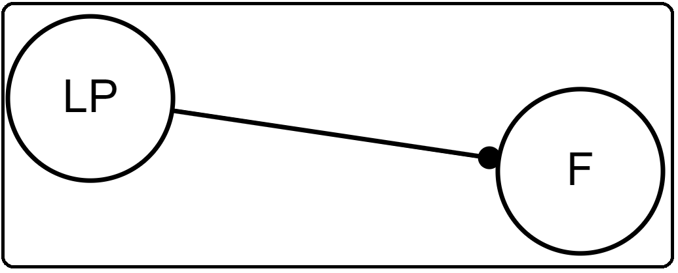 | Large property expands cattle ranching and large-scale agriculture at the expense of forests
h) 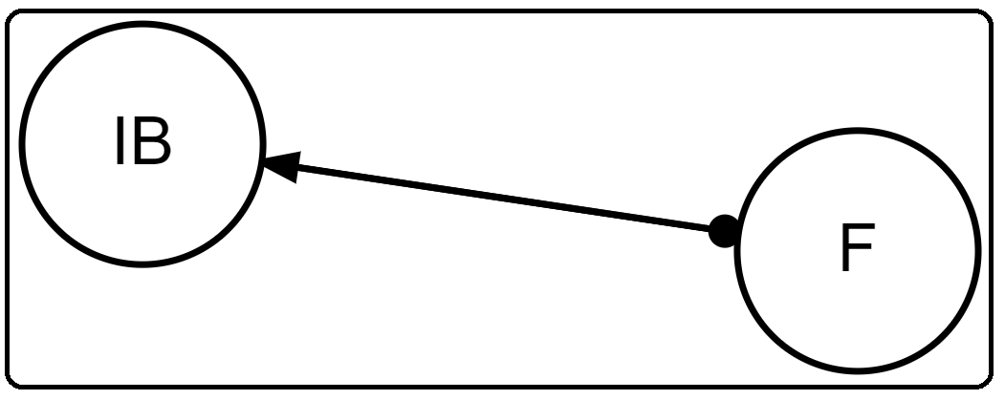 | Illicit business reduces forests, which offer protection to it
i) 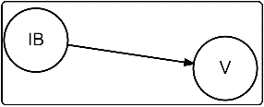 | Illicit business inflates violence
l) 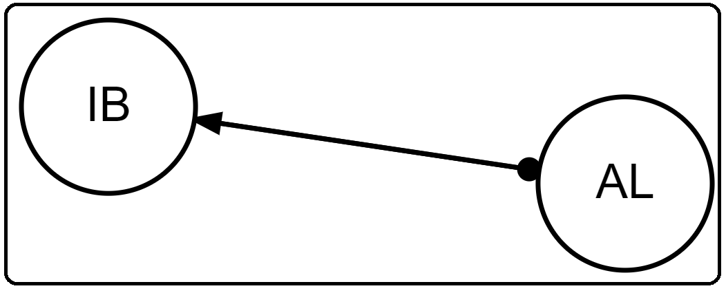 | Illicit business exploits available land. Land that is abandoned becomes available and occupied by criminal gangs for illicit productions
m)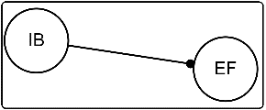 | Illicit business inhibits ecological functions: pesticides and reagents used for coca production and processing are discharged directly in the environment
n)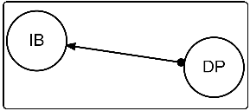 | Displaced people are offered working and settling opportunities by illicit business and increase its workforce.
o) 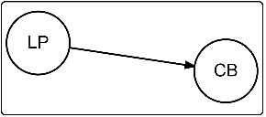 | Capital business requires vast extensions of land to be profitable, so large property stimulates capital intensive activities
p) 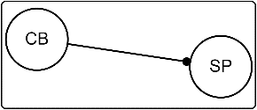 | Capital business exerts a negative effect on small property because of its financial capacity to convince small owners to sell their land
q) 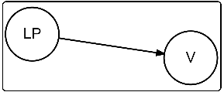 | Large property inflates violence. This occurs either as a reaction to unequal land distribution (lefty guerrilla groups) or because paramilitaries were paid for protection against insurgent groups
r) 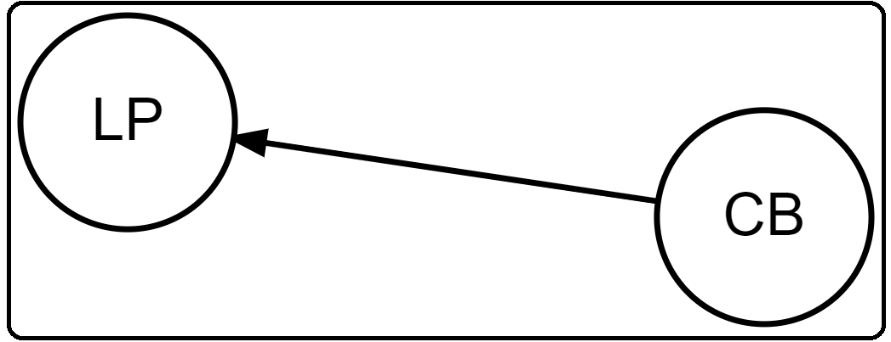 | Capital business becomes profitable on large areas, so it favors land concentration
s) 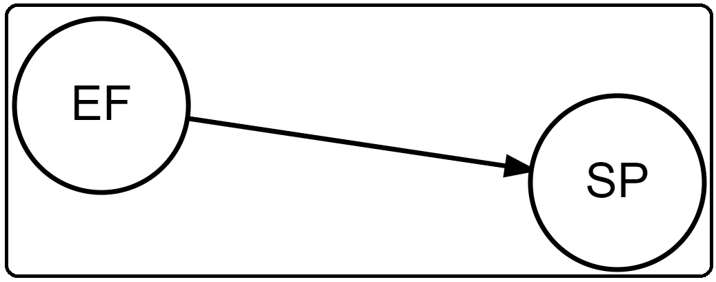 | Ecological functions constitute the very productive base for small farming practices
t) 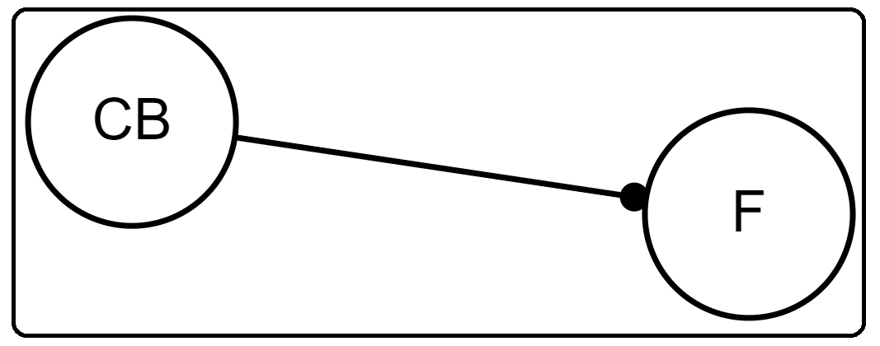 | Capital business inflates forest exploitation
u) 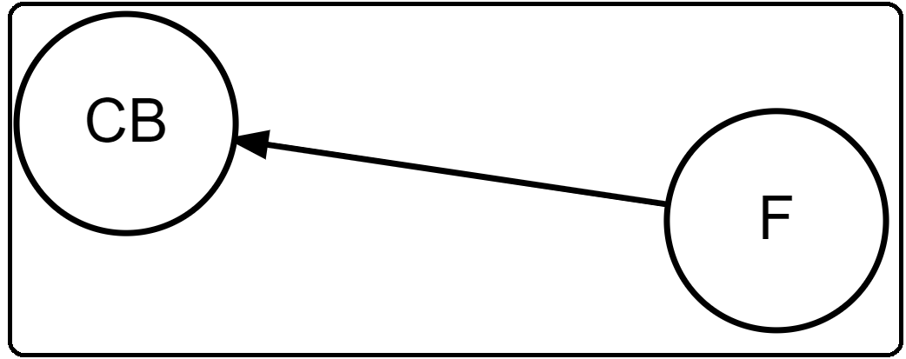 | Forest may attract capital business enterprises

We assumed all the variables but IB as self-regulated. By excluding the self-regulation term on illicit business we wanted to emphasize that the dynamics of illicit activities as intrinsically not subjected to any regulation. A parsimonious model necessarily simplifies a complex reality and leaves out several factors that interact with the variables of the system. To account for the connections with external components or factors, a self-damping on the model variables can be added (Puccia and Levins 1985). By inserting negative self-effects on all the variables but IB, we wanted to take into account the many regulative factors that we could not include as variables in the models. Also mathematical convenience is important: negative self-loops increase the probability of stability, a necessary condition for the moving equilibrium approach to apply (Puccia and Levins 1985).

Appendix F: Paths
Paths possess a magnitude (path_strength) that is the product of the intensity of the links that form the path, averaged over the number of stable matrices resulting from simulation. The sign of each path is indicated in the last column (path_sign).
Model C7 (Figure 1 in main text)

From CB to DP
nodes path_strength #_nodes path_sign
1 CB, SP, AL, F, IB, DP 0.032 6 -1
2 CB, SP, AL, LP, F, IB, DP 0.013 7 1
3 CB, SP, DP 0.18 3 1

From CB to SP
nodes path_strength #_nodes path_sign
1 CB, SP 0.47 2 -1

From SP to F
nodes path_strength #_nodes path_sign
1 SP, AL, F 0.238 3 -1
2 SP, AL, LP, F 0.0932 4 1
3 SP, DP, IB, F 0.098 4 1
4 SP, DP, IB, EF, F 0.04 5 1

From SP to IB
nodes path_strength #_nodes path_sign
1 SP, AL, F, IB 0.132 4 -1
2 SP, AL, LP, F, IB 0.052 5 1
3 SP, DP, IB 0.184 3 -1

From SP to V
nodes path_strength #_nodes path_sign
1 SP, AL, F, IB, V 0.062 5 -1
2 SP, AL, LP, F, IB, V 0.0242 6 1
3 SP, AL, LP, V 0.087 4 -1
4 SP, DP, IB, F, AL, LP, V 0.0088 7 -1
5 SP, DP, IB, EF, F, AL, LP, V 0.00364 8 -1
6 SP, DP, IB, V 0.086 4 -1

From IB to CB
nodes path_strength #_nodes path_sign
1 IB, F, EF, SP, AL, LP, CB 0.009 7 1
2 IB, F, AL, LP, CB 0.05 5 1
3 IB, EF, F, AL, LP, CB 0.020 6 1
4 IB, EF, SP, AL, LP, CB 0.018 6 1
5 IB, V, SP, AL, LP, CB 0.017 6 1

From IB to SP
nodes path_strength #_nodes path_sign
1 IB, F, EF, SP 0.10 4 -1
2 IB, F, AL, SP 0.15 4 1
3 IB, F, AL, LP, V, SP 0.021 6 -1
4 IB, F, AL, LP, CB, SP 0.02 6 -1
5 IB, EF, F, AL, SP 0.062 5 1
6 IB, EF, F, AL, LP, V, SP 0.009 7 -1
7 IB, EF, F, AL, LP, CB, SP 0.0091 7 -1
8 IB, EF, SP 0.21 3 -1
9 IB, V, SP 0.22 3 -1

References
Bender, E.A., Case, T.J., Gilpin, M.E., 1984. Perturbation experiments in community ecology: theory and practice. Ecology 65 (1), 1-13. https://doi.org/10.2307/1939452
Bodini A., Pereira D., Scotti M., 2024. The decline of kilkas, sturgeons and seals in the Caspian Sea: The potential of qualitative loop analysis for the cumulative assessment of multiple drivers of stress. Marine Pollution Bulletin, 200, 116091. https://doi.org/10.1016/j.marpolbul.2024.116091
Levins, R., 1975. Evolution in communities near equilibrium, p. 16-50. In Cody, M.L., Diamond, J.M. [Eds.], Ecology and Evolution of Communities. Harvard University Press.
Logofet, D.O., 1993. Matrices and graphs: stability problems in mathematical ecology. CRC press.
Montoya, J.M., Woodward, G., Emmerson, M.C., Solé, R.V., 2009. Press perturbations and indirect effects in real food webs. Ecology 90 (9), 2426-2433. https://doi.org/10.1890/08-0657.1
Puccia, C.J., Levins, R. 1985. Qualitative modelling of complex systems. Cambridge, Harvard University Press.
Wootton, J.T., 2002. Indirect effects in complex ecosystems: recent progress and future challenges. J. Sea Res. 48 (2), 157-172. https://doi.org/10.1016/S1385-1101(02)00149-1

The signs of the links making the path must be multiplied to obtain the effect of the path.

