Palladium supported on ethylenediaminetetraacetic acid functionalized cellulose: Synthesis, characterization, and its application in carbon−carbon cross-coupling reactions
Zhian Xu, Jinxi Xu, Waner Zheng, Yiqun Li*

Department of Chemistry, College of Chemistry and Materials Science, Jinan University, Guangzhou 511443, China

Outline
1. Optimization of condition for Pd@Cell-EDTA-catalyzed Suzuki reactions…………….…….P2
2. Optimization of condition for Pd@Cell-EDTA-catalyzed Sonogashira reactions……………..P3
3. Spectral data for the synthesized compounds ………………………………………….P4
4. Copies of ¹H, ¹³C NMR for the synthesized compounds …………………………. …P10
5. Copies of ¹⁹ F NMR for the synthesized fluorochemicals……………………………. P37

- Optimization of conditions for Pd@Cell-EDTA-catalyzed Suzuki reactions.
To search the optimal reaction conditions for Suzuki reactions, iodobenzene (1.0 mmol) and phenylboronic acid (1.2 mmol) was selected as model substrates and various conditions were systematically explored (Table S1). Firstly, different solvents were screened and the results showed that the reaction proceeded best under 78% EtOH (Table S1, Entry 8). Low yields were led by other solvents (Table S1, Entries 1−7). Secondly, to examine the catalytic activity of the Pd@Cell-EDTA, the model reaction was performed in incremental amount of catalyst. It was found that 0.05 mol % of Pd is enough to push the reaction to the end successfully (Table S1, Entry 18). Further increasing the dose of Pd to 0.10 and 0.15 mol% obtained the lower yields Table S1, entry 8 and 17). Finally, the temperature effect on this catalytic system was investigated. Reducing the reaction temperature from 78 ℃ to 50 ℃ and to room temperature, the product yields decreased from 89 % to 80 % and 59 %, respectively (Table S1, Entries 15 and 16). In conclusion, based on the above trials, the optimized reaction condition for the Suzuki model reaction was set at the usage of iodobenzene (1.0 mmol), phenylboronic acid (1.2 mmol), K₂CO₃ (2.0 mmol), and 0.05 mol % of Pd under 2 ml 78% EtOH at 78 ℃.
Table S1 Optimization conditions for Pd@Cell-EDTA-catalyzed Suzuki reactions ª
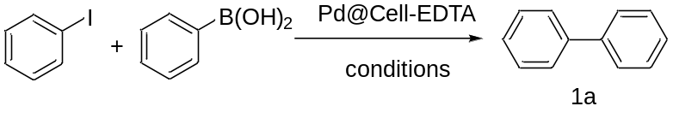
Entry | Solvent | Base | Time / min | Yield ^{b} / %
1 | DMSO | K₂CO₃ | 30 | Trace
2 | DMF | K₂CO₃ | 30 | 28
3 | MeCN | K₂CO₃ | 30 | Trace
4 | PhCH₃ | K₂CO₃ | 30 | 23
5 | 1,2-dichloroethane | K₂CO₃ | 30 | 29
6 | H₂O | K₂CO₃ | 30 | 51
7 | EtOH | K₂CO₃ | 30 | 64
8 | 78% EtOH | K₂CO₃ | 30 | 89
9 | 78% EtOH | None | 45 | N.R.
10 | 78% EtOH | KOH | 45 | 91
11 | 78% EtOH | K₃PO₄·3H₂O | 45 | 82
12 | 78% EtOH | CH₃COONa | 45 | 16
13 | 78% EtOH | Et₃N | 45 | 48
14 | 78% EtOH | Piperidine | 45 | 31
15^{c} | 78% EtOH | K₂CO₃ | 45 | 80
16^{d} | 78% EtOH | K₂CO₃ | 120 | 59
17e | 78% EtOH | K₂CO₃ | 30 | 84
18^{f} | 78% EtOH | K₂CO₃ | 30 | 99
ª Reaction conditions: iodobenzene (1.0 mmol), phenylboronic acid (1.2 mmol), catalyst (0.10 mol%), base (2.0 mmol), solvent (2 mL), 78 ℃. ^{b} Isolated yield. ^{c} 50℃. ^{d} room temperature. ^{e} 0.15 mmol% of catalyst was used. ^{f} 0.05 mol% of catalyst was used.

- Optimization of condition for Pd@Cell-EDTA-catalyzed Sonogashira reactions.
In order to furtherly explore the application universality of Pd@Cell-EDTA, Sonogashira reactions had been performed in the presence of Pd@Cell-EDTA catalytic system to prepare corresponding diphenylacetylene. The model reaction of iodobenzene (1.0 mmol) and phenylacetylene (1.2 mmol) was exerted to search of the optimal reaction conditions (Table S2). Among the screened solvents, MeOH (Table S2, entry 7) gave the best yields while aprotic solvent such as DMSO, DMF, acetonitrile, and toluene (Table S2, entries 1-4) as well as protic solvent H₂O (Table S2, entry 5) afford lower yields or gave no product. Subsequently, it is gratifying that 0.10 mol % of Pd in the catalyst was enough to push the reaction forward to completion in highest yield (Table S2, entry 7). Further increasing the catalyst loading could not efficiently promote the product yields (Table S2, entry 14). Unfortunately, with the exception of K₂CO₃, none of the other bases could make the reaction proceed smoothly (Table S2, entries 8-11). Moreover, the temperature effect on the model was also explored and it resulted that only trace of product had been detected while decreasing the temperature from 70 ℃ to 50 ℃ (Table S2, Entry 12). To conclude, the optimal condition for model reaction involved the usage of iodobenzene (1.0 mmol), phenylacetylene (1.2 mmol), K₂CO₃ (2.0 mmol), and 0.10 mol % of Pd of catalyst in 3 mL MeOH at 65 ℃.
Table S2 Optimization conditions for Pd@Cell-EDTA-catalyzed Sonogashira reactions ª
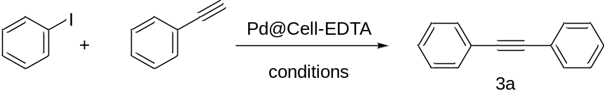
Entry | Solvent | Base | Time / h | Yield ^{b} / %
1 | DMSO | K₂CO₃ | 2 | 21
2 | DMF | K₂CO₃ | 2 | Trace
3 | MeCN | K₂CO₃ | 2 | N.R.
4 | Toluene | K₂CO₃ | 2 | N.R.
5 | H₂O | K₂CO₃ | 2 | N.R.
6 | EtOH | K₂CO₃ | 2 | 79
7 | MeOH | K₂CO₃ | 2 | 94
8 | MeOH | KOH | 2 | Trace
9 | MeOH | NaOAc | 2 | Trace
10 | MeOH | Et₃N | 2 | 19
11 | MeOH | Piperidine | 2 | 26
12^{c} | MeOH | K₂CO₃ | 2 | trace
13^{d} | MeOH | K₂CO₃ | 3.5 | 90
14e | MeOH | K₂CO₃ | 2 | 95
ª Reaction conditions: iodobenzene (1.0 mmol), phenylacetylene (1.2 mmol), base (2.0 mmol), catalyst (0.10 mol%), 3ml solvent at 70 ℃. ^{b} Isolated yield. ^{c} 50 ℃. ^{d} 0.05 mol% catalyst was used. ^{e} 0.15 mol% catalyst was used.

3. Spectral data for the synthesized compounds
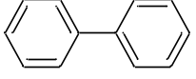
1,1'-biphenyl (1a)
¹H NMR (300 MHz, Chloroform-d) δ 7.78 – 7.66 (m, 4H), 7.62 – 7.50 (m, 4H), 7.51 – 7.39 (m, 2H). ¹³C NMR (75 MHz, Chloroform-d) δ 141.37, 128.90, 127.39, 127.31.
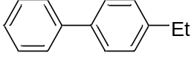
4-ethyl-1,1'-biphenyl (1b)
¹H NMR (300 MHz, Chloroform-d) δ 7.98 (d, J = 8.2 Hz, 2H), 7.91 (d, J = 8.0 Hz, 2H), 7.78 (t, J = 7.7 Hz, 2H), 7.69 (d, J = 6.9 Hz, 1H), 7.63 (d, J = 7.9 Hz, 2H), 3.06 (q, J = 7.6 Hz, 2H), 1.67 (t, J = 7.6 Hz, 3H). ¹³C NMR (75 MHz, Chloroform-d) δ 143.69, 141.61, 139.04, 129.16, 128.73, 127.51, 127.41, 28.98, 16.04.
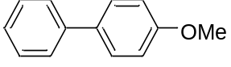
4-methoxy-1,1'-biphenyl (1c)
¹H NMR (300 MHz, Chloroform-d) δ 7.53 (t, J = 7.6 Hz, 4H), 7.40 (t, J = 7.6 Hz, 2H), 7.28 (t, J = 7.3 Hz, 1H), 6.96 (d, J = 8.7 Hz, 2H), 3.82 (s, 3H). ¹³C NMR (75 MHz, Chloroform-d) δ 159.21, 140.88, 133.83, 128.79, 128.21, 126.79, 126.72, 114.27, 55.38.
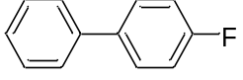
4-fluoro-1,1'-biphenyl (1d)
¹H NMR (300 MHz, Chloroform-d) δ 7.67 (t, J = 6.9 Hz, 4H), 7.57 (t, J = 7.3 Hz, 2H), 7.53 – 7.44 (m, 1H), 7.26 (t, J = 8.7 Hz, 2H). ¹³C NMR (75 MHz, Chloroform-d) δ 162.64 (d, J = 244.5 Hz), 140.38, 137.45, 128.98, 128.83 (d, J = 8.3 Hz), 127.42, 127.16, 115.76 (d, J = 21.0 Hz). ¹⁹F NMR (282 MHz, Chloroform-d) δ -115.64.
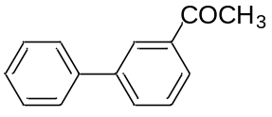
1-([1,1'-biphenyl]-3-yl)ethan-1-one (1e)
¹H NMR (300 MHz, Chloroform-d) δ 8.20 (s, 1H), 7.91 (d, J = 7.7 Hz, 1H), 7.75 (d, J = 7.7 Hz, 1H), 7.66 – 7.55 (m, 2H), 7.55 – 7.31 (m, 4H), 2.62 (s, 3H). ¹³C NMR (75 MHz, Chloroform-d) δ 198.00, 141.65, 140.14, 137.66, 131.71, 129.11, 129.00, 127.88, 127.27, 127.20, 126.91, 26.75.
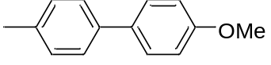
4-methoxy-4'-methyl-1,1'-biphenyl (1f)
¹H NMR (300 MHz, Chloroform-d) δ 7.63 – 7.49 (m, 4H), 7.30 (d, J = 8.5 Hz, 2H), 7.09 – 6.99 (m, 2H), 3.91 (s, 3H), 2.46 (s, 3H). ¹³C NMR (75 MHz, Chloroform-d) δ 159.01, 138.03, 136.40, 133.81, 128.01, 126.64, 114.24, 55.38, 21.12.
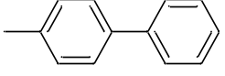
4-methyl-1,1'-biphenyl (1g)
¹H NMR (300 MHz, Chloroform-d) δ 7.80 – 7.73 (m, 2H), 7.68 (d, J = 8.0 Hz, 2H), 7.59 (t, J = 7.4 Hz, 2H), 7.49 (t, J = 7.3 Hz, 1H), 7.42 (d, J = 7.9 Hz, 2H), 2.57 (s, 3H). ¹³C NMR (75 MHz, Chloroform-d) δ 141.25, 138.45, 137.06, 129.59, 128.82, 127.09, 127.06, 21.19.
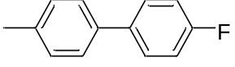
4-fluoro-4'-methyl-1,1'-biphenyl (1h)
¹H NMR (300 MHz, Chloroform-d) δ 7.67 (dd, J = 8.2, 5.8 Hz, 2H), 7.59 (d, J = 7.9 Hz, 2H), 7.39 (d, J = 7.9 Hz, 2H), 7.25 (t, J = 8.7 Hz, 2H), 2.55 (s, 3H). ¹³C NMR (75 MHz, Chloroform-d) δ 162.42 (d, J = 243.7 Hz), 137.46, 137.36 (d, J = 3.0 Hz), 137.09, 129.65, 128.53 (d, J = 8.3 Hz), 126.93, 115.63 (d, J = 21.0 Hz), 21.12. ¹⁹F NMR (282 MHz, Chloroform-d) δ -115.97.
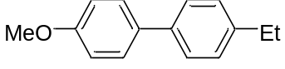
4-ethyl-4'-methoxy-1,1'-biphenyl (1i)
¹H NMR (300 MHz, Chloroform-d) δ 7.67 (t, J = 9.0 Hz, 4H), 7.41 (d, J = 7.9 Hz, 2H), 7.12 (d, J = 8.7 Hz, 2H), 3.95 (s, 3H), 2.85 (q, J = 7.6 Hz, 2H), 1.45 (t, J = 7.6 Hz, 3H). ¹³C NMR (75 MHz, Chloroform-d) δ 159.02, 142.73, 138.26, 133.76, 128.32, 128.00, 126.69, 114.23, 55.24, 28.55, 15.69.
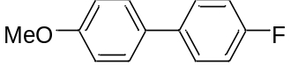
4-fluoro-4'-methoxy-1,1'-biphenyl (1j)
¹H NMR (300 MHz, Chloroform-d) δ 7.61 – 7.49 (m, 2H), 7.17 (t, J = 8.7 Hz, 1H), 7.04 (d, J = 8.7 Hz, 1H), 3.89 (s, 1H). ¹³C NMR (75 MHz, Chloroform-d) δ 162.16 (d, J = 244.5 Hz), 159.21, 136.98, 132.79, 128.23 (d, J = 8.2 Hz), 128.05, 115.58 (d, J = 21.0 Hz), 114.32, 55.27. ¹⁹F NMR (282 MHz, Chloroform-d) δ -116.52.
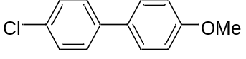
4-chloro-4'-methoxy-1,1'-biphenyl (1k)
¹H NMR (300 MHz, Chloroform-d) δ 7.51 (dd, J = 8.6, 4.8 Hz, 4H), 7.42 (d, J = 8.6 Hz, 2H), 7.02 (d, J = 8.7 Hz, 2H), 3.88 (s, 3H). ¹³C NMR (75 MHz, Chloroform-d) δ 159.44, 139.28, 132.70, 132.43, 128.90, 128.03, 127.94, 114.37, 55.33.
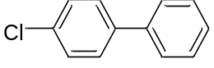
4-chloro-1,1'-biphenyl (1l)
¹H NMR (300 MHz, Chloroform-d) δ 7.52 – 7.41 (m, 3H), 7.41 (d, J = 2.3 Hz, 1H), 7.40 – 7.27 (m, 5H). ¹³C NMR (75 MHz, Chloroform-d) δ 130.0, 139.7, 133.4, 129.0, 129.0, 128.4, 127.7, 127.0.
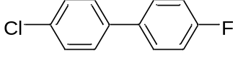
4-chloro-4'-fluoro-1,1'-biphenyl (1m)
¹H NMR (300 MHz, Chloroform-d) δ 7.47 – 7.26 (m, 6H), 7.06 (t, J = 8.6 Hz, 2H). ¹³C NMR (75 MHz, Chloroform-d) δ 162.68 (d, J = 245.2 Hz), 138.70, 136.13 (d, J = 3.0 Hz), 129.04, 128.61 (d, J = 8.2 Hz), 128.28, 115.83 (d, J = 21.7 Hz). ¹⁹F NMR (282 MHz, Chloroform-d) δ -114.85.
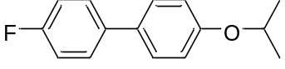
4-fluoro-4'-isopropoxy-1,1'-biphenyl (1n)
¹H NMR (300 MHz, Chloroform-d) δ 7.63 – 7.45 (m, 4H), 7.16 (t, J = 8.7 Hz, 2H), 7.03 (d, J = 8.6 Hz, 2H), 4.64 (hept, J = 6.0 Hz, 1H), 1.46 (s, 3H), 1.44 (s, 3H). ¹³C NMR (75 MHz, Chloroform-d) δ 162.17 (d, J = 243.7 Hz), 157.59, 137.14, 132.59, 128.24 (d, J = 8.3 Hz), 128.11, 116.25, 115.61 (d, J = 21.0 Hz), 70.01, 22.15. ¹⁹F NMR (282 MHz, Chloroform-d) δ -116.62.
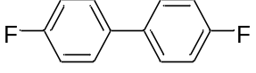
4,4'-difluoro-1,1'-biphenyl (1o)
¹H NMR (300 MHz, Chloroform-d) δ 7.52 (dd, J = 8.6, 5.4 Hz, 4H), 7.16 (t, J = 8.7 Hz, 4H). ¹³C NMR (75 MHz, Chloroform-d) δ 162.52 (d, J = 244.5 Hz), 136.42, 128.62 (d, J = 7.5 Hz), 115.73 (d, J = 24.0 Hz). ¹⁹F NMR (282 MHz, Chloroform-d) δ -115.57.
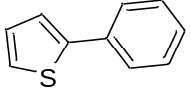
2-phenylthiophene (1p)
¹H NMR (300 MHz, Chloroform-d) δ 7.82 – 7.65 (m, 2H), 7.53 – 7.31 (m, 5H), 7.17 (m, 1H). ¹³C NMR (75 MHz, Chloroform-d) δ 144.57, 134.56, 129.04, 128.16, 127.61, 126.10, 124.95, 123.24.
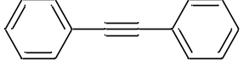
1,2-diphenylethyne (2a)
¹H NMR (300 MHz, Chloroform-d) δ 7.87 – 7.67 (m, 4H), 7.50 (d, J = 5.1 Hz, 6H). ¹³C NMR (75 MHz, Chloroform-d) δ 131.90, 128.65, 128.55, 123.58, 89.84.
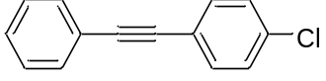
1-chloro-4-(phenylethynyl)benzene (2b)
¹H NMR (300 MHz, Chloroform-d) δ 7.59 (dd, J = 6.3, 2.7 Hz, 2H), 7.50 (d, J = 8.4 Hz, 2H), 7.46 – 7.30 (m, 5H). ¹³C NMR (75 MHz, Chloroform-d) δ 134.32, 132.88, 131.69, 128.76, 128.56, 128.48, 123.02, 121.86, 90.47, 88.40.
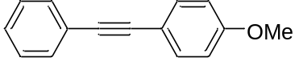
1-methoxy-4-(phenylethynyl)benzene (2c)
¹H NMR (300 MHz, Chloroform-d) δ 7.71 – 7.50 (m, 4H), 7.45 – 7.35 (m, 3H), 6.94 (d, J = 8.7 Hz, 2H), 3.82 (s, 3H). ¹³C NMR (75 MHz, Chloroform-d) δ 159.65, 133.08, 131.47, 128.36, 127.97, 123.64, 115.35, 114.04, 89.54, 88.18, 55.17.
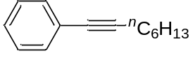
oct-1-yn-1-ylbenzene (2d)
¹H NMR (300 MHz, Chloroform-d) δ 7.40 – 7.37 (m, 2H), 7.31 – 7.17 (m, 3H), 2.39 (t, J = 7.0 Hz, 2H), 1.69 – 1.27 (m, 8H), 0.90 (t, J = 6.7 Hz, 3H). ¹³C NMR (75 MHz, Chloroform-d) δ 128.20, 127.47, 124.18, 90.50, 80.61, 31.44, 28.80, 28.67, 22.63, 19.47, 14.11.
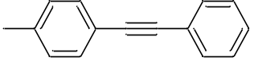
1-methyl-4-(phenylethynyl)benzene (2e)
¹H NMR (300 MHz, Chloroform-d) δ 7.54 (dd, J = 7.0, 2.3 Hz, 2H), 7.44 (d, J = 8.0 Hz, 2H), 7.40 – 7.29 (m, 3H), 7.17 (d, J = 7.9 Hz, 2H), 2.38 (s, 3H). ¹³C NMR (75 MHz, Chloroform-d) δ 138.39, 131.61, 131.57, 129.19, 128.38, 128.13, 123.57, 120.29, 89.74, 88.89, 21.51.
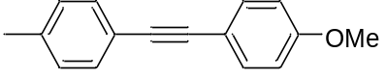
1-methoxy-4-(p-tolylethynyl)benzene (2f)
¹H NMR (300 MHz, Chloroform-d) δ 7.63 – 7.37 (m, 4H), 7.19 (d, J = 7.9 Hz, 2H), 6.91 (d, J = 8.7 Hz, 2H), 3.83 (s, 3H), 2.40 (s, 3H). ¹³C NMR (75 MHz, Chloroform-d) δ 159.59, 138.09, 133.07, 131.44, 129.19, 120.62, 115.67, 114.07, 88.84, 88.35, 55.29, 21.55.
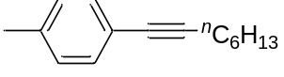
1-methyl-4-(oct-1-yn-1-yl)benzene (2g)
¹H NMR (300 MHz, Chloroform-d) δ 7.31 (d, J = 8.0 Hz, 2H), 7.10 (d, J = 7.9 Hz, 2H), 2.41 (t, J = 7.0 Hz, 2H), 2.34 (s, 3H), 1.68 – 1.33 (m, 8H), 0.93 (t, J = 6.8 Hz, 3H). ¹³C NMR (75 MHz, Chloroform-d) δ 137.39, 131.43, 128.95, 121.07, 89.65, 80.60, 31.43, 28.85, 28.66, 22.62, 21.40, 19.46.
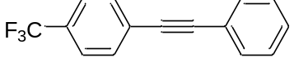
1-(phenylethynyl)-4-(trifluoromethyl)benzene (2h)
¹H NMR (300 MHz, Chloroform-d) δ 7.72 – 7.50 (m, 6H), 7.45 – 7.33 (m, 3H). ¹³C NMR (75 MHz, Chloroform-d) δ 131.95, 131.89, 130.04 (q, J = 32.2 Hz), 128.97, 128.59, 127.29 (q, J = 1.5 Hz), 125.40 (q, J = 3.7 Hz), 124.11 (q, J = 270.7 Hz), 122.73. ¹⁹F NMR (282 MHz, Chloroform-d) δ -62.73.
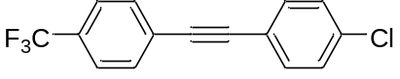
1-chloro-4-((4-(trifluoromethyl)phenyl)ethynyl)benzene (2i)
¹H NMR (300 MHz, Chloroform-d) δ 7.62 (s, 4H), 7.48 (d, J = 8.5 Hz, 2H), 7.35 (d, J = 8.5 Hz, 2H). ¹³C NMR (75 MHz, Chloroform-d) δ 134.97, 132.97, 131.83, 130.14 (q, J = 32.2 Hz), 128.85, 126.81, 125.33 (q, J = 37.5 Hz), 123.95 (q, J = 270.7 Hz), 121.10, 90.61, 88.91. ¹⁹F NMR (282 MHz, Chloroform-d) δ -62.78.
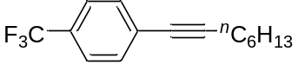
1-(oct-1-yn-1-yl)-4-(trifluoromethyl)benzene (2k)
¹H NMR (300 MHz, Chloroform-d) δ 7.52 (q, J = 8.4 Hz, 4H), 2.44 (t, J = 7.0 Hz, 2H), 1.72 – 1.27 (m, 8H), 0.94 (t, J = 6.7 Hz, 3H). ¹³C NMR (75 MHz, Chloroform-d) δ 131.75, 129.26 (q, J = 32.2 Hz), 128.07 (d, J = 1.5 Hz), 125.06 (q, J = 2.7 Hz), 124.07 (q, J = 270.7 Hz), 93.32, 79.51, 31.37, 28.64, 28.56, 22.57, 13.97. ¹⁹F NMR (282 MHz, Chloroform-d) δ -62.80.
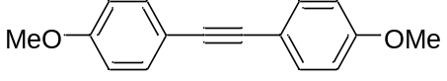
1,2-bis(4-methoxyphenyl)ethyne (2m)
¹H NMR (300 MHz, Chloroform-d) δ 7.48 (d, J = 8.7 Hz, 4H), 6.88 (d, J = 8.7 Hz, 4H), 3.81 (s, 6H). ¹³C NMR (75 MHz, Chloroform-d) δ 159.47, 132.94, 115.78, 114.04, 88.07, 55.30.

4. Copies of ¹H, ¹³C NMR for the synthesized compounds
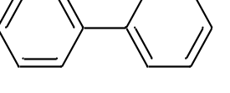
1,1'-biphenyl (1a)
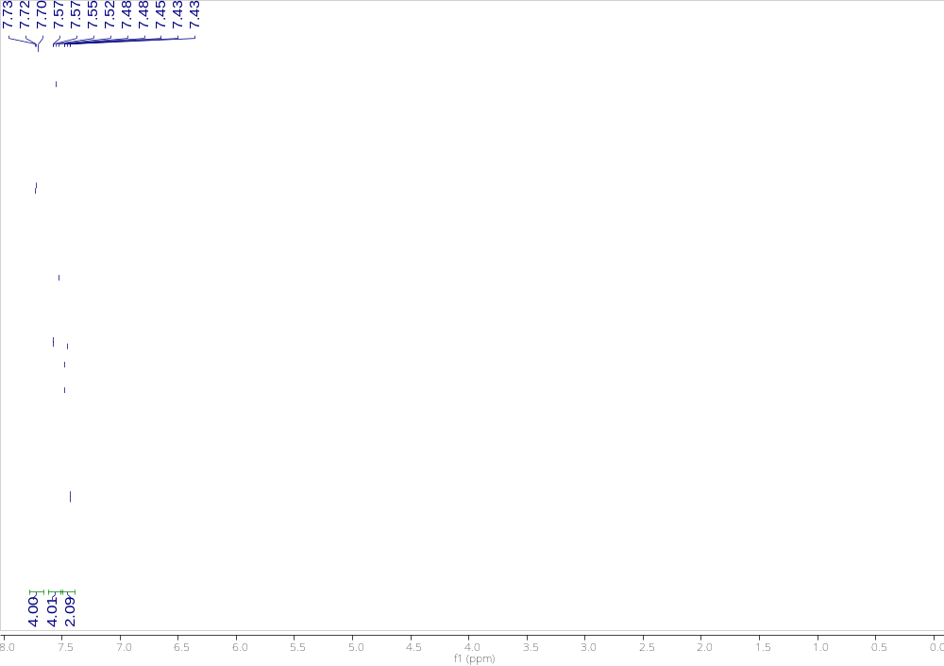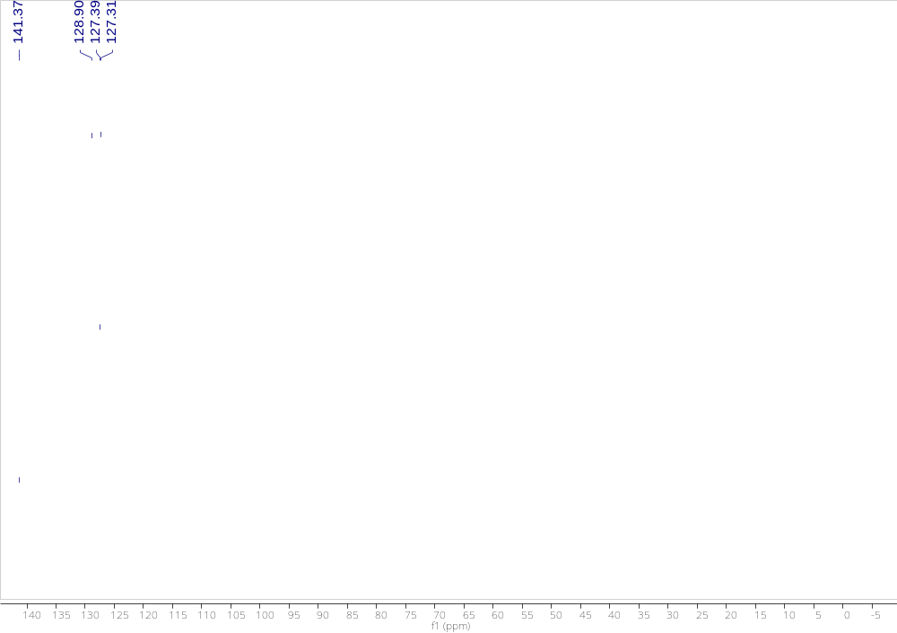
4-ethyl-1,1'-biphenyl (1b)
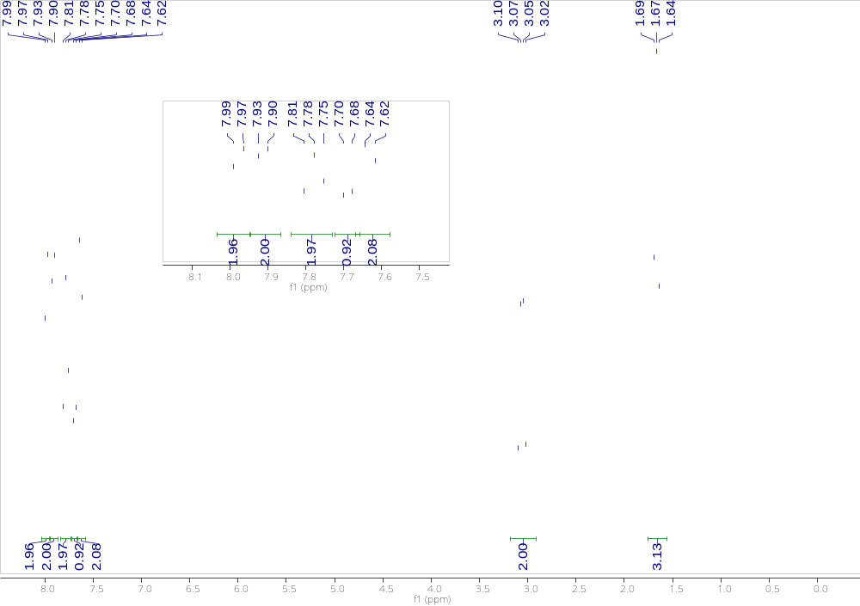
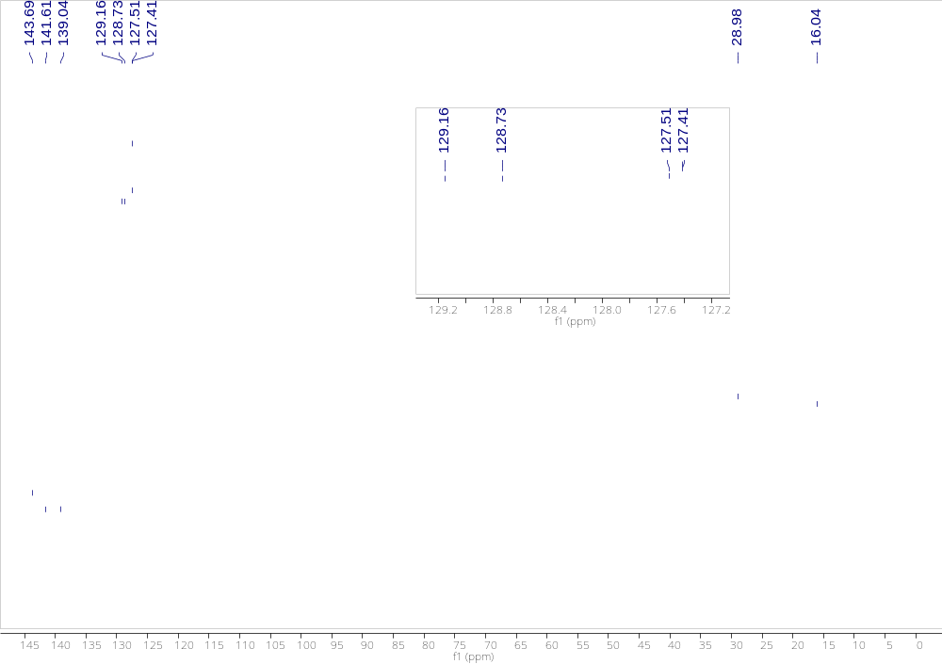

4-methoxy-1,1'-biphenyl (1c)
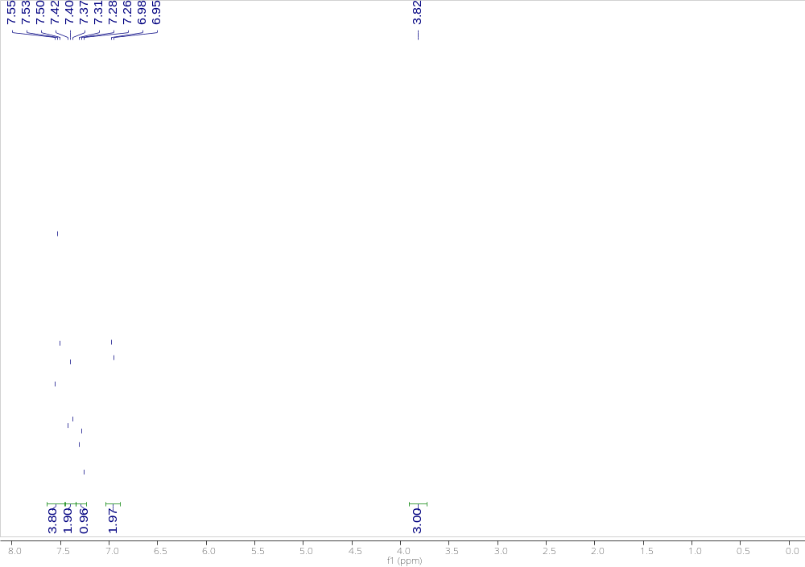
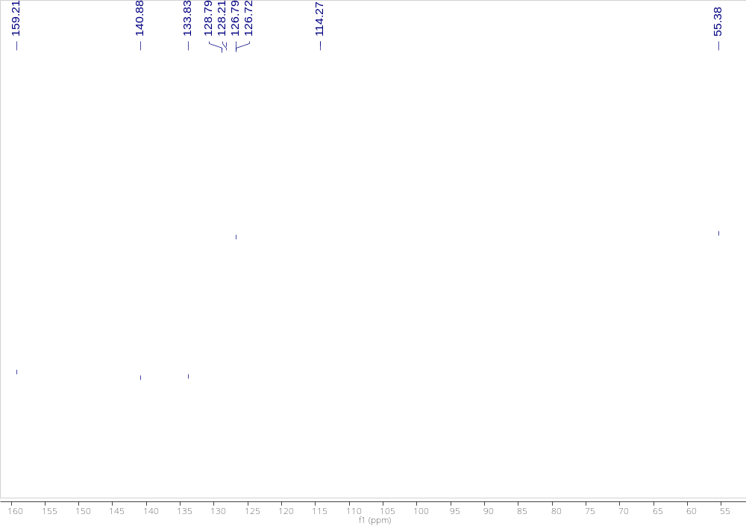

4-fluoro-1,1'-biphenyl (1d)
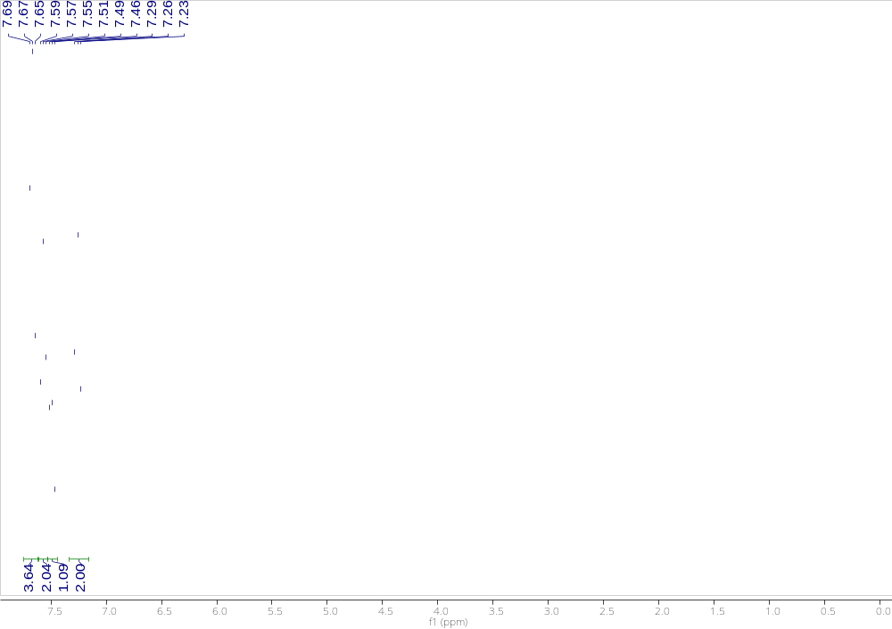
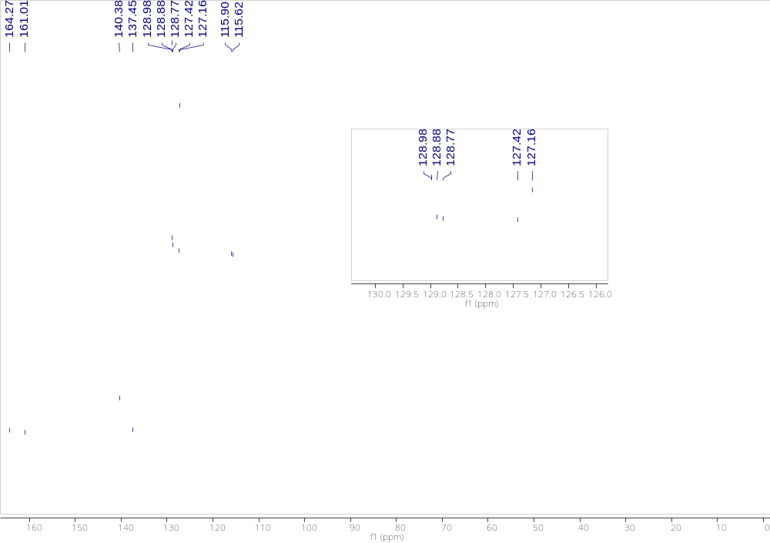

1-([1,1'-biphenyl]-3-yl)ethan-1-one (1e)
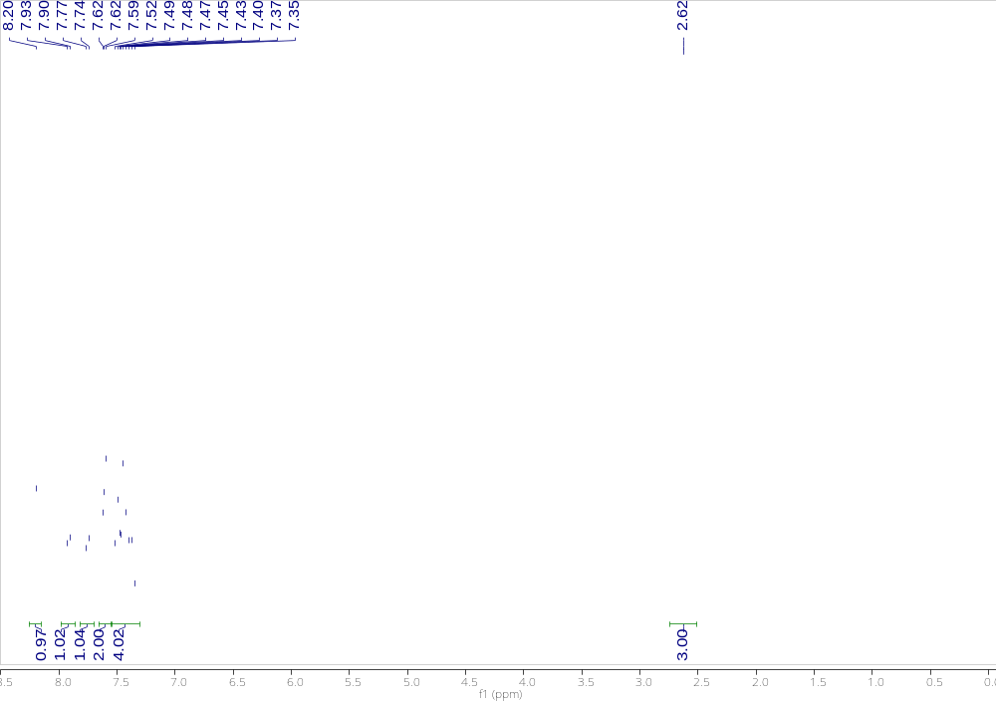
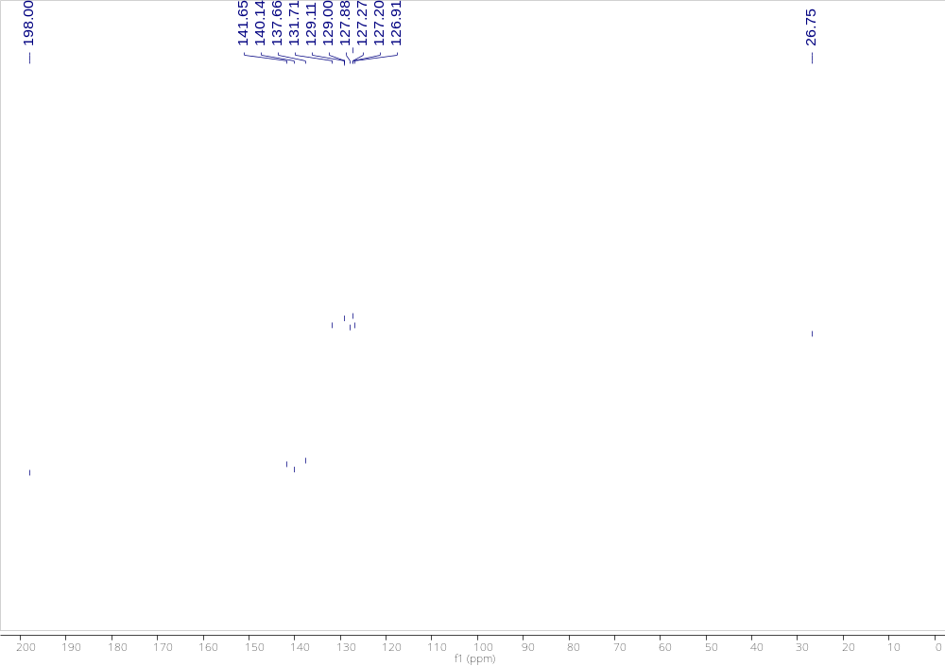

4-methoxy-4'-methyl-1,1'-biphenyl (1f)
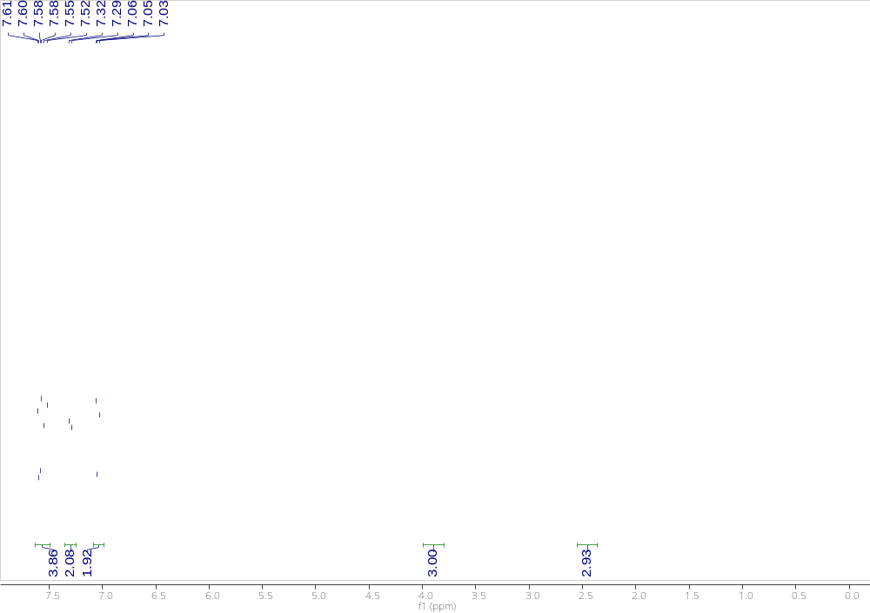
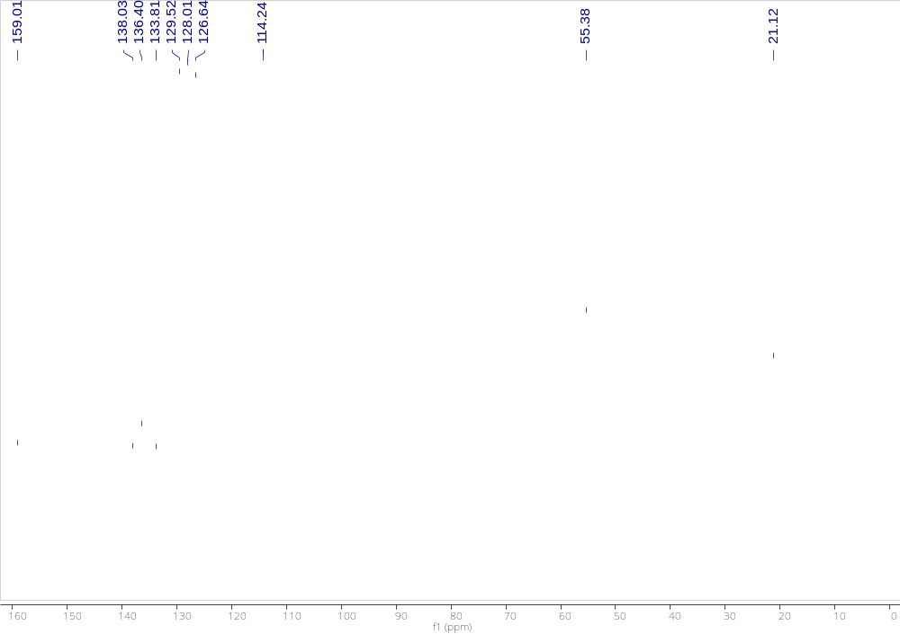

4-methyl-1,1'-biphenyl (1g)
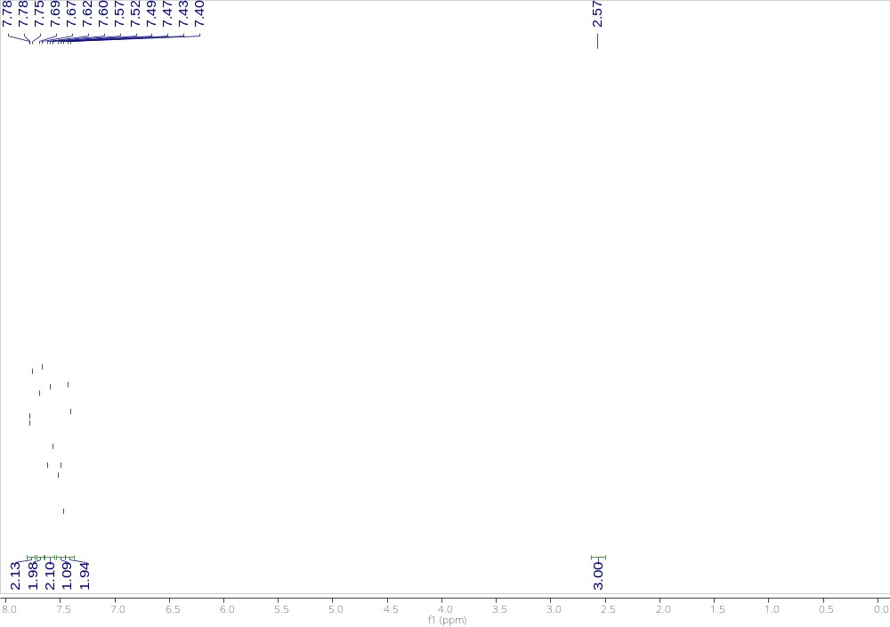
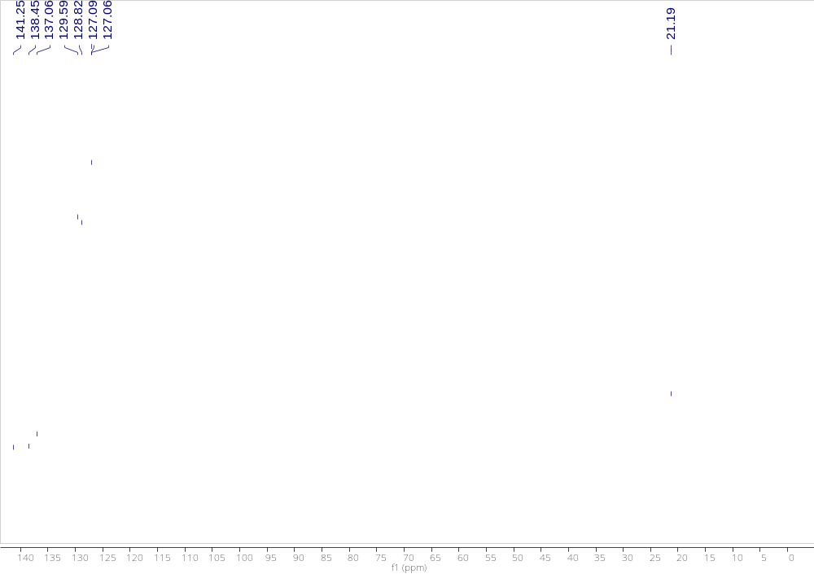

4-fluoro-4'-methyl-1,1'-biphenyl (1h)
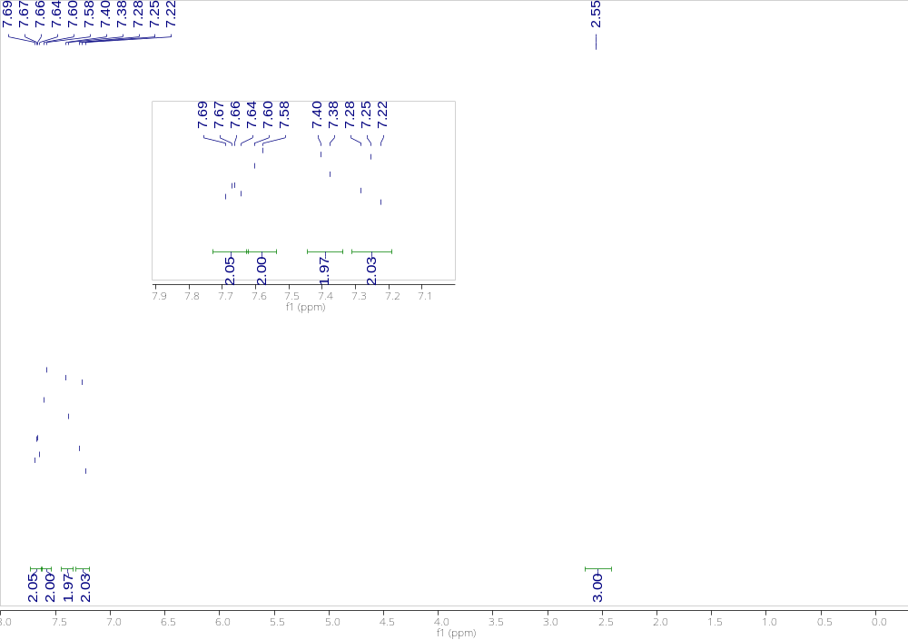
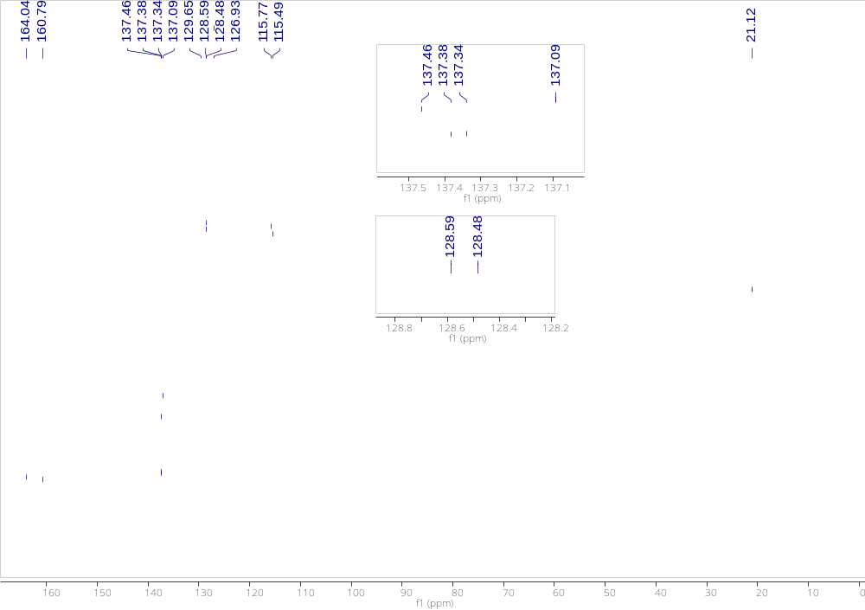

4-ethyl-4'-methoxy-1,1'-biphenyl (1i)
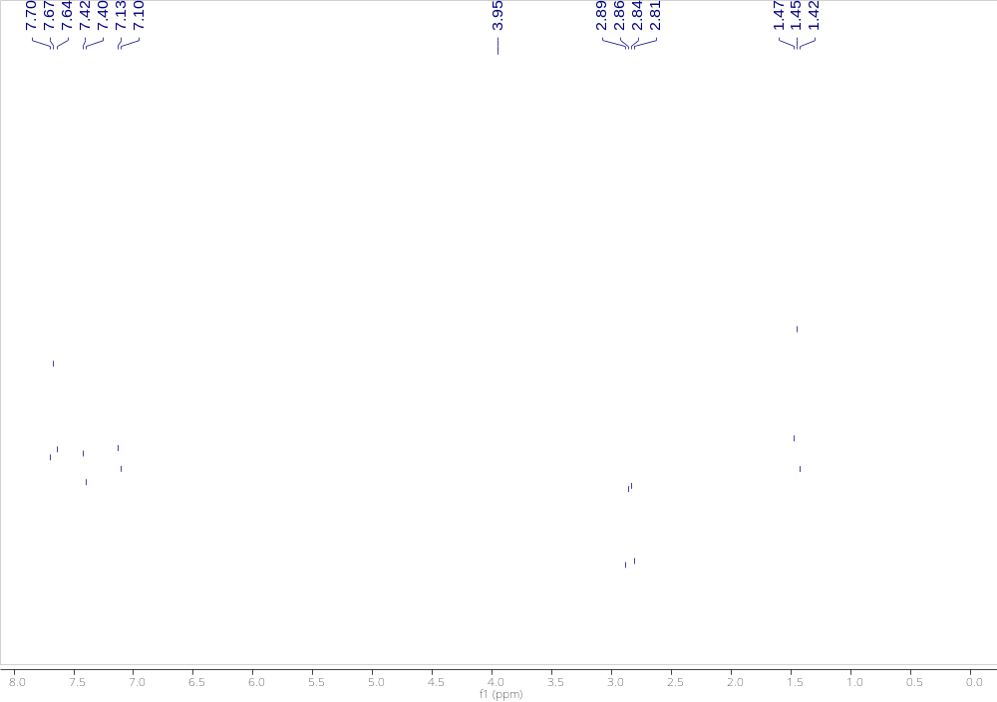
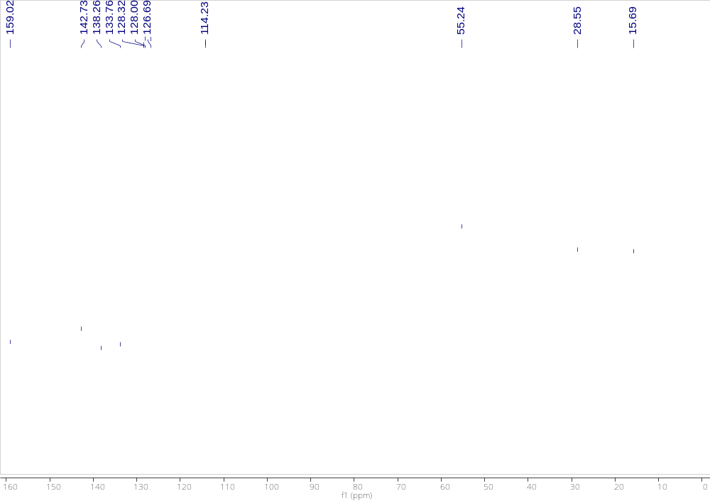

4-fluoro-4'-methoxy-1,1'-biphenyl (1j)
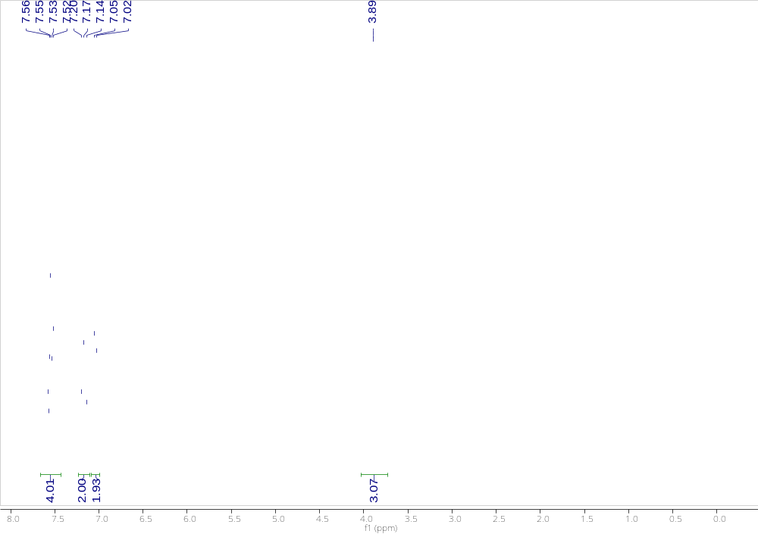
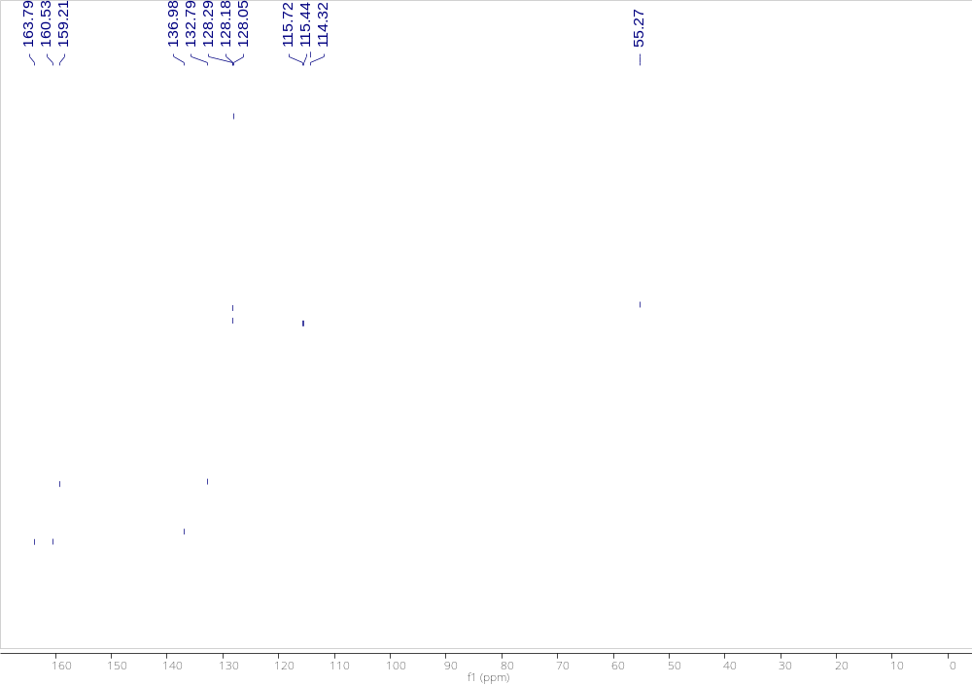

4-chloro-4'-methoxy-1,1'-biphenyl (1k)
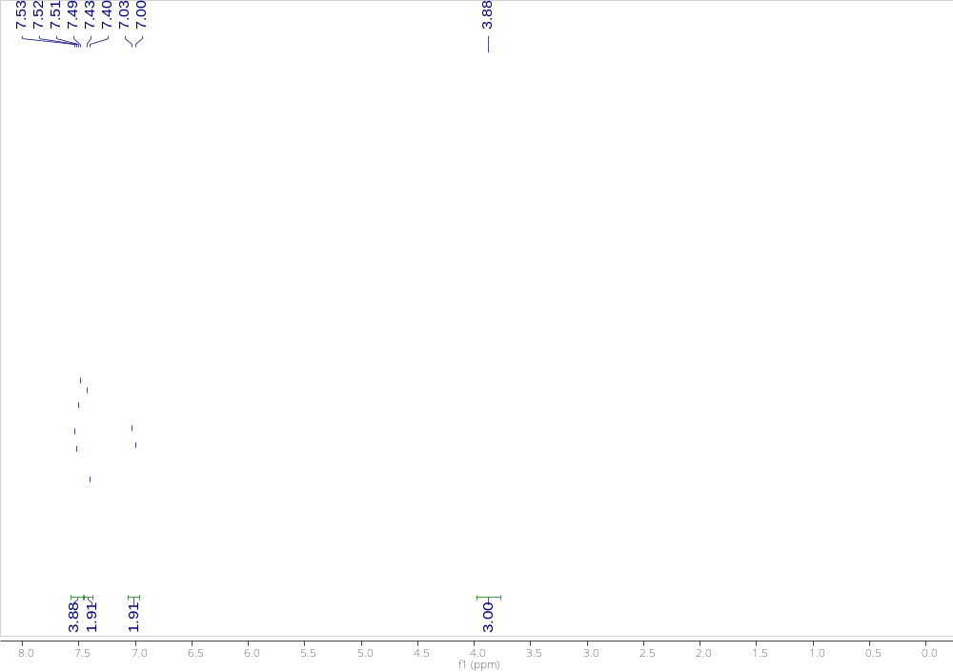
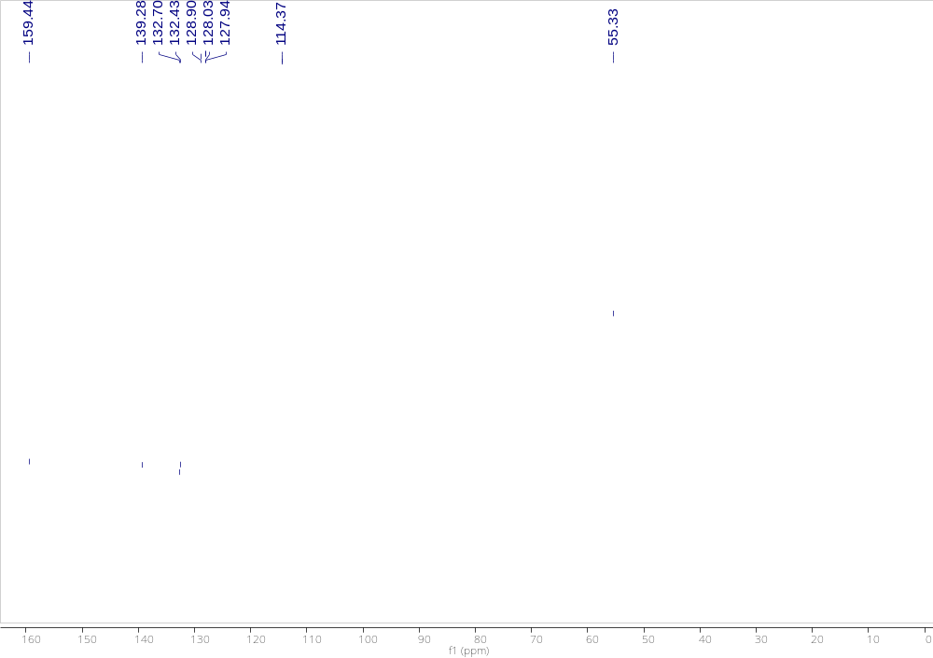

4-chloro-1,1'-biphenyl (1l)
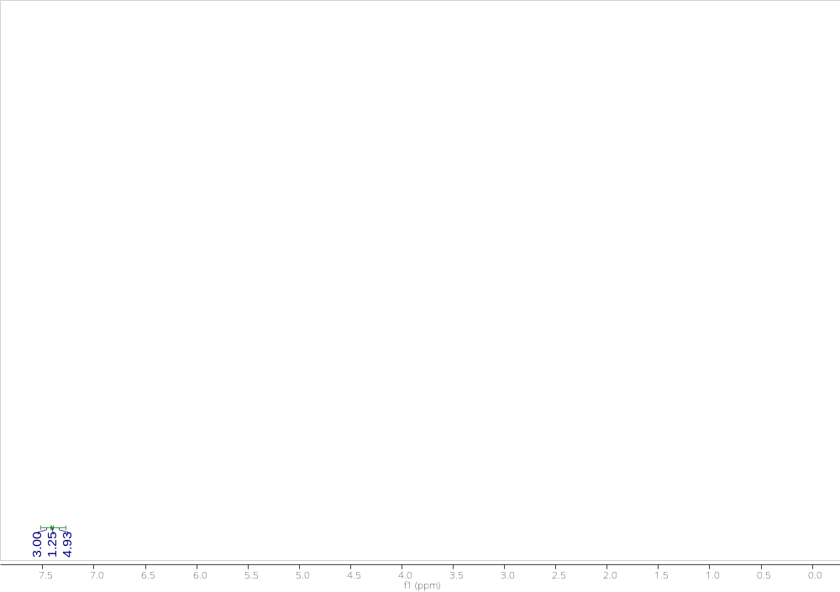
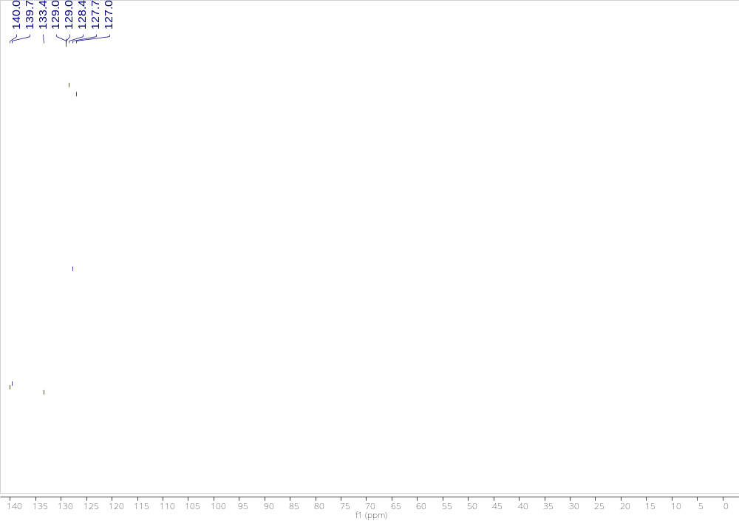

4-chloro-4'-fluoro-1,1'-biphenyl (1m)
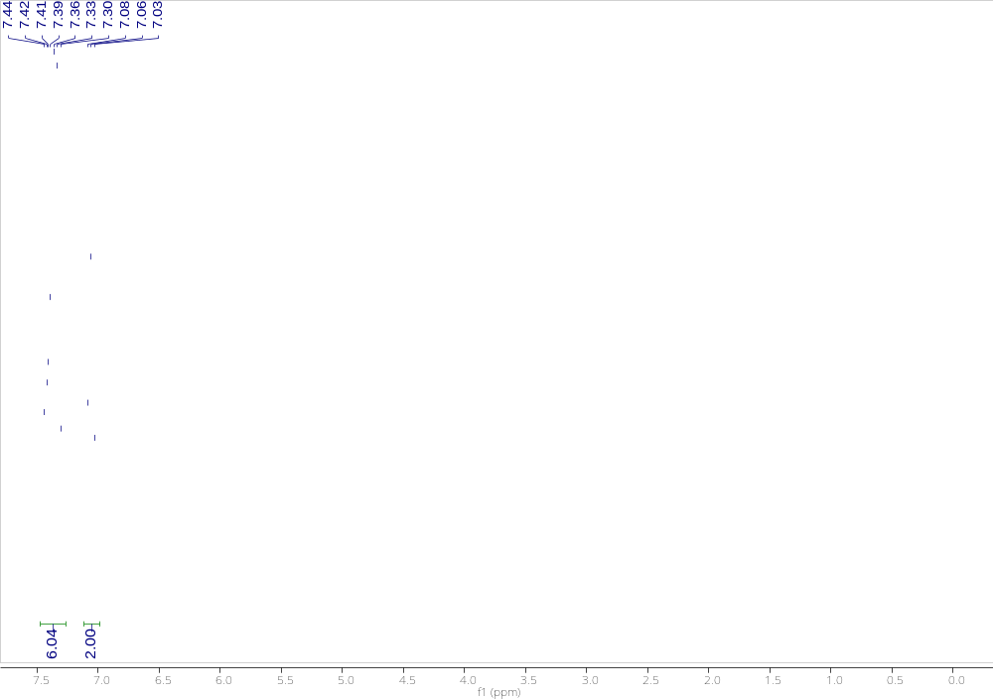
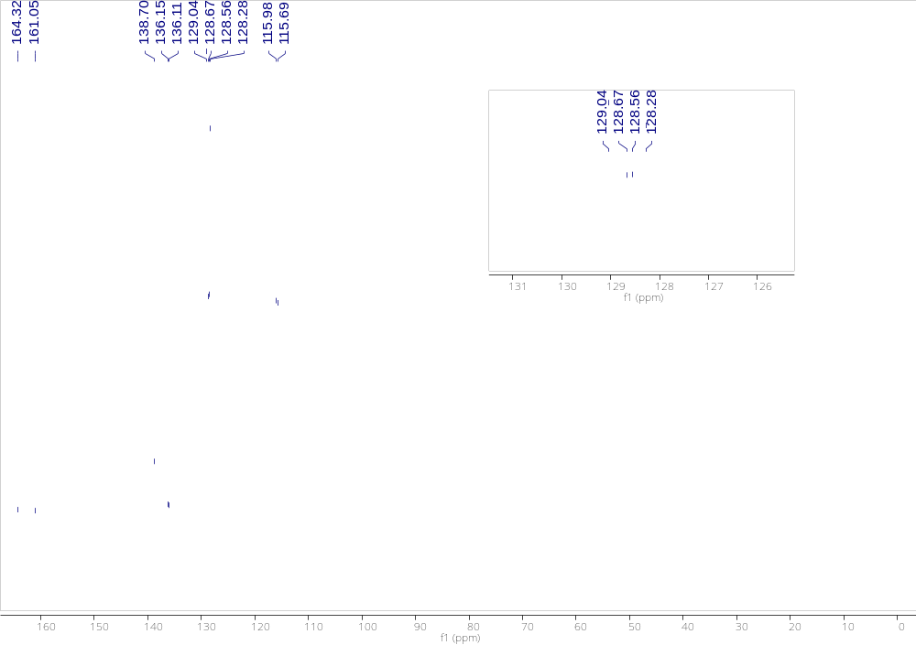

4-fluoro-4'-isopropoxy-1,1'-biphenyl (1n)
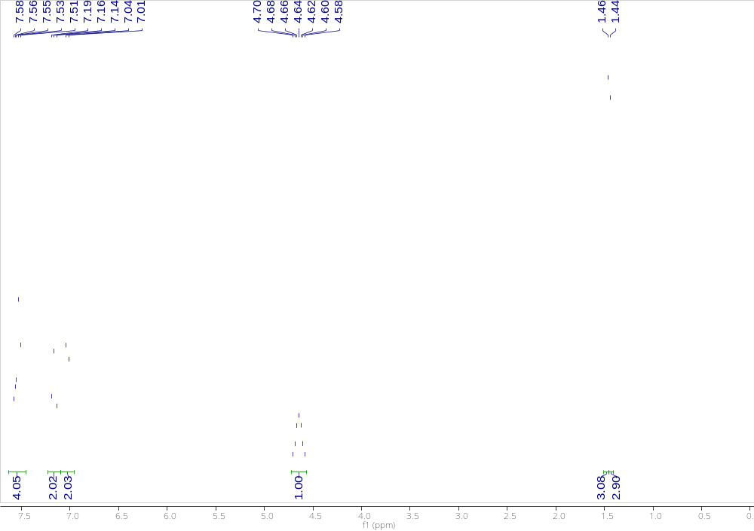
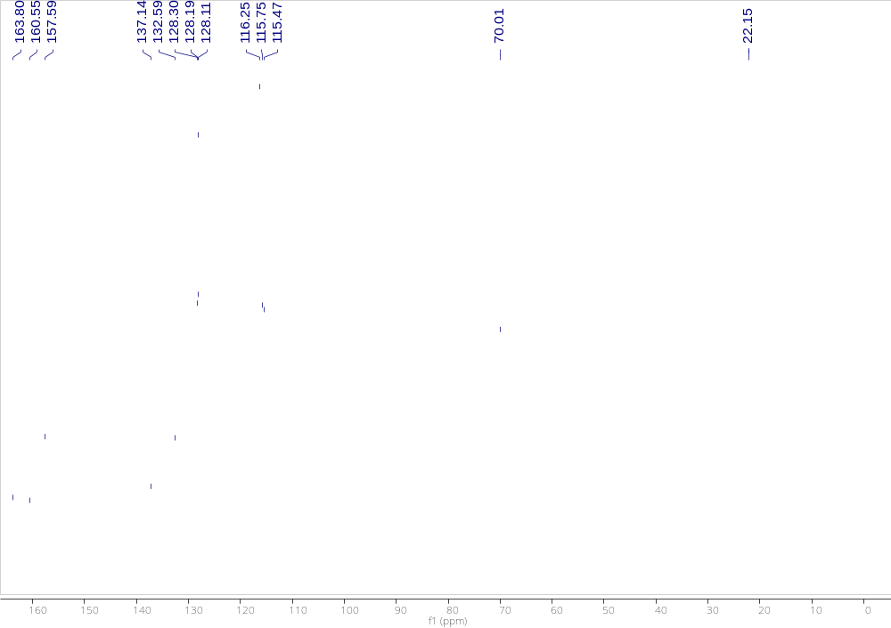

4,4'-difluoro-1,1'-biphenyl (1o)
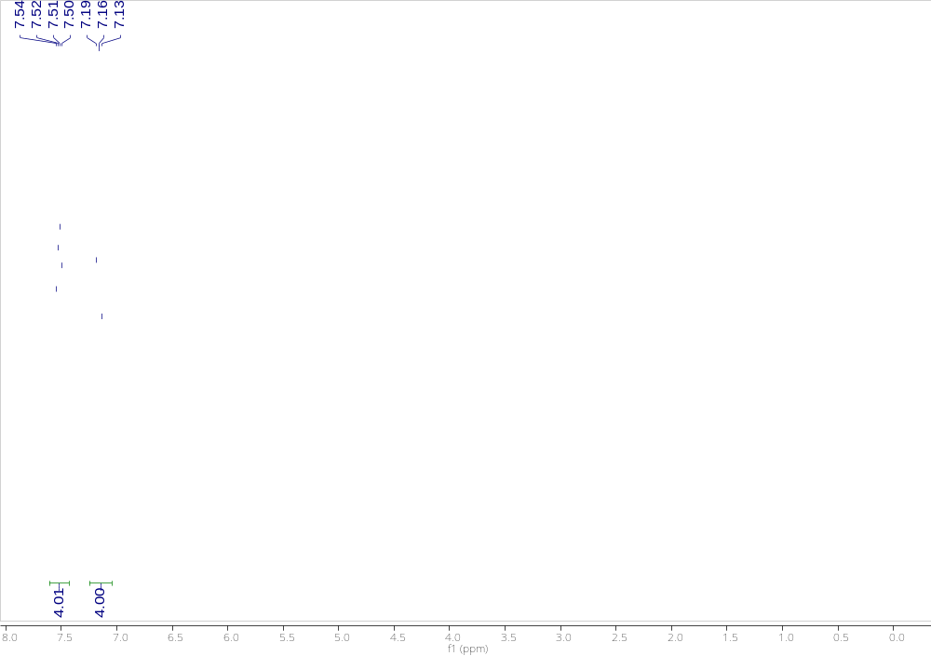
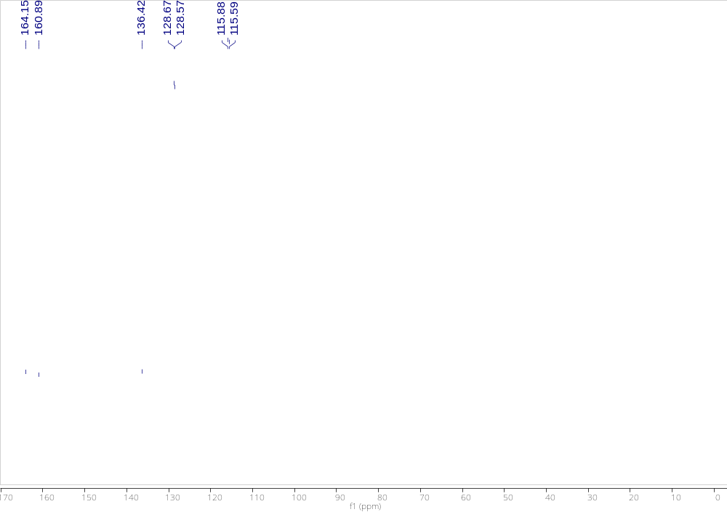

2-phenylthiophene (1p)
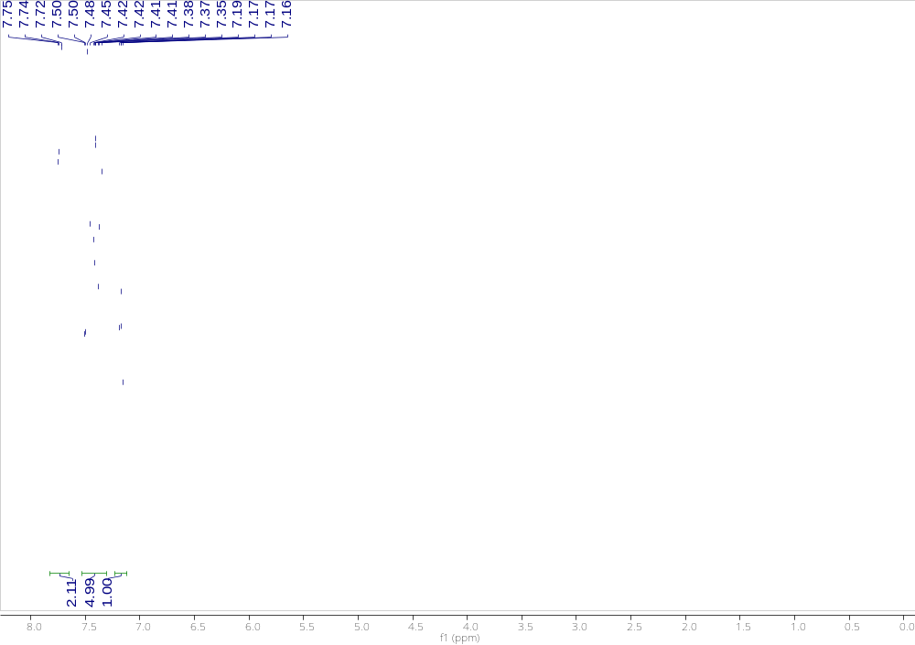
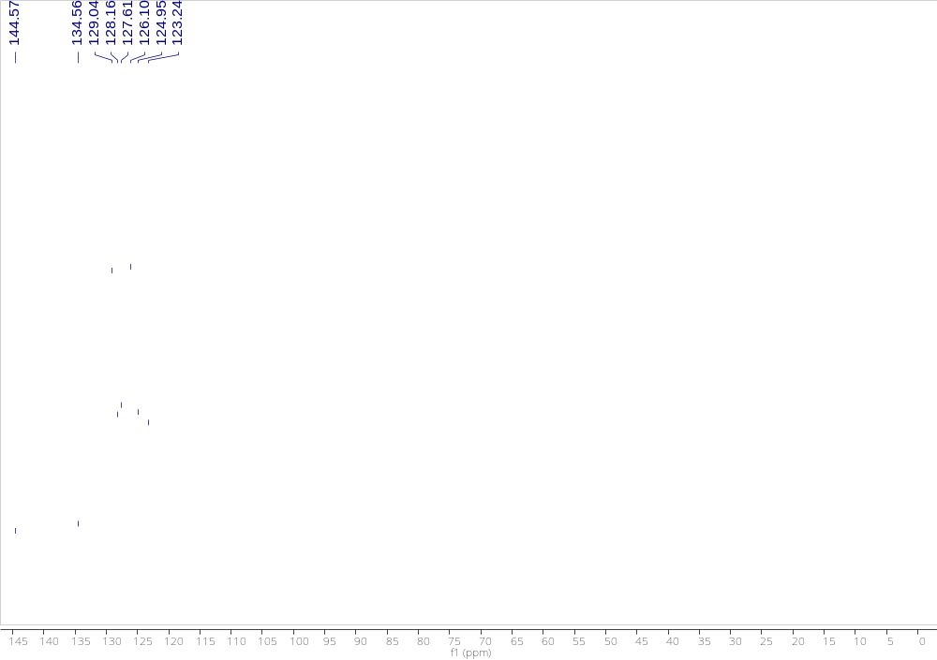

1,2-diphenylethyne (2a)
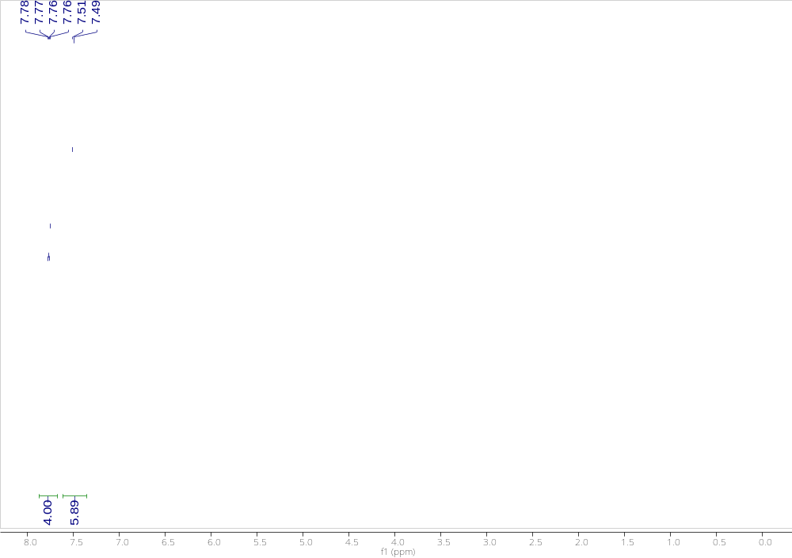
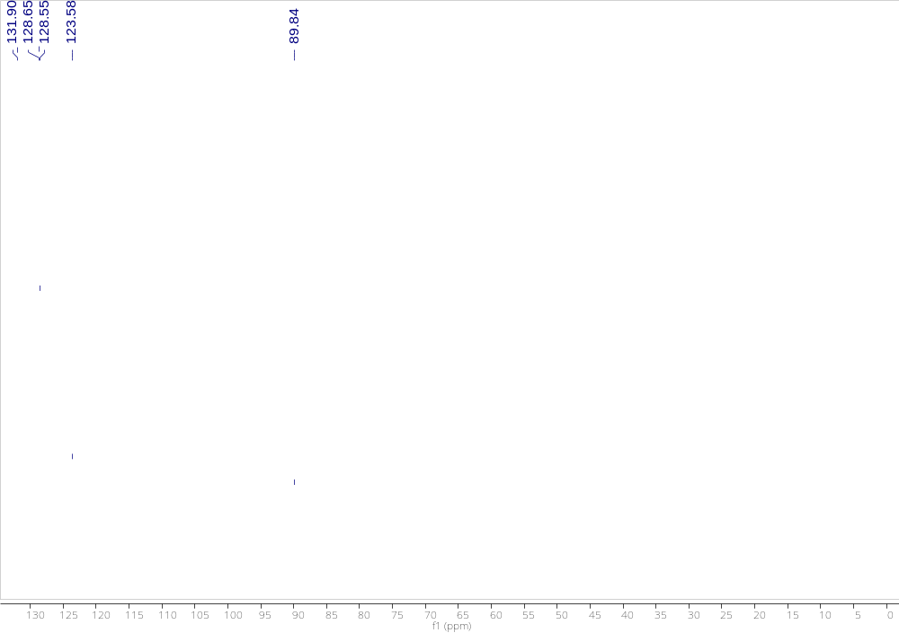

1-chloro-4-(phenylethynyl)benzene (2b)
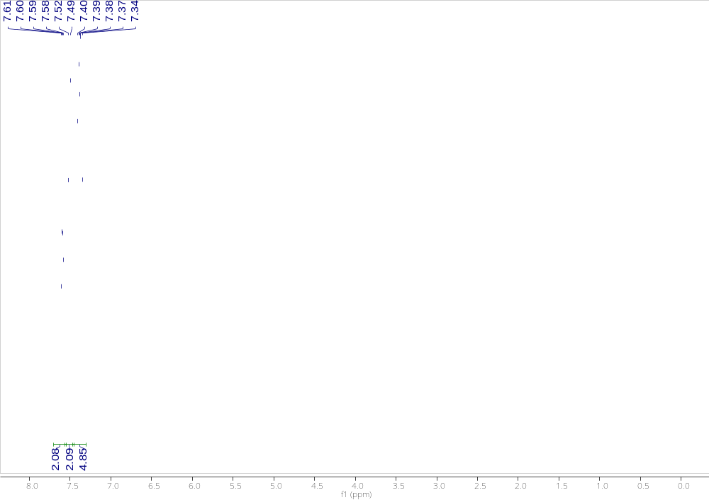
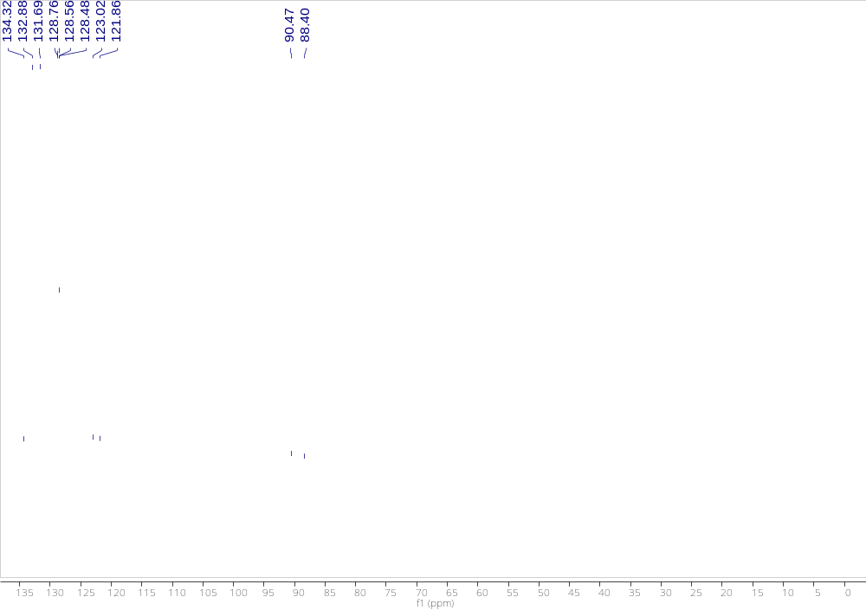

1-methoxy-4-(phenylethynyl)benzene (2c)
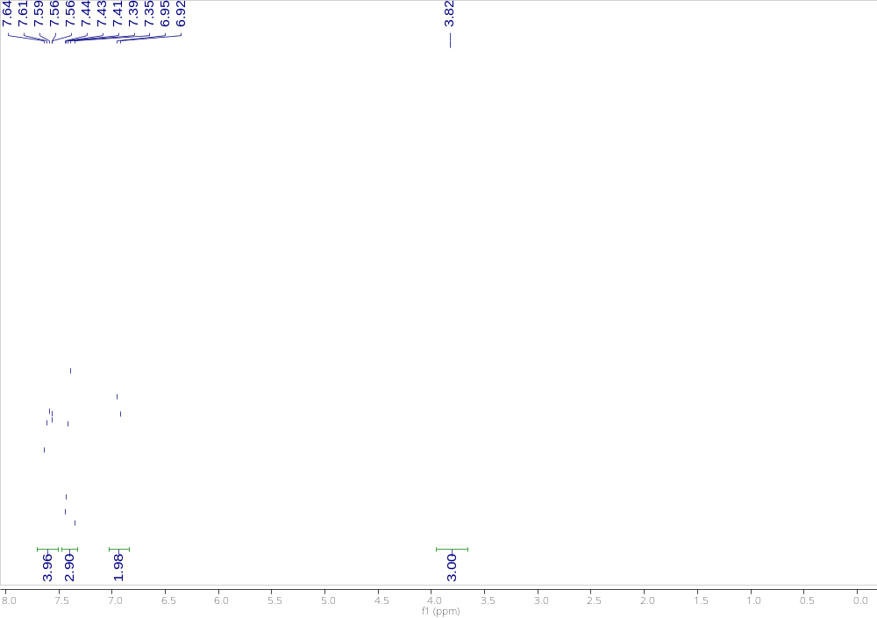
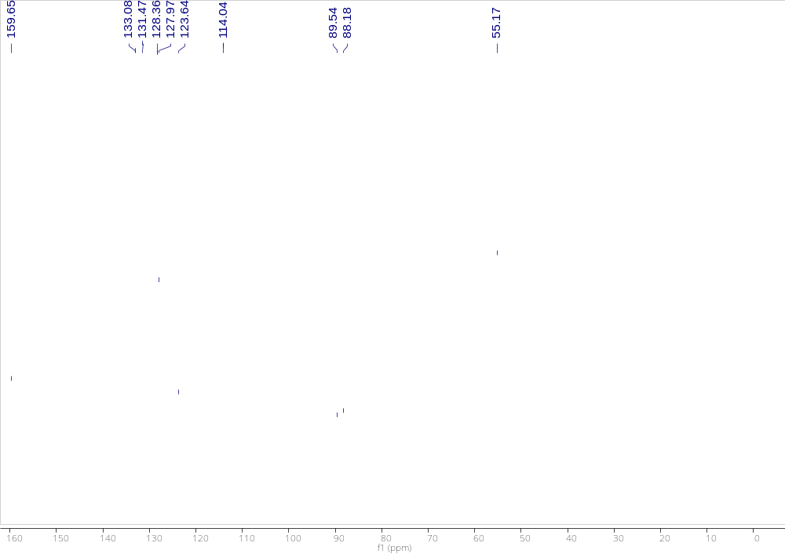

oct-1-yn-1-ylbenzene (2d)
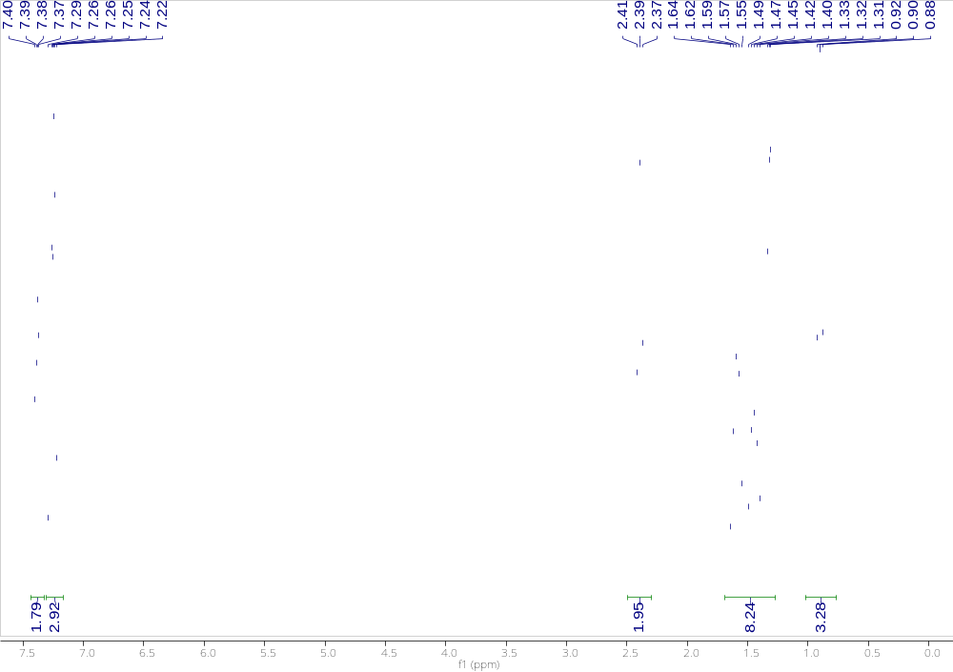
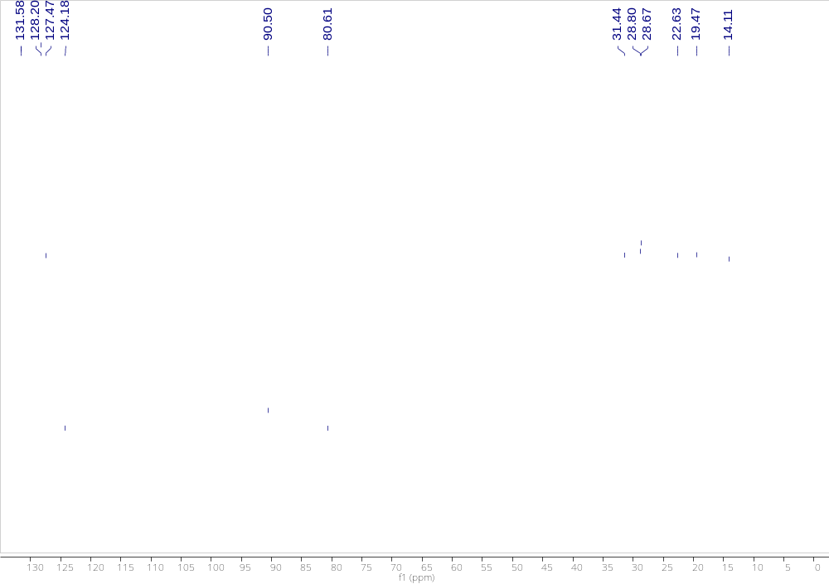

1-methyl-4-(phenylethynyl)benzene (2e)
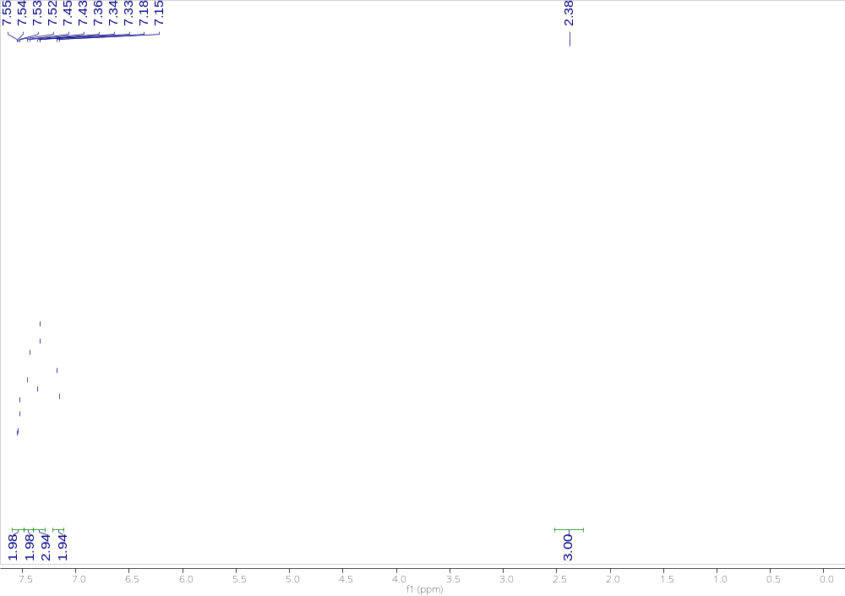
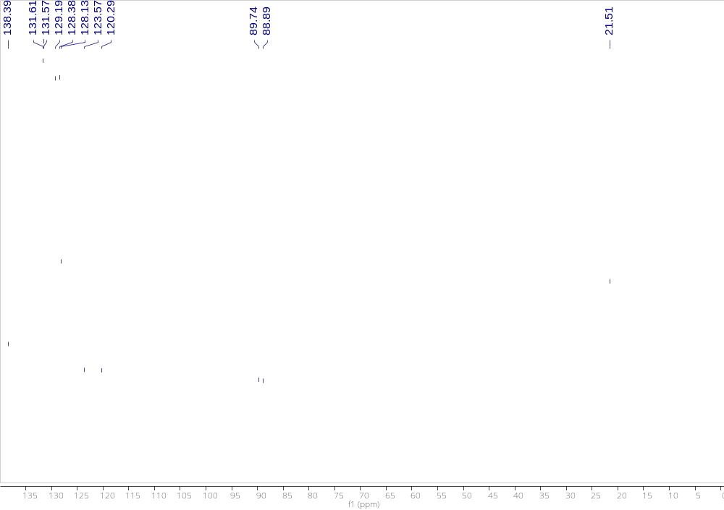

1-methoxy-4-(p-tolylethynyl)benzene (2f)
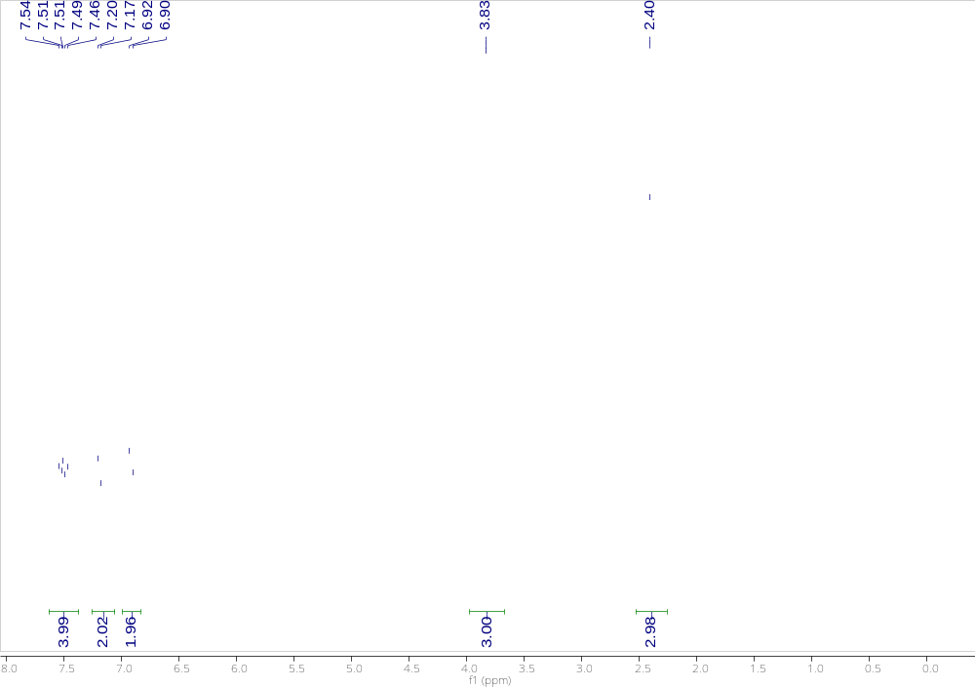
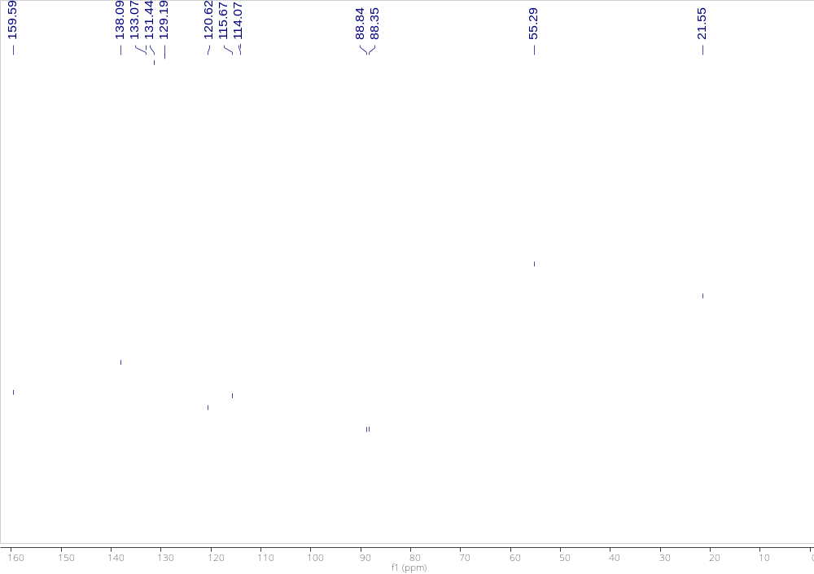

1-methyl-4-(oct-1-yn-1-yl)benzene (2g)
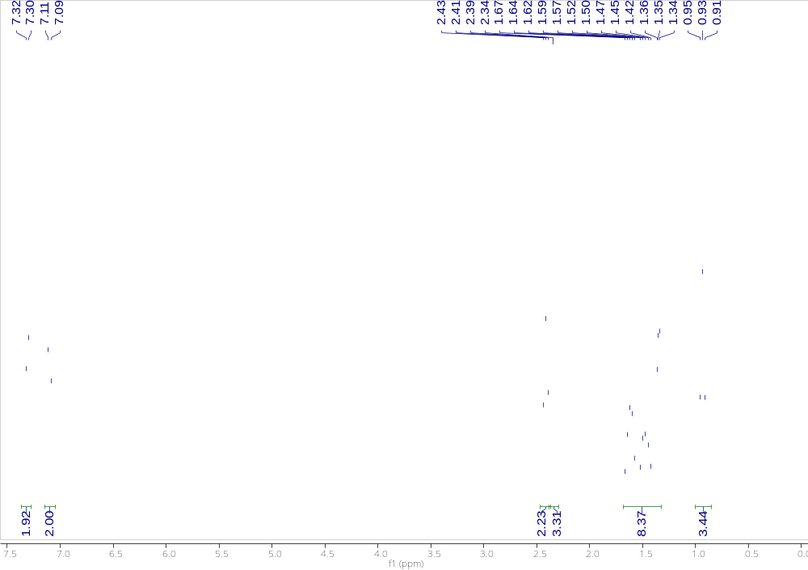
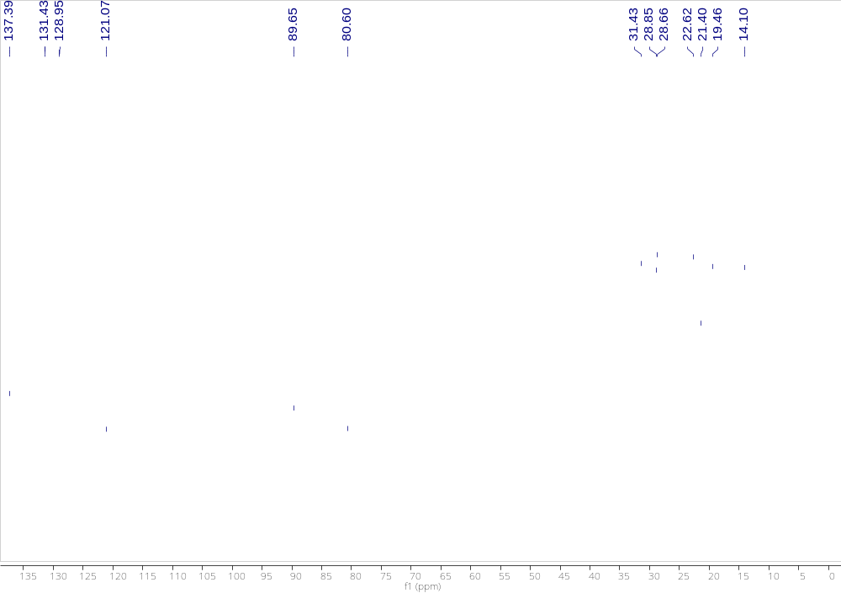

1-(phenylethynyl)-4-(trifluoromethyl)benzene (2h)
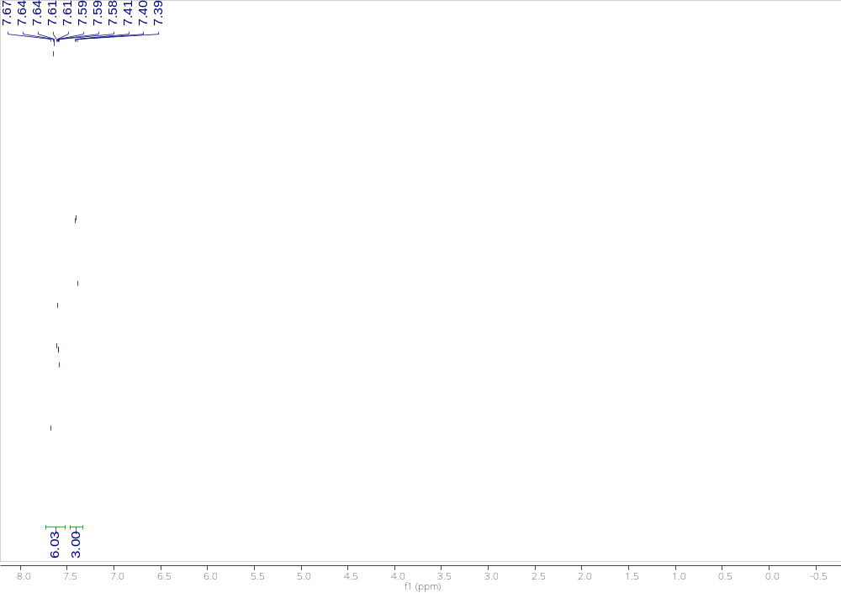
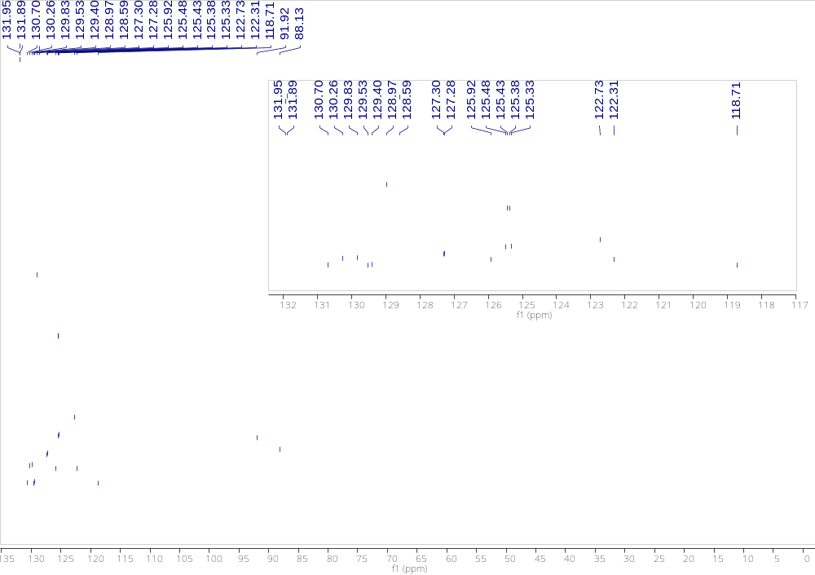

1-chloro-4-((4-(trifluoromethyl)phenyl)ethynyl)benzene (2i)
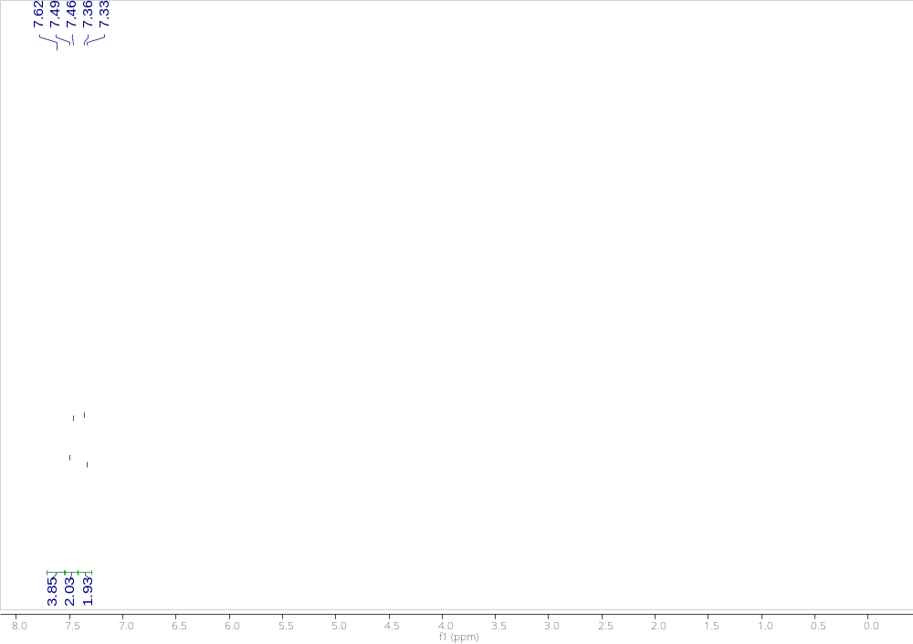
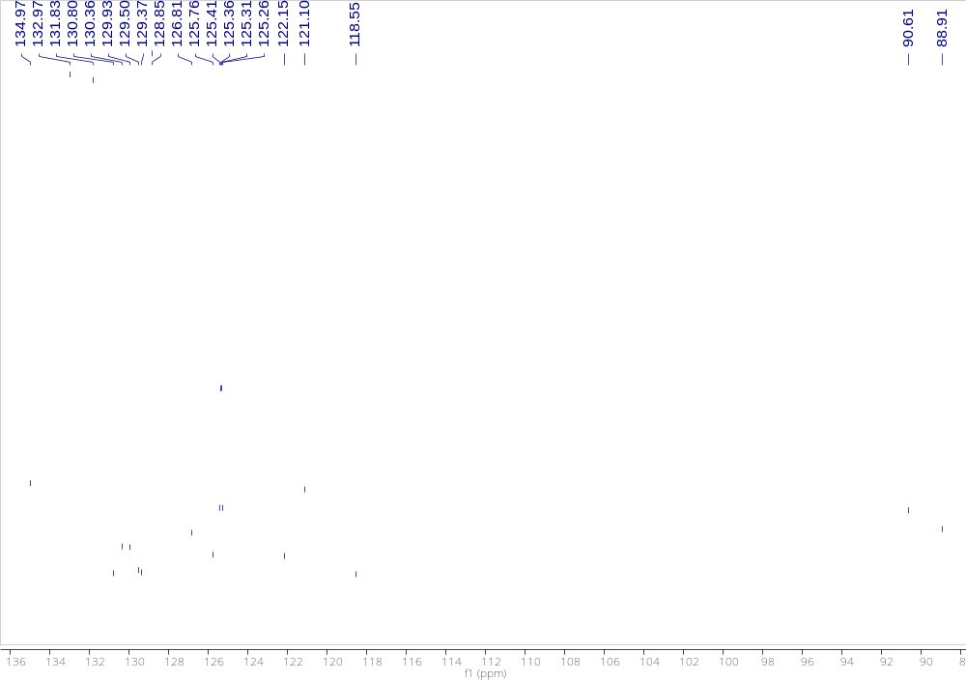

1-(oct-1-yn-1-yl)-4-(trifluoromethyl)benzene (2k)
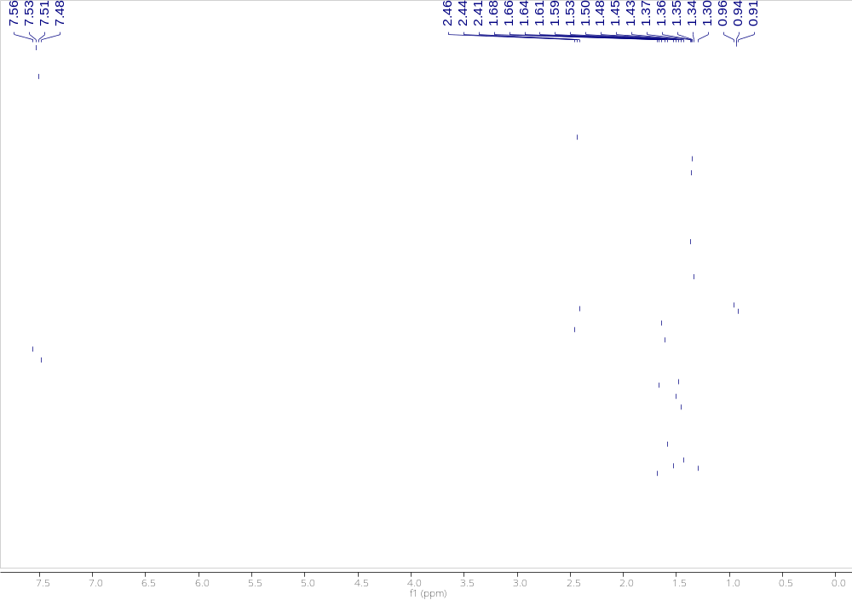
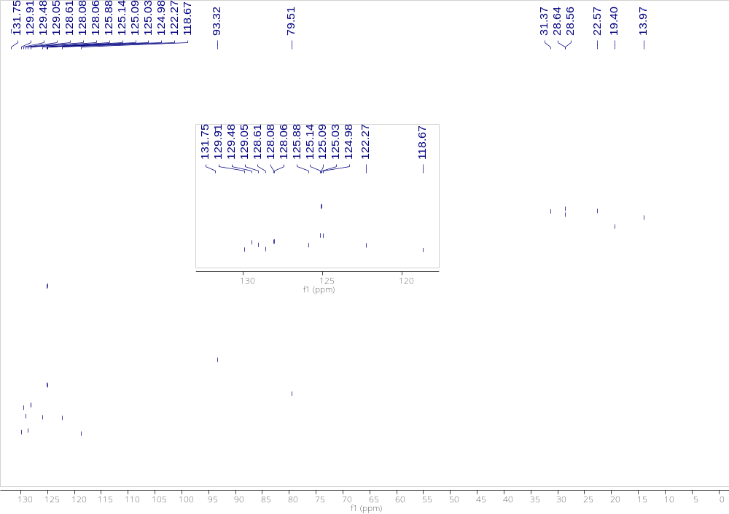

1,2-bis(4-methoxyphenyl)ethyne (2m)
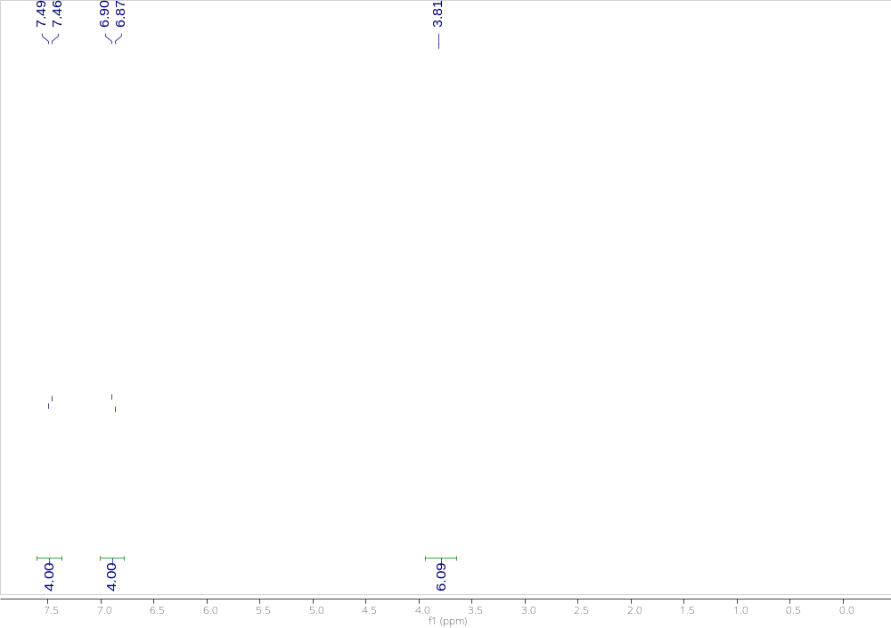
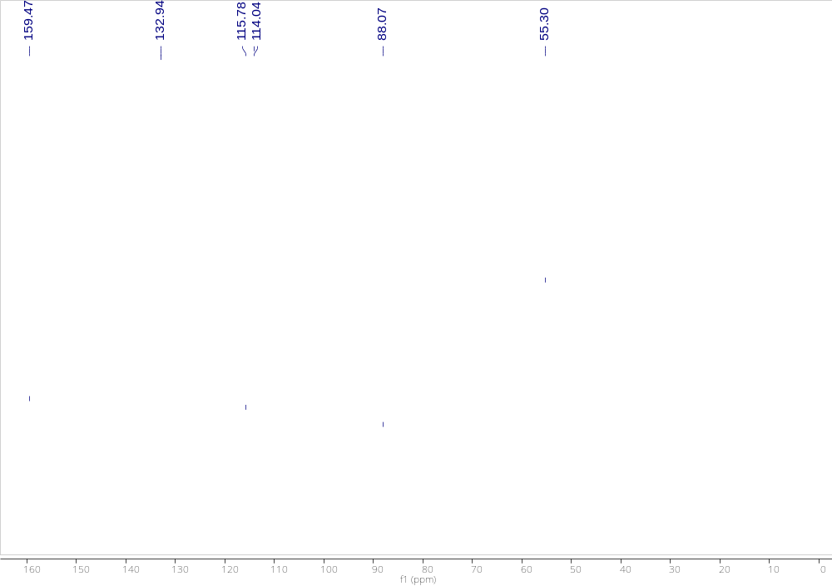

5. Copies of ¹⁹ F NMR for the synthesized fluorochemicals
4-fluoro-1,1'-biphenyl (1d)
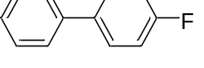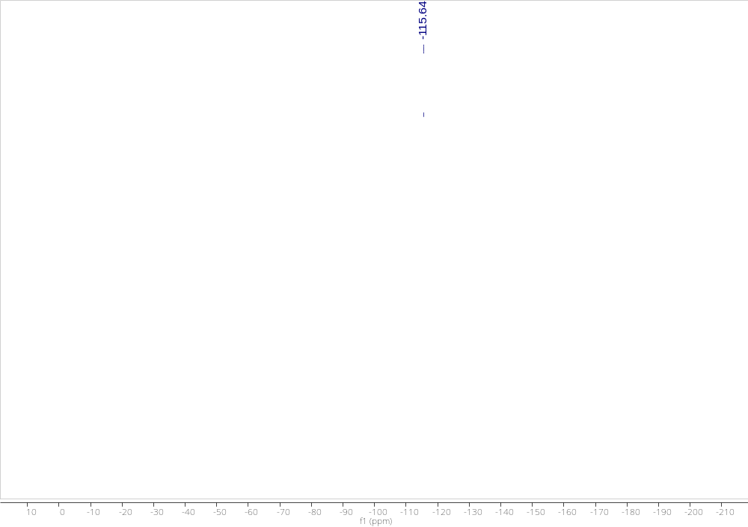

4-fluoro-4'-methyl-1,1'-biphenyl (1h)
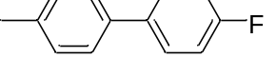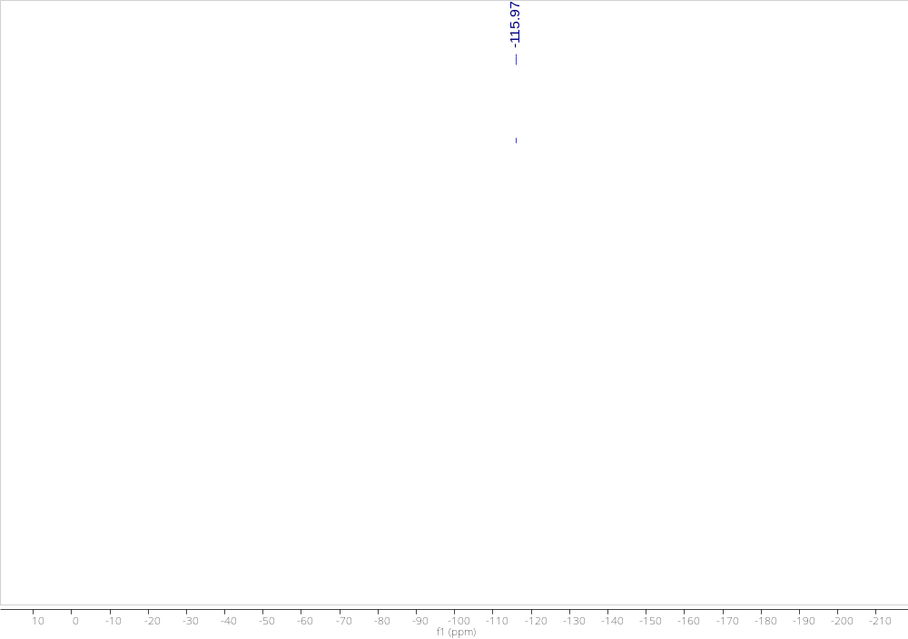
4-fluoro-4'-methoxy-1,1'-biphenyl (1j)
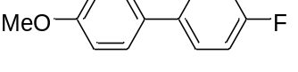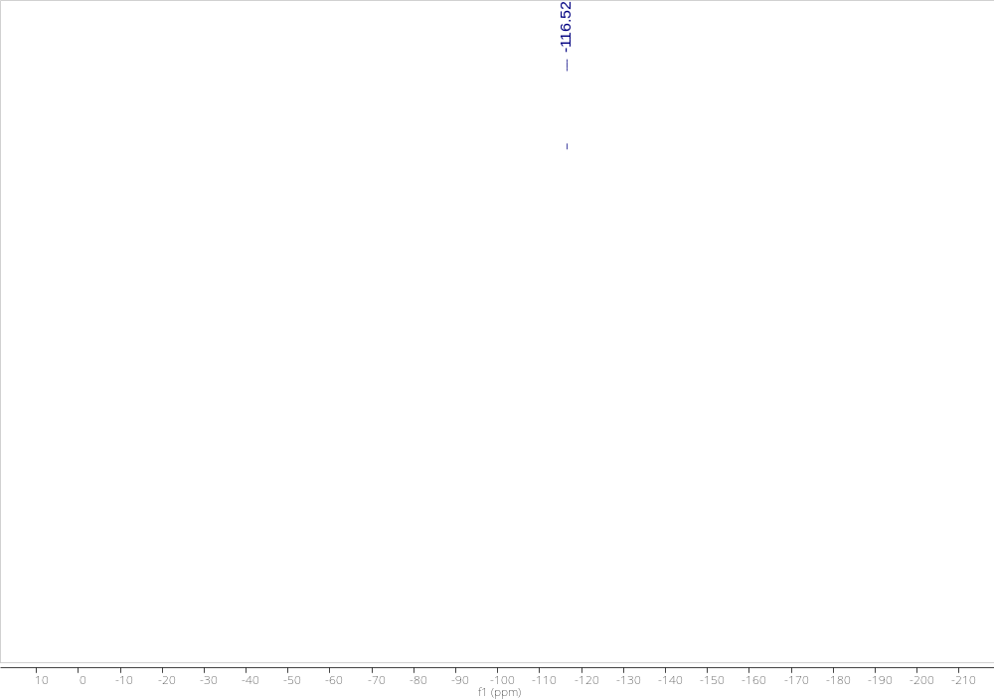

4-chloro-4'-fluoro-1,1'-biphenyl (1m)
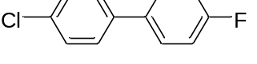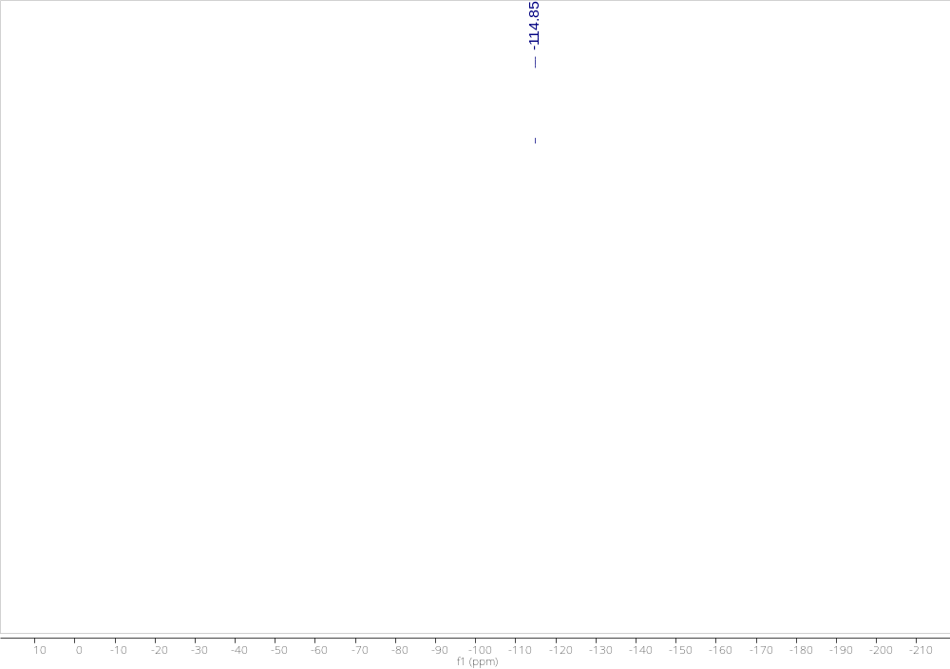

4-fluoro-4'-isopropoxy-1,1'-biphenyl (1n)
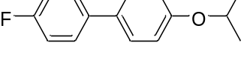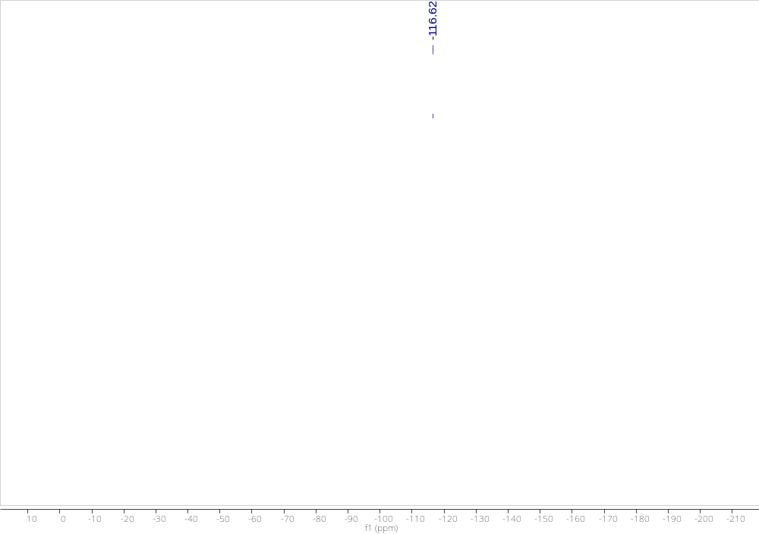

4,4'-difluoro-1,1'-biphenyl (1o)
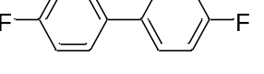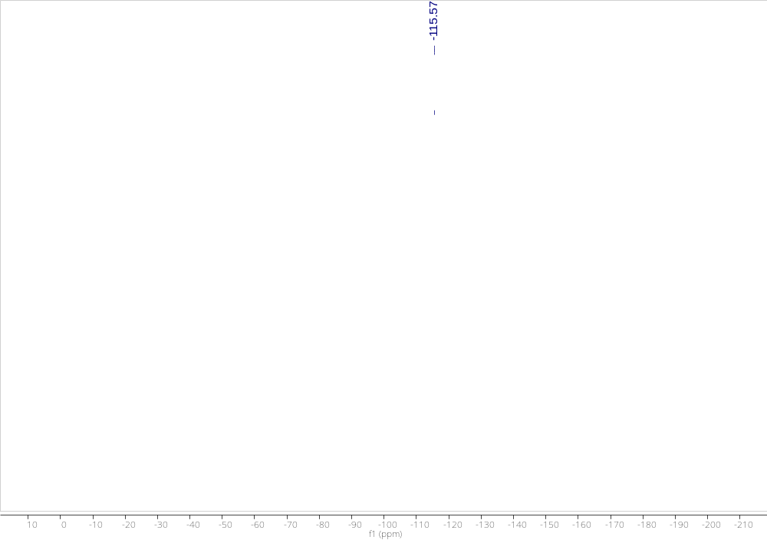

1-(phenylethynyl)-4-(trifluoromethyl)benzene (2h)
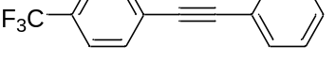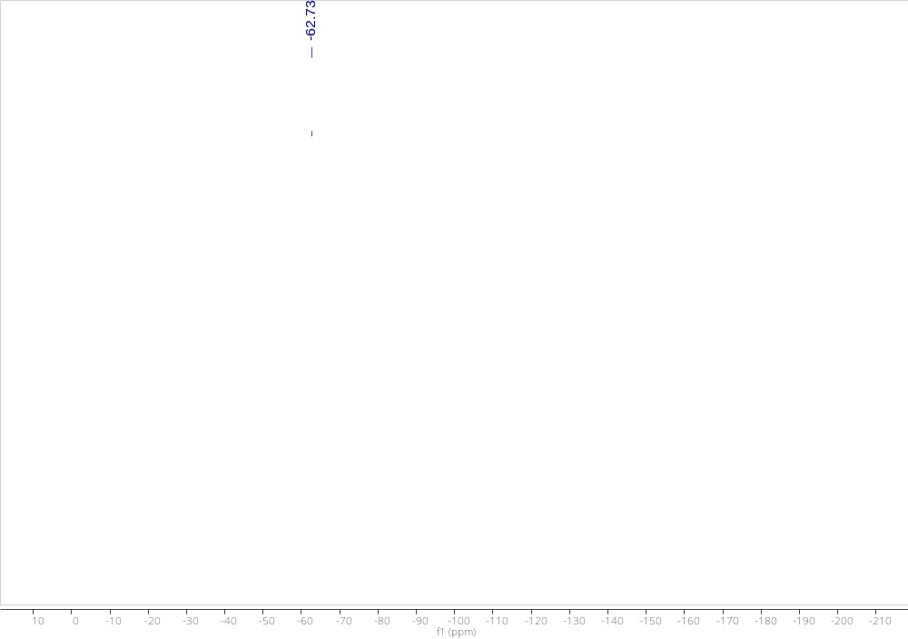

1-chloro-4-((4-(trifluoromethyl)phenyl)ethynyl)benzene (2i)
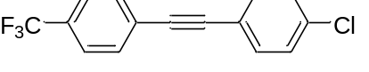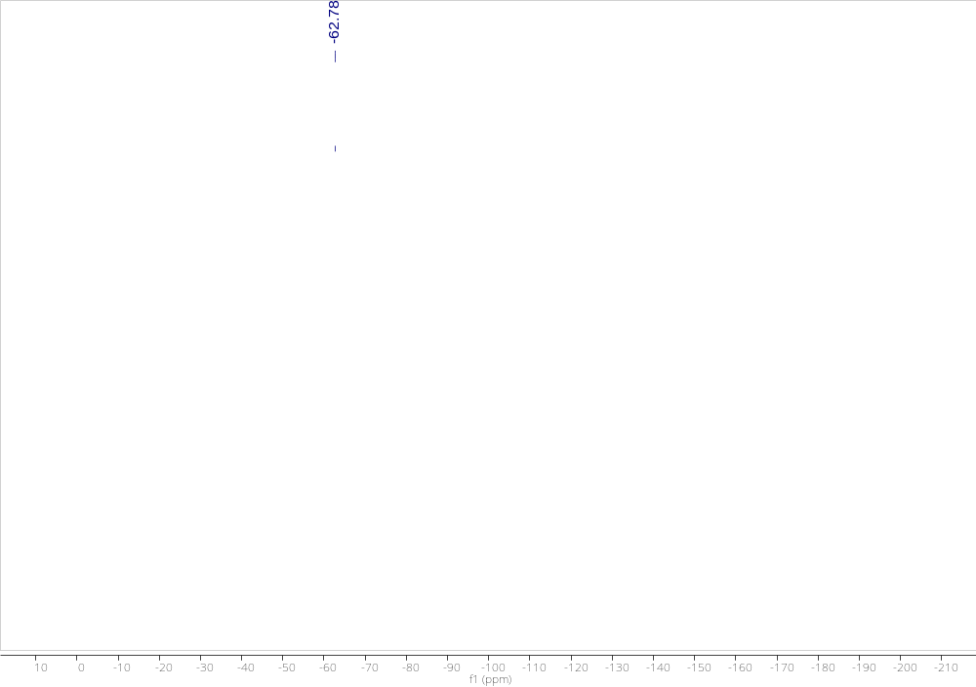

1-(oct-1-yn-1-yl)-4-(trifluoromethyl)benzene (2k)
