Supplementary Material for
Transferable Drude-Based Polarizable Force Field Framework for Predictive Modeling of Battery Electrolytes
Chenlu Wang, Qisheng Wu*
Suzhou Laboratory, Suzhou, Jiangsu 215123, People’s Republic of China
*Corresponding: wuqs@szlab.ac.cn

Contents
Supplementary Note 1 | Conventional Force Field Functional Form 4
Supplementary Note 2 | Polarizable Force Field Functional Form 6
Supplementary Note 3 | Compositions of Simulated Systems 12
Supplementary Table 1 | Compositions of LiFSI:DME:TFEO ether-based systems. 12
Supplementary Table 2 | Compositions of LiTFSI:DME:DOL:FEC ether-based systems. 12
Supplementary Table 3 | Compositions of LiPF₆:EC:EMC:FEC carbonate-based systems. 13
Supplementary Table 4 | Compositions of LiPF₆:EC:DMC carbonate-based systems. 13
Supplementary Table 5 | Compositions of LiFSI:PSF fluorosulfonyl-based systems. 14
Supplementary Table 6 | Compositions of LiFSI:TPSF fluorosulfonyl-based systems. 14
Supplementary Note 4 | Realization of Polarizable Force Field Framework in OPLS&Pol 15
Supplementary Fig. 1 | Atomic structures and LJ atom-type classifications. 15
Supplementary Fig. 2 | Summary of LJ parameters and assignments. 16
Supplementary Fig. 3 | Comparison of atomic partial charge assignment schemes. 17
Supplementary Fig. 4 | Molecular electrostatic potential distributions. 18
Supplementary Fig. 5 | Gas-phase energetics and geometries of Li⁺-ligand complexes. 19
Supplementary Fig. 6 | Benchmarking gas-phase energetics of Li⁺-molecule complexes. 20
Supplementary Table 7 | RESP-derived atomic partial charges for molecules. 21
Supplementary Table 8 | Reference atomic partial charges for ions. 23
Supplementary Table 9 | OPLS&Pol parameters: polarizabilities and dipole moments. 24
Supplementary Table 10 | OPLS&Pol parameters: equilibrium distances and LJ scaling factors. 27
Supplementary Table 11 | Parameter comparison between OPLS&Pol and CL&Pol. 29
Supplementary Note 5 | Static and Transport Properties of Neat Components 30
Supplementary Table 12 | Benchmark comparison of calculated densities for neat components. 30
Supplementary Table 13 | Benchmark comparison of calculated self-diffusion coefficients for neat components. 31
Supplementary Note 6 | Polarization-Driven Li⁺ Solvation across Concentration Regimes 32
Supplementary Fig. 7 | Simulation configurations for LiFSI:DME:TFEO ether-based system. 32
Supplementary Fig. 8 | Benchmarking Li⁺ solvation structures in 1LiFSI:9DME. 33
Supplementary Fig. 9 | Benchmarking Li⁺ solvation structures in 1LiFSI:1.4DME. 34
Supplementary Fig. 10 | Benchmarking Li⁺ solvation structures in 1LiFSI:1.2DME and 1LiFSI:1.2DME:2TFEO. 35
Supplementary Fig. 11 | Benchmarking FSI⁻ speciation in 1LiFSI:1.4DME (333.15 K). 36
Supplementary Fig. 12 | Benchmarking FSI⁻ speciation in 1LiFSI:1.4DME (298.15 K). 37
Supplementary Fig. 13 | Benchmarking FSI⁻ speciation in 1LiFSI:9DME (298.15 K). 38
Supplementary Fig. 14 | Benchmarking FSI⁻ speciation in 1LiFSI:1.2DME (298.15 K). 39
Supplementary Fig. 15 | Benchmarking FSI⁻ speciation in 1LiFSI:1.2DME:2TFEO (298.15 K). 40
Supplementary Fig. 16 | Comprehensive accuracy assessment of FSI⁻ speciation in LiFSI:DME:TFEO electrolytes. 41
Supplementary Fig. 17 | Population landscapes of Li⁺ solvation in LiFSI:DME:TFEO electrolytes. 42
Supplementary Note 7 | Polarization-Resolved Competition in Multicomponent Electrolytes 43
Supplementary Fig. 18 | Simulation configurations for LiTFSI:DME:DOL:FEC ether-based systems. 43
Supplementary Fig. 19 | Concentration-dependent Li⁺ solvation structures in LiTFSI:DME:DOL:FEC electrolytes. 44
Supplementary Fig. 20 | Comparison of TFSI⁻ speciation in LiTFSI:DME:DOL:FEC electrolytes. 45
Supplementary Fig. 21 | Decomposition of Li⁺ solvation in 1LiTFSI:2DME:12DOL:1.5FEC (293.15 K). 46
Supplementary Fig. 22 | Structural diversity of Li⁺ solvation in 1LiTFSI:2DME:12DOL:1.5FEC (293.15 K). 47
Supplementary Note 8 | Thermodynamic Origin of Solvation Competition in Carbonate Systems 48
Supplementary Fig. 23 | Simulation configurations for LiPF₆:EC:EMC:FEC carbonate-based systems. 48
Supplementary Fig. 24 | Concentration-dependent Li⁺ solvation structures in LiPF₆:EC:EMC:FEC electrolytes. 49
Supplementary Fig. 25 | Comparison of PF₆⁻ speciation in LiPF₆:EC:EMC:FEC electrolytes. 50
Supplementary Fig. 26 | Decomposition of Li⁺ solvation in 3LiPF₆:13EC:20EMC (333.15 K). 51
Supplementary Fig. 27 | Structural diversity of Li⁺ solvation in 3LiPF₆:13EC:20EMC (333.15 K). 52
Supplementary Fig. 28 | Decomposition of Li⁺ solvation in 3LiPF₆:13EC:20EMC:4FEC (333.15 K). 53
Supplementary Fig. 29 | Structural diversity of Li solvation in 3LiPF₆:13EC:20EMC:4FEC (333.15 K). 54
Supplementary Fig. 30 | Concentration-dependent Li⁺ solvation structures in LiPF₆:EC:EMC electrolytes. 55
Supplementary Fig. 31 | Comparison of PF₆⁻ speciation in LiPF₆:EC:EMC electrolytes. 56
Supplementary Fig. 32 | Simulation configurations for LiPF₆:EC:DMC carbonate-based systems. 57
Supplementary Fig. 33 | Comparison of Li⁺ solvation structures and PF₆⁻ speciation in LiPF₆:EC:DMC electrolytes. 58
Supplementary Note 9 | Polarization-Stabilized Aggregation in Fluorosulfonyl Electrolytes 59
Supplementary Fig. 34 | Simulation configurations for LiFSI:PSF fluorosulfonyl-based systems. 59
Supplementary Fig. 35 | Simulation configurations for LiFSI:TPSF fluorosulfonyl-based systems. 60
Supplementary Fig. 36 | Comparison of FSI⁻ speciation in LiFSI:PSF and LiFSI:TPSF electrolytes. 61
Supplementary Fig. 37 | Decomposition of Li⁺ solvation in 1LiFSI:6.5PSF (298.15 K). 62
Supplementary Fig. 38 | Structural diversity of Li⁺ solvation in 1LiFSI:6.5PSF (298.15 K). 63
Supplementary Fig. 39 | Decomposition of Li⁺ solvation in 1LiFSI:5TPSF (298.15 K). 64
Supplementary Fig. 40 | Structural diversity of Li⁺ solvation in 1LiFSI:5TPSF (298.15 K). 65
Supplementary Fig. 41 | Comparison of densities for LiFSI:PSF and LiFSI:TPSF electrolytes. 66
Supplementary Note 10 | Analysis of Transport Properties and Ionic Conductivity 67
Supplementary Fig. 42 | MSDs of species in 1LiFSI:1.4DME (333.15 K) based on OPLS&Pol. 67
Supplementary Fig. 43 | Dynamic properties of species in 1LiFSI:1.4DME (333.15 K). 68
Supplementary References 69

Supplementary Note 1 | Conventional Force Field Functional Form
In the conventional force fields (CFF) formalism, as exemplified by all-atom optimized potentials for liquid simulations (OPLS-AA),¹ the total potential energy (U_{total}) is partitioned into bonded (U_{bonded}) and nonbonded (U_{nonbonded}) components:
(1)
The U_{bonded} term describes the intramolecular interaction, encompassing two-body bond stretching, three-body angle bending, and four-body dihedral torsions:
(2)
Here, i, j, k, and s denote the atoms involved in the interactions; the parameters K_{b}^{ij}, K_{θ}^{ijk}, and K_{v}^{ijks} are the force constants for bond, angle, and dihedral terms, respectively; r₀^{ij} and θ₀^{ijk} represent the equilibrium bond length and angle, while r^{ij}, θ^{ijk} and φ^{ijks} correspond to the instantaneous bond length, angle, and dihedral angle. Dihedral interactions are modeled using a Fourier series consisting of up to four cosine terms. The phase behavior is implicitly determined by the signs and magnitudes of the coefficients, obviating the need for an explicit phase shift parameter.
Nonbonded interactions in CFFs are described by van der Waals (vdW) and electrostatic terms, represented by the Lennard-Jones (LJ) and Coulomb potentials, respectively. Electronic polarization is incorporated implicitly via two approximations: (i) in the LJ potential, where parametrization captures dispersion and repulsion in a mean-field polarized environment, and (ii) in the electrostatic term, through uniform scaling of atomic partial charges to approximate electronic screening. The U_{nonbonded} term is expressed as:
(3)
Here, ε₀ is the vacuum permittivity; r^{ij} is the interatomic distance; σ^{ij} and ε^{ij} are the LJ collision diameter and well depth parameters; q^{i} and q^{j} represent the atomic partial charges. The empirical charge scaling factor, F_{q}, are defined as:
(4)
The LJ parameters for unlike atoms are obtained using the geometric mixing rules:
(5)
(6)
To prevent double-counting of nonbonded interactions between atoms in close covalent proximity, a scaling scheme is applied based on topological separation. The weighting coefficient w^{ij} is introduced as follows:
(7)
Here, b₁, a₂, and d₃ indicate atoms separated by one, two, and three bonds, respectively.

Supplementary Note 2 | Polarizable Force Field Functional Form
In the polarizable force field (PFF) formalism based on the Drude oscillator model, the total potential energy (U_{total}^{pol}) is similarly composed of bonded (U_{bonded}^{pol}) and nonbonded (U_{nonbonded}^{pol}) components:
(8)
Each polarizable heavy atom is modeled as a pair of charged particles: a Drude core (DC) carrying nearly the full atomic mass, and a negatively charged Drude particle (DP, mass 0.4 g·mol⁻¹)^{2,3} representing the induced electron cloud. The DP is harmonically tethered to its DC by an isotropic spring, introducing a polarization energy term (U_{D}):
(9)
Here, k and m denote the DC and its bound DP, respectively; r^{km} denotes the magnitude of the displacement vector between them, which is initialized at approximately 0.1 Å; K_{D} is the force constant, which is set as 500 kcal·mol⁻¹·Å⁻², following the standard parametrization by Lamoureux et al.^{2,3} Accordingly, the U_{bonded}^{pol} term of the PFF extends the CFF expression (Eq. 2) by aggregating contributions from all Drude oscillators:
(10)
To distinguish the formalisms, a given atomic partial charge in the CFF (q) is denoted as q’ in the PFF. The q’ is partitioned between the DC (q_{DC}) and its corresponding DP (q_{DP}):
(11)
(12)
Here, q_{D} is the absolute value of the charge associated with the induced dipole, related to the atomic polarizability (α) via:
(13)
Explicit polarizability is assigned exclusively to non-hydrogen atoms, with the α of each H atom lumped into that of its bonded heavy atom.^{4–6}
Within the Drude oscillator model, DPs interact exclusively via electrostatics, whereas DCs and H atoms participate in both Coulombic and LJ interactions. Although baseline LJ parameters are adapted from OPLS-AA, the corresponding LJ terms in the PFF must be rescaled to eliminate the double-counting of polarization effects implicitly embedded in the CFF parameterization. To address this, the pair-specific scaling factor (K_{LJ}) is applied following the scheme proposed by Goloviznina et al.^{4–6}, computed as:
(14)
Here, k and s denote a pair of interacting particles (i.e., two DCs, a DC and an H atom, or two H atoms); Q^{k}, A^{k}, and μ^{k} represent the net charge, total polarizability, and dipole moment of the molecule or ion containing the atom k, respectively. r_{CoM}^{ks} is the equilibrium center-of-mass (CoM) distance between the species. The coefficients c₀ = 0.25 and c₁ = 0.11 were adopted from the scheme proposed by Goloviznina et al.,^{4,5} which was parameterized for systems encompassing both neutral and charged species.
A well-known challenge in MD simulations using Drude oscillators is “polarization catastrophe”,⁷ a numerical instability arising from overly strong short-range dipole-dipole interactions, which can cause induced dipoles to collapse. To mitigate this, the Thole damping function, S(r),⁸ is employed to temper these short-range electrostatic interactions:
(15)
The scaling parameter (s^{ks}) is determined by the atomic polarizabilities (α^{k}, α^{s}) and damping parameters (a^{k}, a^{s}) using mixing rules: a geometric mean for α, and an arithmetic mean for a. The resulting expression for s^{ks} is:
(16)
In this work, the damping parameter a was universally set to 2.6 for all polarizable particles,⁹ with interactions truncated at 1.2 nm. The S(r) is applied to all Drude oscillators (DC-DC, DP-DP, DC-DP) regardless of connectivity, effectively regulating the interactions between the DP charge (-q_{D}) and the Drude component of the DC charge (q_{D}).
In electrolytes containing ions with highly localized charge density, such as Li⁺, the S(r) alone is insufficient to prevent numerical instabilities. In particular, short-range interactions between such ions and nearby induced dipoles must be further damped.^{5,6,10} To this end, a modified Tang-Toennies (TT) damping function, f_{TT}(r),¹¹ as adapted by Goloviznina et al.⁶, was employed:
(17)
Here, DC_{Li} denotes the DCs of Li⁺ ions. The parameters were empirically set to b_{TT} = 4.5 and c_{TT} = 1.0.⁶ The f_{TT}(r) attenuates interactions between the nonpolarizable part of the DC_{Li} charge (q’) and either the DP charge (-q_{D}) or the Drude component of the DC charge (q_{D}) on other polarizable atoms. This serves as a safeguard against unphysical charge trapping and trajectory instabilities, without perturbing the system’s physical properties under normal conditions.
Therefore, the U_{nonbonded}^{pol} term of the PFF, incorporating all the above modifications, is expressed as the sum over specific particle pairs interactions:
(18)
Here, a and b run over nonpolarizable atoms (H atoms); k and s refer to DCs (all other non-H atoms, including C, N, O, F, S, P, and Li atoms); m and n denote the DPs associated with k and s. The individual interaction terms are defined as follows:
U^{ab} term represents LJ and Coulomb interactions between H atoms (H-H), scaled by K_{LJ}:
(19)
U^{ks} term represents LJ and Coulomb interactions between DCs (DC-DC), incorporating K_{LJ}, S(r) and f_{TT}(r):
(20)
U^{mn} term is Coulomb interactions between DPs (DP-DP), modulated by S(r):
(21)
U^{as} term represents LJ and Coulomb interactions between H atoms and DCs (H-DC), including K_{LJ}:
(22)
U^{an} term is electrostatic interactions between H atoms and DPs (H-DP):
(23)
U^{kn} term is electrostatic interactions between DCs and DPs (DC-DP), modulated by both S(r) and f_{TT}(r):
(24)

Supplementary Note 3 | Compositions of Simulated Systems
Supplementary Table 1 | Compositions of LiFSI:DME:TFEO ether-based systems. Molar ratios and numbers of molecules or formula units (N) for LiFSI:DME:TFEO electrolytes, neat solvent (DME), and neat diluent (TFEO).
System | LiFSI:DME:TFEO | N  (LiFSI) | N  (DME) | N  (TFEO) | Description
1 | 1:9:0^{12,13} | 40 | 360 | 0 | Low-concentration electrolyte (LCE)
2 | 1:1.2:0¹² | 200 | 240 | 0 | High-concentration electrolyte (HCE)
3 | 1:1.4:0^{12,13} | 200 | 280 | 0 | HCE
4 | 1:1.2:2^{12,14} | 80 | 96 | 160 | localized high-concentration electrolyte (LHCE)
5 | 0:1:0 | 0 | 200 | 0 | Neat DME
6 | 0:0:1 | 0 | 0 | 200 | Neat TFEO

Supplementary Table 2 | Compositions of LiTFSI:DME:DOL:FEC ether-based systems. Molar ratios and numbers of molecules or formula units (N) for LiTFSI:DME:DOL:FEC electrolytes, neat solvent (DOL), and neat additive (FEC).
System | LiTFSI:DME:DOL:FEC | N  (LiTFSI) | N  (DME) | N  (DOL) | N  (FEC) | Description
1 | 1:20:0:0^{15,16} | 25 | 500 | 0 | 0 | LCE
2 | 17:90:110:0^{15,17} | 85 | 450 | 550 | 0 | LCE
3 | 1:2:12:0¹⁸ | 32 | 64 | 384 | 0 | LCE
4 | 1:2:12:1.5¹⁸ | 32 | 64 | 384 | 48 | LCE
5 | 0:0:1:0 | 0 | 0 | 200 | 0 | Neat DOL
6 | 0:0:0:1 | 0 | 0 | 0 | 200 | Neat FEC

Supplementary Table 3 | Compositions of LiPF₆:EC:EMC:FEC carbonate-based systems. Molar ratios and numbers of molecules or formula units (N) for LiPF₆:EC:EMC:FEC electrolytes and neat solvents (EC and EMC).
System | LiPF₆:EC:EMC:FEC | N  (LiPF₆) | N  (EC) | N  (EMC) | N  (FEC) | Description
1 | 3:13:20:0¹⁸ | 36 | 156 | 240 | 0 | LCE
2 | 3:13:20:4¹⁸ | 36 | 156 | 240 | 48 | LCE
3 | 21:50:132:0¹⁹ | 42 | 100 | 264 | 0 | LCE
4 | 39:100:264:0¹⁹ | 39 | 100 | 264 | 0 | LCE
5 | 8:25:66:0¹⁹ | 32 | 100 | 264 | 0 | LCE
6 | 7:20:40:0^{20–23} | 35 | 100 | 200 | 0 | LCE
7 | 0:1:0:0 | 0 | 200 | 0 | 0 | Neat EC
8 | 0:0:1:0 | 0 | 0 | 200 | 0 | Neat EMC

Supplementary Table 4 | Compositions of LiPF₆:EC:DMC carbonate-based systems. Molar ratios and numbers of molecules or formula units (N) for LiPF₆:EC:DMC electrolyte and neat solvent (DMC).
System | LiPF₆:EC:DMC | N  (LiPF₆) | N  (EC) | N  (DMC) | Description
1 | 1:3:7^{24,25} | 32 | 96 | 224 | LCE
2 | 0:0:1 | 0 | 0 | 200 | Neat DMC

Supplementary Table 5 | Compositions of LiFSI:PSF fluorosulfonyl-based systems. Molar ratios and numbers of molecules or formula units (N) for LiFSI:PSF electrolyte and neat solvent (PSF).
System | LiFSI:PSF | N  (LiFSI) | N  (PSF) | Description
1 | 1:6.5²⁶ | 80 | 520 | LCE
2 | 0:1 | 0 | 200 | Neat PSF

Supplementary Table 6 | Compositions of LiFSI:TPSF fluorosulfonyl-based systems. Molar ratios and numbers of molecules or formula units (N) for LiFSI:TPSF electrolyte and neat solvent (TPSF).
System | LiFSI:TPSF | N  (LiFSI) | N  (TPSF) | Description
1 | 1:5^{26–28} | 80 | 400 | LCE
2 | 0:1 | 0 | 200 | Neat TPSF

Supplementary Note 4 | Realization of Polarizable Force Field Framework in OPLS&Pol
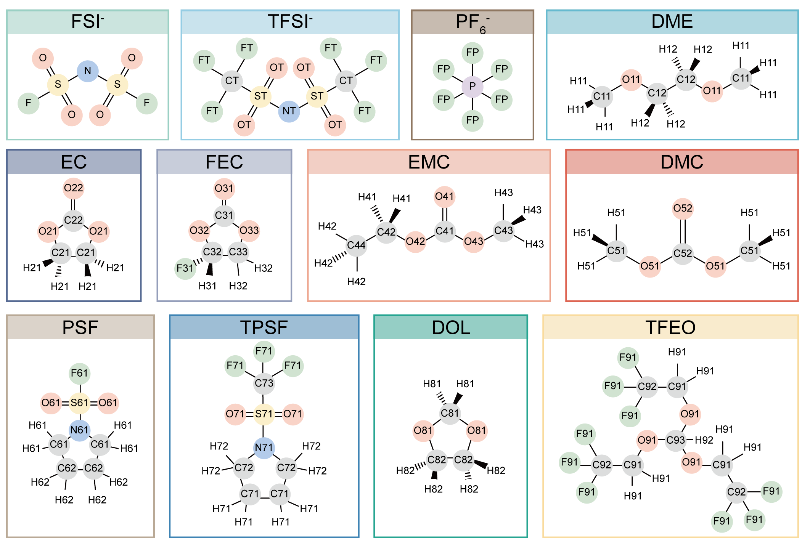
Supplementary Fig. 1 | Atomic structures and LJ atom-type classifications. Illustrated are representative electrolyte components used in lithium batteries, categorized into anions (FSI⁻, TFSI⁻, PF₆⁻), solvents (DME, EC, EMC, DMC, PSF, TPSF, DOL), an additive (FEC), and a diluent (TFEO). Atoms are labeled and color-coded by their LJ atom types to distinguish local topological and chemical environments.

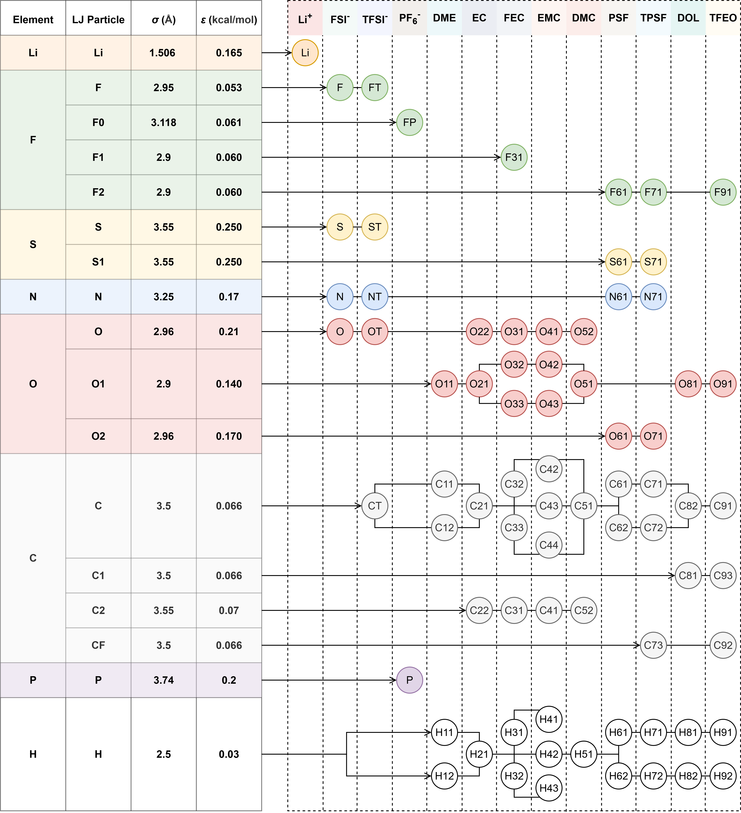
Supplementary Fig. 2 | Summary of LJ parameters and assignments. Overview of LJ parameters for representative electrolyte components, comprising ions, solvents, an additive, and a diluent. The table (left) tabulates the defined LJ atom types and their corresponding interaction parameters, where the parameters were adopted from OPLS-AA.¹ The schematic (right) maps these atom types to specific atomic sites within each molecule, serving as a reference for force field (FF) construction.

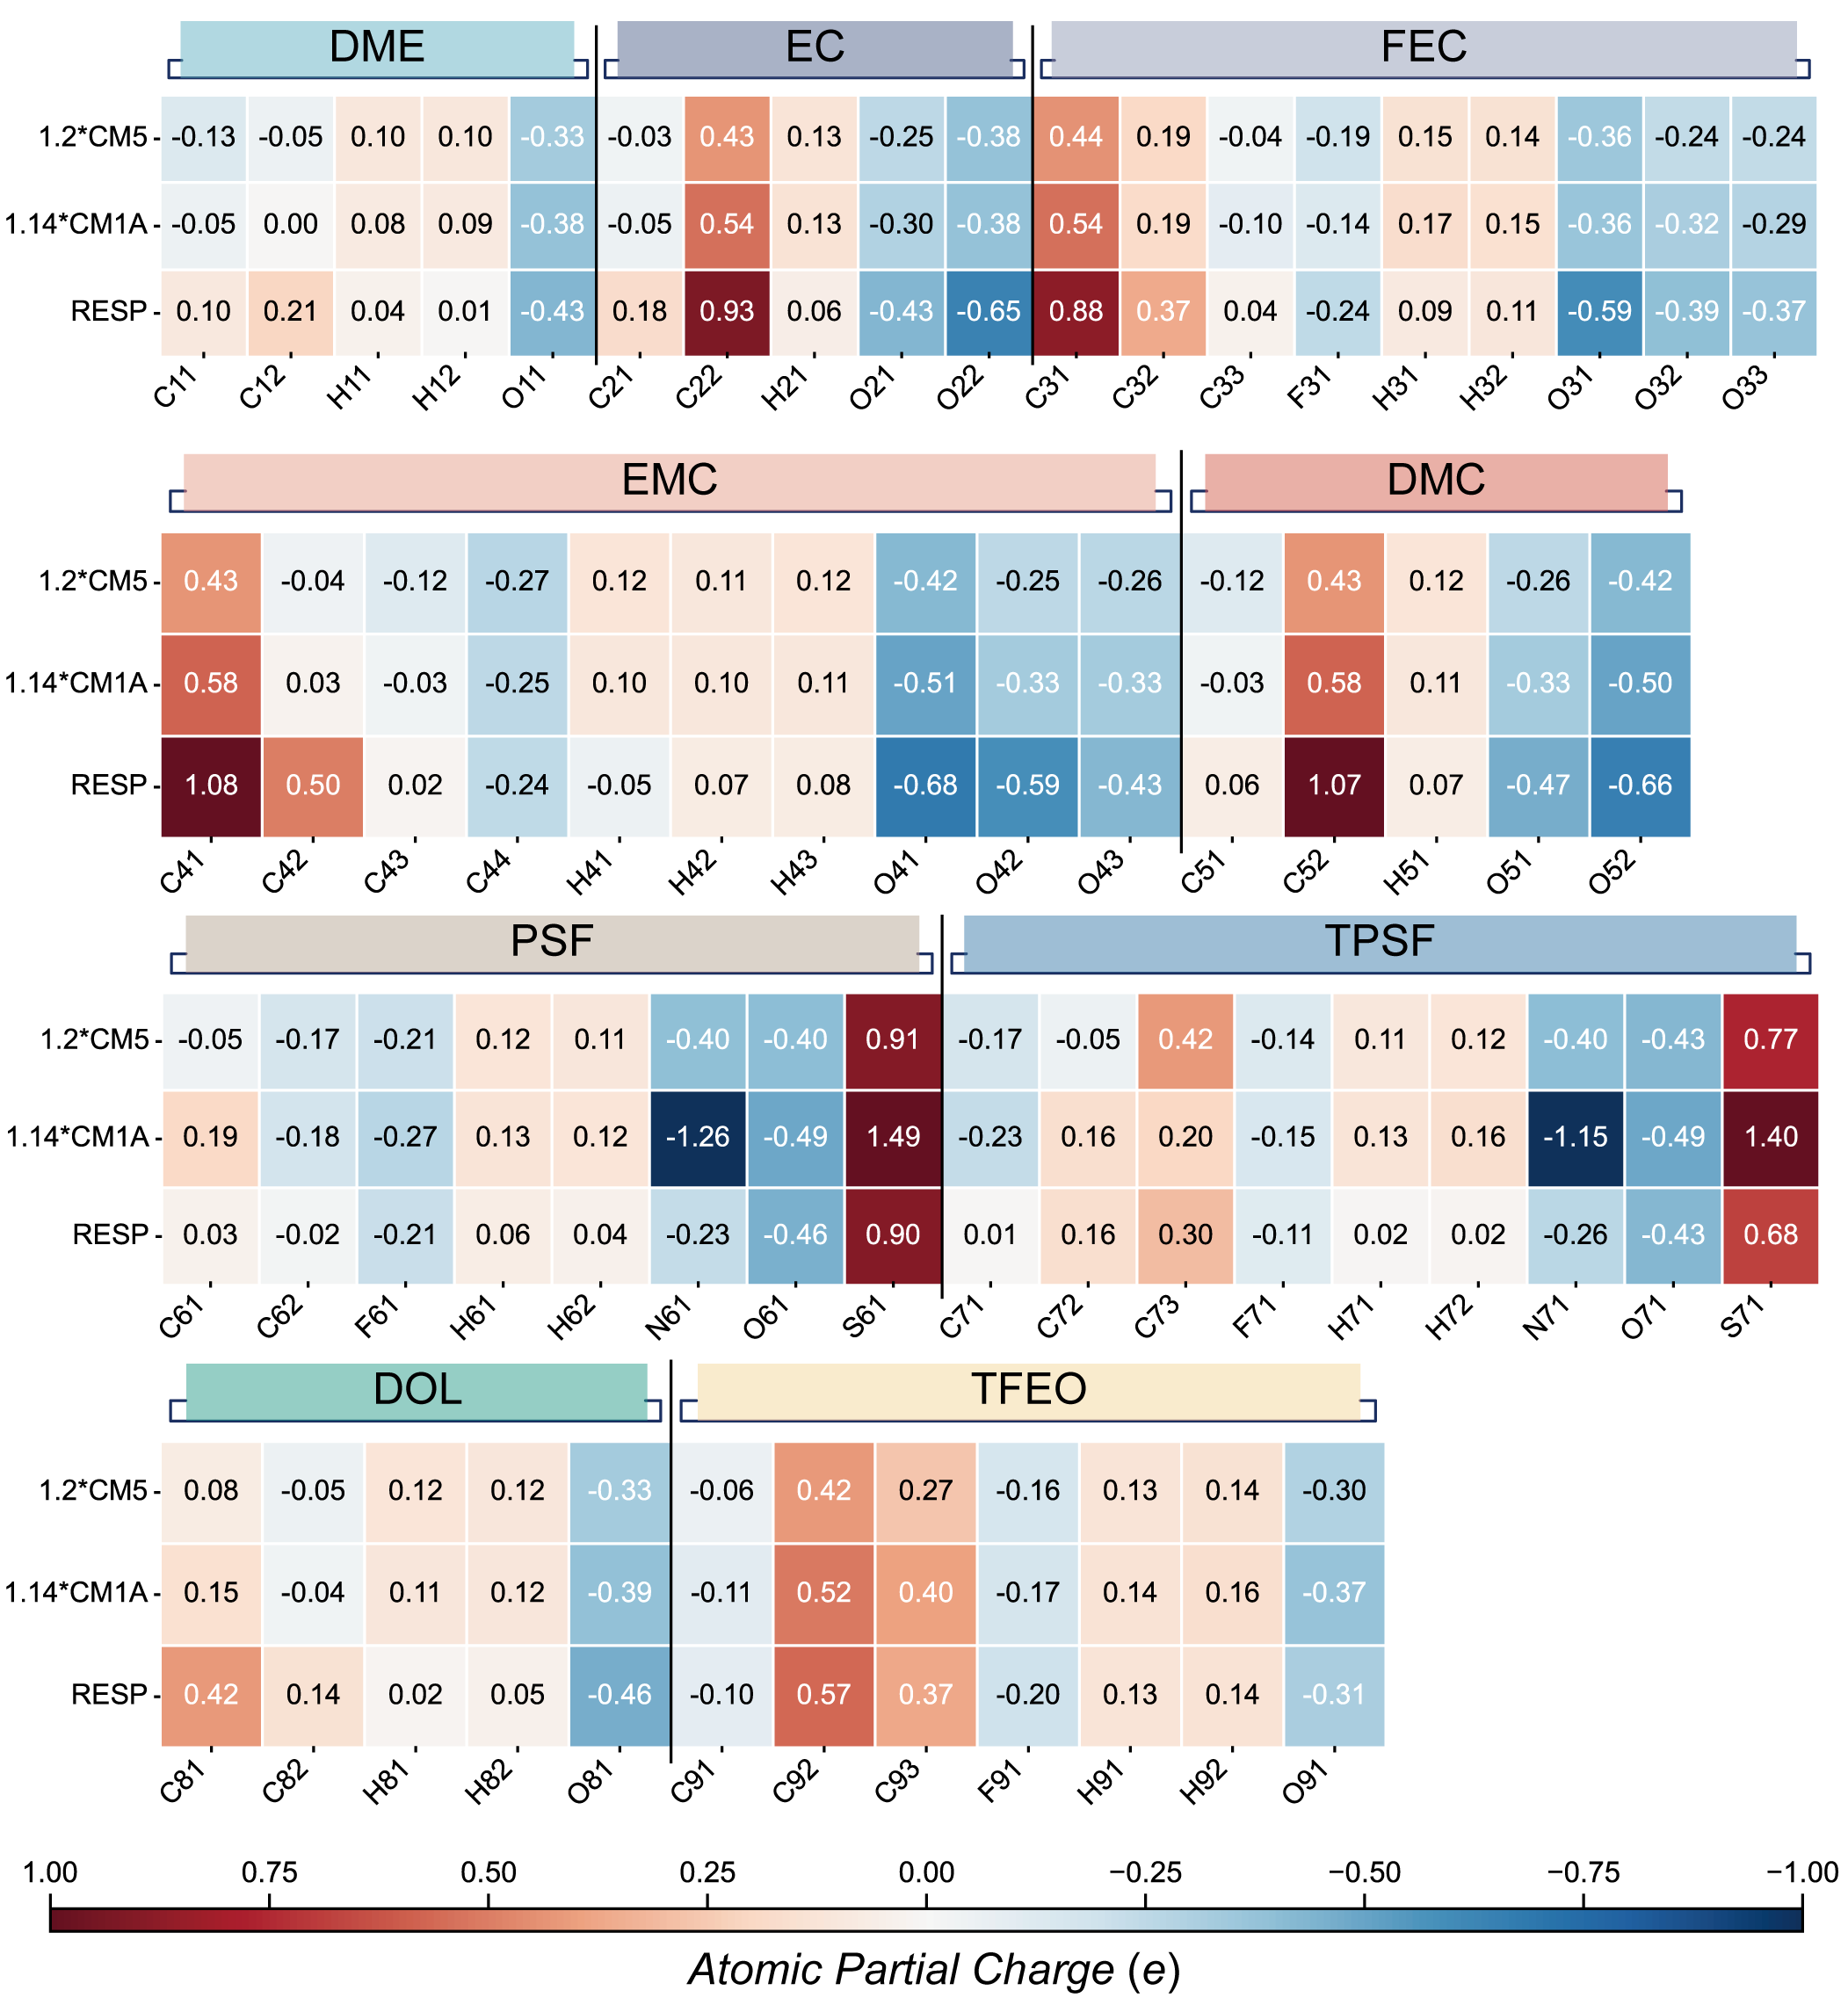
Supplementary Fig. 3 | Comparison of atomic partial charge assignment schemes. The heatmap visualizes the atomic partial charges derived from the restrained electrostatic potential (RESP),²⁹ 1.14*CM1A,^{30–32} and 1.2*CM5^{30,33} schemes across various electrolyte components, including solvents (DME, EC, EMC, DMC, PSF, TPSF, DOL), an additive (FEC), and a diluent (TFEO). Methodological details: To obtain the atomic partial charges, geometry optimizations were performed at the B3LYP³⁴/def2-SVP^{35,36} level, incorporating Grimme’s D3 dispersion correction with Becke-Johnson damping D3(BJ).^{37,38}

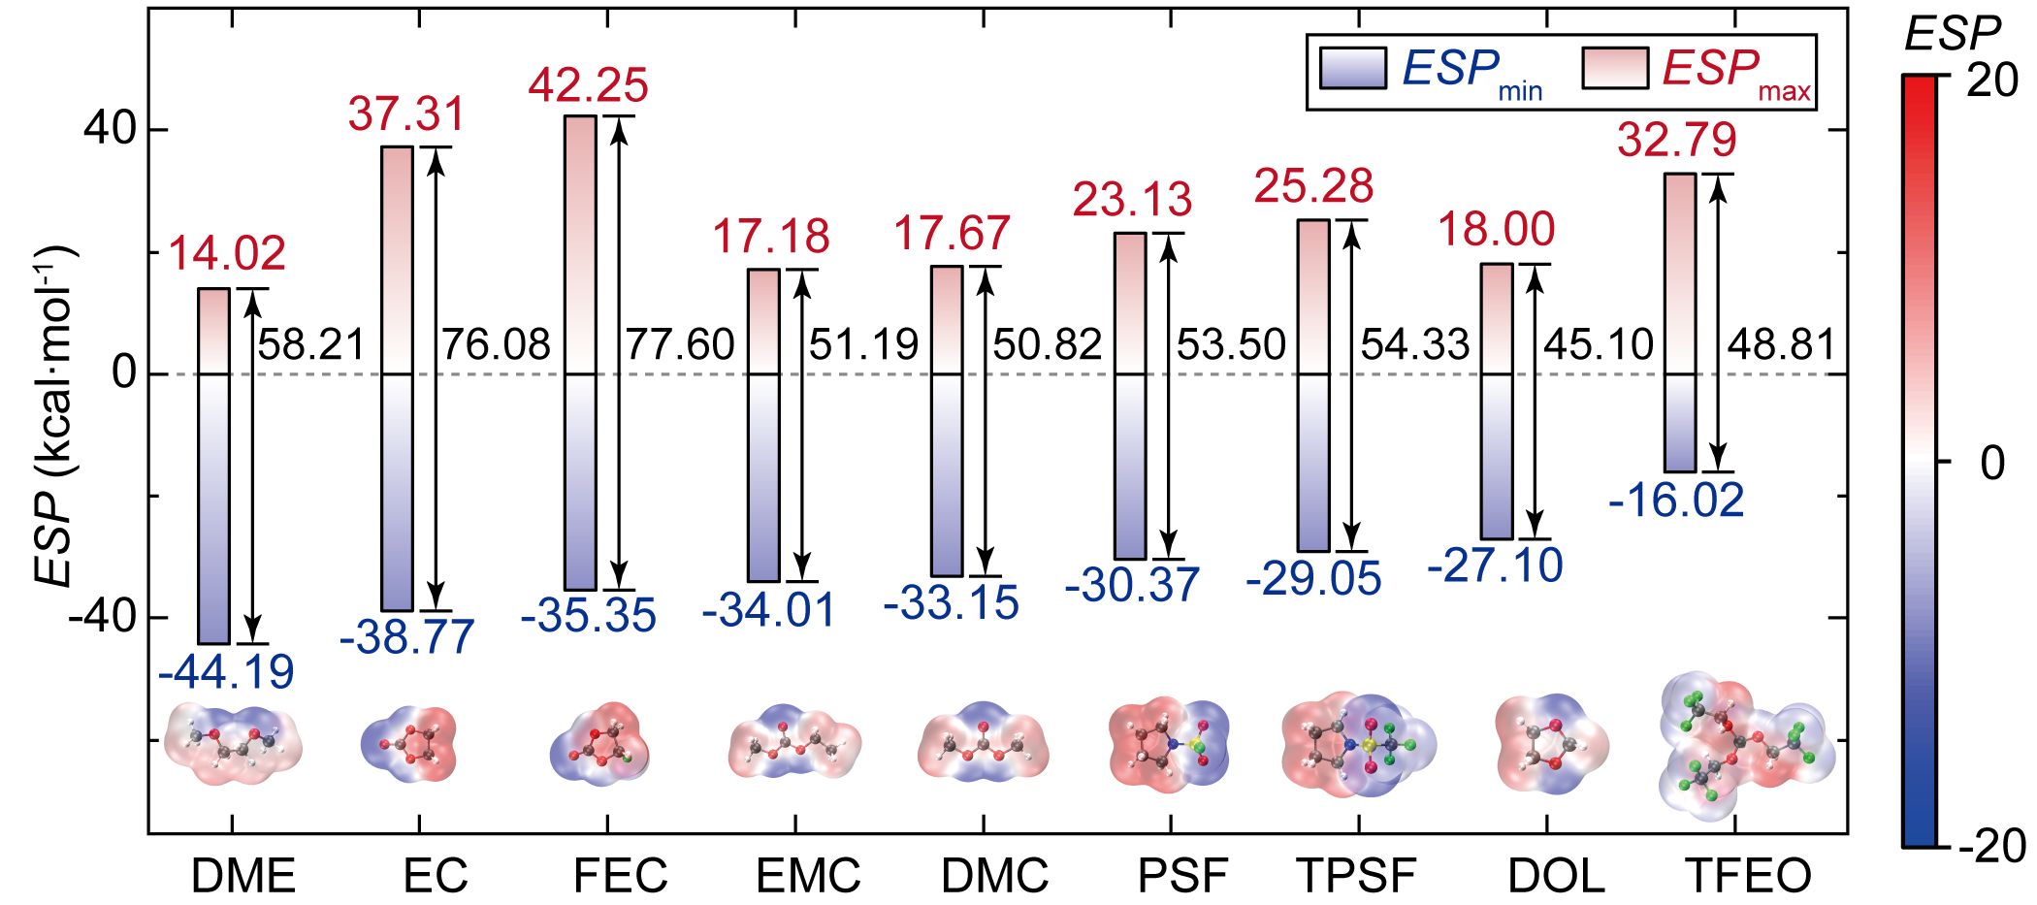
Supplementary Fig. 4 | Molecular electrostatic potential distributions. Electrostatic potential (ESP) surfaces for the investigated solvents (DME, EC, EMC, DMC, PSF, TPSF, DOL), additive (FEC), and diluent (TFEO). The maximum (ESP_{max}), and minimum (ESP_{min}) potentials, along with the potential span (∆ESP = ESP_{max}-ESP_{min}) are indicated. Calculation protocol: Following geometry optimization, single-point energy calculations were conducted at the B3LYP³⁴-D3(BJ)^{37,38}/def2-TZVP^{35,39} level to generate the ESP. This high-level theory ensures the generation of physically smooth and transferable ESP surfaces, which is critical for compatibility with CFFs.^{26,40,41}

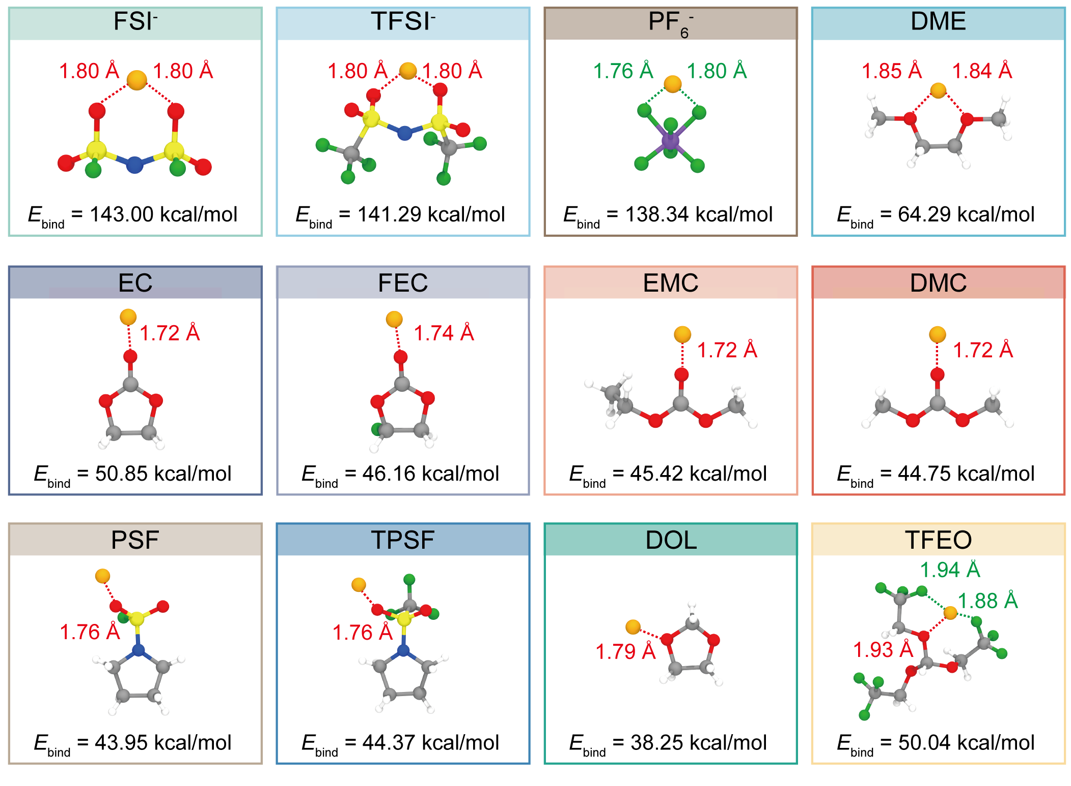
Supplementary Fig. 5 | Gas-phase energetics and geometries of Li⁺-ligand complexes. Calculated binding energies (E_{bind}) and optimized coordination motifs for Li⁺ with the full spectrum of electrolyte components, including anions (FSI⁻, TFSI⁻, PF₆⁻), solvents (DME, EC, EMC, DMC, PSF, TPSF, DOL), the additive (FEC), and the diluent (TFEO). Dashed lines denote contact distances between Li⁺ and coordinating atoms. The E_{bind} represents the stability gain upon complexation relative to isolated species, defined as: E_{bind} = E_{Li+} + E_{mol} - E_{bound}. Here, E_{Li+}, E_{mol}, and E_{bound} represent the energies of the isolated Li⁺, the fully relaxed isolated molecule or anion, and the fully relaxed bound complex, respectively. Computational details: Geometries of isolated species and ion-ligand complexes were optimized at the M06-2X⁴²/def2-TZVP^{35,39} level, with D3zero⁴³ dispersion correction applied to accurately capture mid-range noncovalent interactions. The M06-2X functional was selected for its proven reliability in modeling main-group thermochemistry and noncovalent interactions.⁴⁴

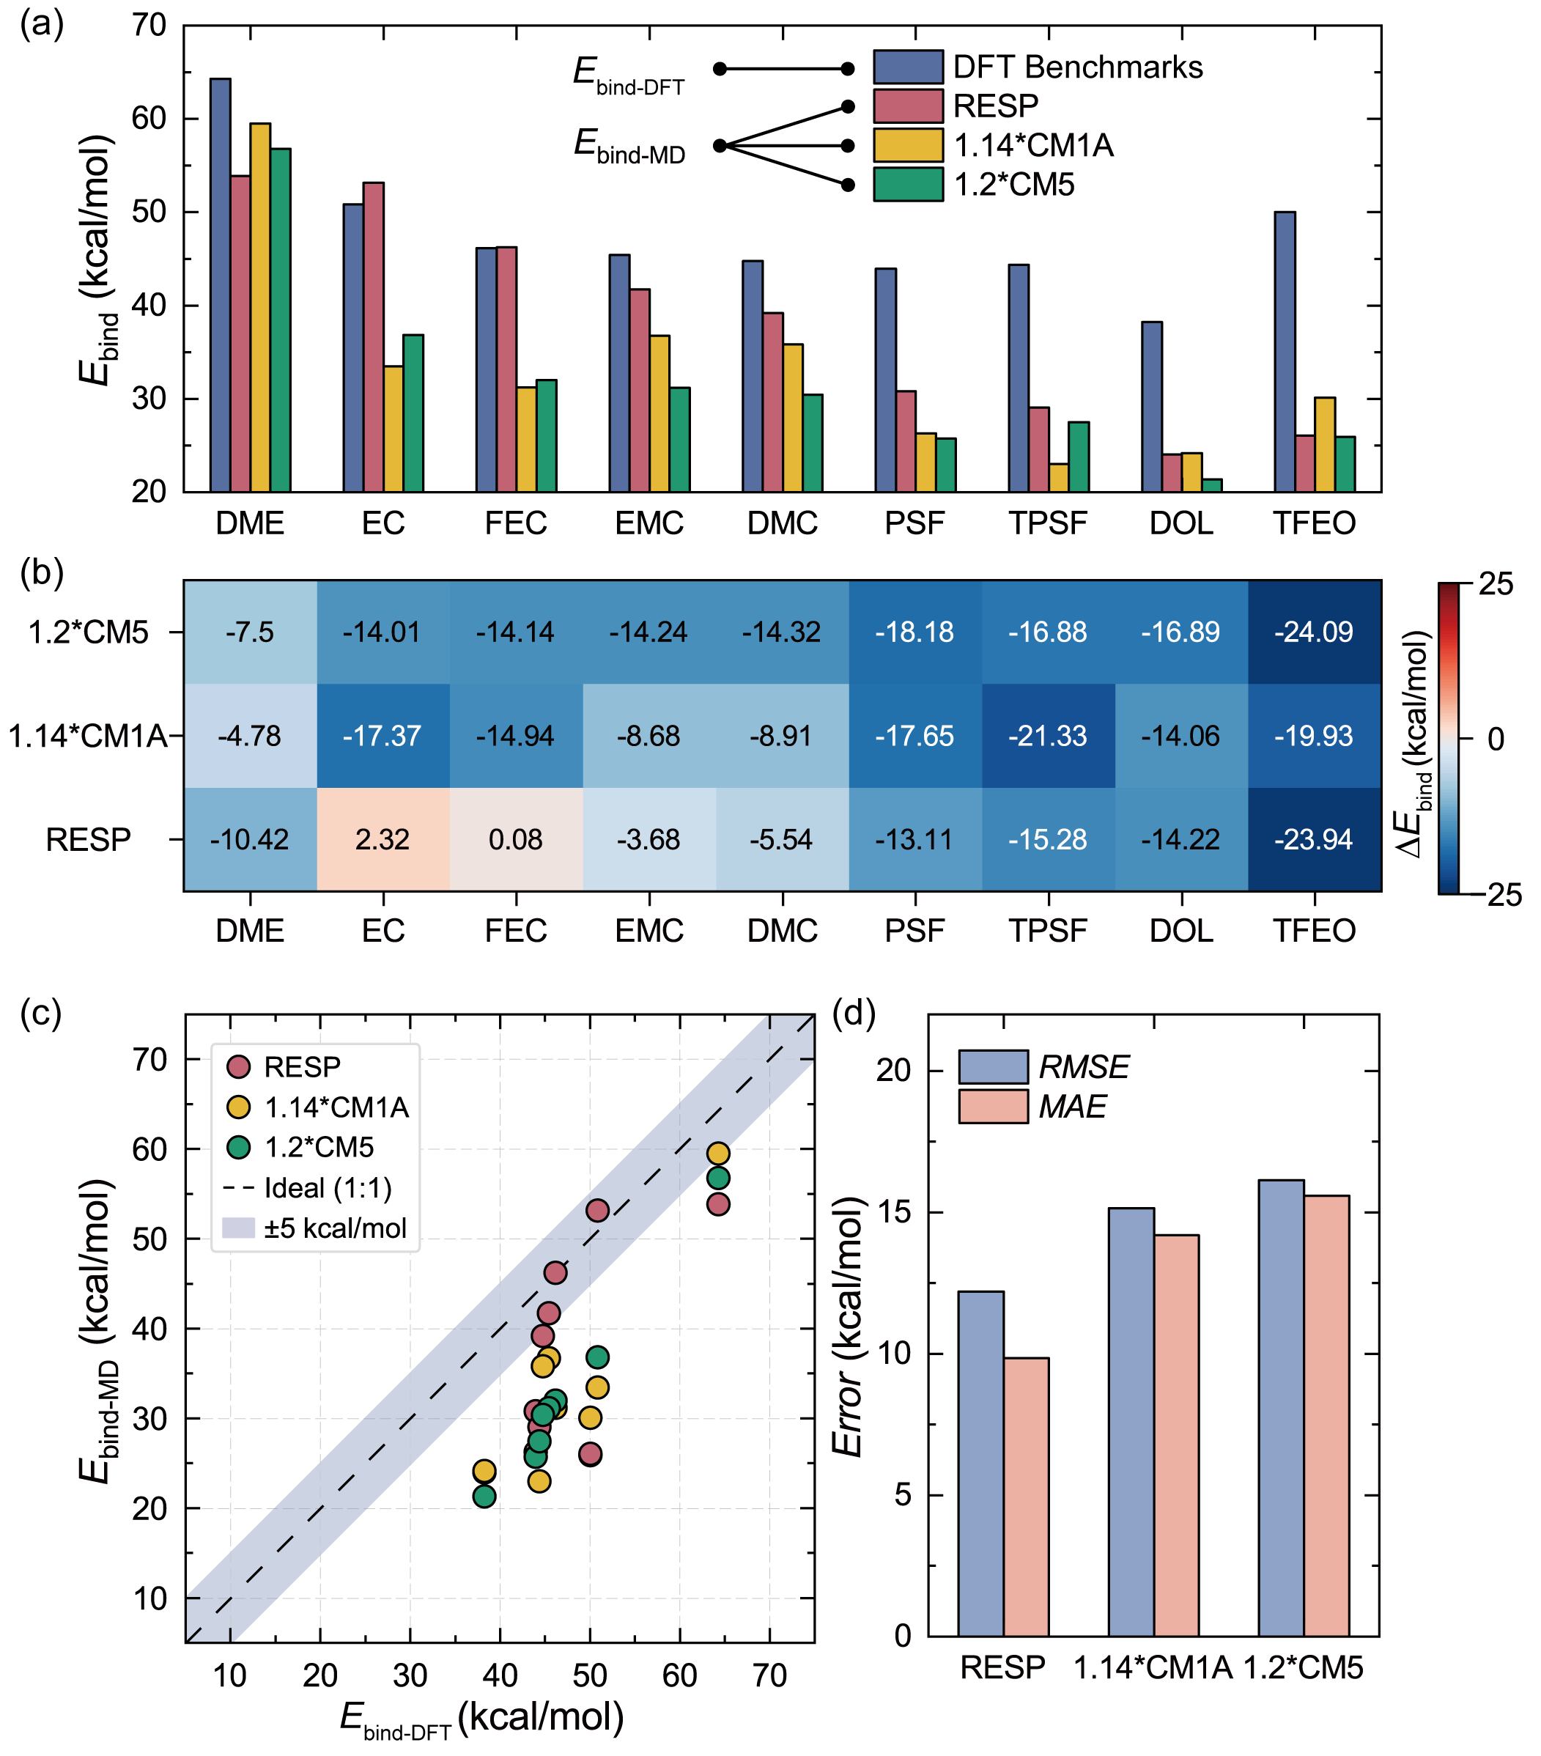
Supplementary Fig. 6 | Benchmarking gas-phase energetics of Li⁺-molecule complexes. (a) Comparison of E_{bind} derived from MD simulations (E_{bind-MD}) using three schemes relative to density functional theory (DFT) benchmarks (E_{bind-DFT}, referenced in Supplementary Fig. 5). (b) Heatmap visualizing the deviations (∆E_{bind} = E_{bind-MD} - E_{bind-DFT}) for each species. (c) Correlation plot of E_{bind-MD} versus E_{bind}. The dashed diagonal indicates perfect agreement, while the shaded region denotes a ±5 kcal·mol⁻¹ tolerance. (d) Statistical accuracy of E_{bind} predictions, quantified by the root-mean-square error (RMSE) and mean absolute error (MAE) for each scheme.

Supplementary Table 7 | RESP-derived atomic partial charges for molecules. Atomic partial charges (q’), atom counts (N_{atoms}), and total net charges (Q) for the molecules (DME, EC, EMC, DMC, PSF, TPSF, DOL, FEC, TFEO), computed using the Multiwfn 3.7.^{45–48}
Molecule | Atom | q’ (e) | N_{atoms} | Q (e)
DME | C11 | 0.0967 | 2 | 0
DME | H11 | 0.0380 | 6 | 0
DME | O11 | -0.4342 | 2 | 0
DME | C12 | 0.2085 | 2 | 0
DME | H12 | 0.0075 | 4 | 0
EC | H21 | 0.0557 | 4 | 0
EC | C21 | 0.1790 | 2 | 0
EC | O21 | -0.4304 | 2 | 0
EC | C22 | 0.9261 | 1 | 0
EC | O22 | -0.6461 | 1 | 0
FEC | O31 | -0.5943 | 1 | 0
FEC | C31 | 0.8783 | 1 | 0
FEC | O32 | -0.3921 | 1 | 0
FEC | O33 | -0.3707 | 1 | 0
FEC | C32 | 0.3660 | 1 | 0
FEC | C33 | 0.0354 | 1 | 0
FEC | H31 | 0.0916 | 1 | 0
FEC | F31 | -0.2432 | 1 | 0
FEC | H32 | 0.1145 | 2 | 0
EMC | O41 | -0.6847 | 1 | 0
EMC | C41 | 1.0819 | 1 | 0
EMC | O42 | -0.5930 | 1 | 0
EMC | O43 | -0.4292 | 1 | 0
EMC | C42 | 0.5011 | 1 | 0
EMC | C43 | 0.0170 | 1 | 0
EMC | C44 | -0.2442 | 1 | 0
EMC | H41 | -0.0469 | 2 | 0
EMC | H42 | 0.0711 | 3 | 0
EMC | H43 | 0.0772 | 3 | 0

Molecule | Atom | q’ (e) | N_{atoms} | Q (e)
DMC | H51 | 0.0660 | 6 | 0
DMC | C51 | 0.0635 | 2 | 0
DMC | O51 | -0.4672 | 2 | 0
DMC | C52 | 1.0706 | 1 | 0
DMC | O52 | -0.6592 | 1 | 0
PSF | H61 | 0.0641 | 4 | 0
PSF | C61 | 0.0335 | 2 | 0
PSF | N61 | -0.2283 | 1 | 0
PSF | C62 | -0.0182 | 2 | 0
PSF | S61 | 0.8988 | 1 | 0
PSF | H62 | 0.0417 | 4 | 0
PSF | O61 | -0.4563 | 2 | 0
PSF | F61 | -0.2117 | 1 | 0
TPSF | C71 | 0.0072 | 2 | 0
TPSF | C72 | 0.1634 | 2 | 0
TPSF | N71 | -0.2636 | 1 | 0
TPSF | S71 | 0.6803 | 1 | 0
TPSF | O71 | -0.4276 | 2 | 0
TPSF | C73 | 0.2983 | 1 | 0
TPSF | F71 | -0.1110 | 3 | 0
TPSF | H72 | 0.0175 | 4 | 0
TPSF | H71 | 0.0155 | 4 | 0
DOL | C81 | 0.4210 | 1 | 0
DOL | H81 | 0.0157 | 2 | 0
DOL | O81 | -0.4618 | 2 | 0
DOL | C82 | 0.1444 | 2 | 0
DOL | H82 | 0.0456 | 4 | 0
TFEO | H91 | 0.1313 | 6 | 0
TFEO | C91 | -0.0961 | 3 | 0
TFEO | C92 | 0.5700 | 3 | 0
TFEO | O91 | -0.3128 | 3 | 0
TFEO | F91 | -0.1983 | 9 | 0
TFEO | C93 | 0.3737 | 1 | 0
TFEO | H92 | 0.1399 | 1 | 0

Supplementary Table 8 | Reference atomic partial charges for ions. The q’, N_{atoms}, and Q values for Li⁺, FSI⁻, TFSI⁻, and PF₆⁻.^{49–52}
Ion | Atom | q’ (e) | N_{atoms} | Q (e)
Li⁺ | Li | 1 | 1 | 1
FSI⁻ | N | -0.66 | 1 | -1
FSI⁻ | O | -0.53 | 4 | -1
FSI⁻ | S | 1.02 | 2 | -1
FSI⁻ | F | -0.13 | 2 | -1
TFSI⁻ | CT | 0.35 | 2 | -1
TFSI⁻ | FT | -0.16 | 6 | -1
TFSI⁻ | ST | 1.02 | 2 | -1
TFSI⁻ | NT | -0.66 | 1 | -1
TFSI⁻ | OT | -0.53 | 4 | -1
PF₆⁻ | P | 1.34 | 1 | -1
PF₆⁻ | FP | -0.39 | 6 | -1

Supplementary Table 9 | OPLS&Pol parameters: polarizabilities and dipole moments. The listed parameters include atomic polarizabilities (α), total polarizabilities (A), and dipole moments (μ) for the electrolyte components established in this work. Mean denotes the averaged value; SD denotes the standard deviation.
Species | Atom | α (Å³) |  | A (Å³) |  | μ (Debye)
Species | Atom | Mean | SD | Mean | SD | Mean | SD
Li⁺ | Li | 0.019 | 0.000 | 0.019 | 0.000 | 0 | 0
FSI⁻ | N | 0.946 | 0.017 | 9.610 | 0.122 | 1.7325 | 0.8288
FSI⁻ | O | 0.709 | 0.009
FSI⁻ | S | 2.442 | 0.031
FSI⁻ | F | 0.471 | 0.009
TFSI⁻ | CT | 1.343 | 0.019 | 13.935 | 0.209 | 3.6986 | 1.6373
TFSI⁻ | FT | 0.457 | 0.006
TFSI⁻ | ST | 2.388 | 0.038
TFSI⁻ | NT | 0.930 | 0.021
TFSI⁻ | OT | 0.700 | 0.010
PF₆⁻ | P | 2.460 | 0.021 | 4.642 | 0.040 | 0 | 0
PF₆⁻ | FP | 0.364 | 0.003
DME | C11 | 1.584 | 0.055 | 9.204 | 0.160 | 1.9550 | 0.4750
DME | H11 | 0.134 | 0.000
DME | O11 | 0.688 | 0.039
DME | C12 | 1.660 | 0.047
DME | H12 | 0.134 | 0.000
EC | H21 | 0.134 | 0.000 | 6.599 | 0.051 | 6.0356 | 0.1793
EC | C21 | 1.495 | 0.010
EC | O21 | 0.585 | 0.004
EC | C22 | 1.237 | 0.014
EC | O22 | 0.667 | 0.011

Species | Atom | α (Å³) |  | A (Å³) |  | μ (Debye)
Species | Atom | Mean | SD | Mean | SD | Mean | SD
FEC | O31 | 0.662 | 0.010 | 6.734 | 0.056 | 5.2701 | 0.4475
FEC | C31 | 1.229 | 0.010
FEC | O32 | 0.582 | 0.005
FEC | O33 | 0.580 | 0.007
FEC | C32 | 1.348 | 0.019
FEC | C33 | 1.500 | 0.015
FEC | H31 | 0.134 | 0.000
FEC | F31 | 0.431 | 0.006
FEC | H32 | 0.134 | 0.000
EMC | O41 | 0.651 | 0.009 | 9.350 | 0.082 | 0.9776 | 0.2908
EMC | C41 | 1.228 | 0.013
EMC | O42 | 0.594 | 0.008
EMC | O43 | 0.601 | 0.006
EMC | C42 | 1.625 | 0.022
EMC | C43 | 1.789 | 0.014
EMC | C44 | 1.789 | 0.027
EMC | H41 | 0.134 | 0.000
EMC | H42 | 0.134 | 0.000
EMC | H43 | 0.134 | 0.000
DMC | H51 | 0.134 | 0.000 | 7.468 | 0.112 | 1.0792 | 0.3554
DMC | C51 | 1.791 | 0.030
DMC | O51 | 0.601 | 0.011
DMC | C52 | 1.230 | 0.022
DMC | O52 | 0.650 | 0.012

Species | Atom | α (Å³) |  | A (Å³) |  | μ (Debye)
Species | Atom | Mean | SD | Mean | SD | Mean | SD
PSF | H61 | 0.134 | 0.000 | 11.741 | 0.170 | 5.4558 | 0.2403
PSF | C61 | 1.557 | 0.026
PSF | N61 | 0.794 | 0.012
PSF | C62 | 1.499 | 0.024
PSF | S61 | 2.107 | 0.033
PSF | H62 | 0.134 | 0.000
PSF | O61 | 0.618 | 0.010
PSF | F61 | 0.418 | 0.008
TPSF | C71 | 1.492 | 0.021 | 13.744 | 0.172 | 5.1917 | 0.3535
TPSF | C72 | 1.570 | 0.022
TPSF | N71 | 0.791 | 0.012
TPSF | S71 | 2.102 | 0.031
TPSF | O71 | 0.617 | 0.009
TPSF | C73 | 1.190 | 0.017
TPSF | F71 | 0.410 | 0.006
TPSF | H72 | 0.134 | 0.000
TPSF | H71 | 0.134 | 0.000
DOL | C81 | 1.498 | 0.022 | 6.364 | 0.081 | 1.5159 | 0.1653
DOL | H81 | 0.134 | 0.000
DOL | O81 | 0.567 | 0.010
DOL | C82 | 1.463 | 0.021
DOL | H82 | 0.134 | 0.000
TFEO | H91 | 0.134 | 0.000 | 15.868 | 0.193 | 3.0725 | 0.6854
TFEO | C91 | 1.555 | 0.023
TFEO | C92 | 1.172 | 0.014
TFEO | O91 | 0.568 | 0.008
TFEO | F91 | 0.410 | 0.005
TFEO | C93 | 1.359 | 0.014
TFEO | H92 | 0.134 | 0.000

Supplementary Table 10 | OPLS&Pol parameters: equilibrium distances and LJ scaling factors. The listed parameters include equilibrium center-of-mass distances (r_{CoM}), and LJ scaling coefficients (K_{LJ}) for the electrolyte components established in this work. SD denotes the standard deviation.
Species Pair |  | r_{CoM} (Å) |  | K_{LJ}
Species 1 | Species 2 | Mean | SD | Mean | SD
Li⁺ | FSI⁻ | 2.8245 | 0.0177 | 1 | /
Li⁺ | TFSI⁻ | 3.2630 | 0.0148 | 1 | /
Li⁺ | PF₆⁻ | 3.2630 | 0.0158 | 1 | /
Li⁺ | DME | 1.8870 | 0.0000 | 1 | /
Li⁺ | EC | 3.6063 | 0.2300 | 1 | /
Li⁺ | FEC | 4.0880 | 0.2154 | 1 | /
Li⁺ | EMC | 3.2755 | 0.0144 | 1 | /
Li⁺ | DMC | 3.0620 | 0.0142 | 1 | /
Li⁺ | PSF | 3.9870 | 0.0000 | 1 | /
Li⁺ | TPSF | 3.9875 | 0.0361 | 1 | /
Li⁺ | DOL | 3.0380 | 0.0125 | 1 | /
Li⁺ | TFEO | 2.2755 | 0.0177 | 1 | /
DME | FSI⁻ | 4.2500 | 0.0184 | 0.6419 | 0.0220
DME | TFSI⁻ | 4.4380 | 0.0187 | 0.6565 | 0.0411
DME | DME | 3.3750 | 0.0184 | 0.9137 | 0.0386
DME | FEC | 4.5620 | 0.1543 | 0.6663 | 0.0382
DME | DOL | 5.3380 | 0.1434 | 0.9192 | 0.0170
DME | TFEO | 8.2000 | 0.2305 | 0.8962 | 0.0241
EC | PF₆⁻ | 4.5563 | 0.1144 | 0.3669 | 0.0039
EC | EC | 4.3190 | 0.0902 | 0.4518 | 0.0138
EC | FEC | 5.3245 | 0.0530 | 0.4850 | 0.0191
EC | EMC | 4.3308 | 0.0554 | 0.6176 | 0.0127
EC | DMC | 4.2130 | 0.0432 | 0.6151 | 0.0144

Species Pair |  | r_{CoM} (Å) |  | K_{LJ}
Species 1 | Species 2 | Mean | SD | Mean | SD
FEC | TFSI⁻ | 5.1380 | 0.0166 | 0.4876 | 0.0292
FEC | PF₆⁻ | 4.5625 | 0.0361 | 0.3883 | 0.0123
FEC | FEC | 5.7370 | 0.0375 | 0.5257 | 0.0438
FEC | EMC | 4.6625 | 0.0714 | 0.6824 | 0.0356
FEC | DOL | 5.3880 | 0.0545 | 0.6697 | 0.0363
EMC | PF₆⁻ | 4.6625 | 0.1668 | 0.4581 | 0.0026
EMC | EMC | 4.3880 | 0.0408 | 0.9764 | 0.0123
DMC | PF₆⁻ | 4.4870 | 0.0154 | 0.4755 | 0.0034
DMC | DMC | 4.0370 | 0.0131 | 0.9642 | 0.0241
PSF | FSI⁻ | 6.1375 | 0.4603 | 0.4349 | 0.0112
PSF | PSF | 6.3505 | 0.1237 | 0.6421 | 0.0203
TPSF | FSI⁻ | 6.1745 | 0.1591 | 0.4446 | 0.0096
TPSF | TPSF | 5.7750 | 0.0170 | 0.6987 | 0.0288
DOL | TFSI⁻ | 6.1120 | 0.0149 | 0.5455 | 0.0279
DOL | DOL | 5.2630 | 0.0154 | 0.9259 | 0.0149
TFEO | FSI⁻ | 5.9130 | 0.0354 | 0.4954 | 0.0111
TFEO | TFEO | 7.9500 | 0.1952 | 0.8816 | 0.0437

Supplementary Table 11 | Parameter comparison between OPLS&Pol and CL&Pol. Comparison of key parameters (α, μ, r_{CoM}, K_{LJ}) for LiFSI:DME electrolytes derived in this work versus those from the published CL&Pol.^{4–6,53} For CL&Pol benchmark, we evaluated different K_{LJ},^{4–6,53} including values obtained from the general predictive scheme used in this work (K_{pred}), and those derived from symmetry-adapted perturbation theory (K_{SAPT}).
Species | Atom | α (Å³) |  | μ (Debye)
Species | Atom | This work | CL&Pol | This work | CL&Pol
Li⁺ | Li | 0.019 | 0.032 | 0 | 0
FSI⁻ | N | 0.946 | 1.698 | 1.7325 | 0.4245
FSI⁻ | O | 0.709 | 1.144 | 1.7325 | 0.4245
FSI⁻ | S | 2.442 | 1.553 | 1.7325 | 0.4245
FSI⁻ | F | 0.471 | 0.625 | 1.7325 | 0.4245
DME | C11 | 1.584 | 1.016 | 1.9550 | 1.2442
DME | H11 | 0.134 | 0.323 | 1.9550 | 1.2442
DME | O11 | 0.688 | 1.144 | 1.9550 | 1.2442
DME | C12 | 1.660 | 1.016 | 1.9550 | 1.2442
DME | H12 | 0.134 | 0.323 | 1.9550 | 1.2442

Species Pair | r_{CoM} (Å³) |  | K_{LJ}
Species Pair | This work | CL&Pol | This work | CL&Pol
 |  |  |  | K_{pred} | K_{SAPT}
Li⁺-FSI⁻ | 2.8245 | 2.548 | 1 | 1 | 1
Li⁺-DME | 1.887 | 1.737 | 1 | 1 | 1
FSI⁻-DME | 4.250 | 4.583 | 0.6419 | 0.6607 | 0.73
DME-DME | 3.375 | 3.856 | 0.9137 | 0.9657 | 0.89

Supplementary Note 5 | Static and Transport Properties of Neat Components
Supplementary Table 12 | Benchmark comparison of calculated densities for neat components. Densities (ρ, g·cm⁻³) of neat solvents (DME, EC, EMC, DMC, PSF, TPSF, DOL), the additive (FEC), and the diluent (TFEO). Results are benchmarked against internal calculations using the newly developed OPLS&Pol and canonical OPLS-AA with three charge schemes (OPLS-RESP, OPLS-1.14CM1A, OPLS-1.2CM5), as well as reference values retrieved from literature, including experimental data,^{26,54–59} machine learning force fields (MLPs: BAMBOO,⁶⁰ QRNN,⁶¹ SevenNet⁶²), and APPLE&P.^{63,64}
Species | This Work |  |  |  | Published Benchmarks
Species | OPLS-RESP | OPLS-1.14CM1A | OPLS-1.2CM5 | OPLS&Pol | Experiment | BAMBOO | QRNN | SevenNet | APPLE&P
DME | 0.8684 | 0.8853 | 0.8788 | 0.8833 | 0.86109⁵⁵ | / | / | / | 0.8512⁶⁴
EC | 1.3532 | 1.2873 | 1.3012 | 1.3158 | 1.321⁵⁶ | 1.310⁶⁰ | 1.35⁶¹ | 1.3661⁶² | 1.3020⁶⁴
FEC | 1.5198 | 1.4615 | 1.4656 | 1.4797 | 1.48⁵⁷ | 1.474⁶⁰ | 1.47⁶¹ | 1.5027⁶² | /
EMC | 1.0313 | 1.0358 | 1.0184 | 1.0266 | 1.01⁵⁸ | 1.015⁶⁰ | 0.99⁶¹ | 1.1463⁶² | /
DMC | 1.0754 | 1.0870 | 1.0679 | 1.0670 | 1.063⁵⁶ | 1.060⁶⁰ | 1.07⁶¹ | 1.2170⁶² | 1.0318⁶³
PSF | 1.3718 | 1.4006 | 1.3535 | 1.2473 | 1.314²⁶ | / | / | / | /
TPSF | 1.4783 | 1.4995 | 1.4616 | 1.3683 | 1.37698²⁶ | / | / | / | /
DOL | 1.0533 | 1.0766 | 1.0553 | 1.0635 | 1.05862⁵⁹ | / | / | / | /
TFEO | 1.5383 | 1.5259 | 1.5274 | 1.5281 | 1.46⁵⁴ | / | / | / | /

Supplementary Table 13 | Benchmark comparison of calculated self-diffusion coefficients for neat components. Self-diffusion coefficients (D, 10⁻⁹ m²·s⁻¹) of neat solvents (DME, EC, EMC, DMC, PSF, TPSF, DOL), the additive (FEC), and the diluent (TFEO). Results are benchmarked against internal calculations using the newly developed OPLS&Pol and canonical OPLS-AA with three charge schemes (OPLS-RESP, OPLS-1.14CM1A, OPLS-1.2CM5), as well as reference values retrieved from literature, including experimental data,^{16,26,58} QRNN,⁶¹ and APPLE&P.⁶⁴
Species | This Work |  |  |  | Published Benchmarks
Species | OPLS-RESP | OPLS-1.14CM1A | OPLS-1.2CM5 | OPLS&Pol | Experiment | QRNN | APPLE&P
DME | 1.7170 | 1.2190 | 1.4320 | 1.4240 | 3.150¹⁶ | / | 3.290⁶⁴
EC | 0.0604 | 0.4375 | 0.2938 | 0.3164 | 0.800¹⁶ | 0.482⁶¹ | 0.780⁶⁴
FEC | 0.0781 | 0.4167 | 0.3131 | 0.1987 | 0.127⁵⁸ | 0.365⁶¹ | /
EMC | 0.5460 | 0.4137 | 0.5822 | 0.9150 | / | 1.950⁶¹ | /
DMC | 1.0320 | 0.6016 | 0.7617 | 1.5730 | 2.600¹⁶ | 2.320⁶¹ | 2.200⁶⁴
PSF | 0.0246 | 0.0084 | 0.0717 | 0.5288 | 0.431²⁶ | / | /
TPSF | 0.0357 | 0.0048 | 0.0744 | 0.4440 | 0.150²⁶ | / | /
DOL | 1.3800 | 0.9803 | 1.2980 | 1.3750 | 2.550¹⁶ | / | /
TFEO | 0.1418 | 0.1300 | 0.1286 | 0.1712 | / | / | /

Supplementary Note 6 | Polarization-Driven Li⁺ Solvation across Concentration Regimes
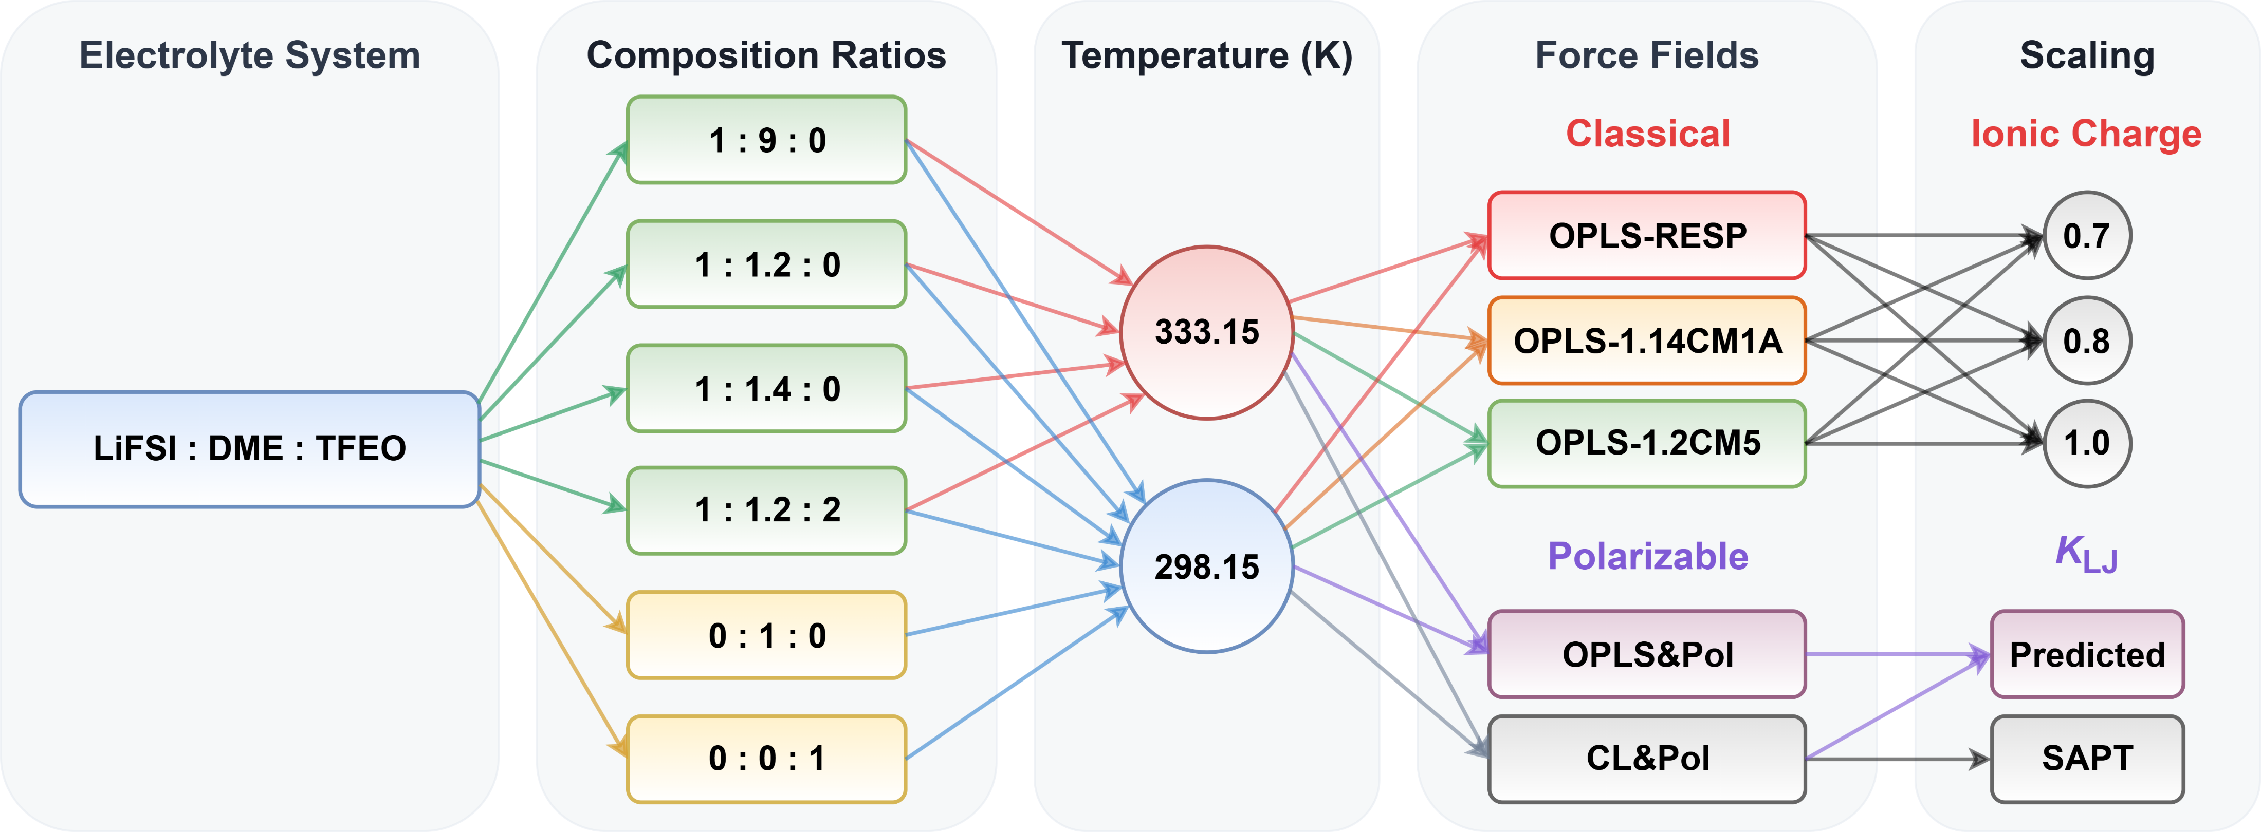
Supplementary Fig. 7 | Simulation configurations for LiFSI:DME:TFEO ether-based system. Comprehensive overview of FF variants and MD simulation configurations for LiFSI:DME:TFEO electrolytes, neat solvent (DME), and neat diluent (TFEO). This matrix of MD simulations spans 102 unique configurations, with molar ratios adopted from the literature.^{12–14} For the LiFSI:DME systems, we further evaluated different K_{LJ} within the published CL&Pol,^{4–6,53} including K_{pred} as well as K_{SAPT}.

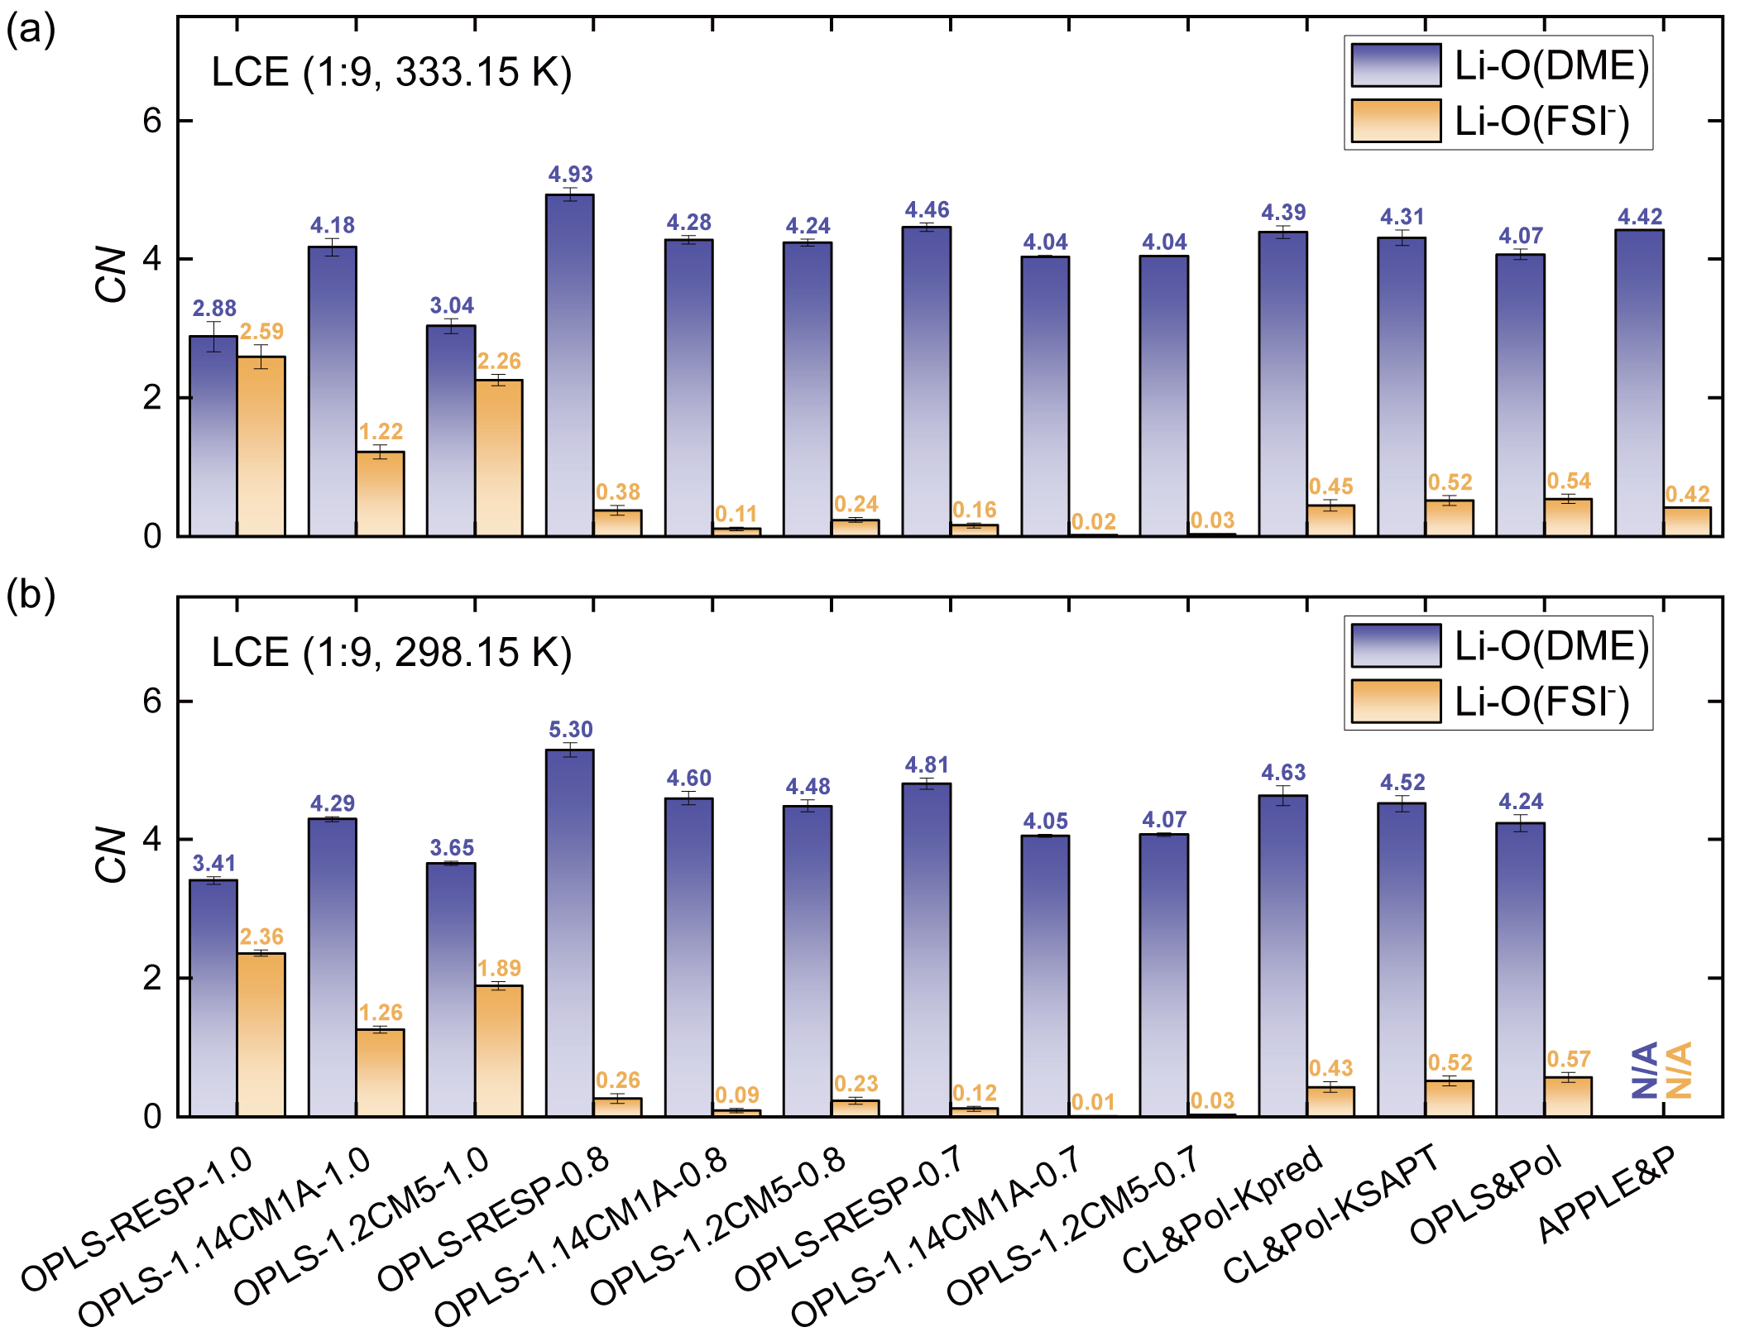
Supplementary Fig. 8 | Benchmarking Li⁺ solvation structures in 1LiFSI:9DME. (a) Coordination numbers (CNs) of Li⁺ with ether oxygen O(DME) and sulfonyl oxygen O(FSI⁻) within the first solvation shell (cutoff distance = 2.80 Å). Predictions computed using 12 FFs at 333.15 K are benchmarked against values from APPLE&P.¹³ (b) Corresponding CNs of Li-O(DME) and Li-O(FSI⁻) pairs predicted by 12 FFs at 298.15 K.

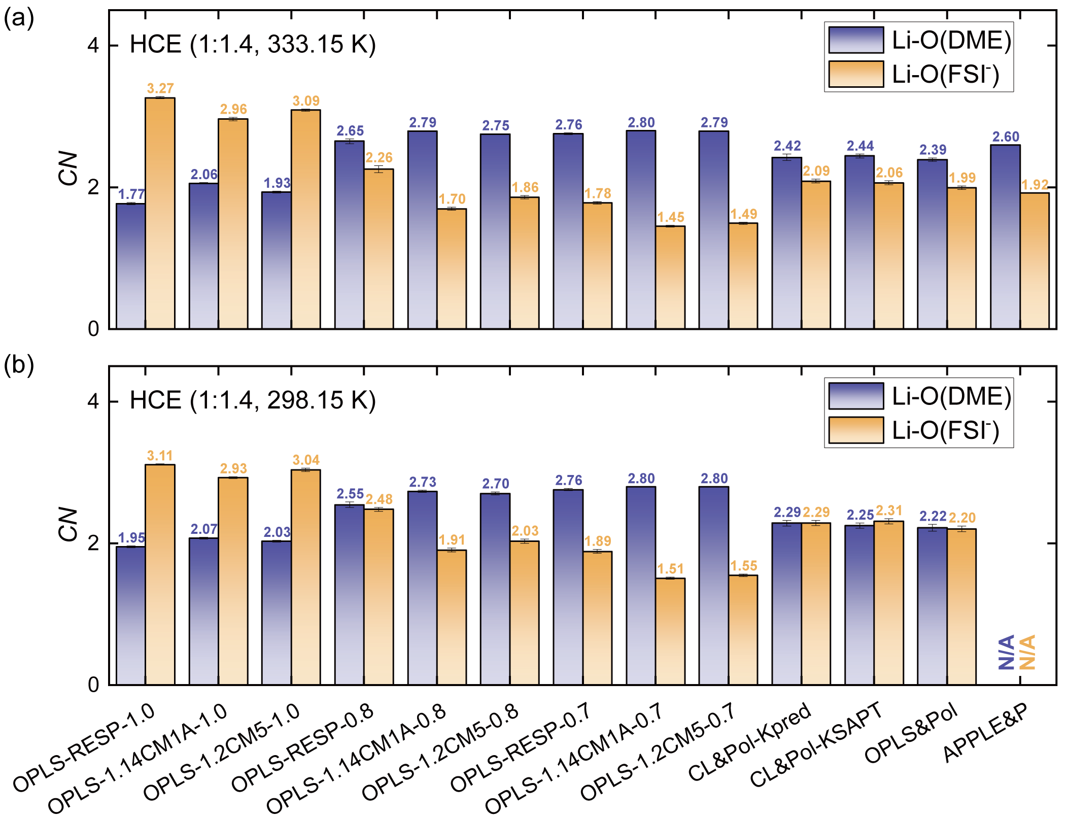
Supplementary Fig. 9 | Benchmarking Li⁺ solvation structures in 1LiFSI:1.4DME. (a) CNs of Li-O(DME) and Li-O(FSI⁻) pairs predicted by 12 FFs at 333.15 K are benchmarked against values from APPLE&P.¹³ (b) Corresponding CNs of Li-O(DME) and Li-O(FSI⁻) pairs predicted by 12 FFs at 298.15 K.

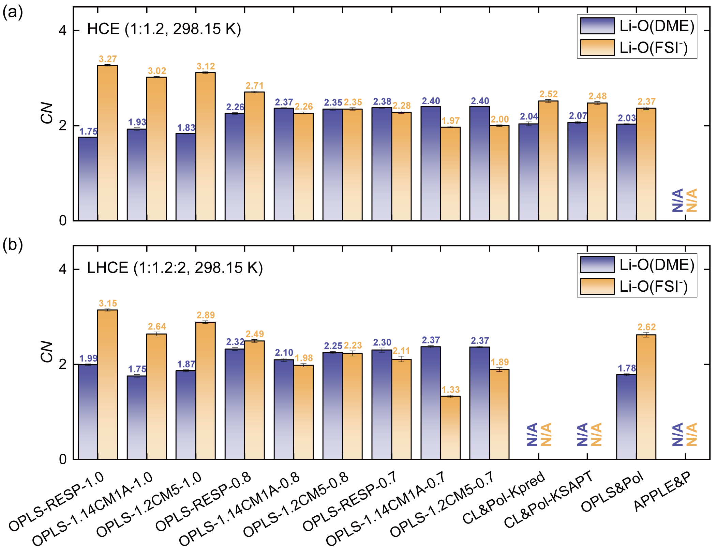
Supplementary Fig. 10 | Benchmarking Li⁺ solvation structures in 1LiFSI:1.2DME and 1LiFSI:1.2DME:2TFEO. (a) CNs of Li-O(DME) and Li-O(FSI⁻) pairs in 1LiFSI:1.2DME, predicted by 12 FFs at 298.15 K. (b) CNs of Li-O(DME) and Li-O(FSI⁻) pairs in 1LiFSI:1.2DME:2TFEO, predicted by 10 FFs at 298.15 K.

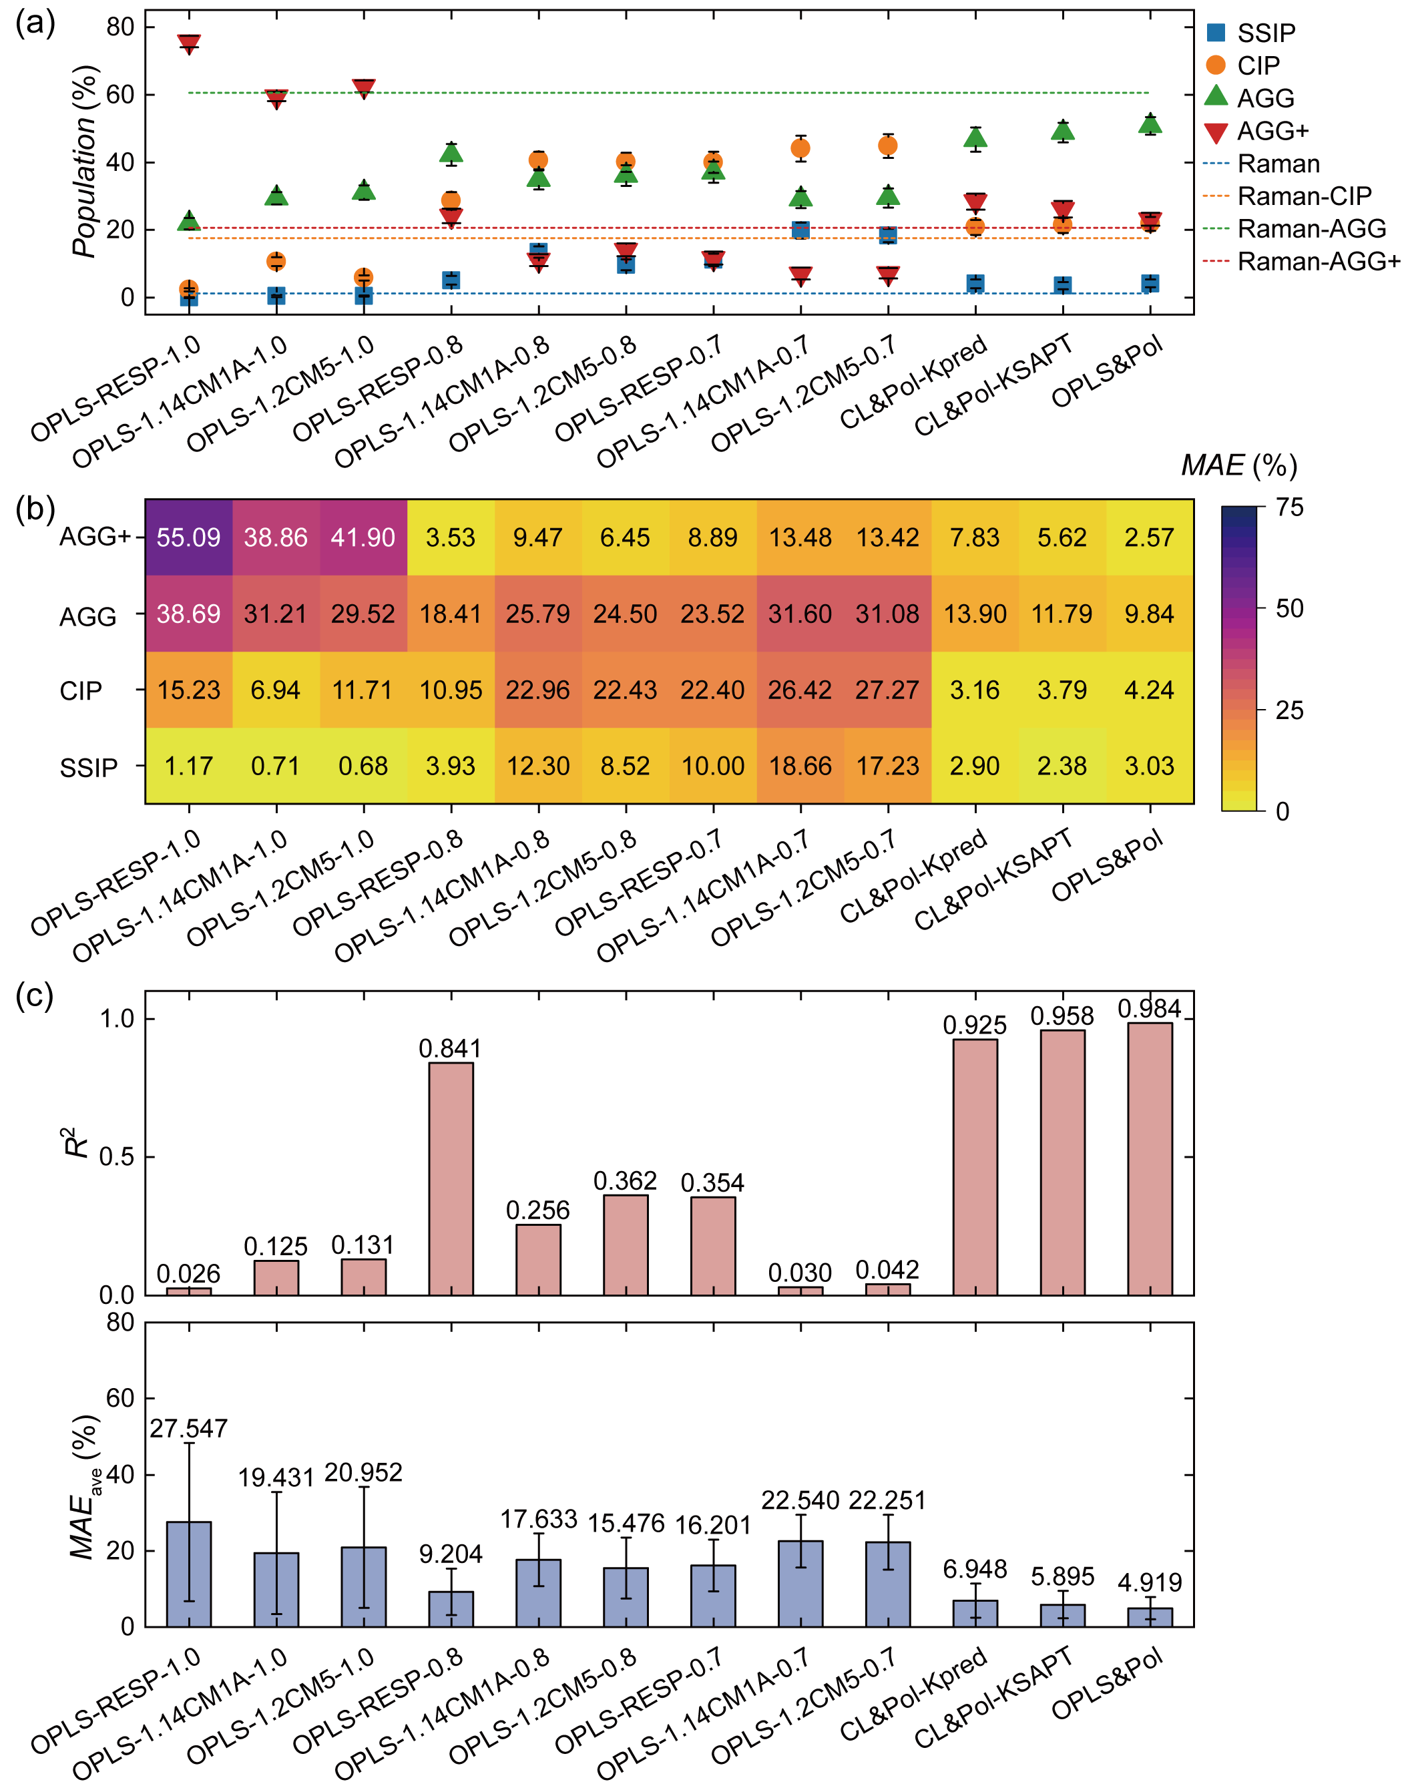
Supplementary Fig. 11 | Benchmarking FSI⁻ speciation in 1LiFSI:1.4DME (333.15 K). (a) Population distributions of four FSI⁻ coordination states (SSIP, CIP, AGG, AGG+) predicted by 12 FFs, benchmarked against experimental Raman spectroscopy data.¹² (b) Heatmap quantifying the mean absolute error (MAE) for individual coordination states, with darker colors indicating larger deviations from experimental values. (c) Statistical evaluation of predictive fidelity via the coefficient of determination (R²) and state-averaged MAE (MAE_{ave}).

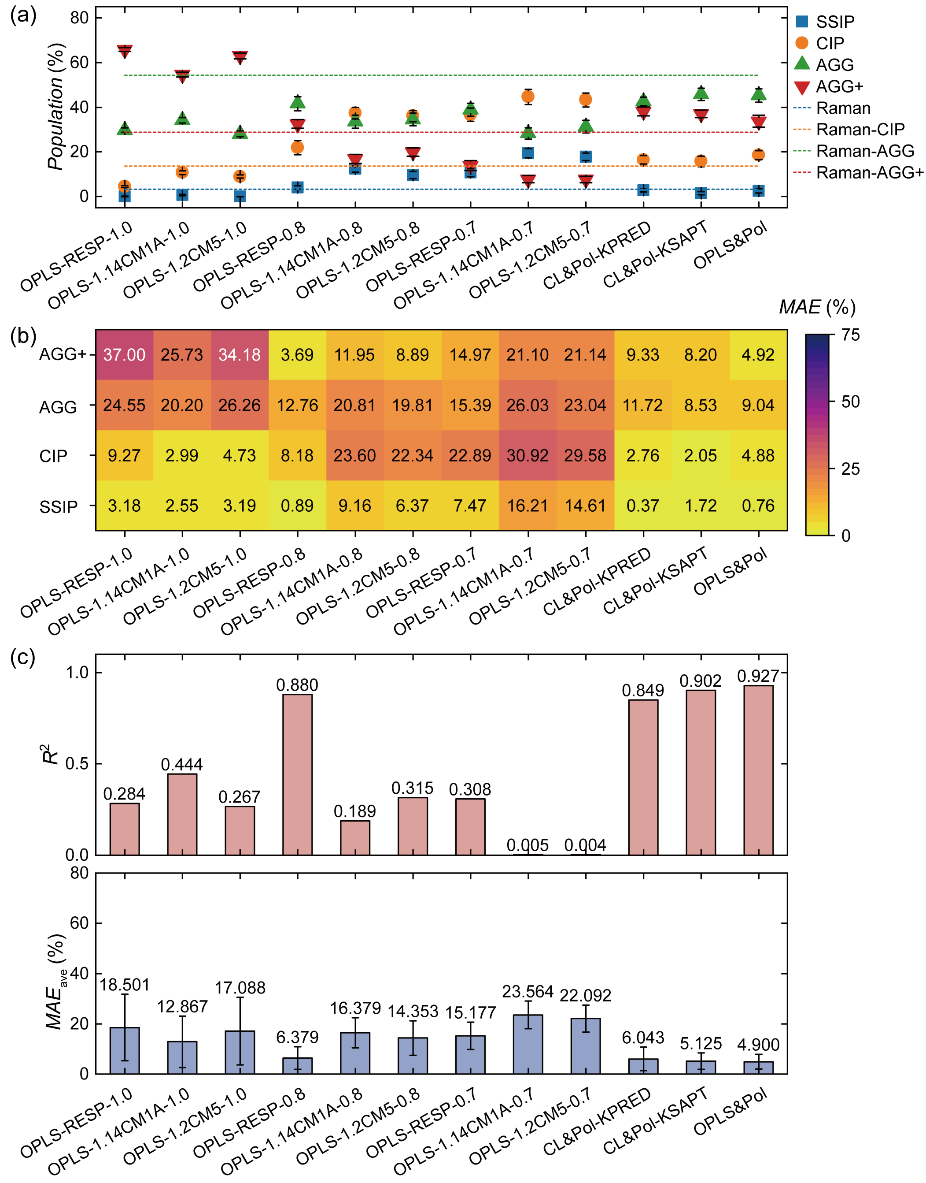
Supplementary Fig. 12 | Benchmarking FSI⁻ speciation in 1LiFSI:1.4DME (298.15 K). (a) Population distributions of SSIP, CIP, AGG, AGG+ predicted by 12 FFs, benchmarked against experimental Raman spectroscopy data.¹² (b) Heatmap quantifying the MAE for individual coordination states, with darker colors indicating larger deviations from experimental values. (c) Statistical evaluation of predictive fidelity via the R² and MAE_{ave}.

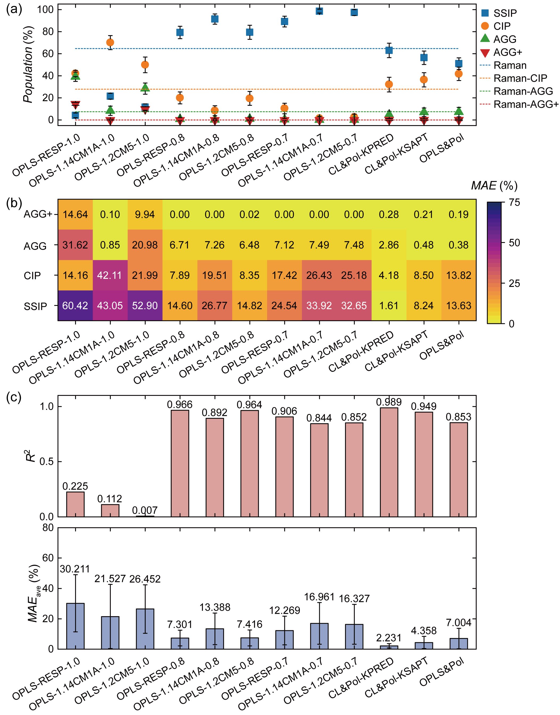
Supplementary Fig. 13 | Benchmarking FSI⁻ speciation in 1LiFSI:9DME (298.15 K). (a) Population distributions of SSIP, CIP, AGG, AGG+ predicted by 12 FFs, benchmarked against experimental Raman spectroscopy data.¹² (b) Heatmap quantifying the MAE for individual coordination states, with darker colors indicating larger deviations from experimental values. (c) Statistical evaluation of predictive fidelity via the R² and MAE_{ave}.

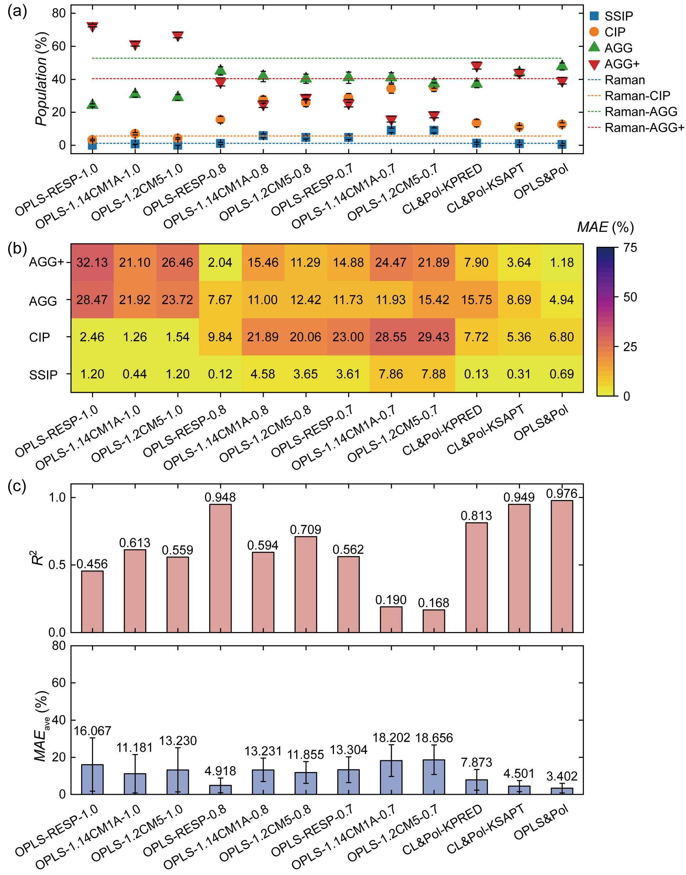
Supplementary Fig. 14 | Benchmarking FSI⁻ speciation in 1LiFSI:1.2DME (298.15 K). (a) Population distributions of SSIP, CIP, AGG, AGG+ predicted by 12 FFs, benchmarked against experimental Raman spectroscopy data.¹² (b) Heatmap quantifying the MAE for individual coordination states, with darker colors indicating larger deviations from experimental values. (c) Statistical evaluation of predictive fidelity via the R² and MAE_{ave}.

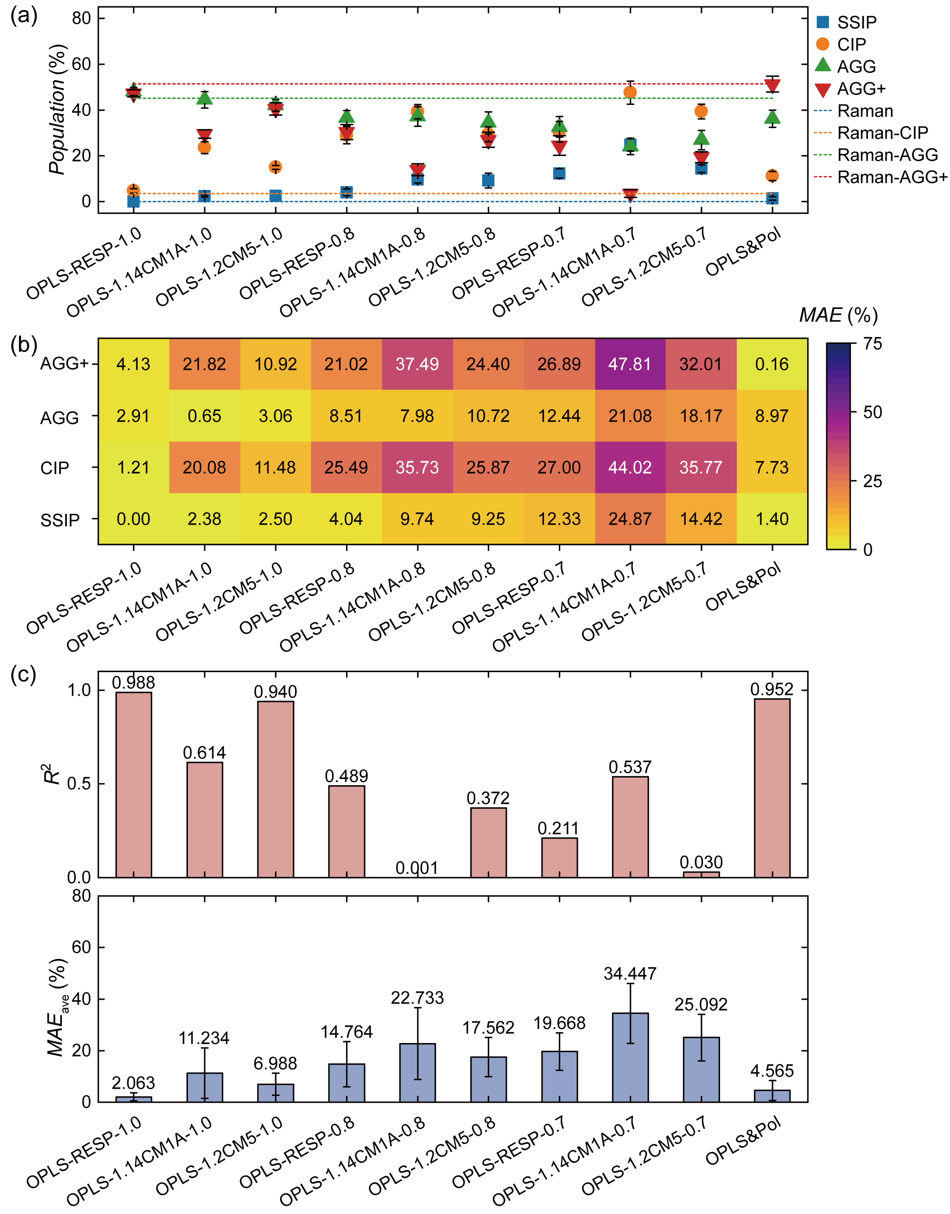
Supplementary Fig. 15 | Benchmarking FSI⁻ speciation in 1LiFSI:1.2DME:2TFEO (298.15 K). (a) Population distributions of SSIP, CIP, AGG, AGG+ predicted by 10 FFs, benchmarked against experimental Raman spectroscopy data.¹² (b) Heatmap quantifying the MAE for individual coordination states, with darker colors indicating larger deviations from experimental values. (c) Statistical evaluation of predictive fidelity via the R² and MAE_{ave}.

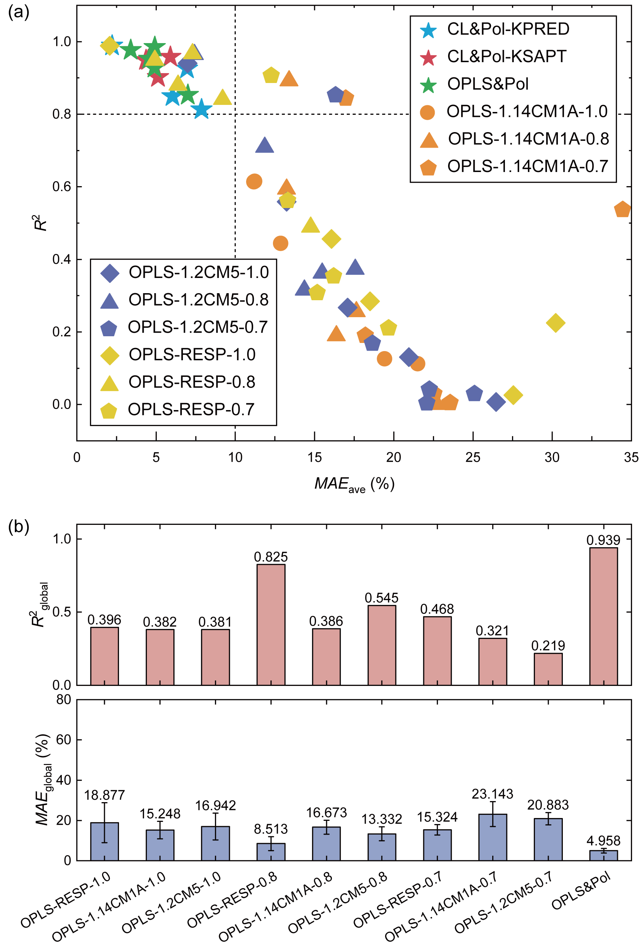
Supplementary Fig. 16 | Comprehensive accuracy assessment of FSI⁻ speciation in LiFSI:DME:TFEO electrolytes. (a) Scatter plot correlating R² with MAE_{ave} across various system conditions. Dashed lines delineate the high-fidelity region (R² = 0.8, MAE_{ave} = 10%). (b) Global fidelity metrics (R²_{global}, MAE_{global}) for each FF, averaged across all investigated electrolyte formulations and concentration regimes.

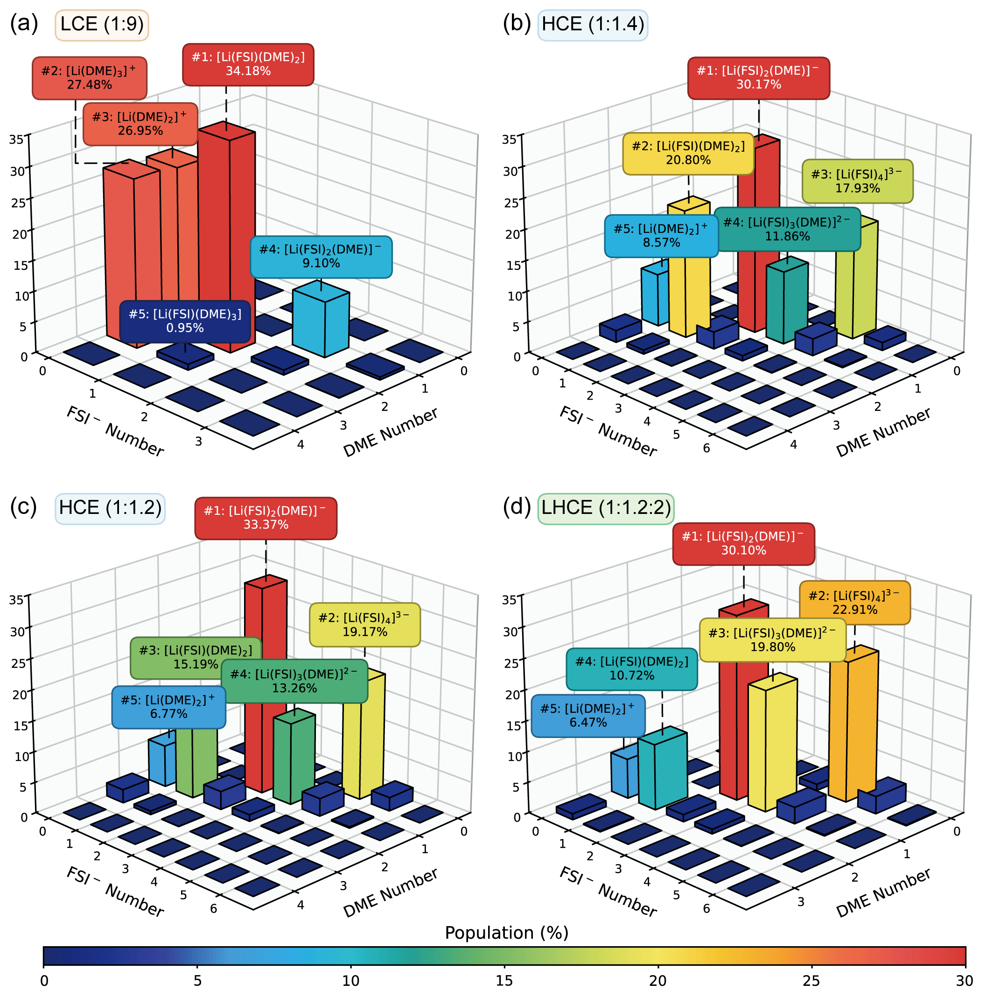
Supplementary Fig. 17 | Population landscapes of Li⁺ solvation in LiFSI:DME:TFEO electrolytes. Predicted distributions of solvation motifs defined by the general formula [Li(FSI)_{x}(DME)_{y}]^{1-x} at 298.15 K using OPLS&Pol. Annotations denote the population percentages of the top five dominant solvation motifs in each formulation. (a) LCE (1LiFSI:9DME). (b) HCE (1LiFSI:1.4DME). (c) HCE (1LiFSI:1.2DME). (d) LHCE (1LiFSI:1.2DME:2TFEO).

Supplementary Note 7 | Polarization-Resolved Competition in Multicomponent Electrolytes
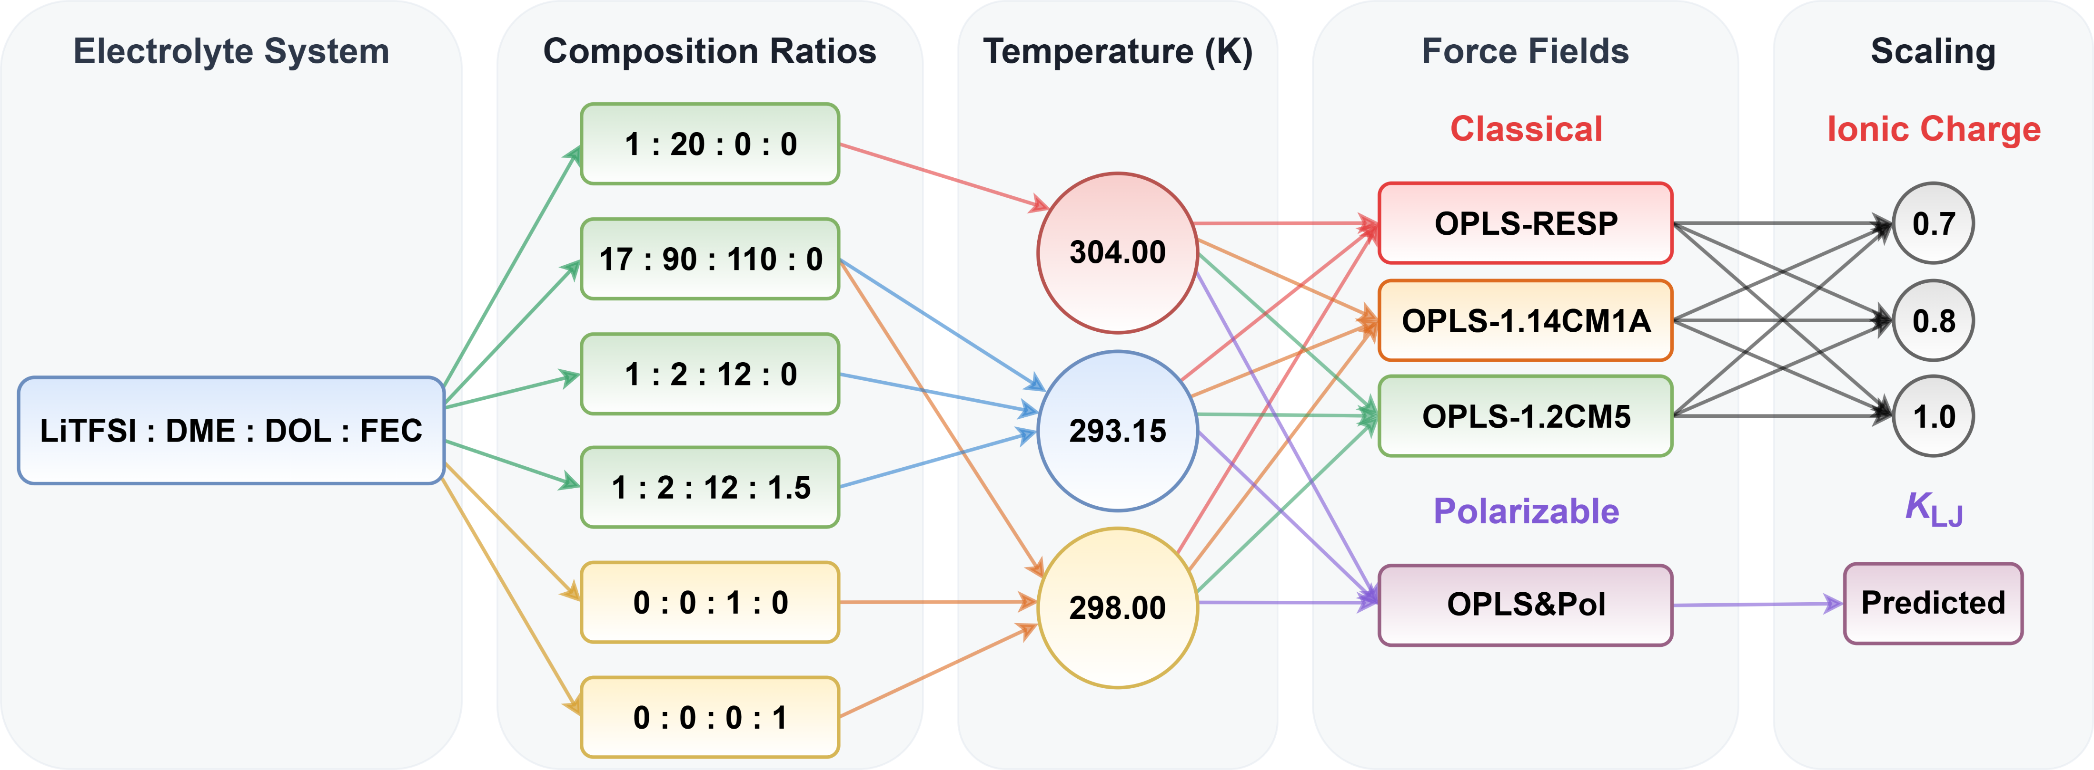
Supplementary Fig. 18 | Simulation configurations for LiTFSI:DME:DOL:FEC ether-based systems. Overview of FF variants and MD simulation configurations for LiTFSI:DME:DOL:FEC electrolytes, neat solvent (DOL), and neat additive (FEC). This set of MD simulations comprises 58 unique configurations, with molar ratios adopted from the literature.^{15,17,16,18}

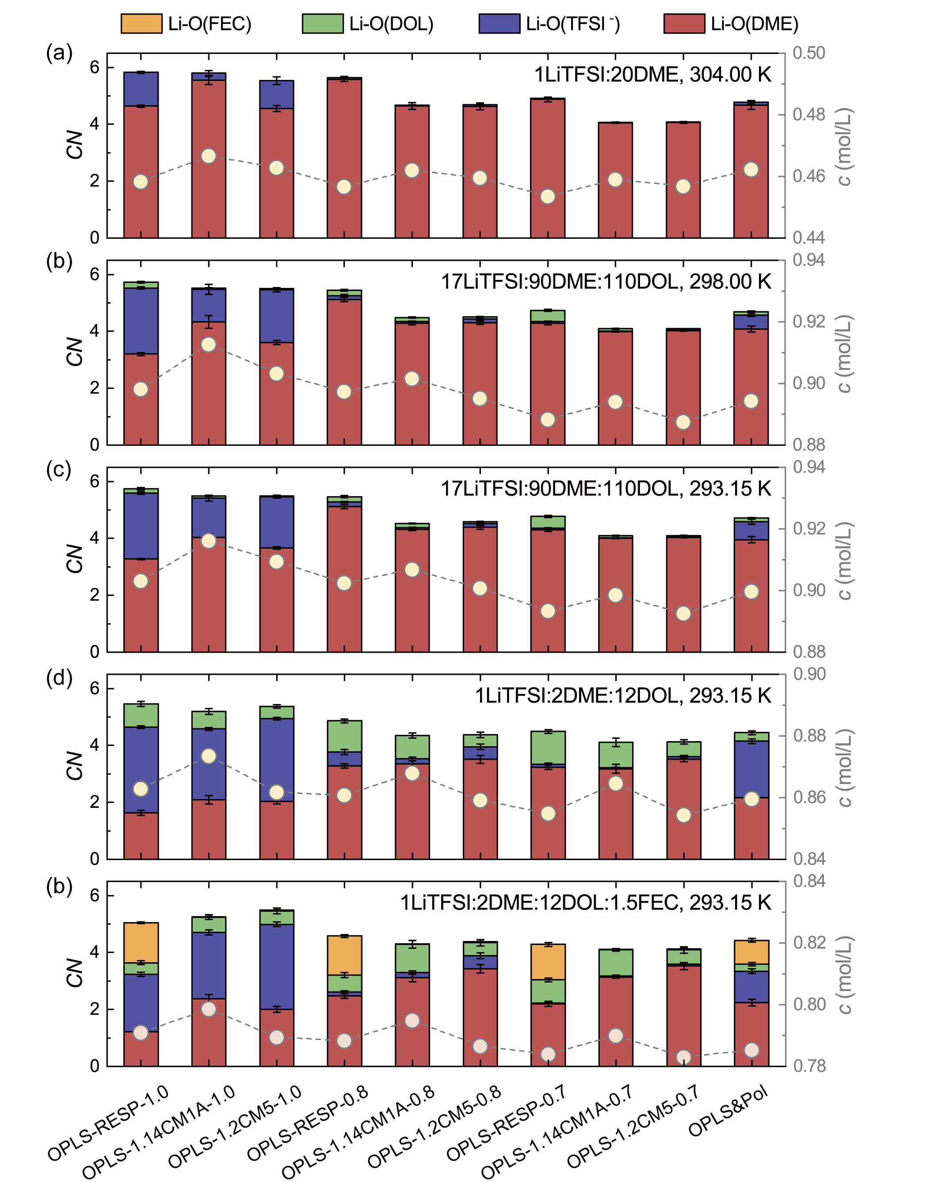
Supplementary Fig. 19 | Concentration-dependent Li⁺ solvation structures in LiTFSI:DME:DOL:FEC electrolytes. Comparative assessment of 10 FFs across diverse chemical compositions and thermal conditions. Stacked bars (left axis) represent the CNs for Li-O pairs involving O(TFSI⁻), O(DME), O(DOL), and O(FEC), specifically targeting the carbonyl oxygen of FEC (atom O31 in Supplementary Figs. 1-3). Yellow circles connected by dashed lines (right axis) denote the equilibrium salt concentrations (c). (a) Binary LCE (1LiTFSI:20DME) at 304.00 K. (b, c) Solvent-rich ternary LCE (17LiTFSI:90DME:110DOL) at 298.00 K and 293.15 K, respectively. (d) Solvent-lean ternary LCE (1LiTFSI:2DME:12DOL) at 293.15 K. (e) Quaternary LCE (1LiTFSI:2DME:12DOL:1.5FEC) at 293.15 K.

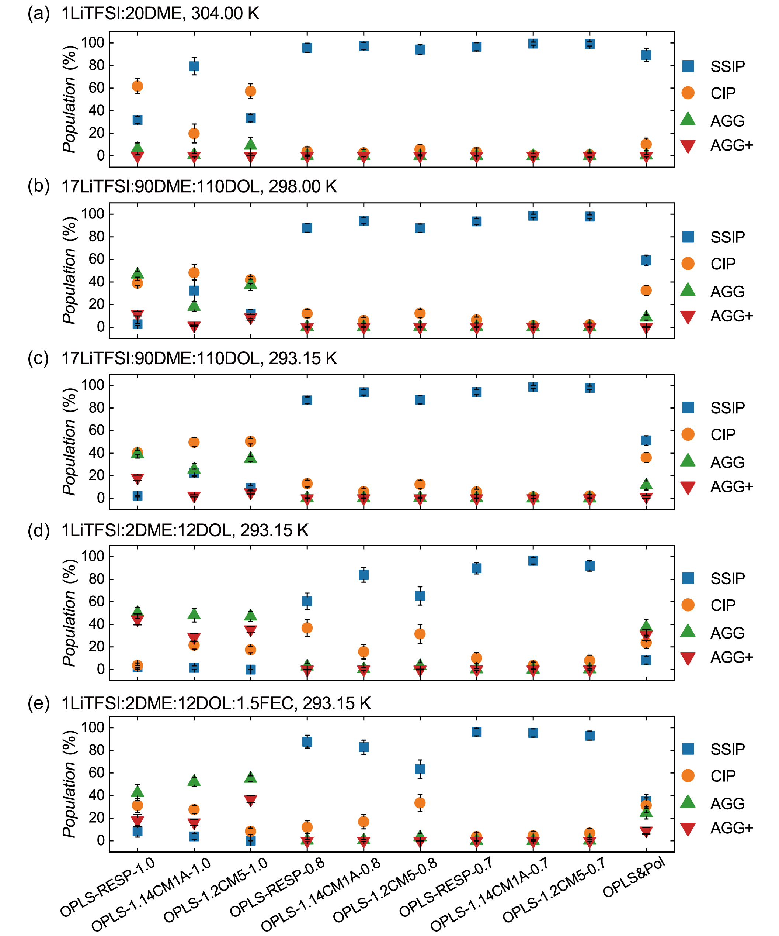
Supplementary Fig. 20 | Comparison of TFSI⁻ speciation in LiTFSI:DME:DOL:FEC electrolytes. Population distributions of SSIP, CIP, AGG, AGG+ predicted by 10 FFs across diverse chemical compositions and thermal conditions. (a) Binary LCE at 304.00 K. (b, c) Solvent-rich ternary LCE at 298.00 K and 293.15 K, respectively. (d) Solvent-lean ternary LCE at 293.15 K. (e) Quaternary LCE at 293.15 K.

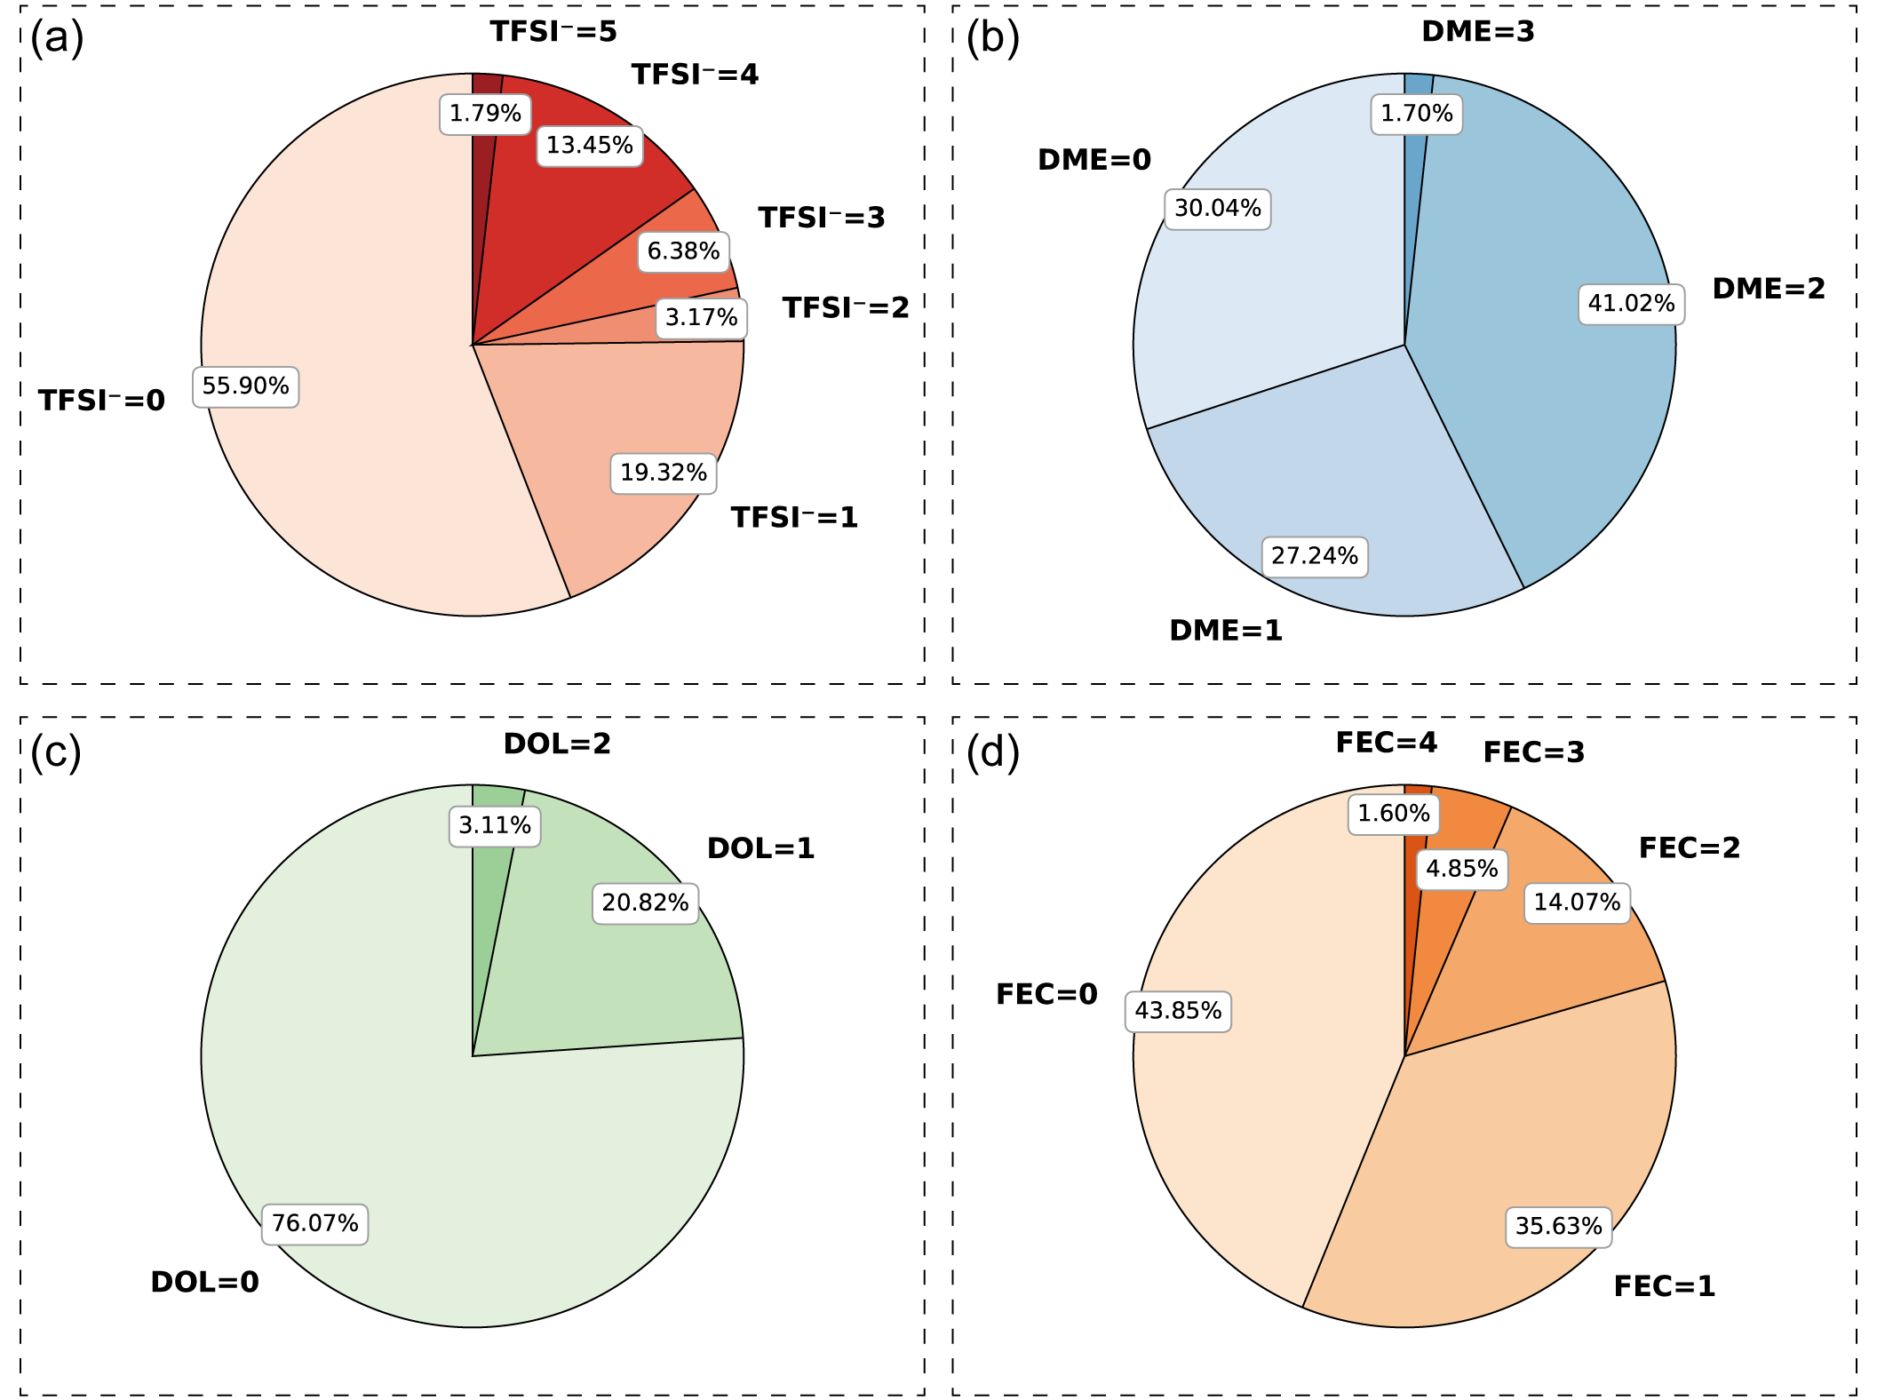
Supplementary Fig. 21 | Decomposition of Li⁺ solvation in 1LiTFSI:2DME:12DOL:1.5FEC (293.15 K). Pie charts illustrate the population distribution of coordinating species within the first solvation shell of Li⁺ as predicted by OPLS&Pol. Classifications correspond to the stoichiometric coefficients in the general formula [Li(TFSI)_{x}(DME)_{y}(DOL)_{z}(FEC)_{k}]^{1-x}. (a) Distribution of TFSI⁻ anions (x). The dominance of the x = 0 population (55.90%) quantifies the prevalence of fully dissociated Li⁺ cations. (b) Distribution of coordinated DME molecules (y). The y = 2 state (41.02%) represents the most frequent configuration, reflecting the preferred bidentate coordination. (c) Distribution of coordinated DOL molecules (z). The high fraction of the z = 0 population (76.07%) confirms the minimal participation of DOL in the first shell. (d) Distribution of coordinated FEC molecules (k). While the uncoordinated state (k = 0) constitutes the largest single fraction, the cumulative population of Li⁺ exhibiting FEC coordination (k ≥ 1) comprises the majority (56.15%), evidencing the strong competitive capability of FEC.

Supplementary Fig. 22 | Structural diversity of Li⁺ solvation in 1LiTFSI:2DME:12DOL:1.5FEC (293.15 K). The treemap visualizes the heterogeneity of the first solvation shell of Li⁺ as predicted by OPLS&Pol. Each tile represents a unique coordination complex defined by the general formula [Li(TFSI)_{x}(DME)_{y}(DOL)_{z}(FEC)_{k}]^{1-x}, with the tile area proportional to its population. The analysis identifies a total of 98 distinct structural motifs. Individual tiles are explicitly labeled for major species with a population ≥ 0.50% (23 types), while the remaining 75 minor species are aggregated into the gray “Others” category (7.10%). Tiles are color-coded based on ligand composition: blue (1 component/homoleptic), green (2 components/binary), orange (3 components/ternary), and red (4 components/quaternary). The table below details the top 12 dominant structures.

Supplementary Note 8 | Thermodynamic Origin of Solvation Competition in Carbonate Systems
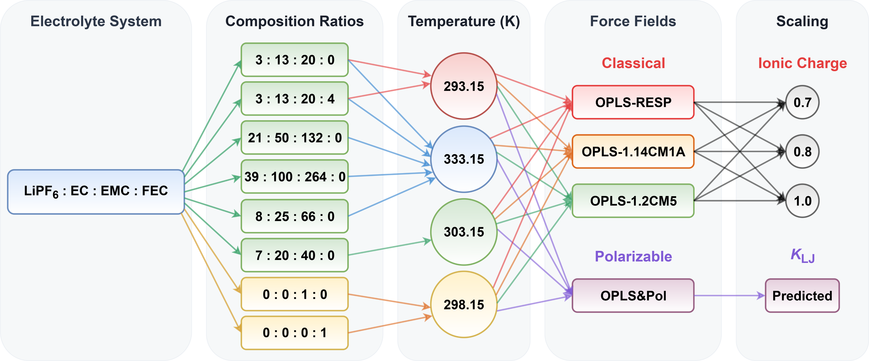
Supplementary Fig. 23 | Simulation configurations for LiPF₆:EC:EMC:FEC carbonate-based systems. Overview of FF variants and MD simulation configurations for LiPF₆:EC:EMC:FEC electrolytes and neat solvents (EC and EMC). This set of MD simulations comprises 88 unique configurations, with molar ratios adopted from the literature.^{18,23,20–22,19}

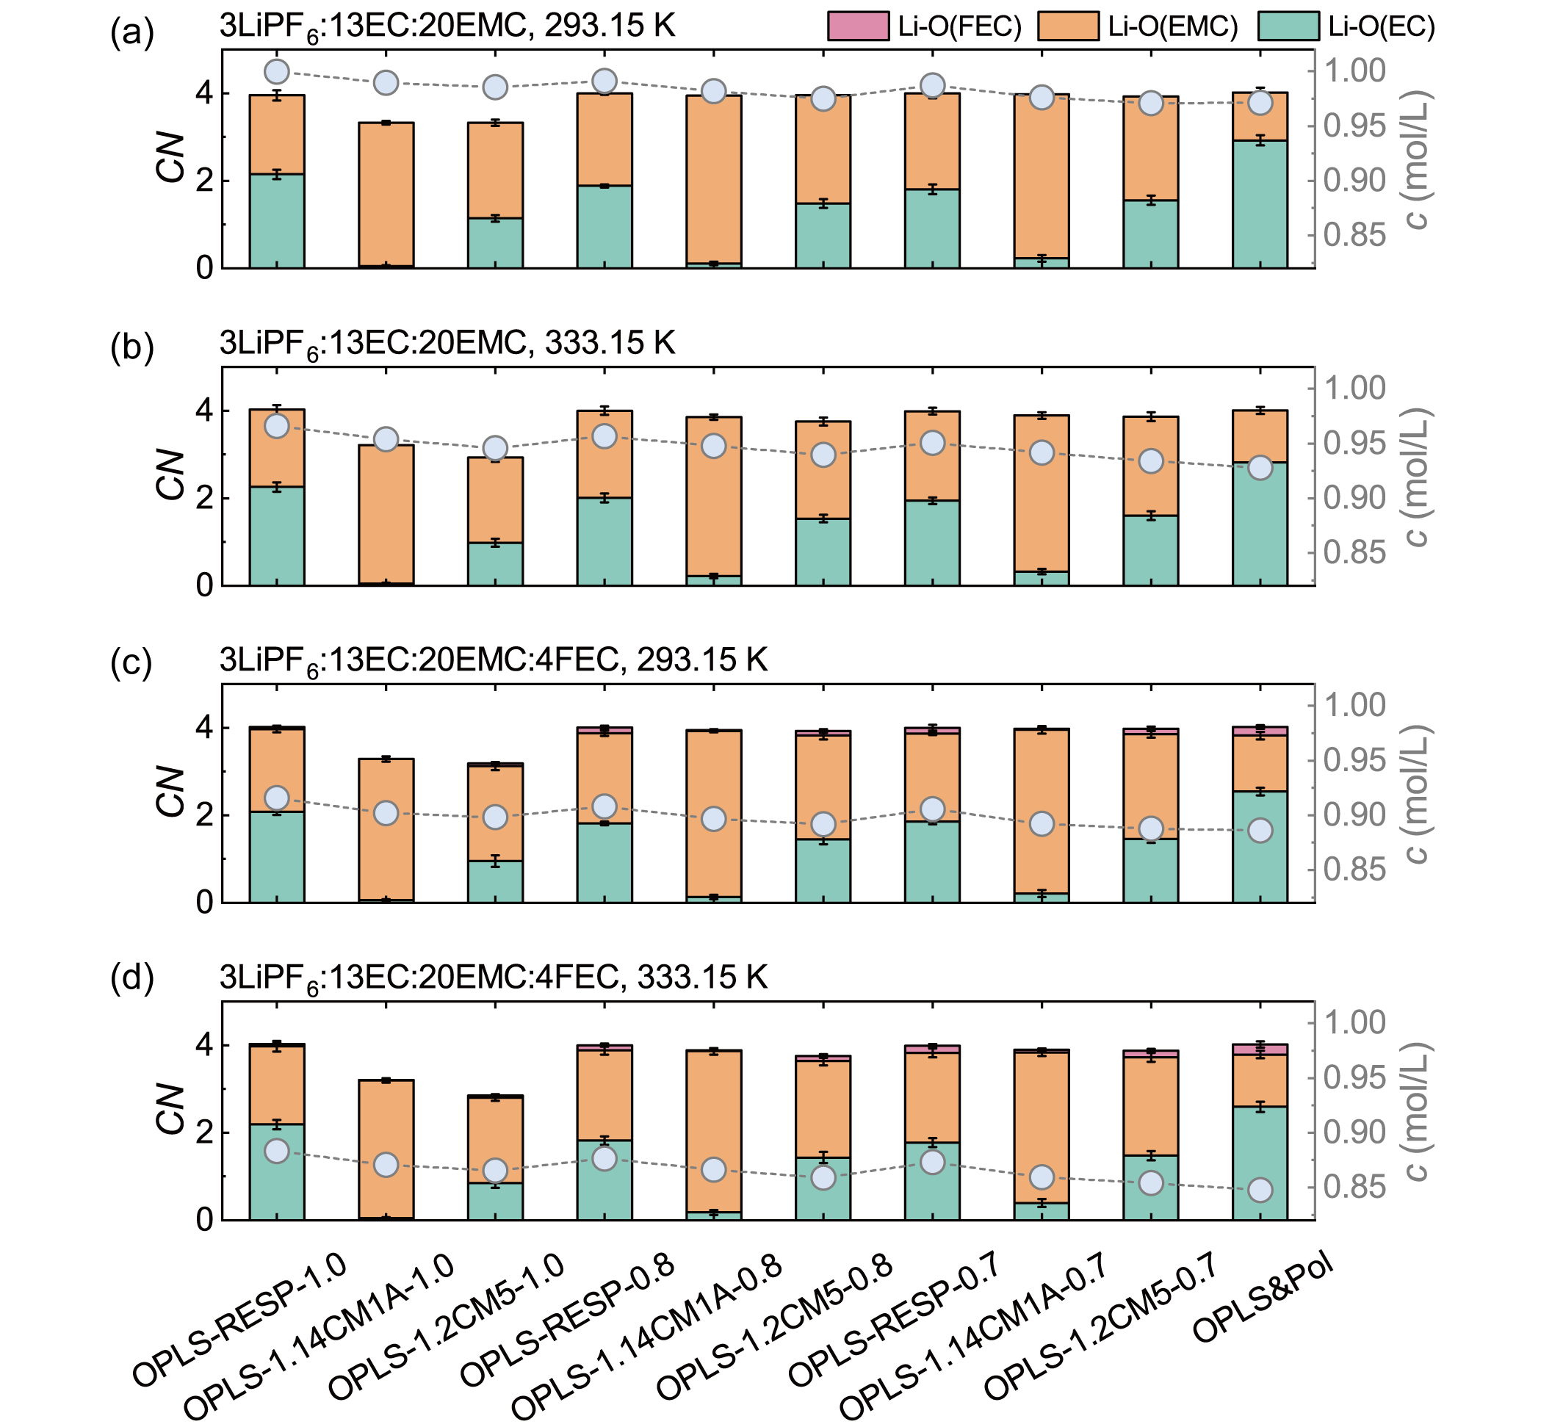
Supplementary Fig. 24 | Concentration-dependent Li⁺ solvation structures in LiPF₆:EC:EMC:FEC electrolytes. Comparative assessment of 10 FFs across diverse chemical compositions and thermal conditions. Stacked bars (left axis) represent the CNs for Li-O pairs involving the carbonyl oxygens of EMC, EC, and FEC. These specific interaction sites correspond to atoms O41, O22, and O31, respectively (as detailed in Supplementary Figs. 1-3). Blue circles connected by dashed lines (right axis) denote the c. (a, b) Ternary LCE (3LiPF₆:13EC:20EMC) at 293.15 K and 333.15 K, respectively. (c, d) Quaternary LCE (3LiPF₆:13EC:20EMC:4FEC) at 293.15 K and 333.15 K, respectively.

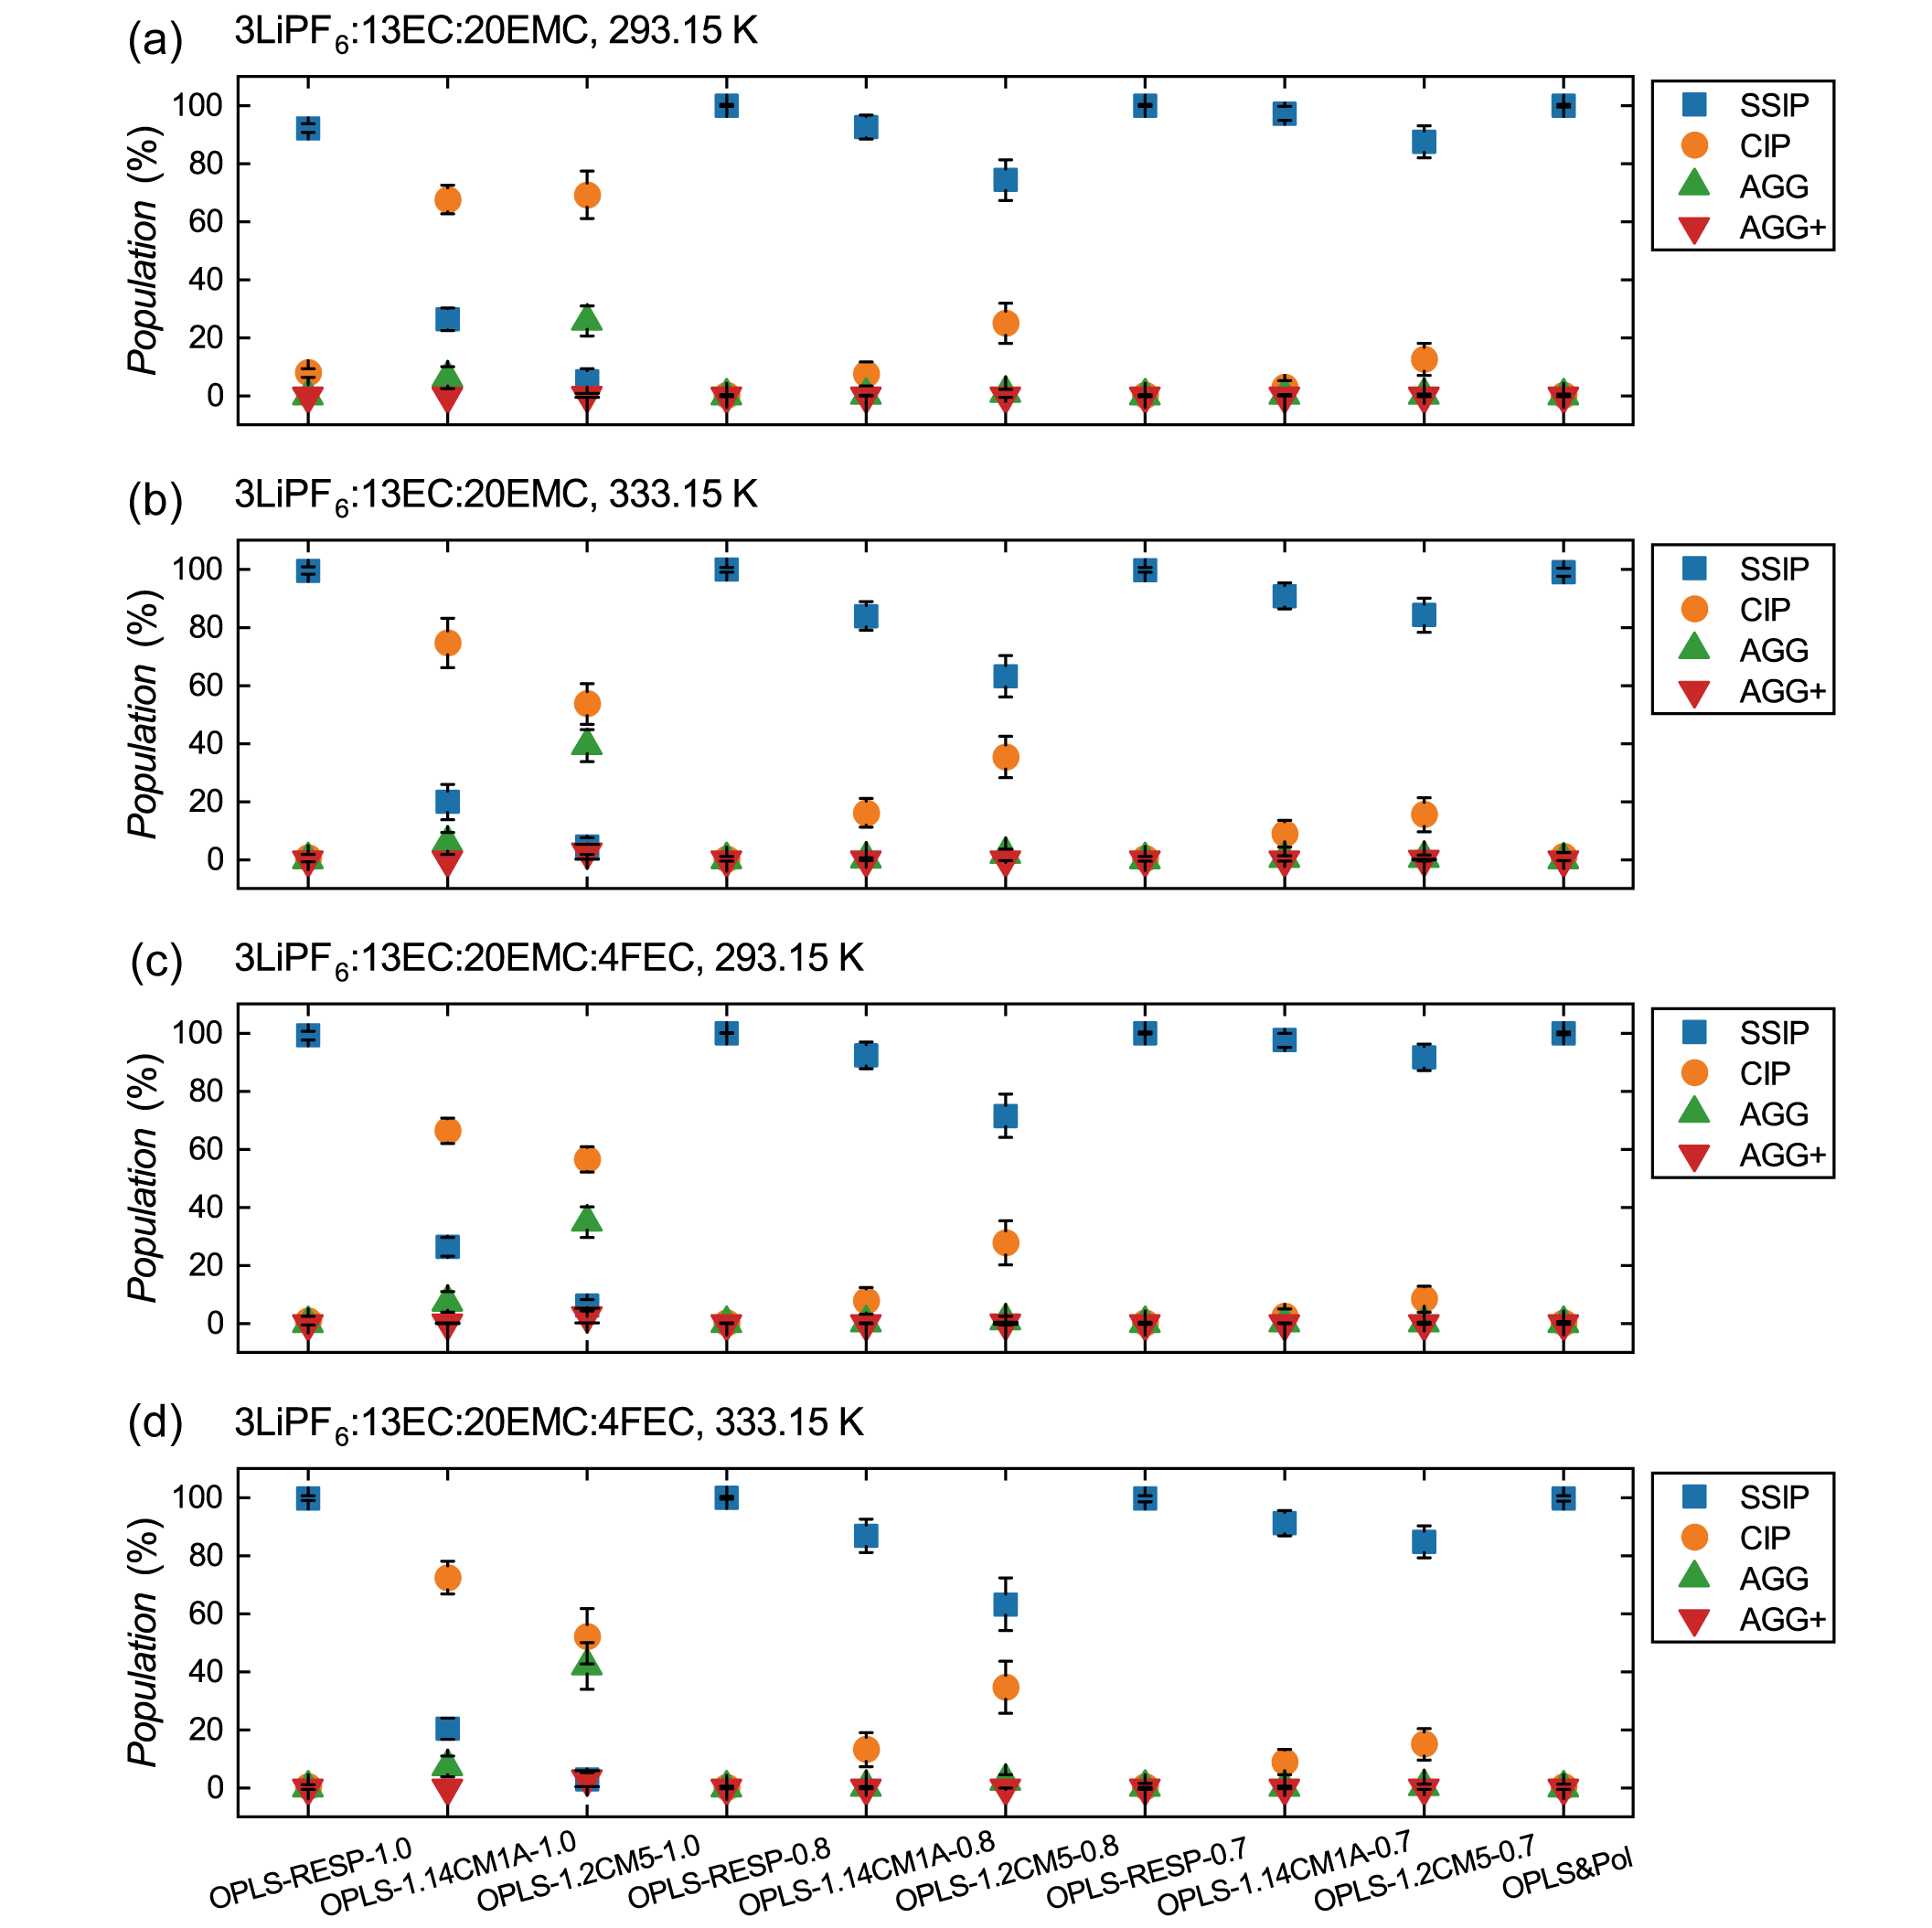
Supplementary Fig. 25 | Comparison of PF₆⁻ speciation in LiPF₆:EC:EMC:FEC electrolytes. Population distributions of SSIP, CIP, AGG, AGG+ predicted by 10 FFs across diverse chemical compositions and thermal conditions. (a, b) Ternary LCE at 293.15 K and 333.15 K, respectively. (c, d) Quaternary LCE at 293.15 K and 333.15 K, respectively.

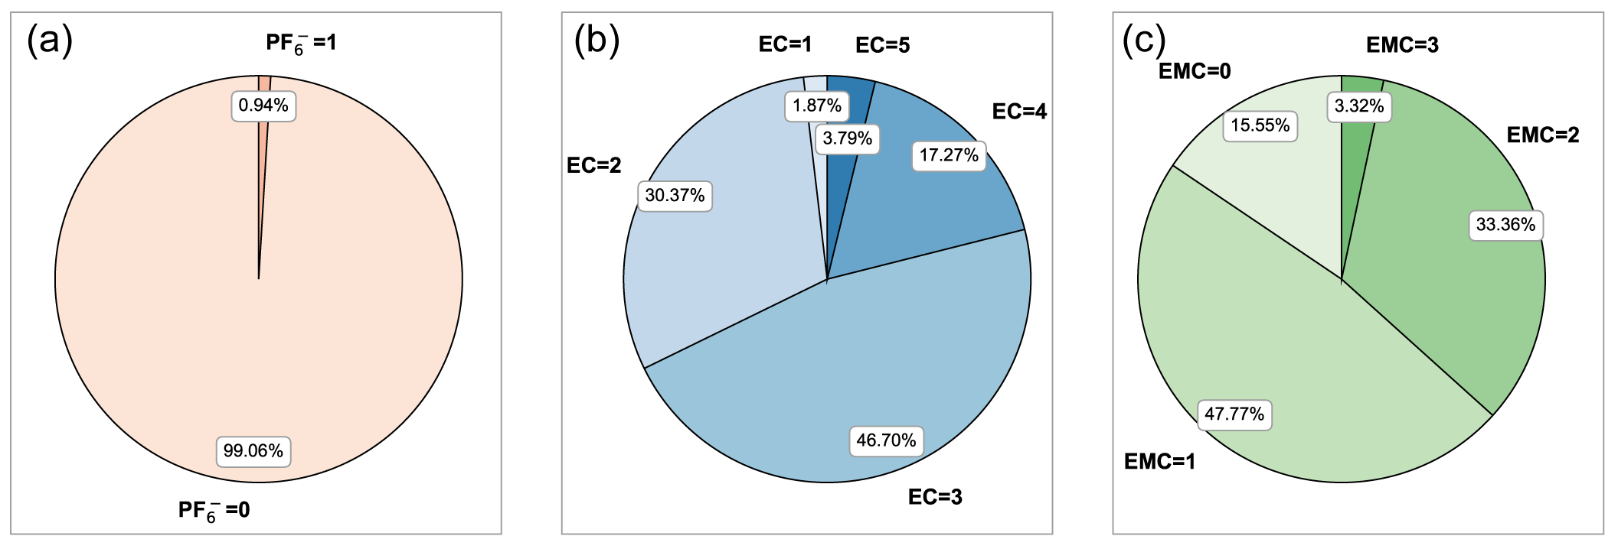
Supplementary Fig. 26 | Decomposition of Li⁺ solvation in 3LiPF₆:13EC:20EMC (333.15 K). Pie charts illustrate the population distribution of coordinating species within the first solvation shell of Li⁺ as predicted by OPLS&Pol. Classifications correspond to the stoichiometric coefficients in the general formula [Li(PF₆)_{x}(EC)_{y}(EMC)_{z}]^{1-x}. (a) Distribution of PF₆⁻ anions (x). The predominance of the x = 0 population (99.06%) indicates that Li⁺ cations exist almost exclusively in a fully dissociated state. (b) Distribution of coordinated EC molecules (y). The tri-EC coordinated motif (y = 3, 46.70%) represents the dominant structural unit, followed by the di-EC species (y = 2, 30.37%). (c) Distribution of coordinated EMC molecules (z). The linear carbonate EMC participates actively in the first shell, primarily contributing one (z = 1, 47.77%) or two (z = 2, 33.36%) molecules.

Supplementary Fig. 27 | Structural diversity of Li⁺ solvation in 3LiPF₆:13EC:20EMC (333.15 K). The treemap visualizes the heterogeneity of the first solvation shell of Li⁺ as predicted by OPLS&Pol. Each tile represents a unique coordination complex defined by the general formula [Li(PF₆)_{x}(EC)_{y}(EMC)_{z}]^{1-x}, with the tile area proportional to its population. The analysis identifies a total of 28 distinct structural motifs. Individual tiles are explicitly labeled for major species with a population ≥ 0.50% (8 types), while the remaining 20 minor species are aggregated into the gray “Others” category (1.90%). Tiles are color-coded based on ligand composition: blue (1 component/homoleptic), green (2 components/binary). The table below details the top 12 dominant structures.

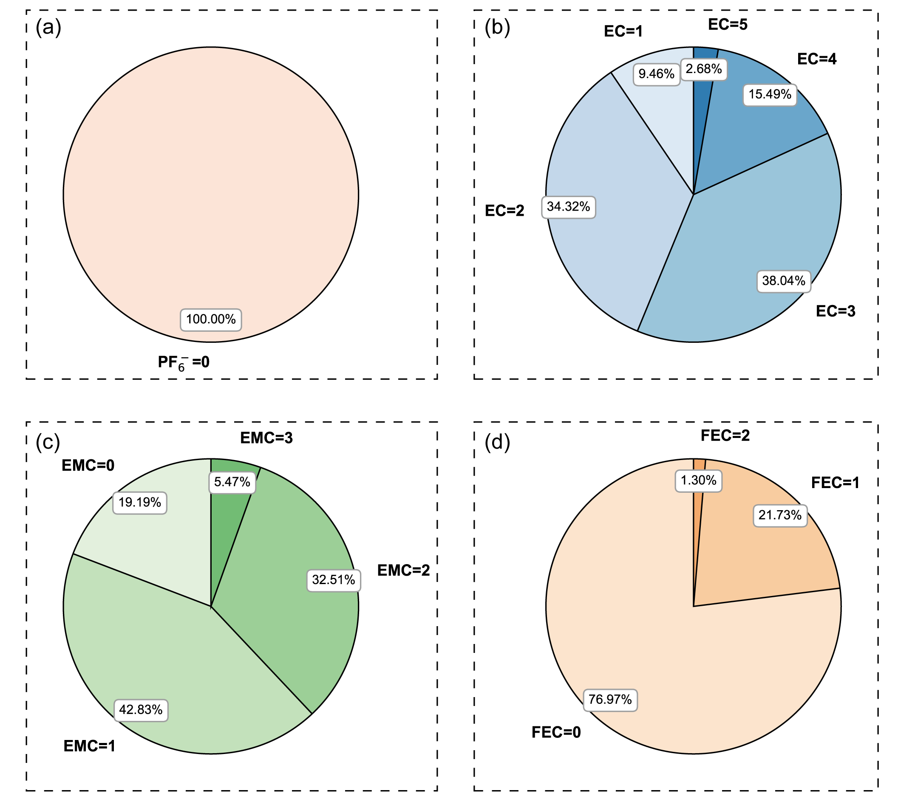
Supplementary Fig. 28 | Decomposition of Li⁺ solvation in 3LiPF₆:13EC:20EMC:4FEC (333.15 K). Pie charts illustrate the population distribution of coordinating species within the first solvation shell of Li⁺ as predicted by OPLS&Pol. Classifications correspond to the stoichiometric coefficients in the general formula [Li(PF₆)_{x}(EC)_{y}(EMC)_{z}(FEC)_{k}]^{1-x}. (a) Distribution of PF₆⁻ anions (x). The exclusive presence of the x = 0 population (100%) indicates that Li⁺ cations exist fully dissociated in this system. (b) Distribution of coordinated EC molecules (y). The tri-EC coordinated motif (y = 3, 38.04%) represents the dominant structural unit, followed by the di-EC species (y = 2, 34.32%). (c) Distribution of coordinated EMC molecules (z). The linear carbonate EMC participates actively in the first shell, primarily contributing one (z = 1, 42.83%) or two (z = 2, 32.51%) molecules. (d) Distribution of coordinated FEC molecules (k). Although FEC remains uncoordinated in the majority of motifs (k = 0, 76.97%), it is incorporated into the first shell of a significant fraction (23.03%) of cations, predominantly as a monodentate ligand (k = 1, 21.73%).

Supplementary Fig. 29 | Structural diversity of Li solvation in 3LiPF₆:13EC:20EMC:4FEC (333.15 K). The treemap visualizes the heterogeneity of the first solvation shell of Li⁺ as predicted by OPLS&Pol. Each tile represents a unique coordination complex defined by the general formula [Li(PF₆)_{x}(EC)_{y}(EMC)_{z}(FEC)_{k}]^{1-x}, with the tile area proportional to its population. The analysis identifies a total of 68 distinct structural motifs. Individual tiles are explicitly labeled for major species with a population ≥ 0.50% (15 types), while the remaining 53 minor species are aggregated into the gray “Others” category (2.72%). Tiles are color-coded based on ligand composition: blue (1 component/homoleptic), green (2 components/binary), orange (3 components/ternary), and red (4 components/quaternary). The table below details the top 12 dominant structures.

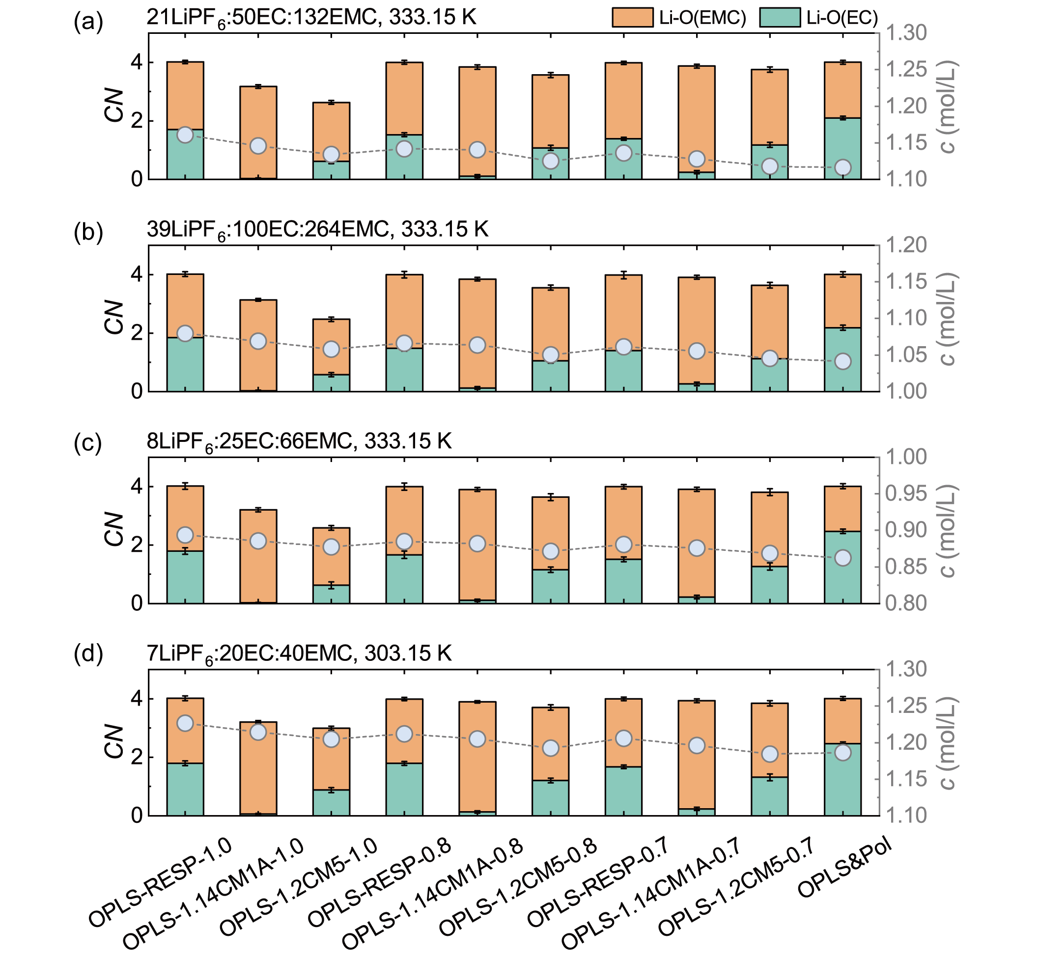
Supplementary Fig. 30 | Concentration-dependent Li⁺ solvation structures in LiPF₆:EC:EMC electrolytes. Comparative assessment of 10 FFs across varying salt-to-solvent ratios and thermal conditions. Stacked bars (left axis) represent the CNs for Li-O pairs involving the carbonyl oxygens of EMC and EC. These specific interaction sites correspond to atoms O41, and O22, respectively (as detailed in Supplementary Figs. 1-3). Blue circles connected by dashed lines (right axis) denote the c. (a-c) Ternary LCEs (21LiPF₆:50EC:132EMC, 39LiPF₆:100EC:264EMC, and 8LiPF₆:25EC:66EMC) with decreasing c at 333.15 K, respectively. (d) Ternary LCE (7LiPF₆:20EC:40EMC) at 303.15 K.

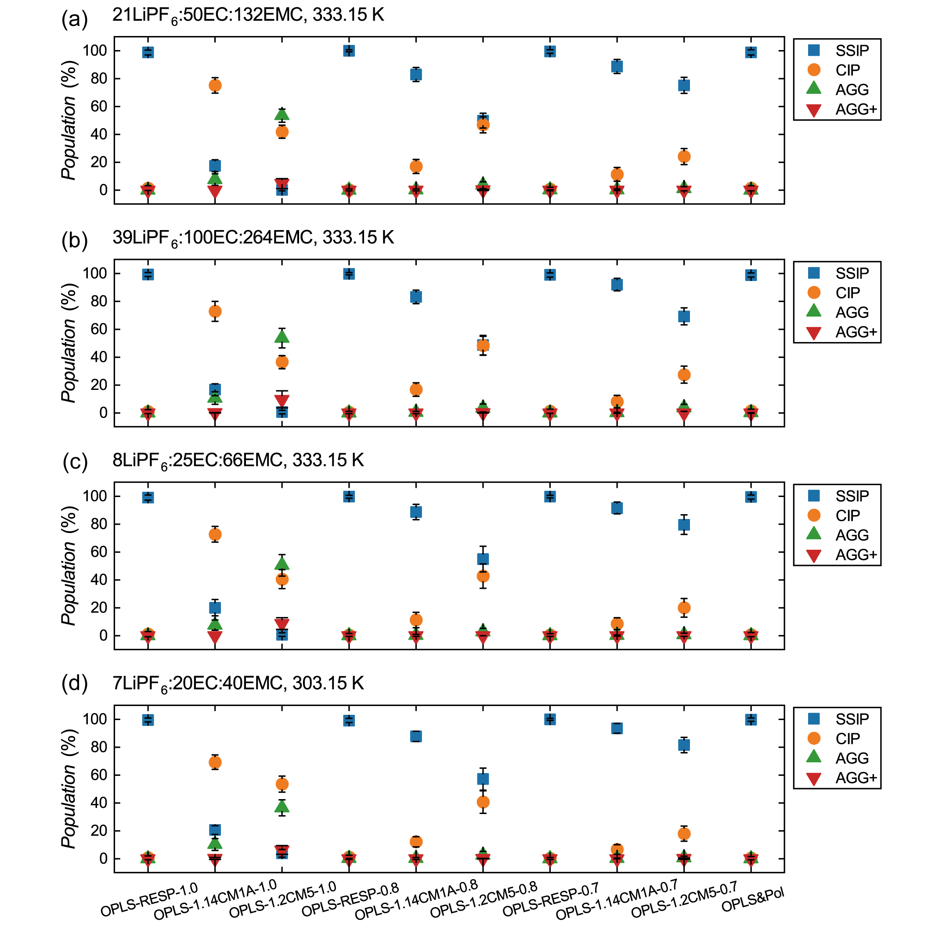
Supplementary Fig. 31 | Comparison of PF₆⁻ speciation in LiPF₆:EC:EMC electrolytes. Population distributions of SSIP, CIP, AGG, AGG+ predicted by 10 FFs across varying salt-to-solvent ratios and thermal conditions. (a-c) Ternary LCEs with decreasing c at 333.15 K, respectively. (d) Ternary LCE at 303.15 K.

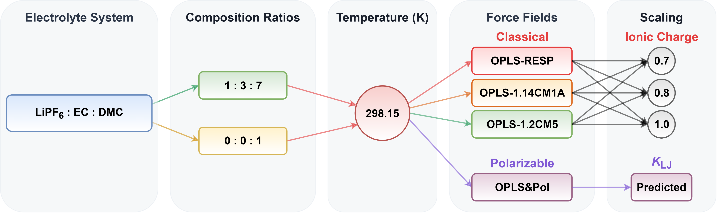
Supplementary Fig. 32 | Simulation configurations for LiPF₆:EC:DMC carbonate-based systems. Overview of FF variants and MD simulation configurations for LiPF₆:EC:DMC electrolyte and neat solvent (DMC). This set of MD simulations comprises 14 unique configurations, with molar ratios adopted from the literature.^{24,25}

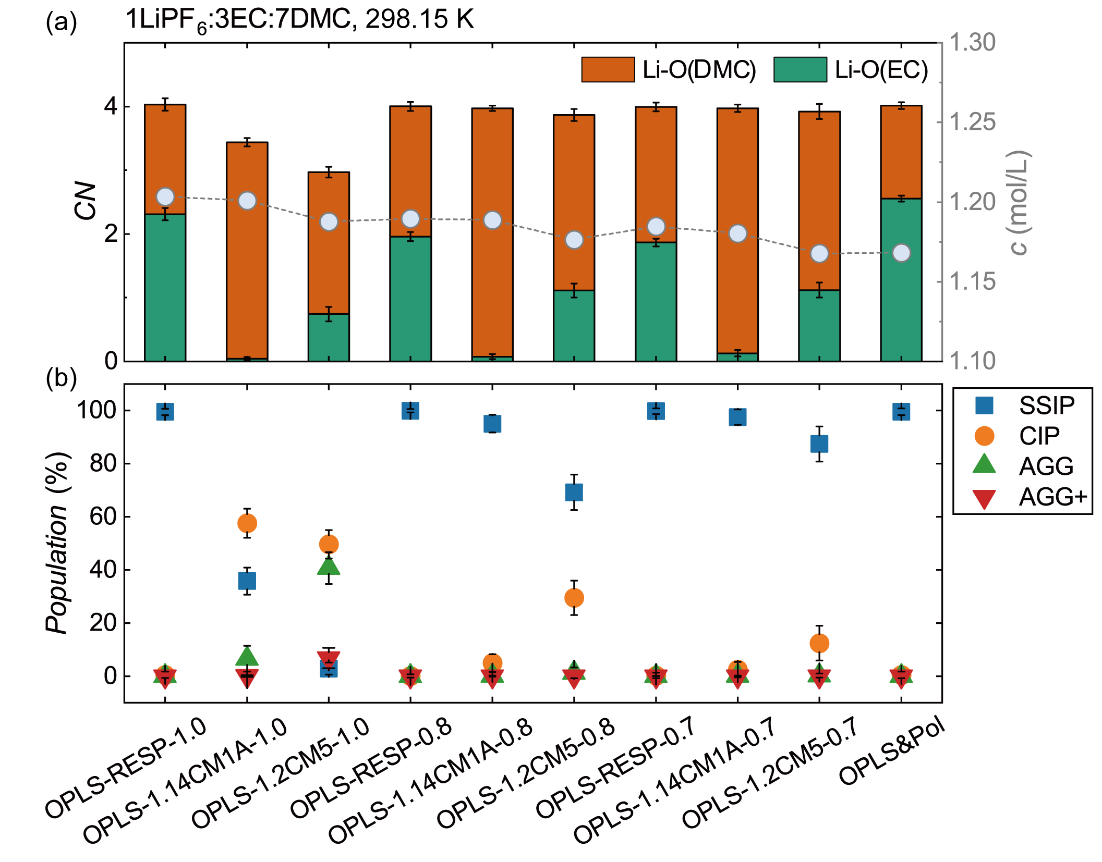
Supplementary Fig. 33 | Comparison of Li⁺ solvation structures and PF₆⁻ speciation in LiPF₆:EC:DMC electrolytes. Comparative assessment of 10 FFs for ternary LCE (1LiPF₆:3EC:7DMC) at 298.15 K. (a) Stacked bars (left axis) represent the CNs for Li-O pairs involving the carbonyl oxygens of DMC and EC. These specific interaction sites correspond to atoms O52, and O22, respectively (as detailed in Supplementary Figs. 1-3). Blue circles connected by dashed lines (right axis) denote the c. (b) Population distributions of SSIP, CIP, AGG, AGG+.

Supplementary Note 9 | Polarization-Stabilized Aggregation in Fluorosulfonyl Electrolytes
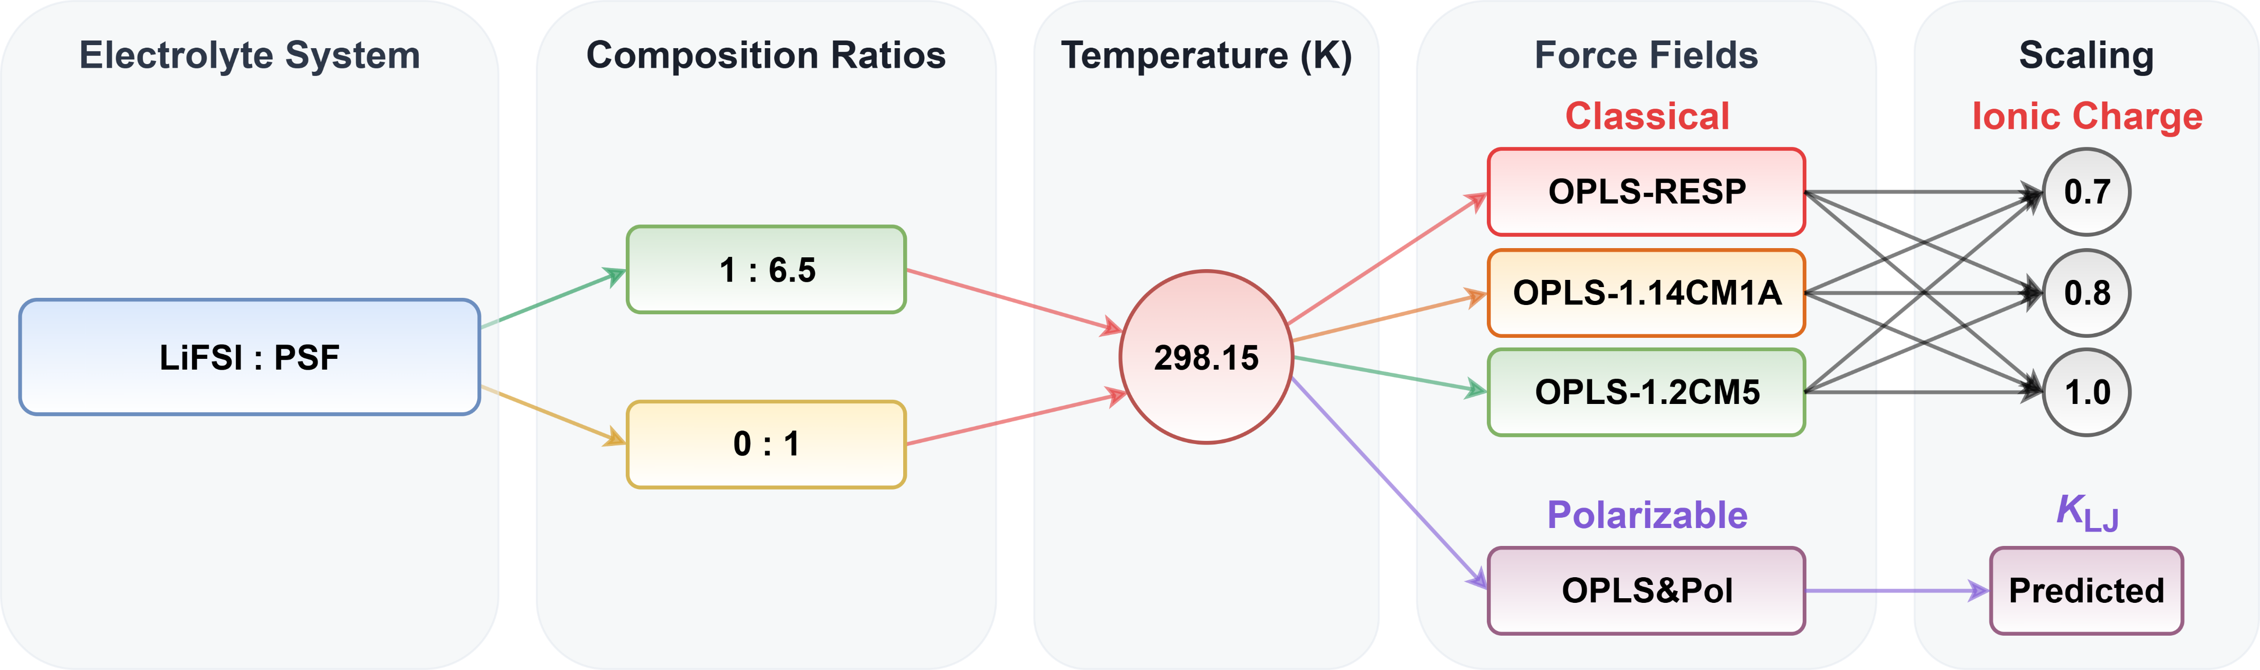
Supplementary Fig. 34 | Simulation configurations for LiFSI:PSF fluorosulfonyl-based systems. Overview of FF variants and MD simulation configurations for LiFSI:PSF electrolyte and neat solvent (PSF). This set of MD simulations comprises 14 unique configurations, with molar ratios adopted from the literature.²⁶

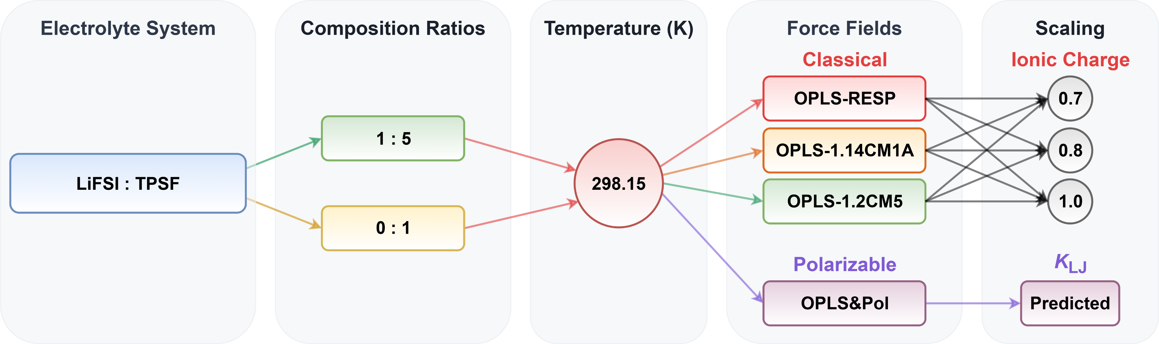
Supplementary Fig. 35 | Simulation configurations for LiFSI:TPSF fluorosulfonyl-based systems. Overview of FF variants and MD simulation configurations for LiFSI:TPSF electrolyte and neat solvent (TPSF). This set of MD simulations comprises 14 unique configurations, with molar ratios adopted from the literature.^{26–28}

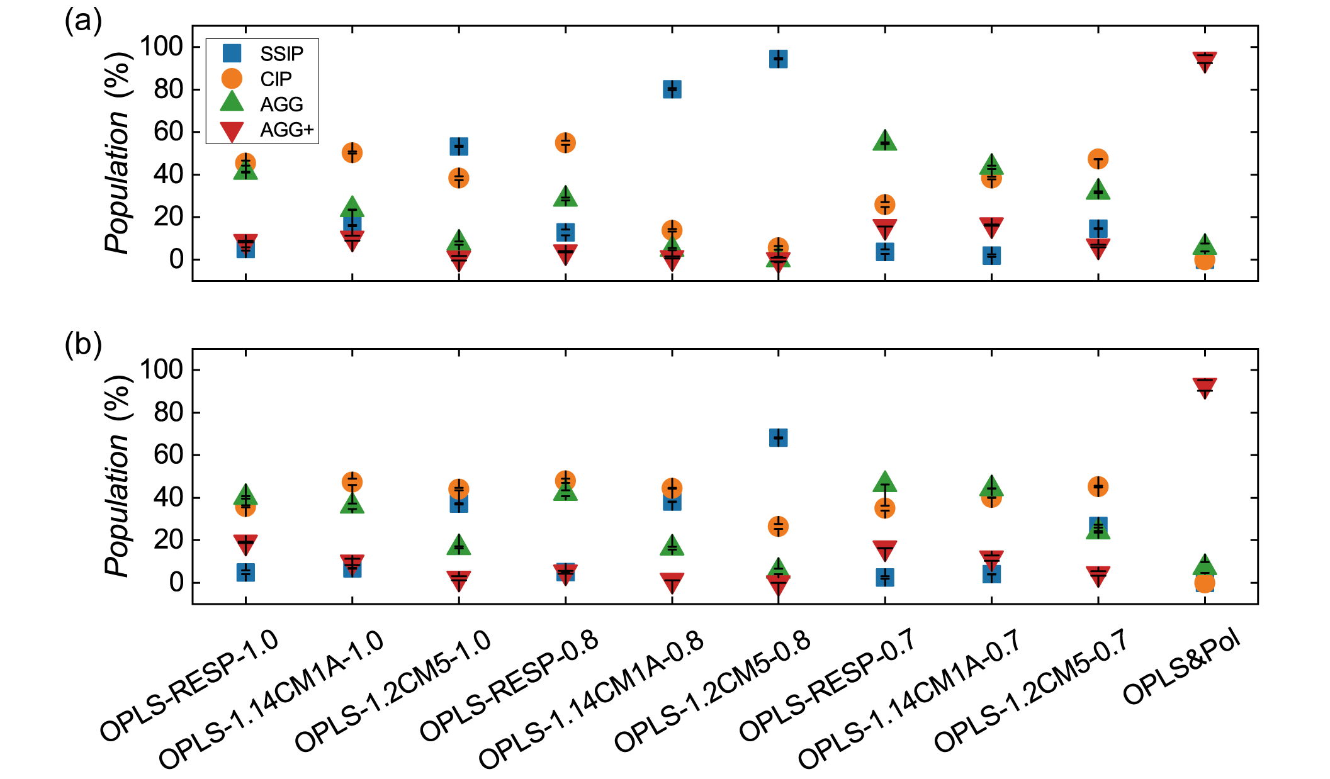
Supplementary Fig. 36 | Comparison of FSI⁻ speciation in LiFSI:PSF and LiFSI:TPSF electrolytes. Population distributions of SSIP, CIP, AGG, AGG+ predicted by 10 FFs for the LCEs at 298.15 K. (a) 1LiFSI:6.5PSF. (b) 1LiFSI:5TPSF.

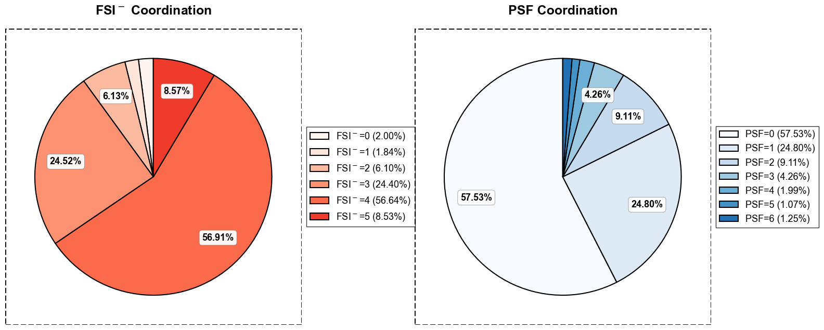
Supplementary Fig. 37 | Decomposition of Li⁺ solvation in 1LiFSI:6.5PSF (298.15 K). Pie charts illustrate the population distribution of coordinating species within the first solvation shell of Li⁺ as predicted by OPLS&Pol. Classifications correspond to the stoichiometric coefficients in the general formula [Li(FSI)_{x}(PSF)_{y}]^{1-x}. Left: Distribution of FSI⁻ anions (x). Right: Distribution of coordinated PSF molecules (y).

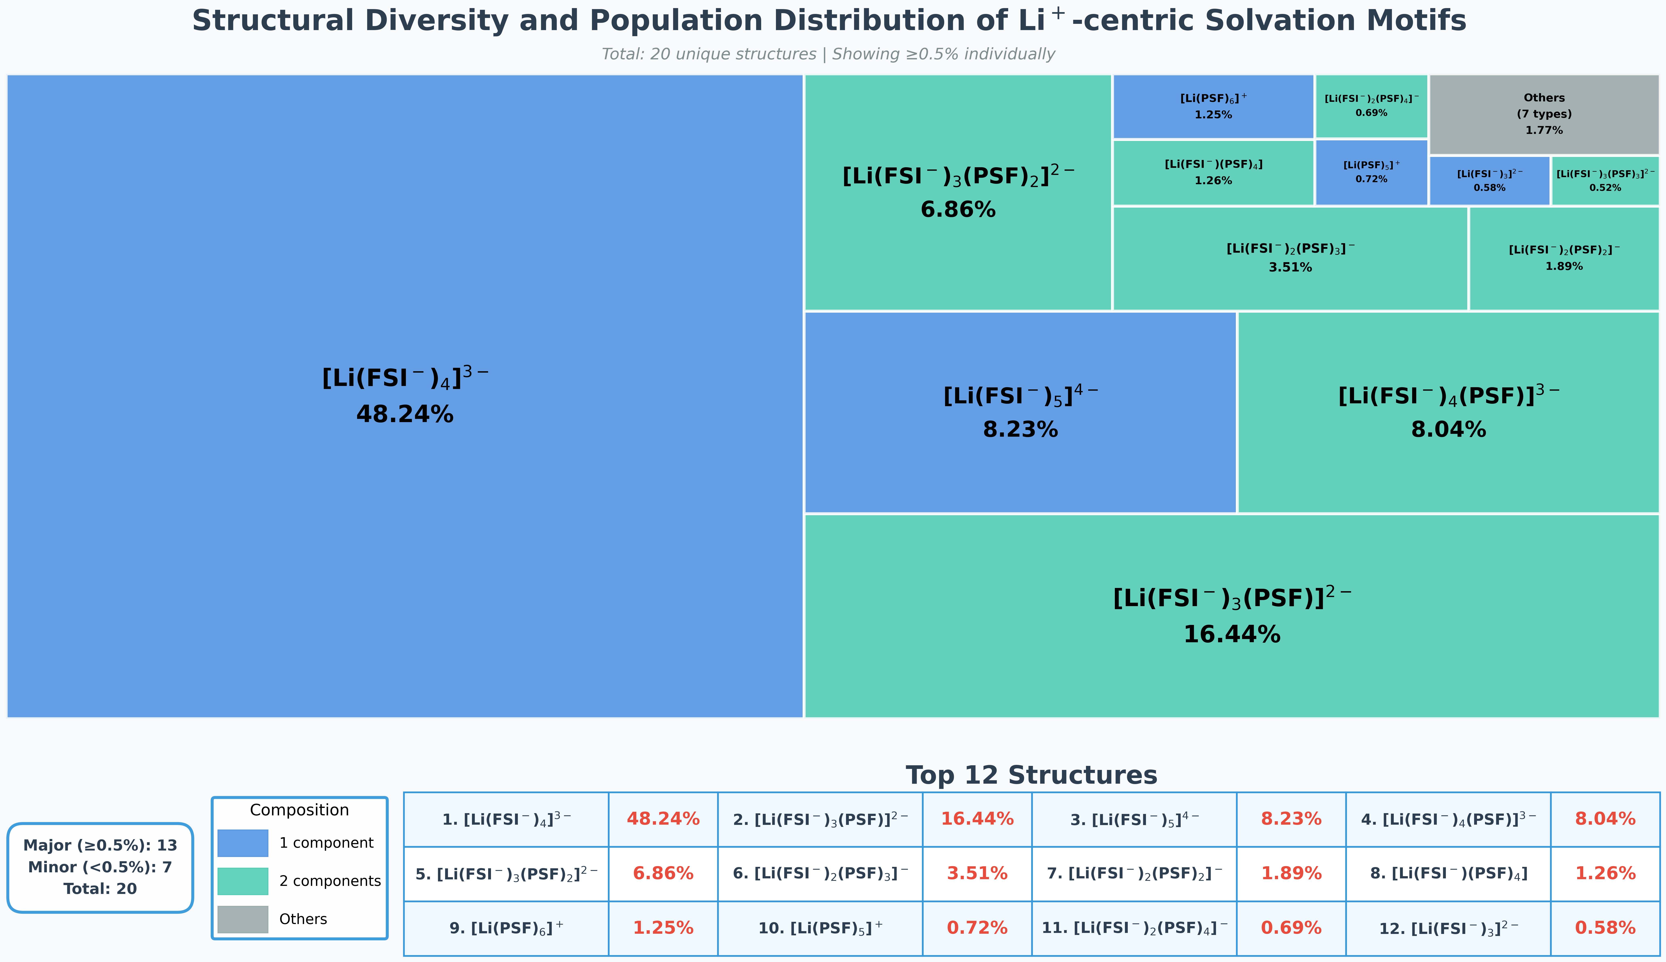
Supplementary Fig. 38 | Structural diversity of Li⁺ solvation in 1LiFSI:6.5PSF (298.15 K). The treemap visualizes the heterogeneity of the first solvation shell of Li⁺ as predicted by OPLS&Pol. Each tile represents a unique coordination complex defined by the general formula [Li(FSI)_{x}(PSF)_{y}]^{1-x}, with the tile area proportional to its population. The analysis identifies a total of 20 distinct structural motifs. Individual tiles are explicitly labeled for major species with a population ≥ 0.50% (13 types), while the remaining 7 minor species are aggregated into the gray “Others” category (1.77%). Tiles are color-coded based on ligand composition: blue (1 component/homoleptic) and green (2 components/binary). The table below details the top 12 dominant structures.

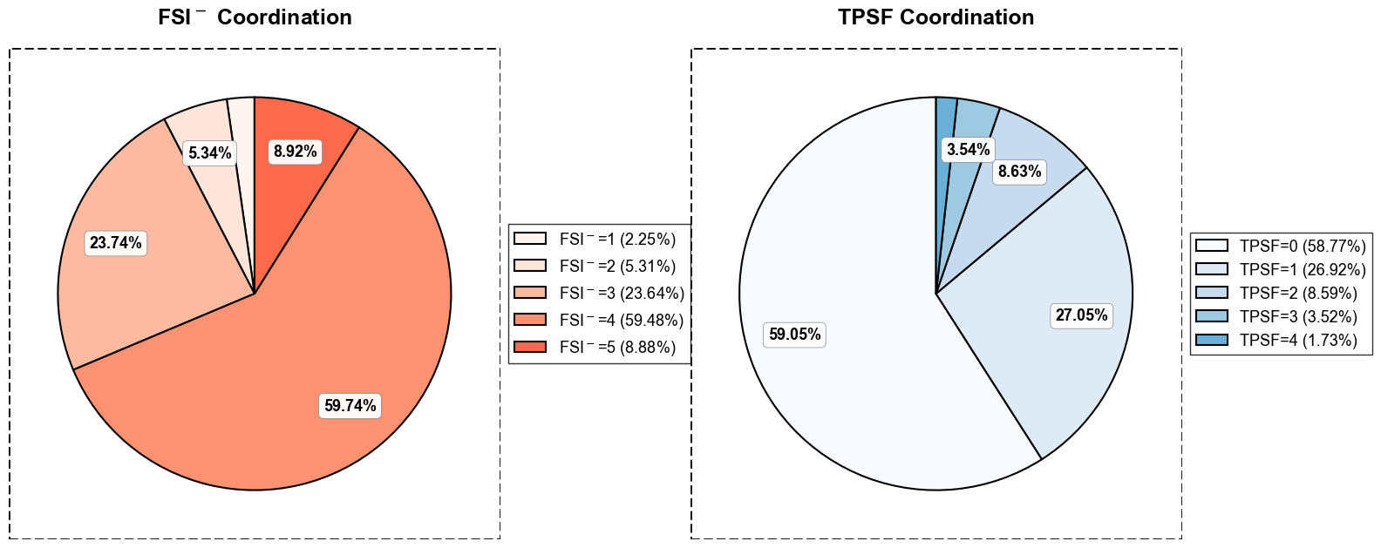
Supplementary Fig. 39 | Decomposition of Li⁺ solvation in 1LiFSI:5TPSF (298.15 K). Pie charts illustrate the population distribution of coordinating species within the first solvation shell of Li⁺ as predicted by OPLS&Pol. Classifications correspond to the stoichiometric coefficients in the general formula [Li(FSI)_{x}(TPSF)_{y}]^{1-x}. Left: Distribution of FSI⁻ anions (x). Right: Distribution of coordinated TPSF molecules (y).

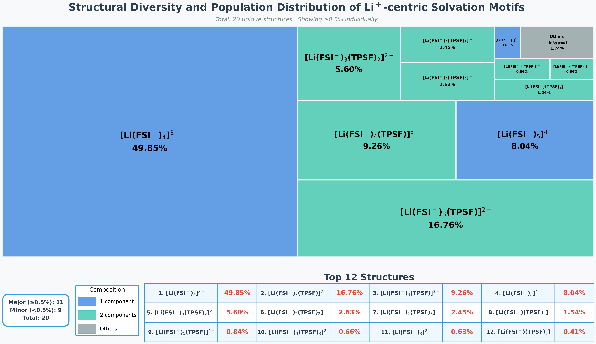
Supplementary Fig. 40 | Structural diversity of Li⁺ solvation in 1LiFSI:5TPSF (298.15 K). The treemap visualizes the heterogeneity of the first solvation shell of Li⁺ as predicted by OPLS&Pol. Each tile represents a unique coordination complex defined by the general formula [Li(FSI)_{x}(TPSF)_{y}]^{1-x}, with the tile area proportional to its population. The analysis identifies a total of 20 distinct structural motifs. Individual tiles are explicitly labeled for major species with a population ≥ 0.50% (11 types), while the remaining 9 minor species are aggregated into the gray “Others” category (1.74%). Tiles are color-coded based on ligand composition: blue (1 component/homoleptic) and green (2 components/binary). The table below details the top 12 dominant structures.

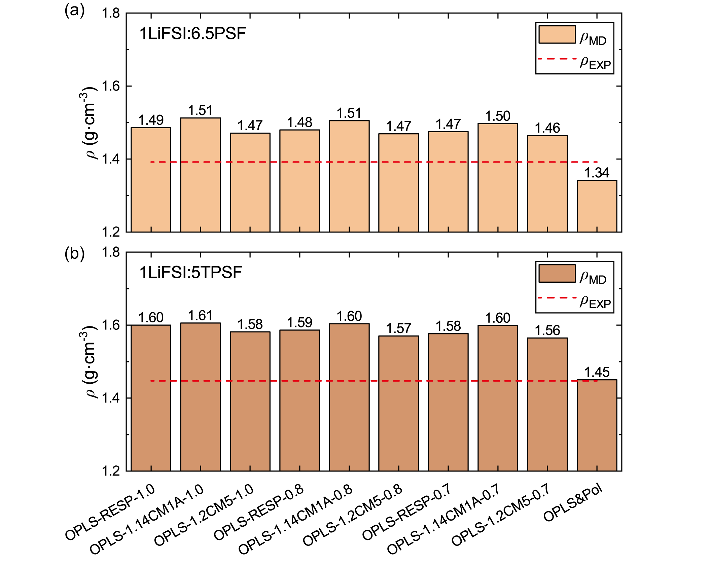
Supplementary Fig. 41 | Comparison of densities for LiFSI:PSF and LiFSI:TPSF electrolytes. Calculated densities predicted by 10 FFs and experimental densities for the LCEs at 298.15 K. (a) 1LiFSI:6.5PSF. (b) 1LiFSI:5TPSF.

Supplementary Note 10 | Analysis of Transport Properties and Ionic Conductivity
Self-diffusion coefficients (D) for all species were calculated from the slope of the mean squared displacement (MSD) according to the Einstein relation:
(24)
Here, r_{i}(t) is the CoM position of species i at time t. To minimize statistical noise and ensure convergence, the MSDs were computed using multiple time origins (time averaging), denoted by the average over starting times τ. To rigorously identify the true diffusive regime, the MSD profiles were analyzed on a double-logarithmic scale. The linear fitting window was strictly selected within the region where the slope of the log-log plot reached unity (slope ~ 1), confirming that the species had relaxed out of the initial ballistic or sub-diffusive regimes and exhibited Fickian diffusion dynamics.
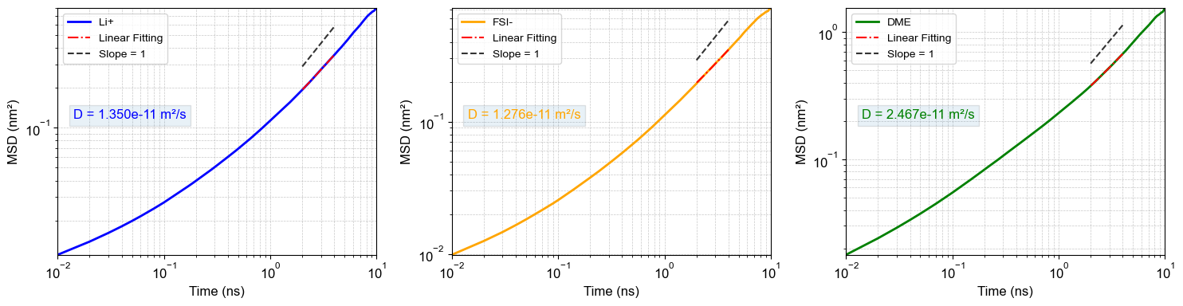
Supplementary Fig. 42 | MSDs of species in 1LiFSI:1.4DME (333.15 K) based on OPLS&Pol.
The ionic conductivity was estimated using the Nernst-Einstein (NE) equation (σ_{NE}), which assumes that charge carriers move independently (i.e., uncorrelated motion). σ_{NE} is computed as the sum of cationic (σ₊) and anionic (σ₋) contributions, collectively governed by salt concentrations (c), ionic diffusion coefficients (D₊ and D₋), and temperatures (T):
(25)
Here, N_{A} is the Avogadro constant, k_{B} is the Boltzmann constant.
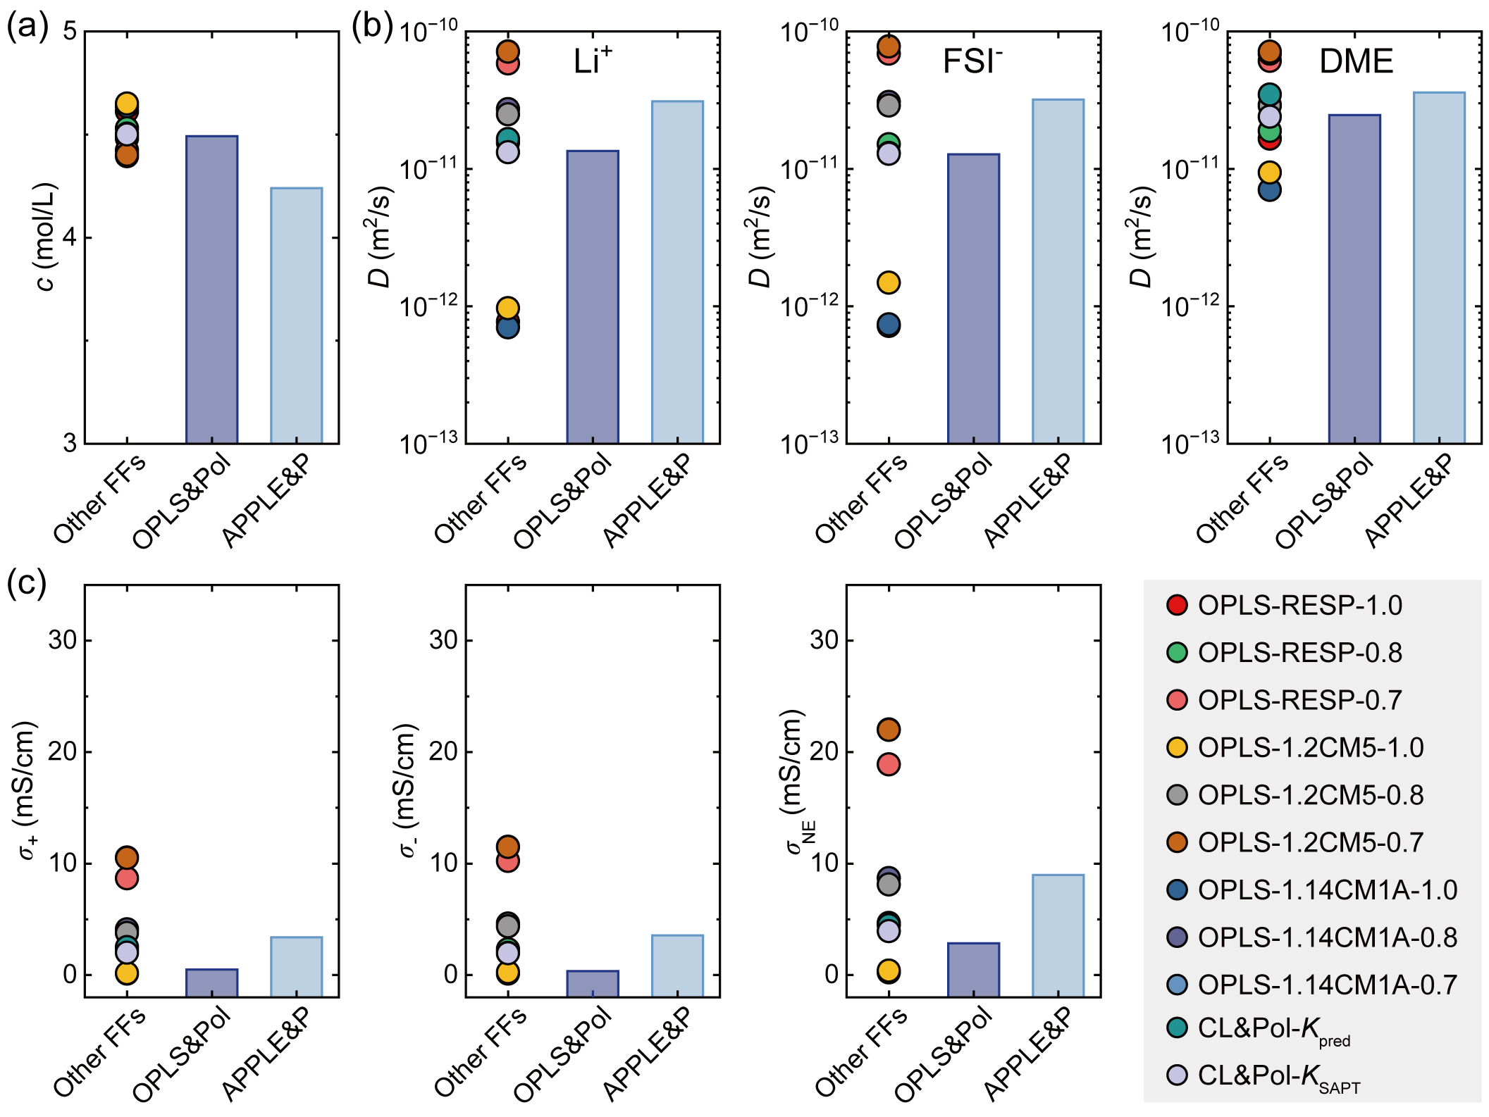
Supplementary Fig. 43 | Dynamic properties of species in 1LiFSI:1.4DME (333.15 K). (a) The c predicted by different FFs versus previously reported results using APPLE&P.¹³ (b) The D for Li⁺, FSI⁻, and DME across all FFs. (c) The σ_{NE}, σ₊ and σ₋, calculated for each FF. Note that OPLS&Pol and APPLE&P serve as benchmarks, while “Other FFs” denotes the collection of CFFs and CL&Pol series (including K_{pred} and K_{SAPT})^{4–6,53} as listed in the legend.

Supplementary References
1. Doherty, B., Zhong, X., Gathiaka, S., Li, B. & Acevedo, O. Revisiting OPLS force field parameters for ionic liquid simulations. J. Chem. Theory Comput. 13, 6131–6145 (2017).
2. Lamoureux, G., MacKerell, A. D. & Roux, B. A simple polarizable model of water based on classical drude oscillators. J. Chem. Phys. 119, 5185–5197 (2003).
3. Lamoureux, G. & Roux, B. Modeling induced polarization with classical drude oscillators: theory and molecular dynamics simulation algorithm. J. Chem. Phys. 119, 3025–3039 (2003).
4. Goloviznina, K., Canongia Lopes, J. N., Costa Gomes, M. & Pádua, A. A. H. Transferable, polarizable force field for ionic liquids. J. Chem. Theory Comput. 15, 5858–5871 (2019).
5. Goloviznina, K., Gong, Z. & Padua, A. A. H. The CL&pol polarizable force field for the simulation of ionic liquids and eutectic solvents. WIREs Comput. Mol. Sci. 12, e1572 (2022).
6. Goloviznina, K., Gong, Z., Costa Gomes, M. F. & Pádua, A. A. H. Extension of the CL&pol polarizable force field to electrolytes, protic ionic liquids, and deep eutectic solvents. J. Chem. Theory Comput. 17, 1606–1617 (2021).
7. Taylor, T., Schmollngruber, M., Schröder, C. & Steinhauser, O. The effect of thole functions on the simulation of ionic liquids with point induced dipoles at various densities. J. Chem. Phys. 138, 204119 (2013).
8. Thole, B. T. Molecular polarizabilities calculated with a modified dipole interaction. Chem. Phys. 59, 341–350 (1981).
9. Noskov, S. Yu., Lamoureux, G. & Roux, B. Molecular dynamics study of hydration in ethanol−water mixtures using a polarizable force field. J. Phys. Chem. B 109, 6705–6713 (2005).
10. Rafael Maglia De Souza, Karttunen, M. & Ribeiro, M. C. C. Fine-tuning the polarizable CL&pol force field for the deep eutectic solvent ethaline. J. Chem. Inf. Model. 61, 5938–5947 (2021).
11. Tang, K. T. & Toennies, J. P. An improved simple model for the van der waals potential based on universal damping functions for the dispersion coefficients. J. Chem. Phys. 80, 3726–3741 (1984).
12. Efaw, C. M. et al. Localized high-concentration electrolytes get more localized through micelle-like structures. Nat. Mater. 22, 1531–1539 (2023).
13. Qian, J. et al. High rate and stable cycling of lithium metal anode. Nat. Commun. 6, 6362 (2015).
14. Cao, X. et al. Optimization of fluorinated orthoformate based electrolytes for practical high-voltage lithium metal batteries. Energy Storage Mater. 34, 76–84 (2021).
15. Park, C. et al. Molecular simulations of electrolyte structure and dynamics in lithium–sulfur battery solvents. J. Power Sources 373, 70–78 (2018).
16. Hayamizu, K., Aihara, Y., Arai, S. & Martinez, C. G. Pulse-gradient spin-Echo¹ H,⁷ li, and¹⁹ F NMR diffusion and ionic conductivity measurements of 14 organic electrolytes containing LiN(SO₂ CF₃ )₂. J. Phys. Chem. B 103, 519–524 (1999).
17. Safari, M., Kwok, C. Y. & Nazar, L. F. Transport properties of polysulfide species in lithium–sulfur battery electrolytes: coupling of experiment and theory. ACS Cent. Sci. 2, 560–568 (2016).
18. Wu, Q., McDowell, M. T. & Qi, Y. Effect of the electric double layer (EDL) in multicomponent electrolyte reduction and solid electrolyte interphase (SEI) formation in lithium batteries. J. Am. Chem. Soc. 145, 2473–2484 (2023).
19. Maiti, M. et al. Mechanistic understanding of the correlation between structure and dynamics of liquid carbonate electrolytes: impact of polarization. Phys. Chem. Chem. Phys. 25, 20350–20364 (2023).
20. Bergstrom, H. K., Fong, K. D. & McCloskey, B. D. Interfacial effects on transport coefficient measurements in Li-ion battery electrolytes. J. Electrochem. Soc. 168, 60543 (2021).
21. Fang, C. et al. Quantifying selective solvent transport under an electric field in mixed-solvent electrolytes. Chem. Sci. 14, 5332–5339 (2023).
22. Szczęsna-Chrzan, A. et al. Ionic conductivity, viscosity, and self-diffusion coefficients of novel imidazole salts for lithium-ion battery electrolytes. J. Mater. Chem. A 11, 13483–13492 (2023).
23. Zhang, S. S., Jow, T. R., Amine, K. & Henriksen, G. L. LiPF6–EC–EMC electrolyte for li-ion battery. J. Power Sources 107, 18–23 (2002).
24. Dave, A. et al. Autonomous optimization of non-aqueous li-ion battery electrolytes via robotic experimentation and machine learning coupling. Nat. Commun. 13, 5454 (2022).
25. Perner, V. et al. Insights into the solubility of poly(vinylphenothiazine) in carbonate-based battery electrolytes. ACS Appl. Mater. Interfaces 13, 12442–12453 (2021).
26. Han, X. et al. Dilute electrolyte with vehicular aggregates for stable high‐energy lithium‐metal batteries. Adv. Mater. 38, e12236 (2026).
27. Xue, W. et al. Ultra-high-voltage ni-rich layered cathodes in practical li metal batteries enabled by a sulfonamide-based electrolyte. Nat. Energy 6, 495–505 (2021).
28. Cui, X. et al. 4.2 V O3‐layered cathodes in sodium‐ion pouch cells enabled by an intermolecular‐reinforced ether electrolyte. Adv. Mater. 37, 2415611 (2025).
29. Bayly, C. I., Cieplak, P., Cornell, W. & Kollman, P. A. A well-behaved electrostatic potential based method using charge restraints for deriving atomic charges: the RESP model. J. Phys. Chem. 97, 10269–10280 (1993).
30. Dodda, L. S., Vilseck, J. Z., Tirado-Rives, J. & Jorgensen, W. L. 1.14*CM1A-LBCC: Localized bond-charge corrected CM1A charges for condensed-phase simulations. J. Phys. Chem. B 121, 3864–3870 (2017).
31. Jorgensen, W. L. & Tirado-Rives, J. Potential energy functions for atomic-level simulations of water and organic and biomolecular systems. Proc. Natl. Acad. Sci. 102, 6665–6670 (2005).
32. Dodda, L. S., Cabeza de Vaca, I., Tirado-Rives, J. & Jorgensen, W. L. LigParGen web server: An automatic OPLS-AA parameter generator for organic ligands. Nucleic Acids Res. 45, W331–W336 (2017).
33. Marenich, A. V., Jerome, S. V., Cramer, C. J. & Truhlar, D. G. Charge model 5: An extension of hirshfeld population analysis for the accurate description of molecular interactions in gaseous and condensed phases. J. Chem. Theory Comput. 8, 527–541 (2012).
34. Stephens, P. J., Devlin, F. J., Chabalowski, C. F. & Frisch, M. J. Ab initio calculation of vibrational absorption and circular dichroism spectra using density functional force fields. J. Phys. Chem. 98, 11623–11627 (1994).
35. Weigend, F. & Ahlrichs, R. Balanced basis sets of split valence, triple zeta valence and quadruple zeta valence quality for H to rn: design and assessment of accuracy. Phys. Chem. Chem. Phys. 7, 3297 (2005).
36. Schäfer, A., Horn, H. & Ahlrichs, R. Fully optimized contracted gaussian basis sets for atoms Li to Kr. J. Chem. Phys. 97, 2571–2577 (1992).
37. Grimme, S., Ehrlich, S. & Goerigk, L. Effect of the damping function in dispersion corrected density functional theory. J. Comput. Chem. 32, 1456–1465 (2011).
38. Grimme, S., Antony, J., Ehrlich, S. & Krieg, H. A consistent and accurate ab initio parametrization of density functional dispersion correction (DFT-D) for the 94 elements H-pu. J. Chem. Phys. 132, 154104 (2010).
39. Schäfer, A., Huber, C. & Ahlrichs, R. Fully optimized contracted gaussian basis sets of triple zeta valence quality for atoms li to kr. J. Chem. Phys. 100, 5829–5835 (1994).
40. He, X. et al. Improving the reliability of classical molecular dynamics simulations in battery electrolyte design. J. Energy Chem. 101, 34–41 (2025).
41. Wu, Y. et al. Electrostatic potential as solvent descriptor to enable rational electrolyte design for lithium batteries. Adv. Energy Mater. 13, (2023).
42. Zhao, Y. & Truhlar, D. G. The M06 suite of density functionals for main group thermochemistry, thermochemical kinetics, noncovalent interactions, excited states, and transition elements: two new functionals and systematic testing of four M06-class functionals and 12 other functionals. Theor. Chem. Acc. 120, 215–241 (2008).
43. Perdew, J. P., Ernzerhof, M. & Burke, K. Rationale for mixing exact exchange with density functional approximations. J. Chem. Phys. 105, 9982–9985 (1996).
44. Lu, Y., Yang, Z., Zhang, Q., Xie, W. & Chen, J. Regulating electrostatic interaction between hydrofluoroethers and carbonyl cathodes toward highly stable lithium–organic batteries. J. Am. Chem. Soc. 146, 1100–1108 (2024).
45. Lu, T. & Chen, F. Multiwfn: a multifunctional wavefunction analyzer. J. Comput. Chem. 33, 580–592 (2012).
46. Lu, T. & Chen, F. Quantitative analysis of molecular surface based on improved marching tetrahedra algorithm. J. Mol. Graphics Model. 38, 314–323 (2012).
47. Zhang, J. & Lu, T. Efficient evaluation of electrostatic potential with computerized optimized code. Phys. Chem. Chem. Phys. 23, 20323–20328 (2021).
48. Lu, T. A comprehensive electron wavefunction analysis toolbox for chemists, multiwfn. J. Chem. Phys. 161, 82503 (2024).
49. Canongia Lopes, J. N., Deschamps, J. & Pádua, A. A. H. Modeling ionic liquids using a systematic all-atom force field. J. Phys. Chem. B 108, 2038–2047 (2004).
50. Canongia Lopes, J. N. et al. Potential energy landscape of bis(fluorosulfonyl)amide. J. Phys. Chem. B 112, 9449–9455 (2008).
51. Canongia Lopes, J. N. & Pádua, A. A. H. Molecular force field for ionic liquids composed of triflate or bistriflylimide anions. J. Phys. Chem. B 108, 16893–16898 (2004).
52. Dang, L. X. Development of nonadditive intermolecular potentials using molecular dynamics: solvation of li+ and F− ions in polarizable water. J. Chem. Phys. 96, 6970–6977 (1992).
53. Pádua, A. A. H. Resolving dispersion and induction components for polarisable molecular simulations of ionic liquids. J. Chem. Phys. 146, 204501 (2017).
54. Cao, X. et al. Effects of fluorinated solvents on electrolyte solvation structures and electrode/electrolyte interphases for lithium metal batteries. Proc. Natl. Acad. Sci. 118, e2020357118 (2021).
55. Gurung, B. B. & Roy, M. N. Study of densities, viscosities and ultrasonic speeds of binary mixtures containing 1,2-dimethoxyethane and an alkan-l-ol at 298.15 K. J. Solution Chem. 35, 1587–1606 (2006).
56. Xu, K. Nonaqueous liquid electrolytes for lithium-based rechargeable batteries. Chem. Rev. 104, 4303–4418 (2004).
57. Hagiyama, K. et al. Physical properties of substituted 1,3-dioxolan-2-ones. Chem. Lett. 37, 210–211 (2008).
58. Li, A.-M. et al. High voltage electrolytes for lithium-ion batteries with micro-sized silicon anodes. Nat. Commun. 15, 1206 (2024).
59. Giner, B., Artigas, H., Haro, M., Lafuente, C. & López, M. C. Viscosities of binary mixtures of 1,3-dioxolane or 1,4-dioxane with isomeric chlorobutanes. J. Mol. Liq. 129, 176–180 (2006).
60. Gong, S. et al. A predictive machine learning force-field framework for liquid electrolyte development. Nat. Mach. Intell. 7, 543–552 (2025).
61. Dajnowicz, S. et al. High-dimensional neural network potential for liquid electrolyte simulations. J. Phys. Chem. B 126, 6271–6280 (2022).
62. Ju, S. et al. Application of pretrained universal machine-learning interatomic potential for physicochemical simulation of liquid electrolytes in li-ion batteries. Digital Discovery 4, 1544–1559 (2025).
63. Lee, S. & Park, S. S. Dielectric constants of binary mixtures of propylene carbonate with dimethyl carbonate and ethylene carbonate from molecular dynamics simulation: comparison between non-polarizable and polarizable force fields. Mol. Phys. 111, 277–285 (2013).
64. Borodin, O. Polarizable force field development and molecular dynamics simulations of ionic liquids. J. Phys. Chem. B 113, 11463–11478 (2009).

