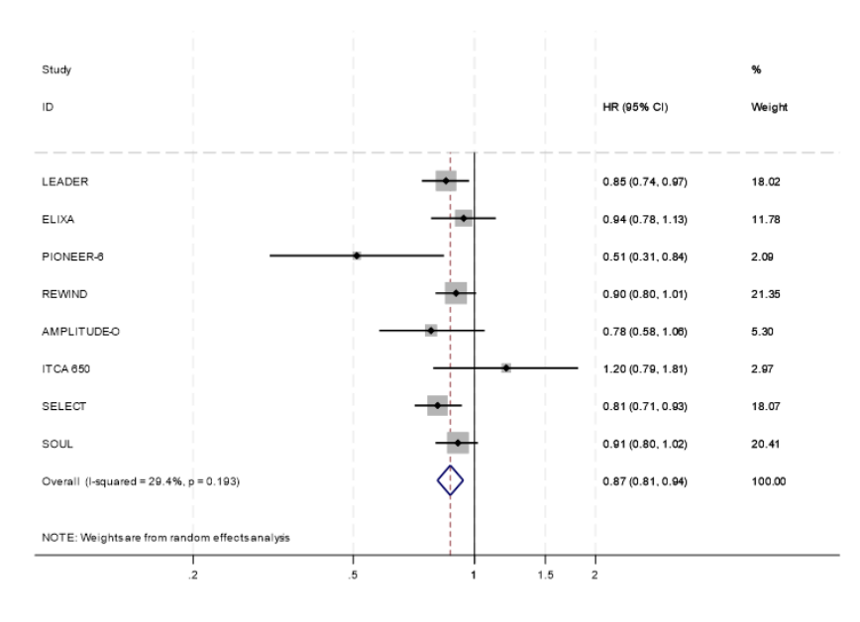
Figure 1: Forest plot diagram between GLP-1 receptor agonists and placebo for all-cause mortality according to random effects analysis.
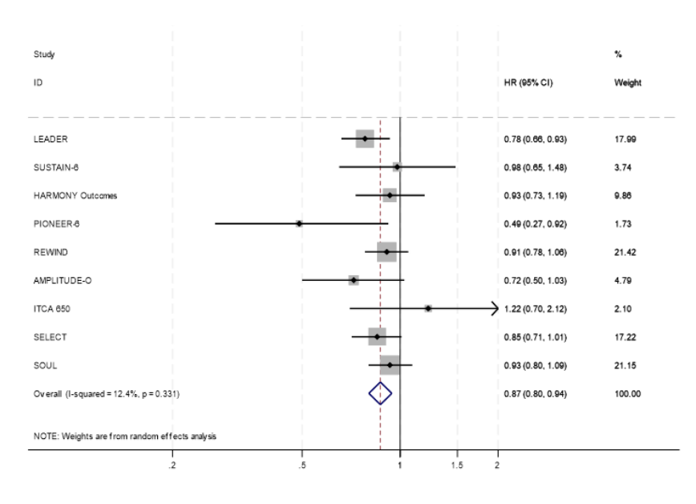
Figure 2: Forest plot diagram between GLP-1 receptor agonists and placebo for cardiovascular death according to random effects analysis.

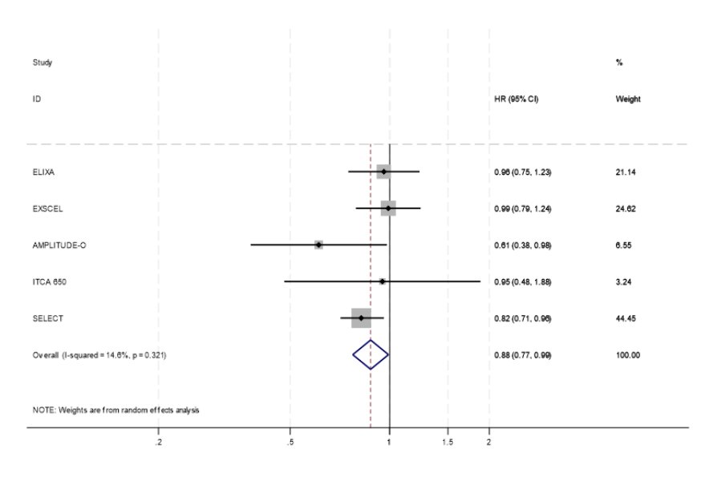
Figure 3: Forest plot diagram between GLP-1 receptor agonists and placebo for heart failure hospitalisation according to random effects analysis.
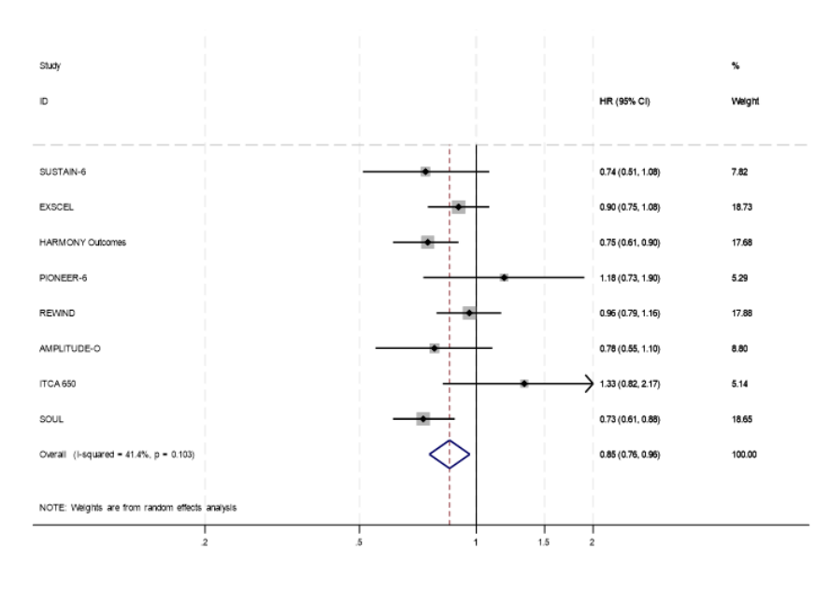

Figure 4: Forest plot diagram between GLP-1 receptor agonists and placebo for non-fatal myocardial infarction according to random effects analysis.
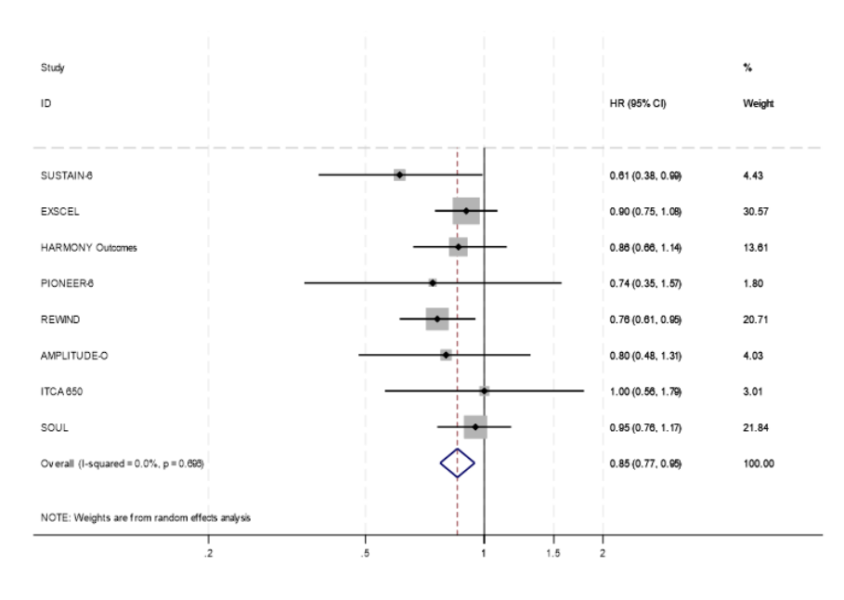 Figure 5: Forest plot diagram between GLP-1 receptor agonists and placebo for non-fatal stroke according to random effects analysis.

