The hijacking of a wheat Exo70-like protein by a fungal pathogen triggers disease

Singh et al.

Supplementary figure legends

Supplementary Figure 1. Leaf infiltrations and TtExo70FX15 (Tsc2) protein structure visualizations for Kronos wild type (WT), four Ptr ToxB-insensitive Kronos TILLING mutants with missense mutations, and one Kronos TILLING mutant with a missense mutation that was Ptr ToxB-sensitive. Protein structures depict the AlphaFold-predicted wild-type TtExo70FX15 (Tsc2) protein, with missense mutation sites highlighted to indicate their spatial positions. The locations of the point mutations are shown in red and labeled next to orange arrows. Representative Ptr ToxB infiltration reactions for each mutant are shown on the right.

Supplementary Figure 2. Leaf infiltrations and TtExo70FX15 (Tsc2) protein structure visualizations for Prosper wild type (WT) and eleven EMS-induced Ptr ToxB-insensitive missense mutants identified in Prosper. Protein structures depict the AlphaFold-predicted wild-type TtExo70FX15 (Tsc2) protein, with missense mutation sites highlighted to indicate their spatial positions. The locations of the point mutations are shown in red and labeled next to orange arrows. Representative Ptr ToxB infiltration reactions for each mutant are shown on the right.

Supplementary Figure 3. Yeast two-hybrid (Y2H) assay to test the interaction between Tsc2 and Ptr ToxB. Yeast co-transformants carrying pGBKT7-ToxB and pGADT7-Tsc2 grew on SD/-Leu/-Trp (DDO), confirming successful co-transformation. However, no growth was observed on QDO/X-α-gal, indicating that the downstream reporter genes were not activated, and no direct interaction occurred. The positive control (pGBKT7-53 × pGADT7-T) showed strong growth on both DDO and QDO/X-α-gal, leading to blue coloration, while the negative control (pGBKT7-Lam × pGADT7-T) grew on DDO but failed to grow on QDO/X-α-gal.

Supplementary Figure 1. Leaf infiltrations and TtExo70FX15 (Tsc2) protein structure visualizations for Kronos wild type (WT), four Ptr ToxB-insensitive Kronos TILLING mutants with missense mutations, and one Kronos TILLING mutant with a missense mutation that was Ptr ToxB-sensitive. Protein structures depict the AlphaFold-predicted wild-type TtExo70FX15 (Tsc2) protein, with missense mutation sites highlighted to indicate their spatial positions. The locations of the point mutations are shown in red and labeled next to orange arrows. Representative Ptr ToxB infiltration reactions for each mutant are shown on the right.

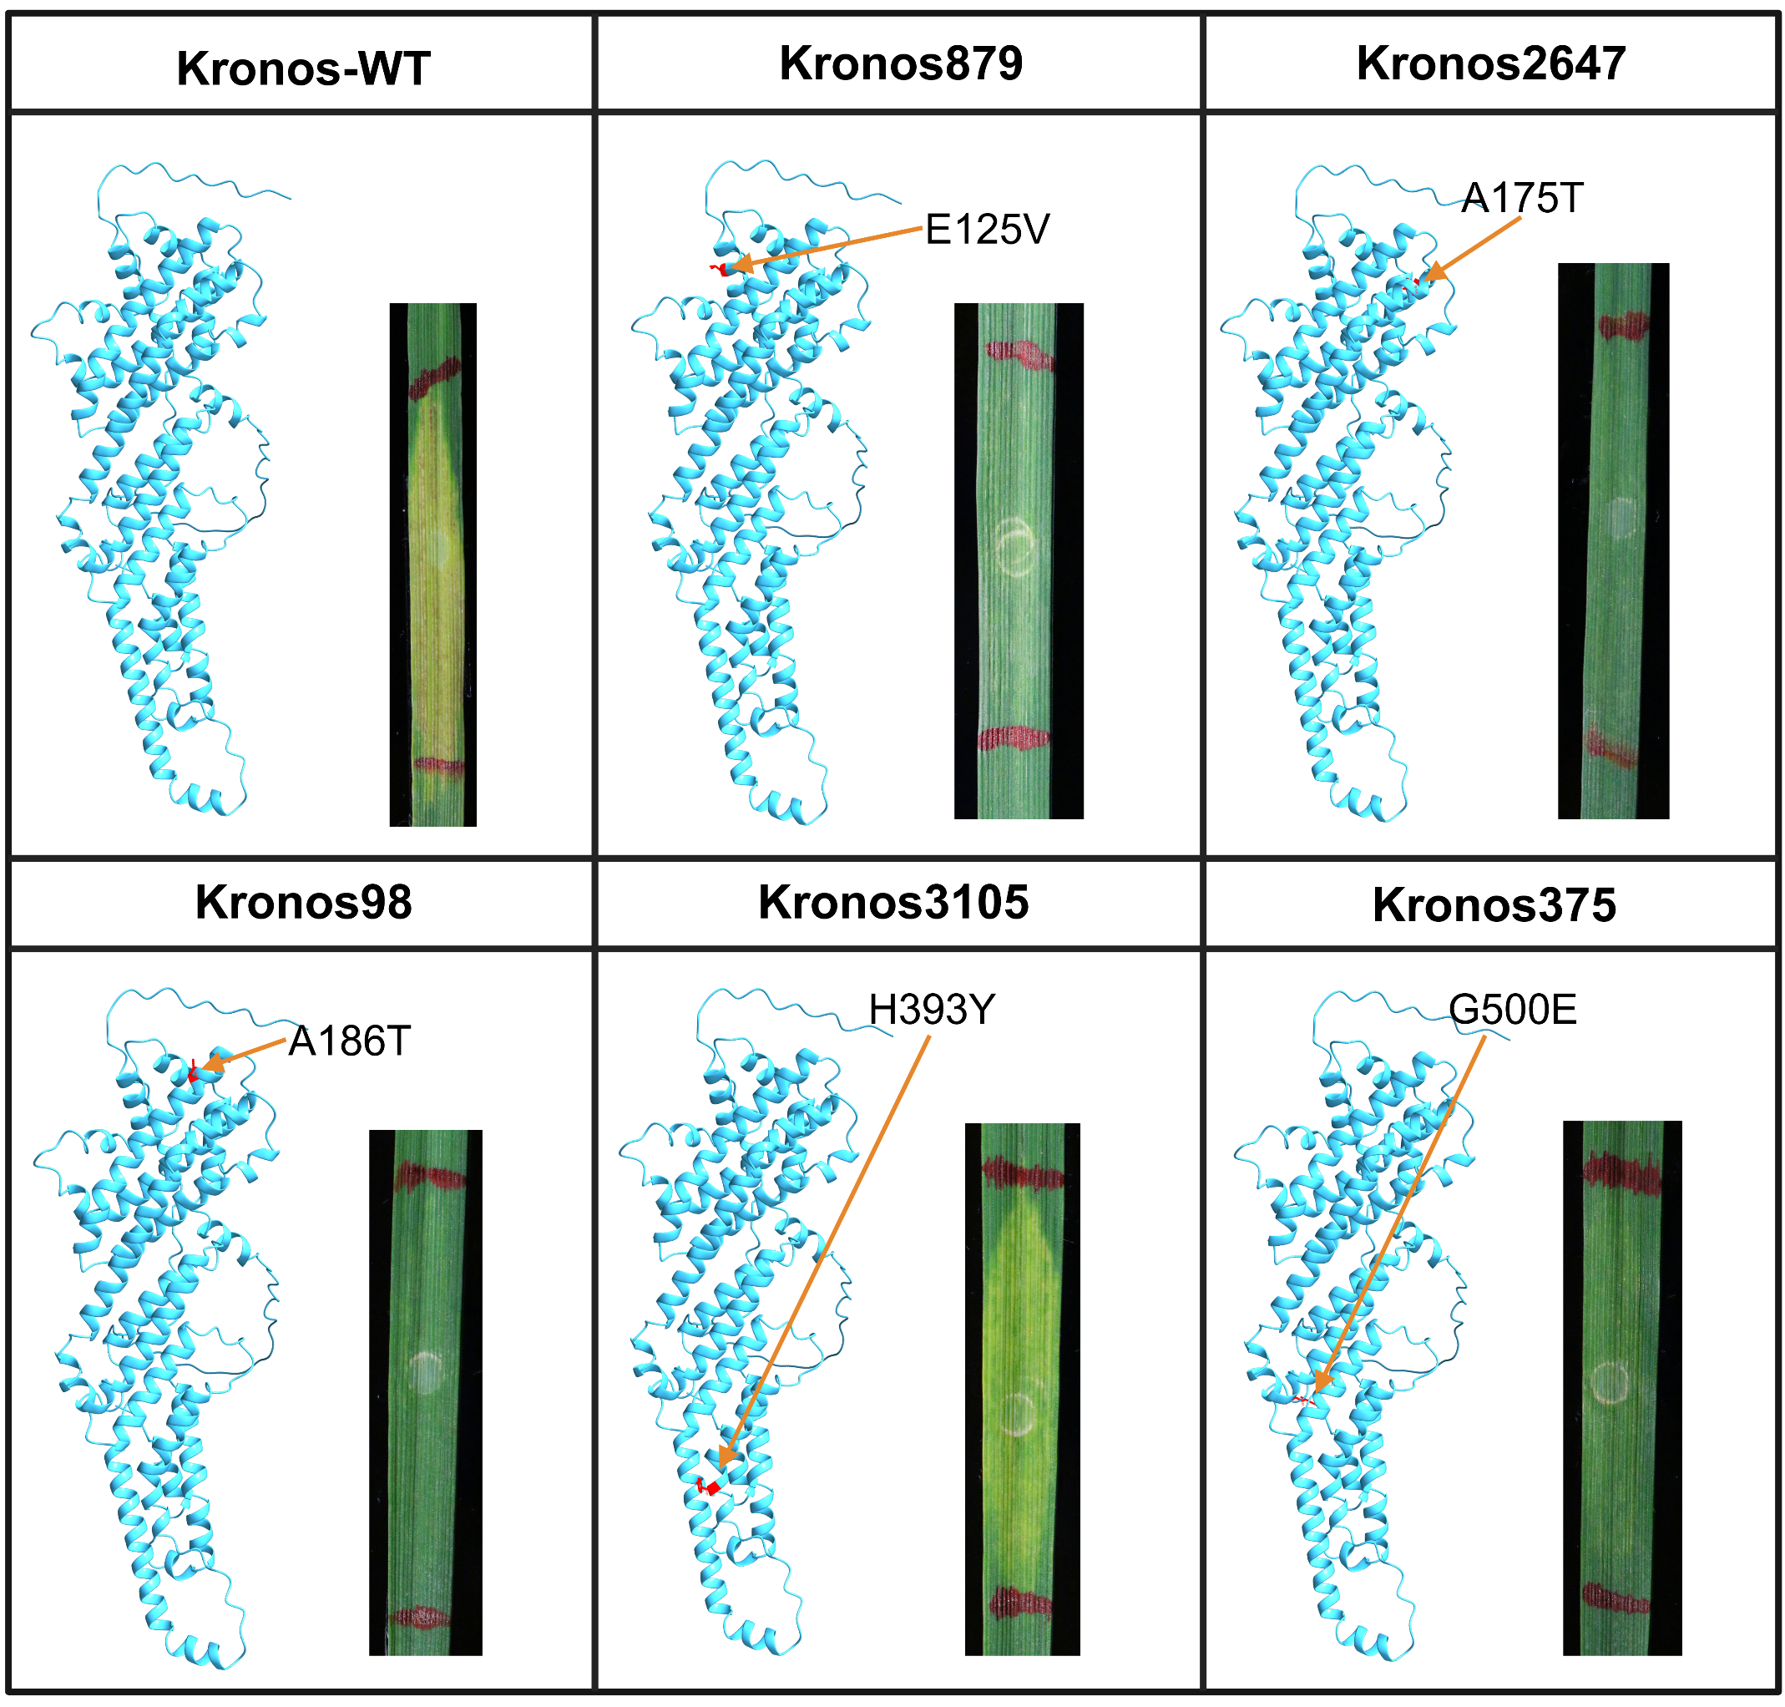

Supplementary Figure 2. Leaf infiltrations and TtExo70FX15 (Tsc2) protein structure visualizations for Prosper wild type (WT) and eleven EMS-induced Ptr ToxB-insensitive missense mutants identified in Prosper. Protein structures depict the AlphaFold-predicted wild-type TtExo70FX15 (Tsc2) protein, with missense mutation sites highlighted to indicate their spatial positions. The locations of the point mutations are shown in red and labeled next to orange arrows. Representative Ptr ToxB infiltration reactions for each mutant are shown on the right. (Continued on next page)

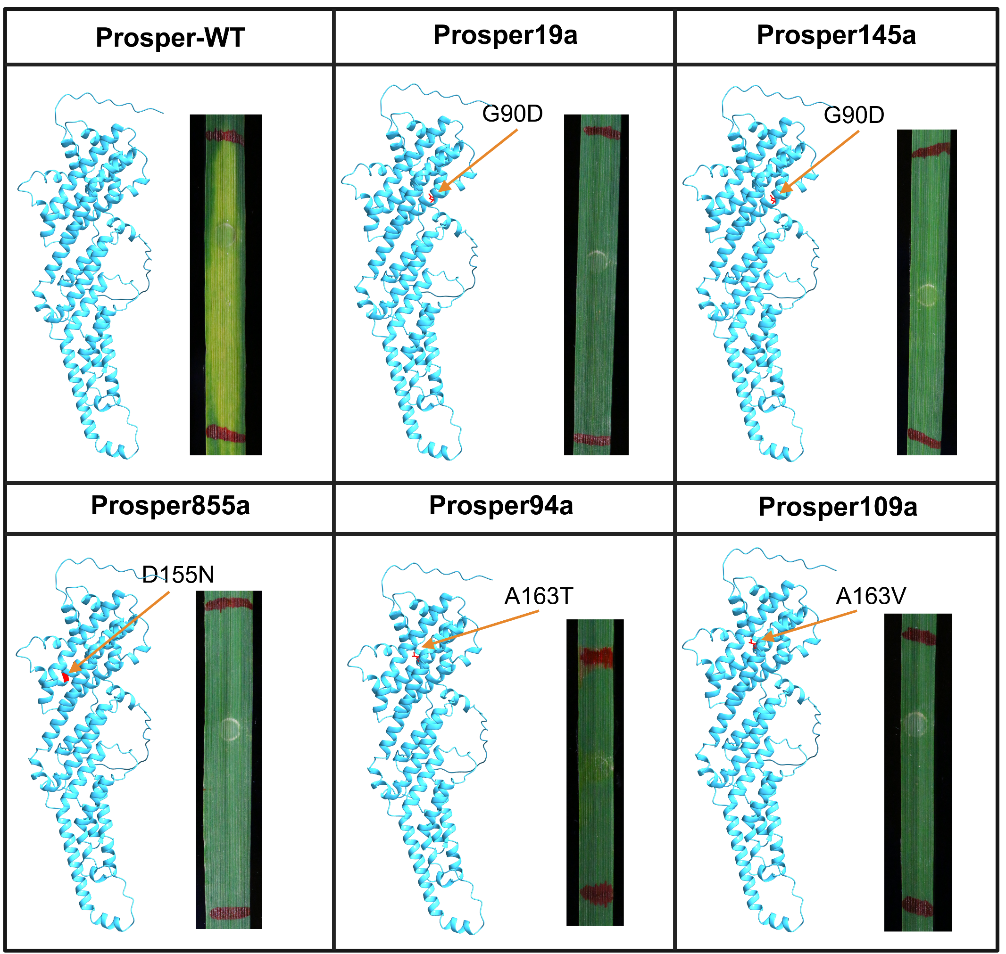

Supplementary Figure 2 (continued from previous page).

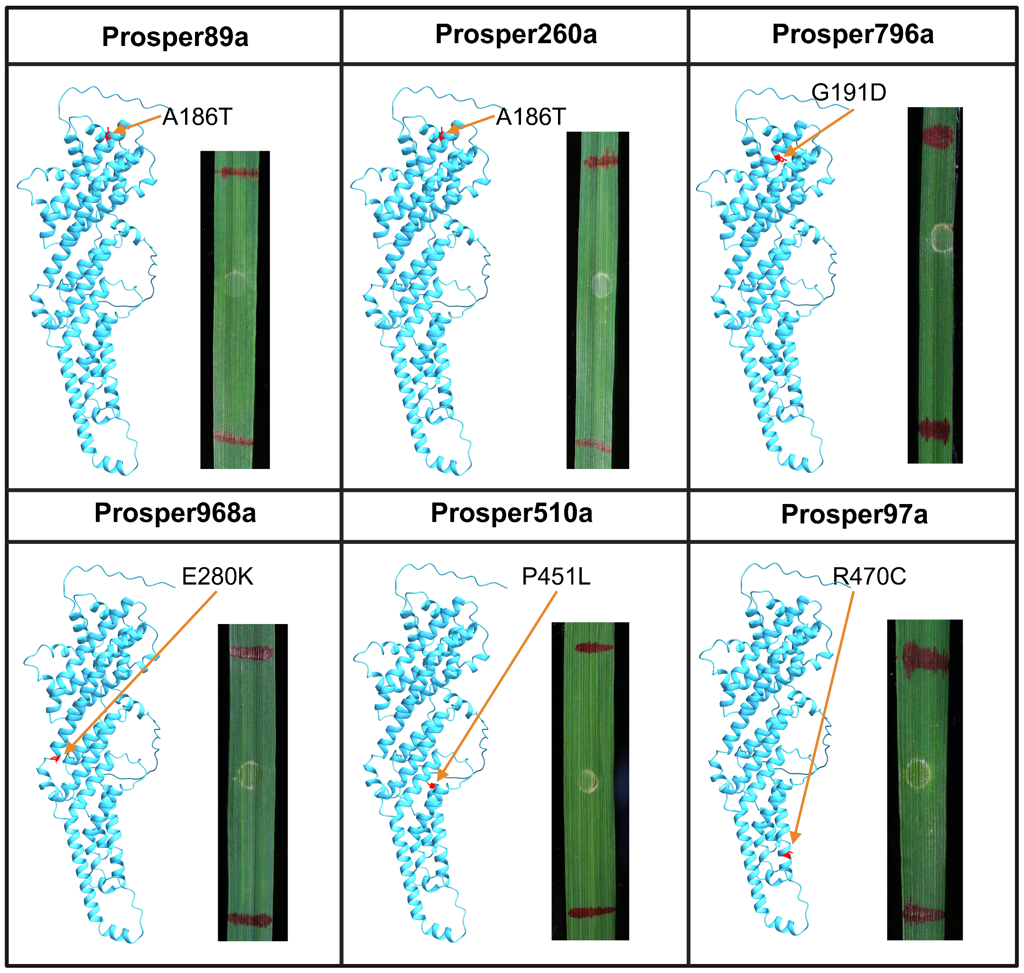

Supplementary Figure 3. Yeast two-hybrid (Y2H) assay to test the interaction between Tsc2 and Ptr ToxB. Yeast co-transformants carrying pGBKT7-ToxB and pGADT7-Tsc2 grew on SD/-Leu/-Trp (DDO), confirming successful co-transformation. However, no growth was observed on QDO/X-α-gal, indicating that the downstream reporter genes were not activated, and no direct interaction occurred. The positive control (pGBKT7-53 × pGADT7-T) showed strong growth on both DDO and QDO/X-α-gal, leading to blue coloration, while the negative control (pGBKT7-Lam × pGADT7-T) grew on DDO but failed to grow on QDO/X-α-gal.

