Supplementary information

Subsurface snowmelt buffers river response to warming in the Tibetan Plateau
Zhanliang Zhu^{1,2,3}, Xiongpeng Tang^{1,2,3,*}, Jianyun Zhang⁴, Chao Gao^{1,2,3}, Silong Zhang^{1,2,3}, Haoting Xu^{1,2,3}, Yehai Tang^{1,2,3}, Yanli Liu⁴, Tiesheng Guan^{4,5,*}
¹Guangdong-Hong Kong Joint Laboratory for Water Security, Beijing Normal University, Zhuhai 519087, China.
²Center for Water Research, Advanced Institute of Natural Sciences, Beijing Normal University, Zhuhai 519087, China.
³College of Water Sciences, Beijing Normal University, Beijing 100875, China.
⁴Nanjing Hydraulic Research Institute, Nanjing 210029, China.
⁵Nanjing Research Institute of Hydrology and Water Conservation Automation, Ministry of Water Resources, Nanjing 210012, China.

*Corresponding author: Xiongpeng Tang (xptang@bnu.edu.cn);
Tiesheng Guan (guantiesheng@nsy.com.cn)

Contents of this file
Texts S1 to S8
Figures S1 to S9
Tables S1 to S4

S1. Selected ten basins
Table S1 summarizes the physiographic and hydroclimatic characteristics of the ten gauged headwater basins selected across the Tibetan Plateau (TP). These basins were chosen to represent snow-influenced cold-region source areas spanning broad gradients in catchment scale (15,402–138,193 km²), mean elevation (3,455–5,274 m), annual precipitation (104–667 mm), and cryospheric conditions, including glacier coverage (<0.1–9.3%) and snow cover duration (78–150 days). Most outlets provide continuous monthly runoff observations for 1968–2018, enabling consistent multi-decadal intercomparison, while Lazi is analysed over its available record (1982–2008). Collectively, this basin set supports cross-basin evaluation of snowmelt-driven runoff partitioning and timing responses under warming.

Table S1. Physiographic and hydroclimatic characteristics of the ten gauged headwater basins across the Tibetan Plateau (TP), including basin area, elevation, annual precipitation, glacier coverage, snow cover duration, and the period of observed runoff records.
Gauged station  (abbreviation in parentheses) | River Basin | Area (km²) | Elevation (m) | Annual precipitation (mm) | Glacier coverage (%) | Snow cover days (days) | Observed runoff records (start–end, missing)
Changdu (CD) | Langcang River | 56275 | 4555 | 482 | 0.4 | 129 | 1968-2018; 0
Dajin (DJ) | Dadu River | 41252 | 3915 | 667 | <0.1 | 78 | 1968-2018; 0
Daofu (DF) | Yanlong River | 14541 | 4163 | 593 | <0.1 | 82 | 1968-2018; 0
Ganzi (GZ) | Yalong  River | 33857 | 4366 | 496 | 0.2 | 136 | 1968-2018; 10
Jiayuqiao (JYQ) | Nujiang River | 73206 | 4800 | 505 | 1.8 | 150 | 1982-2018; 0
Kaqun (KQ) | Tarim River | 58777 | 4597 | 104 | 9.3 | 138 | 1968-2018; 0
Lazi (LZ) | Yarlung Zangbo River | 50008 | 5274 | 444 | 2.1 | 101 | 1982-2008;0
Tangnaihai (TNH) | Yellow River | 121986 | 4162 | 496 | <0.1 | 92 | 1968-2018; 0
Xiangtang (XT) | Datong River | 15402 | 3455 | 412 | 0.3 | 93 | 1968-2018; 0
Zhimenda (ZMD) | Yangtze River | 138193 | 4790 | 355 | 1.0 | 104 | 1968-2018; 0
Notes:
1. Gauged station (abbreviation in parentheses) denotes the discharge station used for model calibration/validation and basin delineation; basin area refers to the upstream contributing area of each station.
2. Elevation (m) is the basin-mean elevation (meters above sea level) derived from the basin hypsometry.
3. Annual precipitation (mm) is the basin-mean annual total precipitation computed from the CN05.1 gridded meteorological dataset.
4. Glacier coverage (%) is the fraction of basin area covered by glaciers, calculated from the Randolph Glacier Inventory (RGI).
5.Snow cover days (days) is the basin-mean annual number of snow-covered days derived from the MODIS binary snow-cover product (snow/no-snow classification).
6. Observed runoff records (start–end) report the available observation period at each gauging station after quality control (Monthly) and the percentage of missing years after quality control.

Figure S1. Spatial distribution of frozen soil across the ten TP headwater basins. Panels (a–j) show the basin-wise distribution of frozen soil (including permafrost and seasonally frozen soil), indicating that all study basins contain widespread frozen soil. The frozen-ground dataset is obtained from the National Tibetan Plateau / Third Pole Environment Data Center^{1,2}. White areas within basin boundaries denote no-data regions in the original dataset.

S2. Model configuration and calibration
We conducted cold-region hydrological simulations for 1968–2018 using VIC-glacier^{3,4} (version 4.2.d⁵). Model configuration and the degree-day glacier module largely follow our previous setup⁶ to ensure consistency across basins and periods. To reduce equifinality associated with runoff-only calibration, we adopted a state–flux dual-constraint strategy^{7,8}. We first constrained simulated snow dynamics using daily ERA5-Land snow water equivalent (SWE), thereby calibrating SWE of VIC-glacier’s output; we then calibrated and evaluated routed runoff against monthly gauge observations at basin outlets to obtain parameter sets that are internally consistent for both snow states and integrated runoff response.
For basins with sufficiently complete records (Table S1), the calibration period is 1968–2000 and the validation period is 2001–2018; for Ganzi, Jiayuqiao and Lazi, the split year is fixed at 2000 due to record-length constraints, with pre-2000 years used for calibration and post-2000 years for validation. SCE-UA algorithm, a representative global optimization strategy, was selected for model parameter calibration. Detailed methodological steps and theoretical foundations of the SCE-UA algorithm can be found in Duan et al.⁹.Calibrated parameters, prior ranges and objective functions are summarized in Table S2, and SWE and runoff simulation performance are presented in Figure S2, Figure S3 and Table S3.
Table S2. Calibrated parameter types, physical meaning, prior ranges, calibration constraints, and optimal values for the VIC-glacier simulations.
type | Parameter | Description | Range | Calibration reference | Objective function
Snow |  | New snow albedo | 0.80~0.90 | SWE
Snow |  | Snow roughness | 0.001~0.03 | SWE
Snow |  | Accumulation period albedo decay parameter | 0.3~0.99 | SWE
Snow |  | Accumulation period albedo decay parameter | 0.3~0.99 | SWE
Snow |  | Thaw period albedo decay parameter | 0.1~0.99 | SWE
Snow |  | Thaw period albedo decay parameter | 0.1~0.99 | SWE
Soil |  | Maximum baseflow rate | 0~1 | Runoff | NSE_{Q}
Soil |  | Maximum flow velocity of baseflow [mm/day] | 0~30 | Runoff | NSE_{Q}
Soil |  | Infiltration shape parameter | 0~0.4 | Runoff | NSE_{Q}
Soil |  | Proportion of maximum soil moisture during nonlinear baseflow occurrence | 0~1 | Runoff | NSE_{Q}
Soil |  | Thickness of the second soil layer [m] | 0.7~1.0 | Runoff | NSE_{Q}
Soil |  | Thickness of the third soil layer [m] | 0.7~2.5 | Runoff | NSE_{Q}
Figure S2. Grid-scale performance of VIC-glacier snow water equivalent (SWE) against ERA5-Land across the ten basins. (a–j) Absolute relative error between simulated daily SWE and ERA5-Land SWE at each grid cell; white areas indicate no-data in the original ERA5-Land SWE product. Most grid cells exhibit errors below 10%, indicating robust skill in reproducing daily snow characteristics.
Figure S3. Observed and simulated monthly runoff at basin outlets for calibration and validation periods. (a–j) Monthly hydrographs comparing routed VIC-glacier runoff with gauge observations; the white and blue parts denote the split between calibration and validation (typically 1968–2000 and 2001–2018; for Ganzi, Jiayuqiao and Lazi the split year is 2000 due to record-length constraints).
Table S3. Performance metrics of monthly discharge simulations during calibration and validation across the ten basins. Metrics include Nash–Sutcliffe efficiency (NSE), relative error (RE), and root mean square error (RMSE) for each period.
Basin | Calibration |  |  | Validation
Basin | NSE | RE (%) | RMSE (m³/s) | NSE | RE (%) | RMSE (m³/s)
Changdu | 0.91 | -17.56 | 113.55 | 0.83 | -23.06 | 178.59
Dajin | 0.93 | -10.67 | 100.07 | 0.91 | -15.02 | 122.7
Daofu | 0.90 | -4.64 | 36.75 | 0.87 | -5.11 | 41.17
Ganzi | 0.91 | -10.12 | 65.37 | 0.90 | -12.01 | 66.49
Jiayuqiao | 0.93 | -15.20 | 201.05 | 0.92 | -13.59 | 193.56
Kaqun | 0.85 | -30.12 | 102.64 | 0.80 | -33.27 | 114.67
Lazi | 0.74 | 13.26 | 84.09 | 0.68 | 26.61 | 94.44
Tangnaihai | 0.91 | -6.10 | 157.85 | 0.87 | 3.36 | 169.95
Xiangtang | 0.85 | -0.53 | 30.56 | 0.67 | 7.44 | 40.48
Zhimenda | 0.93 | 6.35 | 131.28 | 0.89 | 9.91 | 125.50

S3. Derivation of Dual-phase multi-layer source tracking scheme
We implemented a diagnostic source-tracking module with VIC-glacier to partition model-resolved bulk storages and fluxes into contributions from distinct water sources ¹⁰. It decomposes VIC-glacier’s bulk variables into source-resolved components in a way that (i) is physically interpretable and (ii) satisfies exact mass closure at every time step. The tracker is designed for long multi-decadal simulations, where even small inconsistencies would otherwise accumulate.
(1) State variables and constraints
The soil column is represented by three layers indexed by n = 1, 2, 3 (top to bottom). For each layer n and source k ∈ {Rain, Snow, Glacier, U} (with U denoting “unknown” initial water), we track $W_{n,k}^{liq}(t)$ and $W_{n,k}^{ice}(t)$ (unit in mm). At any time, the source-resolved storages exactly sum to VIC-glacier’s bulk storages:
$\sum_{k}{W_{n,k}^{liq}\left(t\right)=W_{n}^{liq}(t)}, \sum_{k}{W_{n,k}^{ice}\left(t\right)=W_{n}^{ice}(t)}$ (1)
Initialization assigns all pre-existing soil water/ice to the “unknown” source, i.e., $W_{n,U}^{liq}\left(t_{0}\right)=W_{n}^{liq}\left(t_{0}\right)$ and $W_{n,U}^{ice}\left(t_{0}\right)=W_{n}^{ice}\left(t_{0}\right)$, while other sources start at zero. After spin-up, the unknown fraction becomes negligible and analyses focus on {Rain, Snow, Glacier}.
(2) Surface boundary: partitioning infiltration and direct runoff by source
At each time step, VIC-glacier provides the total surface water supply as the sum of rainfall reaching the ground and meltwater inputs:
$S_{tot}\left(t\right)=S_{rain}\left(t\right)+S_{snow}\left(t\right)+S_{glacier}\left(t\right)$ (2)
VIC-glacier partitions $S_{tot}$ into infiltration $I(t)$ and direct surface runoff $R_{surf}(t)$ such that $S_{tot}=I+R_{surf}$​. We assume well-mixed surface water (no preferential infiltration by source), hence the source-specific infiltration and direct runoff are:
$i_{k}\left(t\right)=I\left(t\right)\frac{S_{k}\left(t\right)}{S_{tot}\left(t\right)}, R_{surf,k}\left(t\right)=R_{surf}\left(t\right)\frac{S_{k}\left(t\right)}{S_{tot}\left(t\right)}$ (3)
for k ∈ {Rain, Snow, Glacier} when $S_{tot}$ > 0 (otherwise $i_{k}$ = $R_{surf,k}$ = 0). The infiltration i_{k} enters the top soil layer as $q_{1,k}^{in}=i_{k}$.
(3) Within-soil transport and evapotranspiration: proportional flux partitioning
For each layer $n$,VIC-glacier supplies bulk liquid fluxes: inflow from above $Q_{n}^{in}(t)$, utflow $Q_{n}^{out}(t)$, and transpiration $E_{n}^{tr}(t)$. The outflow is separated into percolation and baseflow components:
$Q_{n}^{out}=Q_{n}^{perc}+Q_{n}^{base}$ (4)
We assume instantaneous complete mixing within each layer’s liquid store, so the liquid composition fraction (c) is
$c_{n,k}^{liq}\left(t\right)=\frac{W_{n,k}^{liq}\left(t\right)}{W_{n}^{liq}\left(t\right)} if W_{n}^{liq}\left(t\right)>0$ (5)
Under piston-flow/advection with complete mixing, any liquid outflux carries the layer’s current composition. Therefore,
$q_{n,k}^{out,perc}=Q_{n}^{perc}c_{n,k}^{liq}, q_{n,k}^{out,base}=Q_{n}^{base}c_{n,k}^{liq},$
$e_{n,k}=E_{n}^{tr}c_{n,k}^{liq}, q_{n,k}^{out}=q_{n,k}^{out,perc}+q_{n,k}^{out,base}$ (6)
For layers below the surface (n > 1), inflowis percolation from the layer above with its source composition:
$q_{n,k}^{in}=Q_{n-1}^{perc}c_{n-1,k}^{liq}$ (7)
By construction, $\sum_{k}{q_{n,k}^{in}}=q_{n}^{in},\sum_{k}{q_{n,k}^{\text{out}}}=Q_{n}^{\text{out}}$, and $\sum_{k}{e_{n,k}}=E_{n}^{\text{tr}}$, ensuring exact consistency with VIC-glacier bulk fluxes.
(4) Dual-phase coupling: allocating freeze–thaw fluxes by phase composition
The energy module in VIC-glacier provides, for each layer n, the bulk freezing and melting amounts $Φ_{n}^{\text{freeze}}\left(t\right)$ and $Φ_{n}^{\text{melt}}\left(t\right)$. We treat phase change as non-fractionating with respect to source: freezing draws proportionally from the current liquid mixture; melting releases water proportionally from the current ice mixture. Define the ice composition fraction $c_{n,k}^{\text{ice}}=W_{n,k}^{\text{ice}}/W_{n}^{\text{ice}}$ when $W_{n}^{\text{ice}}$ > 0. Then,
$ϕ_{n,k}^{\text{freeze}}=Φ_{n}^{\text{freeze}} c_{n,k}^{\text{liq}},ϕ_{n,k}^{\text{melt}}=Φ_{n}^{\text{melt}} c_{n,k}^{\text{ice}}$ (8)
such that $\sum_{k}{ϕ_{n,k}^{\text{freeze}}}=Φ_{n}^{\text{freeze}}$ and $\sum_{k}{ϕ_{n,k}^{\text{melt}}}=Φ_{n}^{\text{melt}}$. This closure is essential for representing soil ice as a climatic “memory” reservoir: meltwater released later inherits the historical source composition stored in $W_{n,k}^{ice}$.
(5) Governing equations (source-resolved, dual-phase)
For each layer n and source k, the tracer obeys coupled mass balances:
$\frac{dW_{n,k}^{\text{liq}}}{dt}=q_{n,k}^{\text{in}}-q_{n,k}^{\text{out}}-e_{n,k}+ϕ_{n,k}^{\text{melt}}-ϕ_{n,k}^{\text{freeze}},$
$\frac{dW_{n,k}^{\text{ice}}}{dt}=ϕ_{n,k}^{\text{freeze}}-ϕ_{n,k}^{\text{melt}}$ (9)
Summing over k recovers VIC-glacier’s bulk layer budgets in each phase; summing liquid+ice for a given k shows that phase change conserves the total source-specific storage within a layer.
We solve the tracer system at model’s daily time step using operator splitting: (i) update transport and transpiration using the proportional flux partitioning; (ii) apply freeze–thaw redistribution using the phase-composition partitioning. The scheme preserves the constraints above to machine precision. The tracker produces grid-scale time series of $R_{\text{surf},k}$ and baseflow $B_{k}=\sum_{n}{q_{n,k}^{\text{out,base}}}$ for each source, which are then routed to basin outlets to quantify the evolving surface versus subsurface contributions of snowmelt to runoff.
Specifically, calculation steps are:
(1) Control volumes, sources, and state variables
Each grid cell contains a three-layer soil column. Layers are indexed n = 1, 2, 3 (top to bottom). Each layer is treated as an independent control volume for mass accounting. We define a set of water sources k ang track $W_{n,k}^{liq}(t)$ and $W_{n,k}^{ice}(t)$ (unit in mm). We also define a convenience quantity, total source-specific storage in layer n:
$S_{n,k}\left(t\right)=W_{n,k}^{\text{liq}}\left(t\right)+W_{n,k}^{\text{ice}}\left(t\right)$ (10)
(2) Initialization and the “unknown” source
At simulation start t₀, pre-existing soil water/ice is assigned to the unknown source:
$W_{n,\text{U}}^{\text{liq}}\left(t_{0}\right)=W_{n}^{\text{liq}}\left(t_{0}\right),W_{n,\text{U}}^{\text{ice}}\left(t_{0}\right)=W_{n}^{\text{ice}}\left(t_{0}\right)$ (11)
And $W_{n,k}^{\text{liq}}\left(t_{0}\right)=W_{n,k}^{\text{ice}}\left(t_{0}\right)=0$ for $k∈\{\text{Rain},\text{Snow},\text{Glacier}\}$.
A spin-up period (1961-1967) is used until the domain-integrated unknown fraction becomes negligible (application-specific threshold). Subsequent analyses focus on {Rain, Snow, Glacier}, Importantly, the tracker remains valid even without a spin-up; the unknown term simply represents the fraction of streamflow originating from antecedent water.
(3) Surface water supply
For each time step, VIC-glacier supplies the surface water available for infiltration/runoff as:
$S_{tot}\left(t\right)=S_{rain}\left(t\right)+S_{snow}\left(t\right)+S_{glacier}\left(t\right)$ (12)
where S_{rain} is rainfall reaching the ground, S_{snow} is meltwater released from seasonal snowpack, and S_{glacier} is glacier meltwater produced within the grid cell. VIC-glacier partitions $S_{tot}$ into infiltration $I(t)$ and direct surface runoff $R_{surf}(t)$ such that $S_{tot}=I+R_{surf}$​.
(4) Well-mixed assumption at the surface (closure)
We adopt the closure that surface waters from different sources are well mixed on the infiltration timescale, and thus infiltration does not preferentially select one source over another. Therefore, the source-resolved infiltration and direct runoff are proportional to the source fractions in $S_{tot}$:
$i_{k}\left(t\right)=I\left(t\right)\frac{S_{k}\left(t\right)}{S_{tot}\left(t\right)}, R_{surf,k}\left(t\right)=R_{surf}\left(t\right)\frac{S_{k}\left(t\right)}{S_{tot}\left(t\right)}$ (13)
for k ∈ {Rain, Snow, Glacier} when $S_{tot}$ > 0 (otherwise $i_{k}$ = $R_{surf,k}$ = 0). The infiltration i_{k} enters the top soil layer as $q_{1,k}^{in}=i_{k}$. Mass closure at the surface follows immediately:
$\sum_{k}{i_{k}}=I, \sum_{k}{R_{\text{surf},k}}=R_{\text{surf}}$ (14)
(5) Bulk fluxes provided by VIC-glacier
For each layer $n$,VIC-glacier provides (per time step):
- $Q_{n}^{in}(t)$ liquid inflow from above,
- $Q_{n}^{out}(t)$ liquid outflow leaving the layer,
- $E_{n}^{tr}(t)$ transpiration loss from the layer.
Outflow is decomposed as:
$Q_{n}^{out}(t)=Q_{n}^{perc}(t)+Q_{n}^{base}(t)$ (15)
where $Q_{n}^{perc}$ is percolation to the next layer and $Q_{n}^{base}$ is drainage that contributes to baseflow.
(6) Mixing assumption inside a layer and definition of compositions
We assume complete mixing in each layer’s liquid store at the time step. Define liquid composition:
$c_{n,k}^{\text{liq}}\left(t\right)=\left\{\begin{aligned}\frac{W_{n,k}^{liq}\left(t\right)}{W_{n}^{liq}\left(t\right)} \\ 0,W_{n}^{liq}\left(t\right)=0\end{aligned}\right.,W_{n}^{liq}\left(t\right)>0$ (16)
This is a standard tracer closure (equivalent to a “well-mixed reservoir” approximation) consistent with the lumped layer structure.
(7) Partitioning of fluxes by composition
Outfluxes. Any liquid flux leaving layer n carries the current layer composition:
$q_{n,k}^{\text{out,perc}}\left(t\right)=Q_{n}^{\text{perc}}\left(t\right) c_{n,k}^{\text{liq}}\left(t\right),q_{n,k}^{\text{out,base}}\left(t\right)=Q_{n}^{\text{base}}\left(t\right) c_{n,k}^{\text{liq}}\left(t\right)$ (17)
Thus $q_{n,k}^{out}=q_{n,k}^{out,perc}+q_{n,k}^{out,base}$.
Transpiration. Root uptake is assumed non-discriminating among sources:
$e_{n,k}(t)=E_{n}^{tr}c_{n,k}^{liq}(t)$ (18)
Influxes. For n=1, $q_{1,k}^{in}$=i_{k}. For deeper layers, inflow is percolation from the layer above, with the composition of that above-layer liquid store:
$$q_{n,k}^{\text{in}}\left(t\right)=Q_{n-1}^{\text{perc}}\left(t\right) c_{n-1,k}^{\text{liq}}\left(t\right),n=2,3.$$
Proof of bulk-flux consistency. Summing over sources yields:
$\sum_{k}{q_{n,k}^{\text{out,perc}}}=Q_{n}^{\text{perc}},\sum_{k}{q_{n,k}^{\text{out,base}}}=Q_{n}^{\text{base}},\sum_{k}{e_{n,k}}=E_{n}^{\text{tr}},\sum_{k}{q_{n,k}^{\text{in}}}=Q_{n}^{\text{in}},$ (19)
so the tracker never violates VIC-provided totals.
(8) Bulk phase-change fluxes from VIC-glacier
For each layer n, VIC-glacier’s thermal routine provides bulk phase-change amounts for each time step:
- $Φ_{n}^{\text{freeze}}\left(t\right)$ (liquid→ ice),
- $Φ_{n}^{\text{melt}}\left(t\right)$ (ice → liquid).
We assume phase change does not preferentially select sources. Freezing draws proportionally from the current liquid mixture; melting releases proportionally from the current ice mixture. Define ice composition:
$c_{n,k}^{\text{liq}}\left(t\right)=\left\{\begin{aligned}\frac{W_{n,k}^{ice}\left(t\right)}{W_{n}^{ice}\left(t\right)} \\ 0,W_{n}^{ice}\left(t\right)=0\end{aligned}\right.,W_{n}^{ice}\left(t\right)>0$ (20)
Then allocate:
$ϕ_{n,k}^{\text{freeze}}(t)=Φ_{n}^{\text{freeze}}(t) c_{n,k}^{\text{liq}}(t),ϕ_{n,k}^{\text{melt}}(t)=Φ_{n}^{\text{melt}}(t) c_{n,k}^{\text{ice}}(t)$ (21)
This guarantee:
$\sum_{k}{ϕ_{n,k}^{\text{freeze}}}=Φ_{n}^{\text{freeze}},\sum_{k}{ϕ_{n,k}^{\text{melt}}}=Φ_{n}^{\text{melt}}.$ (22)
(9) Phase change conserves total source storage in a layer
Define $S_{n,k}=W_{n,k}^{\text{liq}}+W_{n,k}^{\text{ice}}$. Under phase change alone:
$$ΔW_{n,k}^{\text{liq}}=+ϕ_{n,k}^{\text{melt}}Δt-ϕ_{n,k}^{\text{freeze}}Δt,$$
$$ΔW_{n,k}^{\text{ice}}=+ϕ_{n,k}^{\text{freeze}}Δt-ϕ_{n,k}^{\text{melt}}Δt,$$
Therefore $ΔS_{n,k}=0$, This is the mathematical basis for the “memory” ¹¹ interpretation: water stored as ice can preserve the historical source mixture and later re-enter the liquid pool when melting occurs.
(10) Source-resolved governing equations
Combining transport/ET and phase change, for each layer n and source k:
Liquid phase
$\frac{dW_{n,k}^{\text{liq}}}{dt}=q_{n,k}^{\text{in}}-q_{n,k}^{\text{out}}-e_{n,k}+ϕ_{n,k}^{\text{melt}}-ϕ_{n,k}^{\text{freeze}},$ (23)
Ice phase
$\frac{dW_{n,k}^{\text{ice}}}{dt}=ϕ_{n,k}^{\text{freeze}}-ϕ_{n,k}^{\text{melt}}$ (24)
(11) Recovery of bulk layer budgets
Summing the liquid equation over k gives:
$\frac{dW_{n}^{\text{liq}}}{dt}=Q_{n}^{\text{in}}-Q_{n}^{\text{out}}-E_{n}^{tr}+ϕ_{n}^{\text{melt}}-ϕ_{n}^{\text{freeze}},$ (25)
and summing the ice equation gives:
$\frac{dW_{n}^{\text{ice}}}{dt}=ϕ_{n}^{\text{freeze}}-ϕ_{n}^{\text{melt}}$ (26)
Thus, the tracker is exactly consistent with VIC-glacier’s phase-wise layer mass balances.
(12) Total source storage balance (phase terms cancel)
Adding liquid and ice equations for a given k:
$\frac{dS_{n,k}}{dt}=q_{n,k}^{\text{in}}-q_{n,k}^{\text{out}}-e_{n,k},$ (27)
showing phase change only redistributes storage between phases and does not create/destroy source mass.
(13) Operator-splitting update
At each time step 𝑡→𝑡+Δ𝑡, we apply two sub-steps.
Step A: transport + ET (no phase change)
$W_{n,k}^{\text{liq}*}=W_{n,k}^{\text{liq}}\left(t\right)+\left(q_{n,k}^{\text{in}}-q_{n,k}^{\text{out}}-e_{n,k}\right)Δt,$ (28)
$W_{n,k}^{\text{ice}*}=W_{n,k}^{\text{ice}}\left(t\right),$ (29)
Step B: freeze–thaw redistribution (no transport)
Compute intermediate compositions $c_{n,k}^{\text{liq}*}$ and $c_{n,k}^{\text{ice}*}$ from $W^{liq*}$ and $W^{ice*}$. Allocate:
$ϕ_{n,k}^{\text{freeze}*}=Φ_{n}^{\text{freeze}} c_{n,k}^{\text{liq}*},ϕ_{n,k}^{\text{melt}*}=Φ_{n}^{\text{melt}} c_{n,k}^{\text{ice}*}$ (30)
Update:
$$W_{n,k}^{\text{liq}}\left(t+Δt\right)=W_{n,k}^{\text{liq}*}-ϕ_{n,k}^{\text{freeze}*}Δt+ϕ_{n,k}^{\text{melt}*}Δt,$$
$W_{n,k}^{\text{ice}}\left(t+Δt\right)=W_{n,k}^{\text{ice}*}+ϕ_{n,k}^{\text{freeze}*}Δt-ϕ_{n,k}^{\text{melt}*}Δt.$ (31)
This explicit splitting is first-order but stable and enforces conservation by construction.
(14) Handling near-zero denominators
When $W_{n}^{\text{liq}}$ (or $W_{n}^{\text{ice}}$) becomes extremely small, composition fractions can become ill-conditioned. We apply a small threshold 𝜖 (e.g., 10⁻⁸ mm in storage units) such that:
- If $W_{n}^{\text{liq}}$ < 𝜖, set $c_{n,k}^{\text{liq}}$ =0 for all k and force $ϕ_{n}^{\text{freeze}}$=0 for that layer/time step (cannot freeze absent liquid);
- f $W_{n}^{\text{ice}}$ < 𝜖, set $c_{n,k}^{\text{ice}}$ =0 for all k and force $ϕ_{n}^{\text{ice}}$=0 (cannot melt absent ice).
This preserves stability without affecting physically meaningful states.
(15) Non-negativity enforcement
After each sub-step, storages are constrained to remain non-negative. If a tiny negative value occurs due to floating-point error (e.g., 10⁻¹² mm), it is set to zero and the residual is compensated within the same phase and layer to maintain closure (in practice, with 𝜖-thresholds, such corrections are rare).
(16) Exact reconciliation
Because VIC-glacier bulk storages are authoritative, we optionally enforce at the end of each time step:
$W_{n}^{\text{liq}}(t+Δt)=∑kW_{n,k}^{\text{liq}}(t+Δt),W_{n}^{\text{ice}}(t+Δt)=∑kW_{n,k}^{\text{ice}}(t+Δt)$ (32)
by distributing any negligible rounding residual across sources proportionally to their current fractions. This guarantees long-run exact consistency.
(17) Mapping tracked fluxes to “surface” vs “subsurface” snowmelt runoff
We define surface snowmelt runoff at the grid-cell scale as the snow-sourced component of direct surface runoff:
$R_{\text{Snow}}^{\text{surf}}\left(t\right)≡R_{\text{surf},\text{Snow}}\left(t\right).$ (33)
We define subsurface snowmelt runoff as the snow-sourced component of baseflow/drainage exiting the soil column:
$R_{\text{Snow}}^{\text{sub}}\left(t\right)≡B_{\text{Snow}}\left(t\right)=\sum_{n=1}^{3}{q_{n,\text{Snow}}^{\text{out,base}}\left(t\right)}.$ (34)
Analogous definitions apply for Rain and Glacier sources. These source-resolved fluxes are then routed using the same routing scheme as VIC-glacier to compute outlet contributions.
Figure S4. Spin-up convergence of the “unknown” initial-water source in the dual-phase tracking scheme. Basin-mean multi-year fractions of the unknown source after a 1961–1967 spin-up, showing that the unknown contribution declines to ~0.1% (or lower) across all basins. Spatial maps (all grid cells) further indicate uniformly negligible unknown fractions (predominantly <0.1%), demonstrating rapid convergence of source attribution.
Figure S5. Mass-conservation diagnostics of the snowmelt-runoff tracking closure across basins and grids. Annual relative closure errors are summarized by basin using scatter and box plots, testing the identity $Q_{\text{Snow}}^{\text{total}}$=$Q_{\text{Snow}}^{\text{surf}}+Q_{\text{Snow}}^{\text{sub}}$. Corresponding grid-scale error maps show that closure residuals are small over most pixels (typically within 0–5 m³/s, confirming near-exact mass closure of the tracking scheme.

S4. Surface and subsurface fractional contributions and centroid timing ($T_{50}$)
(1) Surface and subsurface snowmelt runoff and their fractional contributions
Our tracking scheme partitions daily total runoff into contributions from different water sources (rain, seasonal snowmelt, glacier melt) and distinct flow pathways (surface vs. subsurface drainage). We define surface snowmelt as the portion of daily runoff originating from snowmelt that exits the grid cell through the VIC-glacier surface runoff pathway (direct runoff). Subsurface snowmelt is defined as the portion originating from snowmelt that leaves the soil column via subsurface drainage generation (i.e., baseflow-related outflow). Daily values are obtained directly from the model outputs by summing fluxes that are simultaneously tagged as “snowmelt-sourced” and attributed to either the surface or subsurface pathway. To enable cross-basin comparisons, we also compute fractional contributions by normalizing each component by total runoff at the same temporal resolution, e.g., surface (or subsurface) snowmelt divided by total daily runoff.
(2) Timing of snowmelt runoff release: centroid timing ($T_{50}$)
$T_{50}$ is defined as the day of year when the cumulative sum of snowmelt runoff reaches 50% of its annual total^{12–14}. Let $Q^{m}\left(t\right)$ denote the daily snowmelt runoff time series (this can be surface snowmelt, subsurface snowmelt, or their sum) for a given hydrological year, evaluated on day-of-year $t=1,2,…,N$ (typically N = 365 or 366). Define the annual total snowmelt runoff $Q_{\text{ann}}^{m}$:
$Q_{\text{ann}}^{m}=\sum_{t=1}^{N}{Q^{m}\left(t\right)}$ (35)
and define the cumulative fraction of annual snowmelt runoff up to day t as:
$F\left(t\right)=\frac{\sum_{τ=1}^{t}{Q^{m}\left(τ\right)}}{Q_{\text{ann}}^{m}}$ (36)
Then is defined $T_{50}$ as the first day-of-year when the cumulative fraction reaches 0.5:
$T_{50}=\min\left\{t∈\left[1,N\right]: F\left(t\right)≥0.5\right\}$ (37)
(3) Late-season subsidy and $Q_{min30}$ low-flow diagnostic
To assess whether delayed subsurface snowmelt sustains runoff beyond the spring melt peak, the analysis does not rely on a conventional definition of the “annual lowest-flow season.” Instead, attention is restricted to a late-season hydrological window spanning July to October. Over much of the TP, this interval is typically dominated by rainfall^{15,16}, yet it also overlaps with the waning influence of seasonal snowmelt and the period when meltwater previously infiltrated into soils and groundwater is most likely to be discharged to the channel network^{17,18}. Focusing on July–October therefore provides a targeted diagnostic of whether subsurface snowmelt yields a detectable buffering contribution after direct surface snowmelt has largely ceased. Within this window, a 30-day moving average is calculated from the daily runoff series as:
${\overline{Q}}_{30}\left(t\right)=\frac{1}{30}\sum_{j=0}^{29}{Q\left(t-j\right)}$ (38)
and define
$Q_{\min{3}0}=\min_{t∈\text{Jul-Oct}}{{\overline{Q}}_{30}}\left(t\right)$ (39)
as a stable indicator of late-season low-flow level. Using a 30-day moving average reduces sensitivity to single-day anomalies and better represents a persistent low-flow condition rather than transient fluctuations. We emphasize that $Q_{min30}$ is a diagnostic of late-season (post-peak) low flows rather than the absolute annual minimum flow.

S5. $T_{50}$ of surface and subsurface snowmelt
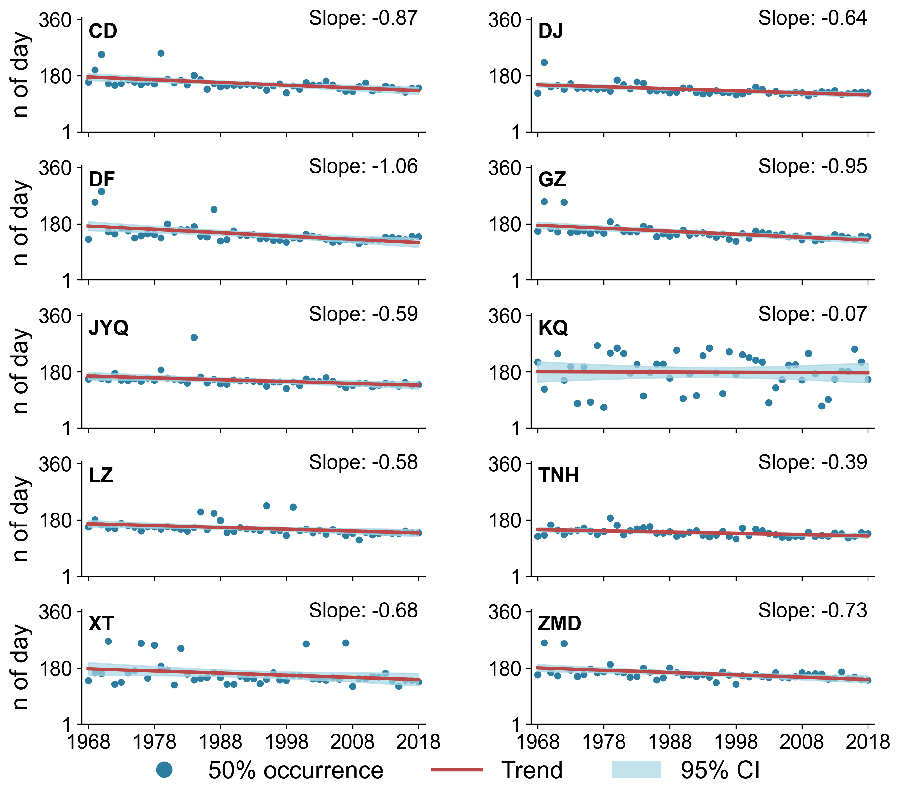
Figure S6. Basin-outlet trends in the $T_{50}$ of surface snowmelt runoff (1968–2018).
Blue dots show annual $T_{50}$ (day of year) for each basin; the red line denotes the fitted linear trend, and the blue shaded band indicates the 95% confidence interval. All basins exhibit earlier $T_{50}$ through time, indicating a systematic advance in the median timing of surface snowmelt delivery.
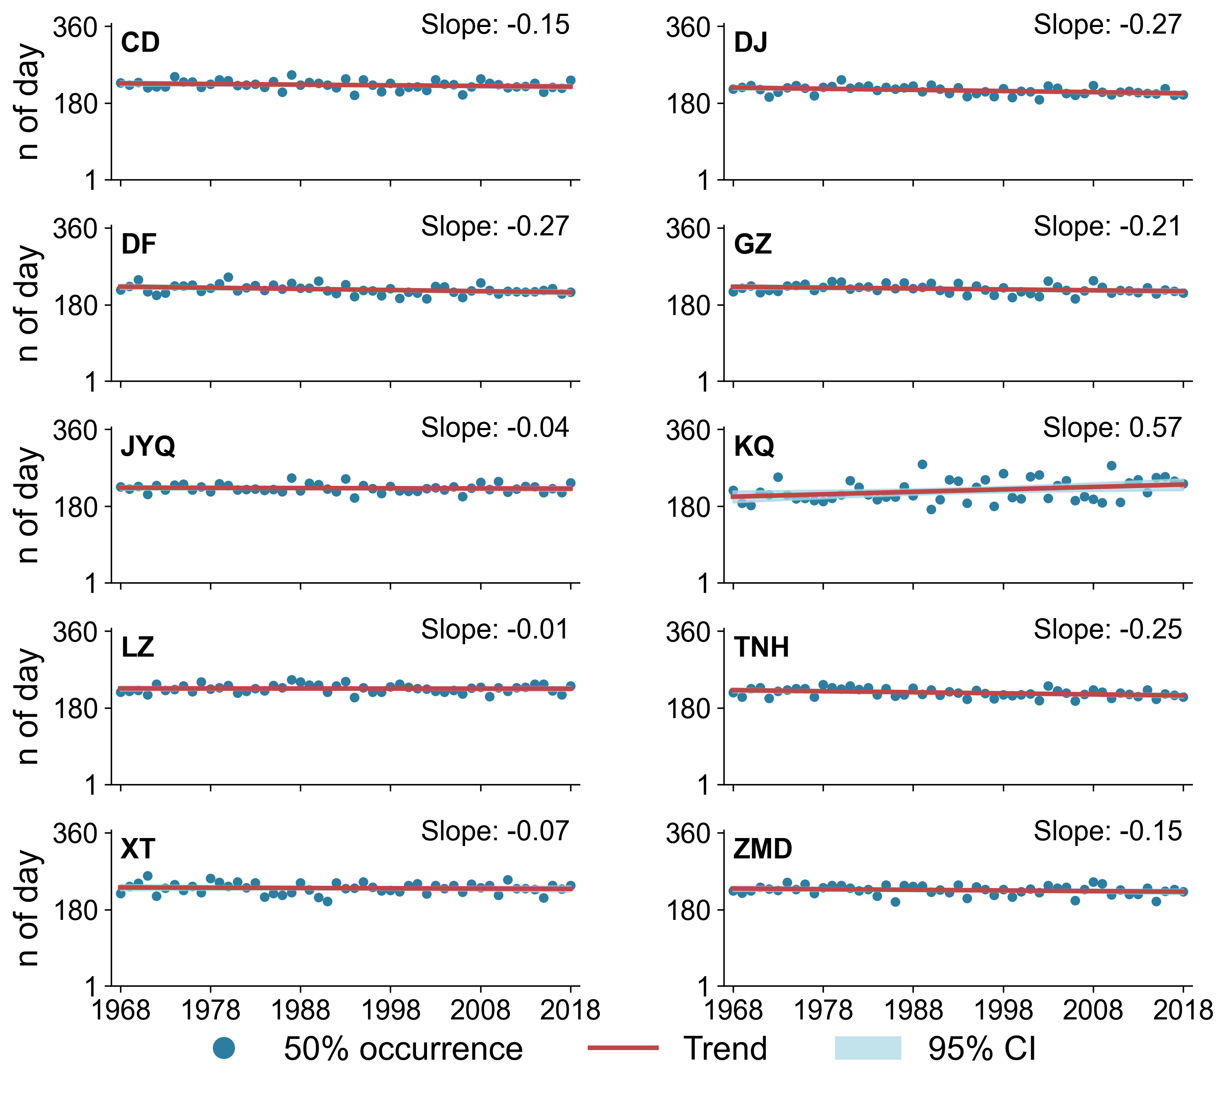
Figure S7. Basin-outlet trends in the $T_{50}$ of subsurface snowmelt runoff (1968–2018). Blue dots show annual $T_{50}$ (day of year) for each basin; the red line denotes the fitted linear trend, and the blue shaded band indicates the 95% confidence interval. $T_{50}$ advances across all basins, indicating that the median timing of subsurface snowmelt release also shifts earlier over the study period.

S6. Buffering index ($B_{i}$)
To quantify the extent to which subsurface pathways damp the warming-driven advance in runoff timing at the basin outlet, we define a basin-scale timing buffering index Bi as the difference between the long-term linear trends in timing for surface snowmelt runoff and total discharge:
$B_{\text{basin}}=\text{trend}\text{surf}-\text{trend}Q$ (40)
where trendsurf is the annual trend of surface snowmelt runoff, and $\text{trend}Q$ is the annual trend of total runoff (routed discharge) at the basin outlet. Trends are estimated as ordinary least-squares linear slopes over 1968–2018 (units: days per decade, or days per year depending on reporting).
Table S4. Basin-scale trends for surface snowmelt runoff, subsurface snowmelt runoff, and total discharge, and the corresponding timing buffering index ($B_{\text{basin}}$) across the ten TP headwater basins (1968–2018).
Basin | trend_surf | trend_sub | trend_Q | B_basin
CD | 8.73 | 1.53 | 0.76 | 7.98
DJ | 6.35 | 2.67 | 2.59 | 3.76
DF | 10.58 | 2.67 | 2.20 | 8.38
GZ | 9.47 | 2.06 | 1.74 | 7.73
JYQ | 5.88 | 0.45 | -0.44 | 6.32
KQ | 0.69 | -5.70 | -0.97 | 1.65
LZ | 5.81 | 0.13 | 0.40 | 5.41
TNH | 3.90 | 2.49 | 2.06 | 1.85
XT | 6.79 | 0.68 | 0.33 | 6.46
ZMD | 7.33 | 1.50 | 0.09 | 7.24

S7. Calculation of late-season melt subsidy vs low-flow change
For every basin and each year, the seasonal total Q:
$Q_{\text{season}}\left(y\right)=\sum_{t∈\text{season}}{Q_{\text{tot}}\left(t\right)}$ (41)
And subsurface snowmelt:
$Q_{\text{sub,season}}\left(y\right)=\sum_{t∈\text{season}}{Q_{\text{sub,snow}}\left(t\right)}$ (42)
For the fraction of seasonal subsurface snowmelt runoff:
$F_{\text{sub,season}}\left(y\right)=\frac{Q_{\text{sub,season}}\left(y\right)}{Q_{\text{season}}\left(y\right)}$ (43)
To avoid numerical instability when the seasonal discharge total was extremely small, we imposed a minimum-flow threshold on the seasonal total runoff Q_{season}(y). Specifically, if Q_{season}(y) < 1 mm (seasonal total expressed as basin-average depth), the corresponding year was treated as missing (NaN) and excluded from subsequent averaging.
Then we quantified seasonal low flow using the minimum 30-day moving-average discharge within each season. For each day t in a given season, we computed the 30-day moving average runoff:
$Q\min{3}0,\text{season}\left(y\right)=\min_{{t∈\text{season}\overline{Q}}_{30}}\left(t\right)$ (44)
We also partitioned the study period into two non-overlapping 20-year windows: Early (1968–1988) and Late (1998–2018). For each basin and each season, we computed the mean of the seasonal fraction metric:
$${\overline{F}}_{\text{sub,season}}^{\text{early}}=\text{mean of }F_{\text{sub,season}}{\left(y\right)}_{∈[1968,1988]}$$
${\overline{F}}_{\text{sub,season}}^{\text{late}}=\text{mean of }F_{\text{sub,season}}{\left(y\right)}_{∈[1998,2018]}$ (45)
We then defined the inter-period change as:
$F_{\text{sub,season}}={\overline{F}}_{\text{sub,season}}^{\text{late}}-{\overline{F}}_{\text{sub,season}}^{\text{early}}.$ (46)
Analogously, for the seasonal low-flow indicator:
$${\overline{Q}}_{\text{low,season}}^{\text{early}},{\overline{Q}}_{\text{low,season}}^{\text{late}},$$
$ΔQ_{\text{low,season}}={\overline{Q}}_{\text{low,season}}^{\text{late}}-{\overline{Q}}_{\text{low,season}}^{\text{early}}$ (47)

S8. Surface snowmelt vs. subsurface snowmelt
An additional experiment was designed to clarify why an increase in the subsurface snowmelt fraction does not necessarily imply an increase in subsurface snowmelt volume or an improvement in late-season water availability. We focus on the late-season window July–October (JASO), during which low-flow sensitivity is highest and subsurface pathways are expected to exert stronger buffering effects (Figure S8).
Figure S8. Seasonal absolute volumes vs. ratio shift in subsurface snowmelt contribution. Panel (a) compares early vs. late absolute volumes in JASO. For each basin, stacked colored bars represent the snowmelt components (surface + subsurface), while the hollow outline indicates the corresponding total seasonal runoff Qseason​. This layout emphasizes that snowmelt is only one component of total runoff, and that changes in total runoff need not mirror changes in snowmelt components. Panel (b) shows late minus early changes for the same quantities. Stacked colored bars represent ΔQsurf and ΔQsub, while the hollow outline indicates ΔQseason​. Above each basin, the annotated value ΔFsub(percentage points) highlights the ratio shift in subsurface contribution.
Across basins, changes in late-season low flow are not uniquely controlled by the subsurface snowmelt fraction. Although several basins show an increase in the subsurface contribution during JASO (positive ΔFsub,season; e.g., DJ, DF, GZ, TNH) , the low-flow metric (ΔQlow,season​, the 10th percentile of daily runoff) probably still decline. This apparent paradox arises because Fsub,season=Qsub,season/Qseason is a ratio, and therefore reflects a relative shift in composition rather than an absolute increase in water availability. In DJ, for example, ΔFsub,season≈+0.19 percentage points occurs alongside a decrease in seasonal total runoff (ΔQseason≈−6.58) and a pronounced decline in low flow (ΔQlow,season≈−0.41). Here, the fraction rises since the total seasonal runoff decreases, while subsurface snowmelt is comparatively less reduced (or even slightly increased), yet the absolute water supply during the lowest-flow days still deteriorates¹⁹.
More broadly, the low-flow response is governed by the absolute magnitude and intra-seasonal distribution of runoff rather than by composition alone. Even when both seasonal total runoff and subsurface snowmelt increase (e.g., DF, GZ, TNH), ΔQlow,season​ may remain negative, implying that the additional runoff is not expressed as a sustained baseflow “floor” but is instead redistributed toward higher-flow days or offset by concurrent reductions in other components (e.g., rainfall timing or storage changes). Conversely, basins can exhibit improved low flow despite a slight decrease in subsurface fraction (e.g., JYQ and LZ), indicating that enhanced low-flow conditions can emerge from overall wetting or more persistent non-snow inputs even without a larger subsurface snowmelt share. Thus, an increasing subsurface fraction indicates a relative buffering tendency, but it does not guarantee a positive low-flow change unless it is accompanied by stable or increasing seasonal total runoff and a persistence-enhancing redistribution of daily flows.
Figure S9. Fraction versus flux controls on late-season low-flow change across basins: subsurface snowmelt fraction can rise as low flows decline. Scatter shows the relationship between changes in seasonal subsurface snowmelt runoff (ΔQsub,season) and changes in total seasonal runoff (ΔQseason) for the late-season window (JASO), with marker color indicating mean glacier coverage. The accompanying table summarizes early–late differences in subsurface fraction (ΔFsub,season), low-flow metric (ΔQlow,season), and seasonal totals, illustrating that increases in subsurface fraction reflect compositional shifts (Fsub,season=Qsub,season/Qseason) and do not uniquely determine low-flow change.

References
1. Zhao, L. A new map of permafrost distribution on the Tibetan Plateau (2017). National Tibetan Plateau / Third Pole Environment Data Center. https://doi.org/10.11888/Geocry.tpdc.270468 (2019).
2. Zou, D. et al. A new map of permafrost distribution on the Tibetan Plateau. Cryosphere 11, 2527–2542 (2017).
3. Liang, X., Lettenmaier, D. P., Wood, E. F. & Burges, S. J. A simple hydrologically based model of land surface water and energy fluxes for general circulation models. J. Geophys. Res.: Atmos. 99, 14415–14428 (1994).
4. Liang, X., Wood, E. F. & Lettenmaier, D. P. Surface soil moisture parameterization of the VIC-2L model: Evaluation and modification. Global and Planetary Change 13, 195–206 (1996).
5. Hamman, J. & Nijssen, B. VIC: VIC 4.2.d. Zenodo https://doi.org/10.5281/ZENODO.56057 (2016).
6. Zhu, Z. et al. Deciphering nonlinear hydrological process by a coupled deep learning and physical based model in southern Tibetan Plateau. Water Resour. Res. 61, e2024WR038515 (2025).
7. Zhu, Z. et al. Enhanced runoff simulation by precise capture of snowmelt variation signals with satellite-based snow products in a high-elevation basin. J. Hydrol. 643, 131920 (2024).
8. Chen, X., Long, D., Hong, Y., Zeng, C. & Yan, D. Improved modeling of snow and glacier melting by a progressive two-stage calibration strategy with GRACE and multisource data: How snow and glacier meltwater contributes to the runoff of the Upper Brahmaputra River basin? Water Resour. Res. 53, 2431–2466 (2017).
9. Duan, Q. Y., Gupta, V. K. & Sorooshian, S. Shuffled complex evolution approach for effective and efficient global minimization. Journal of Optimization Theory and Applications 76, 501–521 (1993).
10. Li, D., Wrzesien, M. L., Durand, M., Adam, J. & Lettenmaier, D. P. How much runoff originates as snow in the western United States, and how will that change in the future? Geophys. Res. Lett. 44, 6163–6172 (2017).
11. Gu, H. et al. Seasonal catchment memory of high mountain rivers in the Tibetan Plateau. Nat. Commun. 14, 3173 (2023).
12. Guo, Y. et al. Warming leads to both earlier and later snowmelt floods over the past 70 years. Nat. Commun. 16, 3663 (2025).
13. Han, J. et al. Streamflow seasonality in a snow-dwindling world. Nature 629, 1075–1081 (2024).
14. Andermann, C. et al. Impact of transient groundwater storage on the discharge of Himalayan rivers. Nat. Geosci. 5, 127–132 (2012).
15. Nan, Y. et al. Glacier meltwater has limited contributions to the total runoff in the major rivers draining the Tibetan Plateau. npj Clim. Atmos. Sci. 8, 155 (2025).
16. Bao, Z. et al. Changes in Headwater Streamflow from Impacts of Climate Change in the Tibetan Plateau. Engineering 34, 133–142 (2024).
17. Ma, R., Sun, Z., Chang, Q., Ge, M. & Pan, Z. Control of the interactions between stream and groundwater by permafrost and seasonal frost in an alpine catchment, northeastern tibet plateau, china. J. Geophys. Res.: Atmos. 126, e2020JD033689 (2021).
18. Xia, K. et al. Nonlinear dynamics of groundwater depth under hydrologic change and its enhancing contribution to runoff in the Tibetan Plateau. J. Hydrol. 134883 (2025) doi:10.1016/j.jhydrol.2025.134883.
19. Siirila-Woodburn, E. R. et al. A low-to-no snow future and its impacts on water resources in the western United States. Nat. Rev. Earth Environ. 2, 800–819 (2021).

