Supporting Information for:

Inundation crisis in North China coastal gateway amid sinking lowlands, rising sea levels, and engineering initiatives

Yongxuan Ran, Xie Hu, Fang Wang, Shengli Tao, Xiao Yu, Jing Liu, Zurui Ao, Xiuyu Liang, Guoquan Wang

Figure S1. Coastal morphology transformation in Binhai New Area, Tianjin. Comparison of optical images from Google Earth during the SRTM mission (a) in December 2000 and the Copernicus mission (b) in December 2015, illustrating significant changes in coastal morphology in the Binhai New Area of Tianjin. The highlighted areas in black boxes show the impact of substantial human activities, including land reclamation and the development of coastal defenses, which have notably altered the coastline.

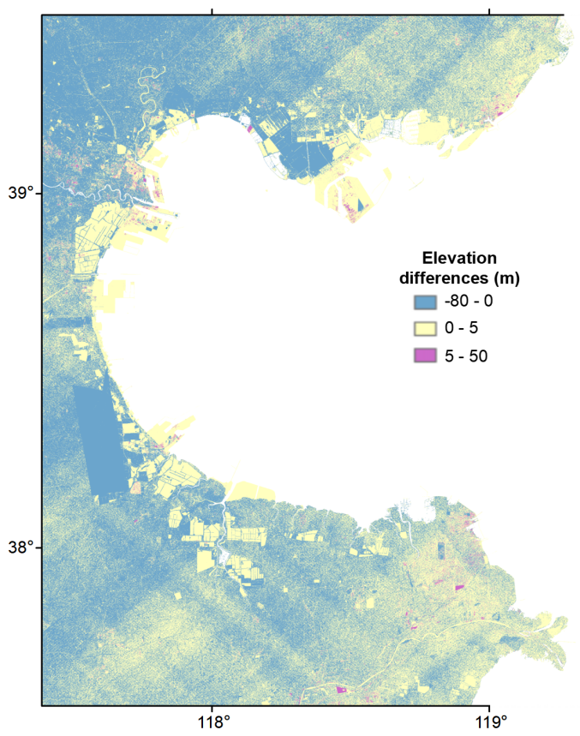
Figure S2. Elevation difference map of Bohai Economic Rim. Using Copernicus Global DEM minus SRTM DEM, illustrating coastal morphology changes (2000 - 2015).

