Lacticaseibacillus rhamnosus OF44 Alleviates Allergic Rhinitis by Rebalancing Host Immunity and Gut Microbial Function

Liehai Hu^{1, 2}, Bin Hou^{1, 2}, Wenjun Tai^{1, 2}, Yunhui Xia^{1, 2, *}, Dongmei Li^{1, 2, *}, Bin Shi^{1 *}

¹ State Key Laboratory of Analytical Chemistry for Life Science & Pulmonary and Critical Care Medicine, Suqian People's Hospital of Nanjing Gulou Hospital Group, Suqian Scientific Research Institute of Nanjing University Medical School, Nanjing University, Suqian, 223800 Jiangsu, China.
² Jiangsu Key Laboratory of Molecular Medicine, Nanjing University, Nanjing, Jiangsu 210093, China
*Corresponding Author at: State Key Laboratory of Analytical Chemistry for Life Science & Pulmonary and Critical Care Medicine, Suqian People's Hospital of Nanjing Gulou Hospital Group, Suqian Scientific Research Institute of Nanjing University Medical School, Nanjing University, Suqian, 223800 Jiangsu, China
E-mail address: yunhuixia@nju.edu.cn (Yunhui Xia)
- mail address: lidm@nju.edu.cn (Dongmei Li)
E-mail address: shibin01230123@126.com (Bin Shi)

Figure S1. (A) Changes in body weight of rats during experiment. (B) Liver organ coefficient. (C) Blood eosinophil counts. (D–F) Scores for nasal secretion, nasal rubs, and sneezing in the rhinitis symptom assessment.

Figure S2. (A) Hematoxylin and eosin-stained sections of rat colon. (B) Serum D-lactic acid concentration. (C) Serum LPS concentration.

Figure S3. (A) Species accumulation boxplot. (B) Alluvial diagram at the phylum level. (C–D) LEfSe evolutionary cladograms of differential species.

Figure S4. (A–C) LEfSe box plots showing the top 20 genus with the highest relative abundance and statistical significance.

Figure S5. (A–C) ReporterScore results based on KEGG pathway.

Figure S6. (A) SCFA-related pathway key enzymes expression changes, AR+OF44-M group v.s. control group. (B) Species–KO association network visualized using the Fruchterman–Reingold force-directed layout algorithm.

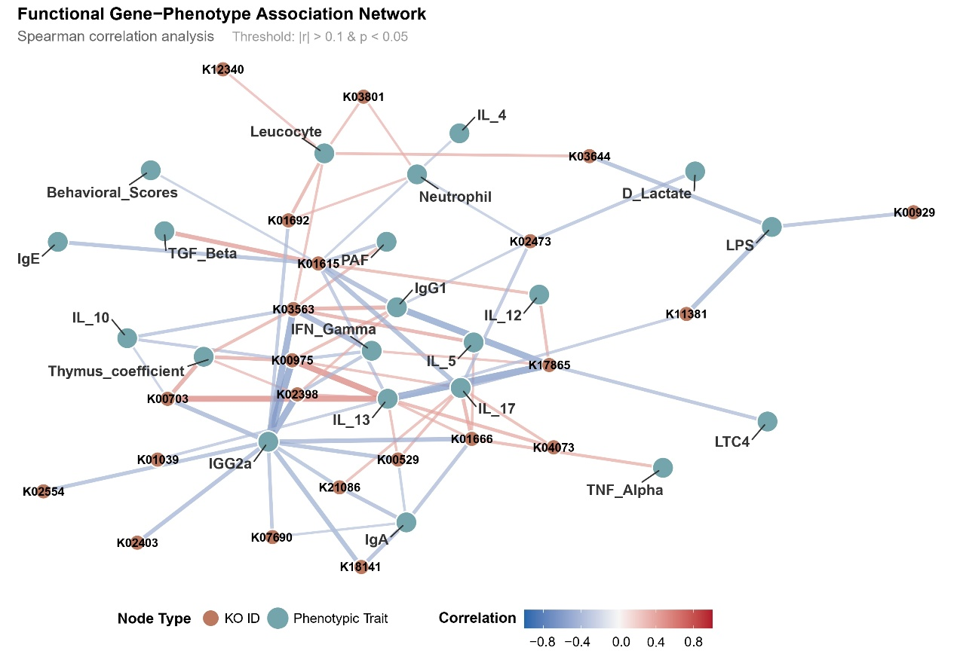
Figure S6. Functional gene-phenotype association network.

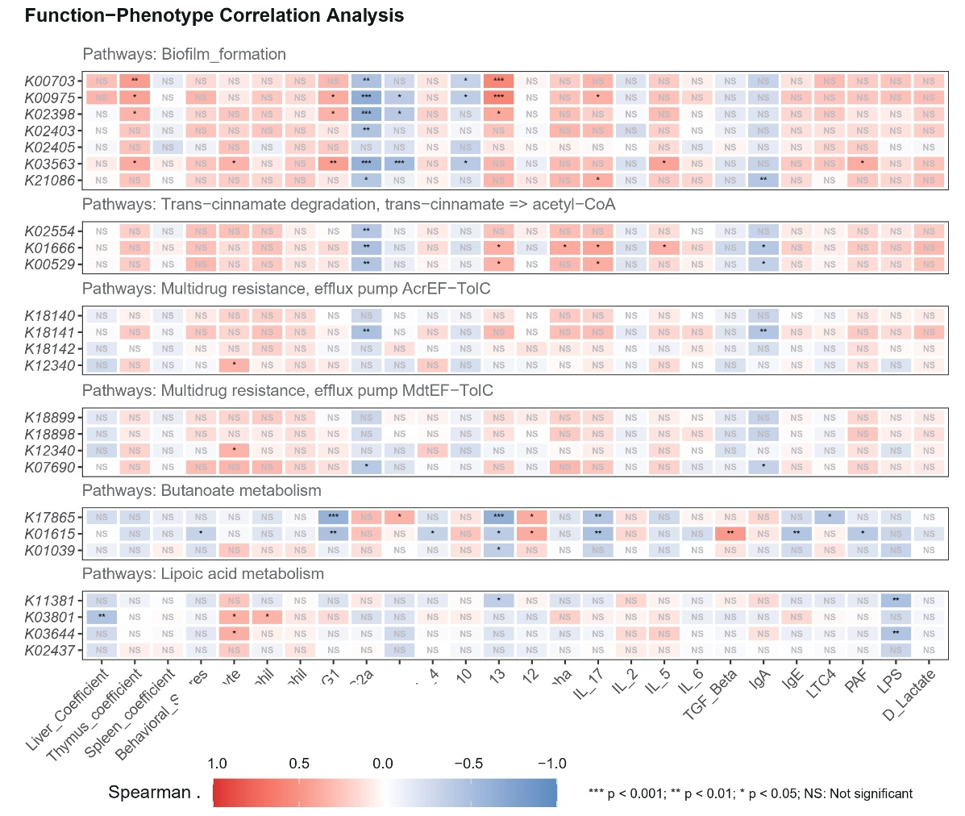
Figure S6. (A) Function-phenotype correlation analysis.

