Evolutionary graph pangenome of the order Poales from chloroplast genomes highlight phylogenetic inconsistencies

Rakan Haib and Sariel Hübner

Supplementary information
See Supplementary_table.xlsx for tables

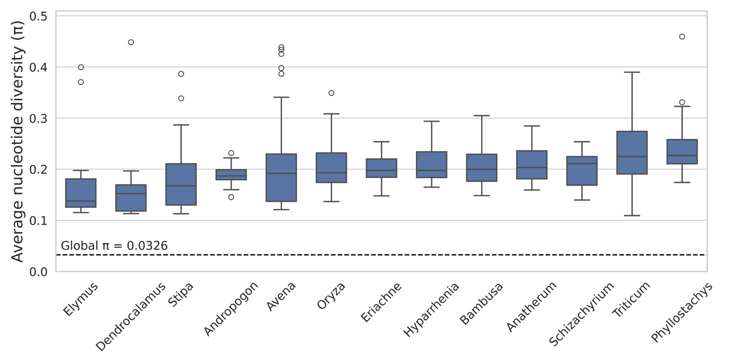
Figure S1. Average nucleotide diversity (π) across Poales families. The dashed line shows the global π obtained from the 709 Poales evograph (0.0326), which is markedly lower than within-family diversity levels.

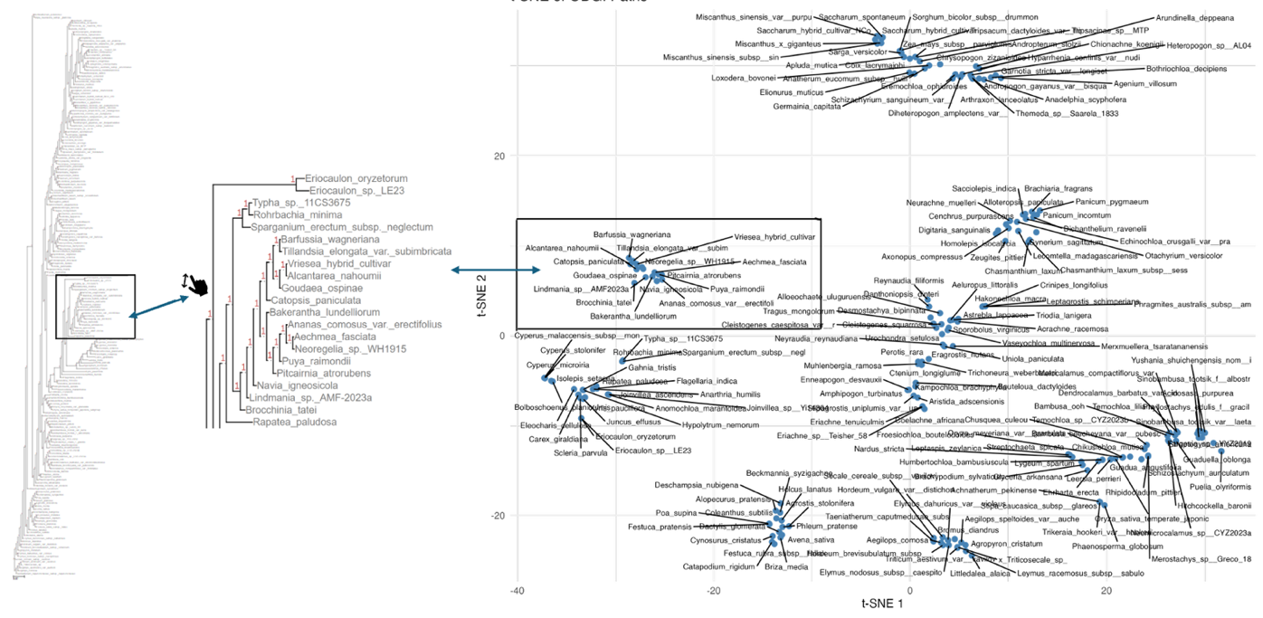
Figure S2. Integrated SNP-based phylogeny and t-SNE projection of ODGI path embeddings for 192 chloroplast haplotypes. The left panel shows the SNP-derived tree, with a representative clade enlarged in the central inset. The same haplotypes form a matching cluster in the t-SNE map on the right, where each point reflects path similarity based on node presence in the pangenome graph.

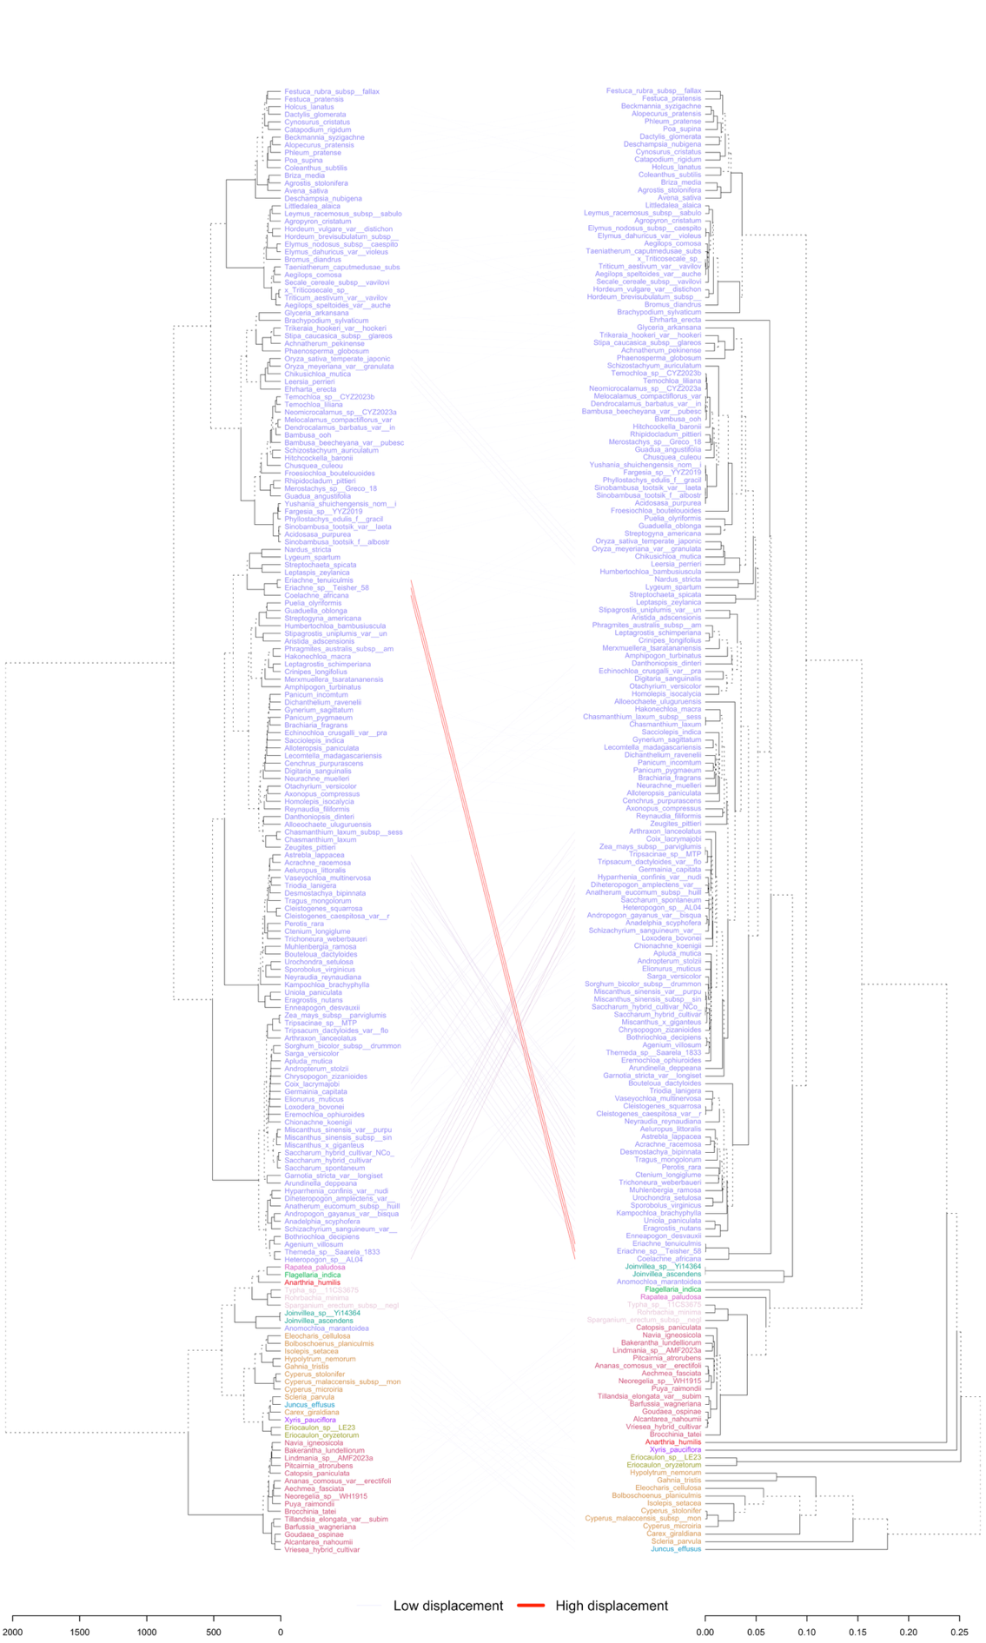
Figure S3. Genus-colored tanglegram comparing graph-based and SNP-based phylogenies. This tanglegram compares the full graph-based phylogeny (left) with the SNP-based RAxML tree (right). Tip labels are uniformly colored by family to provide consistent taxonomic reference across both trees, while branches are shown in black for clarity. Connector lines are drawn in light grey to visualize topological differences between the two trees.
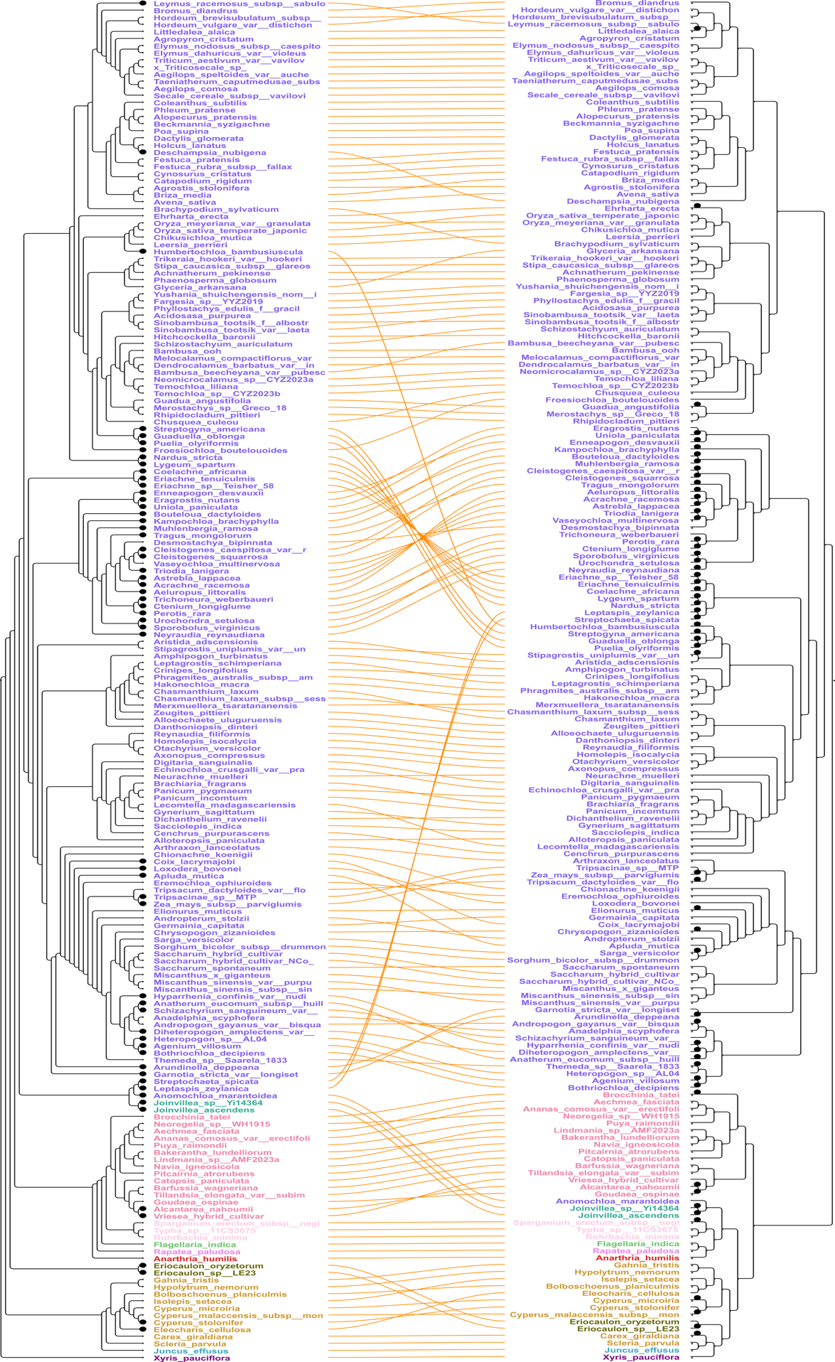

Figure S4. SplitsTree visualization comparing phylogenetic topologies. The phylogenetic tree was inferred from 111 universal chloroplast genes (right) and from the evograph (left). Tip labels are colored by family.
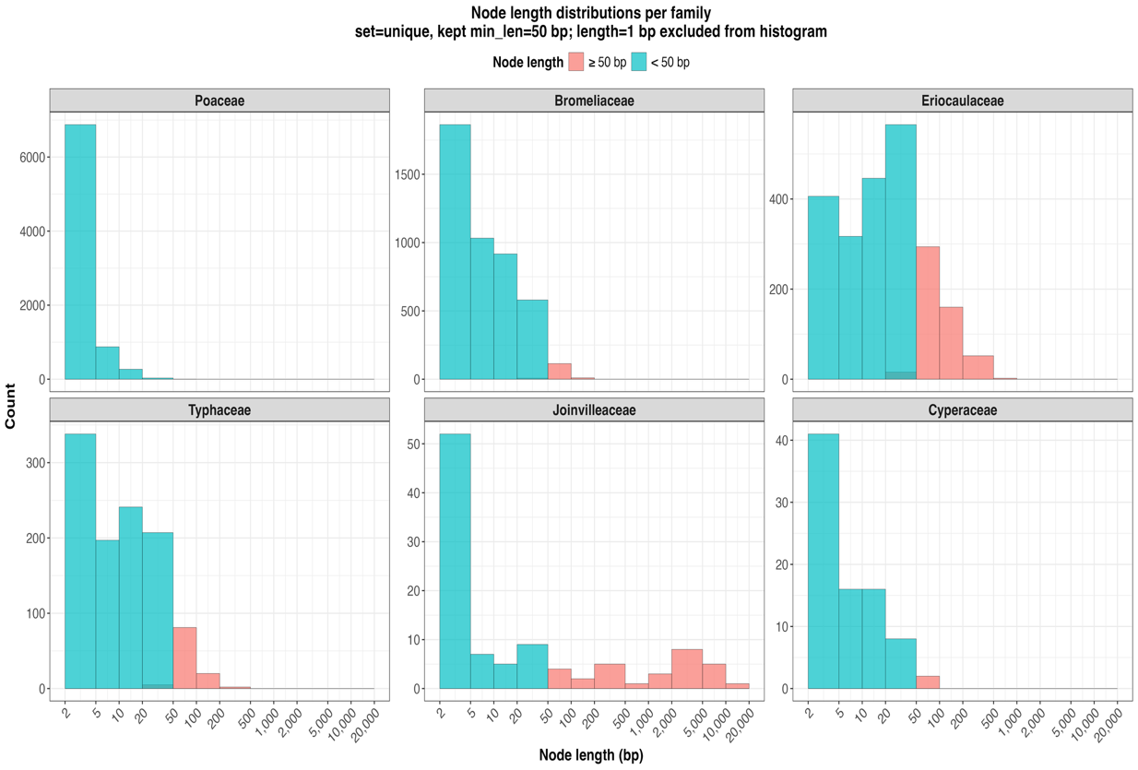
Figure S5. Distribution of evograph node lengths summarized by family using unique nodes only. Nodes of length 1bp were excluded. Short nodes (<50 bp) dominate across all families, whereas longer nodes (≥50 bp) occur less frequently but show family-specific enrichment, particularly in Joinvilleaceae and Eriocaulaceae.

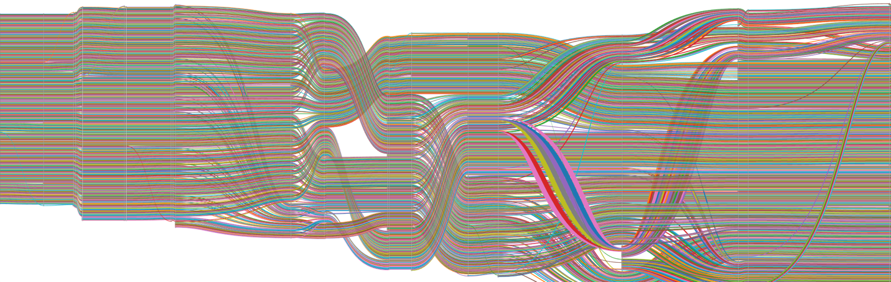
Figure S6. Pangenome graph representation of the Poales order in SequenceTubeMap view. Each path corresponds to an individual species genome and is shown in a distinct color, while nodes represented as bars.
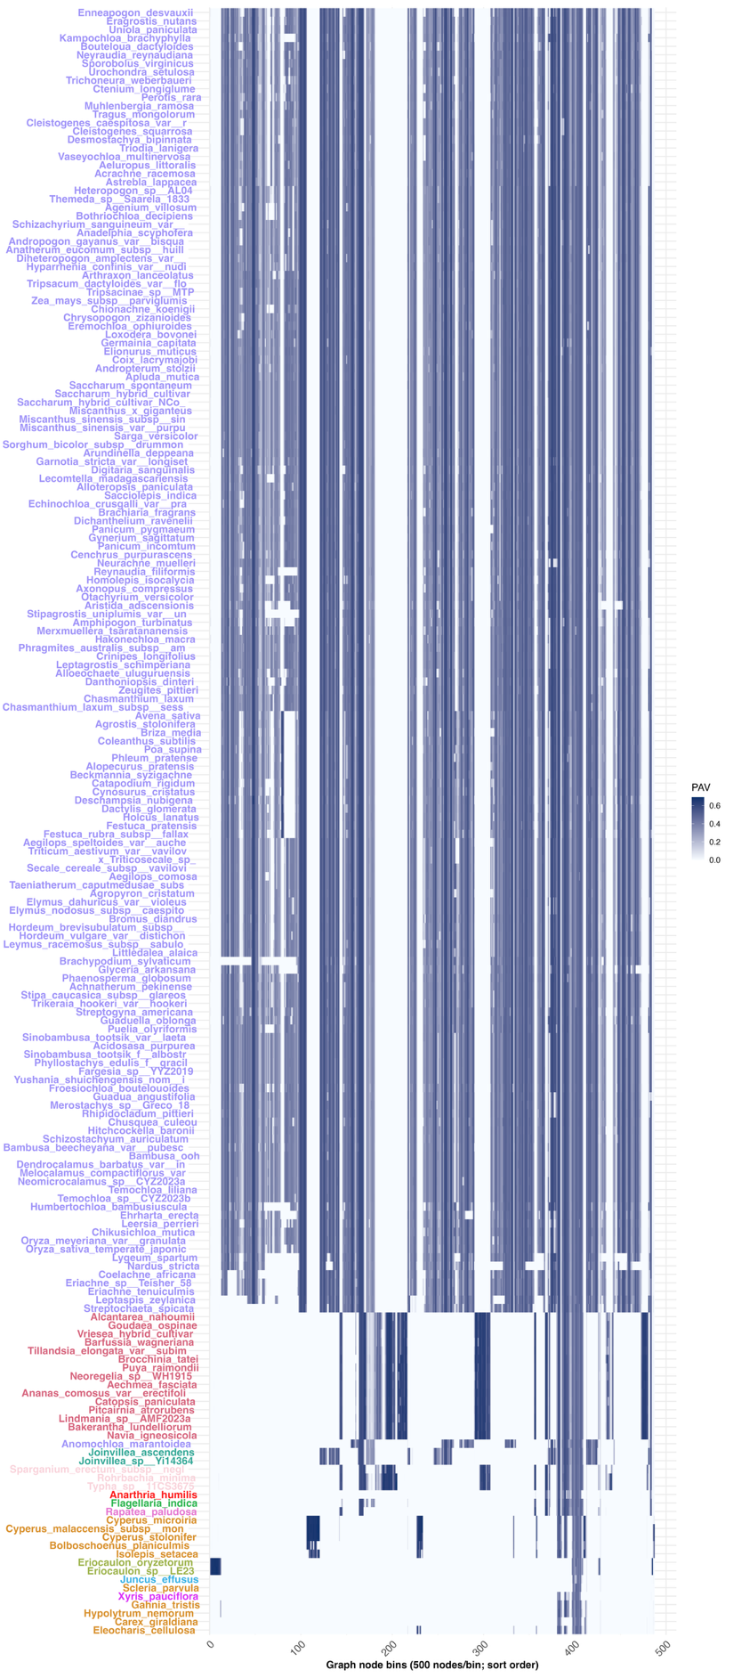
Figure S7. 192 Poales representative in a PAV heatmap. Presence–absence variation (PAV) heatmap summarizing graph-derived variation across a representative subset of taxa from the full 192-path evograph. One path per tribe or PAV-based cluster was selected to reduce redundancy while preserving major evolutionary patterns. Rows represent the selected species, and columns correspond to contiguous graph bins of 500 topologically sorted nodes. For each species and bin, the bin-level PAV value reflects the proportion of nodes traversed within the bin. Blue indicates high node retention (presence), while white indicates absence.
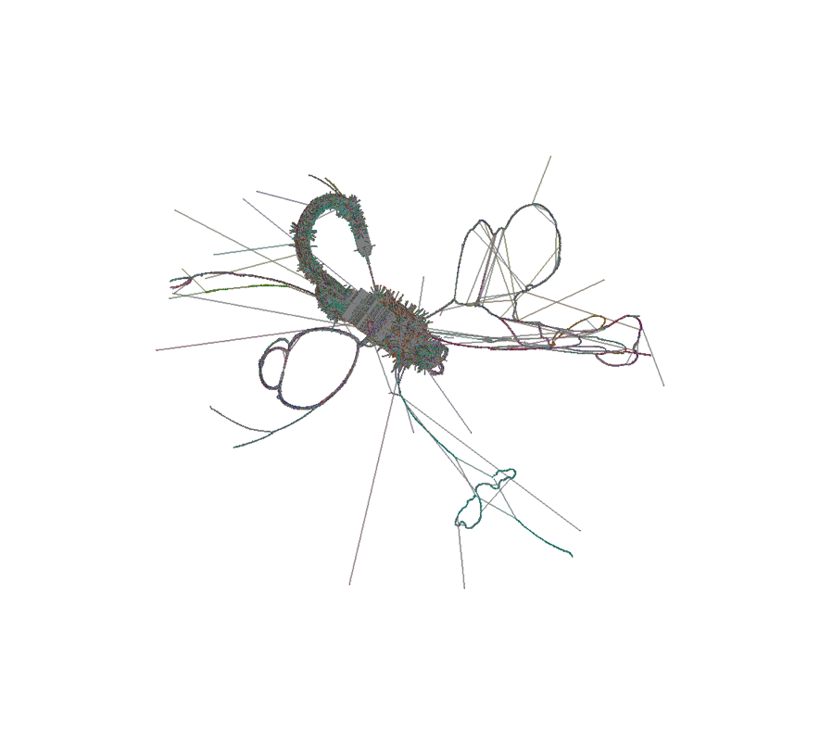
Figure S8. Smoothed pangenome graph of 709 unique chloroplast genomes from Poales. The dense core corresponds to highly conserved chloroplast regions, whereas radiating branches and loops reflect lineage-specific structural variation. Poaceae, which contributes the majority of genomes, dominates the graph topology by reinforcing the central backbone and adding extensive variation compared to other Poales families.
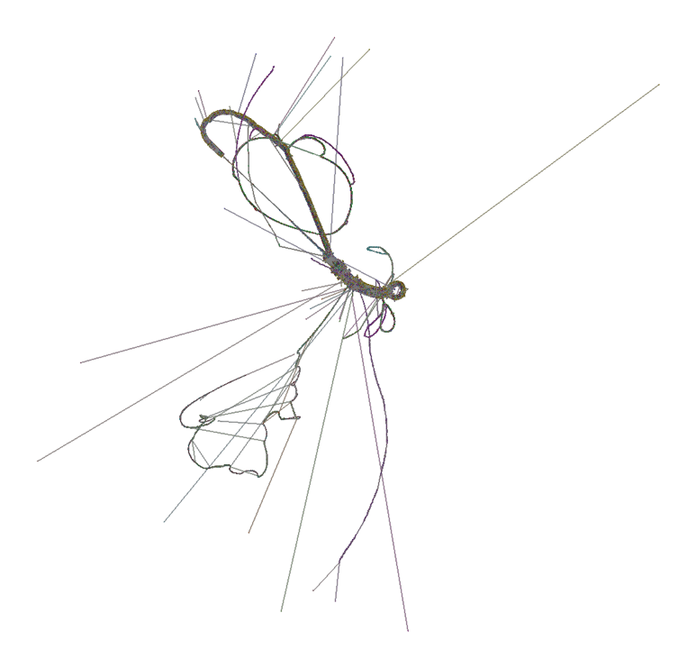
Figure S9. Smoothed pangenome graph of 192 representative Poales chloroplast genomes (one per tribe). Compared to the full 709-genome graph above, the reduced representation decreases Poaceae dominance, simplifying the topology and highlighting subfamily- and tribe-level structure.

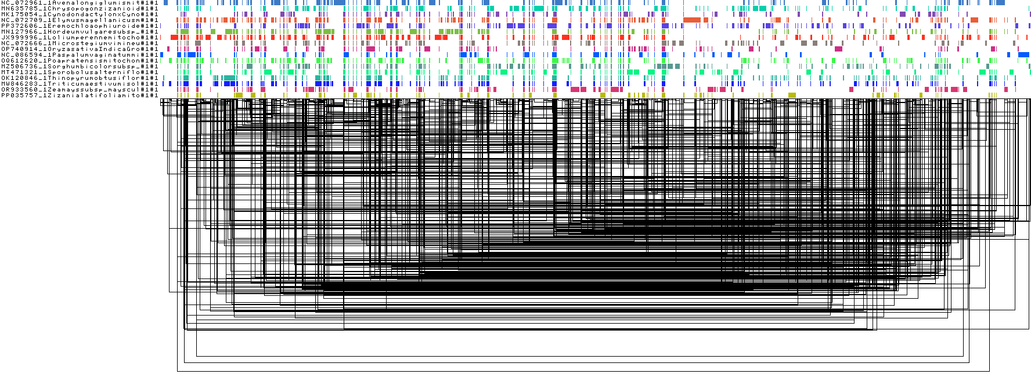

Figure S10. Visualization of the optimized mitochondrial evograph. The figure displays the ordered sequence segments (colored blocks, top panel) and their pairwise syntenic connections (black lines, bottom panel) derived from the smoothed and ordered pangenome graph file. Each horizontal row represents one of the 17 mitochondrial assemblies, where colored blocks denote distinct sequence segments and shared colors indicate conserved regions. The dense black interconnections below illustrate syntenic links among homologous segments across genomes.

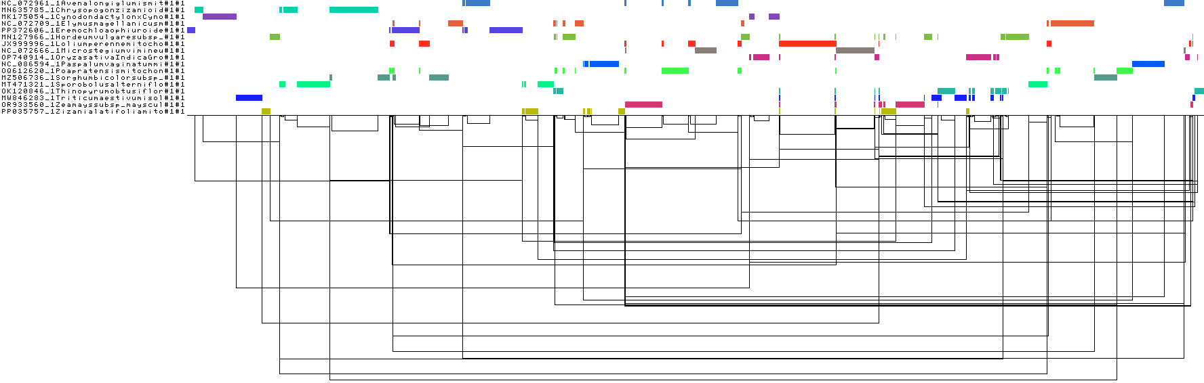
Figure S11. Visualization of the default PGGB parameters applied to 17 mitochondrial assemblies. This visualization shows the smoothed and ordered pangenome graph generated with default settings. Each horizontal row represents one mitochondrial assembly, with colored blocks denoting aligned sequence segments. The reduced number and uneven distribution of shared colors indicate partial alignment and fragmented core regions compared to the optimized configuration.

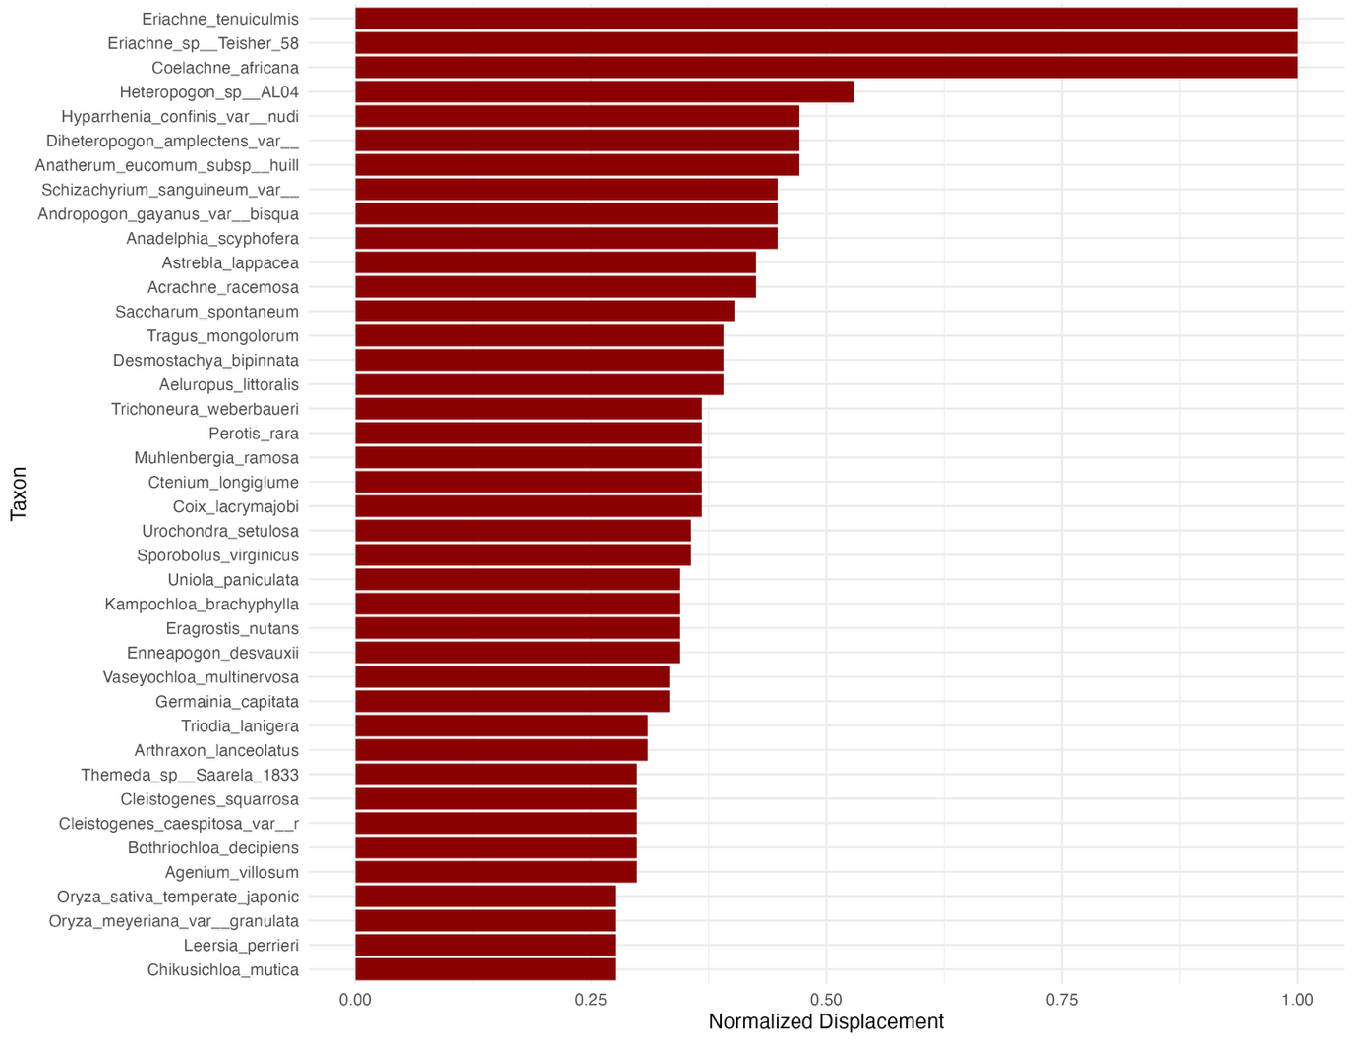
Figure S12. Top 40 candidate taxa ranked by normalized topological displacement between the graph-based and SNP-based trees.

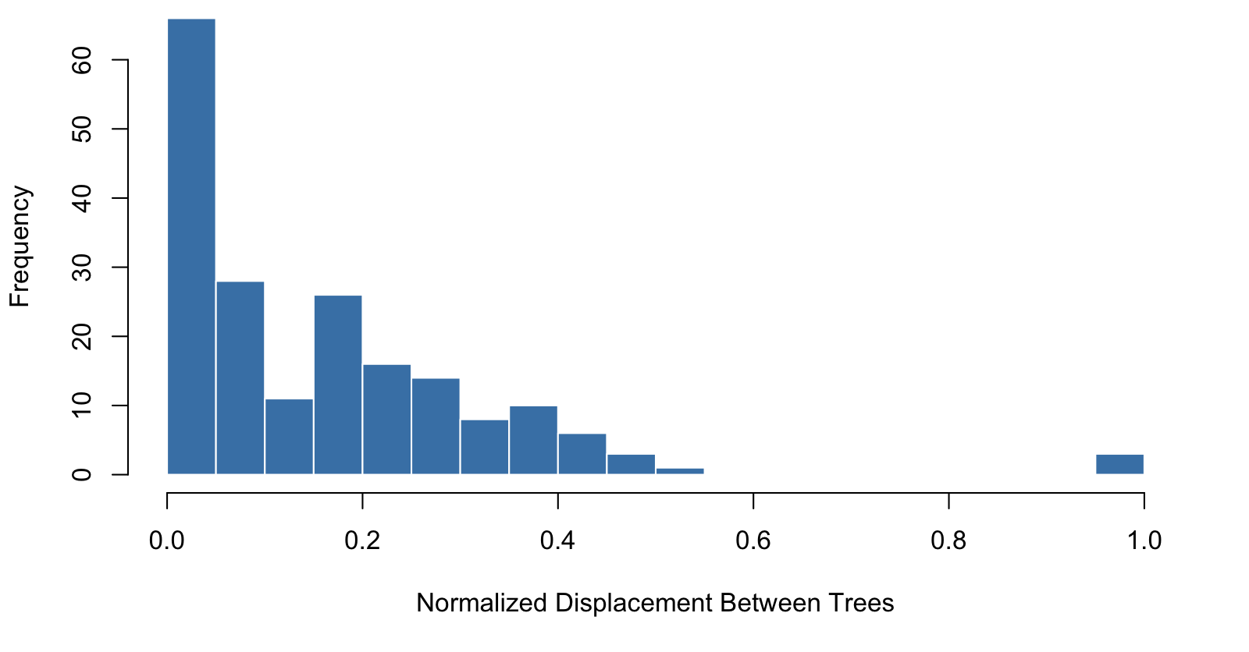
Figure S13. Distribution of normalized displacement values across all taxa. A right-skewed frequency pattern where only a small subset of species exhibits strong topological discordance consistent with reticulate evolution.

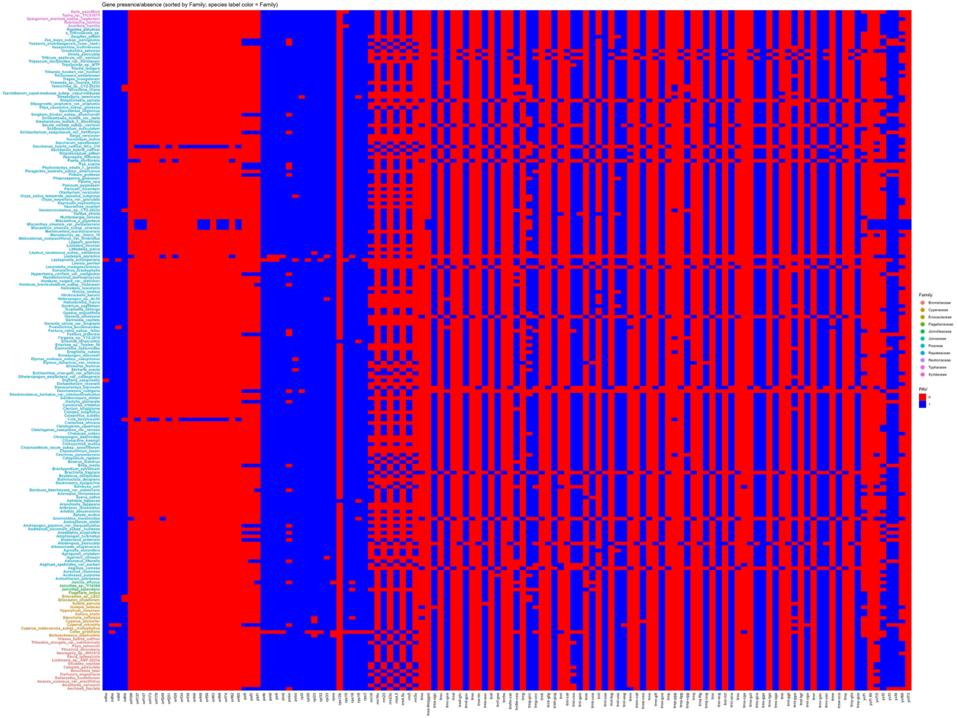

Figure S14. Heatmap showing presence–absence variation (PAV) of chloroplast genes across Poales taxa. Rows represent taxa and columns represent genes. Presence is indicated in blue and absence in red. Taxa are ordered by family and colored accordingly.
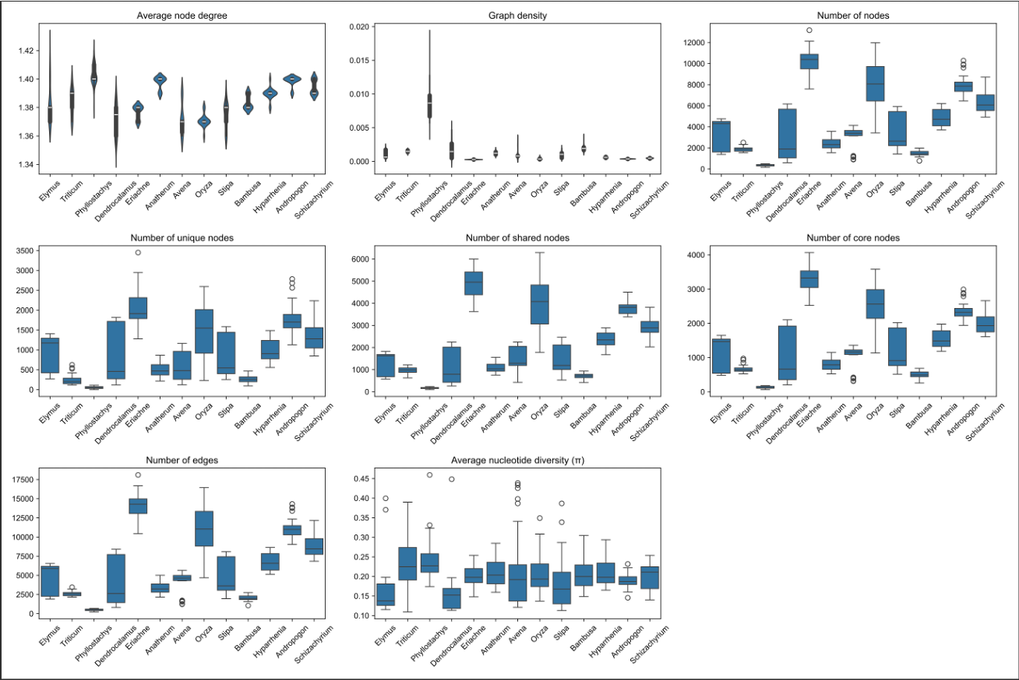

Figure S15. Distribution of graph density and cloud-node ratio (cloud/total nodes) across 13 representative genera. Summary of genus-level divergence and connectivity inferred from evographs. For each genus, ten species were randomly sampled and evographs were constructed over 30 independent iterations, ensuring balanced representation and reproducibility of the statistics.

