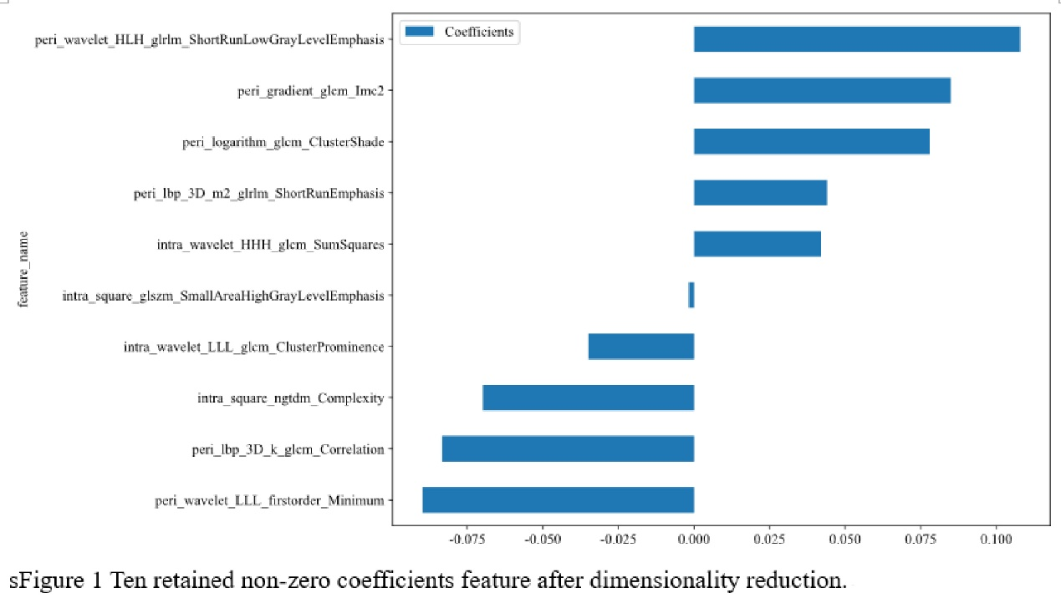
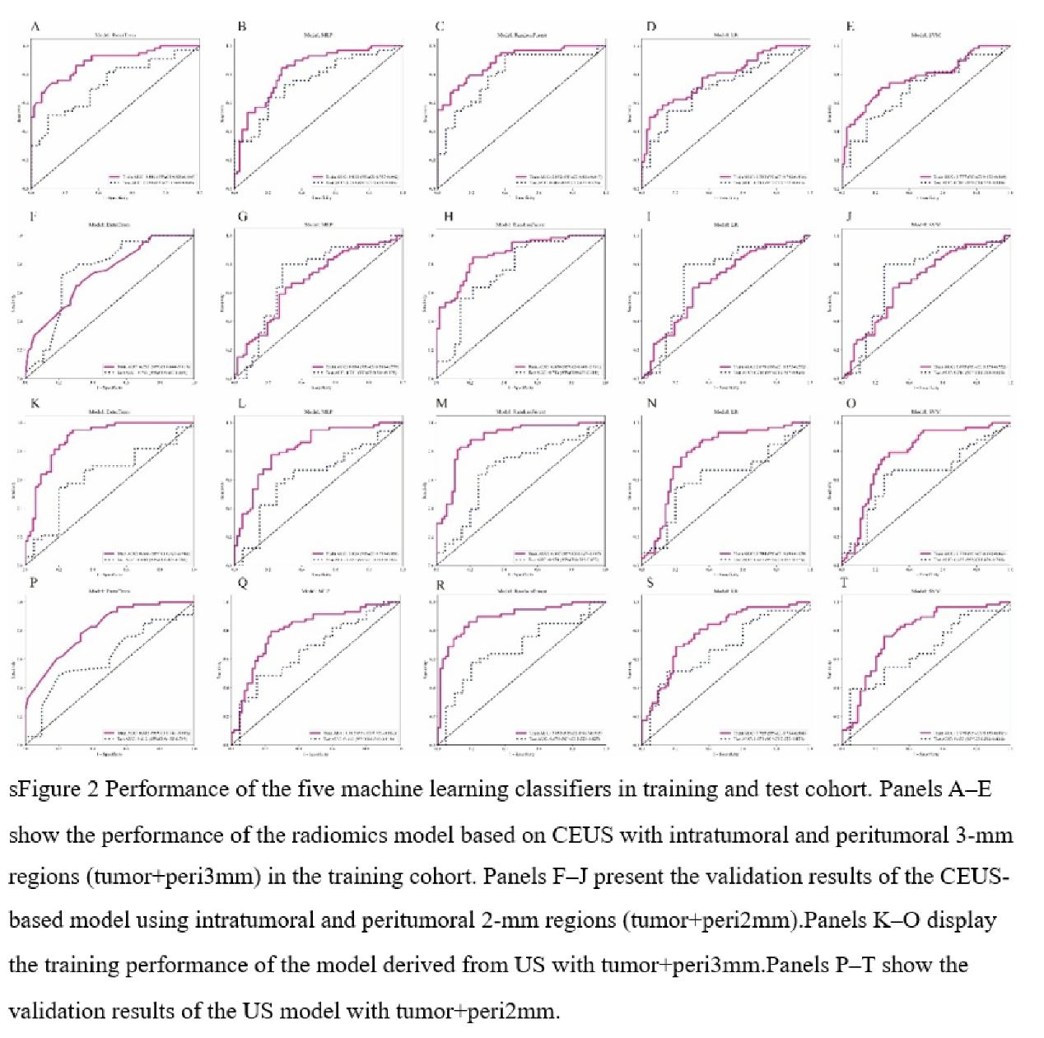

Group | model_name | Accuracy | AUC | 95% CI | Sensitivity | Specificity | PPV | NPV | Precision | Recall | F1 | Threshold
CEUS 3mm | LR | 0.738 | 0.783 | 0.7018 - 0.8640 | 0.586 | 0.875 | 0.81 | 0.7 | 0.81 | 0.586 | 0.68 | 0.598
CEUS 3mm | SVM | 0.738 | 0.777 | 0.6930 - 0.8603 | 0.707 | 0.766 | 0.732 | 0.742 | 0.732 | 0.707 | 0.719 | 0.48
CEUS 3mm | RandomForest | 0.803 | 0.892 | 0.8363 - 0.9471 | 0.793 | 0.812 | 0.793 | 0.812 | 0.793 | 0.793 | 0.793 | 0.489
CEUS 3mm | ExtraTrees | 0.811 | 0.886 | 0.8277 - 0.9450 | 0.741 | 0.875 | 0.843 | 0.789 | 0.843 | 0.741 | 0.789 | 0.519
CEUS 3mm | MLP | 0.779 | 0.83 | 0.7573 - 0.9022 | 0.845 | 0.719 | 0.731 | 0.836 | 0.731 | 0.845 | 0.784 | 0.446
CEUS 2mm | LR | 0.664 | 0.675 | 0.5772 - 0.7718 | 0.636 | 0.696 | 0.712 | 0.619 | 0.712 | 0.636 | 0.672 | 0.572
CEUS 2mm | SVM | 0.664 | 0.675 | 0.5778 - 0.7723 | 0.636 | 0.696 | 0.712 | 0.619 | 0.712 | 0.636 | 0.672 | 0.562
CEUS 2mm | RandomForest | 0.820 | 0.87 | 0.8083 - 0.9309 | 0.848 | 0.786 | 0.824 | 0.815 | 0.824 | 0.848 | 0.836 | 0.521
CEUS 2mm | ExtraTrees | 0.672 | 0.732 | 0.6439 - 0.8194 | 0.652 | 0.696 | 0.717 | 0.629 | 0.717 | 0.652 | 0.683 | 0.591
CEUS 2mm | MLP | 0.664 | 0.684 | 0.5882 - 0.7793 | 0.636 | 0.696 | 0.712 | 0.619 | 0.712 | 0.636 | 0.672 | 0.538
US 3mm | LR | 0.762 | 0.784 | 0.6992 - 0.8697 | 0.793 | 0.734 | 0.73 | 0.797 | 0.73 | 0.793 | 0.76 | 0.486
US 3mm | SVM | 0.754 | 0.778 | 0.6922 - 0.8633 | 0.793 | 0.719 | 0.719 | 0.793 | 0.719 | 0.793 | 0.754 | 0.489
US 3mm | RandomForest | 0.844 | 0.887 | 0.8272 - 0.9471 | 0.828 | 0.859 | 0.842 | 0.846 | 0.842 | 0.828 | 0.835 | 0.526
US 3mm | ExtraTrees | 0.828 | 0.888 | 0.8295 - 0.9464 | 0.948 | 0.719 | 0.753 | 0.939 | 0.753 | 0.948 | 0.84 | 0.46
US 3mm | MLP | 0.779 | 0.824 | 0.7503 - 0.8978 | 0.776 | 0.781 | 0.763 | 0.794 | 0.763 | 0.776 | 0.769 | 0.509
US 2mm | LR | 0.746 | 0.785 | 0.7035 - 0.8660 | 0.69 | 0.797 | 0.755 | 0.739 | 0.755 | 0.69 | 0.721 | 0.534
US 2mm | SVM | 0.754 | 0.779 | 0.6949 - 0.8627 | 0.759 | 0.75 | 0.733 | 0.774 | 0.733 | 0.759 | 0.746 | 0.538
US 2mm | RandomForest | 0.836 | 0.895 | 0.8369 - 0.9530 | 0.862 | 0.812 | 0.806 | 0.867 | 0.806 | 0.862 | 0.833 | 0.495
US 2mm | ExtraTrees | 0.721 | 0.813 | 0.7409 - 0.8857 | 0.776 | 0.672 | 0.682 | 0.768 | 0.682 | 0.776 | 0.726 | 0.466
US 2mm | MLP | 0.779 | 0.802 | 0.7212 - 0.8823 | 0.793 | 0.766 | 0.754 | 0.803 | 0.754 | 0.793 | 0.773 | 0.476
sTable 1 Performance of train cohort.

Group | model_name | Accuracy | AUC | 95% CI | Sensitivity | Specificity | PPV | NPV | Precision | Recall | F1 | Threshold
CEUS 3mm | LR | 0.698 | 0.714 | 0.5724 - 0.8549 | 0.697 | 0.7 | 0.793 | 0.583 | 0.793 | 0.697 | 0.742 | 0.454
CEUS 3mm | SVM | 0.698 | 0.702 | 0.5575 - 0.8455 | 0.758 | 0.6 | 0.758 | 0.6 | 0.758 | 0.758 | 0.758 | 0.45
CEUS 3mm | RandomForest | 0.811 | 0.802 | 0.6770 - 0.9260 | 0.939 | 0.6 | 0.795 | 0.857 | 0.795 | 0.939 | 0.861 | 0.378
CEUS 3mm | ExtraTrees | 0.66 | 0.733 | 0.5980 - 0.8686 | 0.515 | 0.9 | 0.895 | 0.529 | 0.895 | 0.515 | 0.654 | 0.542
CEUS 3mm | MLP | 0.698 | 0.753 | 0.6203 - 0.8858 | 0.636 | 0.8 | 0.84 | 0.571 | 0.84 | 0.636 | 0.724 | 0.529
CEUS 2mm | LR | 0.774 | 0.716 | 0.5672 - 0.8642 | 0.8 | 0.75 | 0.741 | 0.808 | 0.741 | 0.8 | 0.769 | 0.582
CEUS 2mm | SVM | 0.774 | 0.716 | 0.5680 - 0.8648 | 0.8 | 0.75 | 0.741 | 0.808 | 0.741 | 0.8 | 0.769 | 0.57
CEUS 2mm | RandomForest | 0.717 | 0.756 | 0.6234 - 0.8881 | 0.92 | 0.536 | 0.639 | 0.882 | 0.639 | 0.92 | 0.754 | 0.426
CEUS 2mm | ExtraTrees | 0.755 | 0.753 | 0.6169 - 0.8888 | 0.72 | 0.786 | 0.75 | 0.759 | 0.75 | 0.72 | 0.735 | 0.595
CEUS 2mm | MLP | 0.755 | 0.711 | 0.5637 - 0.8591 | 0.8 | 0.714 | 0.714 | 0.8 | 0.714 | 0.8 | 0.755 | 0.538
US 3mm | LR | 0.642 | 0.617 | 0.4575 - 0.7759 | 0.545 | 0.8 | 0.818 | 0.516 | 0.818 | 0.545 | 0.655 | 0.589
US 3mm | SVM | 0.679 | 0.633 | 0.4763 - 0.7903 | 0.636 | 0.75 | 0.808 | 0.556 | 0.808 | 0.636 | 0.712 | 0.494
US 3mm | RandomForest | 0.698 | 0.67 | 0.5129 - 0.8265 | 0.697 | 0.7 | 0.793 | 0.583 | 0.793 | 0.697 | 0.742 | 0.504
US 3mm | ExtraTrees | 0.642 | 0.63 | 0.4725 - 0.7881 | 0.545 | 0.8 | 0.818 | 0.516 | 0.818 | 0.545 | 0.655 | 0.537
US 3mm | MLP | 0.642 | 0.627 | 0.4675 - 0.7870 | 0.576 | 0.75 | 0.792 | 0.517 | 0.792 | 0.576 | 0.667 | 0.531
US 2mm | LR | 0.642 | 0.671 | 0.5199 - 0.8225 | 0.515 | 0.85 | 0.85 | 0.515 | 0.85 | 0.515 | 0.642 | 0.596
US 2mm | SVM | 0.604 | 0.653 | 0.5002 - 0.8059 | 0.394 | 0.95 | 0.929 | 0.487 | 0.929 | 0.394 | 0.553 | 0.667
US 2mm | RandomForest | 0.66 | 0.674 | 0.5234 - 0.8251 | 0.576 | 0.8 | 0.826 | 0.533 | 0.826 | 0.576 | 0.679 | 0.548
US 2mm | ExtraTrees | 0.604 | 0.612 | 0.4551 - 0.7692 | 0.485 | 0.8 | 0.8 | 0.485 | 0.8 | 0.485 | 0.604 | 0.521
US 2mm | MLP | 0.623 | 0.667 | 0.5151 - 0.8183 | 0.485 | 0.85 | 0.842 | 0.5 | 0.842 | 0.485 | 0.615 | 0.531
sTable 2 Performance of test cohort.

