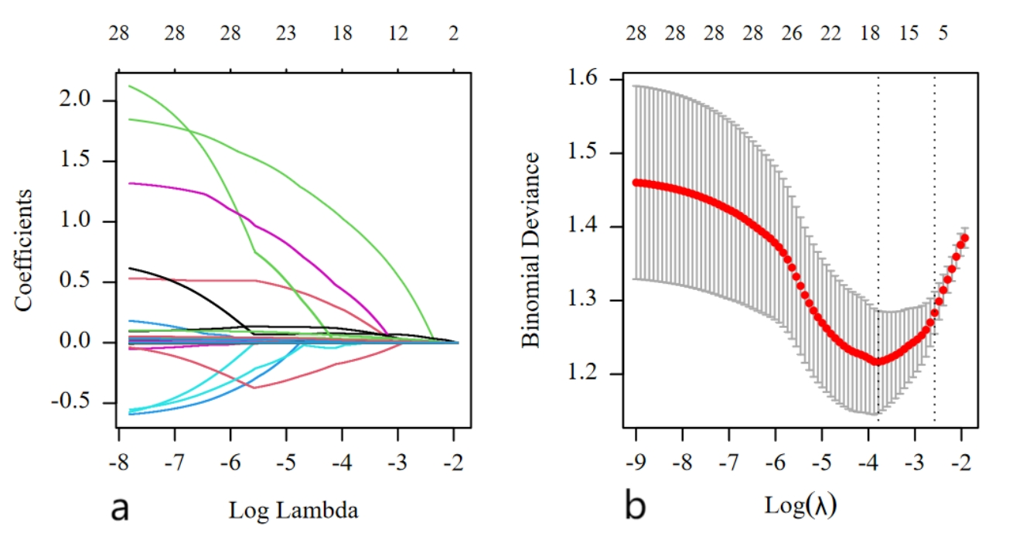
Figure S1. LASSO regression analysis for predicting mechanical ventilation tetanus patients. A：LASSO coefficient paths for predicting mechanical ventilation in tetanus patients. B：Cross-Validation error curve for LASSO regression in tetanus patients.

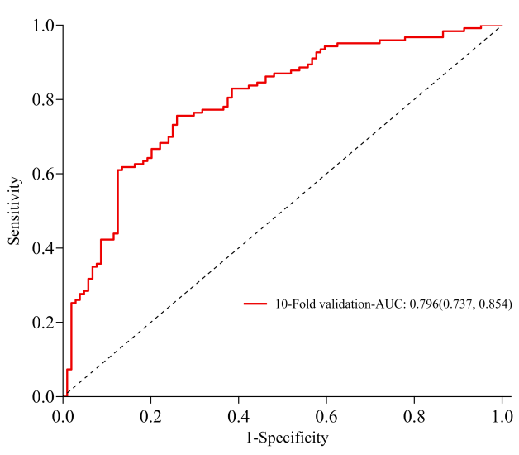
Figure S2. Receiver operating characteristic (ROC) curve for predicting mechanical ventilation in tetanus patients using nomogram model with 10-fold cross-validation.

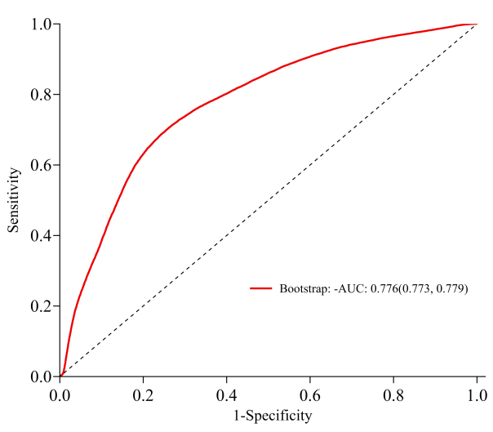
Figure S3. Receiver operating characteristic (ROC) curve for predicting mechanical ventilation in tetanus patients using nomogram model with bootstrap validation.

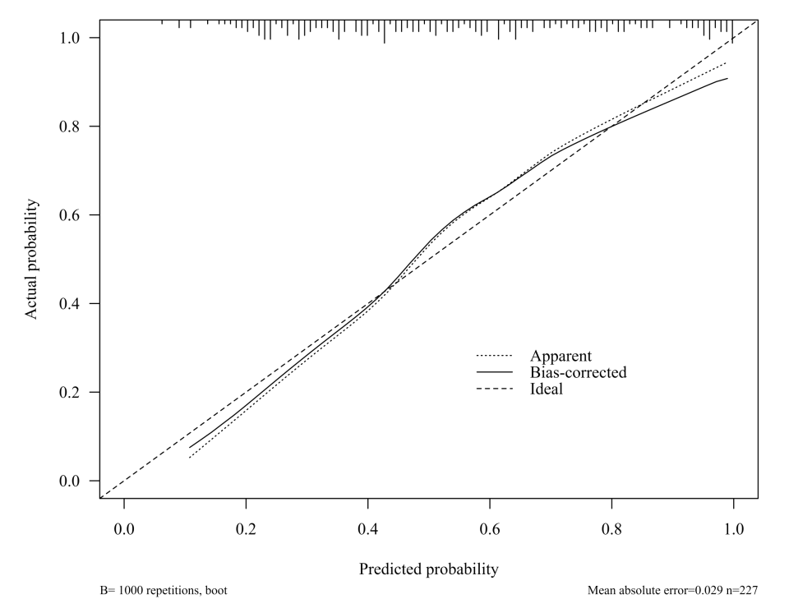
Figure S4. Calibration curve for predicting mechanical ventilation in tetanus patients using nomogram model.

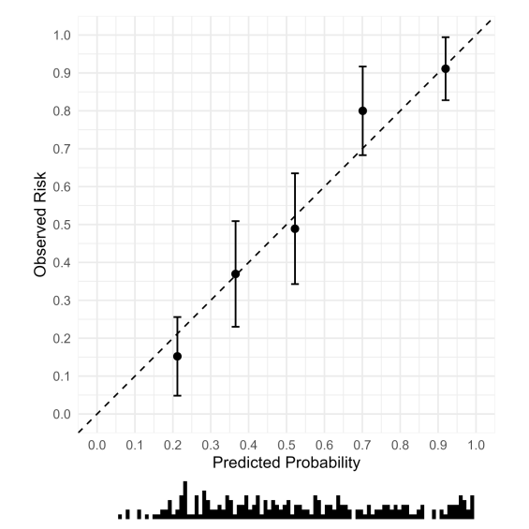
Figure S5. Calibration Plot for Assessing the Accuracy of Predicted Probabilities in Tetanus Patients.

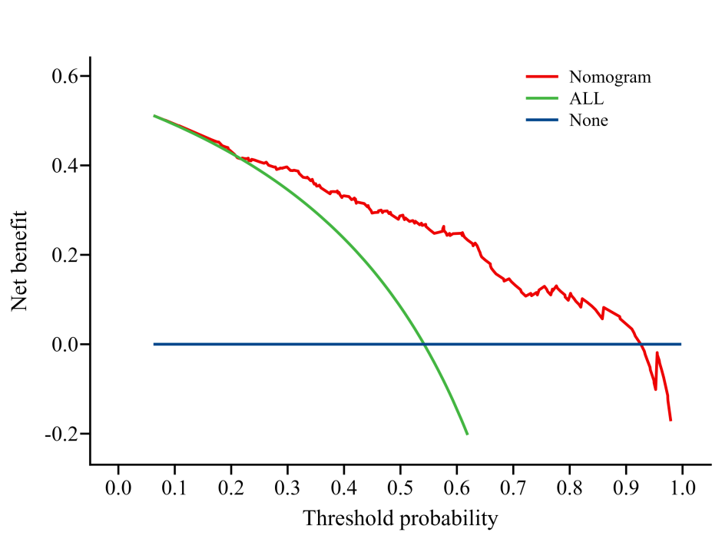
Figure S6. Decision curve analysis for predicting mechanical ventilation in tetanus patients using the nomogram model.

