Geometrically Polarized Transport in Wedge-Shaped Mesoporous Carbon: A New Paradigm for Sodium-Ion Storage
Gang Huang ª, Wenjie Ma ^{b}, Kadi Hu ^{c}, Longbo Luo ª, Jingxue Yu ^{d}, Qin Shen ^{e}, Ziqi Tian ^{c}, Yuan Chen ^{f}, Yanqing Wang ª*

- College of Polymer Science and Engineering, State Key Laboratory of Advanced Polymer Materials, Sichuan University, Chengdu 610065, P. R. China
- School of Materials Science and Engineering, South China University of Technology, Guangzhou 510640, P.R. China
- Zhejiang Key Laboratory of Advanced Fuel Cells and Electrolyzers Technology, Ningbo Institute of Materials Technology and Engineering, Chinese Academy of Sciences, Ningbo, 315201, People’s Republic of China
- School of Materials Engineering Jinling Institute of Technology, Nanjing, 211169
- Nanjing Shengjie New Energy Materials Co., Ltd. Nanjing, 211800
- School of Chemical and Biomolecular Engineering, The University of Sydney, Darlington, New South Wales 2006, Australia
* Corresponding authors
E-mail: yanqingwang@scu.edu.cn (Y. Wang)

Experimental Section
Synthesis of WSM-7: Typically, P123/F127 (molar ratio = 2.17), 4.86 mmol of phloroglucinol (PG) and 14.3 mmol of 1,3,5-trimethylbenzene (TMB) are mixed in ethanol/water solution (V_{EtOH} /V_{EtOH+H2O} = 20 %) to form P123+F127/PG/TMB micelle system. Then, 43 mM of Ethylenediamine (EDA) is added dropwise under stirring. After reaction for 22 h, the formed polyphenol assemblies are collected by centrifugation and washed with water and ethanol to remove the residual organic solvent. The dried product is pyrolyzed under nitrogen atmosphere by preheating at 300 °C for 1 h and further heating at 800 °C for 2 h under a N₂ atmosphere with a heating rate of 2 °C min⁻¹. The final products are denoted as WSM-7.

Synthesis of WSM-25: Typically, P123/F127 (molar ratio = 2.17), 4.86 mmol of PG and 14.3 mmol of TMB are mixed in ethanol/water solution (V_{EtOH} /V_{EtOH+H2O} = 30 %) to form P123+F127/PG/TMB micelle system. Then, 43 mM of EDA is added dropwise under stirring. After reaction for 22 h, the formed polyphenol assemblies are collected by centrifugation and washed with water and ethanol to remove the residual organic solvent. The dried product is pyrolyzed under nitrogen atmosphere by preheating at 300 °C for 1 h and further heating at 800 °C for 2 h under a N₂ atmosphere with a heating rate of 2 °C min⁻¹. The final products are denoted as WSM-25.

Synthesis of WSM-45: Typically, P123/F127 (molar ratio = 6.25), 4.86 mmol of PG and 14.3 mmol of TMB are mixed in ethanol/water solution (V_{EtOH} /V_{EtOH+H2O} = 30 %) to form P123+F127/PG/TMB micelle system. Then, 43 mM of EDA is added dropwise under stirring. After reaction for 22 h, the formed polyphenol assemblies are collected by centrifugation and washed with water and ethanol to remove the residual organic solvent. The dried product is pyrolyzed under nitrogen atmosphere by preheating at 300 °C for 1 h and further heating at 800 °C for 2 h under a N₂ atmosphere with a heating rate of 2 °C min⁻¹. The final products are denoted as WSM-45.

Synthesis of NM: Typically, P123/F127 (molar ratio = 0.72), 4.86 mmol of PG and 14.3 mmol of TMB are mixed in ethanol/water solution (V_{EtOH} /V_{EtOH+H2O} = 40 %) to form P123+F127/PG/TMB micelle system. Then, 43 mM of EDA is added dropwise under stirring. After reaction for 22 h, the formed polyphenol assemblies are collected by centrifugation and washed with water and ethanol to remove the residual organic solvent. The dried product is pyrolyzed under nitrogen atmosphere by preheating at 300 °C for 1 h and further heating at 800 °C for 2 h under a N₂ atmosphere with a heating rate of 2 °C min⁻¹. The final products are denoted as NM.

Material Characterization: Morphologies of different types of mesoporous carbon spheres are studied by scanning electron microscopy (SEM, FEI Inspect-F, Finland) and high-resolution transmission electron microscopy (TEM, TA Talos F200S). Structures of different types of mesoporous carbon spheres are characterized through X-ray diffraction (XRD) on an Ultima IV diffractometer equipped with 40 kV Cu Kα X radiation. The surface chemistry of samples is examined by X-ray photoelectron spectroscopy (XPS, AXIS Ultra DLD, Krato). The structure is further investigated by Raman spectroscopy using an HR Evolution spectrometer handpiece and a 532 nm laser. Pore structure information is collected by N₂ adsorption/desorption at 77 K using a Micromeritics ASAP 2460 gas adsorption device. Closed pores are measured by using the Small Angle X-ray scattering technique (SAXS, Xeuss 2.0).

Electrochemical Measurements: The electrochemical properties of different types of mesoporous carbon spheres are investigated in a two-electrode coin half cells of type 2032. The working electrode is prepared by mixing active material, super-P, and PVDF (mass ratio = 8:1:1) into N-methyl-2-pyrrolidone (NMP) for a slurry mixture. The uniform slurry mixture is cast on copper foil and vacuum-dried at 80 ℃ for 24 h. For half cells, 1.0 M NaPF₆ in ethylene carbonate and diethyl carbonate (EC: DEC = 1:1 in volume) as electrolyte. A glass microfiber filter was used as a diaphragm, and sodium foil is used as a counter electrode. For full cells, which was assembled using Na₃V₂(PO₄)₃ as cathode and WSM-25 as anode. The mass ratio of the two electrodes is 4:1. Constant current charge and discharge tests and rate performance tests are performed between 0.01 and 3.0 V using the NEWARE battery test system. Cyclic voltammetry (CV) and electrochemical impedance spectroscopy (EIS) are measured on all cells using an electrochemical workstation (CHI 660e). The amplitude is 5 mV in the frequency range from 0.01 Hz to 10⁵ Hz.

Theoretical Calculations: Density functional theory (DFT) calculations within the Vienna ab initio Simulation Package (VASP), utilizing the projected augmented wave (PAW) method and the Perdew-Burke-Ernzerhof (PBE) exchange-correlation functional. We optimize all structures with a Gaussian smearing width (SIGMA) of 0.05 eV, an energy convergence criterion of 1×10⁻⁵ eV per atom, and a plane-wave cutoff energy of 400 eV.^{[1-2]}
The adsorption energy (ΔE_{ads}) is defined as:
ΔE_{ads} = E_{total} - E* - E_{adsorbate}
where E_{total}, E*, and E_{adsorbate} represent the energy of system, catalyst, and adsorbate, respectively.

COMSOL simulation: Finite element simulations are performed using COMSOL Multiphysics 6.2, and the electric field is simulated using a steady-state current physical field. Both models take into account a simplified structure of the study space, with two electrodes of 8 μm length, 5 μm distance between them, 1 μm thickness of the material structure covering the electrodes' surface, and the electrolyte as the main body of the simulation solution. The conductivities of the two models are 5.5 S/m and 10 S/m, respectively; the boundary conditions are the potentials of the anode and cathode electrodes, with the cathode electrode as the zero-potential boundary, and the anode electrode potential is set to the polarization potential measured with the battery in the test.

Molecular dynamics calculation: In this work, molecular dynamics simulations were performed using LAMMPS. The initial structure of the simulation system is shown in Figure S1. The substrate consists of two graphene channels with different widths, where the width of a single-layer graphene sheet is 3.5 nm. Four combinations of channels with different widths were simulated, namely 1-3 nm, 3-5 nm, 5-7 nm, and 7-9 nm. The dimensions of the corresponding simulation boxes are 10×4×15 nm³, 12×4×15 nm³, 14×4×15 nm³, and 16×4×15 nm³, respectively. The interior of the channels and the region 2.5 nm above the channels were filled with a 1:1 mixture of ethylene carbonate (EC) and diethyl carbonate (DEC) as solvents, with a density of approximately 1.02 g/cm³. In the solvent layer above the channels of different systems, 12, 17, 23, and 29 pairs of Na⁺ and PF₆⁻ ions were randomly placed, respectively, to ensure that the ion concentration in all systems was roughly close to 1 mol/L. The SPC/E model was adopted for water molecules.
The van der Waals interactions in the system were calculated using the Lennard-Jones potential, with a specific cutoff radius of 12 Å. The detailed interaction parameters are listed in Table S1. The Lorentz-Berthelot combining rule was used to calculate the interaction parameters between different types of atoms. The PPPM (particle-particle particle-mesh) solver was employed to compute the long-range Coulomb interactions. All simulations were carried out under the canonical ensemble (NVT), and the temperature was controlled at 298 K using a Nosé-Hoover thermostat. During the simulations, the substrate was kept fixed, and the time step was set to 1.0 fs. After complete relaxation, simulations lasting more than 20 ns were performed to ensure that all these systems reached an equilibrium state.

Calculation of Na⁺ Diffusion Coefficient: Galvanostatic intermittent titration technique
(GITT) measurements of all electrodes are carried out using the NEWARE battery testing system at 25°C. The GITT measurements are set using a pulse current of 35 mA g⁻¹ for 0.5 h with a rest interval of 1.0 h. The Na⁺ diffusion coefficient can be estimated based on Fick’s second law:^{[3]}
$$D=\frac{4}{πτ}{\left(\frac{m_{B}V_{M}}{M_{B}S}\right)}^{2}{\left(\frac{{ΔE}_{S}}{{ΔE}_{τ}}\right)}^{2} (1)$$
where $τ$ is the pulse duration, $m_{B}$ is the mass of active material, $M_{B}$ is the molar mass of hard carbon, $V_{M}$ is the molar volume of electrode material, $S$ is the surface area of active material, ${ΔE}_{S}$ is the potential change caused by the pulse, ${ΔE}_{τ}$ is the potential change due to the pulse current.

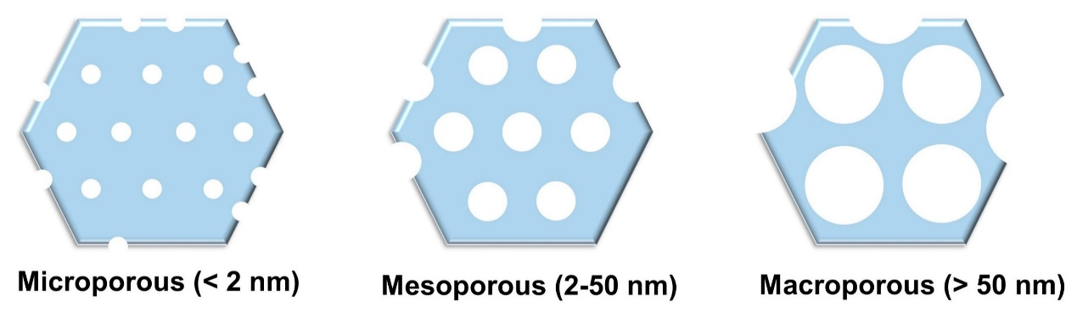
Figure S1. The structural features of porous materials.

According to the International Union of Pure and Applied Chemistry (IUPAC) definition, porous materials are classified into three categories according to their pore sizes: microporous (< 2 nm), mesoporous (2-50nm) and macroporous (> 50 nm).^{[4]}

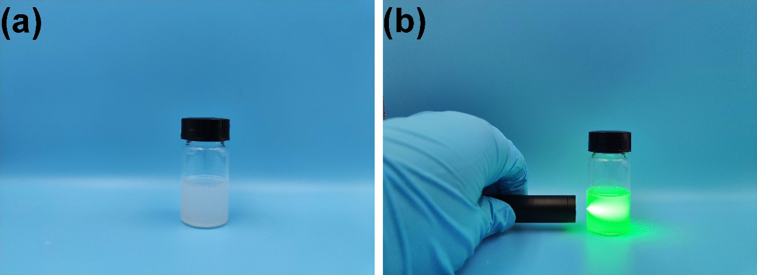
Figure S2. Photographs of the mixed solution for the preparation of the mesoporous nanospheres in an emulsion system. (a) WSM emulsion system; (b) The Tyndall effect.

Figure S3. The possible chemical structures of PG-EDA.
Through the amine-catalyzed polymerization-induced self-assembly. In EtOH/H₂O, EDA and oxidized catechol of PG are covalently polymerized to form oligomers through Michael addition reaction and Schiff base reaction. Specific steps are as follows: The hydroxyl groups of phloroglucinol are deprotonated by ethylenediamine, generating oxyanions. Subsequently, the oxyanion attacks the benzene ring of another phloroglucinol molecule (typically at the ortho or para positions relative to the hydroxyl groups), forming new C–O or C–C bonds. Ethylenediamine acts as a crosslinking agent, where its amino groups (–NH₂) react with the oxyanions of phloroglucinol to form –NH–CH₂–CH₂–NH– bridging structures.

Nucleation energy calculation derivation
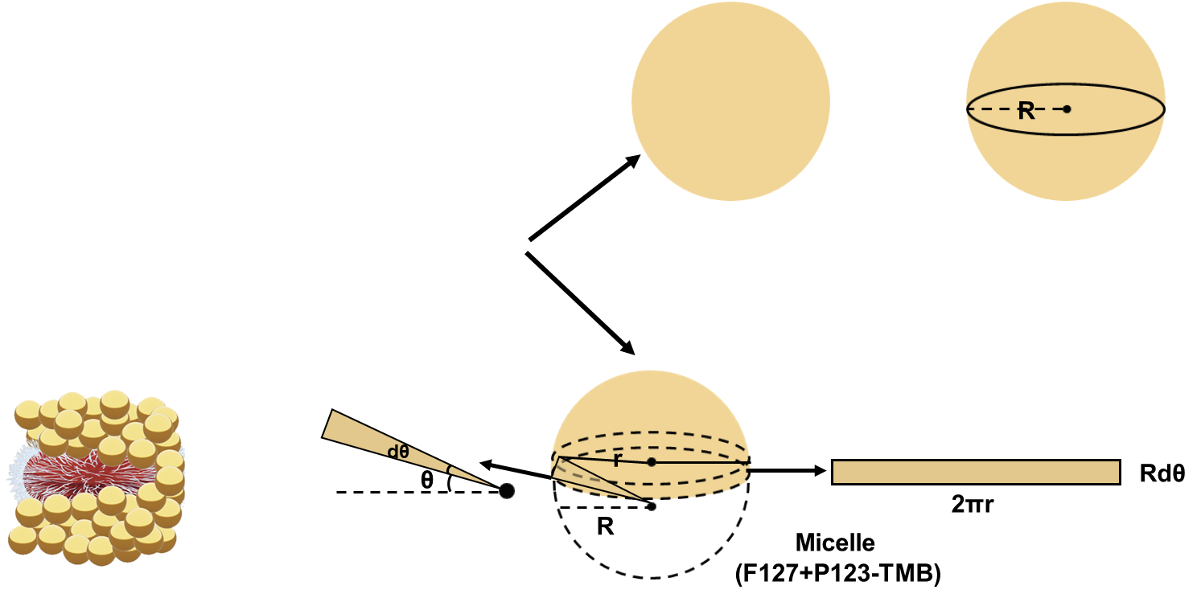
Figure S4. Schematic illustration of calculating the surface area in homogeneous nucleation and heterogeneous nucleation.

The total free energy change (∆𝐺₁) for homogeneous nucleation is shown in Eq. (1) as follows:
$∆G_{1} =\frac{4}{3}πR^{3}∆G_{V}+ 4πR^{2}σ (1)$
For heterogeneous nucleation, the presence of composite micelle provide an external interface for nucleation. An infinitesimal angle 𝑑𝜃 is selected on the surface of the composite micelle, as shown in Figure S2. Area relation are shown in Eq. (2-4) as follows:
$S_{1} = \int_{θ}^{\frac{π}{2}}{2πr∙Rdθ} = \int_{θ}^{\frac{π}{2}}{2πR\cos{θ∙Rdθ = 2πR^{2}}}\left(1 - \sin{θ}\right) (2)$

$S_{2} = πr^{2 }= πR^{2}{\left(\cos{θ}\right)}^{2} (3)$

$S_{3} ={ S}_{2} = πr^{2} = πR^{2}{\left(\cos{θ}\right)}^{2} (4)$
Where $S_{1}$, $S_{2}$ and $S_{3}$ are the total contact area between solid and liquid phase environment, the contact area of PG and composite micelle surface and the contact area between liquid phase and substrate.

Surface energy relation are shown in Eq. (5) as follows (Figure S3):
$σ_{3} = σ_{1}∙\sin{θ}+ σ_{2} (5)$
Where $σ_{1}$, $σ_{2}$and $σ_{3}$rpresent the specific surface energy between the PG and the liquid phase environment, the specific surface energy of the formed interface between PG and substrate and the specific surface energy at the interface between the substrate and the liquid phase environment.

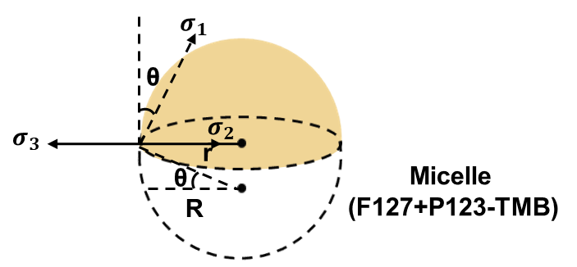
Figure S5. Schematic illustration of interfacial energy relations during heterogeneous nucleation.

The change of surface energy ($∆G_{2}^{S}$) in heterogeneous nucleation system is shown in Eq. (6):
$∆G_{2}^{S} = S_{1}∙σ_{1} +{ S}_{2}∙σ_{2} -{ S}_{3}∙σ_{3}=2πR^{2}\left(1 - \sin{θ}\right)∙σ_{1}-πR^{2}{\left(\cos{θ}\right)}^{2}σ_{1}∙\sin{θ}$ = $4πR^{2}σ_{1}∙\left[\frac{2 - 3\sin{θ + {\left(\sin{θ}\right)}^{3}}}{4}\right] (6)$
A rectangular coordinate system for calculating the volume of self-assembled heterogeneous nucleation is established (Figure S4).
Along the X axis, selected an infinitesimal distance 𝑑𝑥, the volume is shown in Eq. (7):
$$V = \int_{R\sin{θ}}^{R}{πr^{2}}dx = \int_{R\sin{θ}}^{R}{π\left(R^{2}- x^{2}\right)}dx= \frac{4}{3}πR^{3}\left[\frac{2 - 3\sin{θ + {\left(\sin{θ}\right)}^{3}}}{4}\right] (7)$$
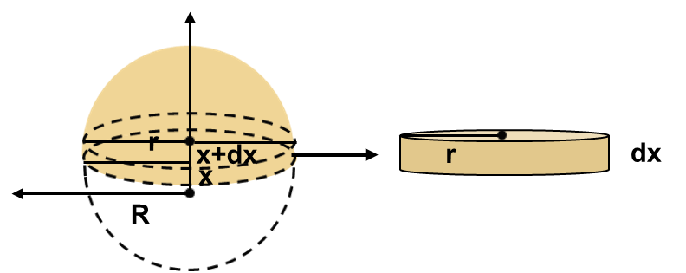
Figure S6. Schematic illustration of calculating the volume of self-assembled heterogeneous nucleation.

Therefore, the change in volume free energy (${∆G}_{2}^{V}$) is shown in Eq. (8):
${∆G}_{2}^{V} = V∙{∆G}_{V} = \frac{4}{3}πR^{3}\left[\frac{2 - 3\sin{θ + {\left(\sin{θ}\right)}^{3}} }{4}\right]∙∆G_{V} (8)$
For heterogeneous nucleation, the total free energy change ($∆G_{2}$) is shown in Eq. (9):
$$∆G_{2}= {{∆G}_{2}^{V}+∆G}_{2}^{S}$$
$= \frac{4}{3}πR^{3}\left[\frac{2 - 3\sin{θ + {\left(\sin{θ}\right)}^{3}} }{4}\right]∙∆G_{V}+ 4πR^{2}σ_{1}∙\left[\frac{2 - 3\sin{θ + {(\sin{θ})}^{3}}}{4}\right]$
$= \left( \frac{4}{3}πR^{3}∆G_{V}+4πR^{2}σ_{1}\right)∙\left[\frac{2 - 3\sin{θ + {(\sin{θ})}^{3}}}{4}\right]$ $Cause:$ $σ_{1}$=$σ$
$= ∆G_{1}∙\left[\frac{2 - 3\sin{θ + {(\sin{θ})}^{3}}}{4}\right] (9)$
Assumptions: $f\left(θ\right) = \left[\frac{2 - 3\sin{θ + {(\sin{θ})}^{3}}}{4}\right]$
$f^{'}\left(θ\right)= \frac{3\cos{θ}}{4}\left(\sin^{2}θ-1\right), Cause: θ ϵ \left(0, \frac{π}{2}\right)$
${So, f}^{'}(θ) < 0$
When $θ=0,$ $f\left(0\right) = \frac{1}{2}$
$When θ=\frac{π}{2},f\left(\frac{π}{2}\right) = 0$
So, $f\left(θ\right) ϵ \left(0, \frac{1}{2}\right)$
So, $∆G_{2}< ∆G_{1}$
The results show that the change value of total free energy for heterogeneous nucleation is smaller than that for homogeneous nucleation. Therefore, it is easier for monomers to undergo heterogeneous nucleation on the surface of composite micelles in emulsion systems. Compared with homogeneous nucleation, heterogeneous nucleation can realize diverse morphologies and structures by controlling the nucleation rate or conditions in different regions.^{[5]}

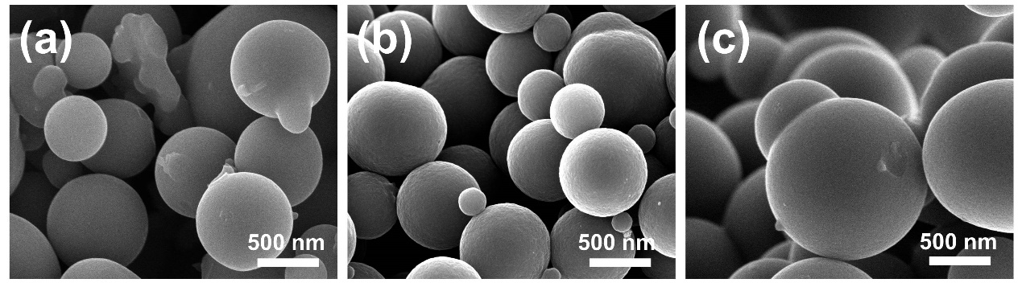
Figure S7. SEM images. (a) With TMB, without P123+F127. (b) With P123+F127,without TMB. (c) Without P123+F127 and TMB.

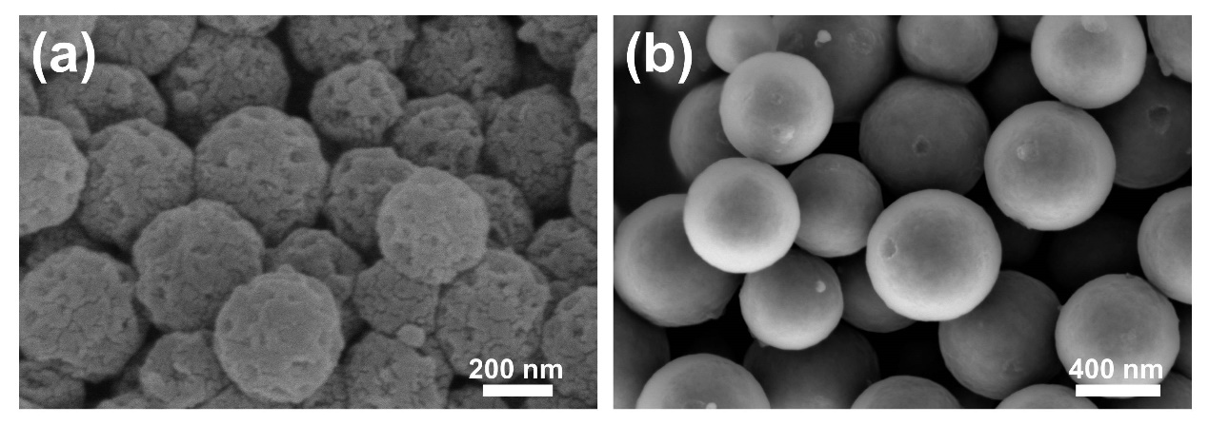
Figure S8. SEM images with different amounts of TMB. (a) 10.7 mmol. (b) 17.9 mmol.

Figure S9. SEM images of PDA mesoporous spheres.

Figure S10. Particle size: (a) WSM-25. (b) NM. (c) WSM-7, and (d) WSM-45.

Figure S11. Theoretical derivation of wedge angles and cross-sectional lines.
The sphere radii of WSM-7, WSM-25, and WSM-45 are 120 nm, 150 nm, and 175 nm, respectively. To simplify the theoretical calculation process for the wedge angle ($θ$) and the cross-sectional line ($l$), this study adopts the arithmetic mean of 150 nm as a unified approximate value for the three radii. The specific calculation is shown below:
WSM-7:
$$\cos{θ=1-\frac{7^{2}}{2×{150}^{2}}≈0.986111 θ=arc\cos{0.986111≈2.7°}}$$

WSM-25:
$$\cos{θ=1-\frac{{25}^{2}}{2×{150}^{2}}≈0.9989111 θ=arc\cos{0.9989111≈9.6°}}$$

WSM-45:
$$\cos{θ=1-\frac{{45}^{2}}{2×{150}^{2}}≈0.955 θ=arc\cos{0.955≈17.3°}}$$

Figure S12. BET of WSM-7, WSM-25 and WSM-45.

Figure S13. BET of NM.
Negative adsorption values are observed in the N₂ adsorption–desorption isotherms and BET specific surface area analysis of the samples. This phenomenon is attributed to the intrinsically low adsorption capacity of the material and the absence of a developed pore structure. As a result, the measured adsorption at low relative pressures falls below the instrumental background signal or the reference chamber baseline, leading to the occurrence of negative values in the calculated data.
Figure S14. Micropore size distribution.

Figure S15. XRD pattern.

Figure S16. Raman spectra.

Figure S17. HRTEM. (a) WSM-7. (b) WSM-25. (c) WSM-45. (d) NM.

Figure S18. Models of L_{a} and L_{c}.

Figure S19. A comparison between La and Lc.

Figure S20. The full spectrum of XPS.

Figure S21. The spectrum of XPS. (a) C 1s. (b) N 1s. (c) O 1s.

Figure S22. The spectrum of XPS. (a) C 1s. (b) N 1s. (c) O 1s.

Figure S23. Initial structure of the ionic diffusion model.

Figure S24. Snapshots showing the variation of ion diffusion through different pore diameters (0-5 ns; 1-3 nm).

Figure S25. Snapshots showing the variation of ion diffusion through different pore diameters (0-5 ns; 3-5 nm).

Figure S26. Snapshots showing the variation of ion diffusion through different pore diameters (0-5 ns; 5-7 nm).

Figure S27. Snapshots showing the variation of ion diffusion through different pore diameters (0-5 ns; 7-9 nm).

Figure S28. Snapshots showing the variation of ion diffusion through different pore diameters (a) 1-3nm, (b) 3-5nm, (c) 5-7nm, (d) 7-9nm channels over time.

Figure S29. The charge density difference. (a) SSIP, (b) AGG.

Figure S30. The CV curves. (a) NM. (b) WSM-7. (c) WSM-25. (d) WSM-45.
Through comparative analysis, it is found that NM generally exhibits larger irreversible reduction peaks, and their average peak areas are smaller compared to the other mesoporous carbon spheres. This phenomenon can be inferred that the absence of mesopores greatly affects their electrochemical performance.

Figure S31. Electrochemical performances: (a) Initial charge-discharge curves in the potential range of 0.01-3.0 V at 0.1 A g⁻¹. (b) Cycling performance at 0.1 A g⁻¹. (c) Rate capability. (d) Long-term cycling at 20.0 A g⁻¹.
Figure S32. (a-f) Digital pictures of NM and WSM-25 electrodes after and diaphragms cycle .

Figure S33. Electrode thickness after different cycles at 0.5 A g⁻¹. (a-b) WSM-25. (c-d) NM.

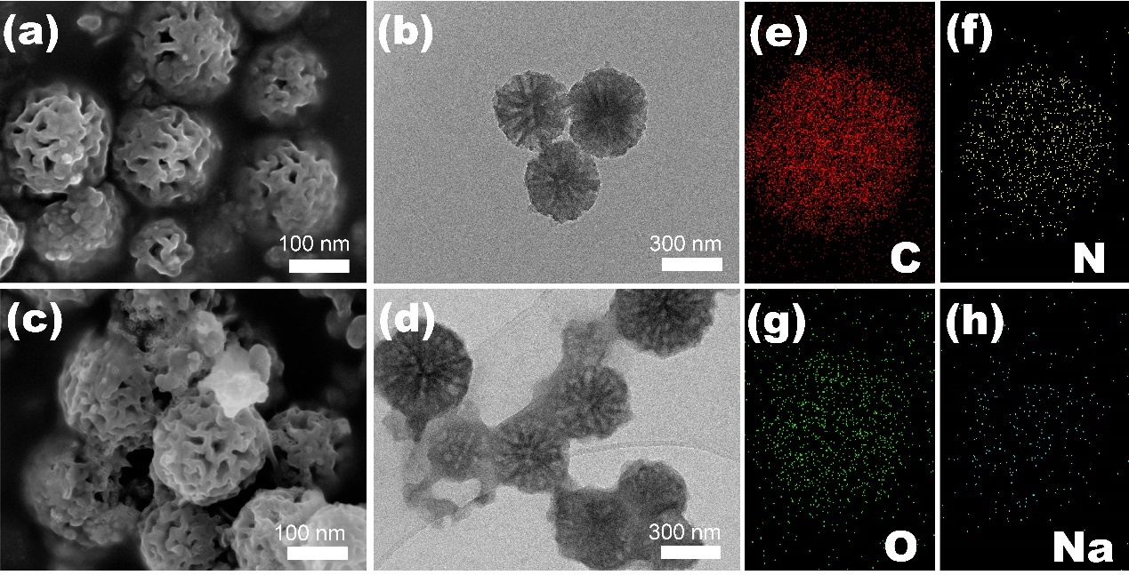
Figure S34. (a-b) SEM and TEM images of WSM-25 after 100 cycles at 0.1 A g⁻¹; (c-d) SEM and TEM images of WSM-25 after 10000 cycles at 20 A g⁻¹; (e-h) EDX mapping images of C, N, O and Na.

Figure S35. The GCD curves. (a) With TMB, without P123+F127. (b) With P123+F127,without TMB. (c) Without P123+F127 and TMB.
As shown in Figure S35, in the absence of P123+F127 or TMB, or both, the GCD curves do not observe a plateau at low voltages, implying that there is a certain correlation between ordered mesoporous and low voltage plateau region. Usually, carbonization at higher temperatures is required to promote graphitization in order to extend the plateau region. However, by preparing mesoporous channels that penetrate the interior of the material, the plateau region can be formed efficiently even under low-temperature carbonization conditions.

Figure S36. Cycle performance. (a) 0.1 A g⁻¹; (b) 5 A g⁻¹.
In the absence of added surfactants and swellers, the cycling performance is essentially the same as that of the non-mesoporous carbon spheres.

Figure S37. Cycle performance of TMB-1.5 and TMB-2.5. (a) 0.1 A g⁻¹; (b) 5 A g⁻¹.

The synthesis process remains entirely consistent with the WSM-25, with the sole modification being an adjustment in the volume of TMB to 1.5 and 2.5 mL. It can be observed that the performance is unsatisfactory in both short and long cycle tests, which emphasizes the important role of the synthesis process in the material performance.

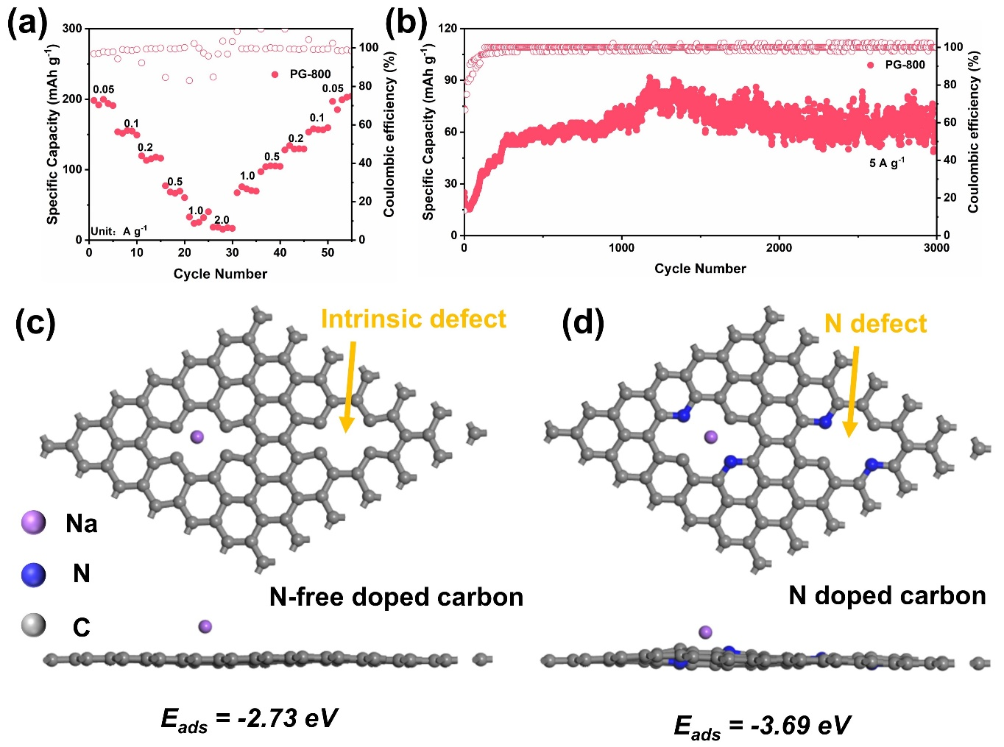
Figure S38. Cycle performance of PG-800. (a) Rate capability; (b) 5 A g⁻¹; DFT calculations on the Na-adsorption models. (c) N-free doped carbon; (d) N doped carbon.

Figure S39. Electrochemical impedance of NM and WSM-25.

Figure S40. (a-b) Cyclic voltammetry curves of NM and WSM-25 at different sweep rates.

Figure S41. Linear relationship between peak current and scanning rate.

Figure S42. The ratio of capacitance behavior to diffusion behavior at different sweep speeds.

Figure S43. GITT curves.

Figure S44. SAXS fitting analysis of WSM-25.
The patterns are fitted based on the following model:^{[6-7]}
$$I=I_{pore}+\frac{A}{q^{α}}+B (1)$$
Equation (1) is the total scattering intensity, $I$ is the porod coefficient, $α$ is the porod index, and $B$ is the scattering background.
$$I_{pore}=\int_{0}^{∞}{∆ρ^{2}V^{2}\left(R\right)f\left(R\right)F^{2}\left(q,R\right)}dR (2)$$
Equation (2) is the scattering intensity expression of the pore, using spherical structure factor to simulate the pore. $∆ρ$ is the excess SLD of the pore to the matrix.
$$F\left(q,R\right)={\left(\frac{\sin\left(qR\right)-qR\cos\left(qR\right)}{{\left(qR\right)}^{3}}\right)}^{2} (3)$$
Equation 3 is the form factor of a spherical particle, $R$ is the pore diameter, $q$ is the scattering vector.
$$f\left(R\right)=\frac{N_{0}}{σ\sqrt{2π}}exp\left[-\frac{1}{2σ^{2}}{\left(R-R_{0}\right)}^{2}\right] (4)$$
Formula 4 is a lognormal distribution function, where $R_{0}$ is the mean radius of core; $σ$ the standard deviation. $N_{0}$ the number density (the total number of pore per unit volume)

Figure S45. (a) The GCD curves of WSM-25 (0.01 V) // WSM-25 (fresh) at 0.1 A g⁻¹.(b) The GCD curves of WSM-25 (fresh) // WSM-25 (fresh) at 0.1 A g⁻¹.

Figure S46. (a) NaF signal changes of SEI formed in NM electrolytes; (b) C 1s peak profiles of the cycled NM electrolytes; (c) Na 1s peak profiles of the cycled NM electrolytes; (d) Depth-profiling XPS spectra of C 1s; (e) Depth-profiling XPS spectra of O 1s; (f) Depth-profiling XPS spectra of F 1s.

Figure S47. (a-d) The proportion of SEI components calculated from the C 1s, O 1s and F 1s spectra.

Figure S48. The atomic fractions of C as a function of etching depth.

Figure S49. The atomic fractions of O as a function of etching depth.

Figure S50. The atomic fractions of F as a function of etching depth.

Figure S51. The atomic fractions of Na as a function of etching depth.

Figure S52. Mechanism capacity contribution of NM and WSM-25.

Figure S53. Lithium-ion half-cell of WSM-25. (a) 50 mA g⁻¹. (b) 4.0 A g⁻¹.

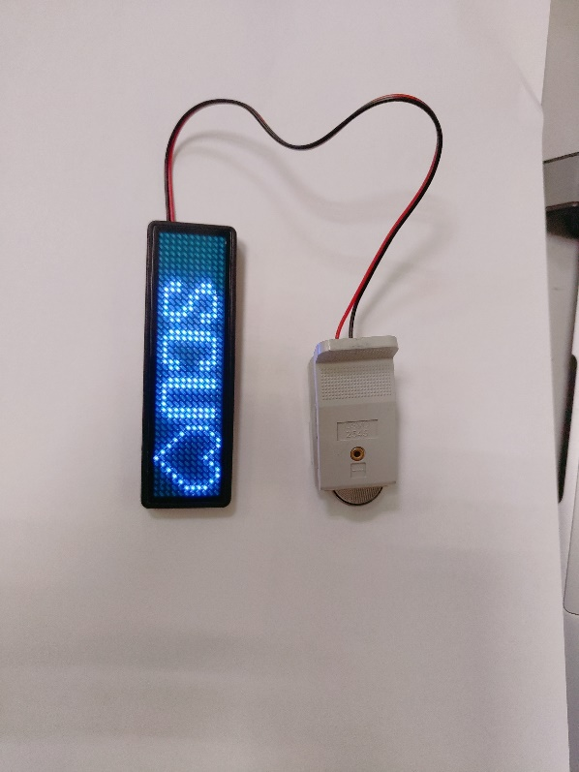
Figure S54. Photograph of the NVP // WSM-25 full battery in practical application.

Table S1. Physical parameters of all samples.

Samples | d₀₀₂  (nm) | I_{D}/I_{G} | La  (nm) | Lc  (nm) | S_{BET}  (m² g⁻¹)
WSM-7 | 0.381 | 1.06 | 18.3 | 1.01 | 282.8
WSM-25 | 0.391 | 1.07 | 18.7 | 1.46 | 294.6
WSM-45 | 0.401 | 1.07 | 18.7 | 1.35 | 300.5
NM | 0.363 | 1.02 | 18.0 | 0.75 | 10.1

Table S2 Interaction parameters between atoms C₁: Carbon atom in graphene; O_{1:} Ether oxygen of carbonate group in EC; O₂: Carbonyl oxygen of carbonate group in EC; C₂: Central carbon of carbonate group in EC; C₃: -CH₂- carbon in EC; H₁: -CH₂- hydrogen in EC; O₃: Ether oxygen of carbonate group in DEC; O₄: Carbonyl oxygen of carbonate group in DEC; C₄: Central carbon of carbonate group in DEC; C₅: -CH₂- carbon in DEC; C₆: -CH₃ carbon in DEC; H₂: -CH₂- hydrogen in DEC; H₃: -CH₃ hydrogen in DEC;
 | C₁ | O₁ | O₂ | C₂ | C₃ | H₁ | O₃ | O₄
Ɛ(kcal/mol) | 0.086 | 0.120 | 0.150 | 0.080 | 0.090 | 0.015 | 0.120 | 0.150
σ (Å) | 3.40 | 3.10 | 2.90 | 3.35 | 3.50 | 2.50 | 3.00 | 2.90
Charge(e) | 0 | -0.420 | -0.550 | 0.880 | 0.250 | 0.080 | -0.430 | -0.560
 | C₄ | C₅ | C₆ | H₂ | H₃ | Na | P | F
Ɛ(kcal/mol) | 0.080 | 0.090 | 0.100 | 0.015 | 0.015 | 0.035 | 0.110 | 0.085
σ (Å) | 3.35 | 3.50 | 3.55 | 2.50 | 2.50 | 2.30 | 3.40 | 2.70
Charge(e) | 0.900 | 0.270 | -0.050 | 0.080 | 0.080 | 1.00 | 2.00 | -0.50

Table S3. Electrochemical properties of several carbon materials for SIBs anode.
Carbon-based materials | Current density  (A g⁻¹) | Reversible  capacity (mAh g⁻¹) | Number of cycles | Reference
HCMP-CO₂ | 0.2 | ≈300.0 | 100 | ^{[3]}
NPCS | 0.1  10.0 | 376.3  172.6 | /  10000 | ^{[8]}
p-CNTs@HC-1000 | 0.3 | 193.1 | 200 | ^{[9]}
NAC-1200 | 0.5 | 313.3 | 3000 | ^{[10]}
NC-950 | 0.05  0.5 | 305.5  164.8 | 100  500 | ^{[11]}
PZHC 450-1200 | 1.0 | 250.0 | 1000 | ^{[12]}
SN-MHSCs | 0.5  20.0 | 174.0  180.0 | 2000  7000 | ^{[13]}
MPNC23-1500 | 1.0 | 106.0 | 2000 | ^{[14]}
Gua@BHETA-15 | 0.5 | 325.0 | 2000 | ^{[15]}
FeSe2/GA@PMC-2 | 5.0 | 345.1 | 1000 | ^{[16]}
WSM-25 | 0.1  20.0 | 658.5  200.1 | 100  50000 | This work

References
[1] B. Delley, J. Chem. Phys. 1990, 92, 508-517.
[2] B. Delley, J. Chem. Phys. 2000, 113, 7756-7764.
[3] Z. Zheng, S. Hu, W. Yin, J. Peng, R. Wang, J. Jin, B. He, Y. Gong, H. Wang, H. J. Fan, Adv. Energy. Mater. 2024, 14, 2303064.
[4] T. Zhao, A. Elzatahry, X. Li, D. Zhao, Nat. Rev. Mater. 2019, 4, 775-791.
[5] K.-J. Wu, C. Edmund, C. Shang, Z. Guo, Prog. Mater Sci. 2022, 123, 100821.
[6] L. Peng, B. Chen, Y. Zhao, Constr. Build. Mater. 2020, 262, 120863.
[7] D. Stevens, J. Dahn, J. Electrochem. Soc. 2000, 147, 4428.
[8] Z. Song, M. Di, X. Zhang, Z. Wang, S. Chen, Q. Zhang, Y. Bai, Adv. Energy. Mater. 2024, 2401763.
[9] Y. He, D. Liu, J. Jiao, Y. Liu, S. He, Y. Zhang, Q. Cheng, Y. Fang, X. Mo, H. Pan, Adv. Funct. Mater. 2024, 2403144.
[10] Y. Zhao, Z. Hu, W. Zhou, P. Gao, Z. Liu, J. Liu, C. Fan, J. Liu, Adv. Funct. Mater. 2024, 2405174.
[11] J. Jiang, Z. Chen, Y. Chen, Q. Zhuang, Z. Ju, X. Zhang, Adv. Funct. Mater. 2024, 2402416.
[12] H. He, J. He, H. Yu, L. Zeng, D. Luo, C. Zhang, Adv. Energy. Mater. 2023, 13, 2300357.
[13] D. Ni, W. Sun, Z. Wang, Y. Bai, H. Lei, X. Lai, K. Sun, Adv. Energy. Mater. 2019, 9, 1900036.
[14] A. Rützler, J. Büttner, J. Oechsler, S. E. Balaghi, S. Küspert, N. Ortlieb, A. Fischer, Adv. Funct. Mater. 2024, 2401188.
[15] P. Zhang, Y. Shu, B. Zhong, L. Yang, X. Guo, Chem. Eng. J. 2024, 155231.
[16] H. Tian, Y. Jia, Y. Wang, Y. Qiao, P. Ji, C. Zhang, H. Gou, G. Wang, Adv. Funct. Mater. 2024, 2406827.

