Article Title: Integrated Risk Assessment of Water Distribution Systems: A Decision Support Framework for Pipe Vulnerability and Contamination Hazard
Journal Name: Water Resources Management
Author Details:

Authors | Affiliations and Contact Details
Asheesh Sharma  (Corresponding author) | Scientist F, IT and Digital Infrastructure Unit, CSIR-National Environmental Engineering Research Institute, Nehru Marg, Nagpur-440020, India. https://orcid.org/0000-0002-5924-1912  Email: asheesh.sharma@csir.res.in
Madni Gazal Khan Lodhi | Project Assistant, IT and Digital Infrastructure Unit, CSIR-National Environmental Engineering Research Institute, Nehru Marg, Nagpur-440020, India  Email: gazalodhi040506@gmail.com
Vigna Purohit | Project Assistant, IT and Digital Infrastructure Unit, CSIR-National Environmental Engineering Research Institute, Nehru Marg, Nagpur-440020, India  Email: vignapurohit9@gmail.com;
Sravanthi Mopati | Project Assistant, IT and Digital Infrastructure Unit, CSIR-National Environmental Engineering Research Institute, Nehru Marg, Nagpur-440020, India  Email: sravanthi.mopati@gmail.com
Omkar Patil | Project Assistant, IT and Digital Infrastructure Unit, CSIR-National Environmental Engineering Research Institute, Nehru Marg, Nagpur-440020, India  Email: omkar3131@gmail.com
Neha K. M. Nasim | Project Associate, IT and Digital Infrastructure Unit, CSIR-National Environmental Engineering Research Institute, Nehru Marg, Nagpur-440020, India. https://orcid.org/0009-0009-9080-5091  Email: nehakmnasim@gmail.com;
Aabha Sargaonkar | Formal Scientist G, IT and Digital Infrastructure Unit, CSIR-National Environmental Engineering Research Institute, Nehru Marg, Nagpur-440020, India  Email: ap_sargaonkar@neeri.res.in

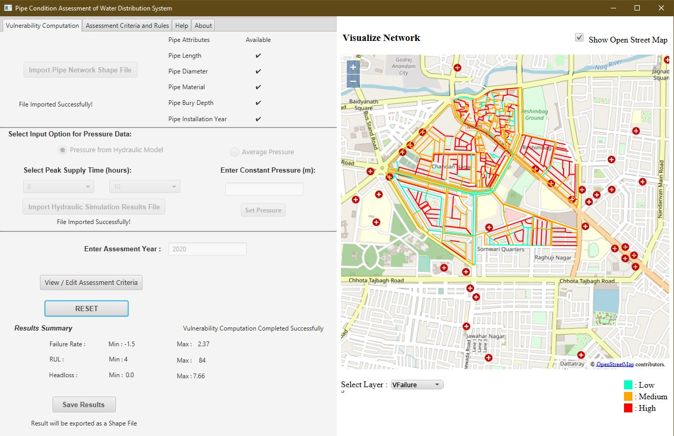
Fig. 6 Pipe condition assessment module

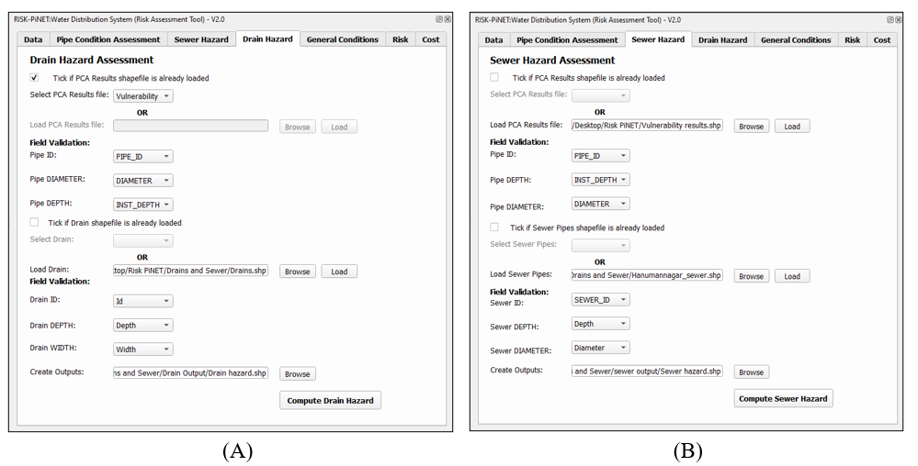
Fig. 7 Hazard assessment module : A) Drain Hazard, B) Sewer Hazard

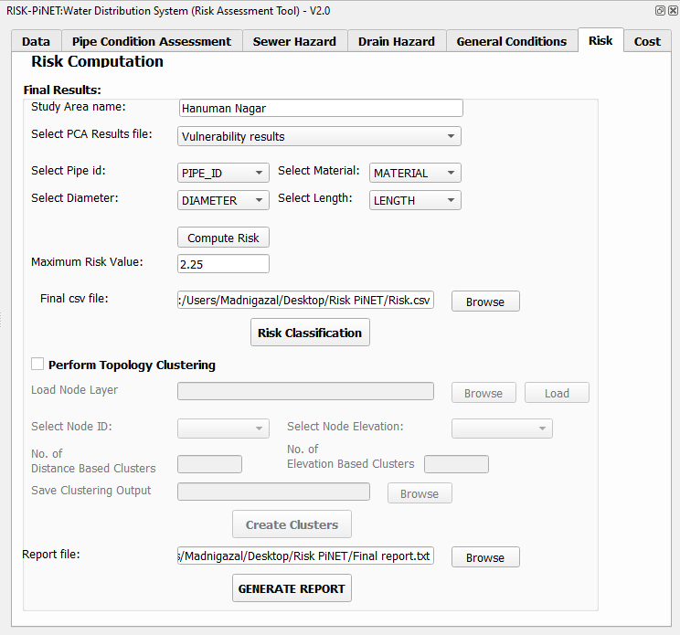
Fig. 8 Risk assessment modul

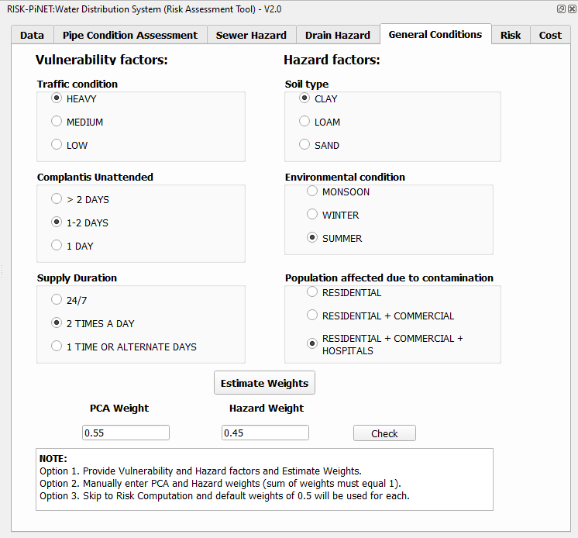
Fig. 9 Computation of weights for vulnertablity and hazard scores
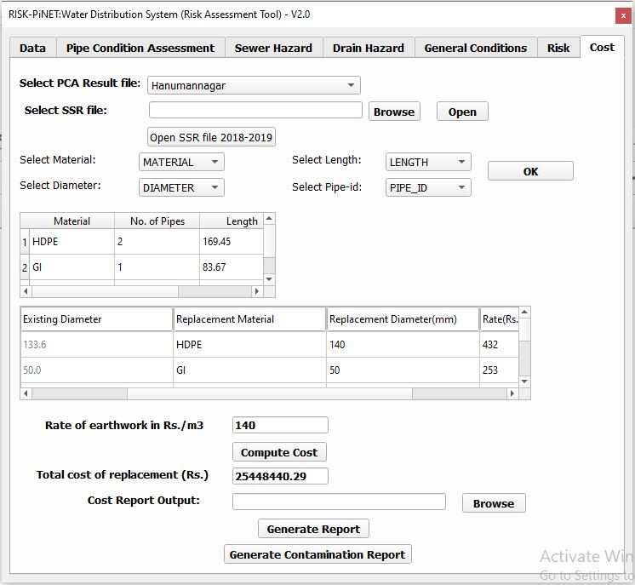
Fig. 10 Prioritization of high risk pipe for rehabilitation and cost estimation

