Supplementary Appendix
Supplemental Methods
Exclusion criteria for patients during the data collection phase
- Inpatient dialysis patients.
- Patients who refuse or are unable to sign the informed consent form.
- Patients who object to blood pressure measurements every 30 minutes.
- Patients with serious data loss, such as those who do not use a swipe card to record weight or frequently remove their blood pressure airbags. Data quality control was the responsibility of two technicians.
Data Characteristics of predictive model
Demographic, clinical and laboratory data obtained from electronic health records and dialysis machine data were collected and trained.
Patients’ demographics included age, gender, diabetes status, duration of dialysis, vascular access type.
Laboratory variables were captured monthly of hemoglobin, high-sensitivity C-reactive protein, N-terminal pro-brain natriuretic peptide (NT-proBNP). Liver function, pre- and post-dialysis BUN and creatine, electrolyte parameters, intact parathyroid hormone, and iron parameters were collected each three months.
Dialysis machine data included variables such as blood purification mode, pre- and post-dialysis weight, predialysis dry weight, interdialytic weight gain, ultrafiltration volume, blood flow rate, dialysate flow rate, dialysate temperature, dialysate conductivity, ultrafiltration rate, systolic blood pressure(SBP) and diastolic blood pressure (DBP) and heart rate measurements every 30 minutes in one hematodialysis session.
Research Framework for Machine Learning Prediction Models
RNN is a deep learning and time series model that takes patients' blood pressure measurements at different time intervals as a sequential dataset with timestamps¹. It takes into account the past information of related neurons when predicting the next blood pressure measurement.
The second model is XGBoost, whose learning process can explore key variables and their decision boundaries². It fits the best classification model using multiple segments of the decision tree that minimize the error.
The third model is LightGBM, which is also a decision tree-based machine learning model like XGBoost. LightGBM supports more sampling methods, including row and column sampling, while XGBoost only supports row-based sampling³.
Evaluation Metrics for Predictive Models
In this study, various evaluation metrics were used to assess the performance of the models, including sensitivity (also known as TPR), specificity (also known as TNR), false negative rate (FNR), false positive rate (FPR), accuracy, precision, F1 score, the area under the precision-recall curve, and the receiver operating characteristic curve. Each of these evaluation metrics has its own focus. The threshold was set to maximize the F1 score of the positive values. Each of the metric calculations is displayed in Fig. S1, with true negative (TN), false negative (FN), true positive (TP) and false positive (FP) values.
Accuracy represents the proportion of correctly classified samples among the total samples.
Precision represents the proportion of true positive samples among all samples predicted as positive.
Recall represents the proportion of true positive samples among all actual positive samples.
The F1 score is the harmonic mean of precision and recall, comprehensively reflecting both precision and recall sensitivity.
The PR curve is a curve where the horizontal axis represents precision and the vertical axis represents recall. The PR curve is used to evaluate the impact of increasing recall (i.e., the true positive rate) on precision. It is generally accepted that the larger the area under the curve in the lower-left region is, the better the overall model performance in terms of precision and recall, and thus, the better the F1 score.
Inclusion criteria for patients in AI intervention phase
- The participants must be at least 18 years old, have completed three sessions of outpatient hemodialysis treatment per week at this center for more than one year.
- Participants must be included in the initial model training data set.
- The incidence rate of IDH must be at least 30% within one year prior to enrollment for participants.
- Participants should be able to tolerate high-flux hemodialysis (HFHD) and Fresenius FX80 dialyzers (Fresenius Medical Care, Bad Homburg, Germany).
Exclusion criteria for patients in AI intervention phase
- Inpatient dialysis patients.
- Patients who refuse or are unable to sign the informed consent form.
- Patients who object to blood pressure measurements every 30 minutes.
- Patients with serious data loss, such as those who do not use a swipe card to record weight or frequently remove their blood pressure airbags. Data quality control was the responsibility of two technicians.
Intradialytic hypotension (IDH) interventions in the control group
We handled intradialytic hypotension in the control group according to Chinese expert consensus on prevention and treatment of IDH in 2022.
- In Trendelenburg position as frequently as possible
- Oxygen inhalation and electrocardiographic monitoring
- Stop ultrafiltration and reduce blood flow
- Administer 100 milliliters of ultrapure dialysate or normal saline intravenously
- Consider pressor agent, replace the treatment mode if necessary
- Establish venous access and advanced life support for severe patient

Supplemental Table 1. Basic parameters of different machine learning models under three IDH definitions
 |  | ROC-AUC | PR-AUC | TP | FP | TN | FN | TPR | FPR | Precision | Accuracy | F1
IDH1
RNN | Training set | 0.935 | 0.634 | 13726 | 29171 | 179590 | 2144 | 0.865 | 0.140 | 0.320 | 0.861 | 0.467
 | Validation Set | 0.929 | 0.591 | 4564 | 9913 | 59608 | 759 | 0.857 | 0.143 | 0.315 | 0.857 | 0.461
 | Test Set 1 | 0.914 | 0.517 | 7546 | 17656 | 112727 | 1715 | 0.815 | 0.135 | 0.299 | 0.861 | 0.438
 | Test Set 2 | 0.906 | 0.436 | 614 | 1563 | 18159 | 222 | 0.734 | 0.079 | 0.282 | 0.913 | 0.408
 | Test Set 3 | 0.914 | 0.511 | 8160 | 19219 | 130886 | 1937 | 0.808 | 0.128 | 0.298 | 0.868 | 0.436
XGBoost | Training set | 0.956 | 0.698 | 15510 | 32762 | 214933 | 1578 | 0.908 | 0.132 | 0.321 | 0.870 | 0.475
 | Validation Set | 0.934 | 0.590 | 4937 | 11440 | 71056 | 795 | 0.861 | 0.139 | 0.302 | 0.861 | 0.447
 | Test Set 1 | 0.914 | 0.498 | 8301 | 21360 | 130793 | 1771 | 0.824 | 0.140 | 0.280 | 0.857 | 0.418
 | Test Set 2 | 0.914 | 0.444 | 681 | 1944 | 20953 | 230 | 0.748 | 0.085 | 0.259 | 0.909 | 0.385
 | Test Set 3 | 0.915 | 0.494 | 8982 | 23304 | 151746 | 2001 | 0.818 | 0.133 | 0.278 | 0.864 | 0.415
LightGBM | Training set | 0.939 | 0.656 | 14964 | 33785 | 213910 | 2124 | 0.876 | 0.136 | 0.307 | 0.864 | 0.455
 | Validation Set | 0.930 | 0.589 | 4920 | 11687 | 70809 | 812 | 0.858 | 0.142 | 0.296 | 0.858 | 0.441
 | Test Set 1 | 0.913 | 0.505 | 8351 | 22196 | 129957 | 1721 | 0.829 | 0.146 | 0.273 | 0.853 | 0.411
 | Test Set 2 | 0.915 | 0.450 | 693 | 2057 | 20840 | 218 | 0.761 | 0.090 | 0.252 | 0.904 | 0.379
 | Test Set 3 | 0.914 | 0.501 | 9044 | 24253 | 150797 | 1939 | 0.824 | 0.139 | 0.272 | 0.859 | 0.409
IDH2
RNN | Training set | 0.940 | 0.638 | 12792 | 28271 | 181680 | 1888 | 0.871 | 0.135 | 0.312 | 0.866 | 0.459
 | Validation Set | 0.931 | 0.581 | 4242 | 9734 | 60182 | 686 | 0.861 | 0.139 | 0.304 | 0.861 | 0.449
 | Test Set 1 | 0.915 | 0.506 | 7057 | 17770 | 113304 | 1513 | 0.824 | 0.136 | 0.284 | 0.862 | 0.423
 | Test Set 2 | 0.908 | 0.409 | 552 | 1645 | 18173 | 188 | 0.746 | 0.083 | 0.251 | 0.911 | 0.376
 | Test Set 3 | 0.915 | 0.498 | 7609 | 19415 | 131477 | 1701 | 0.817 | 0.129 | 0.282 | 0.868 | 0.419
XGBoost | Training set | 0.955 | 0.676 | 14367 | 32809 | 216113 | 1494 | 0.906 | 0.132 | 0.305 | 0.870 | 0.456
 | Validation Set | 0.936 | 0.585 | 4599 | 11269 | 71636 | 724 | 0.864 | 0.136 | 0.290 | 0.864 | 0.434
 | Test Set 1 | 0.919 | 0.499 | 7778 | 21361 | 131526 | 1560 | 0.833 | 0.140 | 0.267 | 0.859 | 0.404
 | Test Set 2 | 0.918 | 0.428 | 624 | 2102 | 20892 | 190 | 0.767 | 0.091 | 0.229 | 0.904 | 0.353
 | Test Set 3 | 0.920 | 0.493 | 8402 | 23463 | 152418 | 1750 | 0.828 | 0.133 | 0.264 | 0.865 | 0.400
LightGBM | Training set | 0.940 | 0.646 | 13870 | 32641 | 216281 | 1991 | 0.875 | 0.131 | 0.298 | 0.869 | 0.445
 | Validation Set | 0.933 | 0.584 | 4600 | 11254 | 71651 | 723 | 0.864 | 0.136 | 0.290 | 0.864 | 0.434
 | Test Set 1 | 0.917 | 0.498 | 7734 | 21177 | 131710 | 1604 | 0.828 | 0.139 | 0.268 | 0.860 | 0.404
 | Test Set 2 | 0.914 | 0.428 | 621 | 1939 | 21055 | 193 | 0.763 | 0.084 | 0.243 | 0.911 | 0.368
 | Test Set 3 | 0.917 | 0.493 | 8355 | 23116 | 152765 | 1797 | 0.823 | 0.131 | 0.266 | 0.866 | 0.402
IDH3
RNN | Training set | 0.914 | 0.865 | 66148 | 24113 | 120876 | 13494 | 0.831 | 0.166 | 0.733 | 0.833 | 0.779
 | Validation Set | 0.912 | 0.861 | 22202 | 8111 | 40033 | 4498 | 0.832 | 0.169 | 0.732 | 0.832 | 0.779
 | Test Set 1 | 0.908 | 0.845 | 37784 | 14421 | 78498 | 8941 | 0.809 | 0.155 | 0.724 | 0.833 | 0.764
 | Test Set 2 | 0.906 | 0.811 | 4350 | 2003 | 13042 | 1163 | 0.789 | 0.133 | 0.685 | 0.846 | 0.733
 | Test Set 3 | 0.908 | 0.842 | 42134 | 16424 | 91540 | 10104 | 0.807 | 0.152 | 0.720 | 0.834 | 0.761
XGBoost | Training set | 0.928 | 0.880 | 75468 | 27744 | 148054 | 13517 | 0.848 | 0.158 | 0.731 | 0.844 | 0.785
 | Validation Set | 0.911 | 0.855 | 24629 | 10173 | 48231 | 5195 | 0.826 | 0.174 | 0.708 | 0.826 | 0.762
 | Test Set 1 | 0.900 | 0.828 | 41335 | 18736 | 92177 | 9977 | 0.806 | 0.169 | 0.688 | 0.823 | 0.742
 | Test Set 2 | 0.895 | 0.785 | 4846 | 2872 | 14794 | 1296 | 0.789 | 0.163 | 0.628 | 0.825 | 0.699
 | Test Set 3 | 0.900 | 0.823 | 46181 | 21608 | 106971 | 11273 | 0.804 | 0.168 | 0.681 | 0.823 | 0.738
LightGBM | Training set | 0.919 | 0.867 | 74516 | 29031 | 146767 | 14469 | 0.837 | 0.165 | 0.720 | 0.836 | 0.774
 | Validation Set | 0.909 | 0.853 | 24612 | 10209 | 48195 | 5212 | 0.825 | 0.175 | 0.707 | 0.825 | 0.762
 | Test Set 1 | 0.901 | 0.829 | 41309 | 18478 | 92435 | 10003 | 0.805 | 0.167 | 0.691 | 0.824 | 0.744
 | Test Set 2 | 0.899 | 0.793 | 4886 | 2745 | 14921 | 1256 | 0.796 | 0.155 | 0.640 | 0.832 | 0.710
 | Test Set 3 | 0.901 | 0.826 | 46195 | 21223 | 107356 | 11259 | 0.804 | 0.165 | 0.685 | 0.825 | 0.740
IDH, Intradialytic hypotension; RNN, recurrent neural network; XGBoost, Extreme Gradient Boosting; LightGBM, Light Gradient Boosting Machine; ROC-AUC, receiver operating characteristic area under the curve; PR-AUC, precision‒recall area under the curve; TP, true positive; FP, false positive; TN, true negative; FN, false negative; TPR, true positive rate; FPR, false positive rate.
Supplemental Table 2. Basic parameters of XGBoost machine learning model under IDH1
Training set | threshold | TP | FP | TN | FN | TPR | FPR | Precision | Accuracy | F1
Training set | 0.069 | 29388 | 61336 | 405040 | 3279 | 89.96% | 13.15% | 32.39% | 87.05% | 0.476
Training set | 0.322 | 20710 | 12453 | 453923 | 11957 | 63.40% | 2.67% | 62.45% | 95.11% | 0.629
Training set | 0.100 | 28158 | 46589 | 419787 | 4509 | 86.20% | 9.99% | 37.67% | 89.76% | 0.524
Training set | 0.200 | 24668 | 24188 | 442188 | 7999 | 75.51% | 5.19% | 50.49% | 93.55% | 0.605
Training set | 0.300 | 21408 | 13961 | 452415 | 11259 | 65.53% | 2.99% | 60.53% | 94.95% | 0.629
Training set | 0.400 | 18198 | 8017 | 458359 | 14469 | 55.71% | 1.72% | 69.42% | 95.49% | 0.618
Training set | 0.500 | 14975 | 4403 | 461973 | 17692 | 45.84% | 0.94% | 77.28% | 95.57% | 0.576
Training set | 0.600 | 11844 | 2227 | 464149 | 20823 | 36.26% | 0.48% | 84.17% | 95.38% | 0.507
Training set | 0.700 | 8575 | 949 | 465427 | 24092 | 26.25% | 0.20% | 90.04% | 94.98% | 0.407
Training set | 0.800 | 5257 | 297 | 466079 | 27410 | 16.09% | 0.06% | 94.65% | 94.45% | 0.275
Training set | 0.900 | 2215 | 37 | 466339 | 30452 | 6.78% | 0.01% | 98.36% | 93.89% | 0.127
Validation Set | 0.069 | 9647 | 21436 | 133447 | 1549 | 86.16% | 13.84% | 31.04% | 86.16% | 0.456
Validation Set | 0.322 | 6419 | 4777 | 150106 | 4777 | 57.33% | 3.08% | 57.33% | 94.25% | 0.573
Validation Set | 0.100 | 9167 | 16517 | 138366 | 2029 | 81.88% | 10.66% | 35.69% | 88.83% | 0.497
Validation Set | 0.200 | 7832 | 8911 | 145972 | 3364 | 69.95% | 5.75% | 46.78% | 92.61% | 0.561
Validation Set | 0.300 | 6646 | 5306 | 149577 | 4550 | 59.36% | 3.43% | 55.61% | 94.07% | 0.574
Validation Set | 0.400 | 5536 | 3266 | 151617 | 5660 | 49.45% | 2.11% | 62.89% | 94.63% | 0.554
Validation Set | 0.500 | 4482 | 1957 | 152926 | 6714 | 40.03% | 1.26% | 69.61% | 94.78% | 0.508
Validation Set | 0.600 | 3409 | 1135 | 153748 | 7787 | 30.45% | 0.73% | 75.02% | 94.63% | 0.433
Validation Set | 0.700 | 2371 | 560 | 154323 | 8825 | 21.18% | 0.36% | 80.89% | 94.35% | 0.336
Validation Set | 0.800 | 1481 | 218 | 154665 | 9715 | 13.23% | 0.14% | 87.17% | 94.02% | 0.230
Validation Set | 0.900 | 602 | 49 | 154834 | 10594 | 5.38% | 0.03% | 92.47% | 93.59% | 0.102

IDH, Intradialytic hypotension; XGBoost, Extreme Gradient Boosting; TP, true positive; FP, false positive; TN, true negative; FN, false negative; TPR, true positive rate; FPR, false positive rate.

Supplemental Table 3. The Impact of AI-assisted on IDH Incidence
 | AI-assisted group  MD (95% CI) | P value | Control group  MD (95% CI) | P value | Between-Group difference MD (95% CI) | P value
Pre-intervention | 55.56% (40.41%, 70.70%) |  | 56.67% (41.52%, 71.81%) |  | -1.11% (-22.53%, 20.31%) | 0.918
Intervention period | 46.11% (30.96%, 61.26%) |  | 60.56% (45.41%, 75.70%) |  | -14.44% (-35.87%, 6.98%) | 0.182
Post-intervention | 36.67% (21.52%, 51.81%) |  | 46.67% (31.52%, 61.81%) |  | -10.00% (-31.42%, 11.42%) | 0.354
Intervention period vs Pre-intervention | -9.44% (-21.89%, 3.00%) | 0.134 | 3.89% (-8.55%, 16.33%) | 0.534 | -13.33% (-30.93%, 4.26%) | 0.135
Post-intervention vs Pre-intervention | -18.89% (-31.33%, -6.45%) | 0.004 | -10.00% (-22.44%, 2.44%) | 0.113 | -8.89% (-26.48%, 8.71%) | 0.316
Post-intervention vs Intervention period | -9.44% (-21.89%, 3.00%) | 0.134 | -13.89% (-26.33%, -1.45%) | 0.029 | 4.44% (-13.15%, 22.04%) | 0.615

Supplemental Table 4. The Impact of AI-assisted on the average SBP
 | AI-assisted group  MD (95% CI) | P value | Control group  MD (95% CI) | P value | Between-Group difference MD (95% CI) | P value
Pre-intervention | 110.59 (101.84, 119.33) |  | 111.78 (103.04, 120.52) |  | -1.19 (-13.95, 11.57) | 0.852
Intervention period | 113.75 (105.00, 122.49) |  | 110.91 (102.16, 119.65) |  | 2.84 (-9.92, 15.60) | 0.657
Post-intervention | 116.36 (107.61, 125.10) |  | 111.59 (102.84, 120.33) |  | 4.77 (-7.99, 17.53) | 0.457
Intervention period vs Pre-intervention | 3.16 (-1.04, 7.36) | 0.137 | -0.87 (-5.07, 3.33) | 0.679 | 4.03 (-1.91, 9.97) | 0.179
Post-intervention vs Pre-intervention | 5.77 (1.57, 9.97) | 0.008 | -0.19 (-4.39, 4.01) | 0.927 | 5.96 (0.02, 11.90) | 0.049
Post-intervention vs Intervention period | 2.61 (-1.59, 6.81) | 0.219 | 0.68 (-3.52, 4.88) | 0.747 | 1.93 (-4.01, 7.87) | 0.518

Supplemental Table 5. The Impact of AI-assisted on the average SBP during IDH
 | AI-assisted group  MD (95% CI) | P value | Control group  MD (95% CI) | P value | Between-Group difference MD (95% CI) | P value
Pre-intervention | 82.87 (80.58, 85.15) |  | 81.66 (79.29, 84.03) |  | 1.20 (-2.14, 4.55) | 0.474
Intervention period | 84.48 (82.11, 86.85) |  | 84.46 (82.00, 86.93) |  | 0.01 (-3.46, 3.49) | 0.993
Post-intervention | 83.83 (81.54, 86.12) |  | 82.06 (79.69, 84.43) |  | 1.76 (-1.58, 5.11) | 0.295
Intervention period vs Pre-intervention | 1.61 (-1.53, 4.76) | 0.308 | 2.80 (-0.46, 6.06) | 0.091 | -1.19 (-5.72, 3.34) | 0.601
Post-intervention vs Pre-intervention | 0.96 (-2.13, 4.05) | 0.534 | 0.40 (-2.80, 3.60) | 0.802 | 0.56 (-3.88, 5.01) | 0.801
Post-intervention vs Intervention period | -0.65 (-3.80, 2.50) | 0.680 | -2.40 (-5.66, 0.86) | 0.146 | 1.75 (-2.78, 6.28) | 0.442

Supplemental Table 6. The Impact of AI-assisted on the average decrease of SBP
 | AI-assisted group  MD (95% CI) | P value | Control group  MD (95% CI) | P value | Between-Group difference MD (95% CI) | P value
Pre-intervention | 8.92 (6.89, 10.94) |  | 8.88 (6.78, 10.97) |  | 0.04 (-2.94, 3.02) | 0.979
Intervention period | 6.65 (4.56, 8.73) |  | 6.99 (4.83, 9.16) |  | -0.35 (-3.42, 2.73) | 0.823
Post-intervention | 8.58 (6.56, 10.61) |  | 7.59 (5.49, 9.69) |  | 0.99 (-1.99, 3.98) | 0.507
Intervention period vs Pre-intervention | -2.27 (-4.66, 0.13) | 0.063 | -1.88 (-4.37, 0.60) | 0.135 | -0.39 (-3.84, 3.07) | 0.824
Post-intervention vs Pre-intervention | -0.33 (-2.68, 2.01) | 0.777 | -1.29 (-3.71, 1.14) | 0.293 | 0.95 (-2.42, 4.33) | 0.574
Post-intervention vs Intervention period | 1.93 (-0.46, 4.33) | 0.111 | 0.60 (-1.89, 3.08) | 0.632 | 1.34 (-2.11, 4.79) | 0.440
Supplemental Table 7. The Impact of AI-assisted on the cumulative decrease in SBP
 | AI-assisted group  MD (95% CI) | P value | Control group  MD (95% CI) | P value | Between-Group difference MD (95% CI) | P value
Pre-intervention | 206.13 (95.23, 317.03) |  | 214.88 (99.91, 329.84) |  | -8.74 (-174.17, 156.68) | 0.916
Intervention period | 94.95 (-17.06, 206.97) |  | 212.39 (96.13, 328.64) |  | -117.43 (-284.59, 49.72) | 0.165
Post-intervention | 103.07 (-7.83, 213.97) |  | 155.80 (40.84, 270.77) |  | -52.74 (-218.16, 112.69) | 0.525
Intervention period vs Pre-intervention | -111.18 (-181.38, -40.98) | 0.003 | -2.49 (-75.29, 70.31) | 0.946 | -108.69 (-209.83, -7.56) | 0.036
Post-intervention vs Pre-intervention | -103.07 (-171.53, -34.61) | 0.004 | -59.07 (-129.93, 11.79) | 0.100 | -44.00 (-142.52, 54.53) | 0.374
Post-intervention vs Intervention period | 8.11 (-62.09, 78.31) | 0.818 | -56.58 (-129.38, 16.22) | 0.125 | 64.70 (-36.44, 165.83) | 0.205

Supplemental Table 8. The Impact of AI-assisted on Patient Clinical Characteristics
 |  | AI-assisted group  MD (95% CI) | Control group  MD (95% CI) | Between-Group difference MD (95% CI) | P value
β2-MG  (mg/l) | Pre-intervention | 33.34 (30.56, 36.13) | 34.44 (31.41, 37.48) | -1.10 (-5.30, 3.10) | 0.594
β2-MG  (mg/l) | Post-intervention | 32.84 (30.06, 35.62) | 35.64 (32.64, 38.63) | -2.80 (-7.01, 1.41) | 0.182
β2-MG  (mg/l) | Post-intervention vs Pre-intervention | -0.51 (-3.40, 2.39) | 1.20 (-2.13, 4.52) | -1.70 (-6.11, 2.70) | 0.433
Net UFV% | Pre-intervention | 3.83 (3.36, 4.31) | 3.98 (3.50, 4.45) | -0.15 (-0.84, 0.55) | 0.668
Net UFV% | Post-intervention | 3.68 (3.20, 4.15) | 3.85 (3.38, 4.33) | -0.17 (-0.86, 0.52) | 0.614
Net UFV% | Post-intervention vs Pre-intervention | -0.15 (-0.50, 0.20) | -0.13 (-0.48, 0.22) | -0.03 (-0.52, 0.47) | 0.915
spKt/V | Pre-intervention | 1.62 (1.29, 1.94) | 1.81 (1.48, 2.13) | -0.19 (-0.66, 0.28) | 0.413
spKt/V | Post-intervention | 1.61 (1.28, 1.95) | 1.45 (1.11, 1.79) | 0.16 (-0.33, 0.65) | 0.499
spKt/V | Post-intervention vs Pre-intervention | 0.00 (-0.47, 0.47) | -0.36 (-0.83, 0.12) | 0.35 (-0.31, 1.02) | 0.286
IDWG% | Pre-intervention | 4.21 (3.71, 4.70) | 4.02 (3.52, 4.51) | 0.19 (-0.53, 0.91) | 0.592
IDWG% | Post-intervention | 3.69 (3.19, 4.18) | 3.88 (3.38, 4.37) | -0.19 (-0.91, 0.53) | 0.593
IDWG% | Post-intervention vs Pre-intervention | -0.52 (-0.89, -0.15) | -0.14 (-0.51, 0.23) | -0.38 (-0.91, 0.14) | 0.148
Hemoglobin (g/l) | Pre-intervention | 115.88 (110.94, 120.82) | 118.54 (113.61, 123.47) | -2.66 (-9.82, 4.50) | 0.453
Hemoglobin (g/l) | Post-intervention | 115.61 (110.67, 120.55) | 115.22 (110.15, 120.30) | 0.39 (-6.89, 7.67) | 0.914
Hemoglobin (g/l) | Post-intervention vs Pre-intervention | -0.27 (-5.05, 4.51) | -3.31 (-8.22, 1.60) | 3.05 (-3.81, 9.90) | 0.370
Hematocrit% | Pre-intervention | 35.27 (33.69, 36.85) | 36.72 (35.14, 38.29) | -1.44 (-3.73, 0.85) | 0.208
Hematocrit% | Post-intervention | 35.81 (34.23, 37.39) | 35.78 (34.16, 37.40) | 0.03 (-2.30, 2.36) | 0.978
Hematocrit% | Post-intervention vs Pre-intervention | 0.53 (-0.93, 2.00) | -0.94 (-2.45, 0.57) | 1.47 (-0.63, 3.58) | 0.162
CRP(mg/l)* | Pre-intervention | 1.35 (0.98, 1.72) | 1.77 (1.40, 2.14) | -0.42 (-0.96, 0.12) | 0.123
CRP(mg/l)* | Post-intervention | 1.90 (1.53, 2.27) | 1.92 (1.53, 2.30) | -0.02 (-0.57, 0.53) | 0.949
CRP(mg/l)* | Post-intervention vs Pre-intervention | 0.55 (0.03, 1.07) | 0.15 (-0.38, 0.67) | 0.40 (-0.34, 1.14) | 0.279
Albumin (g/l) | Pre-intervention | 39.78 (38.21, 41.35) | 40.18 (38.61, 41.74) | -0.39 (-2.68, 1.89) | 0.726
Albumin (g/l) | Post-intervention | 39.16 (37.59, 40.73) | 39.73 (38.13, 41.33) | -0.57 (-2.88, 1.74) | 0.616
Albumin (g/l) | Post-intervention vs Pre-intervention | -0.63 (-1.86, 0.61) | -0.45 (-1.72, 0.82) | -0.18 (-1.95, 1.59) | 0.838
Phosphate(mmol/l) | Pre-intervention | 1.85 (1.53, 2.17) | 1.95 (1.63, 2.27) | -0.09 (-0.56, 0.37) | 0.684
Phosphate(mmol/l) | Post-intervention | 1.72 (1.40, 2.04) | 2.02 (1.70, 2.35) | -0.30 (-0.77, 0.17) | 0.197
Phosphate(mmol/l) | Post-intervention vs Pre-intervention | -0.13 (-0.42, 0.15) | 0.08 (-0.21, 0.36) | -0.21 (-0.61, 0.19) | 0.293
NT-proBNP(pg/ml)* | Pre-intervention | 8.52 (8.14, 8.90) | 8.25 (7.87, 8.62) | 0.27 (-0.27, 0.81) | 0.316
NT-proBNP(pg/ml)* | Post-intervention | 8.54 (8.17, 8.92) | 8.30 (7.91, 8.69) | 0.25 (-0.30, 0.80) | 0.373
NT-proBNP(pg/ml)* | Post-intervention vs Pre-intervention | 0.02 (-0.50, 0.55) | 0.05 (-0.48, 0.58) | -0.03 (-0.77, 0.72) | 0.946
PTH(ng/l)* | Pre-intervention | 5.56 (5.29, 5.83) | 5.51 (5.24, 5.79) | 0.05 (-0.34, 0.44) | 0.806
PTH(ng/l)* | Post-intervention | 5.55 (5.28, 5.82) | 5.51 (5.24, 5.78) | 0.04 (-0.35, 0.43) | 0.837
PTH(ng/l)* | Post-intervention vs Pre-intervention | -0.01 (-0.39, 0.37) | 0.00 (-0.38, 0.38) | -0.01 (-0.54, 0.53) | 0.977
* Given that the data exhibits a certain skewness, this is the result of a lognormal transformation.
β2-MG, β2-Microglobulin; UFV, ultrafiltration volume; spKt/V, single pool Kt/V; IDWG, interdialytic weight gain; CRP, C-reactive protein; NT-proBNP, N-terminal pro-B-type natriuretic peptide; PTH, parathyroid hormone
Supplemental Figure 1. The RNN models for predicting the ROC-AUC curve and PR-AUC curve under three IDH definitions.
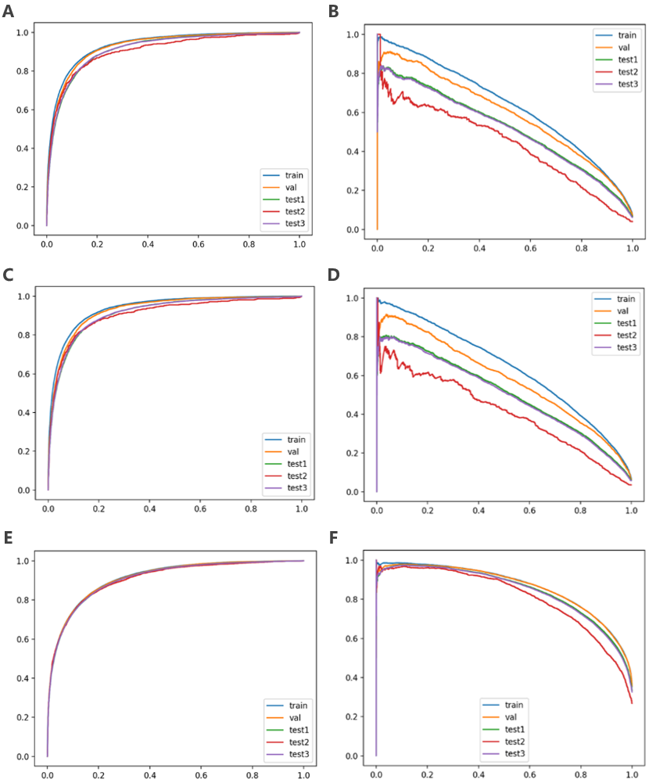
A: ROC-AUC curve under IDH1, B: PR-AUC curve under IDH1, C: ROC-AUC curve under IDH2, D: PR-AUC curve under IDH2, E: ROC-AUC curve under IDH3, F: PR-AUC curve under IDH3
Supplemental Figure 2. XGBoost models for predicting the ROC-AUC curve and PR-AUC curve under three IDH definitions.
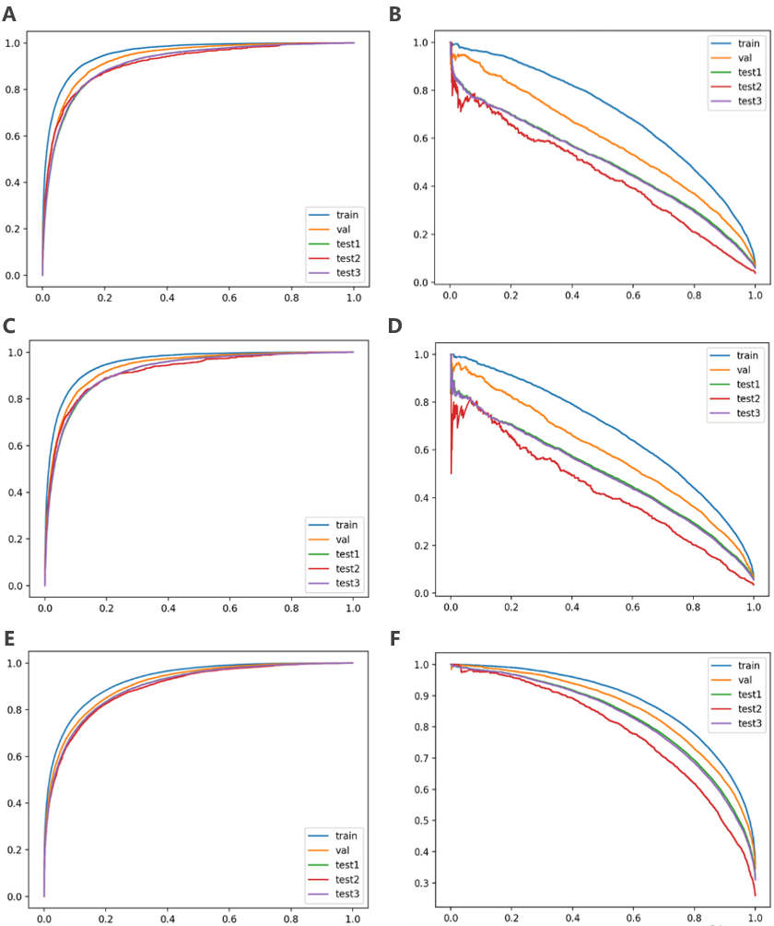
A: ROC-AUC curve under IDH1, B: PR-AUC curve under IDH1, C: ROC-AUC curve under IDH2, D: PR-AUC curve under IDH2, E: ROC-AUC curve under IDH3, F: PR-AUC curve under IDH3

Supplemental Figure 3. LightGBM models for predicting the ROC-AUC curve and PR-AUC curve under the three IDH definitions.
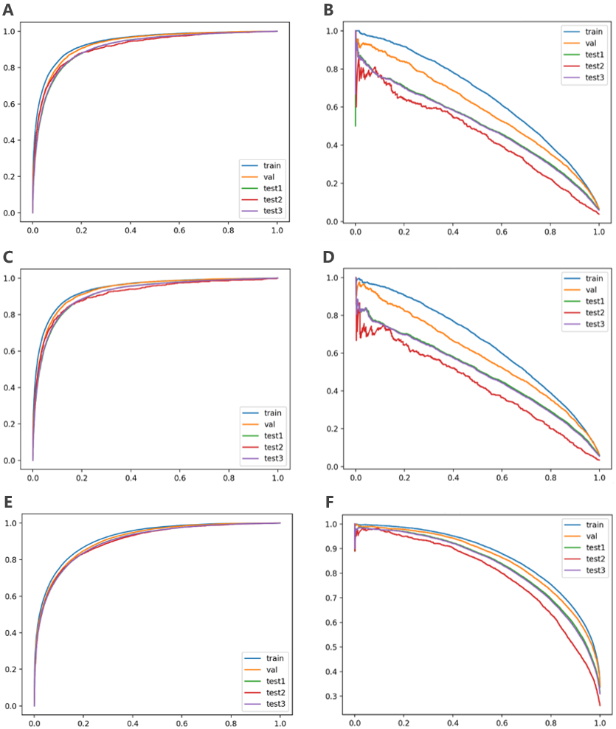
A: ROC-AUC curve under IDH1, B: PR-AUC curve under IDH1, C: ROC-AUC curve under IDH2, D: PR-AUC curve under IDH2, E: ROC-AUC curve under IDH3, F: PR-AUC curve under IDH3

Supplemental Figure 4. Platt scaling plots employed for model calibration. Figures A and B depict the calibration curves for Test Set 1 and Test Set 2 under the IDH1 definition, respectively; Figures C and D show the calibration curves for Test Set 1 and Test Set 2 under IDH2, respectively; Figures E and F present the calibration curves for Test Set 1 and Test Set 2 under IDH3, respectively. IDH, Intradialytic hypotension; RNN, recurrent neural network; XGBoost, Extreme Gradient Boosting; LightGBM, Light Gradient Boosting Machine.
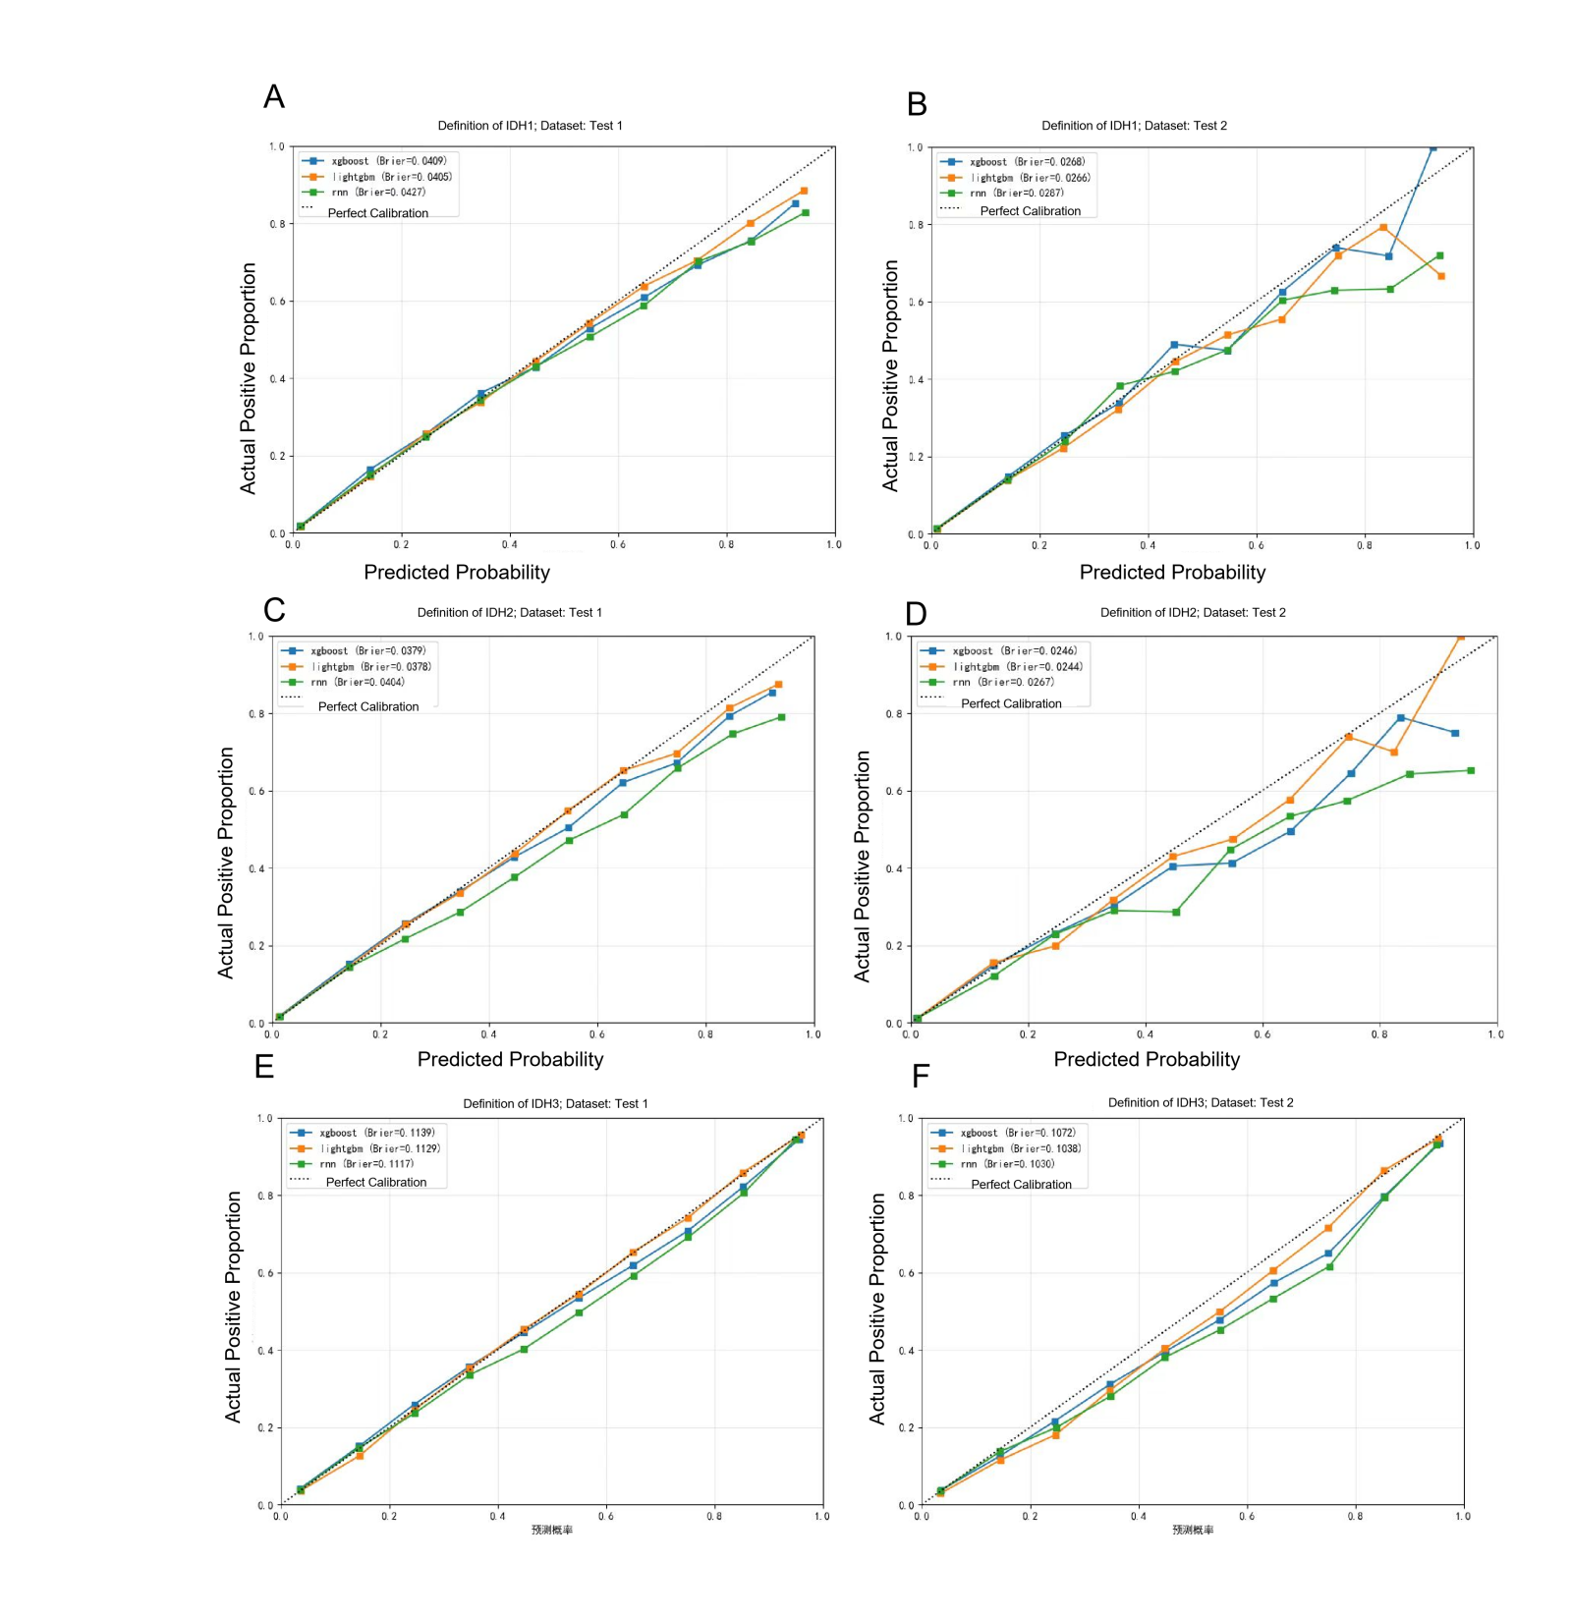
REFERENCE
1. Mao S, Sejdic E. A Review of Recurrent Neural Network-Based Methods in Computational Physiology. IEEE transactions on neural networks and learning systems 2023;34(10):6983–7003. (In eng). DOI: 10.1109/tnnls.2022.3145365.
2. Chen T, Guestrin C. XGBoost: a scalable tree boosting system. Proceedings of the 22nd ACM SIGKDD International Conference on Knowledge Discovery and Data Mining 2016;785–94. https://doi.org/10.1145/2939672. 2939785.
3. Ke G, Meng Q, Finley T, et al. Lightgbm, A highly efficient gradient boosting decision tree. Proceedings of the 31st International Conference on Neural Information Processing Systems 2017; 3149–3157.

