Supplementary Information

Ion adsorption-induced reversible polarization switching
of a van der Waals ferroelectric

Dong-Dong Xu^{1,†}, Ru-Ru Ma^{1,†}, Ai-Ping Fu³, Zhao Guan¹, Ni Zhong^{1,2*}, Hui Peng¹, Ping-Hua Xiang^{1,2*} & Chun-Gang Duan^{1,2}
¹ Key Laboratory of Polar Materials and Devices (MOE) and department of electronics, East China Normal University, Shanghai, 200241, China
² Collaborative Innovation Center of Extreme Optics, Shanxi University, Taiyuan, Shanxi 030006, China
³ State Key Laboratory of Bio-Fibers and Eco-Textiles, Qingdao University, Qingdao 266071, China
†These authors contributed equally to this work.
*Correspondence and requests for materials should be addressed to N.Z. (email: nzhong@ee.ecnu.edu.cn) or P.-H.X. (email: phxiang@ee.ecnu.edu.cn).

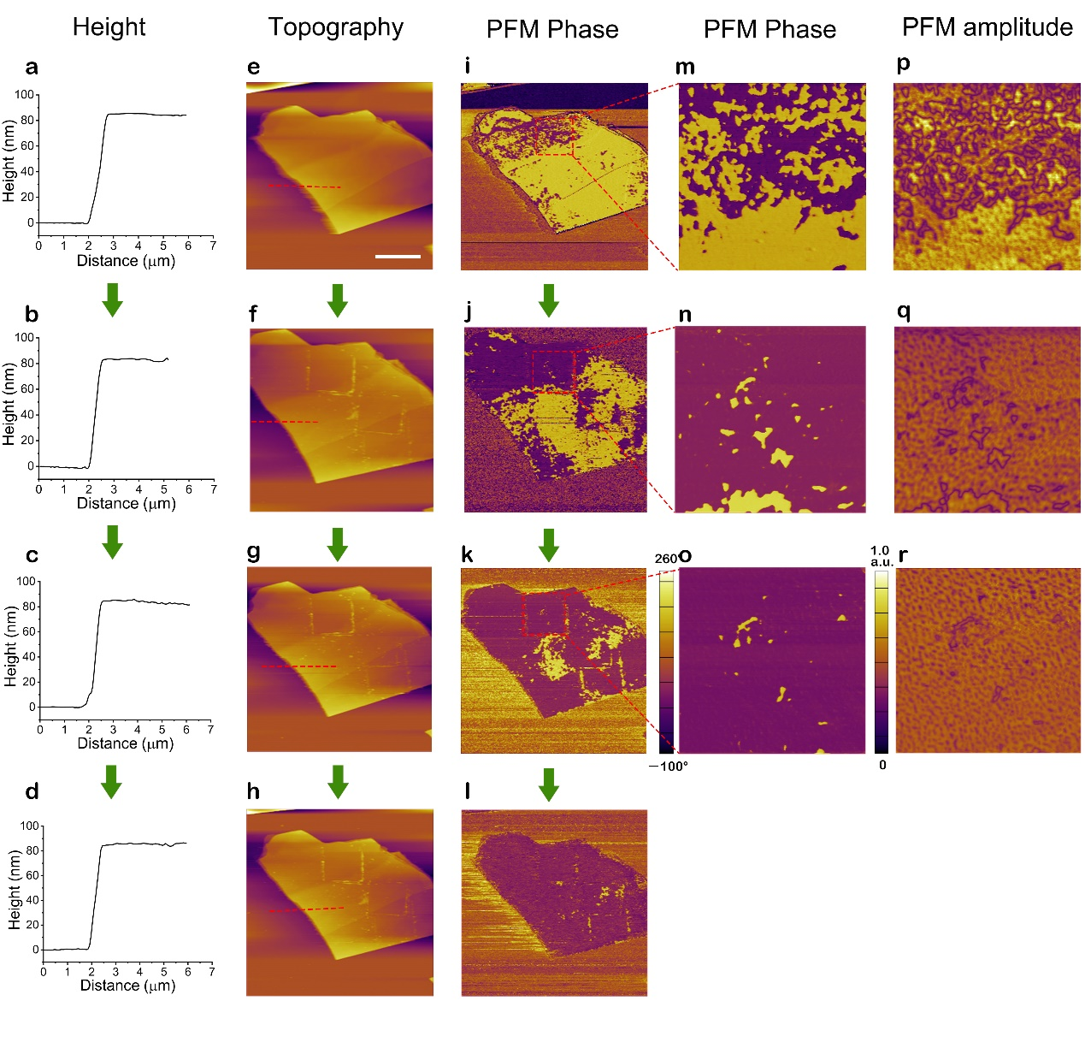
Supplementary Figure 1. Evolution of ferroelectric domains in CIPS. a-i Time evolution of the height (a-d), topography (e-h) and PFM phase images (i-l) of a 84-nm thick CIPS flake after exposure to ionic liquid [DEME][TFSI]. Scale bar in (e), 1.5 μm. m-r The enlarged local PFM phase (m-o) and amplitude signals (p-r).

Supplementary Note 1. Experimental details
- The direction of polarization. To distinguish the direction of polarization before and after treatment, the local electrical switching of CIPS has been performed for each PFM measurement as shown in Supplementary Figs. 2 and 7. Such method also confirms the well-preserved ferroelectricity after ionic liquid treatment.
- The height and topography. Except minor scraping by PFM tips, there are no changes of the height and topography before and after treatment.
- Ionic liquid. Ionic liquids usually exhibit extremely low vapor pressures (typically ≈10⁻¹⁰ Pa at 25 °C) and high thermostability. Therefore, residual moisture content can be eliminated via heating in vacuum.
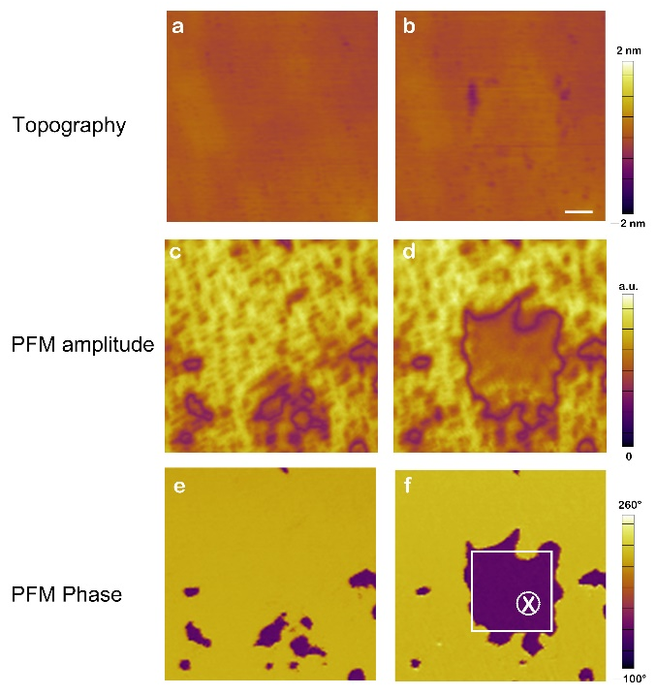
Supplementary Figure 2. Electrical switching of ferroelectric domains to identify the direction of polarization. The topography (a, b), PFM amplitude signals (c,d) and corresponding phase images (e, f) of a CIPS flake before and after applying a positive voltage. Scale bar in (d), 1 μm. The purple region corresponds to the downward polarization state.

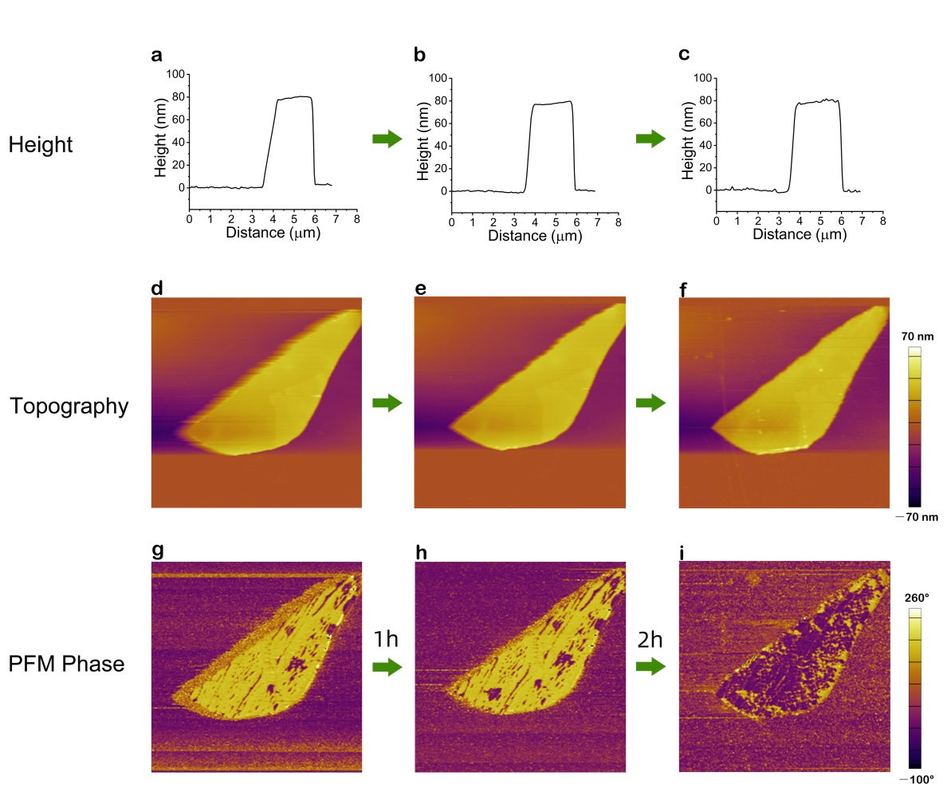
Supplementary Figure 3. Ionic liquid [DEME][TFSI]-induced large-area polarization switching of CIPS. Time evolution of the height (a-c), topography (d-f) and corresponding phase (g,h) of a 80-nm thick CIPS flake after exposure to ionic liquid [DEME][TFSI].

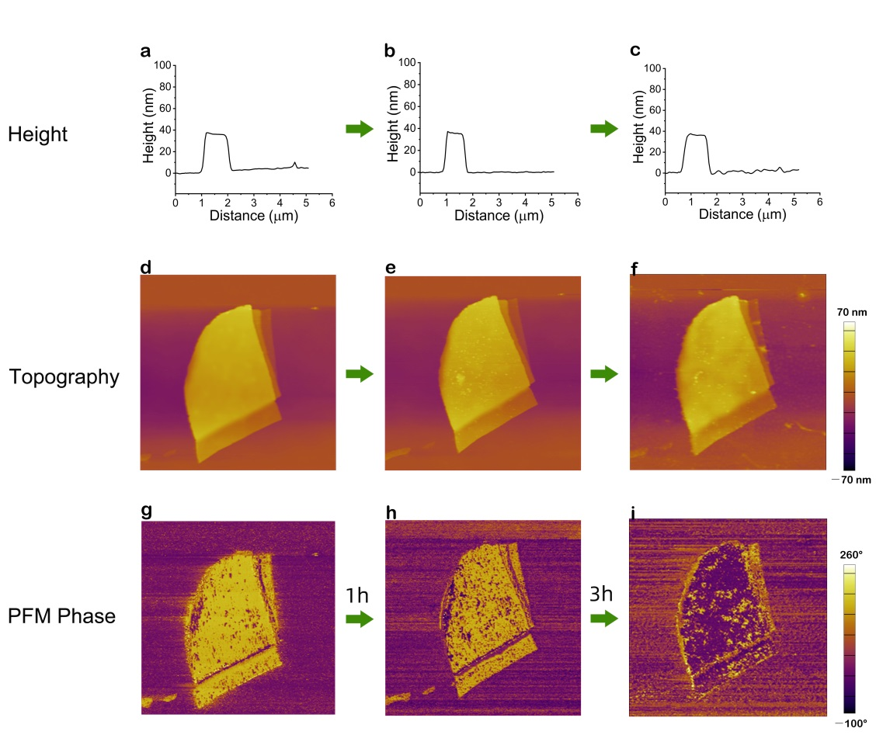
Supplementary Figure 4. Ionic liquid [DEME][TFSI]-induced large-area polarization switching of CIPS. Time evolution of the height (a-c), topography (d-f) and corresponding phase (g,h) of a 37-nm thick CIPS flake after exposure to ionic liquid [DEME][TFSI].

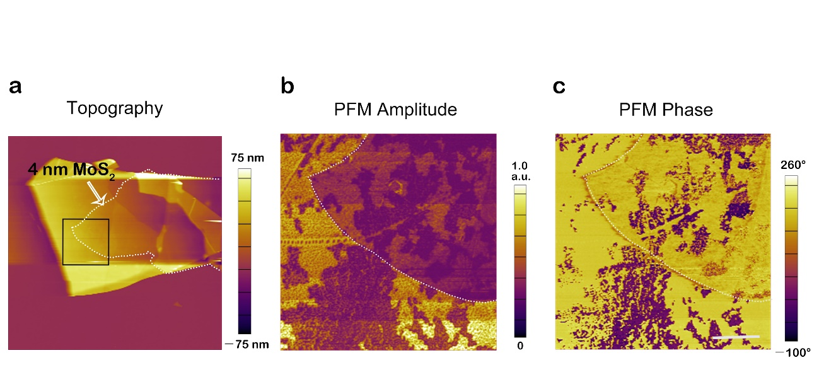
Supplementary Figure 5. The domain structures of a MoS₂/CIPS heterojunction. a a 4 nm thick MoS₂ nanoflake was placed on CIPS. b,c The corresponding PFM amplitude signals (b) and phase images (c) of the region marked in (a). These results indicate that ferroelectric domains beneath MoS₂ thin film can be detected by PFM. Scale bar in (c) is 2 μm.

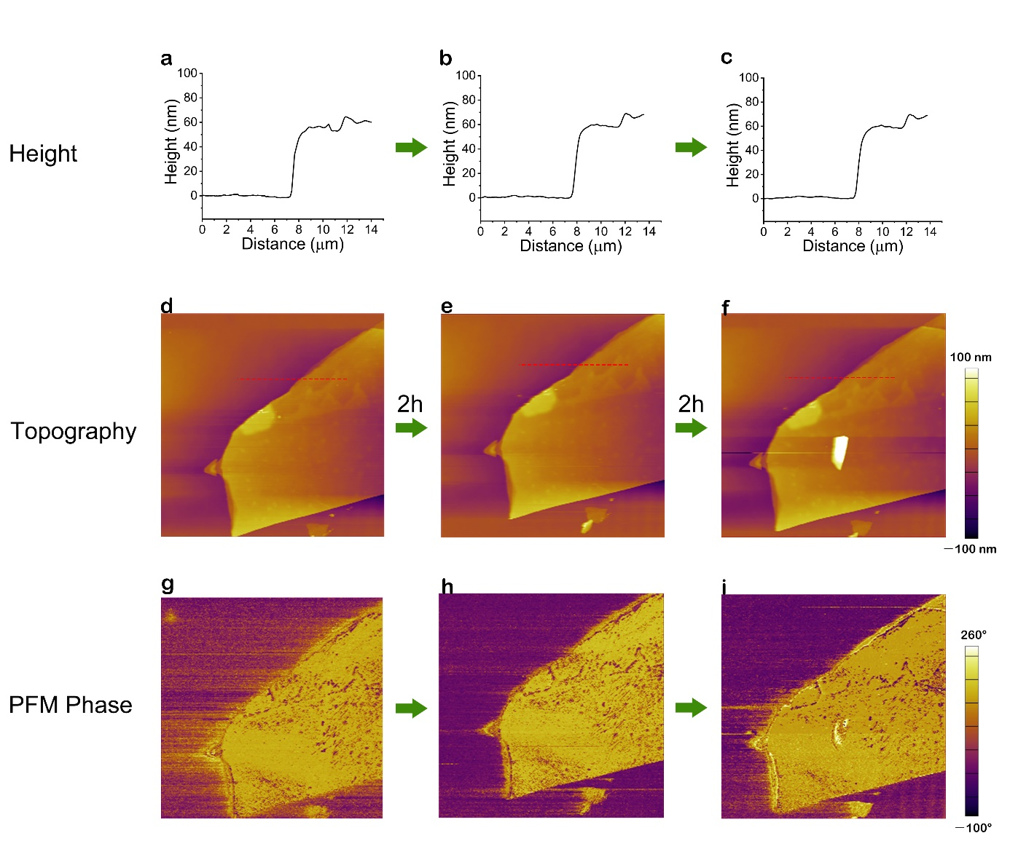
Supplementary Figure 6. Polarization states of CIPS after acidic aqueous solution treatment. Time evolution of the height (a-c), topography (d-f) and corresponding phase (g-h) of CIPS after exposure to H₂SO₄ aqueous solution (pH = 3).

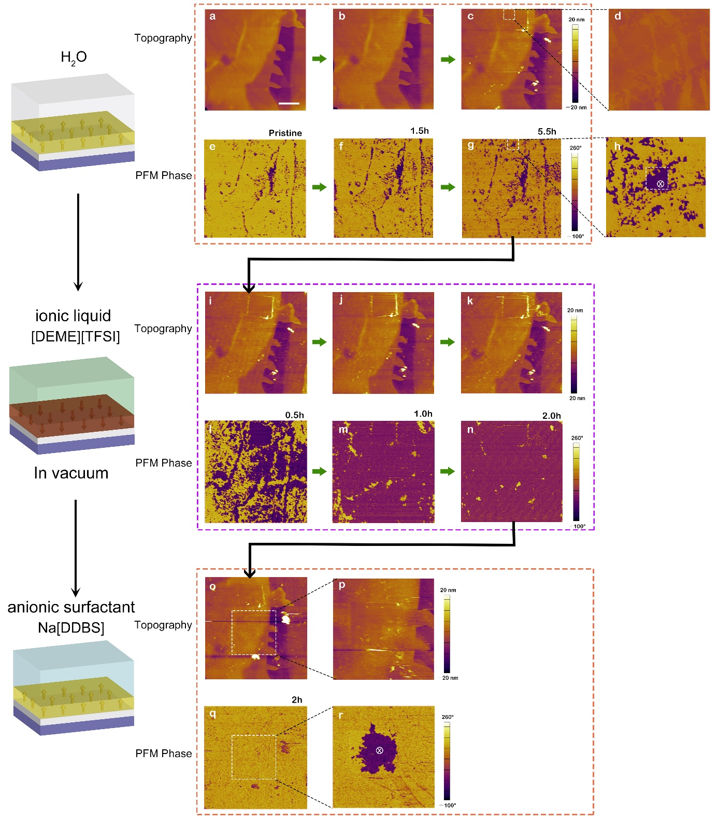
Supplementary Figure 7. Continuous experiments on the same sample using H₂O, [DEME][TFSI] and Na[DDBS], respectively. The topography (a-c, i-k, o) exhibits no change, while the corresponding PFM phase changes significantly, i.e. the polarization can not be switched obviously by H₂O (e-g), but can be reversed by ionic liquid [DEME][TFSI] (l-n) and reversed back by Na[DDBS] solution (q). The direction of polarization is distinguished by electrical switching (d and h; p and r). Scale bar in (a), 3 μm.

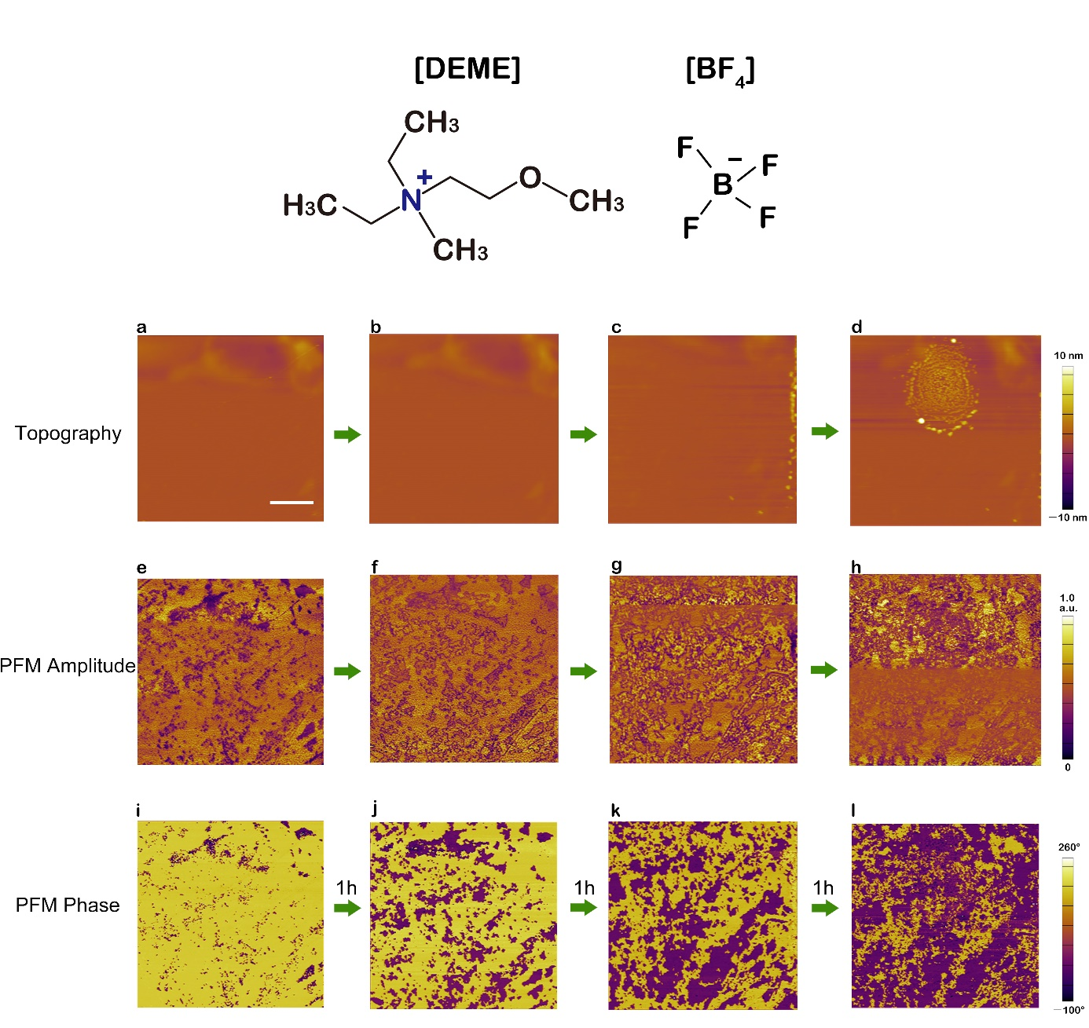
Supplementary Figure 8. Ionic liquid [DEME][BF₄]-induced polarization switching of CIPS. The molecular structure of [DEME][BF₄](up panel). Time evolution of the topography (a-d), PFM amplitude signals (e-h) and corresponding phase images (i-l) of a CIPS flake after exposure to [DEME][BF₄]. Scale bar in (d), 2.5 μm.

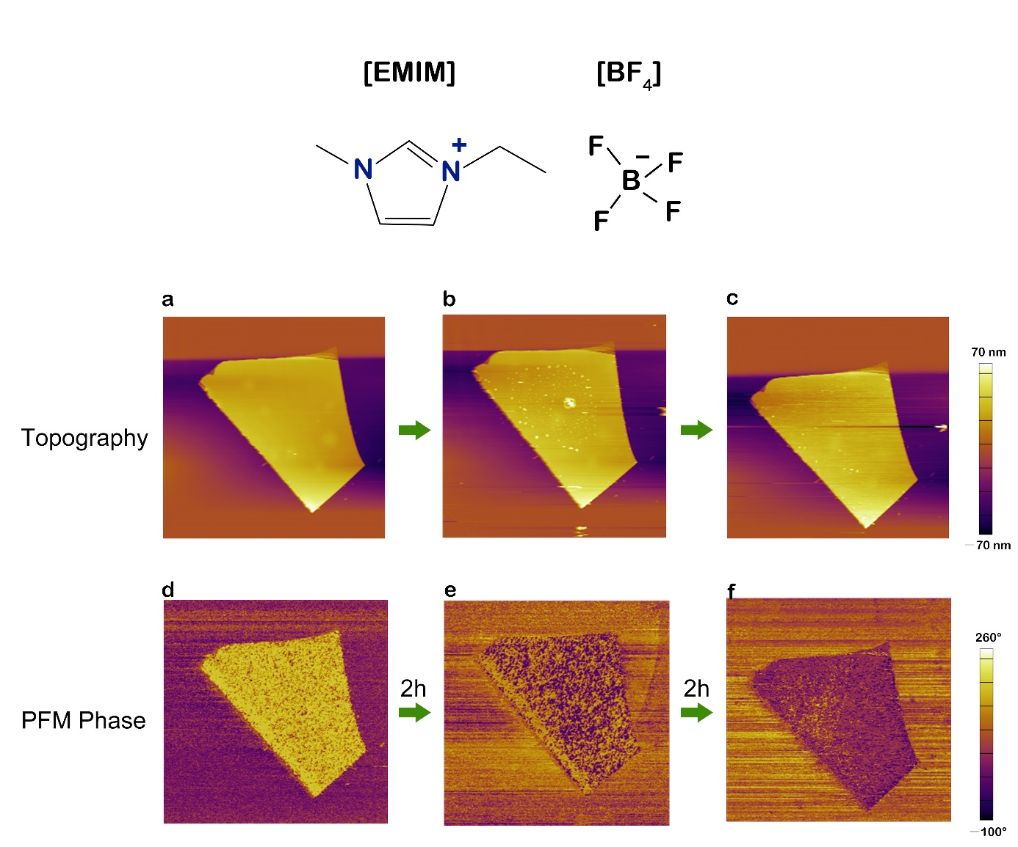
Supplementary Figure 9. Ionic liquid [EMIM][BF₄]-induced polarization switching of CIPS. The molecular structure of [EMIM][BF₄](up panel). Time evolution of the topography (a-c) and corresponding phase images (d-f) of a CIPS flake after exposure to [EMIM][BF₄].

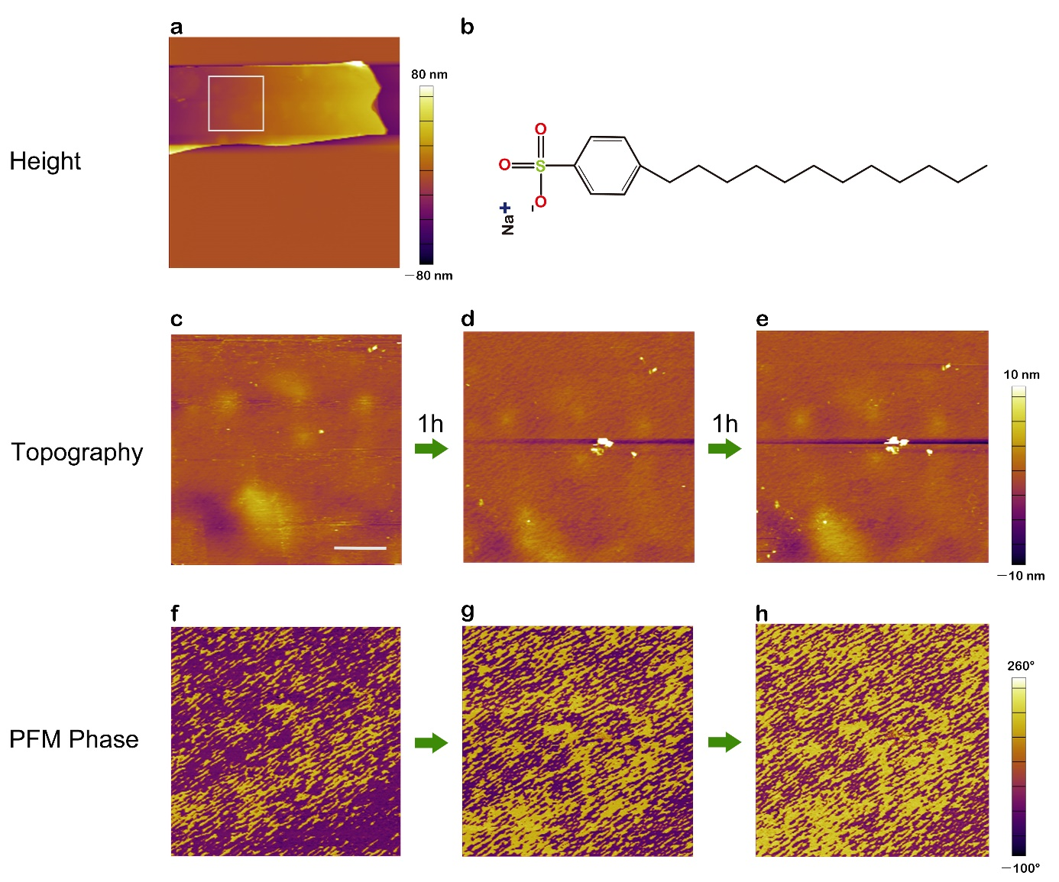
Supplementary Figure 10. Na[DDBS] solution-induced polarization switching of CIPS. a Topography of the CIPS flake used for PFM measurements in (c-h). b The molecular structure of Na[DDBS]. Time evolution of the topography (c-e) and corresponding phase images (f-h) of the CIPS flake in (a) after exposure to Na[DDBS] solution. Scale bar in (c), 2 μm.

Supplementary Figure 11. The comparison of Raman spectra before and after Na[DDBS] solution treatment.

