Supplementary materials
How Minimum Spanning tree data are transformed in a single input vector for machine learning systems processing.
Case No. 561, autism
Step 1: Minimum spanning tree
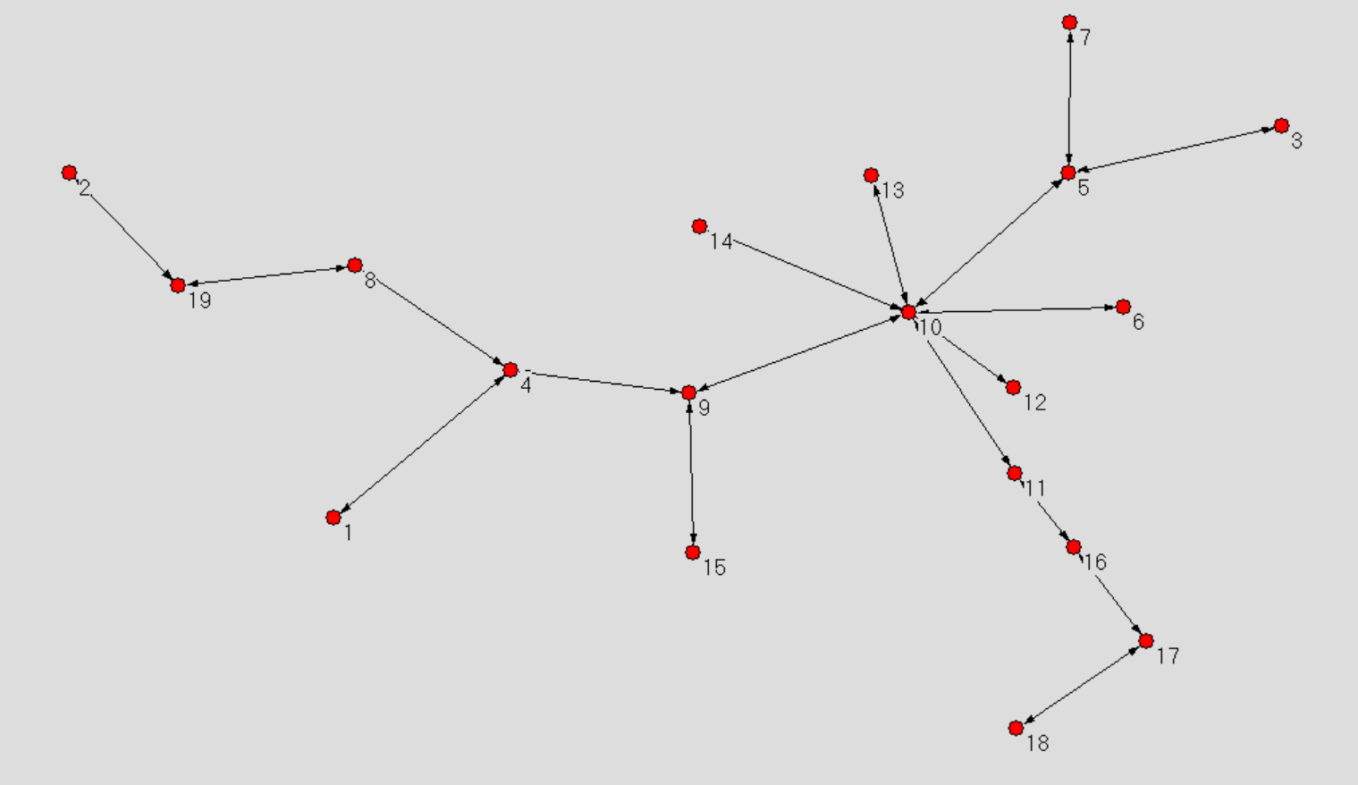

Step 2: List of Electrode number according to decreasing number of links in the map
Electrode ID | Number of links
10 | 7
5 | 3
9 | 3
4 | 3
8 | 2
11 | 2
16 | 2
17 | 2
19 | 2
2 | 1
6 | 1
12 | 1
13 | 1
14 | 1
15 | 1
7 | 1
3 | 1
18 | 1
Step 3: The two columns shown in table above are joined in a single file to form an input vector which is used to train the final classifiers.
MST data transformed in a single input vector for further analyses
Electrodes ID |  |  |  |  |  |  |  |  |  |  |  |  |  |  |  |  |  | Number of links
10 | 5 | 9 | 4 | 8 | 11 | 16 | 17 | 19 | 2 | 6 | 12 | 13 | 14 | 15 | 7 | 3 | 18 | 7 | 3 | 3 | 3 | 2 | 2 | 2 | 2 | 2 | 1 | 1 | 1 | 1 | 1 | 1 | 1 | 1 | 1

