Supplementary pictures
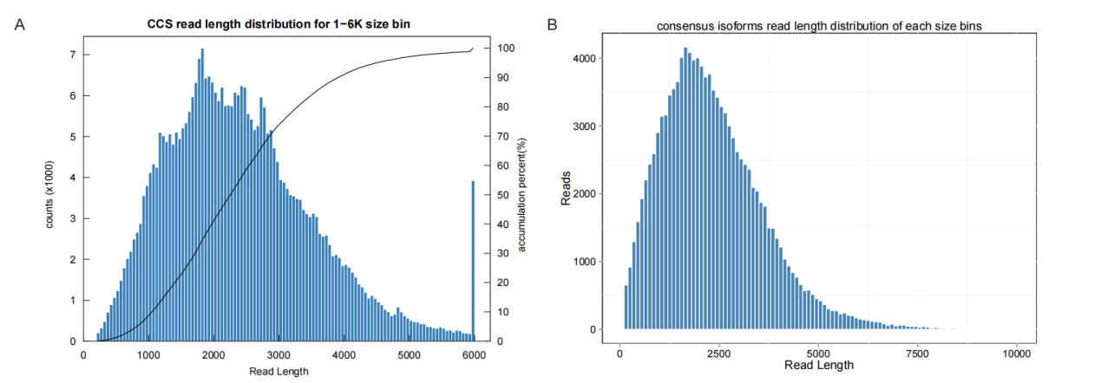
Fig S1. Full-Length Transcriptome Sequencing Quality Assessment. (A). CCS read length distribution for 1 - 6K size bin; (B). consensus isoforms read length distribution of each size bins.
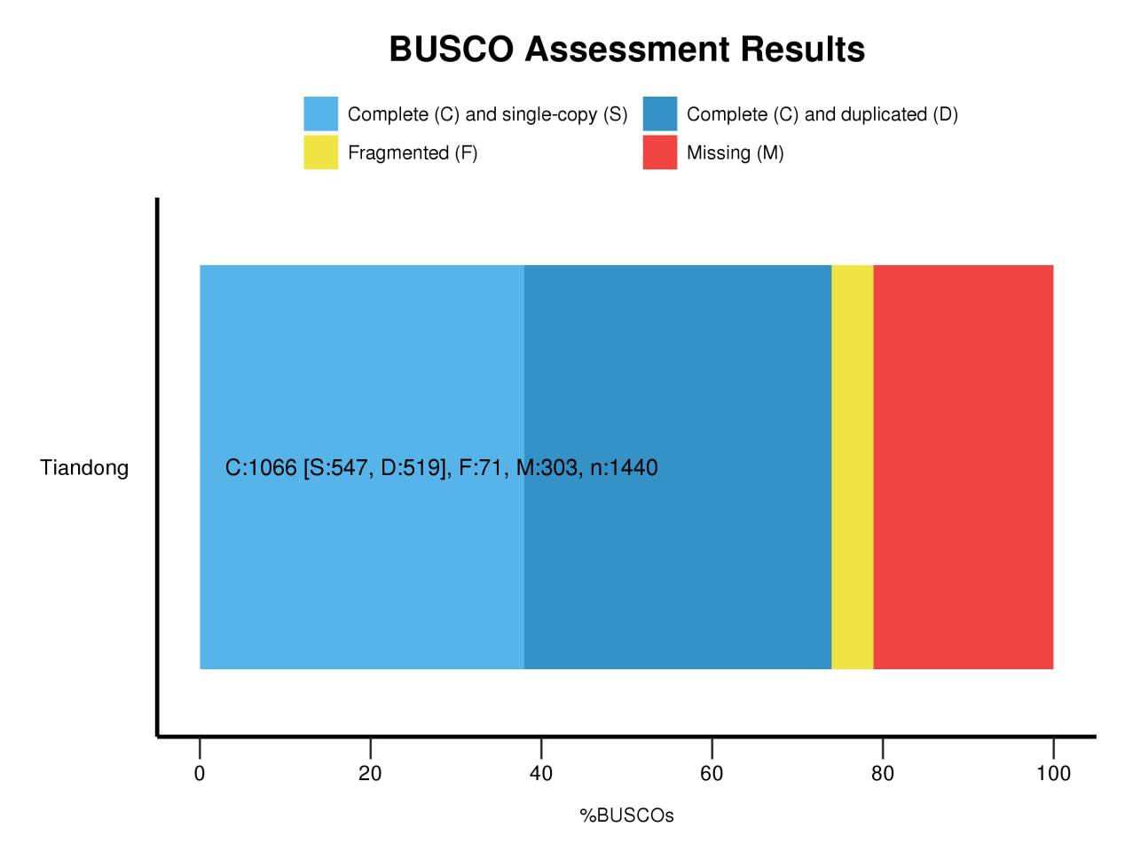
Fig S2. BUSCO Assessment Results.
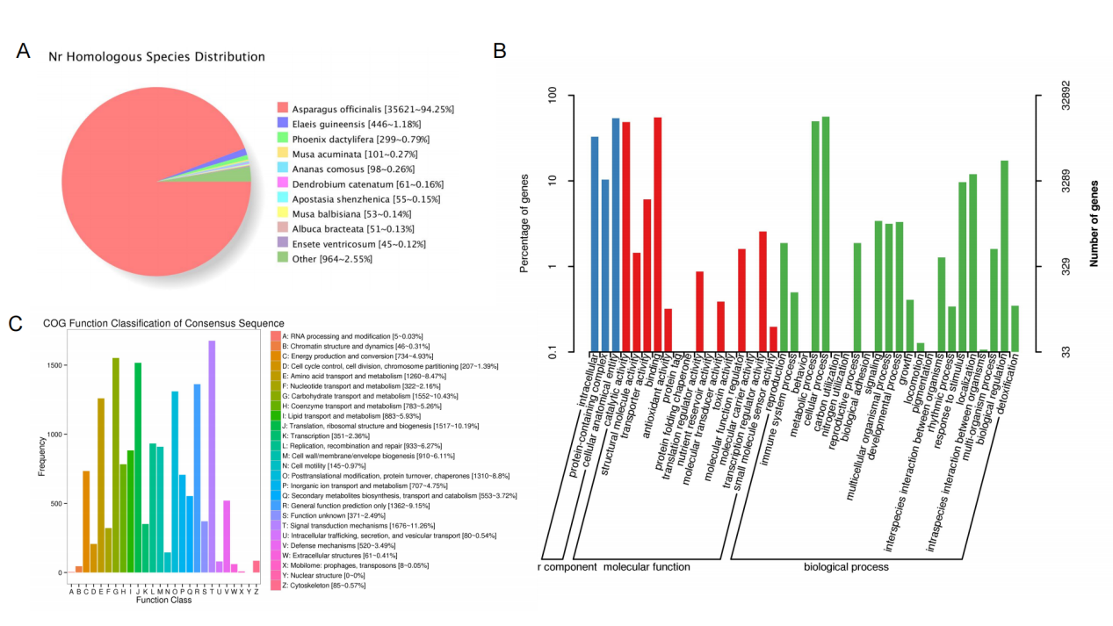
Fig S3. Functional Annotation of the A. cochinchinensis Full-Length Transcriptome. (A) Species distribution of the top BLAST hits in the NR database. (B) Histogram of Gene Ontology (GO) classification at the secondary level. (C) COG/KOG functional classification of transcripts.
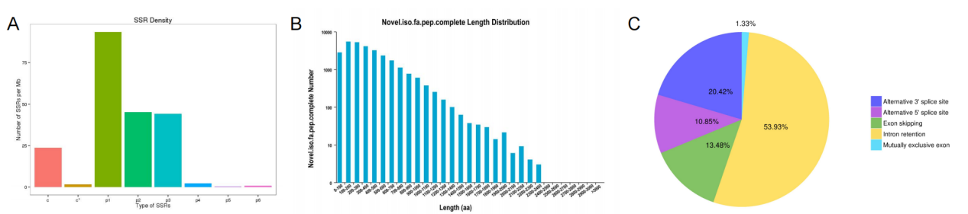
Fig S4. Structural Analysis of Novel Transcripts. (A) Distribution and frequency of different SSR types. (B) Statistics of ORF prediction showing the proportion of complete and partial ORFs. (C) Proportion of different alternative splicing (AS) events identified.
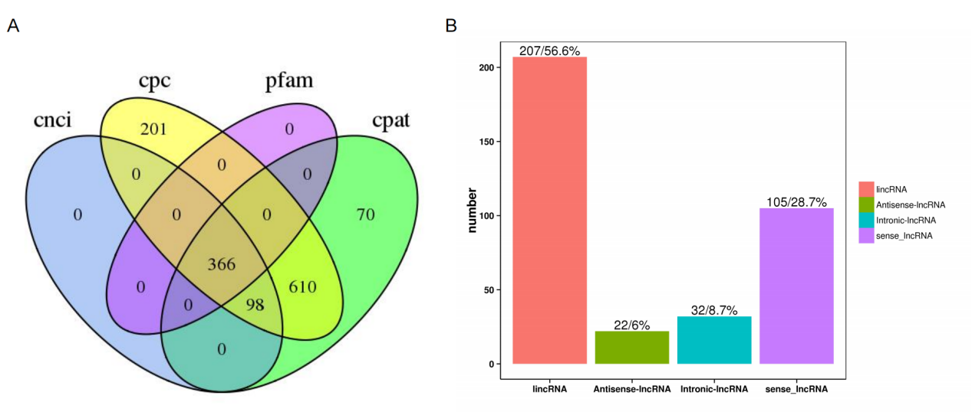
Fig S5. Identification and Classification of lncRNAs. (A) Venn diagram showing the overlap of lncRNAs predicted by four different tools (CPC2, CNCI, CPAT, Pfam). (B) Pie chart classifying the identified lncRNAs into four categories based on their genomic position.
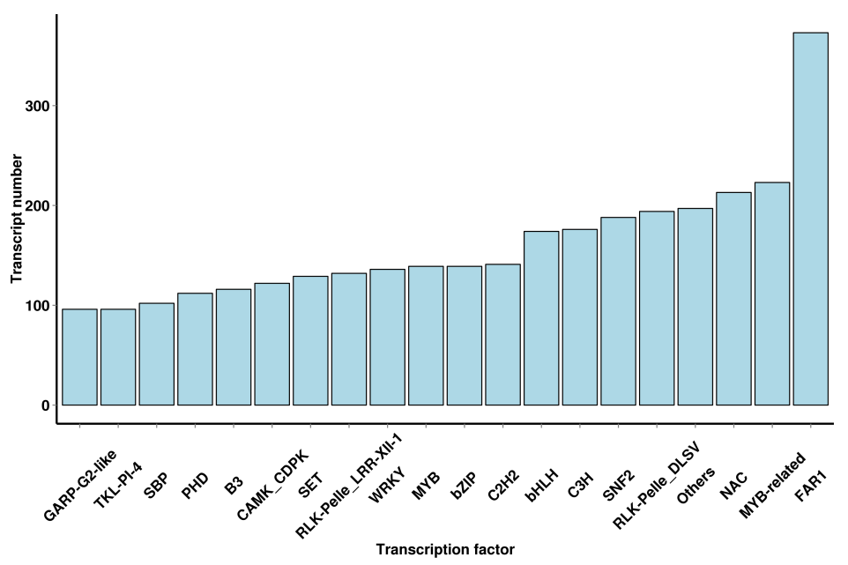
Fig S6. Transcription Factor Family Analysis. Bar plot showing the top 20 most abundant transcription factor (TF) families identified in the A. cochinchinensis transcriptome.

