Supplementary Table 1. Baseline Characteristics of Lung Transplant Recipients with Acute Respiratory Events

Characteristic | Cases (n = 21)
Sex, n (%)
Female | 6 (29)
Male | 15 (71)
Age, mean (SD), years | 44.9 (12.5)
Underlying disease, n (%)
Interstitial lung diseases (IIPs) | 7 (33)
COPD | 1 (5)
GVHD | 4 (19)
IPAH | 3 (14)
Others | 6 (29)
Donor type, n (%)
Living donor | 4 (19)
Brain-dead donor | 17 (81)
Operative procedure, n (%)
Single lung transplantation | 11 (52)
Bilateral lung transplantation | 10 (48)
Time from transplantation to study enrolment, n (%)
< 1 year | 9 (43)
1–3 years | 6 (29)
> 3 years | 6 (29)
Acute respiratory events for the hospitalization, n (%)
Pneumonia | 7 (33%)
Acute rejection | 7 (33%)
CLAD or RAS | 4 (19%)
Pleural effusion | 2 (9.5%)
Stent obstruction | 1 (4.8%)

Supplementary Figure 1. Schema of Case-Crossover study
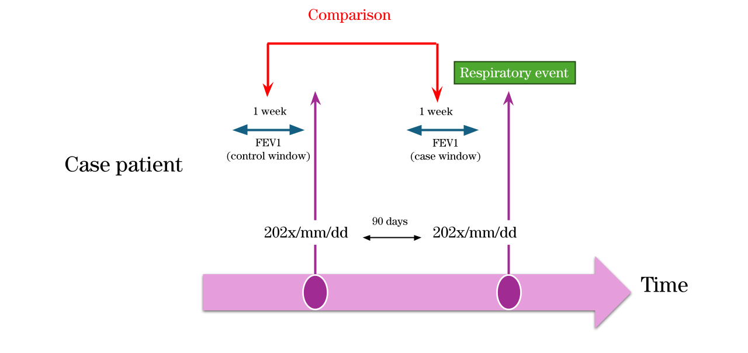Schematic representation of the case-crossover study design. For each acute respiratory event (index date), the case window was defined as the 7-day period immediately preceding the event. The control window was defined as the 7-day period located 90 days before the event. Within each individual, measurements during the case window were compared with those during the control window to assess within-person differences in algorithm-detected abnormalities while controlling for time-invariant confounders.

Supplementary Figure 2. Flow Chart of participants

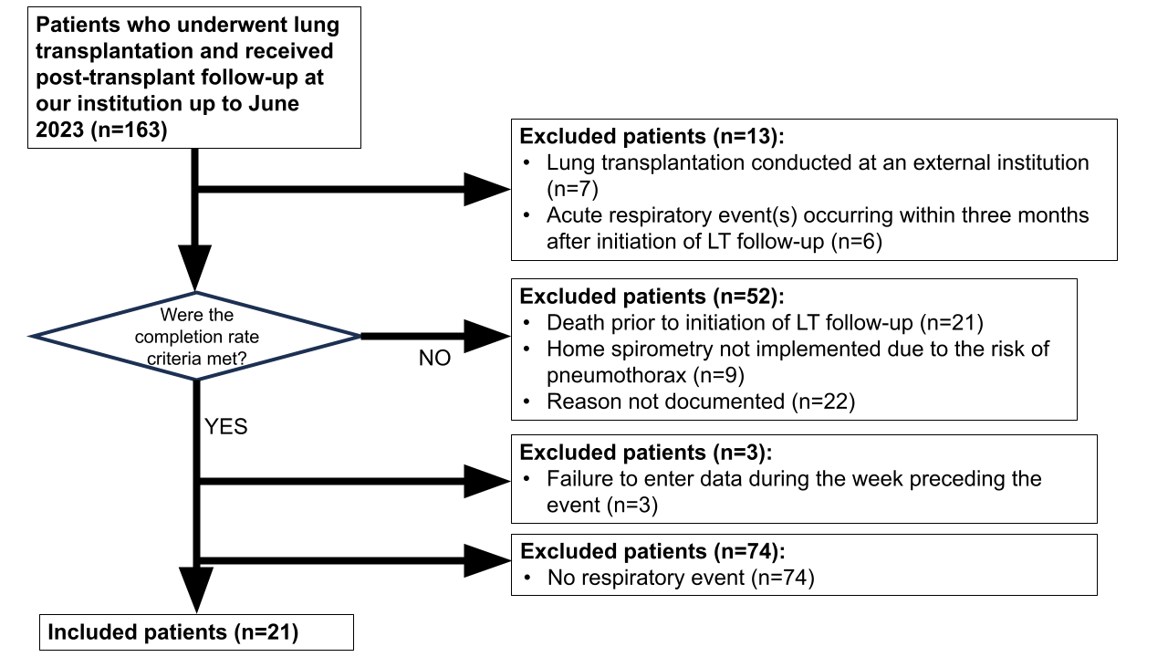

Flow chart illustrating the selection of lung transplant recipients included in the analysis. Among patients enrolled in the LT-FollowUp home spirometry program, those with at least 90 days of post-transplant follow-up data were screened. Episodes with incomplete spirometry records or insufficient baseline data were excluded. Acute respiratory events were identified based on predefined clinical criteria.

