Electronic Supporting Information

Associative and dissociative adsorption of N₂O molecule over C₂₄ fullerene doped with V, Mn, Ru, Pd and Rh: A DFT investigation

Meryem Derdare, Abdel-Ghani Boudjahem *

Computational Catalysis Group, Laboratory of Applied Chemistry, University of Guelma, Box 401, 24000, Guelma, Algeria

* Corresponding author
Computational Catalysis Group, Laboratory of Applied Chemistry, University of Guelma, Box 401, 24000, Guelma, Algeria
E-mail address: Boudjahem@yahoo.fr (A. Boudjahem)

Figure S1. The most stable adsorption configurations, electron density difference (EDD) isosurfaces and density of states for the complexes formed between the RuC₂₄ cluster and the N₂O molecule (I, J and K states).
I
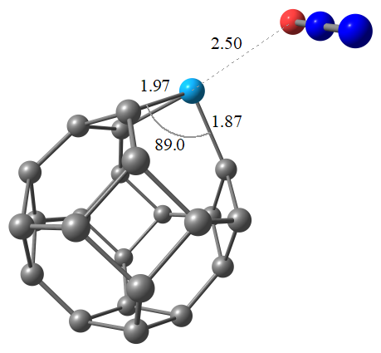
J
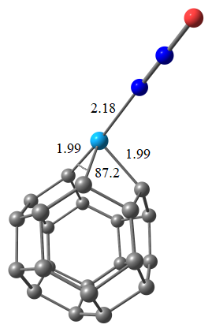
K
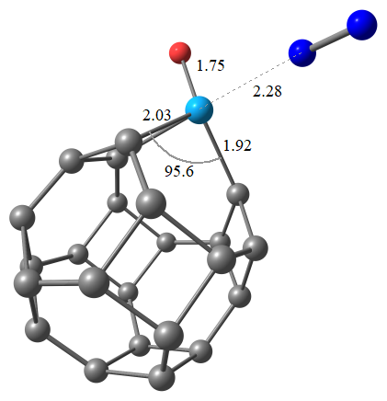

Figure S2. The most stable adsorption configurations, electron density difference (EDD) isosurfaces and density of states for the complexes formed between the PdC₂₄ cluster and the N₂O molecule (L, M and P states).
L
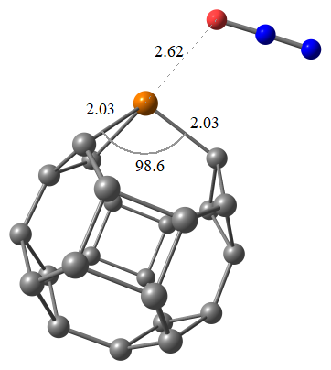
M
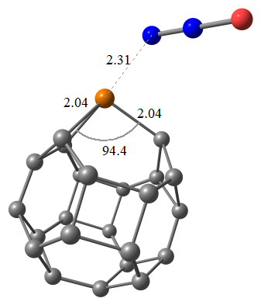
P
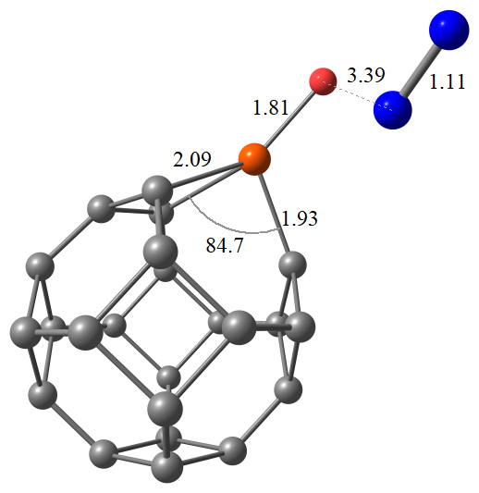
Figure S3. The most stable adsorption configurations, electron density difference (EDD) isosurfaces and density of states for the complexes formed between the RhC₂₄ cluster and the N₂O molecule (Q, R and S states).
Q
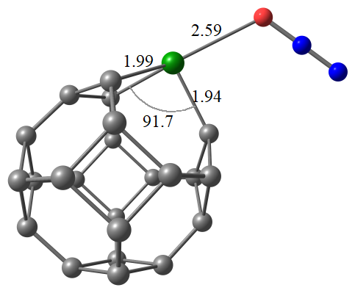
R
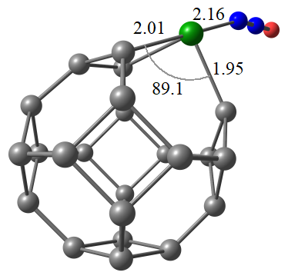
S
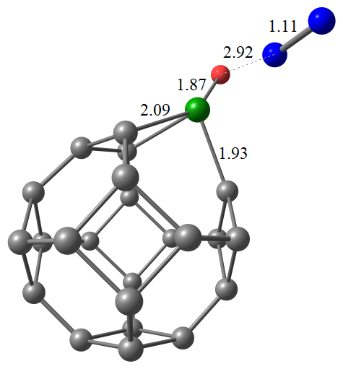

Figure S4. The most stable adsorption configurations, electron density difference (EDD) isosurfaces and density of states for the complexes formed between the AuC₂₄ cluster and the N₂O molecule (T and W states).
T
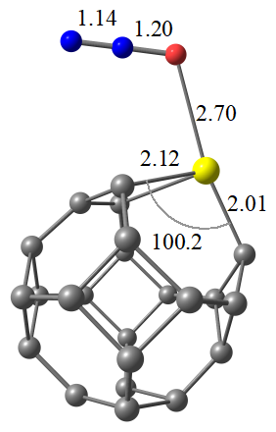
W
