Supplementary Material
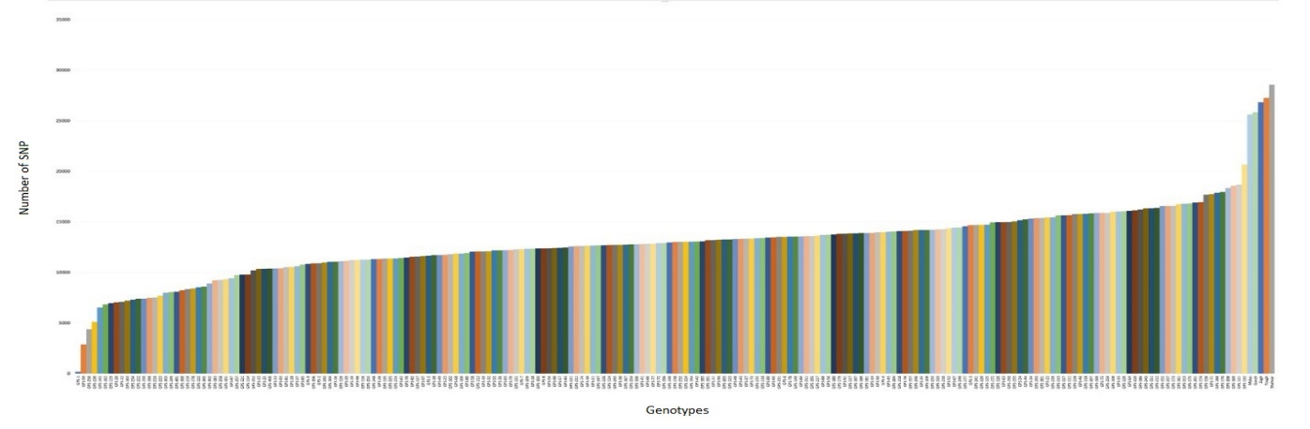

Supplementary Figure S1. Raw number of SNPs for all Iranian pomegranate samples without filtering

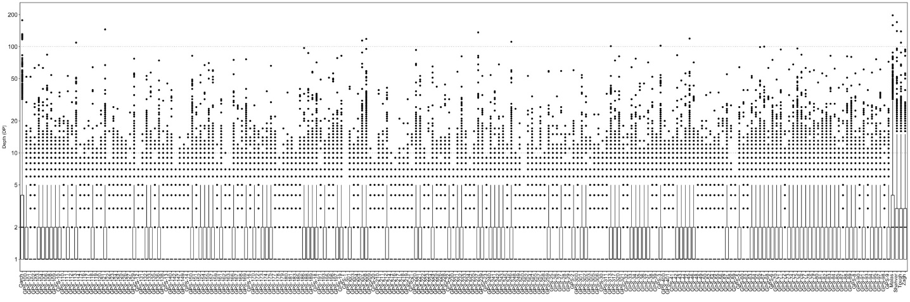

Supplementary Figure S2. Sequence depth by sample for all studied pomegranate genotypes

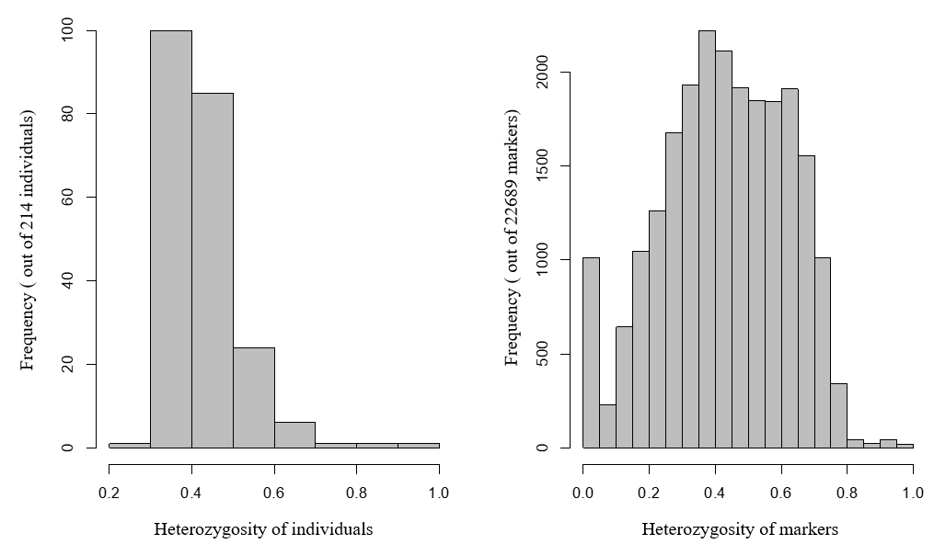

Supplementary Figure S3. Heterozygosity of pomegranate individuals and SNP markers among whole evaluated population.
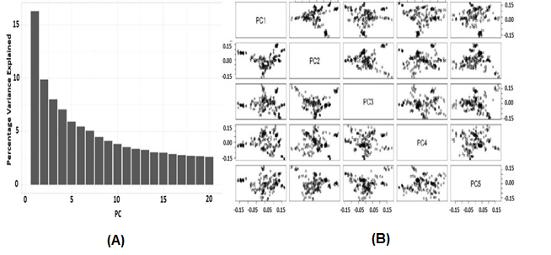

Supplementary Figure S4. Percentage of variance among Iranian pomegranate population justified by the first 20 PCs using principal component analysis based on SNP markers (A); the multi-dimensional scale plot of 214 Iranian pomegranate individuals based on the first 5 PCs (B).

Supplementary Table S1. Description of the evaluated Iranian pomegranate genotypes consisting of their name, identification cod and group.
Genotype Code | Group | Genotype Code | Group | Genotype Code | Group
GPS-1 | Ornamental- Pharmaceutical¹ | GPS-82 | Base | GPS-180 | Ornamental- Pharmaceutical
GPS-2 | Ornamental- Pharmaceutical | GPS-83 | Wild | GPS-181 | Base
GPS-3 | Base² | GPS-84 | Wild | GPS-183 | Base
GPS-4 | Commercial³ | GPS-85 | Base | GPS-185 | Base
GPS-5 | Commercial | GPS-87 | Base | GPS-186 | Base
GPS-6 | Base | GPS-88 | Base | GPS-188 | Base
GPS-7 | Commercial | GPS-89 | Wild | GPS-189 | Base
GPS-8 | Base | GPS-90 | Commercial | GPS-191 | Base
GPS-9 | Base | GPS-91 | Wild | GPS-193 | Wild
GPS-10 | Base | GPS-93 | Ornamental- Pharmaceutical | GPS-195 | Base
GPS-11 | Commercial | GPS-94 | Wild | GPS-196 | Base
GPS-12 | Base | GPS-95 | Base | GPS-197 | Base
GPS-13 | Commercial | GPS-97 | Base | GPS-201 | Ornamental- Pharmaceutical
GPS-14 | Ornamental- Pharmaceutical | GPS-98 | Wild | GPS-203 | Wild
GPS-15 | Commercial | GPS-100 | Base | GPS-204 | Base
GPS-16 | Ornamental- Pharmaceutical | GPS-101 | Base | GPS-207 | Base
GPS-18 | Base | GPS-102 | Ornamental- Pharmaceutical | GPS-208 | Commercial
GPS-19 | Base | GPS-103 | Commercial | GPS-209 | Wild
GPS-20 | Ornamental- Pharmaceutical | GPS-104 | Commercial | GPS-210 | Base
GPS-21 | Wild⁴ | GPS-106 | Commercial | GPS-211 | Base
GPS-22 | Base | GPS-108 | Commercial | GPS-212 | Wild
GPS-23 | Base | GPS-109 | Base | GPS-214 | Base
GPS-24 | Commercial | GPS-110 | Base | GPS-216 | Commercial
GPS-25 | Base | GPS-111 | Commercial | GPS-217 | Commercial
GPS-26 | Commercial | GPS-112 | Base | GPS-218 | Commercial
GPS-27 | Base | GPS-113 | Base | GPS-219 | Base
GPS-28 | Base | GPS-114 | Commercial | GPS-220 | Base
GPS-29 | Base | GPS-116 | Base | GPS-221 | Ornamental- Pharmaceutical
GPS-30 | Wild | GPS-117 | Base | GPS-222 | Base
GPS-32 | Wild | GPS-118 | Base | GPS-223 | Wild
GPS-33 | Commercial | GPS-119 | Ornamental- Pharmaceutical | GPS-224 | Base
GPS-34 | Commercial | GPS-120 | Base | GPS-225 | Base
GPS-35 | Wild | GPS-121 | Ornamental- Pharmaceutical | GPS-226 | Base
GPS-36 | Base | GPS-122 | Base | GPS-228 | Base
GPS-37 | Commercial | GPS-123 | Base | GPS-230 | Ornamental- Pharmaceutical
GPS-38 | Commercial | GPS-124 | Commercial | GPS-231 | Base
GPS-39 | Wild | GPS-125 | Base | GPS-232 | Base
GPS-41 | Commercial | GPS-126 | Base | GPS-233 | Base
GPS-42 | Base | GPS-127 | Base | GPS-234 | Ornamental- Pharmaceutical
GPS-43 | Base | GPS-129 | Base | GPS-235 | Base
GPS-44 | Base | GPS-131 | Ornamental- Pharmaceutical | GPS-237 | Base
GPS-45 | Wild | GPS-132 | Base | GPS-239 | Base
GPS-46 | Commercial | GPS-133 | Base | GPS-240 | Wild
GPS-48 | Base | GPS-135 | Base | GPS-241 | Wild
GPS-49 | Base | GPS-136 | Commercial | GPS-242 | Base
GPS-50 | Wild | GPS-138 | Base | GPS-243 | Base
GPS-52 | Commercial | GPS-140 | Base | GPS-245 | Base
GPS-54 | Wild | GPS-142 | Base | GPS-246 | Base
GPS-55 | Base | GPS-147 | Base | GPS-248 | Base
GPS-56 | Wild | GPS-149 | Base | GPS-249 | Commercial
GPS-57 | Base | GPS-150 | Base | GPS-250 | Ornamental- Pharmaceutical
GPS-58 | Wild | GPS-151 | Base | GPS-252 | Commercial
GPS-59 | Ornamental- Pharmaceutical | GPS-152 | Ornamental- Pharmaceutical | GPS-254 | Base
GPS-60 | Ornamental- Pharmaceutical | GPS-154 | Unknown | GPS-255 | Base
GPS-62 | Wild | GPS-155 | Base | GPS-257 | Base
GPS-63 | Base | GPS-157 | Base | GPS-258 | Base
GPS-64 | Commercial | GPS-159 | Base | GPS-259 | Base
GPS-65 | Wild | GPS-161 | Base | GPS-300 | Commercial
GPS-67 | Commercial | GPS-162 | Base | GPS-301 | Base
GPS-68 | Commercial | GPS-163 | Unknown | GPS-302 | Base
GPS-70 | Base | GPS-166 | Base | GPS-303 | Base
GPS-71 | Base | GPS-167 | Base | GPS-305 | Base
GPS-72 | Commercial | GPS-168 | Base | GPS-306 | Base
GPS-73 | Base | GPS-169 | Base | GPS-311 | Base
GPS-74 | Wild | GPS-170 | Wild | GPS-313 | Commercial
GPS-75 | Commercial | GPS-172 | Ornamental- Pharmaceutical | GPS-317 | Base
GPS-76 | Base | GPS-173 | Base | GPS-320 | Commercial
GPS-77 | Base | GPS-174 | Unknown | GPS-321 | Commercial
GPS-78 | Base | GPS-175 | Base | GPS-400 | Base
GPS-79 | Base | GPS-177 | Base | GPS-401 | Commercial
GPS-80 | Base | GPS-178 | Base
GPS-81 | Commercial | GPS-179 | Base

¹-Ornamental-Pharmaceutical group genotypes: They are mainly used for medicine or even processed, while some of them are considered ornamental and decorative due to the special shape of the fruit and the type of different parts of the tree.
²-Base group genotypes: At the time of initial collection, they were present in second grade orchards, in other words, they do not produce commercial fruit, but due to conventional planting in the region, they had moderate harvest and consumption.
³-Commercial group genotypes: Genotypes of this group have cultivar names in different regions and are cultivated in economic gardens and have good transportation and storage capabilities.
⁴-Wild group genotypes: Genotypes of this group were originally collected from mountainous or forest areas, and because they had spontaneous growth, specific pruning and training was not done in them and they do not have suitable fruit quality.

Supplementary Table S2. Genome data used to perform data analysis NCBI txid22663 ASM765513v2
Molecule | RefSeq | Total Length | Size (Mb) | Scaffold Count | Ungapped Length | Scaffold N50 | Spanned  Gaps | Unspanned  Gaps
All | -- | 320335647 | 320.34 | 473 | 320316847 | 39957110 | 188 | 0
Chromosome 1 | NC_045127.1 | 55558335 | 55.56 | 1 | 55554035 | 55558335 | 43 | 0
Chromosome 2 | NC_045128.1 | 44568936 | 44.57 | 1 | 44565436 | 44568936 | 35 | 0
Chromosome 3 | NC_045129.1 | 39957110 | 39.96 | 1 | 39954610 | 39957110 | 25 | 0
Chromosome 4 | NC_045130.1 | 40126936 | 40.13 | 1 | 40125436 | 40126936 | 15 | 0
Chromosome 5 | NC_045131.1 | 31533359 | 31.53 | 1 | 31531559 | 31533359 | 18 | 0
Chromosome 6 | NC_045132.1 | 28327254 | 28.33 | 1 | 28325254 | 28327254 | 20 | 0
Chromosome 7 | NC_045133.1 | 28781120 | 28.78 | 1 | 28779220 | 28781120 | 19 | 0
Chromosome 8 | NC_045134.1 | 27994861 | 27.99 | 1 | 27993561 | 27994861 | 13 | 0
unplaced | . | 23487736 | 23.49 | 465 | 23487736 | 66592 | 0 | 0

