Supporting Information
Unravelling the Descriptors of Intracrystalline Diffusion and Al Location on Hollow Zeolite Nanosheets for Target Acid-Base Co-Catalyzed Reaction
Zhe Hong ^{a, 1, *}, Lei Miao ^{b, c, 1}, Chuanfang Xiong ^{d}, Chao Gu ª, Na Li ª, Fangtao Huang ^{b}, Zhirong Zhu ^{b, *}, Lei Li ^{a, *}
ª College of Biological, Chemical Sciences and Engineering, Jiaxing University, Jiaxing, Zhejiang, 314001, China;
^{b} School of Chemical Science and Engineering, Tongji University, Shanghai 200092, China;
^{c} Guangzhou Institute for Food Inspection, Guangzhou, 511400, China;
^{d} Jiaxing Ecological Environment Emergency Monitoring and Accident Investigation Center, Jiaxing 314000, China

* Corresponding authors.
E-mail addresses: hongzhe@zjxu.edu.cn (Zhe Hong); zhuzhirong@tongji.edu.cn (Zhirong Zhu). leili@mail.zjxu.edu.cn (Lei Li)
¹ These authors contributed equally to this work.

Table of Contents
S1. Experimental Procedures
S2. Supplementary Figures
S3. Supplementary Tables
S4. Supplementary References
S1 Experimental Procedures
S1.1 Samples Preparation
Synthesis of NaZ5-C and NaZ5-U samples. The parent Na-type ZSM-5 (NaZ5-C and NaZ5-U) samples were prepared via a hydrothermal crystallization process as follows. Firstly, 25% tetrapropylammonium hydroxide (TPAOH), tetraethyl orthosilicate (TEOS) and deionized water were mixed and stirred at 30 ºC to obtain a clear gel. Then, the NaAlO₂ and urea were added dropwise to above solution under vigorous stirring, the molar composition of the precursor gel was SiO₂: Al₂O₃: TPAOH: H₂O: urea = 50: 1: 90: 1200: x (x = 0 and 20). Finally, the precursor gel was transferred to a Teflon-lined autoclave, followed by heating at 170 ºC for 72 h in a rotary oven. The solid product was obtained by filtration, washing, and drying at 120 ºC for 12 h. Calcination process was carried out at 540 ºC for 6 h to remove the template. The resulting Na-type ZSM-5 samples with the urea molar ratios in precursor gel of 0 and 20 were denoted as NaZ5-C and NaZ5-U, respectively.
Synthesis of NaZ5-C-AT and NaZ5-U-AT samples. NaZ5-C-AT and NaZ5-U-AT samples were synthesized via alkali-treatment process. Typically, NaZ5-C and NaZ5-U samples were added to 0.15 M TPAOH aqueous solution (10 mL of solution per gram of zeolite). The mixture was placed in a Teflon autoclave and heated at 170 ºC for 48 h. The resulting solid was recovered by centrifugation, washed with distilled water, and dried at 120 ºC. Finally, the template was removed by calcination in air at 540 ºC for 6 h. The NaZ5-C and NaZ5-U after alkali-treatment process were denoted as NaZ5-C-AT and NaZ5-U-AT, respectively.
Synthesis of Cs modified catalysts. It has been widely reported that Cs species is necessary for side-chain alkylation reaction. Hence, above Na-type ZSM-5 samples were ion-exchanged with aqueous solutions of CsNO₃ via exchange procedures. Typically, NaZ5-C, NaZ5-U, NaZ5-C-AT and NaZ5-U-AT were ion-exchanged at 80 ºC for 4 h with a 0.1 M solution of Cs⁺ (5 mL of solution per gram of zeolite). The powder samples were collected by thoroughly washing, centrifugation, and drying at 120 ºC for 12 h. This ion-exchange process was repeated three times, followed by a calcination step at 540 ºC for 6 h. The resultant Cs⁺-exchanged samples were denoted as CsZ5-C, CsZ5-U, CsZ5-C-AT and CsZ5-U-AT, respectively. For comparison of the catalytic performance, commercial Cs-ZSM-5 and Cs-X sample were also obtained from Na-ZSM-5 (Nankai Zeolites Company, Si/Al = 25) and Na-X (Nankai Zeolites Company, Si/Al = 1.3) using the same Cs⁺-exchange procedures as description above.
Synthesis of SiO₂ modified catalyst. SiO₂ surface modified CsZ5-U was prepared by the chemical liquid phase deposition (CLD) method. Typically, 10 g of the CsZ5-U catalyst was added to the mixture solution of 100 g hexane and 10.42 g TEOS, and then stirred for 4 h. The obtained product was dried at 80 ºC overnight and calcined at 540 ºC for 2 h. The surface modification procedure was conducted 2 times, and the final catalyst was denoted as “CsZ5-U-Si”.
S1.2 Catalysts characterization
The X-ray diffraction (XRD) patterns were collected on a Bruker D8 diffractometer using CuKα radiation 439 (λ = 1.5418 Å) from a generator operating at 30 kV and 10 mA. The specific surface area was determined by N₂ adsorption using a Micromeritics TriStar II 2020 instrument, and then calculated using the Brunauer-Emmett-Teller (BET) method. Micropore volumes (V_{micro}) were calculated by the t-plot method. The total volume was taken from the adsorbed N₂ volume at a P/P₀ = 0.99.
The morphology of the catalyst was observed by Scanning electron microscopy (SEM) images. Manufacturer: Hitachi S-5500 instrument with a 10 kV acceleration voltage. High resolution transmission electron microscopy (HRTEM) images were measured on a field emission transmission electron microscope (JEM 2100F, JEOL). Aberration-corrected HAADF-STEM images and EDX mapping images were captured using a probe aberration-corrected STEM (AC-HAADF-STEM, Thermo Scientific, Themis Z) operated at 300 kV. The high-resolution iDPC-STEM images were obtained using a Cs-corrected STEM (FEI Titan Cubed Themis G2 300) operated at 300 kV. AFM images (Bruker Dimension Edge) were used to record the thickness of zeolites.
XPS was performed using a PHI 5000 V VersaProbe spectrometer with Al K radiation under an ultrahigh vacuum (5 × 10⁻⁷ Pa), calibrated internally by the carbon deposit C(1s) (Eb = 284.8 eV). Nitrogen content of the samples was measured by CHN analysis using a vario MICRO cube elemental analyzer. The elemental compositions of catalysts were measured by inductively coupled plasma optical emission spectroscopy (ICP-AES, OPTIMA-3000). X-ray absorption near-edge spectroscopy (XANES) was performed at the BL14W1 of Shanghai Synchrotron Radiation Facility (SSRF), China. The storage ring of the SSRF was operated at 3.5 GeV with a maximum current of 230 mA. All data were acquired at the Cs K-edge in transmission mode.
Temperature programmed desorption (TPD) were performed on a Micromeritics AutoChem II 2920 apparatus, which equipped with a thermal conductivity detector (TCD). The NH₃-TPD and CO₂-TPD was performed using 0.1 g catalyst from 100 ºC to 600 ºC after sample pretreatment at 300 ºC for 1 h under He flow.
The Py-IR and CO-IR spectra were recorded with a Nicolet 5700 FT-IR spectrometer. For all the absorption IR spectra, 10 mg of powdered samples were firstly pressed to self-supporting wafers and placed in quartz IR cells. For Py-IR, samples were pretreated at 400 ºC for 2h. After cooling down to room temperature and adsorbing pyridine, the IR spectra were separately recorded at 150 ºC. For CO-IR, the samples were also pretreated at 400 ºC for 2 h. Then, the chamber was cooled to 95 ºC for CO adsorption. Subsequently, a mixture gas of 1% CO/N₂ (25 mL/min) was sent into the chamber, and the spectra were recorded until there was no signals change. For DTBPy-IR, the samples were degassed in vacuum at 400 ºC for 2 h. After cooling down to room temperature and adsorbing 2,6-di-tertbutylpyridine, the IR spectra were collected at 150 ºC. All the reported absorption IR spectra were normalized for the pellet weight and area by using Omnic spectroscopy software.
The comparative analysis of external surface acid sites was conducted via probe reaction of 1,3,5-triisopropylbenzene (TIPB) cracking: 5.0 g catalyst was sieved to obtain 150-200 μm particles and packed into a fixed-bed reactor with 2 cm inner diameter at 350 ºC. The feed of TIPB was pumped into the reactor at a weight hourly space velocity (WHSV) of 4.0 h⁻¹ with N₂ (80 mL min⁻¹). The reaction products were analyzed using a gas chromatograph (Agilent Technologies GC 5890) equipped with a flame ionization detector (FID).
¹H and ²⁷Al magic-angle spinning (MAS) NMR experiments were performed on a Bruker AVANCE-III 500 MHz spectrometer (11.7 T). The ¹H MAS NMR spectra were recorded using a one pulse sequence with a 80 s recycle delay, a 16 scanning number, and π/2 pulse width of 3.375 μs under a spinning rate of 20 kHz. ²⁷Al MAS NMR spectra were recorded using one pulse sequence with a spinning rate of 20 kHz. ²⁷Al Multiple Quantum (MQ) MAS NMR spectra were recorded on Bruker Avance III 800 spectrometer equipped using a 3.2 mm MAS NMR probe with the Z-filter 3Q MAS pulse sequence, with spinning rate of 20 kHz, The optimized pulse widths were p1 = 4.8 μs, p2 = 1.6 μs and p3 = 18 μs.
Thermogravimetric/differential thermal analysis (TG/DTG) curves were measured with a NETZSCH STA 449F3. The thermal analysis data were collected in the range of 100-900 ºC in air flow to investigate the coke deposition of catalysts after 80 and 100 h of toluene side-chain alkylation reaction. The reactions were repeated using the operando ultraviolet-visible light (UV-vis) diffuse reflectance spectroscopy (AvaSpec 2048L) coupled with online gas chromatography (Agilent 7890) to track the spatiotemporal progression of the formation of coke species in the zeolite crystals from 0 to 10 h. During the measurements, the spectra were collected with an interval time of 60 s.
The DRIFT spectra were recorded on an infrared spectrometer (SHIMADZU, IRTracer 100), equipping an in situ IR cell. The spectra were recorded in the range of 1000 to 4000 cm⁻¹ with 64 scans accumulation and 4 cm⁻¹ resolution. Samples were pressed into a thin sheet (∼50 mg/20 mm diameter) and placed in the cell connected to a vacuum system. The sample was activated under 10⁻² pa of vacuum at 480 ºC for 1 h and then exposed to methanol vapor at reaction temperature (430 ºC). During the process of temperature dropping to 40 ºC, excess methanol vapor in IR cell was evacuated. Then, the sample was heated again to reaction temperature for 1 to 60 min without evacuating the IR cell.
Measurements of diffusivity: The diffusion properties of guest toluene molecules over as-synthesized Cs-ZSM-5 samples were evaluated by using an intelligent gravimetric analyzer (IGA, Hiden IsoChema). Samples (50 mg) were firstly vacuum outgassed at 200 ºC for 1 h and then cooled to analysis temperatures (60 ºC). The original uptake curves were obtained, and the diffusion rates were calculated using the following formula for platelike zeolite ¹⁻²:
$$\frac{\text{m}\text{(t)}}{\text{m}\text{∞}}\text{ = 1- }\frac{\text{8}}{{\text{π}}^{\text{2}}} \sum_{\text{n=0}}^{\text{∞}}{\frac{\text{1}}{{\left(\text{2n+1}\right)}^{\text{2}}}\text{exp}{\text{[-}{\left(\text{2n+1}\right)}^{\text{2}}}\frac{{\text{π}}^{\text{2}}{\text{D}}_{\text{eff}}}{{\text{L}}^{\text{2}}}}\text{ t}]$$
where m(t) is the amount adsorbed at time t(s), m∞ is the amount adsorbed at equilibrium coverage. D_{eff} represents the apparent diffusion coefficient, and L represents the diffusion length of Cs-ZSM-5 crystal. The diffusion time constant (D_{eff}/L²) was calculated by Fick’s second law, representing the changes in the concentration of toluene inside the MFI channel, and was used to compare the difference in mass transfer capacity of different zeolites.
S1.3 Catalytic evaluation
The reaction of toluene side-chain alkylation with methanol: The prepared catalyst (5.0 g) was sieved to particles of 150-200 μm and packed into a fixed-bed reactor with 2 cm inner diameter. Prior to introduce reactants, the catalyst was activated in situ in dry N₂ flow for 2 h at 520 ºC. Afterward, the temperature was decreased to reaction temperature of 430 ºC. Pre-mixed solution of toluene (T) and methanol (M) with 3 : 1 molar ratio was pumped into the reactor (16 mL h⁻¹) at a WHSV of 2.0 h⁻¹ with N₂ (20 mL min⁻¹). Liquid product was analyzed in a gas chromatograph (Agilent Technologies GC5890) equipped with an INNOWAX capillary column (60 m length, inner diameter 0.25 mm) and a flame ionization detector (FID). Gaseous product was analyzed in another gas chromatograph (GC 6890) equipped with a Carboxen-1000 column and a thermal conductivity detector (TCD).
The conversion of toluene (C_{T}), the selectivity of styrene (S_{ST}), the total selectivity of styrene and ethylbenzene (S_{ST + EB}), and methanol utilization efficiency was estimated by the following equations:
C_{T} (%) = $\frac{{\text{toluene}}_{\text{in }}{-\text{ toluene}}_{\text{out}}}{{\text{toluene}}_{\text{in}}}$ × 100 %
S_{ST} (%) = $\frac{{\text{styrene}}_{\text{out}}}{{\text{toluene}}_{\text{in }}{\text{-}\text{ toluene}}_{\text{out}}}$ × 100 %
S_{ST + EB} (%) = $\frac{{\text{styrene}}_{\text{out}}{\text{+ ethylbenzene}}_{\text{out}}}{{\text{toluene}}_{\text{in }}{\text{-}\text{ toluene}}_{\text{out}}}$ × 100 %
Methanol utilization efficiency (%) = $\frac{{\text{styrene}}_{\text{out}}{\text{+ ethylbenzene}}_{\text{out}}}{{\text{methanol}}_{\text{in }}{\text{-} \text{methanol}}_{\text{out}}}$ × 100 %
The normalized turnover rate was calculated by the following equations:
$${\text{TOF}}_{\text{Cs}}\text{ =} \frac{{\text{[toluene]}}_{\text{in}}\text{S}{\text{ V}}_{\text{in}}}{{\text{n}}_{\text{Cs}} {\text{m}}_{\text{cat.}}}$$
where [toluene]_{in} is the concentration of toluene in the inlet; S, the selectivity of styrene (Note: toluene conversion within the differential kinetic regime $<$15%, which not affected by heat or mass transport limitations); V_{in}, the total molar flow rate; n_{Cs}, the molar quantity of Cs species (calculated as n-Cs⁺ + 2n-Cs₂O) per gram of the catalysts (Note: precisely identify various active sites during the normalization in this reaction is challenging. To clarify the catalytic reaction data more comprehensively, the turnover rate was also normalized by using total Cs⁺ and total base sites as active sites respectively); m_{cat.}, the mass of catalyst in the reactor. The apparent activation energy (E_{a}) and pre-exponential factors (A) are determined from Arrhenius plots, which tested by tuning the temperature from 370 ºC to 470 ºC.

Supplementary Figures
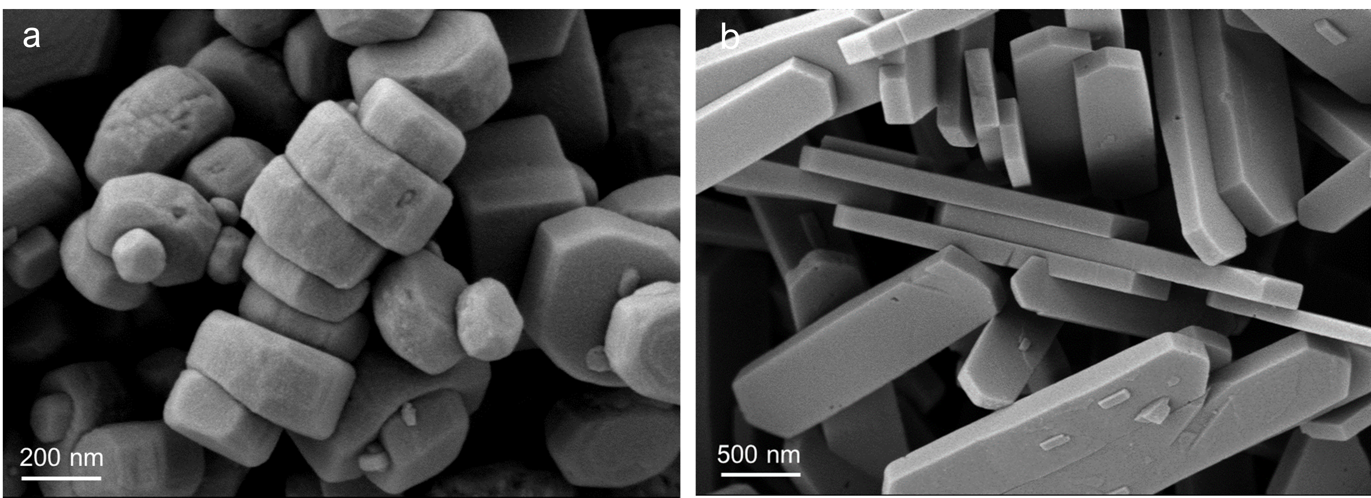
Figure S1. SEM images of the zeolites before alkali-treatment: (a) CsZ5-C and (b) CsZ5-U.

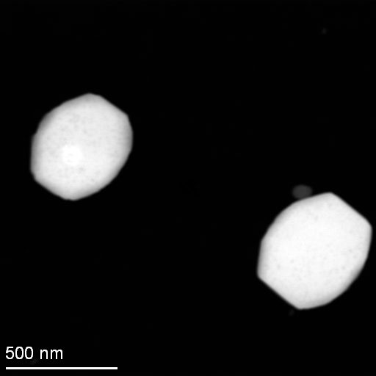
Figure S2. HAADF-STEM images of CsZ5-C.

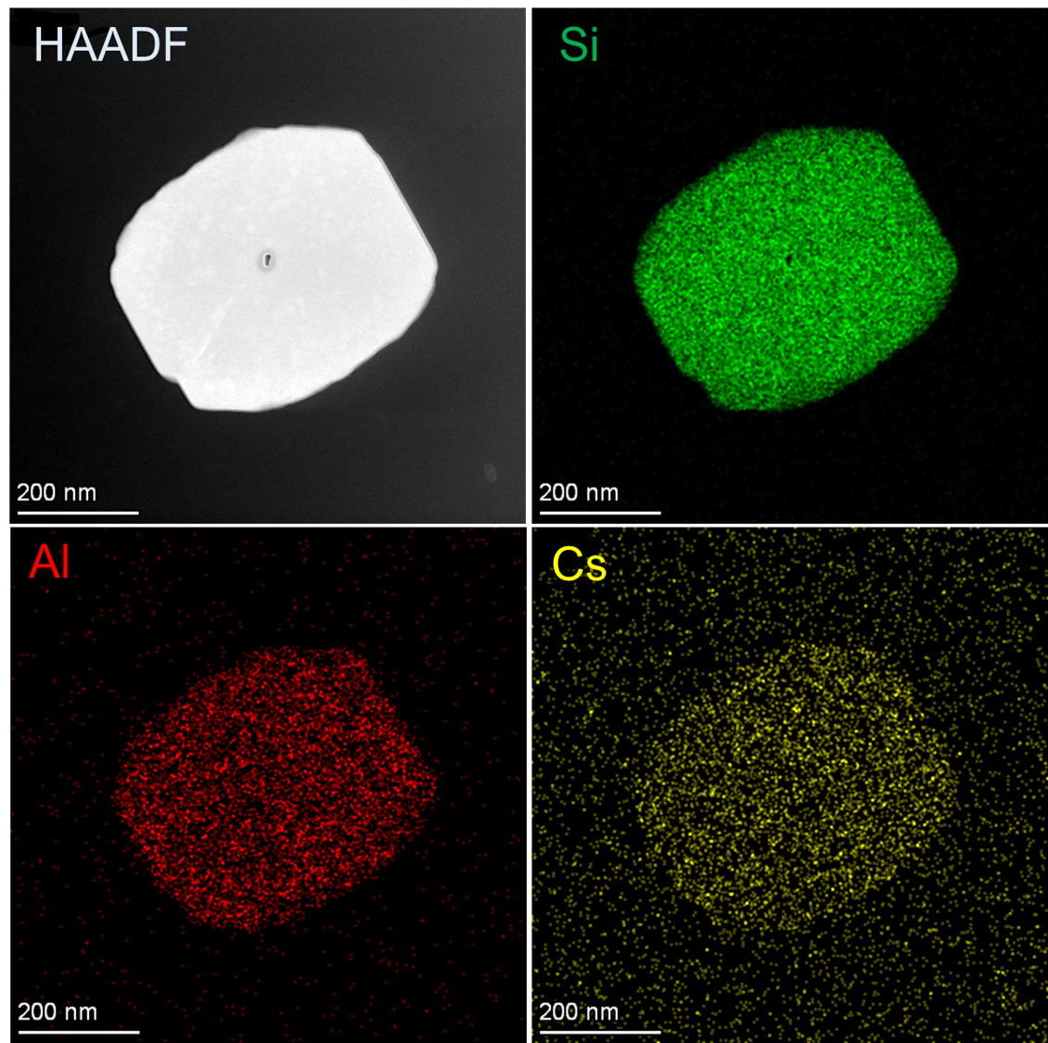
Figure S3. HAADF and EDS mapping images of CsZ5-C.

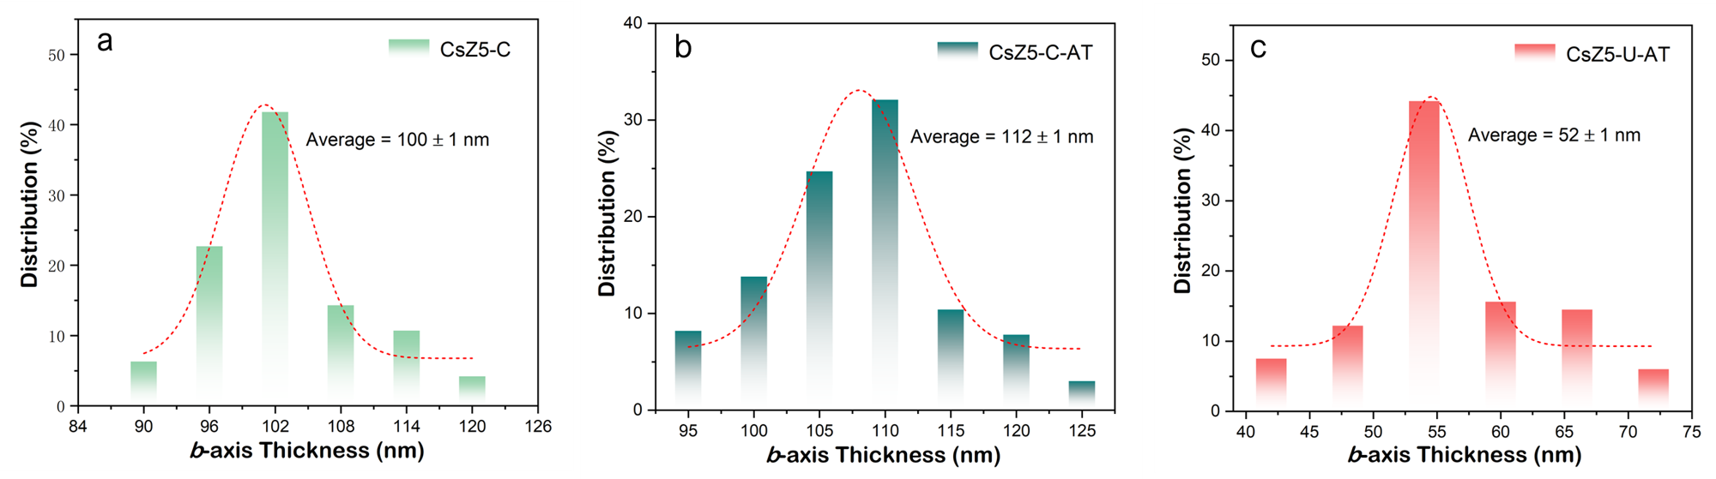
Figure S4. Thickness distribution along b-axis of CsZ5-C, CsZ5-C-AT and CsZ5-U-AT samples.

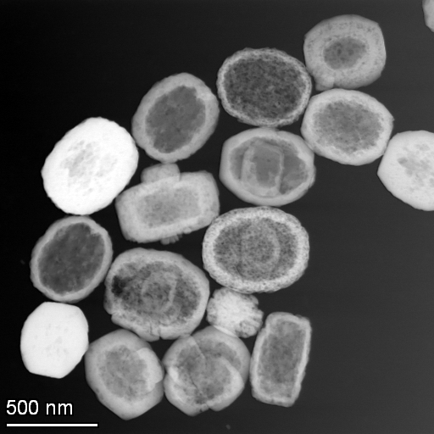
Figure S5. HAADF-STEM images of CsZ5-C-AT.

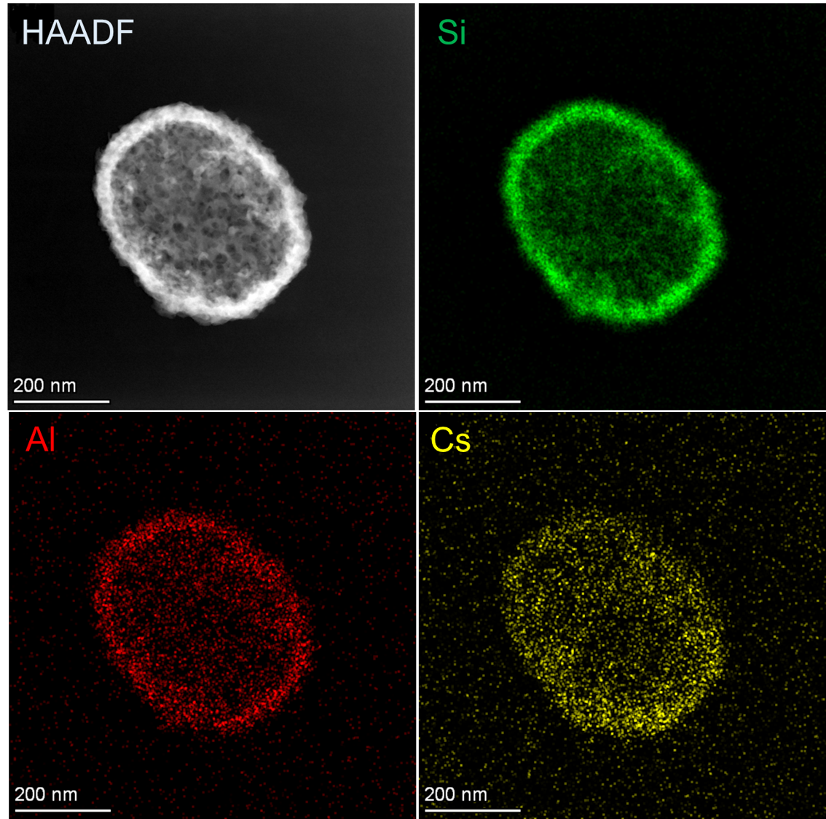
Figure S6. HAADF and EDS mapping images of CsZ5-C-AT.

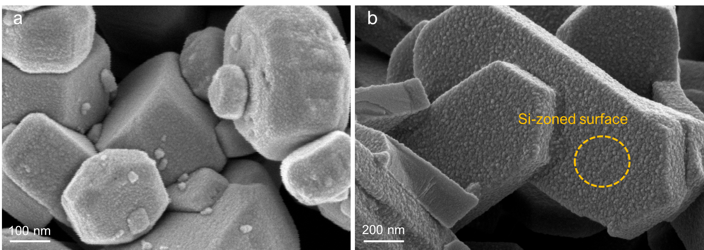
Figure S7. SEM images of the zeolites after alkali-treatment: (a) CsZ5-C-AT and (b) CsZ5-U-AT.

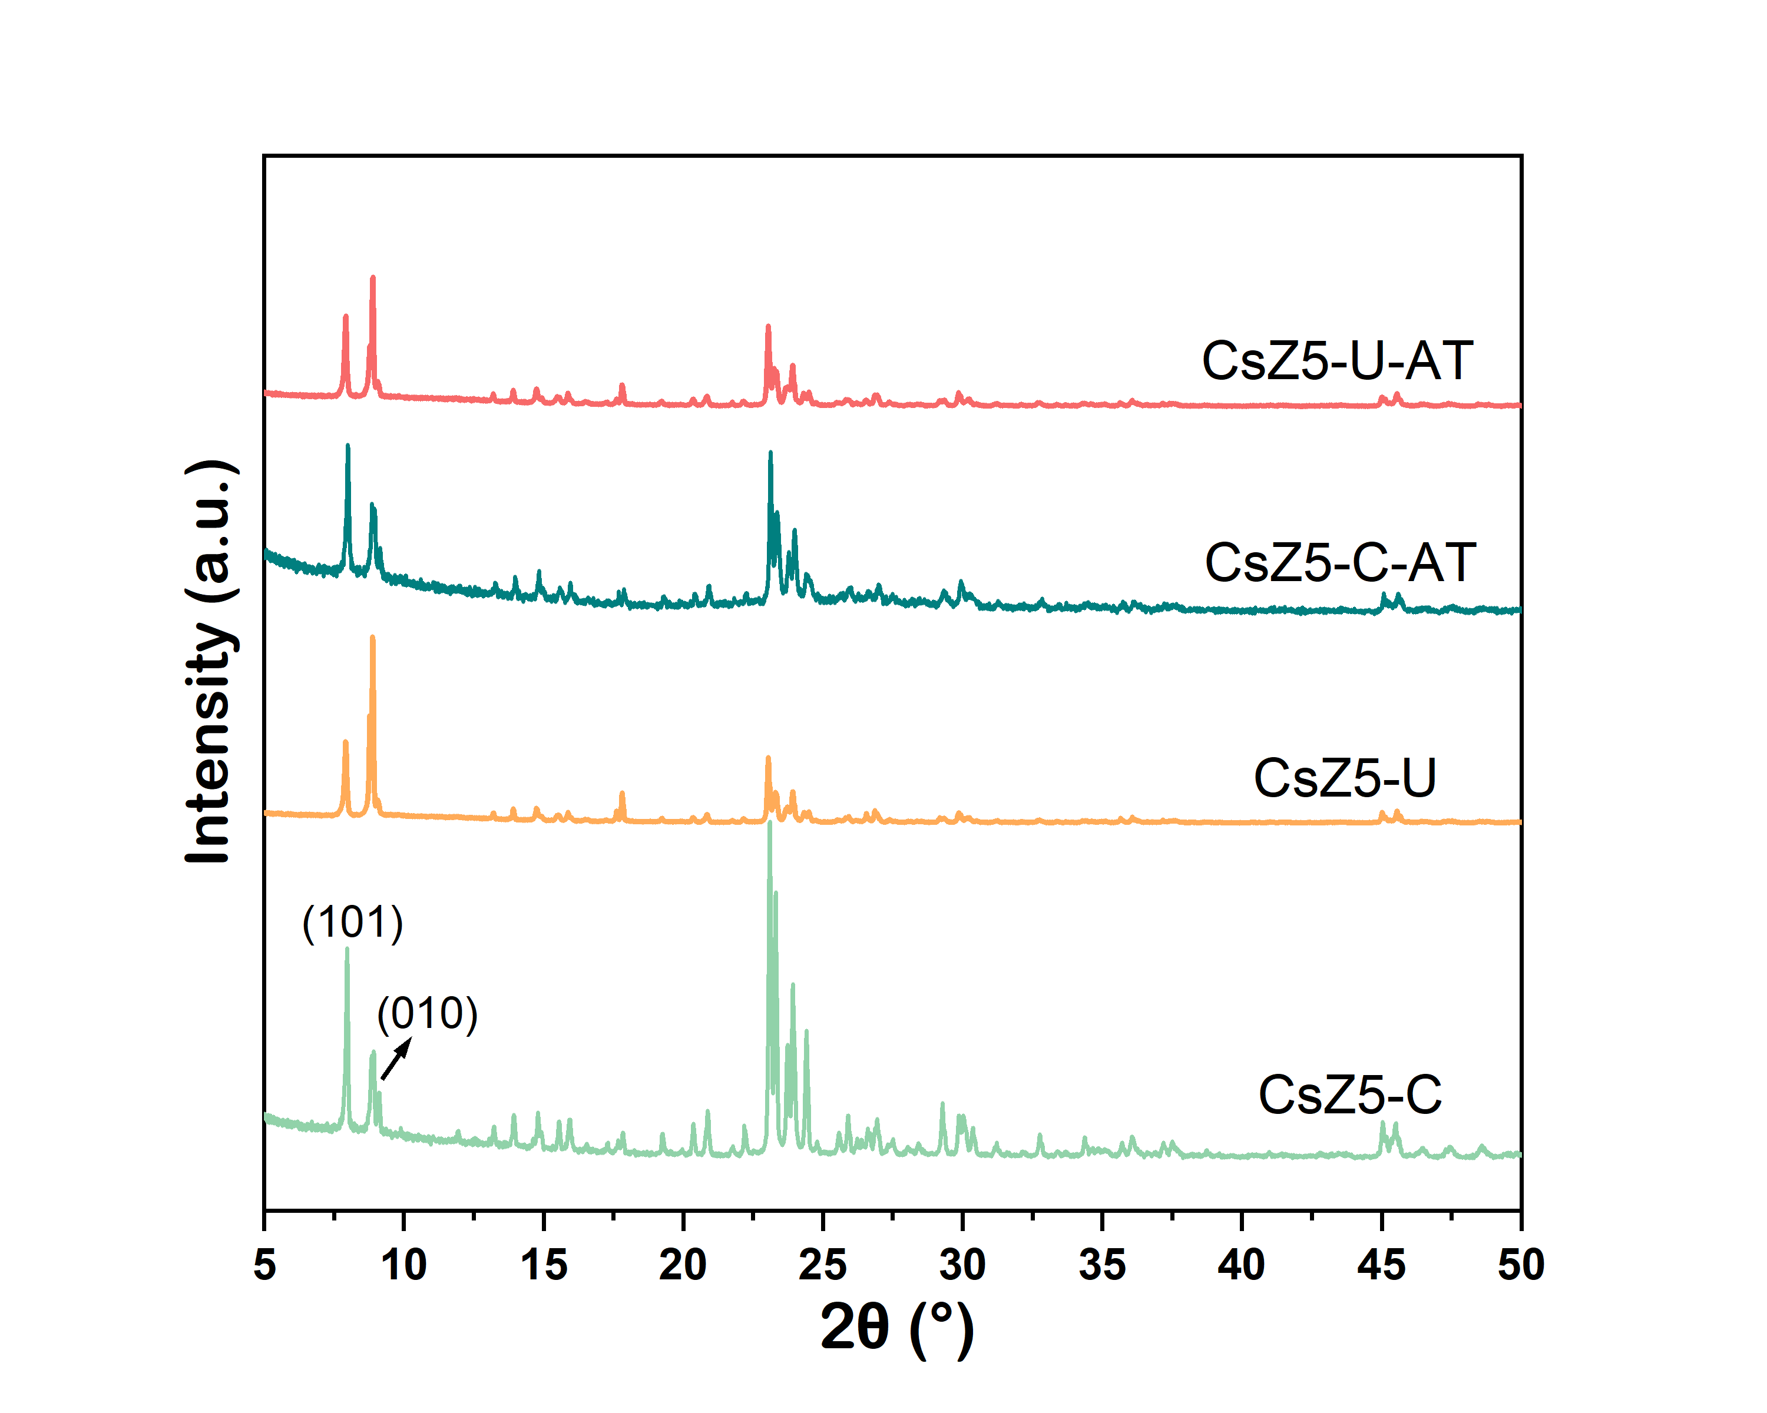
Figure S8. XRD patterns of different Cs-ZSM-5 catalysts.
All samples show a pure MFI zeolite phase with excellent crystallinity. Notably, some of the decreases in the relative diffraction peak intensities are observed after alkali-treatment process. This is due to that the framework of ZSM-5 zeolites might be slightly damaged during the alkali-treatment process ³.
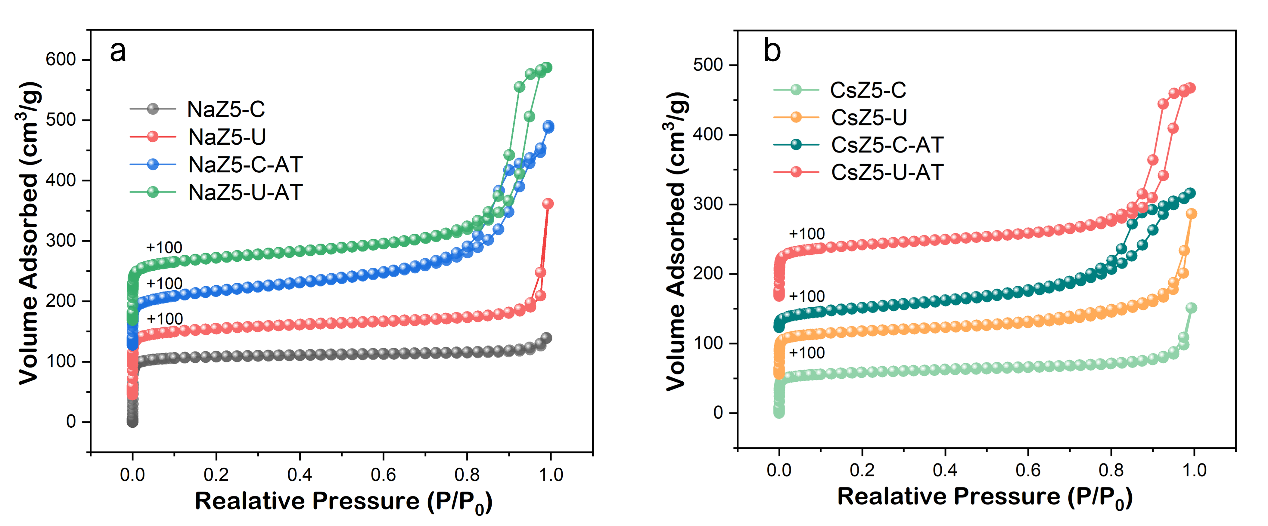
Figure S9. N₂ adsorption desorption isotherms of the (a) Na-type ZSM-5 and (b) Cs modified ZSM-5 samples.

Figure S10. Methanol utilization efficiency on different Cs-ZSM-5 catalysts. Reaction conditions: 430 ºC, toluene/methanol ratio = 3.0, WHSV = 2.0 h⁻¹, TOS = 1 h.

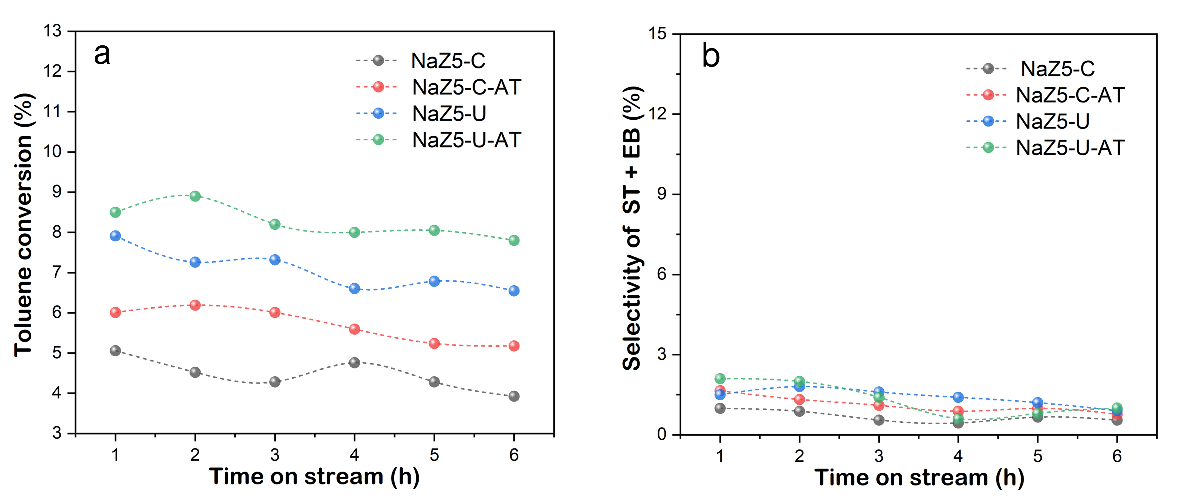
Figure S11. (a) Conversion of toluene and (b) total selectivity of styrene and ethylbenzene for side-chain alkylation over NaZ5-C, NaZ5-C-AT, NaZ5-U and NaZ5-U-AT samples. Reaction conditions: 430 ºC, toluene/methanol ratio = 3.0, WHSV = 2.0 h⁻¹.
As shown in Figure S11, almost no side-chain alkylation product is observed on Na-type ZSM-5 samples, while xylenes and trimethylbenzene are the main products. It indicates that the Cs species is necessary for the side-chain alkylation process.

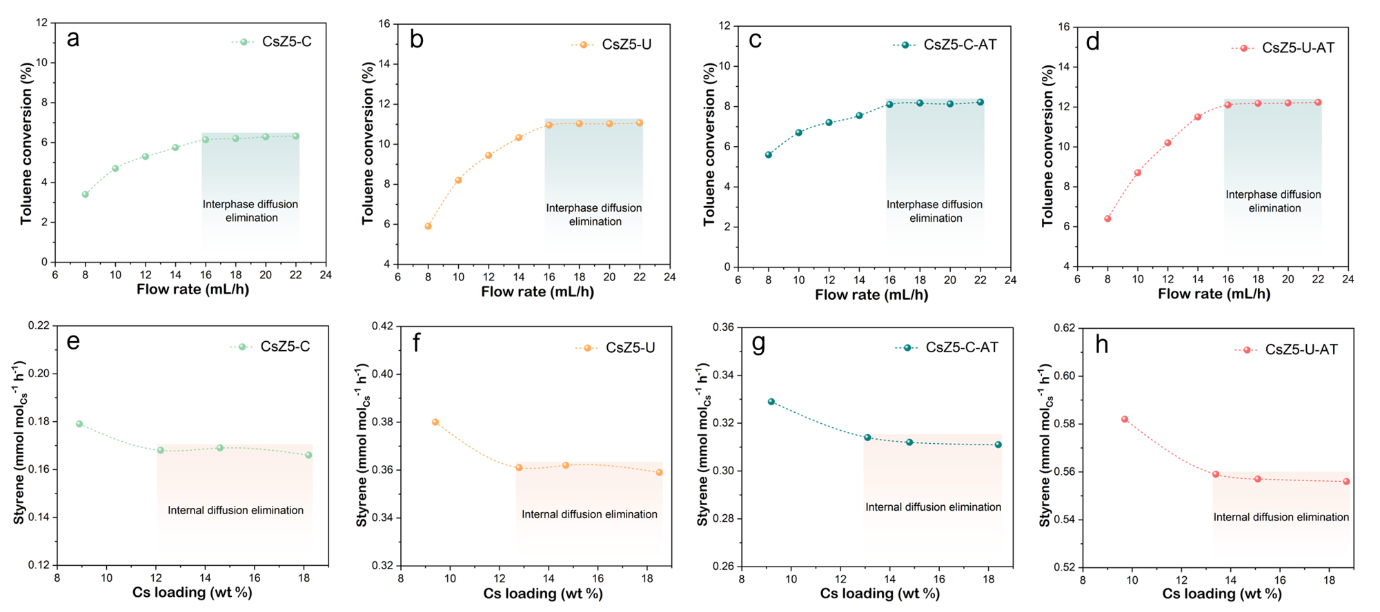
Figure S12. Variation of toluene conversion with the flow rate of reactants on (a) CsZ5-C, (b) CsZ5-U, (c) CsZ5-C-AT and (d) CsZ5-U-AT catalysts (tuning the catalyst mass from 2.5 g to 6.25 g to achieve different reactants flow rates at constant WHSV of 2.0 h⁻¹). Variation of styrene formation rates with the Cs loading on (e) CsZ5-C, (f) CsZ5-U, (g) CsZ5-C-AT and (h) CsZ5-U-AT catalysts (tuning CsOH concentrations from 0.05 M to 0.2 M during Cs⁺-exchange procedures).

The transport effect: To make sure that the obtained kinetic parameters are not significantly influenced by interphase or intra-particle transfer limitations, the transport effect over CsZ5-C, CsZ5-C-AT, CsZ5-U and CsZ5-U-AT catalysts was investigated by using Madon-Boudart criterion ⁴. Herein, the effect of interphase transport is experimentally evaluated by employing different flow rates of reactants at constant WHSV of 2.0 h⁻¹. Figure S12a-12d indicate that there was no significant change in toluene conversion by varying the flow rate of reactants (≥ 16 mL/h). Thus, the interphase diffusion limitation can be excluded at a feed flow rate of 16 mL/h in this study. To avoid the internal diffusion, we modulate the concentrations of CsOH (0.05/0.1/0.15/0.2 M) during Cs ion exchange procedures and the resulting changes in Cs loading on toluene reaction rates and styrene formation rates (toluene conversion was less than 15% to ensure kinetic control). The styrene formation rates on samples with different Cs loading (determined by ICP) showed almost no significant change (Figure S12e-12h). The Cs loading can influence reactivity when diffusional restrictions create intracrystalline gradients of reactants ⁵. Consequently, the similar styrene formation rates normalized per Cs on all four catalysts with different Cs loading imply the exclusion of internal diffusion limitation of measured rates in the experimental range.

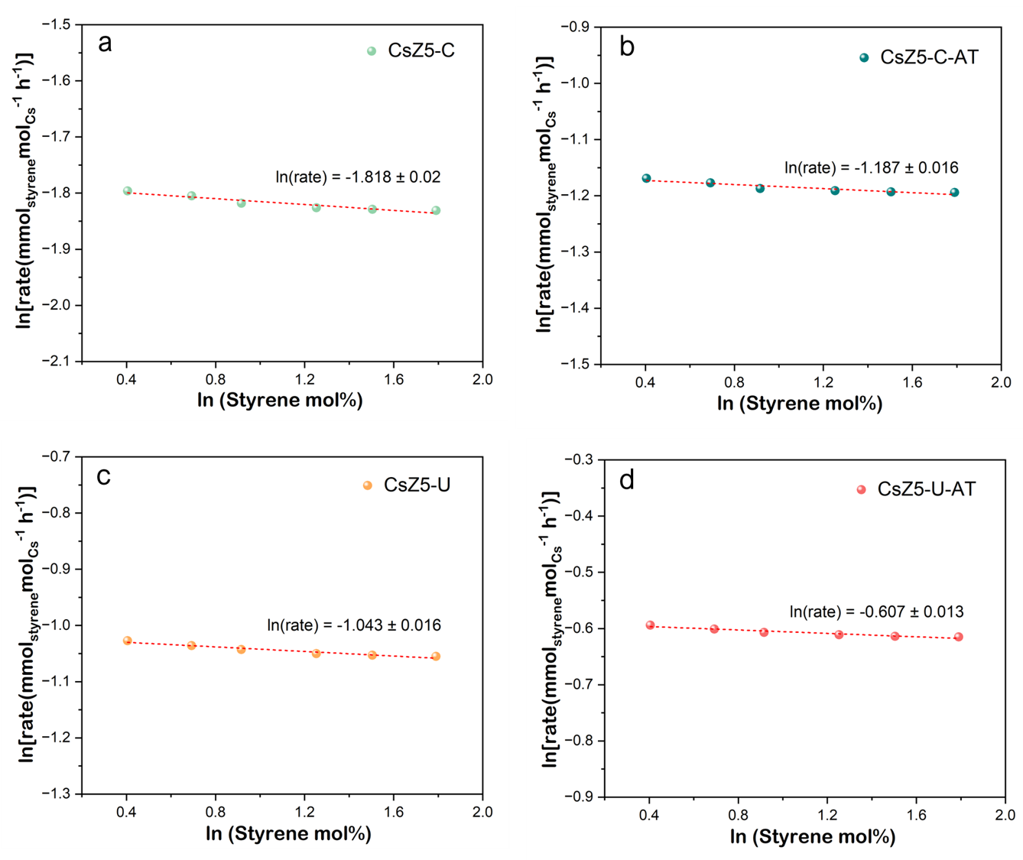
Figure S13. The dependence of styrene formation rates on the concentration of styrene products (1.5-6 mol%) over (a) CsZ5-C, (b) CsZ5-C-AT, (c) CsZ5-U and (d) Cs-Z5-U-AT catalysts.
The product inhibition effect: the potential for product inhibition in the side-chain alkylation reaction should not be ignored. If rates depend on product concentrations, then simply limiting toluene conversion to less than 15% does not imply differential conditions were achieved. That is to say, ignoring product inhibition when it is in fact present may produce inaccurate kinetic data such as apparent activation energies ⁶. Thus, we tried to verify if the product inhibition of styrene occurs in this reaction system. As shown in Figure S13, the dependence of rate on the concentration of styrene products was investigated to check for product inhibition of styrene in this study. Clearly, the relatively low concentration of styrene product (1.5/2/2.5/3.5/4.5/6 mol%) has little effect on styrene formation rates over all four catalysts, indicating the small impact of product inhibition in this reaction system.

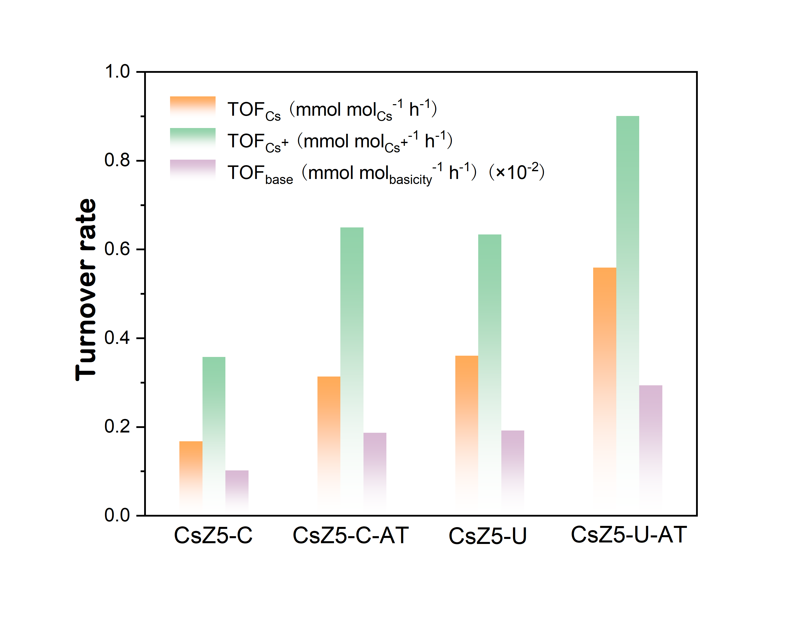
Figure S14. The turnover rate of various catalysts at 430 ºC.

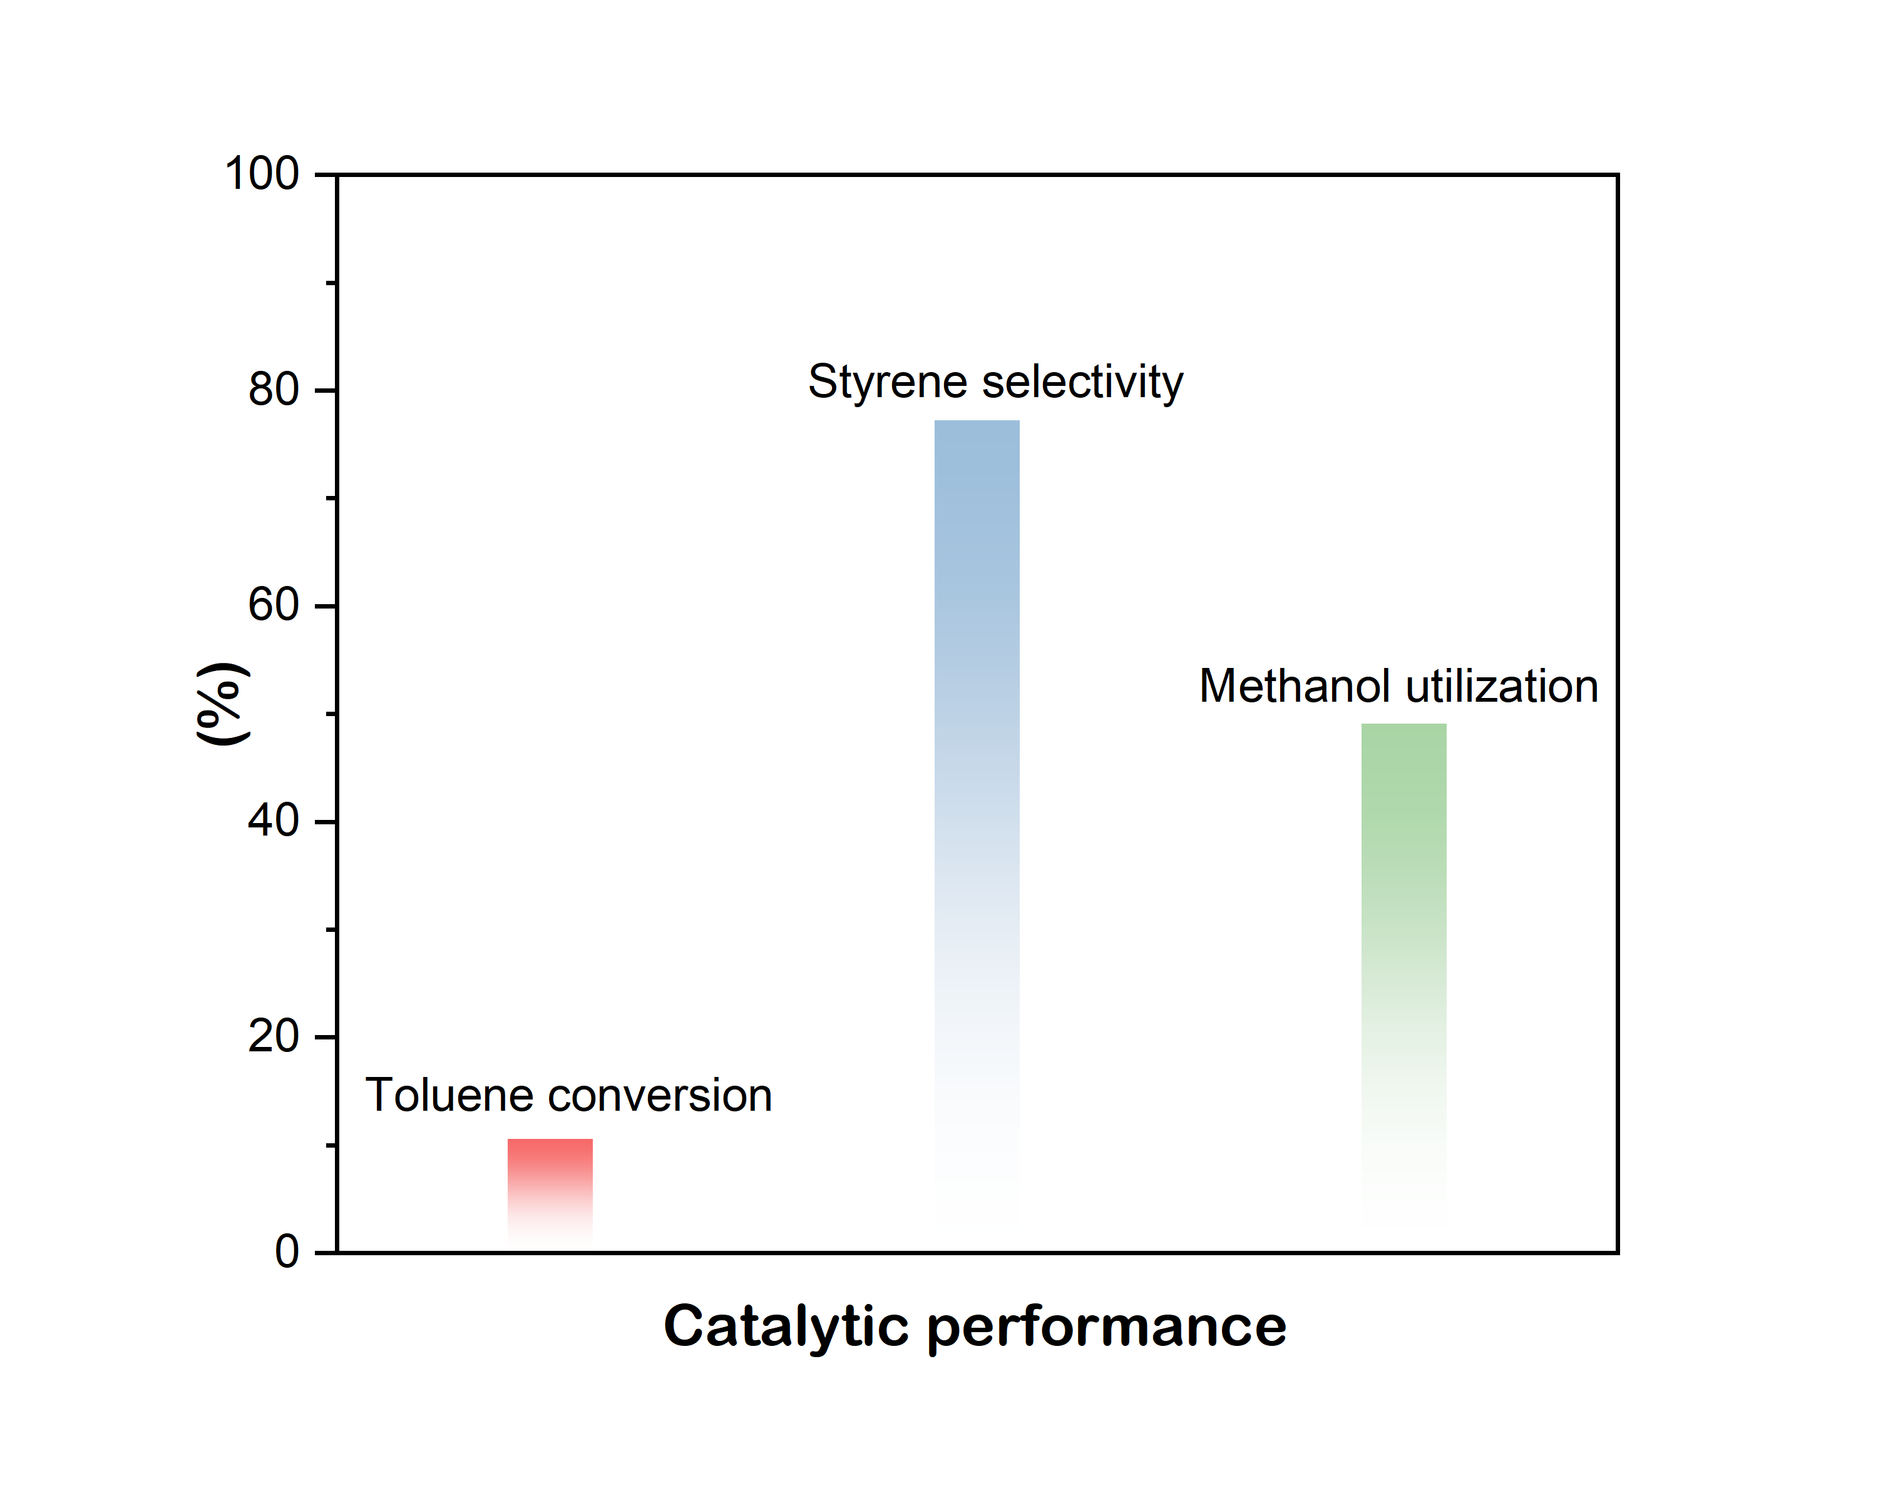
Figure S15. Toluene conversion, styrene selectivity and methanol utilization efficiency on CsZ5-U-Si catalyst. Reaction conditions: 430 ºC, toluene/methanol ratio = 3.0, WHSV = 2.0 h⁻¹, TOS = 1 h.

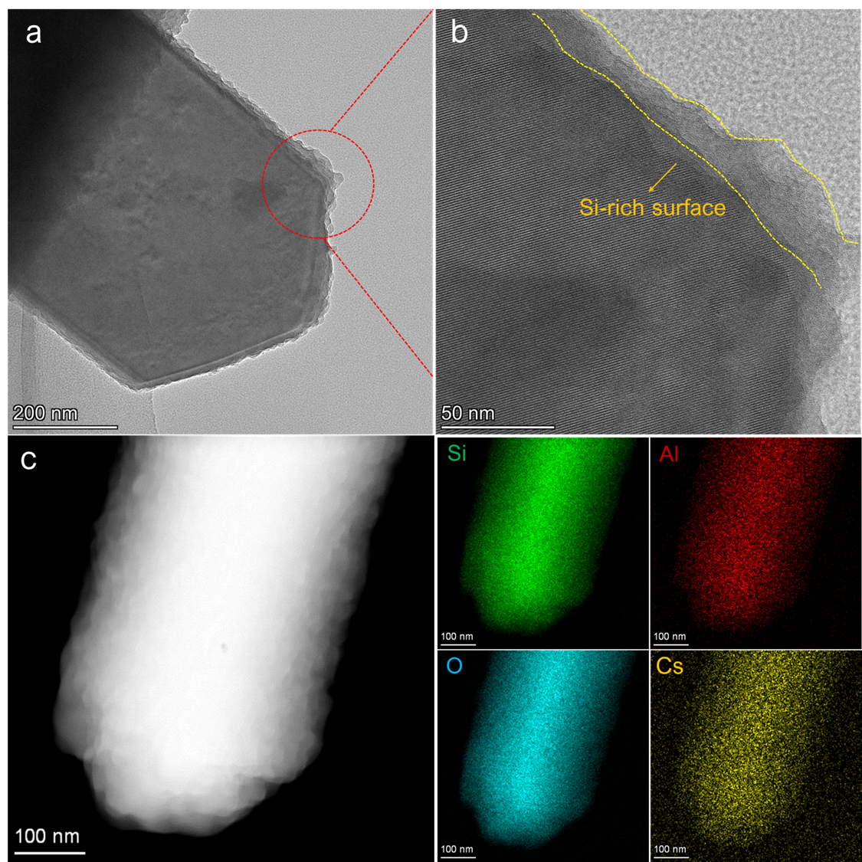
Figure S16. Structure features of CsZ5-U-Si catalyst. (a) TEM images and (b) corresponding enlargement to reveal the Si-zoned surface; (c) HAADF and EDS mapping images.

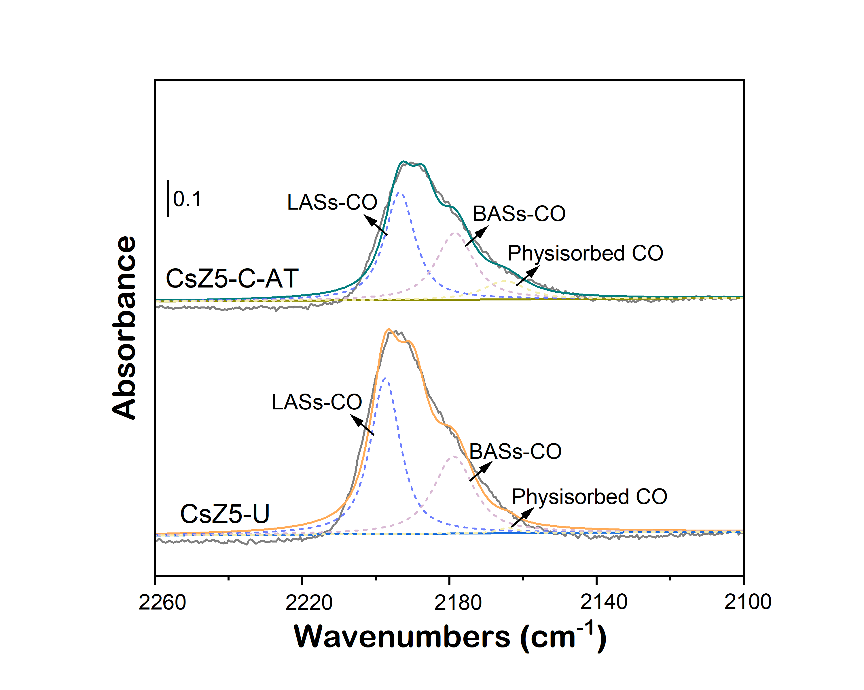
Figure S17. The CO adsorbed FTIR spectra of CsZ5-U and CsZ5-C-AT catalysts.
The band at around 2175-2180 cm⁻¹ indicates the CO interacting with the BASs, while the band at 2195-2205 cm⁻¹ is ascribed to the CO interacting with the LASs, such as CO-Al interactions. Besides, the band at around 2165-2170 cm⁻¹ can be ascribed to the physisorbed CO.

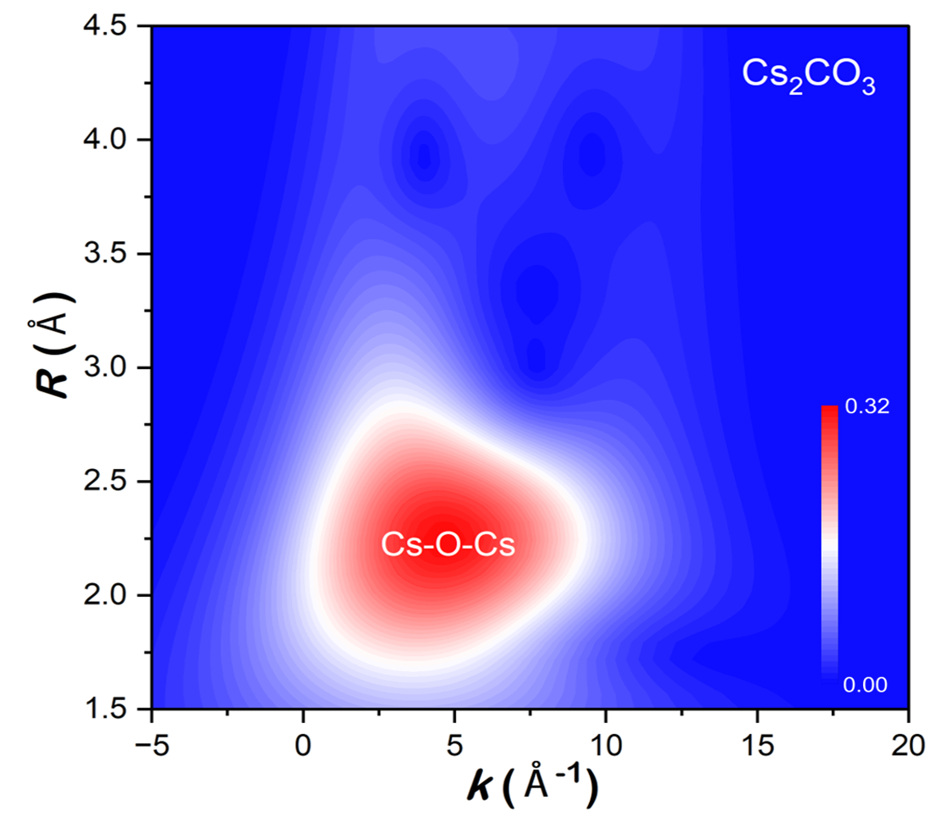
Figure S18. The wavelet transformed (WT) contour plot of the k³-weighted Cs L₃-edge EXAFS signal for Cs₂CO₃ standard sample.

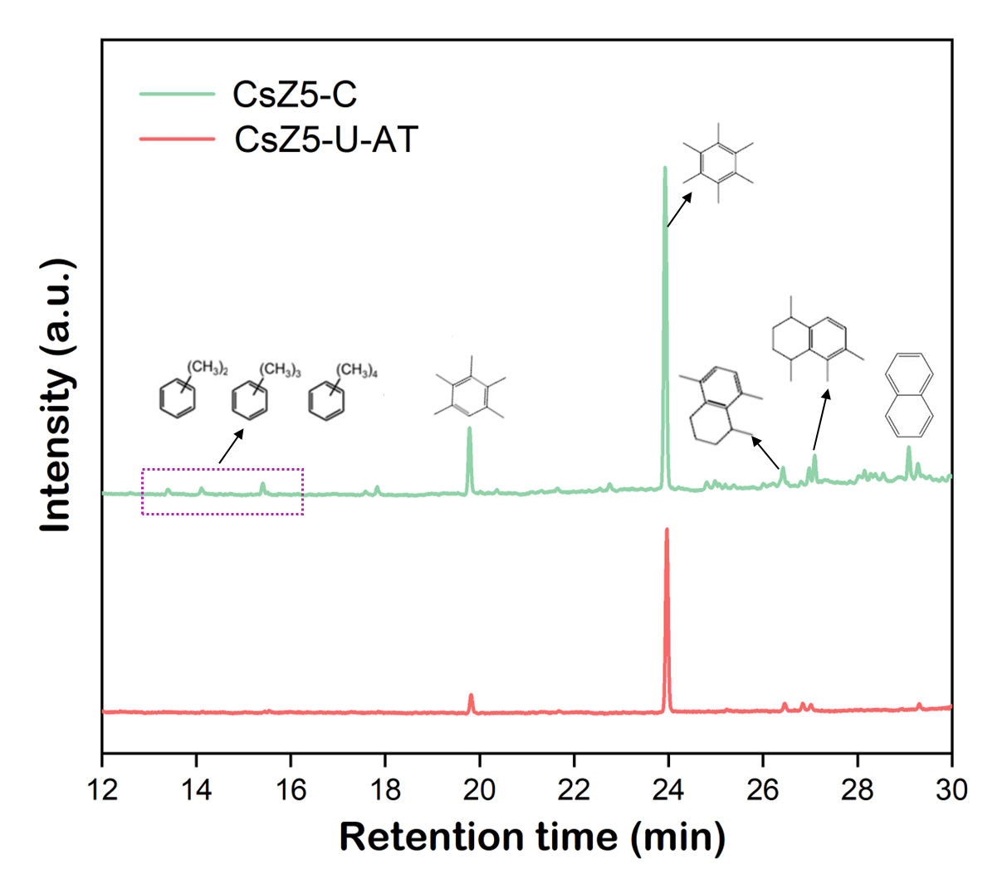
Figure S19. Characterization of coke species by GC-MS chromatograms over spent CsZ5-C and spent CsZ5-U-AT catalysts.

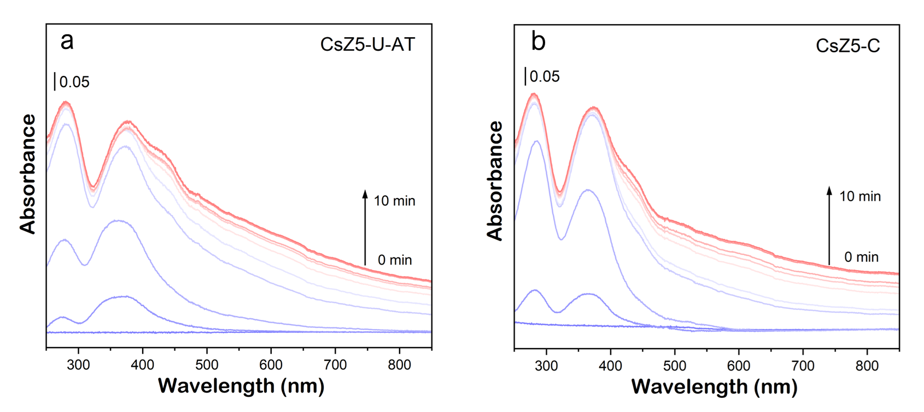
Figure S20. Operando UV-vis spectra at the first 10 min for (a) CsZ5-U-AT and (b) CsZ5-C (the spectra data were recorded every 1 min).

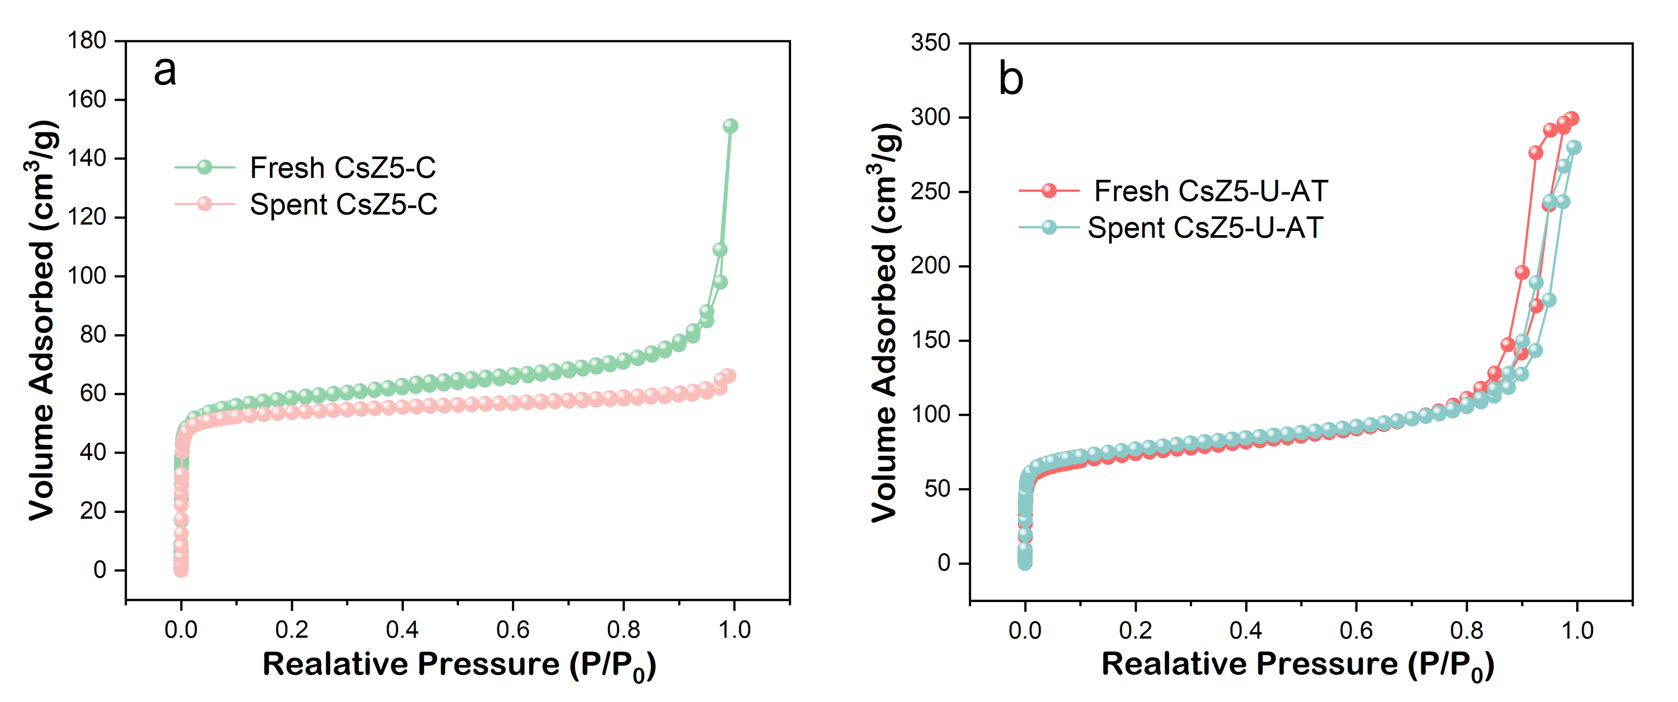
Figure S21. N₂ adsorption desorption isotherms of (a) CsZ5-C and (b) CsZ5-U-AT catalysts before and after reaction.

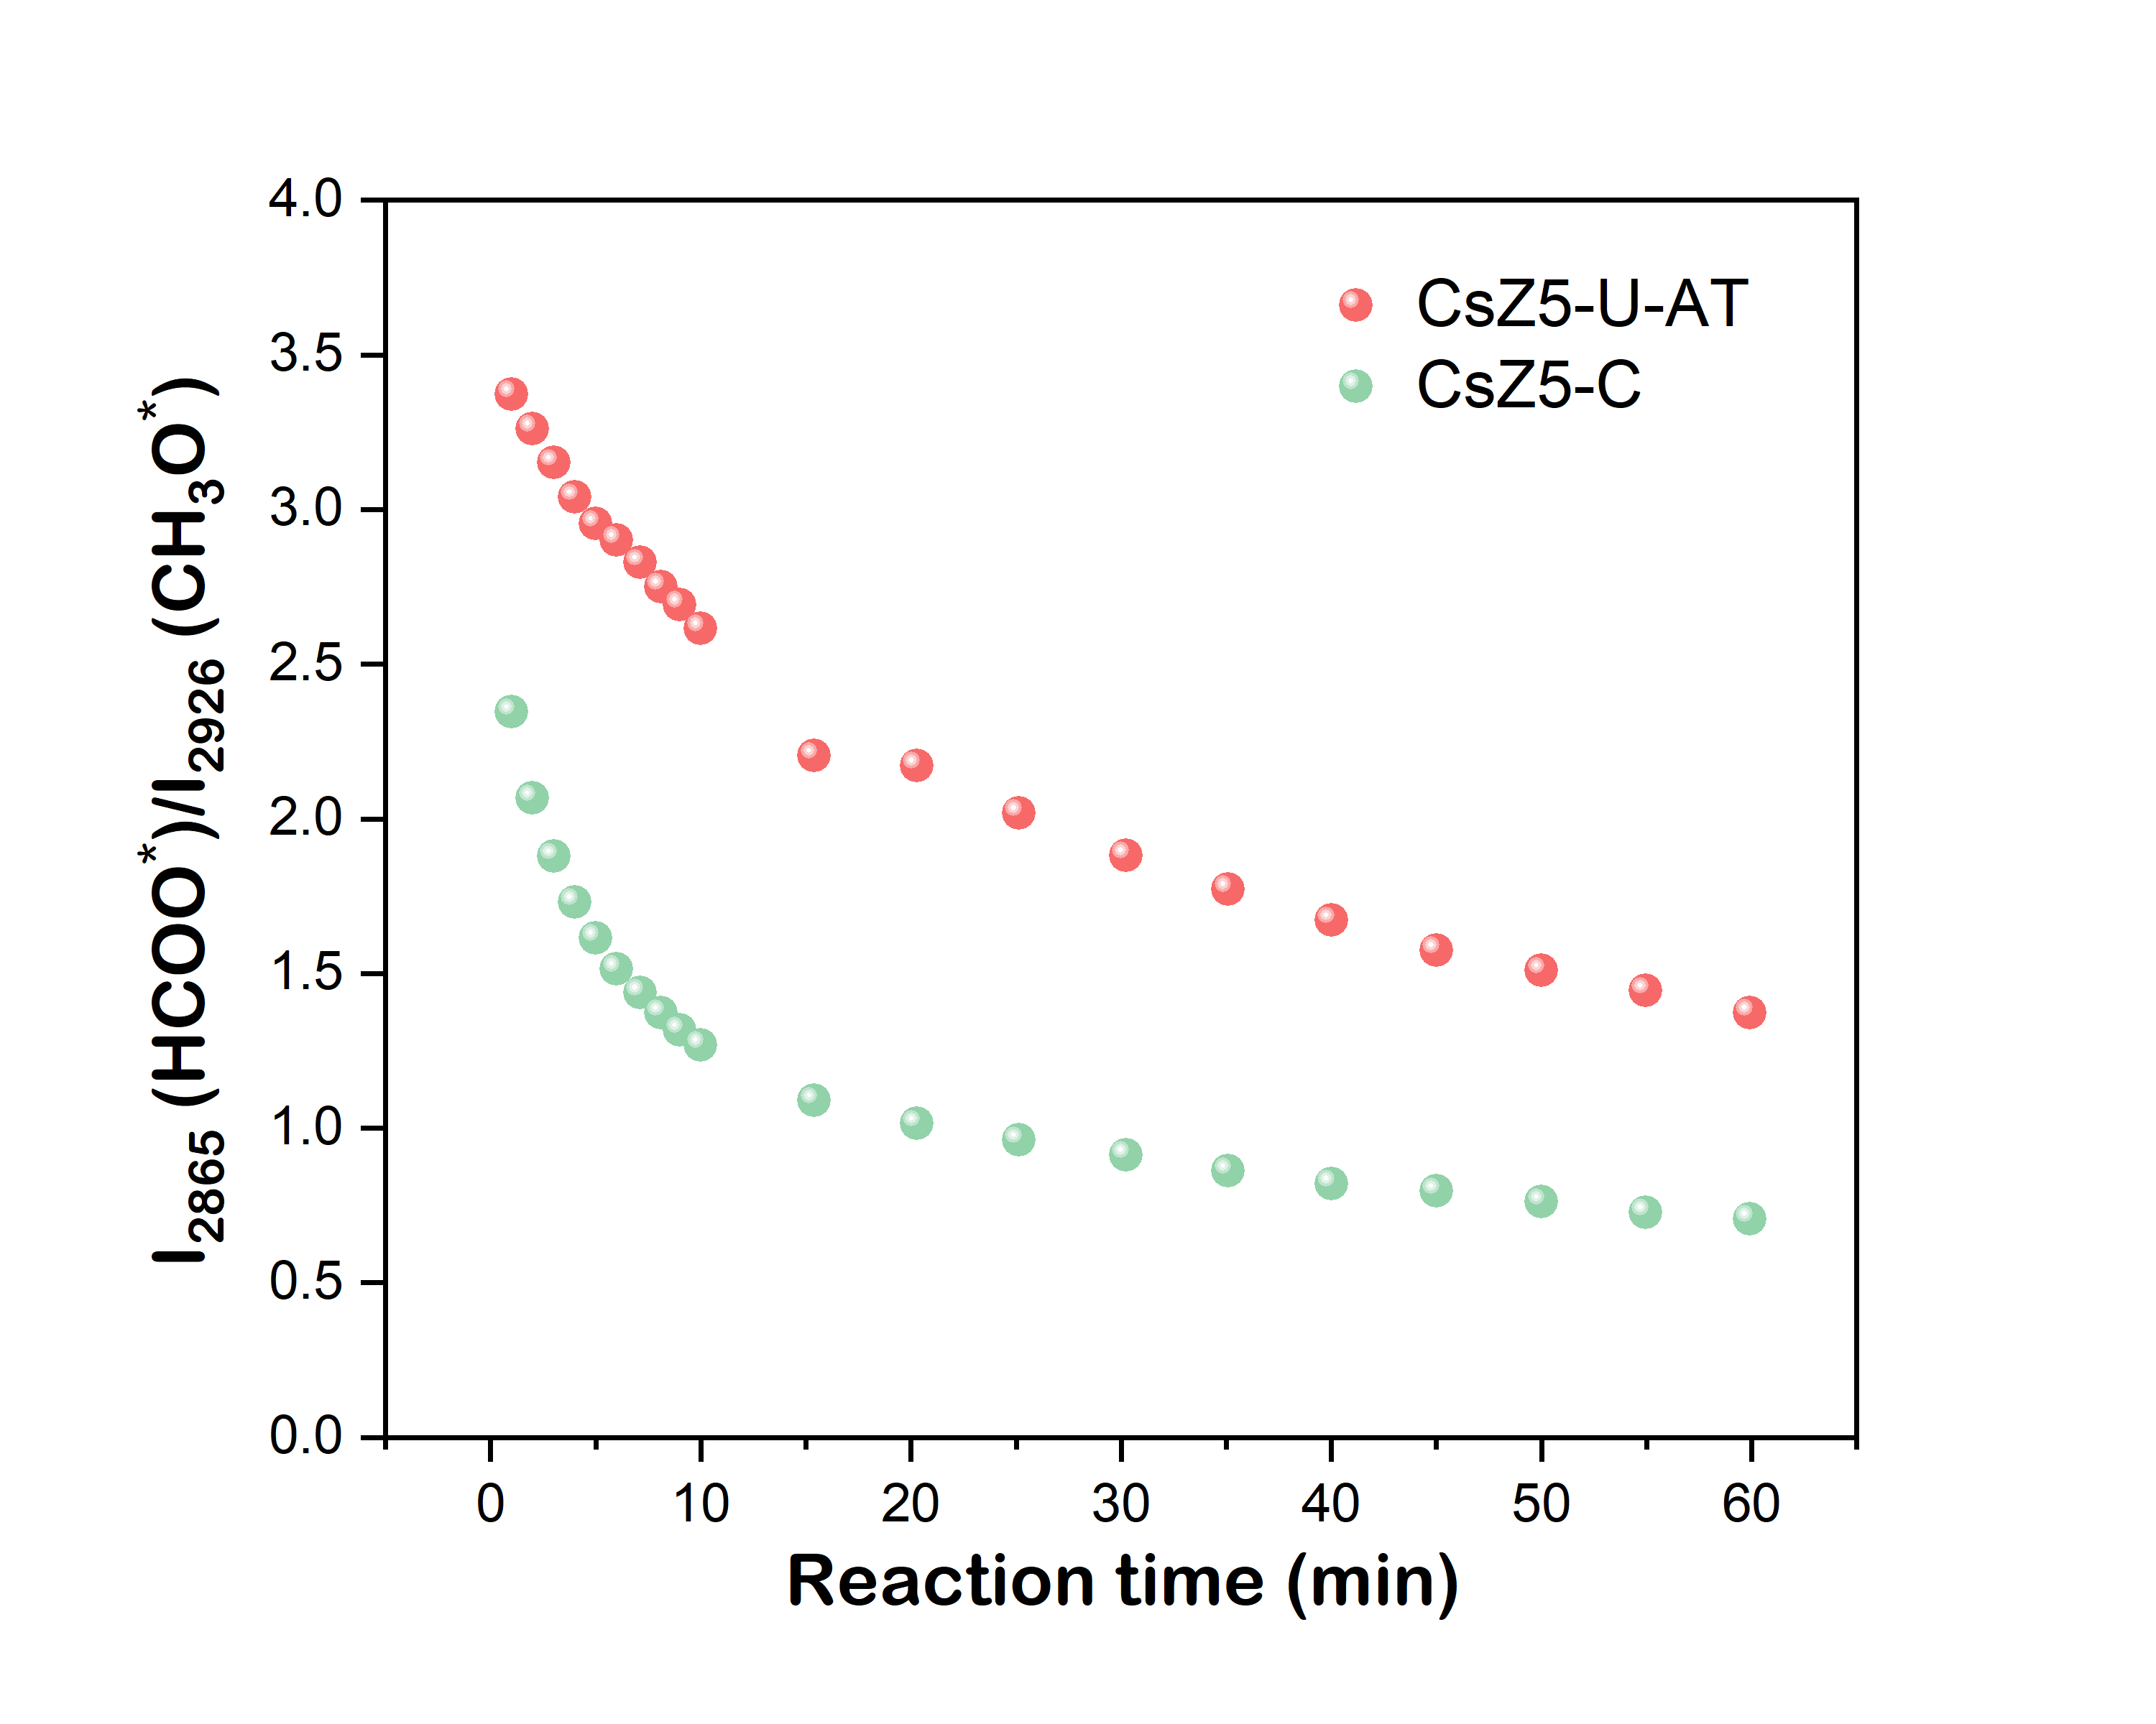
Figure S22. Intensity ratio of HCOO* at 2865 cm⁻¹ and CH₃O* at 2926 cm⁻¹ on CsZ5-C and CsZ5-U-AT catalysts (determined by time-dependent in situ DRFITS in Figure 8).

Supplementary Tables

Table S1 Textural properties and Si/Al ratio of different Na-type ZSM-5 samples
Sample | S_{BET} ª  (m² g⁻¹) | V_{micro} ^{b}  (cm³ g⁻¹) | V_{total} ^{c}  (cm³ g⁻¹) | Bulk Si/Al ratio ^{d} | Surface Si/Al ratio ^{e}
NaZ5-C | 391 | 0.18 | 0.22 | 25.2 | 25.6
NaZ5-U | 498 | 0.20 | 0.37 | 25.6 | 25.8
NaZ5-C-AT | 466 | 0.18 | 0.31 | 24.9 | 28.2
NaZ5-U-AT | 530 | 0.21 | 0.49 | 24.7 | 29.3
ª BET surface area calculated using BET method.
^{b} Micropore volume calculated using t-plot method.
^{c} Total pore volume calculated at p/p₀ = 0.99.
^{d} Determined by XRF results.
^{e} Calculated by XPS results.

Table S2. Catalytic performances of different catalysts in toluene side-chain alkylation reaction
Catalyst | T (ºC) | T/M | WHSV (h⁻¹) | Toluene conversion (%) | Styrene selectivity (%) | TOS (h) | Carrier | Ref.
CsZ5-U-AT※ | 430 | 3 | 2.0 | 12.1 | 80.2 | 1 | N₂ | This work
CsZ5-U | 430 | 3 | 2.0 | 10.9 | 54.8 | 1 | N₂ | This work
CsZ5-C-AT | 430 | 3 | 2.0 | 8.0 | 66.7 | 1 | N₂ | This work
CsZ5-C | 430 | 3 | 2.0 | 6.1 | 43.5 | 1 | N₂ | This work
Commercial Cs-ZSM-5 | 430 | 3 | 2.0 | 6.9 | 52.2 | 1 | N₂ | (7)
CsX | 430 | 3 | 2.0 | 5.1 | 77.1 | 1 | N₂ | (8)
Cs₂O/CsX | 425 | 0.5 | 2.0 | 8.6 | 7.7 | 1 | N₂ | (9)
EDTA-CsX | 425 | 2 | 2.1 | 1.4 | 78.6 | 8 | He | (10)
K₃PO₄-HTLcs | 450 | 5 | 0.6 | - | 39.3 | 1 | N₂ | (11)
B₂O₃/Cs₂O/CsX | 425 | 2 | 2.0 | 9.2 | 27.2 | 1 | N₂ | (12)
ZrB₂O₅/CsX | 410 | 1 | 0.48 mol h⁻¹ g⁻¹ | 3.8 | 71.6 | 2 | N₂ | (13)
ZnO/Cs₂O-CsX | 410 | 1 | 0.48 mol h⁻¹ g⁻¹ | 7.0 | 19.0 | 2 | N₂ | (13)
Cs/Cu-LDO@X | 425 | 5 | 2.0 | 6.6 | 54.2 | - | N₂ | (14)
Cu-Na-X | 425 | 5 | 1.0 | - | 25.0 | 120 | N₂ | (15)
CsX-BN-500 | 430 | 3 | 2.0 | 7.1 | 78.9 | 1 | N₂ | (16)

Table S3. The gas product distribution from toluene-methanol side-chain alkylation over different catalysts
Sample | Gas product distribution (mol %)
Sample | CO | DME | CO₂ | C₂H₄ | C₂H₆ | C₃H₆ | C₃H₈
CsZ5-C | 47.3 | 27.1 | 8.2 | 8.0 | - | 5.8 | 3.8
CsZ5-U | 45.1 | 22.0 | 9.2 | 6.1 | 8.6 | 0.2 | 8.8
CsZ5-C-AT | 52.7 | 19.1 | 8.6 | 5.4 | 3.2 | 5.2 | 5.8
CsZ5-U-AT | 50.2 | 18.4 | 7.6 | 6.5 | 4.1 | 6.0 | 7.2
Reaction conditions: 430 ºC, WHSV = 2.0 h⁻¹, TOS = 1 h.

Table S4. The amounts of acid/base sites and BASs/LASs ratio over different catalysts
Sample | Amount of acid sites ª ($μ$mol g⁻¹) |  | Total acidity ª  ($μ$mol g⁻¹) | Total basicity ^{b}  ($μ$mol g⁻¹) | B/L ^{c}
Sample | Peak 1 (T, ºC) | Peak 2 (T, ºC) | Total acidity ª  ($μ$mol g⁻¹) | Total basicity ^{b}  ($μ$mol g⁻¹) | B/L ^{c}
CsZ5-C | 141 (175) | 119 (480) | 260 | 156 | 0.34
CsZ5-C-AT | 127 (175) | 96 (330) | 223 | 160 | 0.32
CsZ5-U | 131 (161) | 128 (453) | 259 | 195 | 0.24
CsZ5-U-AT | 262 (161) | - | 262 | 203 | 0.19
ª Determined by NH₃-TPD results.
^{b} Determined by CO₂-TPD results.
^{c} Determined by Py-IR results.

Table S5 EXAFS fitting parameters at the Cs L₃-edge for CsZ5-U-AT and Cs₂CO₃ standard sample.
Sample | Path | R ($Å$) | CNs | $\text{σ}$² | $\text{∆}$E₀ (eV) | R-factor
CsZ5-U-AT | Cs-O-Si (Al) | 3.86 | 6.3$\text{±}$0.5 | 0.02 | 5.0 | 0.03
Cs₂CO₃ | Cs-O-Cs | 2.79 | 6.5$\text{±}$0.7 | 0.03 | -4.8 | 0.05
R, the distance between the absorber and backscatter atoms; CNs, coordination numbers; σ², Debye-Waller factors; $\text{∆}$E₀, the inner potential correction that accounts for the difference in the inner potential between the sample and the references; R-factor, the goodness of fit.

Table S6. Summary of coke loss for spent CsZ5-C and CsZ5-U-AT catalyst
Sample | Water loss (%) | Coke loss ª (%)
Spent CsZ5-C | 1.1 | 8.1
Spent CsZ5-U-AT | 1.2 | 4.3
ª Determined by TG results for each catalyst.
As shown in Table S6, the initial weight loss from 35 to 200 ºC is mainly contributed from the physically adsorbed water and organics ⁸, while the weight loss above 200 ºC originates from the decomposition and combustion of coke species in the spent catalysts.

Table S7 Textural properties of spent CsZ5-C and CsZ5-U-AT catalysts
Sample | S_{BET} ª  (m² g⁻¹) | V_{micro} ^{b}  (cm³ g⁻¹) | V_{total} ^{c}  (cm³ g⁻¹)
Spent CsZ5-C | 272 | 0.12 | 0.15
Spent CsZ5-U-AT | 447 | 0.18 | 0.41
ª Calculated using BET method.
^{b} Calculated using t-plot method.
^{c} Total pore volume calculated at p/p₀ = 0.99.
As shown in Table S7, the BET surface area and micropore volume of both CsZ5-C and CsZ5-U-AT decreased after 100 h reaction. The changes in the textural property of catalyst before and after reaction indicate that the pores are blocked by coke to some extent. Nevertheless, the reduction in specific surface area and micropore volume of spent CsZ5-U-AT is much less significant than spent CsZ5-C, which is in good agreement with the improved coke resistance and extended catalytic stability of CsZ5-U-AT catalyst.

References:
(1) Chmelik, C.; Kärger, J. In situ study on molecular diffusion phenomena in nanoporous catalytic solids. Chem. Soc. Rev. 2010, 39 (12), 4864-4884.
(2) Kärger, J.; Ruthven, D. M. Diffusion in nanoporous materials: fundamental principles, insights and challenges. New J. Chem. 2016, 40 (5), 4027-4048.
(3) Hong, Z.; Zhao, G. Q.; Xiong, C. F.; Jia, W. Z.; Huang, F. T.; Zhu, Z. R., Cesium-modified hollow ZSM-5: Efficient acid-base catalyst for side-chain alkylation of 2-picoline with formaldehyde. Appl. Catal. A 2021, 612, 117983.
(4) Madon, R. J.; Boudart, M. Experimental criterion for the absence of artifacts in the measurement of rates of heterogeneous catalytic reactions. Ind. Eng. Chem. Fundament. 1982, 21, 438-447.
(5) Sarazen, M. L.; Doskocil, E.; Iglesia, E. Catalysis on solid acids: Mechanism and catalyst descriptors in oligomerization reactions of light alkenes. J. Catal. 2016, 344, 553-569.
(6) Harris, J. W.; Bhan, A. Moderation of chlorine coverage and ethylene epoxidation kinetics via ethane oxychlorination over promoted Ag/α-Al₂O₃. J. Catal. 2018, 367, 62-71.
(7) Hong, Z.; Miao, L.; Deng, L. H.; Gu, C.; Gao, Y. T.; Xu, Z. Y.; Zhu, Z. R., b-Axis oriented platelike MFI zeolite for efficient production of styrene: Synergy of diffusion anisotropy and Lewis pairs modulation. Chem. Eng. J. 2025, 520, 165870.
(8) Hong, Z.; Wang, X. X.; Huang, F. T.; Lei Miao, L.; Huang, Y. Q.; Zhu, Z. R. Highly dispersed Pt nanoparticles in the Cs modified X zeolite with enhancement for toluene side-chain alkylation with methanol. Catal. Sci. Technol. 2021,11, 92-96.
(9) Li, P. D.; Han, Q.; Zhang, X. M.; Yuan, Y. Y.; Zhang, Y. F.; Guo, H. C.; Xu, L.; Xu, L. A new insight into the reaction behaviors of side-chain alkylation of toluene with methanol over CsX. Catal. Sci. Technol. 2018, 8 (13), 3346-3356.
(10) Seo, D. W.; Rahma, S. T.; Reddy, B. M.; Park, S. E. Carbon dioxide assisted toluene side-chain alkylation with methanol over Cs-X zeolite catalyst. J. CO₂ Util. 2018, 26, 254-261.
(11) Hao, C. Y.; Wen, Y. L.; Wang, B.; Ahmad, F.; Liu, Y. H.; Li, H. J.; Huang, W. Synthesis of HTLcs modified by K₃PO₄ for side chain alkylation of toluene with methanol. Green Energy Environ. 2021, 6 (6), 961-967.
(12) Lee, H.; Lee, S.; Ryoo, R.; Choi, M. Revisiting side-chain alkylation of toluene to styrene: Critical role of microporous structures in catalysts. J. Catal. 2019, 373, 25-36.
(13) Hattori, H.; Amusa, A. A.; Jermy, R. B.; Aitani, A. M.; Al-Khattaf, S. S. Zinc oxide as efficient additive to cesium ion-exchanged zeolite X catalyst for side-chain alkylation of toluene with methanol. J. Mol. Catal. A 2016, 424, 98-105.
(14) Ran, Z. Z.; Shao, X. X.; Mushtaq, M. A.; Du, X. Q.; Liu, H. D.; Hou, S.; Ji, S. F. Preparation of Cs/Cu-LDO@X catalysts and reaction mechanism of the side-chain alkylation of toluene to styrene. Catal. Today 2022, 402, 122-137.
(15) Li, C. D.; Wen, Y. L.; Wang, B.; Fan, M. H.; Liu, W. L.; Cui, Z.; Huang, W. Enhancement of catalytic activity of PAl-NaX catalyst for side-chain alkylation of toluene with methanol: Effects of dehydrogenation component Cu. Fuel 2023, 354, 129271.
(16) Hong, Z.; Wang, X.; Fang, Y. S.; Deng, L. H.; Li, L.; Zhu, Z. R., Restructuring Surface Lewis Pairs of FAU Zeolite through N Doping for Boosting the Toluene Side-Chain Alkylation Performance. Inorg. Chem. 2024, 63 (7), 3258-3266.

hongzhe@zjxu.edu.cn; zhuzhirong@tongji.edu.cn; leili@mail.zjxu.edu.cn

