Supplementary File：Uncropped Original Western Blot Images and Descriptions

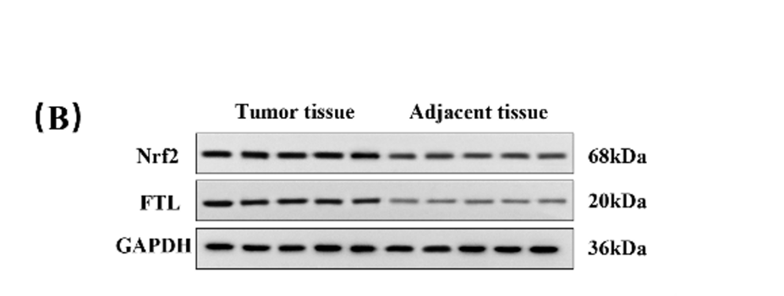
Fig.1(B)
Fig.1(B) Nrf2 The first five bands represent Nrf2 protein expression in five replicates of tumor tissue, and the subsequent five bands represent Nrf2 expression in five replicates of adjacent normal tissue.
Fig.1(B) FTL The first five protein bands represent FTL in five replicates of tumor tissue, and the last five bands represent FTL in five replicates of adjacent normal tissue.
Fig.1(B) GAPDH The first five bands represent five GAPDH replicates from tumor tissue, and the following five bands represent five GAPDH replicates from adjacent normal tissue.

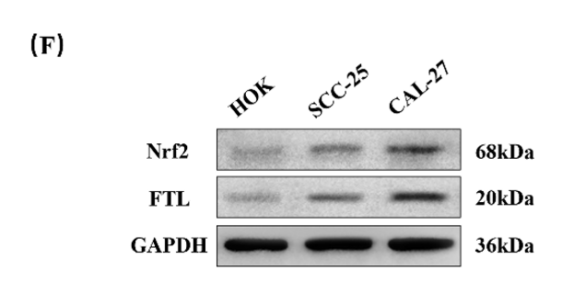
Fig.1(F)
Fig.1(F) Nrf2 The Western blot results for Nrf2 are presented, with bands grouped in triplicates representing three independent experiments. Each set comprises the first band for HOK, the second for SCC-25, and the third for CAL-27. The first set of three Western blot images was used in the manuscript.
Fig.1(F) FTL The Western blot results for FTL are presented, with bands grouped in triplicates representing three independent experiments. Each set comprises the first band for HOK, the second for SCC-25, and the third for CAL-27. The second set of three Western blot images was used in the manuscript.
Fig.1(F) GAPDH The Western blot results for GAPDH are presented, with bands grouped in triplicates representing three independent experiments. In each set, the first band corresponds to HOK, the second to SCC-25, and the third to CAL-27. The third set of three Western blot images shown here was used in the manuscript.
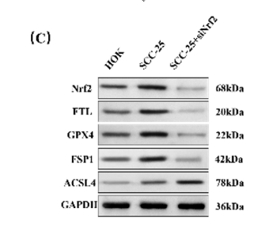
Fig.3(C)
Fig.3(C) Nrf2 The Western blot results for Nrf2 are displayed, with bands grouped in triplicates representing three independent experiments. Within each set, the first band corresponds to HOK, the second to SCC-25, and the third to SCC-25+siNrf2. The third set of three Western blot images presented here was used in the manuscript.

Fig.3(C) FTL The Western blot results for FTL are shown, with the bands grouped in triplicates representing three independent experiments. In each set, the first band corresponds to HOK, the second to SCC-25, and the third to SCC-25+siNrf2. The second set of three Western blot images presented here was used in the manuscript.
Fig.3(C) GPX4 The Western blot results for GPX4 are shown. Bands are grouped in triplicates representing three independent experiments, with each set consisting of the first band for HOK, the second for SCC-25, and the third for SCC-25+siNrf2. The first set of three Western blot images presented here was used in the manuscript.
Fig.3(C) FSP1 The Western blot results for FSP1 are shown, with bands grouped in triplicates representing three independent experiments. In each set, the first band corresponds to HOK, the second to SCC-25, and the third to SCC-25+siNrf2. The first set of three Western blot images presented here was used in the manuscript.
Fig.3(C) ACSL4 The Western blot results for ACSL4 are shown, with bands grouped in triplicates representing three independent experiments. In each set, the first band corresponds to HOK, the second to SCC-25, and the third to SCC-25+siNrf2. The first set of three Western blot images presented here was used in the manuscript.
Fig.3(C) GAPDH Western blot analysis of GAPDH (loading control). Bands are grouped in triplicates (three independent experiments): each set shows HOK, SCC-25, and SCC-25+siNrf2 (left to right). The first set was used in the manuscript.

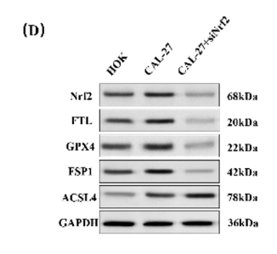
Fig.3(D)
Fig.3(D) Nrf2 The Western blot results for Nrf2 are shown. Bands are grouped in triplicates representing three independent experiments, with each set consisting of the first band for HOK, the second for CAL-27, and the third for CAL-27+siNrf2. The third set of three Western blot images presented here was used in the manuscript.
Fig.3(D) FTL The Western blot results for FTL are shown. Bands are grouped in triplicates representing three independent experiments, with each set consisting of the first band for HOK, the second for CAL-27, and the third for CAL-27+siNrf2. The second set of three Western blot images presented here was used in the manuscript.
Fig.3(D) GPX4 The Western blot results for GPX4 are shown. Bands are grouped in triplicates representing three independent experiments, with each set consisting of the first band for HOK, the second for CAL-27, and the third for CAL-27+siNrf2. The second set of three Western blot images presented here was used in the manuscript.
Fig.3(D) FSP1 The Western blot results for FSP1 are shown. Bands are grouped in triplicates representing three independent experiments, with each set consisting of the first band for HOK, the second for CAL-27, and the third for CAL-27+siNrf2. The first set of three Western blot images presented here was used in the manuscript.
Fig.3(D) ACSL4 The Western blot results for ACSL4 are shown. Bands are grouped in triplicates representing three independent experiments, with each set consisting of the first band for HOK, the second for CAL-27, and the third for CAL-27+siNrf2. The first set of three Western blot images presented here was used in the manuscript.
Fig.3(D) GAPDH Western blot analysis of GAPDH (loading control). Bands are grouped in triplicates (three independent experiments): each set shows HOK, CAL-27 and CAL-27+siNrf2 (left to right). The second set was used in the manuscript.
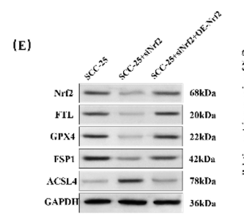
Fig.3(E)
Fig.3(E) Nrf2 The Western blot results for Nrf2 are shown. Bands are grouped in triplicates representing three independent experiments, with each set consisting of the first band for SCC-25, the second for SCC-25+siNrf2, and the third for SCC-25+siNrf2+OE-Nrf2. The first set of three Western blot images presented here was used in the manuscript.
Fig.3(E) FTL The Western blot results for FTL are shown. Bands are grouped in triplicates representing three independent experiments, with each set consisting of the first band for SCC-25, the second for SCC-25+siNrf2, and the third for SCC-25+siNrf2+OE-Nrf2. The first set of three Western blot images presented here was used in the manuscript.
Fig.3(E) GPX4 The Western blot results for GPX4 are shown. Bands are grouped in triplicates representing three independent experiments, with each set consisting of the first band for SCC-25, the second for SCC-25+siNrf2, and the third for SCC-25+siNrf2+OE-Nrf2. The first set of three Western blot images presented here was used in the manuscript.
Fig.3(E) FSP1 The Western blot results for FSP1 are shown. Bands are grouped in triplicates representing three independent experiments, with each set consisting of the first band for SCC-25, the second for SCC-25+siNrf2, and the third for SCC-25+siNrf2+OE-Nrf2. The first set of three Western blot images presented here was used in the manuscript.
Fig.3(E) ACSL4 The Western blot results for ACSL4 are shown. Bands are grouped in triplicates representing three independent experiments, with each set consisting of the first band for SCC-25, the second for SCC-25+siNrf2, and the third for SCC-25+siNrf2+OE-Nrf2. The first set of three Western blot images presented here was used in the manuscript.
Fig.3(E) GPADH The Western blot results for the loading control GAPDH are shown. Bands are grouped in triplicates representing three independent experiments, with each set consisting of the first band for HOK, the second for SCC-25+siNrf2, and the third for SCC-25+siNrf2+OE-Nrf2. The third set of three Western blot images presented here was used in the manuscript.

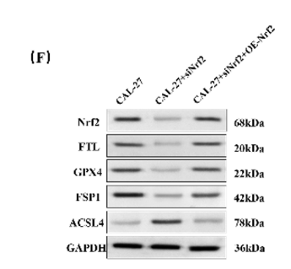
Fig.3(F)

Fig.3(F) Nrf2 The Western blot results for Nrf2 are shown. Bands are grouped in triplicates representing three independent experiments, with each set consisting of the first band for CAL-27, the second for CAL-27+siNrf2, and the third for CAL-27+siNrf2+OE-Nrf2. The first set of three Western blot images presented here was used in the manuscript.
Fig.3(F) FTL The Western blot results for FTL are shown. Bands are grouped in triplicates representing three independent experiments, with each set consisting of the first band for CAL-27, the second for CAL-27+siNrf2, and the third for CAL-27+siNrf2+OE-Nrf2. The second set of three Western blot images presented here was used in the manuscript.
Fig.3(F) GPX4 The Western blot results for GPX4 are shown. Bands are grouped in triplicates representing three independent experiments, with each set consisting of the first band for CAL-27, the second for CAL-27+siNrf2, and the third for CAL-27+siNrf2+OE-Nrf2. The third set of three Western blot images presented here was used in the manuscript.
Fig.3(F) FSP1 The Western blot results for FSP1 are shown. Bands are grouped in triplicates representing three independent experiments, with each set consisting of the first band for CAL-27, the second for CAL-27+siNrf2, and the third for CAL-27+siNrf2+OE-Nrf2. The third set of three Western blot images presented here was used in the manuscript.
Fig.3(F) ACSL4 The Western blot results for ACSL4 are shown. Bands are grouped in triplicates representing three independent experiments, with each set consisting of the first band for CAL-27, the second for CAL-27+siNrf2, and the third for CAL-27+siNrf2+OE-Nrf2. The first set of three Western blot images presented here was used in the manuscript.
Fig.3(F) GPADH The Western blot results for the loading control GAPDH are shown. Bands are grouped in triplicates representing three independent experiments, with each set consisting of the first band for CAL-27, the second for CAL-27+siNrf2, and the third for CAL-27+siNrf2+OE-Nrf2. The third set of three Western blot images presented here was used in the manuscript.

Fig.5(C)
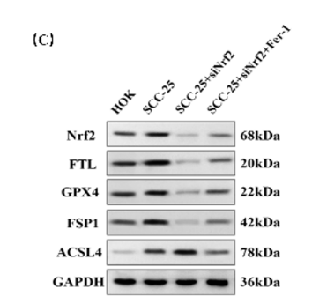
Fig.5(C) Nrf2 The Western blot results for Nrf2 are shown. Bands are grouped in quadruplicates representing three independent experiments, with each set consisting of the first band for HOK, the second for SCC-25, the third for SCC-25+siNrf2, and the fourth for SCC-25+siNrf2+Fer-1. The first set of four Western blot images presented here was used in the manuscript.
Fig.5(C) FTL The Western blot results for FTL are shown. Bands are grouped in quadruplicates representing three independent experiments, with each set consisting of the first band for HOK, the second for SCC-25, the third for SCC-25+siNrf2, and the fourth for SCC-25+siNrf2+Fer-1. The second set of four Western blot images presented here was used in the manuscript.
Fig.5(C) GPX4 The Western blot results for GPX4 are shown. Bands are grouped in quadruplicates representing three independent experiments, with each set consisting of the first band for HOK, the second for SCC-25, the third for SCC-25+siNrf2, and the fourth for SCC-25+siNrf2+Fer-1. The third set of four Western blot images presented here was used in the manuscript.
Fig.5(C) FSP1 The Western blot results for FSP1 are shown. Bands are grouped in quadruplicates representing three independent experiments, with each set consisting of the first band for HOK, the second for SCC-25, the third for SCC-25+siNrf2, and the fourth for SCC-25+siNrf2+Fer-1. The second set of four Western blot images presented here was used in the manuscript.
Fig.5(C) ACSL4 The Western blot results for ACSL4 are shown. Bands are grouped in quadruplicates representing three independent experiments, with each set consisting of the first band for HOK, the second for SCC-25, the third for SCC-25+siNrf2, and the fourth for SCC-25+siNrf2+Fer-1. The second set of four Western blot images presented here was used in the manuscript.
Fig.5(C) GAPDH The Western blot results for the loading control GAPDH are shown. Bands are grouped in quadruplicates representing three independent experiments, with each set consisting of the first band for HOK, the second for SCC-25, the third for SCC-25+siNrf2, and the fourth for SCC-25+siNrf2+Fer-1. The first set of four Western blot images presented here was used in the manuscript.

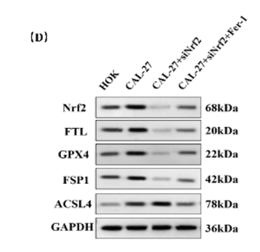
Fig.5(D)

Fig.5(D) Nrf2 The Western blot results for Nrf2 are shown. Bands are grouped in quadruplicates representing three independent experiments, with each set consisting of the first band for HOK, the second for CAL-27, the third for CAL-27+siNrf2, and the fourth for CAL-27+siNrf2+Fer-1. The third set of four Western blot images presented here was used in the manuscript.
Fig.5(D) FTL The Western blot results for FTL are shown. Bands are grouped in quadruplicates representing three independent experiments, with each set consisting of the first band for HOK, the second for CAL-27, the third for CAL-27+siNrf2, and the fourth for CAL-27+siNrf2+Fer-1. The second set of four Western blot images presented here was used in the manuscript.
Fig.5(D) GPX4 The Western blot results for GPX4 are shown. Bands are grouped in quadruplicates representing three independent experiments, with each set consisting of the first band for HOK, the second for CAL-27, the third for CAL-27+siNrf2, and the fourth for CAL-27+siNrf2+Fer-1. The third set of four Western blot images presented here was used in the manuscript.

Fig.5(D) FSP1 The Western blot results for FSP1 are shown. Bands are grouped in quadruplicates representing three independent experiments, with each set consisting of the first band for HOK, the second for CAL-27, the third for CAL-27+siNrf2, and the fourth for CAL-27+siNrf2+Fer-1. The third set of four Western blot images presented here was used in the manuscript.
Fig.5(D) ACSL4 The Western blot results for ACSL4 are shown. Bands are grouped in quadruplicates representing three independent experiments, with each set consisting of the first band for HOK, the second for CAL-27, the third for CAL-27+siNrf2, and the fourth for CAL-27+siNrf2+Fer-1. The second set of four Western blot images presented here was used in the manuscript.
Fig.5(D) GAPDH The Western blot results for the loading control GAPDH are shown. Bands are grouped in quadruplicates representing three independent experiments, with each set consisting of the first band for HOK, the second for CAL-27, the third for CAL-27+siNrf2, and the fourth for CAL-27+siNrf2+Fer-1. The first set of four Western blot images presented here was used in the manuscript.

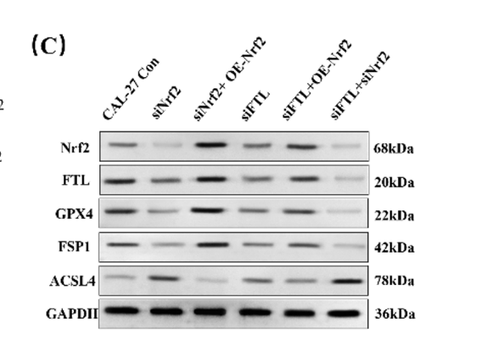
Fig.6(C)

Fig.6(C) Nrf2 replicate-1
Fig.6(C) Nrf2 replicate-2
Fig.6(C) Nrf2 replicate-3
The above three images are all Western blot results for Nrf2 from three independent experimental replicates. Each group consists of the following bands in order: CAL-27 Con, siNrf2, siNrf2+OE-Nrf2, siFTL, siFTL+OE-Nrf2, and siFTL+siNrf2. The first replicate set was used in the manuscript.

Fig.6(C) FTL replicate-1
Fig.6(C) FTL replicate-2
Fig.6(C) FTL replicate-3
The above three images are all Western blot results for FTL from three independent experimental replicates. Each group consists of the following bands in order: CAL-27 Con, siNrf2, siNrf2+OE-Nrf2, siFTL, siFTL+OE-Nrf2, and siFTL+siNrf2. The first replicate set was used in the manuscript.

Fig.6(C) GPX4 replicate-1
Fig.6(C) GPX4 replicate-2
Fig.6(C) GPX4 replicate-3
The above three images are all Western blot results for GPX4 from three independent experimental replicates. Each group consists of the following bands in order: CAL-27 Con, siNrf2, siNrf2+OE-Nrf2, siFTL, siFTL+OE-Nrf2, and siFTL+siNrf2. The first replicate set was used in the manuscript.

Fig.6(C) FSP1 replicate-1
Fig.6(C) FSP1 replicate-2

Fig.6(C) FSP1 replicate-3
The above three images are all Western blot results for FSP1 from three independent experimental replicates. Each group consists of the following bands in order: CAL-27 Con, siNrf2, siNrf2+OE-Nrf2, siFTL, siFTL+OE-Nrf2, and siFTL+siNrf2. The first replicate set was used in the manuscript.
Fig.6(C) ACSL4 replicate-1
Fig.6(C) ACSL4 replicate-2
Fig.6(C) ACSL4 replicate-3
The above three images are all Western blot results for ACSL4 from three independent experimental replicates. Each group consists of the following bands in order: CAL-27 Con, siNrf2, siNrf2+OE-Nrf2, siFTL, siFTL+OE-Nrf2, and siFTL+siNrf2. The first replicate set was used in the manuscript.

Fig.6(C) GAPDH replicate-1
Fig.6(C) GAPDH replicate-2
Fig.6(C) GAPDH replicate-3
The above three images are all Western blot results for the loading control GAPDH from three independent experimental replicates. Each group consists of the following bands in order: CAL-27 Con, siNrf2, siNrf2+OE-Nrf2, siFTL, siFTL+OE-Nrf2, and siFTL+siNrf2. The first replicate set was used in the manuscript.

