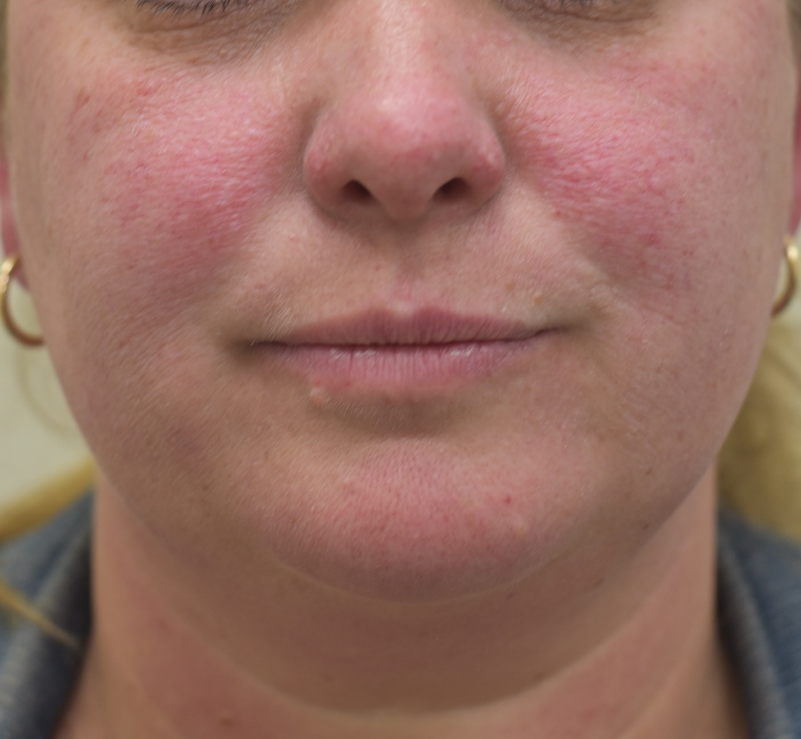
Figure S1: Almost-clear TSC-associated FA health state

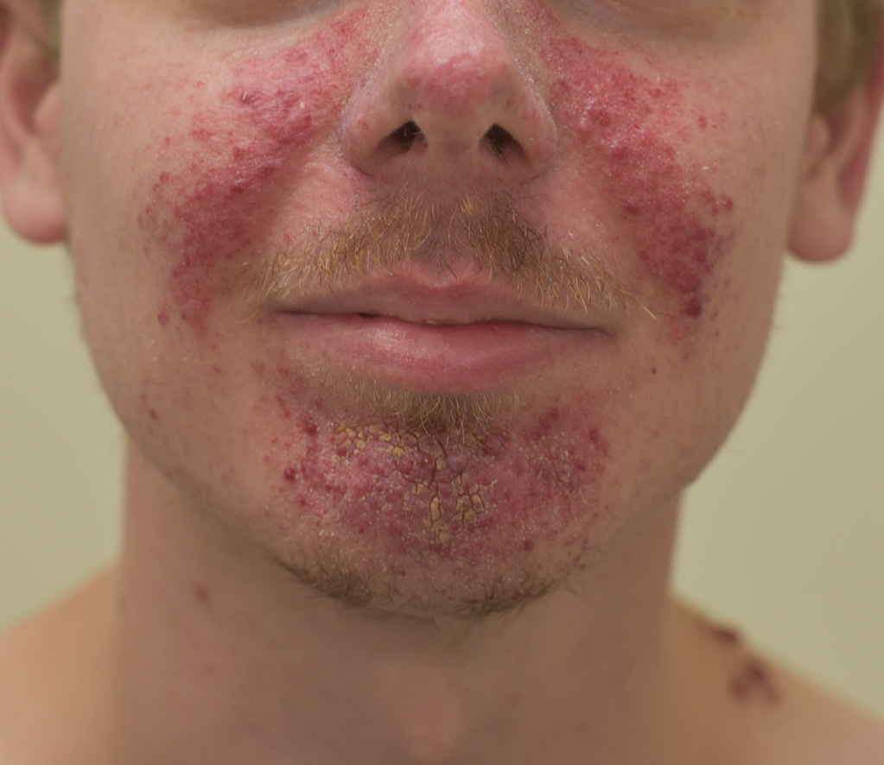
Figure S2: Moderate TSC-associated FA health state

