Supplementary information to:
Quantifying clinical reasoning in Functional Ambulation Category–based gait assessment using interpretable graph modeling of muscle synergies

Riku Kawabata^{1, 2}*, Ningjia Yang³, Shotaro Okajima², Tomokazu Abe², Ryohei Yamano², Ken Kikuchi¹, Hiroyuki Hamada¹, Atsushi Yamashita¹, Qi, An¹, Shigo Shimoda².
- Graduate School of Frontier Sciences, The University of Tokyo, 5-1-5 Kashiwanoha, Kashiwa, Chiba 277-8561, Japan
- Graduate School of Medicine, Nagoya University, 65 Tsurumai-cho, Showa-ku, Nagoya, Aichi 466-8550, Japan
- Research Center for Data Hub and Security, Zhejiang Laboratory, No. 2880 Wenyi West Road, Yuhang District, Hangzhou, Zhejiang 311100, China
* Correspondence: kawabata.riku.v8@f.mail.nagoya-u.ac.jp

Supplementary Figures
Supplementary Figure 1: Group-averaged electromyographic activation profiles across the gait cycle
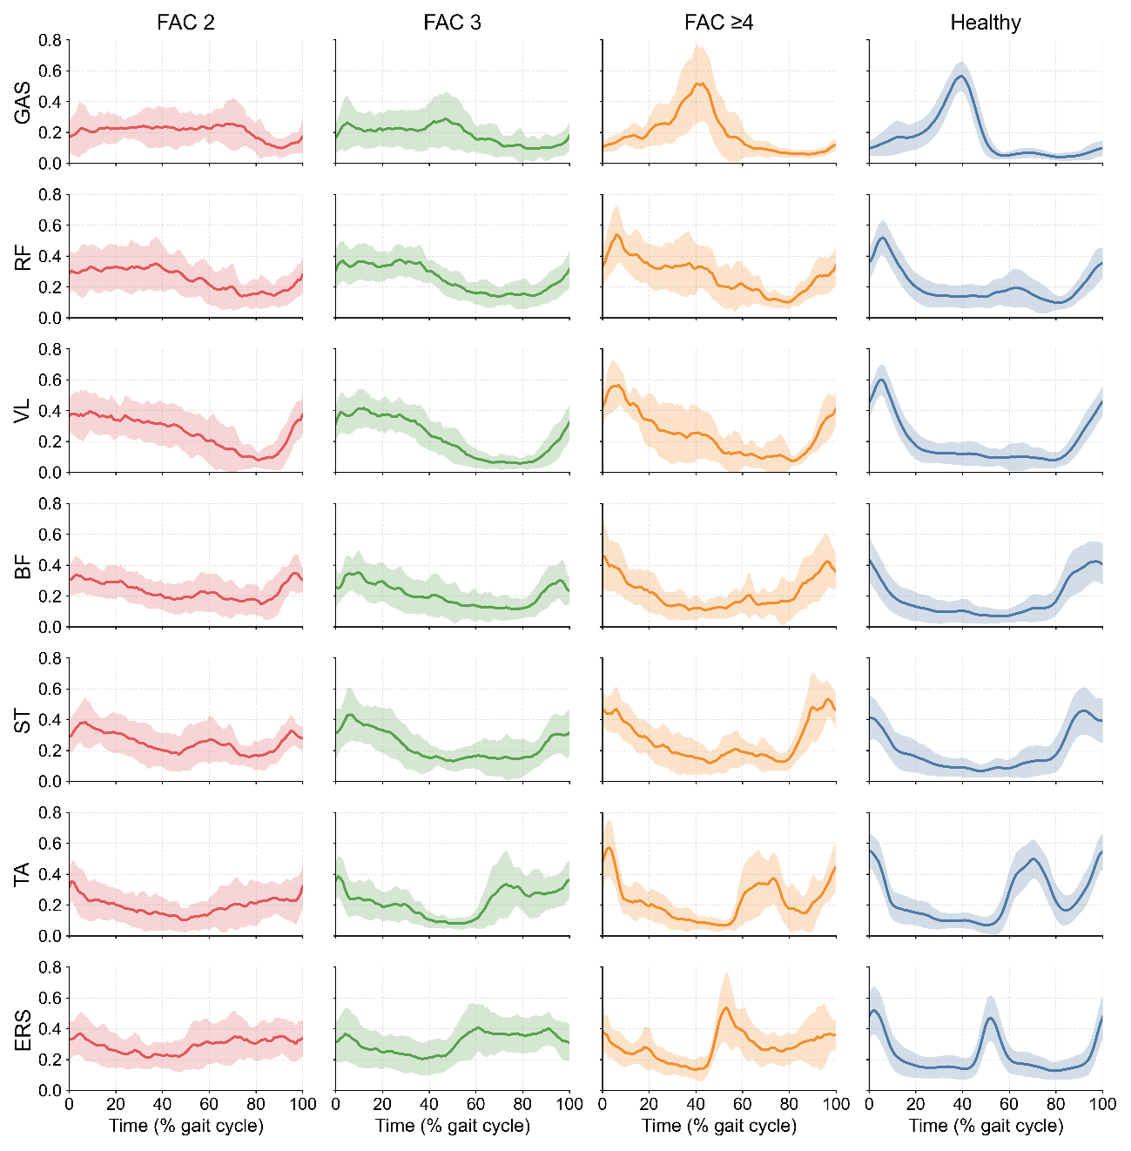
Group-averaged electromyographic (EMG) activation patterns over a single gait cycle are shown for seven muscles: gastrocnemius (GAS), rectus femoris (RF), vastus lateralis (VL), biceps femoris (BF), semitendinosus (ST), tibialis anterior (TA), and erector spinae (ERS). EMG signals were temporally normalized to 101 time points representing 0–100% of the gait cycle. Solid lines indicate group mean activation profiles, and shaded regions denote ±1 standard deviation across participants within each group. These time-aligned EMG profiles served as the input for subsequent muscle synergy extraction and graph-based analyses.

Supplementary Figure 2: Detailed class-wise performance characteristics of baseline classifiers and the graph neural network.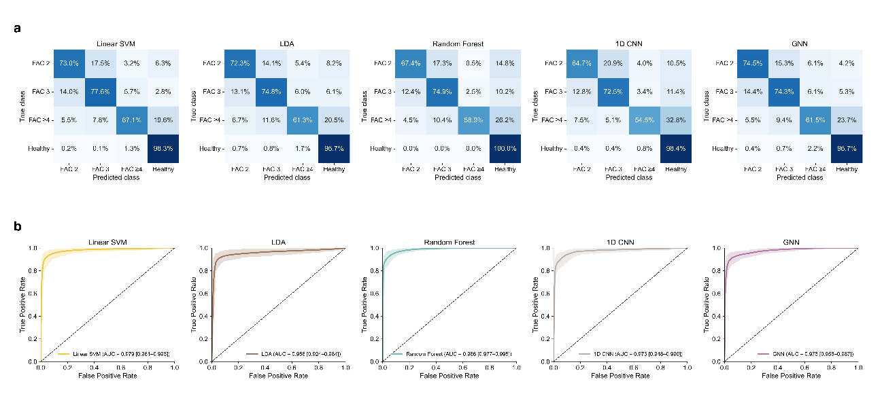
a Normalized confusion matrices for each classification model, including Linear Discriminant Analysis (LDA), linear Support Vector Machine (SVM), Random Forest, one-dimensional Convolutional Neural Network (1D CNN), and the proposed Graph Neural Network (GNN). Confusion matrices were computed as averages across 100 bootstrap resampling iterations of stratified five-fold cross-validation, providing robust estimates of class-wise prediction distributions across the four categories (Healthy, FAC 2, FAC 3, and FAC ≥ 4). b One-vs-rest receiver operating characteristic (ROC) curves for each model and class. Solid lines represent the bootstrap-averaged ROC curves, while shaded regions indicate the corresponding 95% confidence intervals derived from bootstrap resampling.

Supplementary Tables
Supplementary Table 1: Class-wise classification performance across models.
Model | Class | AUC | F1 score | Precision | Recall
LDA | FAC 2 | 0.895 (0.713–0.994) | 0.719 (0.488–0.910) | 0.745 (0.469–1.000) | 0.704 (0.455–0.900)
 | FAC 3 | 0.925 (0.776–0.990) | 0.738 (0.485–0.887) | 0.750 (0.498–0.931) | 0.737 (0.433–0.946)
 | FAC ≥4 | 0.761 (0.392–0.985) | 0.581 (0.000–0.869) | 0.611 (0.000–0.875) | 0.571 (0.000–0.909)
 | Healthy | 0.964 (0.919–0.996) | 0.962 (0.928–0.983) | 0.957 (0.923–0.990) | 0.967 (0.919–1.000)
Linear SVM | FAC 2 | 0.954 (0.894–0.993) | 0.735 (0.436–0.907) | 0.767 (0.542–0.972) | 0.717 (0.413–0.926)
 | FAC 3 | 0.968 (0.910–0.998) | 0.765 (0.525–0.938) | 0.776 (0.571–0.977) | 0.763 (0.482–0.949)
 | FAC ≥4 | 0.858 (0.571–0.986) | 0.667 (0.182–0.909) | 0.722 (0.224–1.000) | 0.638 (0.154–0.909)
 | Healthy | 0.977 (0.935–0.999) | 0.973 (0.939–0.991) | 0.964 (0.926–0.990) | 0.983 (0.942–1.000)
Random Forest | FAC 2 | 0.975 (0.946–0.996) | 0.724 (0.456–0.897) | 0.802 (0.557–1.000) | 0.674 (0.365–0.933)
 | FAC 3 | 0.982 (0.963–0.996) | 0.758 (0.576–0.899) | 0.777 (0.605–0.936) | 0.749 (0.499–0.941)
 | FAC ≥4 | 0.931 (0.855–0.986) | 0.708 (0.414–0.900) | 0.933 (0.720–1.000) | 0.589 (0.273–0.818)
 | Healthy | 0.992 (0.981–0.999) | 0.967 (0.946–0.986) | 0.938 (0.898–0.971) | 1.000 (0.990–1.000)
1D CNN | FAC 2 | 0.944 (0.833–0.990) | 0.686 (0.408–0.889) | 0.744 (0.500–1.000) | 0.647 (0.333–0.867)
 | FAC 3 | 0.974 (0.920–0.996) | 0.735 (0.550–0.893) | 0.753 (0.559–0.972) | 0.725 (0.529–0.882)
 | FAC ≥4 | 0.834 (0.649–0.972) | 0.624 (0.299–0.850) | 0.767 (0.400–1.000) | 0.545 (0.225–0.818)
 | Healthy | 0.960 (0.913–0.994) | 0.958 (0.933–0.976) | 0.934 (0.894–0.970) | 0.984 (0.961–1.000)
GNN | FAC 2 | 0.955 (0.889–0.994) | 0.752 (0.536–0.903) | 0.771 (0.577–0.923) | 0.745 (0.467–0.933)
 | FAC 3 | 0.959 (0.917–0.990) | 0.750 (0.591–0.879) | 0.769 (0.586–0.931) | 0.743 (0.529–0.882)
 | FAC ≥4 | 0.857 (0.714–0.969) | 0.613 (0.369–0.857) | 0.628 (0.374–0.905) | 0.615 (0.316–0.866)
 | Healthy | 0.968 (0.931–0.995) | 0.963 (0.937–0.985) | 0.960 (0.925–0.990) | 0.967 (0.936–1.000)

Supplementary Table 2: Pairwise edge-wise comparison between adjacent stroke subgroups (FAC 2 vs FAC 3, FAC 3 vs FAC ≥4).
Comparison | Edge | p-value (FDR) | Effect size (r)
FAC 2 vs FAC 3 | Syn 1-1 | 1 | 0.010
FAC 2 vs FAC 3 | Syn 1-2 | 1 | 0.003
FAC 2 vs FAC 3 | Syn 1-3 | 0.779 | 0.204
FAC 2 vs FAC 3 | Syn 1-4 | 0.779 | 0.110
FAC 2 vs FAC 3 | Syn 2-2 | 0.779 | $-$0.140
FAC 2 vs FAC 3 | Syn 2-3 | 0.779 | 0.237
FAC 2 vs FAC 3 | Syn 2-4 | 0.779 | $-$0.130
FAC 2 vs FAC 3 | Syn 3-3 | 0.779 | $-$0.130
FAC 2 vs FAC 3 | Syn 3-4 | 0.779 | $-$0.190
FAC 2 vs FAC 3 | Syn 4-4 | 0.779 | 0.090
FAC 3 vs FAC ≥4 | Syn 1-1 | 0.879 | $-$0.053
FAC 3 vs FAC ≥4 | Syn 1-2 | 0.753 | $-$0.147
FAC 3 vs FAC ≥4 | Syn 1-3 | 0.753 | $-$0.147
FAC 3 vs FAC ≥4 | Syn 1-4 | 0.738 | $-$0.316
FAC 3 vs FAC ≥4 | Syn 2-2 | 0.879 | 0.098
FAC 3 vs FAC ≥4 | Syn 2-3 | 1 | 0.004
FAC 3 vs FAC ≥4 | Syn 2-4 | 0.738 | 0.271
FAC 3 vs FAC ≥4 | Syn 3-3 | 0.879 | 0.058
FAC 3 vs FAC ≥4 | Syn 3-4 | 0.753 | $-$0.147
FAC 3 vs FAC ≥4 | Syn 4-4 | 0.738 | $-$0.236
Mann–Whitney U tests were performed for each inter-synergy edge. $p-values$ were corrected for multiple comparisons using the Benjamini–Hochberg false discovery rate (FDR) procedure within each subgroup comparison. Effect sizes are reported as rank-biserial correlation coefficients (r).

Supplementary Methods
Supplementary Methods S1. Graph neural network training and evaluation strategy
To ensure a fair and robust assessment of classification performance while enabling stable and interpretable attribution analysis, we adopted a two-stage training strategy for the graph neural network (GNN), in which model evaluation and model interpretation were explicitly decoupled.
Stage 1: Performance evaluation using bootstrap cross-validation.
Predictive performance of the GNN was quantified using a repeated bootstrap cross-validation procedure. Specifically, 100 bootstrap resampling iterations were performed. In each iteration, participants were resampled with replacement in a stratified manner within each class to preserve the original class distribution. For each bootstrap dataset, stratified five-fold cross-validation was conducted, with folds generated using a fixed random seed specific to the bootstrap iteration. Model training and evaluation were performed independently within each fold, and predictions from all test folds were aggregated to compute overall performance metrics. Reported accuracy, macro-averaged F1-score, and macro-averaged AUC therefore represent averages across both bootstrap iterations and cross-validation folds, capturing variability due to sampling and partitioning of the dataset.
Stage 2: Training of fold-specific models for attribution analysis.
To support post hoc interpretability analyses using Integrated Gradients, a separate set of GNN models was trained using stratified five-fold cross-validation with a fixed random seed. Within each fold, the model was trained on the training subset and evaluated on the held-out fold at each epoch. The model parameters achieving the highest classification accuracy on the held-out fold were retained as the fold-specific “best” model. These fold-best models were not used for performance reporting, but exclusively for attribution analysis, ensuring that explanation results were derived from well-performing and stable models without contaminating the evaluation procedure.
Across both stages, identical network architectures and hyperparameters were used to maintain methodological consistency. Random seeds were fixed for NumPy and PyTorch to enhance reproducibility. This two-stage design allowed reliable estimation of classification performance while providing a principled foundation for interpretable analysis of inter-synergy coordination patterns.

Supplementary Methods S2. Integrated Gradients attribution procedure
To obtain edge-level explanations for the graph neural network (GNN) while strictly avoiding information leakage across cross-validation folds, Integrated Gradients (IG) attribution was computed using a fold-specific strategy. For each fold of the five-fold cross-validation, the corresponding fold-best model was applied only to participants in the held-out test split of the same fold, and IG was never computed on training samples used to fit that mode
Edge-mask formulation for attribution.
Because the graph topology was fixed across participants, attribution was performed with respect to continuous edge masks that gate message passing, rather than with respect to node features. Specifically, each directed edge in the PyTorch Geometric edge_index was associated with a scalar mask $m_{e}∈\left[0,1\right]$, which was passed to all GraphConv layers as edge_weight. The baseline corresponded to $m_{e}=0$ for all edges (no message passing), and the input corresponded to $m_{e}=1$ (full message passing). Integrated Gradients was then computed along the straight-line path between these two states.
Attribution target and normalization.
Attributions were computed with respect to the ground-truth class label of each participant (true-class attribution), ensuring that explanations were aligned with clinical FAC categories rather than with model predictions. The resulting edge-wise attributions were transformed by taking absolute values and were subsequently normalized within each participant by dividing by the maximum attribution value across edges. This per-sample normalization enabled meaningful group-level comparison and downstream statistical modeling by removing inter-individual scale differences in attribution magnitude.
Undirected aggregation of synergy interactions.
The GNN operates on directed edges; however, for interpretability, directed attributions were aggregated into an undirected representation. For each participant, directed attributions corresponding to the same unordered synergy pair were summed and mirrored across the diagonal to form a symmetric $4×4$ matrix, including self-interactions. This matrix captured the relative contribution of each inter-synergy coordination pattern to FAC-related classification.
Output and quality control.
Participant-level symmetric Integrated Gradients (IG) matrices were saved with fold and sample identifiers to preserve provenance. For transparency, the number of test samples contributing to the IG analysis in each group was recorded. All attribution analyses were performed using all test samples within each cross-validation fold.
These participant-level IG-derived edge scores were subsequently used for group comparisons, ordinal logistic regression, and regression tree analyses described in the main text.

