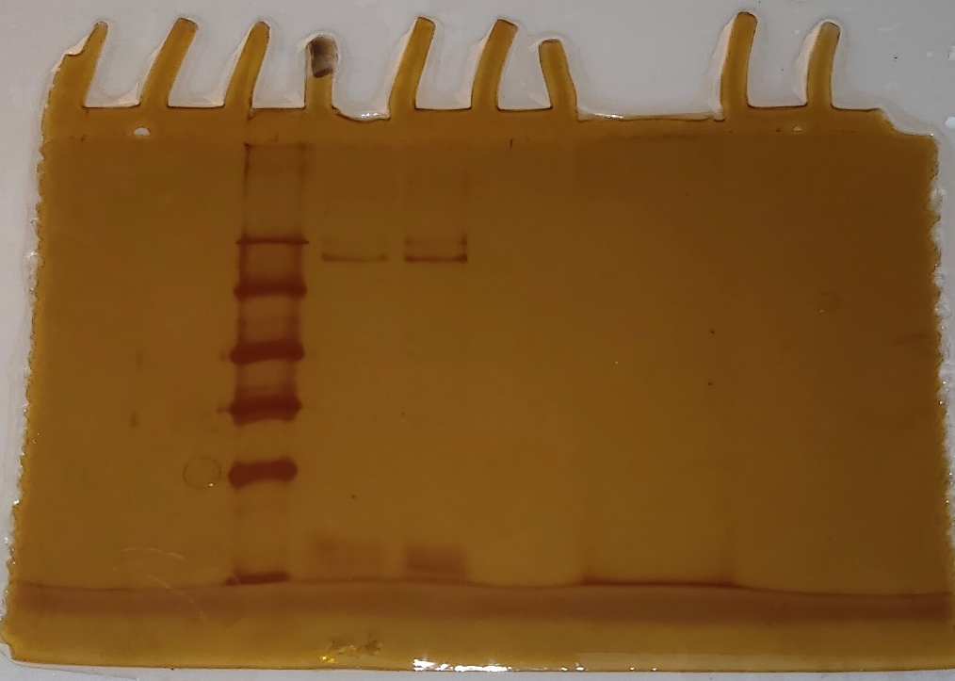
d
c
b
a
Figure 1 SDS–PAGE gel (10%) of purified O. basilicum protease; Lane a: Standard molecular-mass markers (kDa); Lane b: DEAE Cellulose column eluted active protease fraction (15-16) in reducing condition was inhibited by serine protease inhibitor 2 mM PMSF; Lane c: DEAE Cellulose column eluted active protease fraction (17) in reducing condition without inhibitor; lane d: DEAE Cellulose column eluted protease fraction (18) in reducing condition without inhibitor.
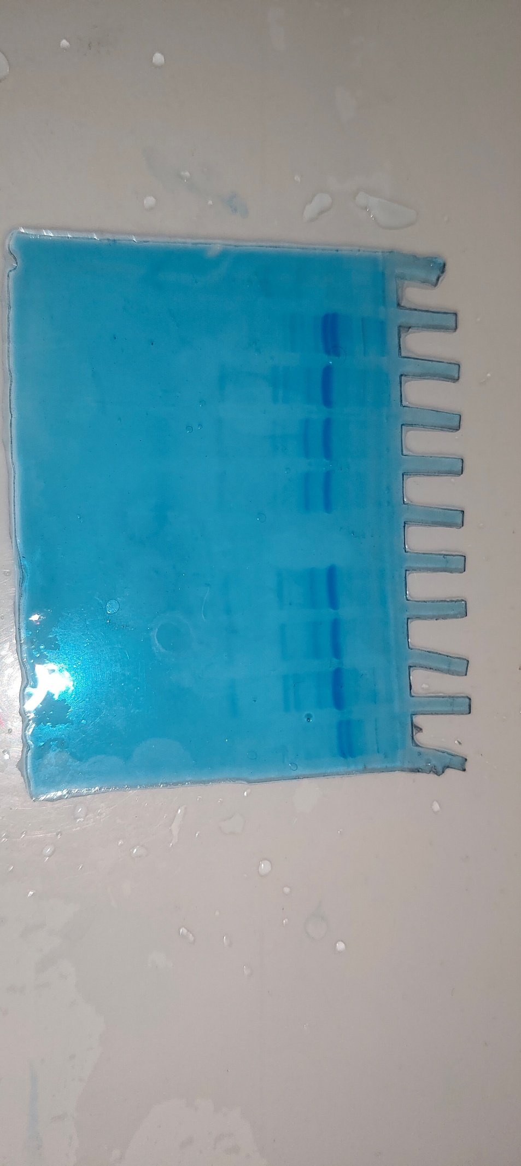
j
i
h
g
f
e
d
c
b
a
Figure 2 SDS-PAGE (15%) of fibrinogen cleavage by O. basilicum protease. Lane b&j: Control fibrinogen incubated at -15°C for 24hr and 6 hr respectively, lane c&i: Control fibrinogen incubated at 37°C for 24hr and 6 hr respectively, lane d&h: Fibrinogen (20µg) incubated with protease 20µg at 37°C for 24hr and 6 hr respectively and lane e&g: Fibrinogen (20µg) incubated with protease 10µg at 37°C for 24hr and 6 hr respectively. 40 µl was loaded equally in each well.

