Supplementary Figure 1. The differences in the content of various immune cells between cluster 1 and cluster 2. (A) EPIC algorithm. (B) MCPcounter algorithm. (C) ssGSEA algorithm. (D) CIBERSORT algorithm.

Supplementary Figure 2. PELI2 modulates PA–induced inflammatory cytokine secretion。(A-C)ELISA analysis of IL-6,IL-8 and TNF-α secretion in HepG2 cells under palmitic acid treatment and PELI2 overexpression.(D-E)ELISA analysis of IL-6,IL-8 and TNF-α secretion in HepG2 cells under palmitic acid treatment and PELI2 knockdown.

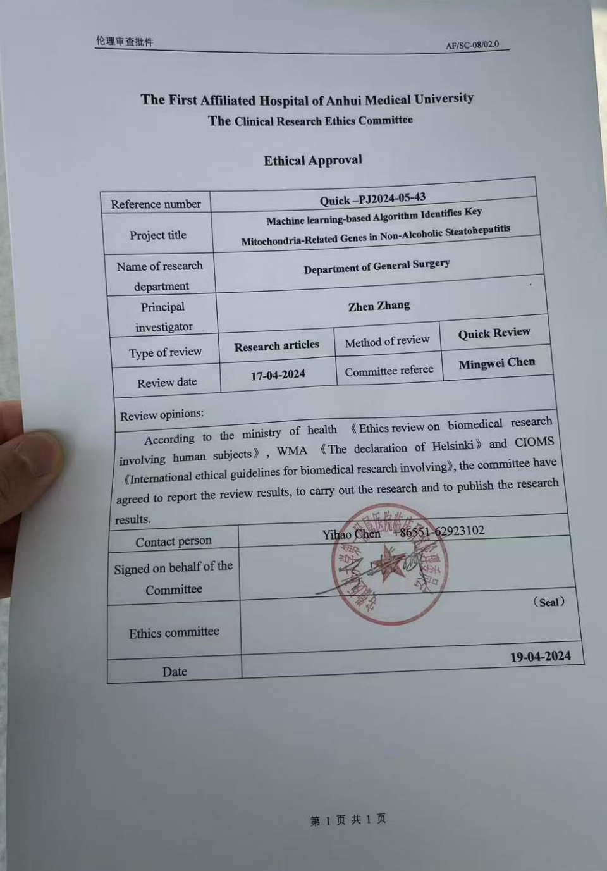
Supplementary Figure 3. Bioethics review approval document.

