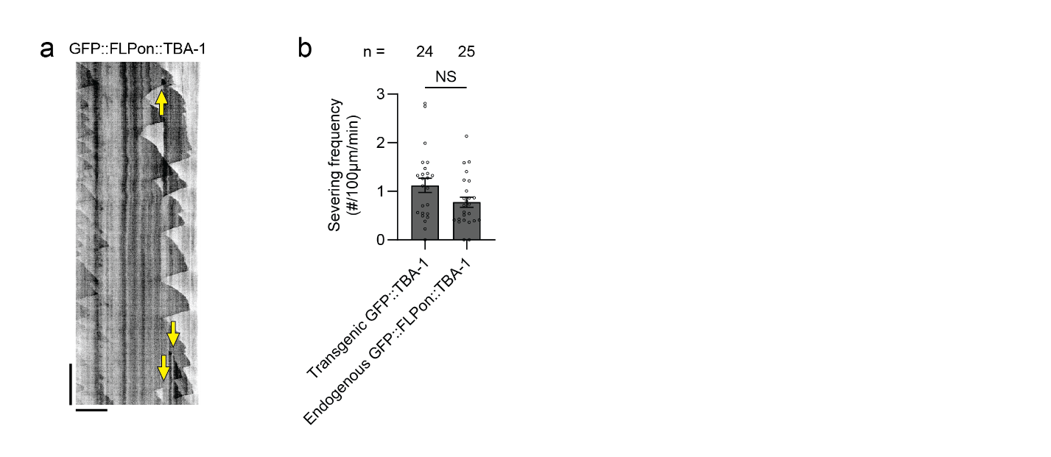
Extended Data Figure 1.
a, Kymograph of endogenous GFP::FLPon::TBA-1 dynamics. Yellow arrows indicate severing events. Scale bar, 10 μm (horizontal) and 60 sec (vertical). b, Quantification of severing frequency in worms expressing transgenic GFP::TBA-1 and endogenous GFP::FLPon::TBA-1. Data shown as mean ± s.e.m. n represents number of animals. Two-tailed unpaired t-test with Welch’s correction.

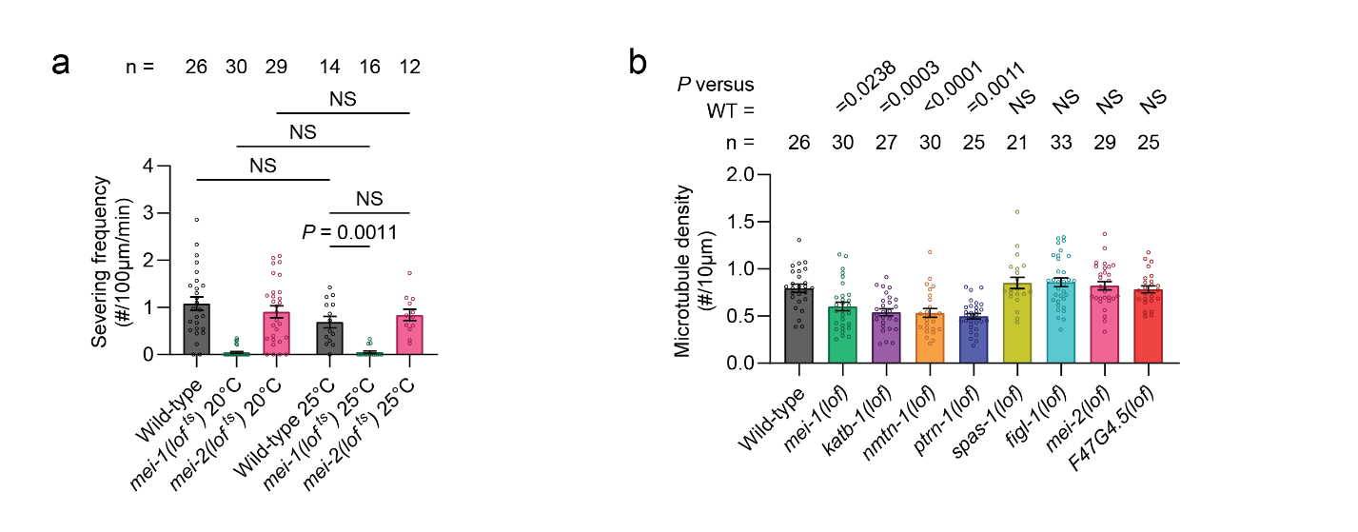
Extended Data Figure 2. Temperature sensitivity of mei-1 and mei-2 alleles.
a, Quantification of severing frequency in wild-type and the mei-1 ts mutant across temperatures. The data for genotypes at 20° are the same as used in Figure 2B. Data shown as mean ± s.e.m. n represents number of animals. Brown–Forsythe and Welch one-way ANOVA with Dunnett's test. b, Quantification of microtubule density in the outgrowing posterior dendrite (L2 stage) across various mutants. Microtubule density is calculated based on the number of dynamic microtubule plus-ends. Data shown as mean ± s.e.m. n represents number of animals. Brown–Forsythe and Welch one-way ANOVA with Dunnett's test.
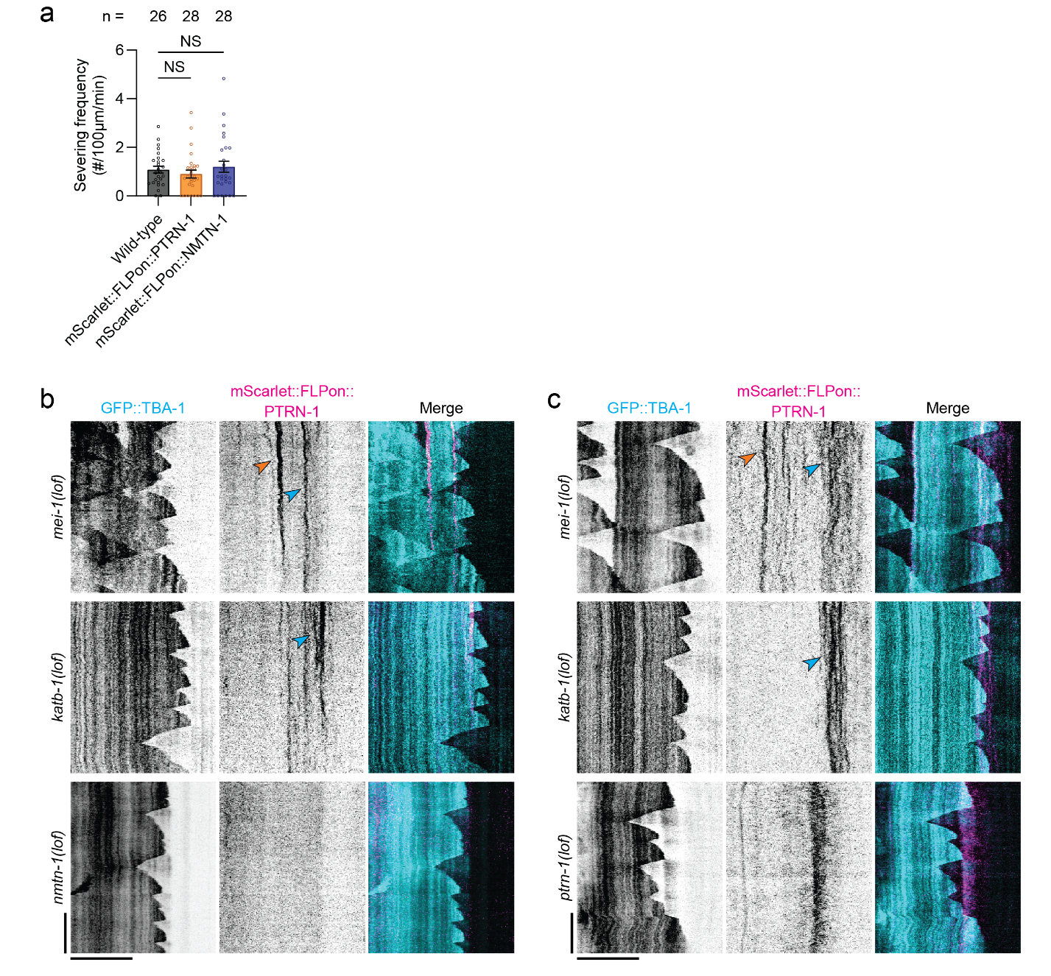
Extended Data Figure 3. Kymograph analysis of PTRN-1 and NMTN-1 dynamics in severing mutants.
a, Quantification of severing frequency in wild-type and PTRN-1/NMTN-1 knock-in strains. Wild-type data is the same as used in Figure 2b. Data shown as mean ± s.e.m. n represents number of animals. Brown–Forsythe and Welch one-way ANOVA with Dunnett's test. b, Kymographs of GFP-TBA-1 and mScarlet::FLPon::PTRN-1 dynamics in L2 stage PVD posterior dendrite in severing mutants. Scale bar, 10 μm (horizontal) and 60 sec (vertical). c, Kymographs of GFP-TBA-1 and mScarlet::FLPon::NMTN-1 dynamics in L2 stage PVD posterior dendrite in severing mutants. Scale bar, 10 μm (horizontal) and 60 sec (vertical).
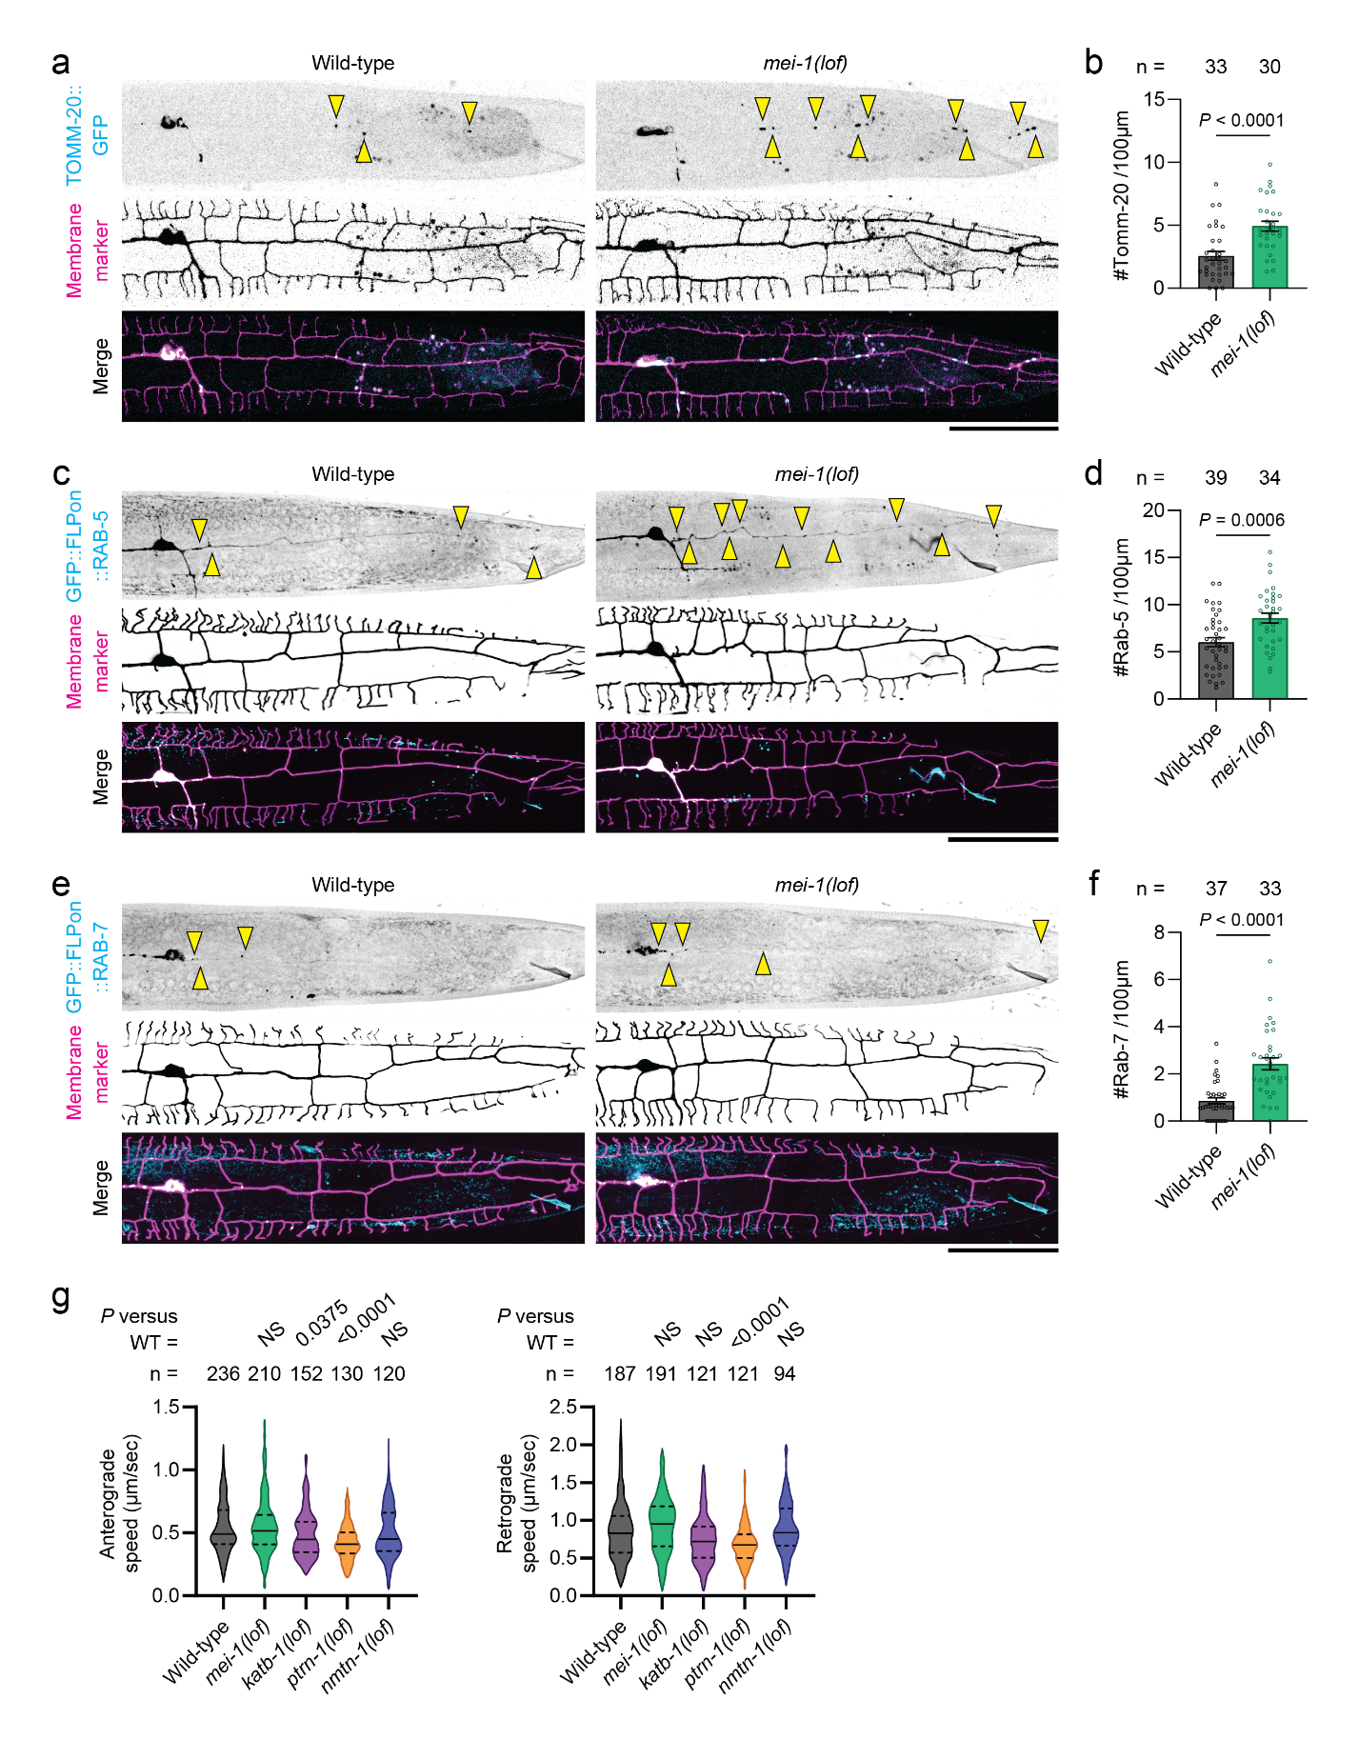
Extended Data Figure 4. Localization of mitochondria, Rab-5, and Rab-7 endosomes in PVD posterior dendrite.
a, Tomm-20 localization in L4 stage PVD posterior primary dendrite in wild-type and mei-1(lof) mutants. Yellow triangles indicate TOMM-20::GFP puncta. b, Quantification of mitochondria density in wild-type and mei-1(lof) mutants. c, Rab-5 localization in L4 stage PVD posterior primary dendrite in wild-type and mei-1(lof) mutants. Yellow triangles indicate GFP::FLPon::RAB-5 puncta. d, Quantification of Rab-5 density in wild-type and mei-1(lof) mutants. e, Rab-7 localization in L4 stage PVD posterior primary dendrite in wild-type and mei-1(lof) mutants. Yellow triangles indicate GFP::FLPon::RAB-7 puncta. f, Quantification of Rab-7 density in wild-type and mei-1(lof) mutants. Data shown as mean ± s.e.m. n represents number of animals. Two-tailed unpaired t-test with Welch’s correction used in b, d, and f. g, Quantification of average anterograde and retrograde speed for RAB-10 positive cargo. Data shown as mean ± quartile, n represents number of cargo tracks. Brown–Forsythe and Welch one-way ANOVA with Dunnett's test.

