Supplementary Tables & Figures
Table S1 Scenarios for simulated interventions
Intervention scenario | Single-factor intervention description
(1) Altering job type | Set job type to be farming, self-employed, or employed.
- Altering working hours | - Low-hour intervention: Set working hours to a fixed value of 28  hours/week.  2. Medium-hour intervention: Set working hours to a fixed value of 42 hours/week.  3. High-hour intervention: Set working hours to a fixed value of 84  hours/week.
- Altering work environment | Set the work environment to be outdoors, workshop/factory, office,  home, other indoors, inside a vehicle, or other.
- Altering job  promotion status | Set promotion status to: administrative promotion only, technical title  promotion only, both administrative and technical promotion, no  promotion, or a job with no higher position available.
- Altering work stress | - Low-stress intervention: Set the work stress index to a fixed value of 2.  2. Medium-stress intervention: Set the work stress index to a fixed  value of 8.  3. High-stress intervention: Set the work stress index to a fixed value of 15.
- Altering work income | - Low-income intervention: Set annual work income to a fixed value  of ¥18,000 (25th percentile).  2. Medium-income intervention: Set annual work income to a fixed  value of ¥30,000 (50th percentile).  3. High-income intervention: Set annual work income to a fixed value  of ¥50,000 (75th percentile).

Table S2 Results of sensitivity analysis
Intervention  Variable | Intervention  Measure | G-formula Mean (95% CI) | RR (95% CI)
Types of  Work | Natural process | 2.459 (0.955,4.664) | 1.000 (1.000,1.000)
Types of  Work | Farming | 3.660 (0.645,6.715) | 1.488 (0.697,2.788)
Types of  Work | Self-employed | 3.271 (1.728,5.540) | 1.330 (1.019,2.080)
Types of  Work | Employed | 2.229 (0.703,4.419) | 0.906 (0.791,0.978)
Working Hours | Natural process | 2.660 (1.023,4.933) | 1.000 (1.000,1.000)
Working Hours | Low working hours | 2.444 (0.475,4.191) | 0.918 (0.347,1.626)
Working Hours | Medium working hours | 2.570 (0.943,4.506) | 0.966 (0.658,1.280)
Working Hours | High working hours | 2.863 (0.527,5.886) | 1.076 (0.216,1.697)
Work Environment | Natural process | 2.676 (1.119,4.919) | 1.000 (1.000,1.000)
Work Environment | Outdoor | 3.427 (1.504,5.963) | 1.280 (1.028,1.768)
Work Environment | Workshop | 2.386 (1.178,4.698) | 0.891 (0.705,1.304)
Work Environment | Office | 2.267 (0.176,4.647) | 0.847 (0.120,1.129)
Work Environment | Home | 2.072 (0.193,4.503) | 0.774 (-0.074,1.218)
Work Environment | Other indoor | 2.764 (1.165,5.409) | 1.032 (0.887,1.400)
Work Environment | Inside transportation vehicles | 2.052 (0.196,5.098) | 0.767 (0.024,1.443)
Job Promotion | Natural process | 2.727 (1.162,4.976) | 1.000 (1.000,1.000)
Job Promotion | Promotion to administrative position | 3.524 (1.540,6.983) | 1.292 (0.739,2.529)
Job Promotion | Promotion to  technical title | 3.283 (1.411,6.167) | 1.204 (0.836,2.025)
Job Promotion | Both | 3.018 (1.295,5.589) | 1.106 (0.917,1.538)
Job Promotion | Neither | 2.741 (1.188,5.083) | 1.005 (0.986,1.098)
Job Promotion | No higher position or rank available for promotion in this job | 2.515 (0.740,4.639) | 0.922 (0.636,1.060)
Note: Bold figures indicate that the result was statistically significant.
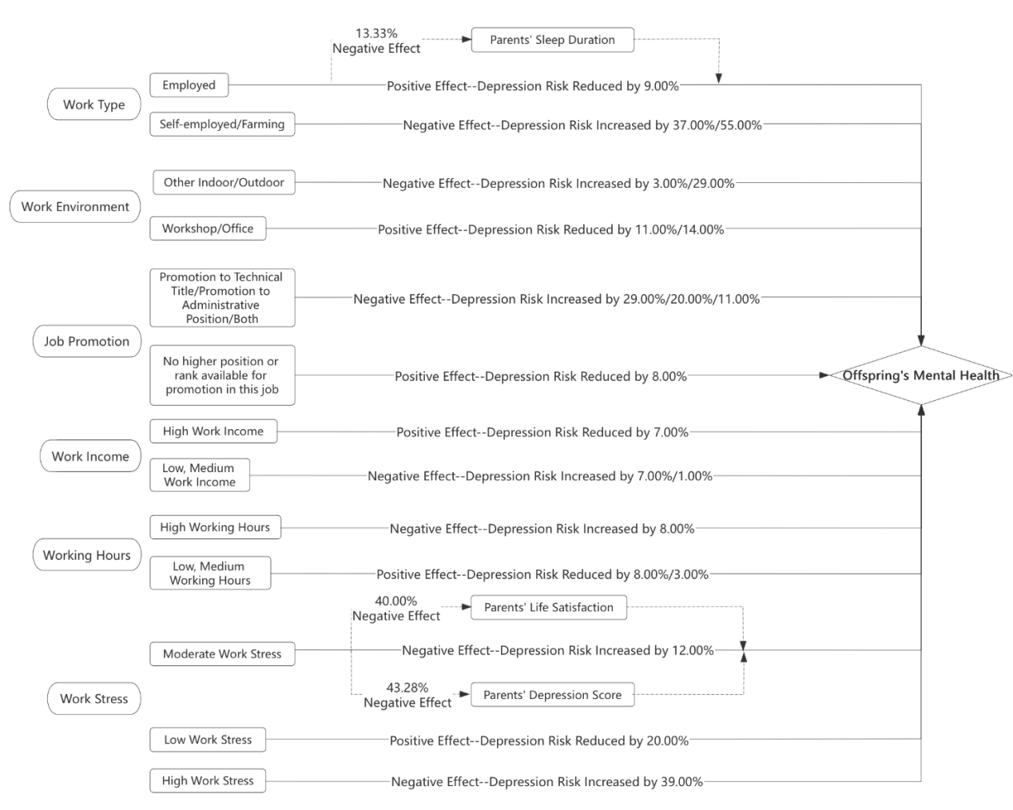
Fig S1a. Total sample
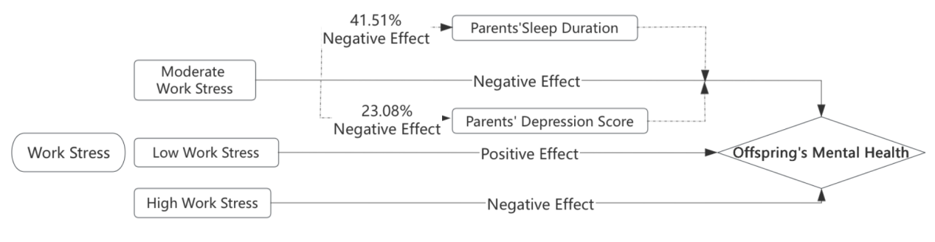
Fig S1b. Maternal sample
Note: Solid lines indicate direct effects, and dashed lines indicate indirect effects.
Fig S1. Mechanism pathways of parent’s occupation on offspring’s mental health

