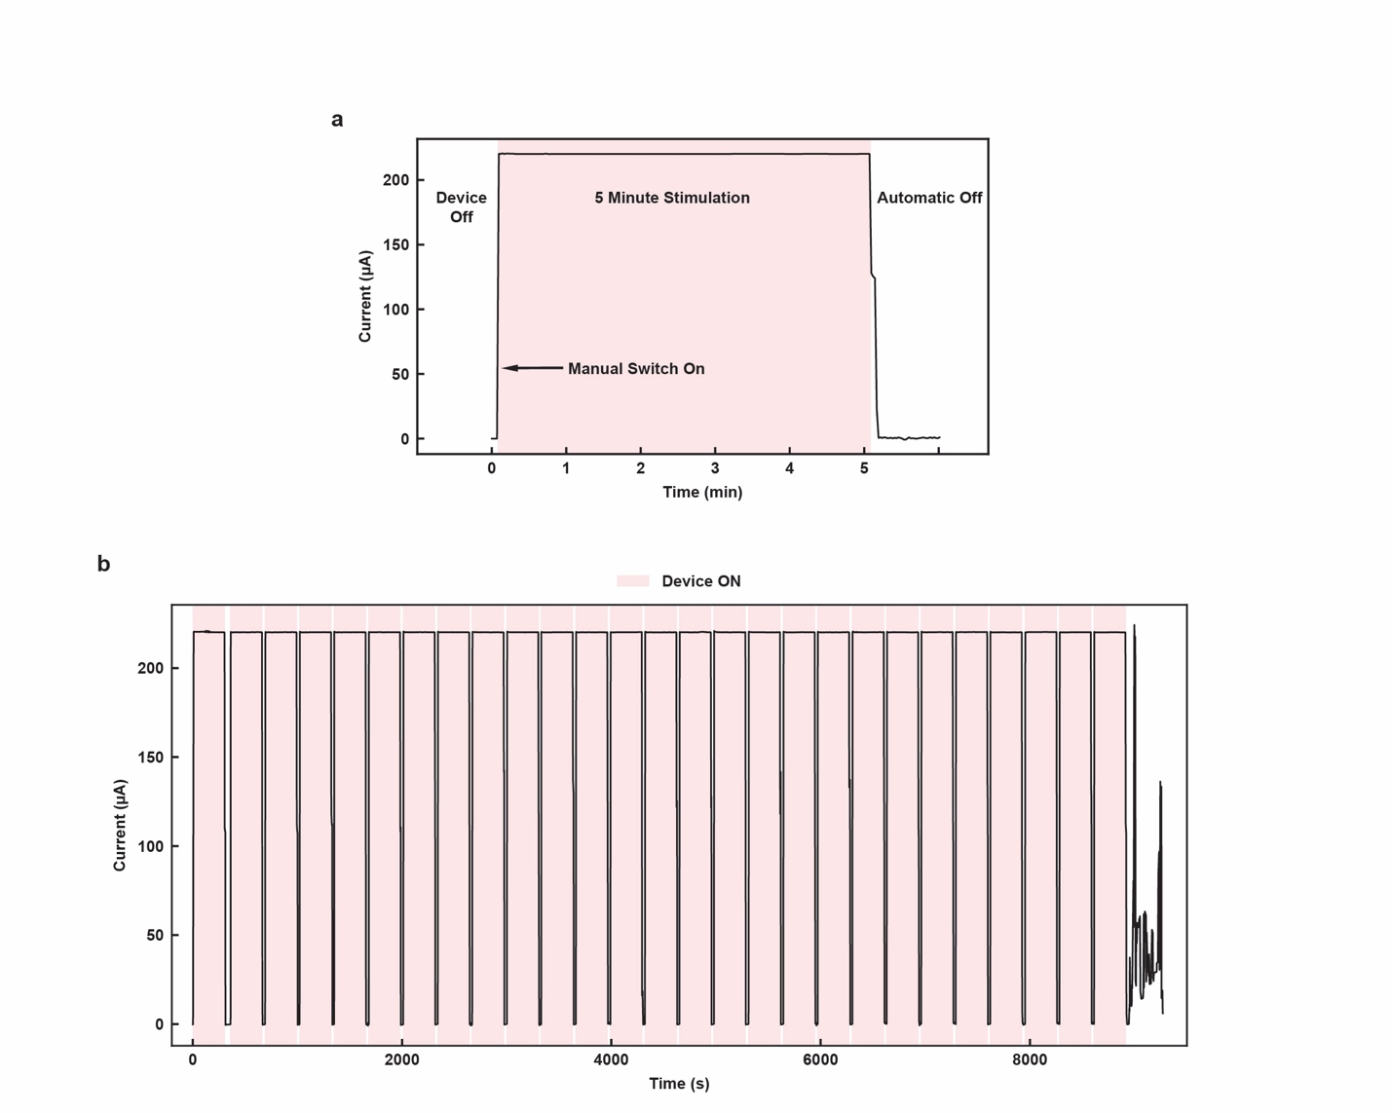
Supplementary Figure 1. Stimulation circuit characterization. a) Current profile of 5-minute stimulation. b) Continuous testing of stimulation cycles of the stimulation module, with a 3.7V, 30 mAh battery.

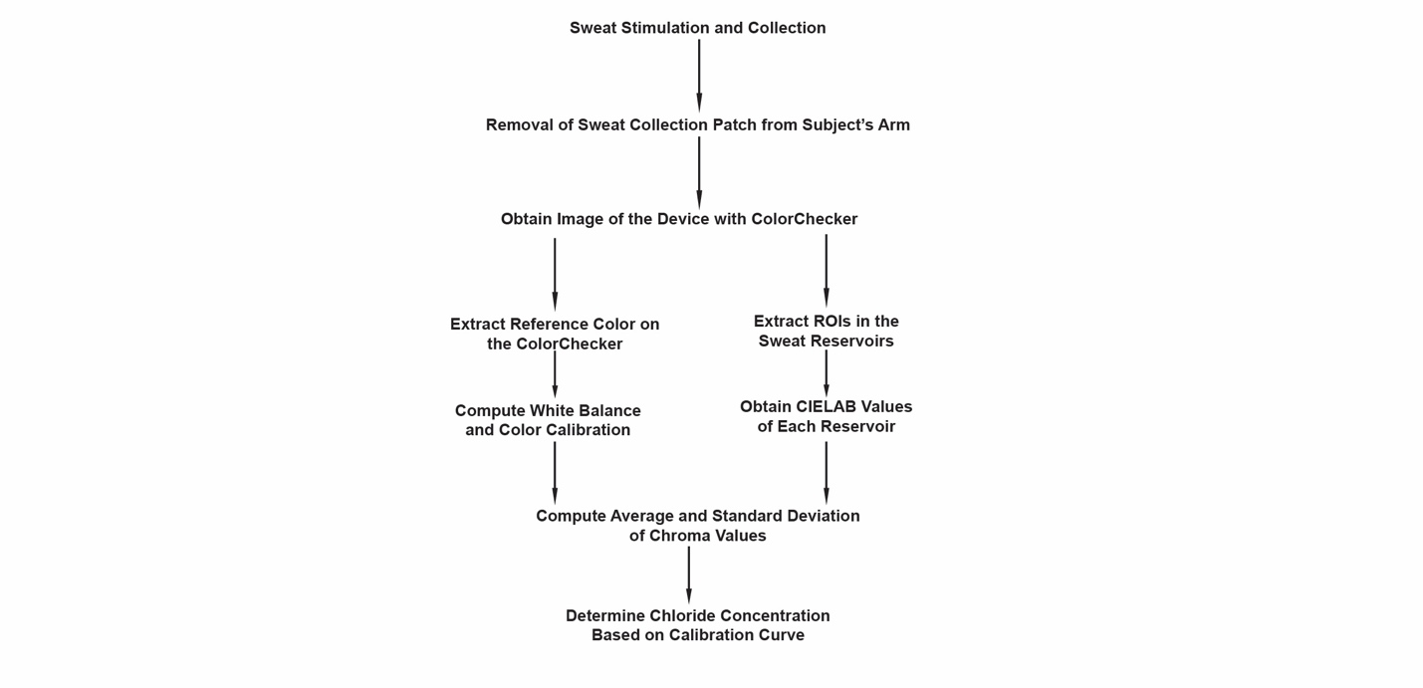
Supplementary Figure 2. Flow chart for the image analysis process.

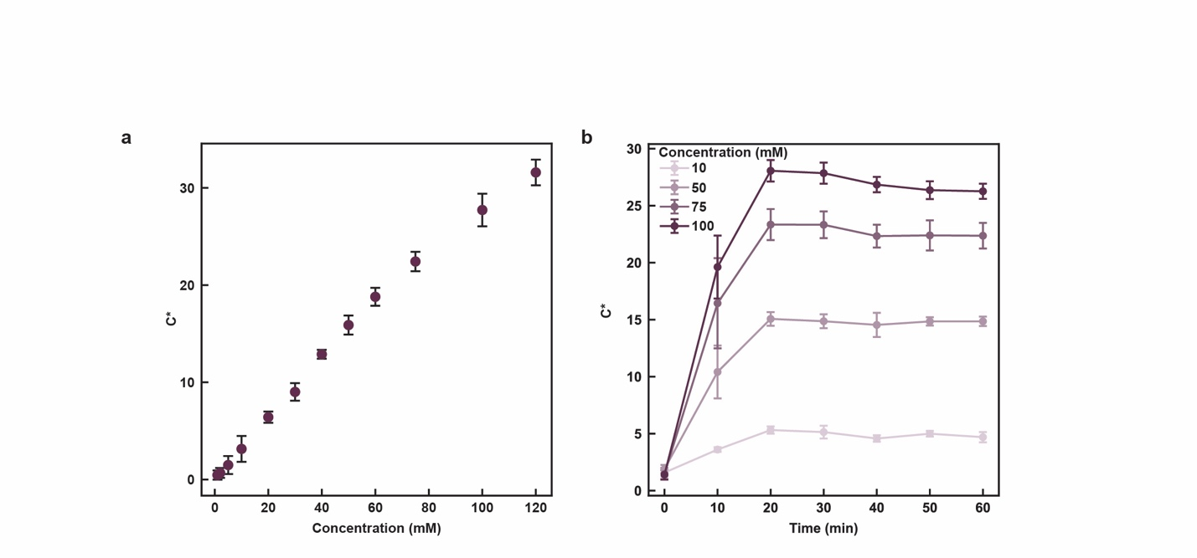
Supplementary Figure 3. Characterization of colorimetric chloride assay. a) Calibration curve of chloride assay. b) Time dynamics of chloride assay color development.
Authors | Year | CF-context related | Iontophoresis used | Wearable sensing | Number of subjects (N) | Subject categories | Sweat generation method | Iontophoretic device used
Zhou et al. (This work) | 2026 | Yes | Yes | Yes | 55 | 3 healthy, 10 CRMS, 42 CF | Iontophoresis | Investigational device
Nelson et al.¹ | 2026 | Yes | Yes | Yes | 27 | 20 CF, 7 healthy | Exercise and Macroduct Stimulation | Macroduct
Björkenheim et al.^{2†} | 2025 | No | Yes | No | 24 | 24 | Iontophoresis | Macroduct
Promphet et al.³ | 2025 | No | No | Yes | 4 | NA | Passive
Shin et al.⁴ | 2025 | No | Yes | Yes | 3 | 1 healthy, 2 gout patients | Iontophoresis | Investigational device
Davis et al.⁵ | 2024 | No | No | Yes | 44 | 12 healthy, 32 cirrhosis | Passive
Kim et al.⁶ | 2024 | Yes | Yes | Yes | 5 | 5 CF | Iontophoresis | Investigational device
Tu et al.^{7†} | 2023 | No | Yes | No | 34 | 10 with COPD, 24 without COPD | Iontophoresis | Macroduct
Tu et al.⁷ | 2023 | No | Yes | Yes | 10 | healthy never smoker 3, healthy smoker 3, post covid 3, 1 patient with COPD | Iontophoresis | Investigational device
Wang et al.⁸ | 2022 | No | Yes | Yes | 5 | 5 healthy | Iontophoresis | Investigational device
Ray et al.^{9†} | 2021 | Yes | Yes | No (Testing Collection Ability of Novel Microfluidic Device) | 51 | 33 CF, 18 healthy | Iontophoresis | Macroduct
Ray et al.⁹ | 2021 | Yes | Yes | Yes | 5 | 2 CF, 3 healthy | Iontophoresis | Macroduct
Jagannath et al.¹⁰ | 2020 | No | No | Yes | 20 | 20 healthy | Passive
Choi et al.¹¹ | 2020 | No | Yes, for comparison with exericise-induced sweating | Yes | 12 | 12 healthy | Iontophoresis and Exercise | Macroduct
Choi et al.¹¹ | 2020 | No | Yes, for comparison with exericise-induced sweating | Yes | 11 | 11 healthy | Iontophoresis and Exercise | Macroduct
Parrila et al.¹² | 2019 | No | No | Yes | 9 | 9 on-body tests total | Exercise
Choi et al.¹³ | 2018 | Yes | Yes | Yes | 20 | 10 CF, 10 healthy | Iontophoresis | Macroduct
Nyein et al.¹⁴ | 2018 | No | No | Yes | 3 | 3 healthy | Exercise
Willems et al.^{15†} | 2017 | No | Yes | No | 12 | 12 healthy | Iontophoresis | Macroduct
Emaminejad et al.¹⁶ | 2017 | Yes | Yes | Yes | 9 | 3 CF, 6 healthy | Iontophoresis | Investigational device
Kim et al.¹⁷ | 2016 | No | Yes | Yes | 2 | 2 healthy | Iontophoresis | Investigational device
Matzeu et al.¹⁸ | 2015 | No | Yes | Yes | 6 | 6 on-body tests | Exercise
Jia et al.¹⁹ | 2013 | No | No | Yes | 10 | 10 healthy | Exercise

Supplementary Table 1. Summary of clinical studies on wearable sweat induction and sensing.
†: Excluded in plot, as there is no wearable biomarker sensing component tested on these subjects. Please note that this table presents representative, comprehensive studies and does not constitute an exhaustive review of wearable sweat sensors.

Metric | LeGrys et al. (2018) | Our Device
Comparing between | Macroduct Left vs. Right Arm | Macroduct vs. Our device
Mean signed difference (bias) | 0.5 mM | 0.45 mM
Standard deviation of differences | 5.7 mM | 6.5 mM
Mean absolute difference (MAD) | Not directly reported | 5.36 mM
Limits of agreement (±1.96 SD) | ±11.2 mM | ±12.7 mM
% within ±10 mM | Not explicitly reported | 83.64%
% outliers >10 mM | 9.60% † | 16.36%

†: Not explicitly reported; but if assuming the paired differences are approximately normal, the probability that a randomly chosen paired difference exceeds 10 mM in absolute value is calculated to be 9.6%.

Supplementary Table 2. Study results comparison between the 2018 Legrys study and the CF SWIFT study.

Group | Healthy | CRMS | CF with modulators | CF without modulators
N | 3 | 10 | 20 | 22
Macroduct mean | 22 | 35.7 | 51.7 | 89.14
Macroduct standard deviation | 13.23 | 16.91 | 25.55 | 29.99
Colorimetric mean | 25.5 | 36.96 | 52.68 | 88.2
Colorimetric standard deviation | 13.49 | 21.28 | 26.14 | 30.32
Mean Difference  (Colorimetric-Macroduct) | 3.5 | 1.25 | 0.98 | -0.94
Mean Absolute Difference | 4.29 | 4.61 | 4.38 | 6.67
Paired t-test p-value | 0.47 | 0.56 | 0.41 | 0.57

Supplementary Table 3. Paired sweat chloride testing results comparison according to subject groups.

Group | N | Device | TP | TN | FP | FN
Healthy | 3 | Macroduct | 0 | 3 | 0 | 0
Healthy | 3 | Colorimetric | 0 | 3 | 0 | 0
CRMS | 9 | Macroduct | 0 | 8 | 1 | 0
CRMS | 9 | Colorimetric | 0 | 7 | 2 | 0
CF | 42 | Macroduct | 24 | 0 | 0 | 18
CF | 42 | Colorimetric | 24 | 0 | 0 | 18
Overall | 56 | Macroduct | 24 | 13 | 1 | 18
Overall | 56 | Colorimetric | 24 | 12 | 2 | 18

Supplementary Table 4. Paired classification results.

Supplementary References
1. Nelson, R.S. et al. Remote analysis and management of sweat biomarkers using a wearable microfluidic sticker in adult cystic fibrosis patients. Proceedings of the National Academy of Sciences 122, (2025). https://doi.org/10.1073/pnas.2506137122
2. Björkenheim, A. et al. Biomarkers of inflammation in sweat after myocardial infarction. Scientific Reports 2025 15:1 15, (2025). https://doi.org/10.1038/s41598-025-90240-8
3. Promphet, N. et al. Non-invasive fingertip sweat biosensor for early kidney disease biomarker screening. Sensors and Actuators B: Chemical 441, (2025). https://doi.org/10.1016/j.snb.2025.137967
4. Shin, S. et al. A bioinspired microfluidic wearable sensor for multiday sweat sampling, transport, and metabolic analysis. Science Advances 11, (2025). https://doi.org/10.1126/sciadv.adw9024
5. Davis, B.C. et al. A novel sweat sensor detects inflammatory differential rhythmicity patterns in inpatients and outpatients with cirrhosis. npj Digital Medicine 2024 7:1 7, (2024). https://doi.org/10.1038/s41746-024-01404-1
6. Kim, J. et al. A skin-interfaced, miniaturized platform for triggered induction, capture and colorimetric multicomponent analysis of microliter volumes of sweat. Biosensors & bioelectronics 253, (2024). https://doi.org/10.1016/j.bios.2024.116166
7. Tu, J. et al. A wireless patch for the monitoring of C-reactive protein in sweat. Nature Biomedical Engineering 2023 7:10 7, (2023). https://doi.org/10.1038/s41551-023-01059-5
8. Wang, M. et al. A wearable electrochemical biosensor for the monitoring of metabolites and nutrients. Nature Biomedical Engineering 2022 6:11 6, (2022). https://doi.org/10.1038/s41551-022-00916-z
9. Ray, T.R. et al. Soft, skin-interfaced sweat stickers for cystic fibrosis diagnosis and management. Science Translational Medicine 13, (2021). https://doi.org/10.1126/scitranslmed.abd8109
10. Jagannath, B. et al. A Sweat-based Wearable Enabling Technology for Real-time Monitoring of IL-1β and CRP as Potential Markers for Inflammatory Bowel Disease. Inflammatory Bowel Diseases 26, (2020). https://doi.org/10.1093/ibd/izaa191
11. Choi, D.-H. et al. The Dynamic Response of Sweat Chloride to Changes in Exercise Load Measured by a Wearable Sweat Sensor. Scientific Reports 2020 10:1 10, (2020). https://doi.org/10.1038/s41598-020-64406-5
12. Parrilla, M. et al. Wearable Potentiometric Ion Patch for On-Body Electrolyte Monitoring in Sweat: Toward a Validation Strategy to Ensure Physiological Relevance. Analytical Chemistry 91, (2019). https://doi.org/10.1021/acs.analchem.9b02126
13. Choi, D.-H. et al. Out-of-clinic measurement of sweat chloride using a wearable sensor during low-intensity exercise. npj Digital Medicine 2020 3:1 3, (2020). https://doi.org/10.1038/s41746-020-0257-z
14. Yin, H. et al. A Wearable Microfluidic Sensing Patch for Dynamic Sweat Secretion Analysis. ACS Sensors 3, (2018). https://doi.org/10.1021/acssensors.7b00961
15. P, W., S, W., A, M. & S, S. Biological Variation of Chloride and Sodium in Sweat Obtained by Pilocarpine Iontophoresis in Adults: How Sure are You About Sweat Test Results? - PubMed. Lung 195, (2017). https://doi.org/10.1007/s00408-017-9984-6
16. Emaminejad, S. et al. Autonomous sweat extraction and analysis applied to cystic fibrosis and glucose monitoring using a fully integrated wearable platform. Proceedings of the National Academy of Sciences 114, (2017). https://doi.org/10.1073/pnas.1701740114
17. Kim, J. et al. Noninvasive Alcohol Monitoring Using a Wearable Tattoo-Based Iontophoretic-Biosensing System. ACS Sensors 1, (2016). https://doi.org/10.1021/acssensors.6b00356
18. Giusy Matzeu, C.F., Alix Vaillant, Shirley Coyle, Dermot Diamond. A Wearable Device for Monitoring Sweat Rates via Image Analysis. IEEE Transactions on Biomedical Engineering 63, (2016). https://doi.org/10.1109/TBME.2015.2477676
19. Jia, W. et al. Electrochemical Tattoo Biosensors for Real-Time Noninvasive Lactate Monitoring in Human Perspiration. (2013). https://doi.org/10.1021/ac401573

