Article Title:
Mechanisms linking family socioeconomic status to children’s depressive symptoms: a longitudinal moderated mediation analysis

Supplementary Material

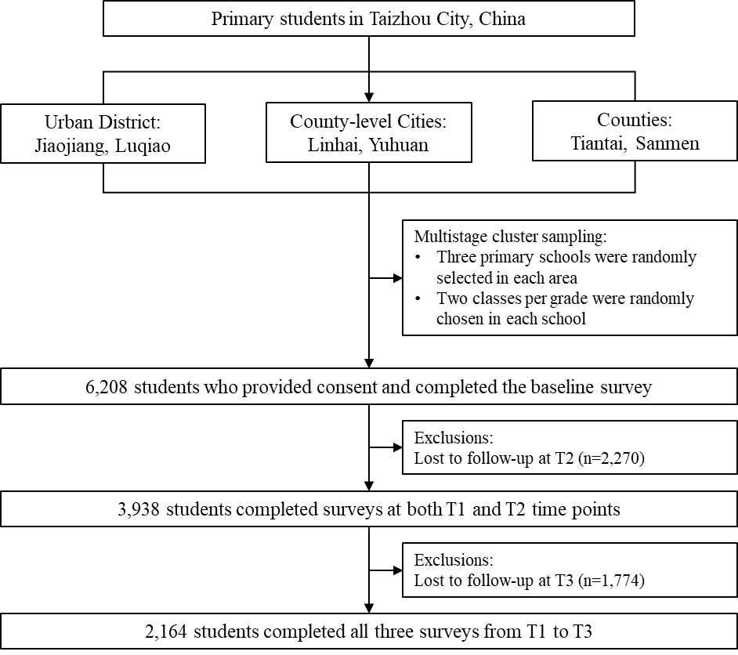
Fig.S1 Flow chart showing sample size included in the study.

Table S1 Summary of variables.
Variables | Details of variables
Family socioeconomic status relevant variables (measured at T1)
Parents’ education | Composite measure of parental educational attainment, the score ranges from 2 to 8, with a higher score indicating a higher overall parental education level.
Family economic status | Dichotomous measure of perceived family financial wellbeing (0 = Relatively poor, 1 = Fair or good).
Average living space per person | Continuous observed variable calculated by dividing total household floor area by the number of co-residents (unit: m²/person).
Mediators (measured at T2)
Loneliness | Latent measure of loneliness using three items of UCLA (relational connectedness, social connectedness and self‐perceived isolation).
Social support | Latent measure of social support using three dimensions of MSPSS (family support, friends support and other significant support).
Parent-child relationship | Latent measure of the overall parent-child relationship quality, reflected by two observed items (relationship with father and relationship with mother)
Mental health outcomes (measured at T3)
Depressive symptoms | Scores of CDI, where higher scores indicate more severe depressive symptoms.
Covariates
Age, sex, school type, household registration, parents' marital status, frequency of physical activity per week
Abbreviations: CDI, children's depression inventory; MSPSS, Multidimensional Scale of Perceived Social Support; UCLA, UCLA loneliness scale.

Table S2 Participant characteristics between those followed at T2 and T3 and those lost to follow-up at T2 and T3
 | Lost to follow-up at T2 and T3 | Followed at T2 and T3
N | 4044 | 2164
Age, years | 10.0±1.8 | 9.3±1.4
Sex
Female | 1801 (44.5%) | 1006 (46.5%)
Male | 2243 (55.5%) | 1158 (53.5%)
School
Public school | 3771 (93.2%) | 1956 (90.4%)
Non-public school | 273 (6.8%) | 208 (9.6%)
Household registration
Urban | 1164 (28.8%) | 831 (38.4%)
Rural | 2880 (71.2%) | 1333 (61.6%)
Parents’ marital status
Married | 3638 (90.0%) | 2006 (92.7%)
Others | 406 (10.0%) | 158 (7.3%)
Frequency of physical activity per week (excluding physical education classes) | 3.2±1.8 | 3.4±1.8
Father’s education
Primary school or lower | 247 (6.1%) | 68 (3.1%)
Middle school | 1412 (34.9%) | 586 (27.1%)
High school | 1215 (30.1%) | 669 (30.9%)
College or higher | 1170 (28.9%) | 841 (38.9%)
Mother’s education
Primary school or lower | 305 (7.5%) | 83 (3.8%)
Middle school | 1309 (32.4%) | 513 (23.7%)
High school | 1089 (26.9%) | 587 (27.1%)
College or higher | 1341 (33.2%) | 981 (45.3%)
Family economic status
Good | 408 (10.1%) | 191 (8.9%)
Fair | 3346 (82.7%) | 1853 (85.6%)
Poor | 290 (7.2%) | 120 (5.5%)
Average living space per person, m² | 33.3±15.7 | 32.2±14.8
Note: Data are mean (SD) or n (%) unless otherwise indicated.

Table S3 Effect size and standardized regression coefficients for the indirect effects for parents’ education, family economic status and average living space per person on depressive symptoms via measurement factors of the latent variables (loneliness, social support and parent-child relationship)
 | Depressive symptoms
 | Indirect effects | Effect size
Model 1: measurement factors of loneliness (CFI 0.976, TLI 0.887, RMSEA 0.051, sRMR 0.019)
Parents’ education
Via relational connectedness | -0.002 (-0.004, 0.001) | -
Via social connectedness | -0.007 (-0.017, 0.002) | -
Via self-perceived isolation | -0.010 (-0.019, -0.001) * | 7.75%
Family economic status
Via relational connectedness | -0.001 (-0.004, 0.001) | -
Via social connectedness | -0.006 (-0.016, 0.003) | -
Via self-perceived isolation | -0.009 (-0.020, 0.001) | -
Average living space per person
Via relational connectedness | -0.001 (-0.003, 0.001) | -
Via social connectedness | -0.002 (-0.011, 0.007) | -
Via self-perceived isolation | -0.002 (-0.010, 0.005) | -
Model 2: measurement factors of social support (CFI 0.987, TLI 0.938, RMSEA 0.051, sRMR 0.019)
Parents’ education
Via family support | -0.021 (-0.034, -0.007) * | 16.28%
Via friends support | -0.004 (-0.013, 0.005) | -
Via other significant support | -0.015 (-0.026, -0.004) * | 11.63%
Family economic status
Via family support | -0.011 (-0.021, -0.001) * | 12.22%
Via friends support | -0.002 (-0.006, 0.003) | -
Via other significant support | -0.007 (-0.016, 0.002) | -
Average living space per person
Via family support | -0.011 (-0.020, -0.001) * | 47.83%
Via friends support | -0.001 (-0.005, 0.002) | -
Via other significant support | -0.008 (-0.016, -0.000) * | 34.78%
Model 3: measurement factors of parent-child relationship (CFI 0.945, TLI 0.793, RMSEA 0.051, sRMR 0.020)
Parents’ education
Via relationship with father | -0.003 (-0.008, 0.003) | -
Via relationship with mother | -0.002 (-0.007, 0.003) | -
Family economic status
Via relationship with father | -0.001 (-0.007, 0.005) | -
Via relationship with mother | -0.001 (-0.006, 0.004) | -
Average living space per person
Via relationship with father | 0.001 (-0.004, 0.005) | -
Via relationship with mother | -0.003 (-0.007, 0.001) | -
Notes: *p value < 0.05.

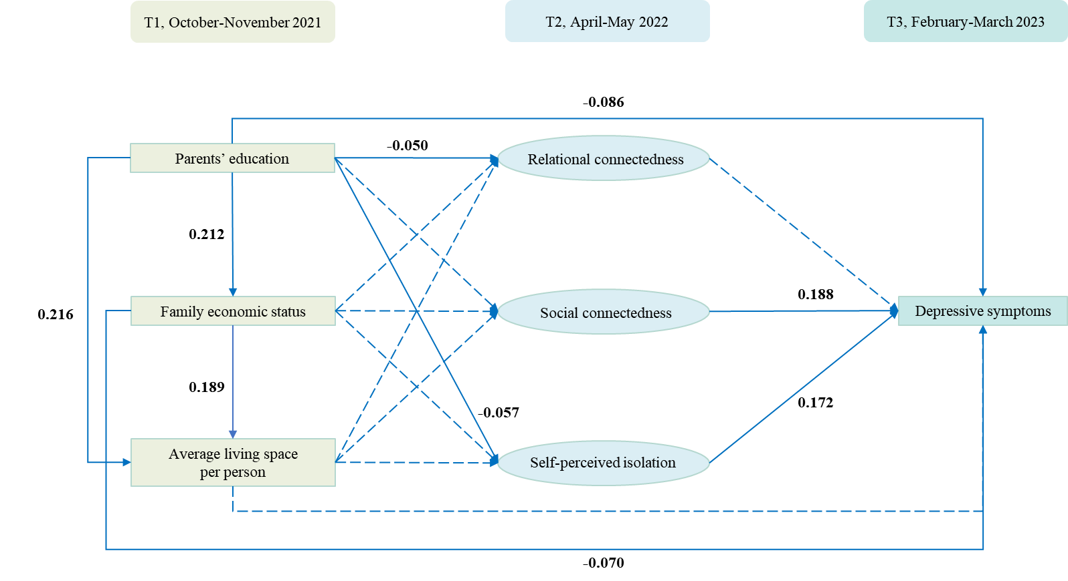
Fig.S2 Standardized coefficients for the direct effects for model 1 (loneliness mediators). Notes: Single-headed arrows indicate regression paths, and rectangles represent measured variables; Coefficients are shown for statistically significant paths, whereas paths with dashed lines were not significant.

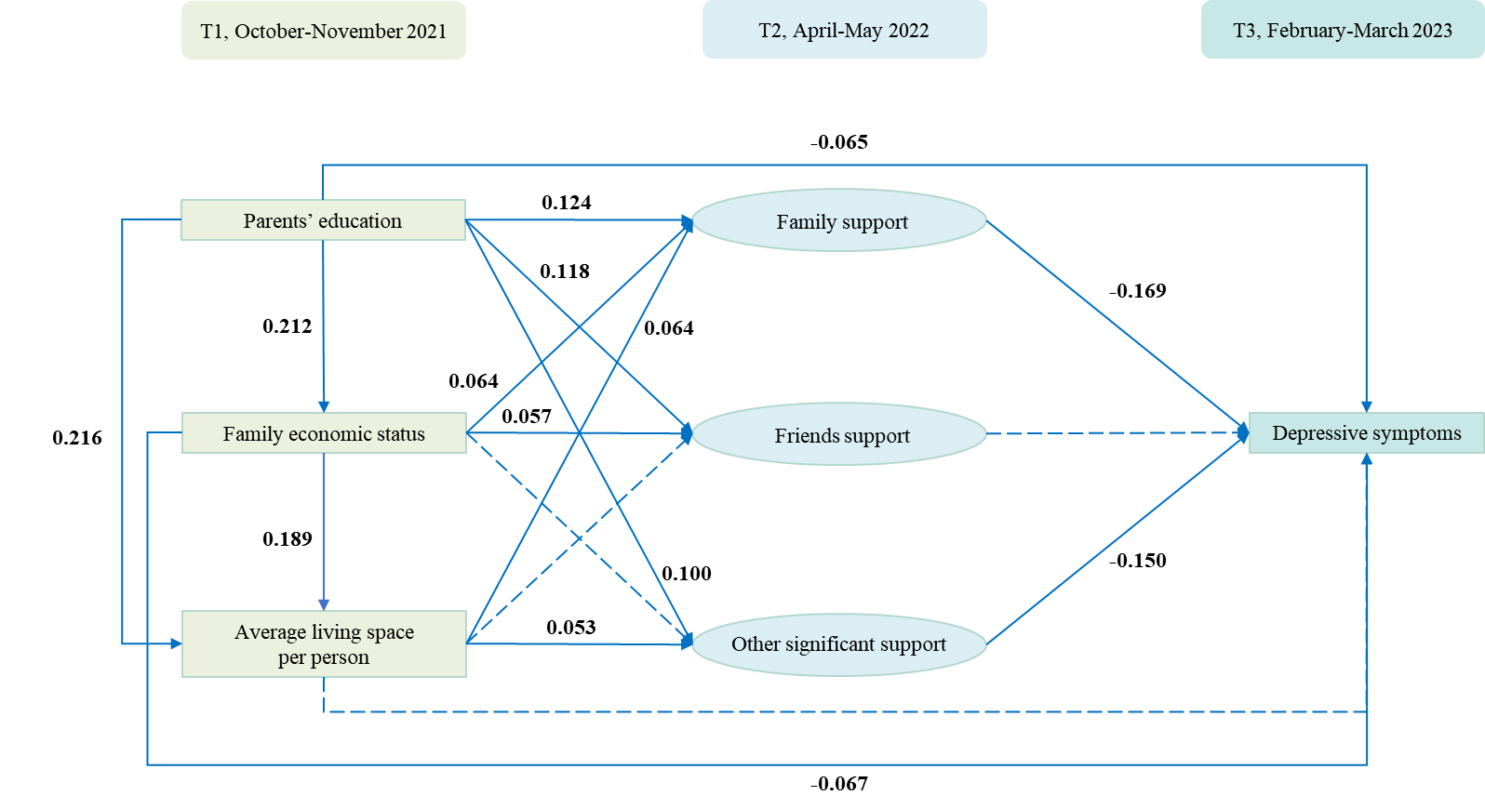
Fig.S3 Standardized coefficients for the direct effects for model 2 (social support mediators). Notes: Single-headed arrows indicate regression paths, and rectangles represent measured variables; Coefficients are shown for statistically significant paths, whereas paths with dashed lines were not significant.

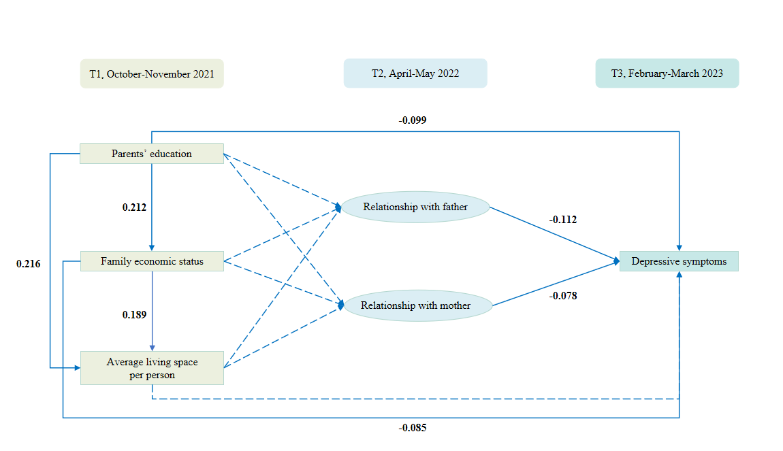
Fig.S4 Standardized coefficients for the direct effects for model 3 (parent-child relationship mediators). Notes: Single-headed arrows indicate regression paths, and rectangles represent measured variables; Coefficients are shown for statistically significant paths, whereas paths with dashed lines were not significant.

Table S4 Moderated-mediation of household registration among family economic status, perceived social support, and depressive symptoms
Direct effects | Coefficient | SE | Boot 95% CI | p value
Family economic status * Household registration  → Perceived social support | 0.29 | 0.14 | 0.03, 0.56 | 0.031
Family economic status → Perceived social support (Rural) | 0.04 | 0.03 | -0.01, 0.09 | 0.154
Family economic status → Perceived social support (Urban) | 0.33 | 0.13 | 0.07, 0.59 | 0.012
Perceived social support * Household registration  → Depressive symptoms | 0.02 | 0.17 | -0.18, 0.23 | 0.824
Perceived social support → Depressive symptoms | -0.17 | 0.03 | -0.23, -0.12 | <0.001
Family economic status * Household registration  → Depressive symptoms | 0.17 | 0.15 | -0.12, 0.45 | 0.26
Family economic status → Depressive symptoms | -0.06 | 0.03 | -0.11, -0.01 | 0.017
Total | -0.09 | 0.03 | -0.14, -0.03 | 0.002
Indirect effects | Coefficient | SE | Boot 95% CI | p value
Rural | -0.01 | 0.01 | -0.02, 0.01 | 0.168
Urban | -0.06 | 0.02 | -0.11, -0.01 | 0.020
Difference (index of moderated-mediation) | -0.05 | 0.02 | -0.10, -0.01 | 0.042

