AFISS Supplementary Files
Table S1: Presence of pathogens by demographic characteristics
Variable | West Nile (393)  n (%) | Zika* (393)  n (%) | SARS-CoV-2 (393)  n (%) | Adenovirus (393)  n (%) | Brucella (393)  N (%) | Chikungunya (393)  n (%) | Burkholderia (393)  n (%) | P. vivax*  (393)  n (%) | P. falciparum (393)  n (%) | CCHF (393)  n (%)
Total | 154(39.2) | 52 (15.2) | 64 (16.3) | 64 (16.3) | 31 (7.9) | 28 (7.1) | 25 (6.4) | 19 (4.8) | 23 (5.9) | 17 (4.3)
Age-category
Under-five (2-4) | 38 (53.5) | 16 (22.5) | 9 (12.7) | 5 (7.0) | 6 (8.5) | 7 (9.9) | 4 (5.6) | 4 (4.6) | 3 (4.2) | 3 (4.2)
Pre-teen (5-12) | 28 (51.9) | 11 (20.4) | 7 (13.0) | 3 (5.6) | 4 (7.4) | 6 (11.1) | 4 (7.4) | 1 (1.9) | 2 (3.7) | 3 (5.6)
Teenage (13-19) | 11 (37.9) | 3 (10.3) | 4 (13.8) | 5 (17.2) | 3 (10.3) | 0 (0.0) | 3 (10.3) | 5 (17.2) | 5 (17.2) | 0 (0.0)
Early career (20-35) | 32 (32.6) | 11 (11.2) | 16 (16.3) | 19 (19.4) | 5 (5.1) | 4 (4.1) | 5 (5.1) | 4 (4.1) | 6 (6.1) | 4 (4.1)
Mid-career (36-45) | 14 (30.4) | 3 (6.5) | 6 (13.0) | 8 (17.4) | 3 (6.5) | 6 (13.0) | 1 (2.2) | 3 (6.5) | 4 (8.7) | 4 (8.7)
Late career (46-59) | 17 (33.3) | 4 (7.8) | 11 (21.6) | 9 (17.7) | 7 (13.7) | 2 (3.9) | 6 (11.8) | 2 (3.9) | 2 (3.9) | 2 (3.9)
Elderly/retirement (60+) | 14 (31.8) | 4 (9.1) | 11 (25.0) | 15 (34.1) | 3 (6.8) | 3 (6.8) | 2 (4.6) | 0 (0.0) | 1 (2.3) | 1 (2.3)
Sex
Male | 77 (41.0) | 26 (13.8) | 21 (11.2) | 26 (13.8) | 13 (6.9) | 18 (9.6) | 11 (5.9) | 9 (4.8) | 10 (5.3) | 12 (6.4)
Female | 77 (37.6) | 26 (12.7) | 43 (21.0) | 38 (18.5) | 18 (8.8) | 10 (4.9) | 14 (6.8) | 10 (4.9) | 13 (6.3) | 5 (2.4)
Marital Status
Not married | 101 (43.4) | 36 (15.5) | 33 (14.2) | 27 (11.6) | 18 (7.7) | 18 (7.7) | 15 (6.4) | 14 (6.0) | 16 (6.9) | 11 (4.7)
Married/Cohabiting | 53 (33.1) | 16 (10.0) | 31 (19.4) | 37 (23.1) | 13 (8.1) | 10 (6.3) | 10 (6.5) | 5 (3.1) | 7 (4.4) | 6 (3.8)

Table S2: Pathogens for detection by Taqman Array card
1 | Bartonella
2 | Brucella
3 | Burkholderia
4 | Coxiella burnetii
5 | Rickettsia
6 | Salmonella
7 | Streptococcus pneumoniae
8 | Yersinia
9 | Orientia tsutsugamushi
10 | Chikungunya virus
11 | Crimean Congo Haemorrhagic Fever (CCHF) virus
12 | Ebola virus
13 | Yellow fever virus
14 | Hepatitis E virus
15 | Hepatitis B virus
16 | Lassa virus
17 | Marburg virus
18 | O nyong-nyong virus
19 | West Nile virus
20 | Zika virus
21 | Dengue virus
22 | Nipah virus
23 | Rift Valley fever virus
24 | Plasmodium falciparum
25 | Plasmodium vivax
26 | Trypanosome B
27 | Adenovirus
28 | Influenza A & B viruses
29 | Respiratory syncytial virus
30 | Cytomegalovirus
31 | Herpes simplex virus
32 | Chlamydia pneumonia
33 | Pneumocystis jirovecii
34 | Mycoplasma pneumoniae
35 | Bordetella pertussis
36 | SARS-CoV-2

Annex A: Standard Operating Procedure for Laboratory analysis of biological samples for AFI study, NCDC National Reference Laboratory, Nigeria
Purpose
- To provide guidance to laboratory scientists on the methods for the laboratory analysis of samples for the AFI research study
- To ensure that the same protocols are used or followed by all scientists working on the laboratory analysis of clinical specimens
- To ensure that results generated are valid and reproducible
General Special Safety Precautions
All individuals handling biological specimens must follow the safety practices for dealing with potentially infectious biological material.
- Wash hands or sanitize promptly after contact with infectious materials
- Wear gloves when working with blood, body fluids, secretions, excretions, mucous membranes, and contaminated items
- Wash/Sanitize hands immediately after removing gloves
- Disinfect and clean spills of infectious material promptly
- Clean and disinfect contaminated equipment and accessories between
- Properly dispose of contaminated consumables and supplies
Scope
- Isolation of total RNA and DNA from clinical samples
- Quantification of nucleic acids
- TaqMan array real-time PCR Run
Responsibility
- Medical laboratory Scientist

1.0 Procedure for nucleic acid extraction using MagNA Pure LC Total Nucleic Acid Isolation Kit - Large Volume
  - Total nucleic acid extraction from biological fluids (Blood and Plasma)
I Purpose
- To provide guidance to laboratory scientists on the isolation of nucleic acids from biological fluids using MagNA Pure LC Total Nucleic Acid Isolation Kit - Large Volume
- To ensure Nucleic acids are isolated following manufacturer’s instructions in a manner that generates impurity-free nucleic acids
IV Equipment:
- Centrifuge
- Pipettes and pipette tips
- Bio-safety cabinet
  - Supplies for nucleic acid extraction
  - MagNA Pure LC Total Nucleic Acid Isolation Kit
  - Spray bottle containing 10% bleach solution
  - Paper towels
  - Gauze
  - Small biosafety bags
  - Markers and pens
  - Hand sanitizing gel/foam

  - Overview of nucleic acid extraction Procedure
2.0 Nanodrop quantification
I Purpose
- To provide guidance to laboratory scientists on how to quantify nucleic acid using the Nanodrops spectrophotometer
II Equipment:
- Nanodrops spectrophotometer
- Pipettes and pipette tips
III Supplies for TaqMan array Real-time PCR
  - Nuclease free water
  - RNase free tubes
  - Kim wipes
2.1 Nanodrop quantification procedure
NOTE:
- Bring your own pipette tips and gloves to the NanoDrop machine.
- Save your data so that you can have it for later
- Clean the pedestal in between each run with water and a KimWipe
2.2 Procedure:
- Log into the computer next to the NanoDrop machine
- On the desktop open the ND1000 program
- In the pop-up window click “Nucleic Acid” for DNA or RNA samples
- Clean the NanoDrop pedestal (the little platform where you put your sample) with a KimWipe and water.
- Load 2μl of H2O and click “Okay”
- Click “Blank” to calibrate it
- Where it says “Sample Type” click DNA-50 for DNA samples or RNA-40 for RNA samples
- Load 2μl of sample onto the pedestal, and click “Measure”
- After the machine analyzes it, save your data. If it is a good reading the graph will show a smooth curve. The absorbance reading at 230nm and 280nm should be about half of the reading at 260nm.
- Remember to clean the pedestal between each reading
3.0 TaqMan Array Card Protocol
3.1 Taqman Array Real-time PCR protocol
I Purpose
- To provide guidance to laboratory scientists on how to prepare nucleic acid extracts and the master mix for loading onto QuantStudio 12K Flex
- To ensure the integrity and reproducibility of results
- To ensure that all laboratory personnel follow the same protocols
II Equipment:
- Centrifuge
- Pipettes and pipette tips
- Bio-safety cabinet
- Quantstudio 12K Flex
- Plate centrifuge
- Scissors
III Supplies for TaqMan array Real-time PCR
  - TaqMan Fast Advanced Master Mix
  - Spray bottle containing 70% Ethanol solution
  - Nuclease free water
  - Paper towels
  - Gauze
  - Small biosafety bags
  - Markers and pens
  - Hand sanitizing gel/foam
  - RNase free tubes

3.2 Overview of Taqman array Procedure
TaqMan Array Cards are 384-well singleplex real-time PCR format cards that are prepared with dried down TaqMan® Assays that has been used to detect multiple infection targets.
- Extracted nucleic acids from the clinical samples will be loaded onto to the specially designed TaqMan array cards (TAC)
- TAC Cards will be further processed as per below:
Step name | Temp. (°C) | Time(M:S) | Data Collection | Cycles
Reverse transcription | 50 | 05:00 |  | 1
Denature | 95 | 10:00 |  | 1
Amplify | 95 | 0:03 |  | 40
Amplify | 60 | 0:30 | Hold step | 40

3.2 Reaction Setup:
- Remove a TaqMan array card from the fridge and allow to equilibrate to room temperature for 15 minutes. Do not remove the Array card from its packaging until it has reached room temperature and you are ready to use.
- Prepare within the PCR workstation, the PCR reaction mix. Make up enough for the number of samples, one for the negative extract, one for positive control and one for dead volume. A negative extract must always be run there is no need for a separate water negative template control (NTC).
- For each reaction, mix
  - Water 66µl
  - *4 x TaqMan Fast Advanced Master Mix 30µl
- Aliquot 96µl of reaction mix into individual 1.5ml RNase free tubes for Each sample to be analyzed
- Create sample specific PCR reaction mix by adding 24µl of extracted nucleic acid into individual PCR reaction mix tube from step d above, include one for the negative extract and one for plasmid positive template control (PTC).
- Mix gently and avoid generating bubbles.
- Place the TaqMan array card in the cabinet, with the foil side down.
- Load 100µl of the sample-specific PCR reaction mix into a micropipette.
- Hold the pipette at an angled position and place the tip in the fill port.
- Dispense the sample specific PCR reaction mix so that it sweeps in and around the fill reservoir.
- Be careful when pushing the micropipette plunger to its second stop position, if a large amount of air is released it can push the reaction mix out via the vent port or introduce bubbles.
- Repeat steps j-m pipetting each sample into an individual fill reservoir.
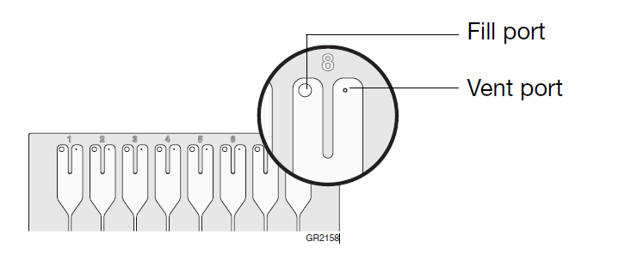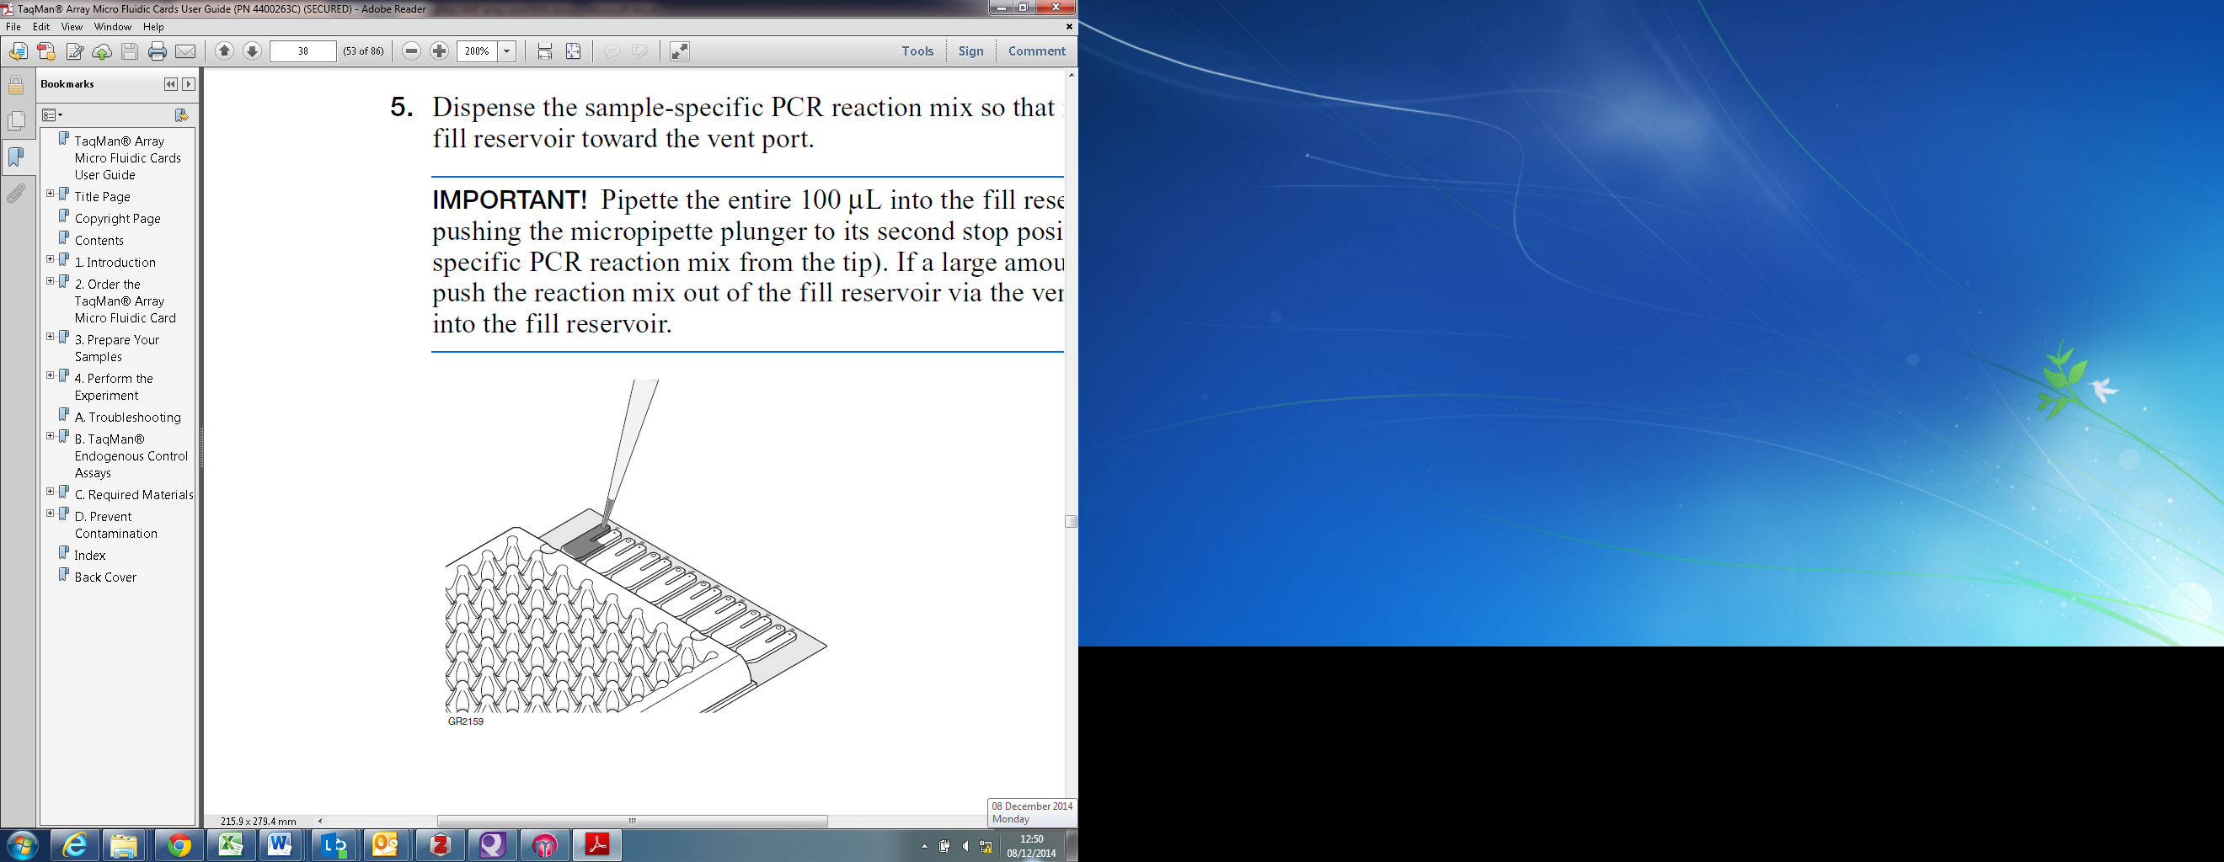

3.3 Array card centrifugation
- Insert TaqMan Array card into the card holder of the Sorvall centrifuge bucket, making sure:
- The fill reservoirs project upwards
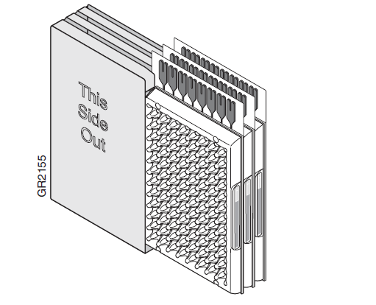
- The reaction wells face the same direction at the ‘This Side Out’ label
- You use blank cards to balance any open positions in the card holder (these prevent damage to the card holder and uneven filling of the cards).
- Centrifuge at 1200rpm for 1 minute twice.
- Examine the Array card to ensure filling is complete. The amount of PCR reaction mix remaining in the fill reservoirs should be consistent from reservoir to reservoir.
- When one of the samples remains in the reservoir as seen in A below; centrifuge the plate for further 1min. If it remains, then process the card but disregard the result from the effected fill sample.
- If in the case of B. The fill reservoir was not filled properly; process the sample but disregard the result from the effected fill sample.
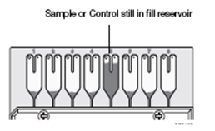
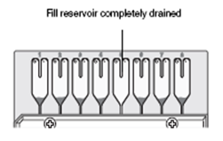
- The Array card micro fluidics card sealer isolates the wells of a TaqMan Array card after it loaded with PCR reaction mix. Place the sealer’s carriage in its starting position. Insert the Array card into the sealer. When properly seated, the Array card’s foil surface should be level with the base of the sealer. The four spring clips ensures that the card is held in the proper position.
A.
B.
- Push the carriage slowly across the base of the sealer in the direction of the arrows. Use a slow, steady, and deliberate motion to push the carriage across the entire length of the Array card until the carriage reaches the mechanical stop.
- Using scissors trim the fill strips.
3.4 QuantStudio run set-up
- Turn on the computer and the QuantStudio instrument using the switch on the back of the machine.
- Verify that the TaqMan Array Micro Fluidic Card Thermal Cycling Block is installed in the instrument tray. If the block is not installed, you must:
  - Turn off the instrument
  - Remove the existing block
  - Install the TaqMan Array Micro Fluidic Card Thermal Cycling Block.
  - Change the plate adapter.

NOTE: For detailed information on changing the instrument blocks, refer to the Applied Biosystems QuantStudio Maintenance and Troubleshooting Guide.
- Open the QuantStudio System Software by double clicking the icon on the desktop.
- Press the touch screen on the QuantStudio you may need to press the ‘on’ symbol at the bottom left of the screen, then press the eject symbol at the bottom right of the screen.
Place the Array card in the instrument tray with:
- Well A1 at the top left corner of the tray and the notched corner at the top right.
- The barcode toward the front of the instrument.
- Click ‘Template’, on the left of the screen; if the software is already open you may need to click the 'Home’ icon in the bottom left of the screen.
- Select the ‘array’ template and click ‘Open’.
- Enter an experiment name in the following format:
‘yyyy-mm-dd_TACArray_Run No’ in the ‘Experiment Name’ box.
- Write your initials in the ‘Operator’ box.
- Scan the Array card barcode into the ‘Barcode’ box.
- Select the ‘Run’ tab, and click ‘Start Run’, click on the serial number from the drop-down menu, you are prompted to save the experiment; save the run in Research_AFI_Neg_Array.
Note: Sample numbers can be added before, during or after the run.
- Click the ‘Setup’ tab on the left, then ‘Define’.
- There are 8 samples, corresponding to the 8 fill ports on the Array card. Enter the corresponding sample number for each. Setup is complete.
3.5 Analysis of results
- Click the ‘Analysis’ tab on the left hand-side of the screen.
- If performing a full card (8 samples) skip to next step, if running a partial card select the unused wells in the plate layout (note this must be within the analysis menu on the left) right click and select ‘omit’.
- Click ‘Anaylsis settings’ set the ‘Algorithm settings’ to ‘Relative Threshold’ and click ‘Apply Analysis Settings’.
- In the ‘Amplification plot’ screen set the graph type to ‘Linear’.
- Check the amplification plot for each target, confirming the sigmoidal curve of the positive template control and any positive clinical samples.
- Click ‘Print Report’ and select the following:
  - Experiment Summary
  - Amplification plot (ΔRn vs. Cycle)
  - Result Table
  - Click ‘Print Report’ and select ‘PDF’ as the printer, save to a USB stick.
3.6 Interpretation of Results
- Interpretation of results:
  - Ct value > 40 = negative.
  - Ct value < 35 with acceptable amplification curves = positive.
  - Negative control shows no amplification signal (undetectable).
  - Positive controls show amplification signal (Ct <40), in the correct dye channel.
  - Ct value 35-40 = Repeat individual target in the 96well plate format as SPATH099.
Repeat results < 40 = positive
Repeat results >40 = negative
3.7 Validity of Results
• The negative extraction control should be negative. If positive the run should be regarded as an assay failure and all samples must be repeated. It is advisable to re-extract the samples and/or re-run with original samples. Refer to advice from Senior staff.
• The Positive control must be positive. If negative the run is an assay failure and all samples must be repeated.
• Internal control (MS2) results: The negative extraction control and clinical samples should produce a Ct within the range for the batch of MS2 stock, as determined in SPATH/037. Test samples within 3 standard deviations of the mean expected for the MS2 batch (typically Ct30 ± 1ct) are interpreted as internal control POSITIVE.
• If a Diagnostic test is NEGATIVE for a sample and the sample is INTERNAL CONTROL NEGATIVE then the sample should be re-extracted, both diagnostic and MS2 tests should be repeated on the re-extracted sample.
• MS2 reactions that repeatedly fail upon re-extraction should be reported as "inhibitory”.

