Supplementary information
Highly-efficient RuNi single-atom alloy catalysts toward chemoselective hydrogenation of nitroarenes
Wei Liu¹, Yusen Yang¹*, Haisong Feng¹, Yiming Niu², Lei Wang¹, Pan Yin¹, Song Hong¹, Bingsen Zhang², Xin Zhang¹*, Min Wei¹*
¹ State Key Laboratory of Chemical Resource Engineering, Beijing Advanced Innovation Center for Soft Matter Science and Engineering, Beijing University of Chemical Technology, Beijing 100029, P. R. China
² Shenyang National Laboratory for Materials Science, Institute of Metal Research, Chinese Academy of Sciences, Shenyang 110016, P. R. China

Author Information
* Corresponding authors. Tel: +86-10-64412131; Fax: +86-10-64425385.
E-mail addresses: yangyusen@mail.buct.edu.cn (Y. Yang); zhangxin@mail.buct.edu.cn (X. Zhang); weimin@mail.buct.edu.cn (M. Wei).

Supplementary Methods
In situ XAFS measurements
In situ X-ray absorption fine structure spectroscopy (XAFS) at the Ru K-edge (fluorescence mode) and Ni K-edge (transmission mode) was carried out at the beamline 1W1B and 1W2B of the Beijing Synchrotron Radiation Facility (BSRF), Institute of High Energy Physics (IHEP), Chinese Academy of Sciences (CAS). Typically, the powdered sample was pressed into a self-supporting wafer and carefully placed into a reaction microdevice equipped with polyimide windows. Afterwards, the sample was pre-reduced in a H₂/He flow (1/19, v/v; 30 mL∙min⁻¹) at 300 °C for 1 h, and then cooled to room temperature in a high-purity He stream to collect in situ XAFS spectra. In the 4-NS adsorption experiment, based on the above pretreatment, a certain amount of 4-NS was carefully evaporated into the in situ cell in He flow (30 mL∙min⁻¹) at 60 °C, followed by flowing pure He to remove physically adsorbed 4-NS; afterwards, XAFS spectra were collected. Finally, the gas flow was switched to a H₂/He (1/19, v/v) atmosphere to trigger the surface reaction and then XAFS spectra were collected. All the XAFS data were processed using Athena software package¹. Wavelet transformation for the Ru K-edge XAFS signals was employed based on Morlet wavelets².
In situ DRIFTS and FT-IR measurements
In situ DRIFTS and FT-IR experiments were conducted on a Bruker TENSOR II equipped with an MCT narrow-band detector and a modified in situ reaction cell. The detailed pre-treatment and test conditions are given as follows. As for CO−DRIFTS measurements, about 50 mg of sample was carefully put into the support sink of diffuse reflectance cell firstly. Subsequently, the sample was pre-reduced in a H₂/He flow (1/19, v/v; 30 mL∙min⁻¹) at 300 °C (heating rate: 5 °C·min^{–1}) for 1 h, followed by cooling to the room temperature in a high purity He stream, and then the background signal was collected. Afterwards, the CO/He (1/19, v/v; 30 mL∙min⁻¹) was purged into the cell, and DRIFTS spectra were collected until the adsorption spectrums kept unchanged. Finally, the gas flow was switched to a pure He stream to collect CO chemisorption spectra. In situ FT-IR measurements of 4-NS adsorption and surface reaction were performed using a transmission reactor. The sample (20 mg) was pressed into self-supporting wafer with a diameter of 13 mm, followed by a pretreatment under the same conditions. After the sample was cooled down to 60 °C in He stream, 4-NS was introduced into the reactor for 30 min. Subsequently, He was purged to remove the physically adsorbed molecule followed by collection of IR signals. Finally, the spectra for hydrogenation process were collected per 60 s after the introduction of H₂ (flow rate: 30 mL∙min⁻¹).
Computational details
We performed first-principle calculation within the DFT methodology by using the Vienna ab initio simulation package (VASP 5.4)^{3,4}. The exchange and correlation energy were calculated with the generalized gradient approximation (GGA) of the density functional theory, using the PBE functional⁵. Grimme’s DFT-D3 method was added to investigate the effect of van der Waals interaction⁶. The projector augmented wave (PAW) method was used to describe the core electrons^{7,8}. A 3 × 3 × 1 Monkhorst-Pack k point mesh and a 400 eV cutoff energy for the plane-wave basis were employed for the geometry optimizations. The convergence criterion for the total energy self-consistent iterations was 10⁻⁴ eV, and the geometry optimization stopped when the total force on the system was less than 0.05 eV/Å. The energy barriers were determined by the climbing image nudged elastic band (CI-NEB) method⁹.
According to the HRTEM characterization, the Ni (111) surface was modeled with a three-layer slab in a p(5×5) surface unit cell consisting of 75 atoms; the bottom one slab was fixed while the top two slabs were relaxed. A vacuum space of 15 Å ensures no spurious interaction between the periodically repeated slabs or adsorbates in the direction normal to the slab. As Ni is not a non-magnetic metal, we performed spinpolarization calculation for the Ni (111) surface. The RuNi (111) surface was built by substituting one Ni atom on the topmost layer with one Ru atom.
The activation energy (E_{a}) and adsorption energy (E_{ads}) are calculated by the following equations:
$E_{a}=E_{TS}-E_{IS}$ (1)
$E_{ads}=E_{A/M}-E_{A}-E_{M}$ (2)
where $E_{TS}$,$E_{IS}$, $E_{A/M}$, $E_{A}$and $E_{M}$ represent the energies of the TS (transition state), IS (initial state), adsorbed system, substrate, and adsorbate species, respectively.

Supplementary Figures
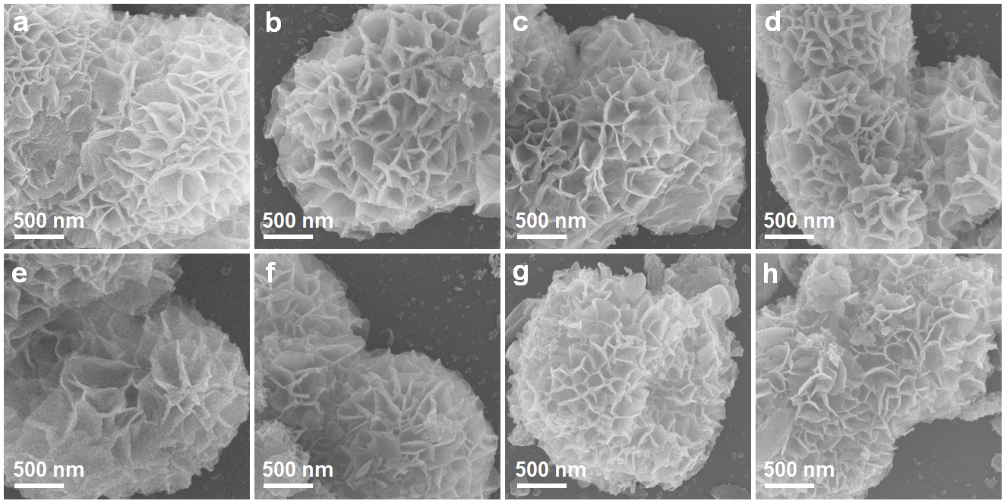
Supplementary Figure 1. SEM images of a−h Ni/Al₂O₃, 0.1 wt.%, 0.2 wt.%, 0.4 wt.%, 0.6 wt.%, 0.8 wt.%, 1 wt.% and 2 wt.% RuNi samples, respectively.

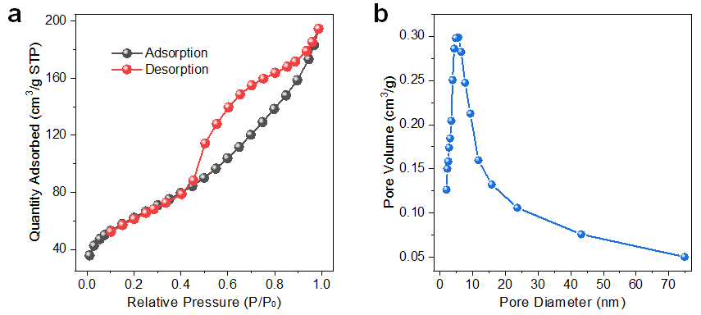
Supplementary Figure 2. a Nitrogen adsorption-desorption isotherm and b the pore size distribution profile of Ni/Al₂O₃ sample.

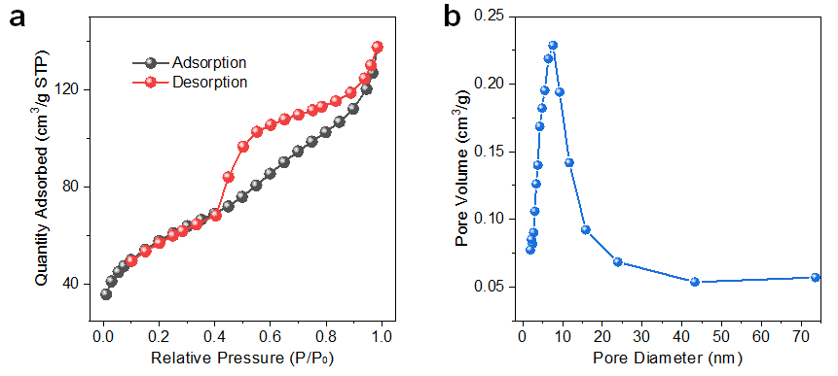
Supplementary Figure 3. a Nitrogen adsorption-desorption isotherm and b the pore size distribution profile of 0.1 wt.% RuNi sample.

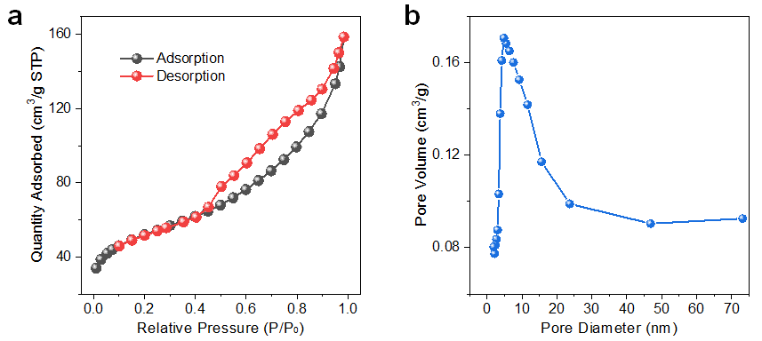
Supplementary Figure 4. a Nitrogen adsorption-desorption isotherm and b the pore size distribution profile of 0.2 wt.% RuNi sample.

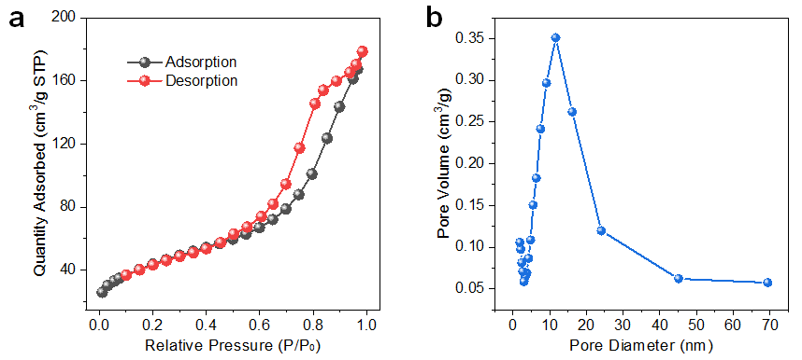
Supplementary Figure 5. a Nitrogen adsorption-desorption isotherm and b the pore size distribution profile of 0.4 wt.% RuNi sample.

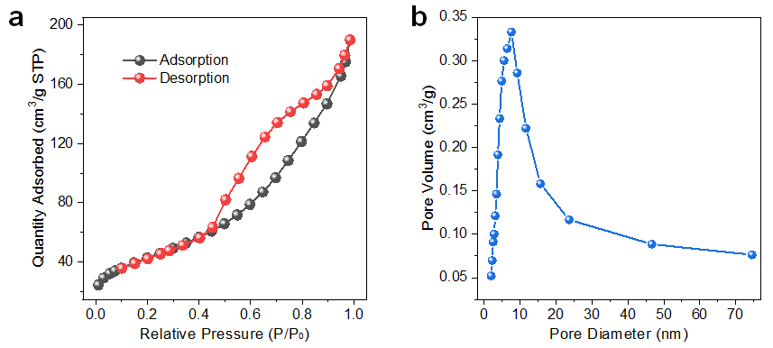
Supplementary Figure 6. a Nitrogen adsorption-desorption isotherm and b the pore size distribution profile of 0.6 wt.% RuNi sample.

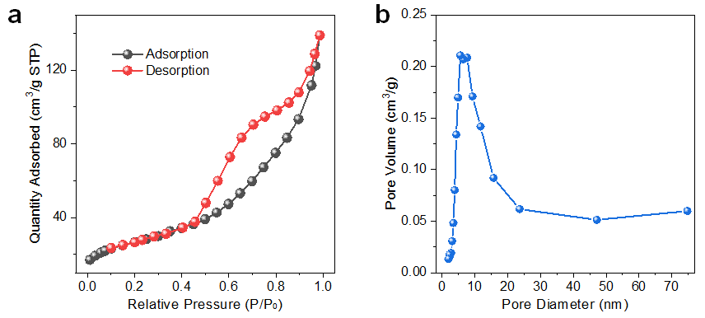
Supplementary Figure 7. a Nitrogen adsorption-desorption isotherm and b the pore size distribution profile of 0.8 wt.% RuNi sample.

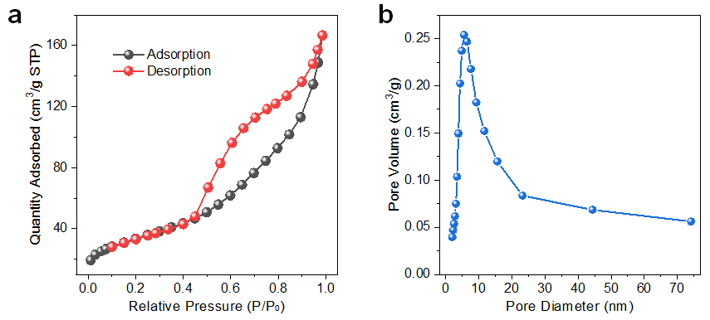
Supplementary Figure 8. a Nitrogen adsorption-desorption isotherm and b the pore size distribution profile of 1 wt.% RuNi sample.

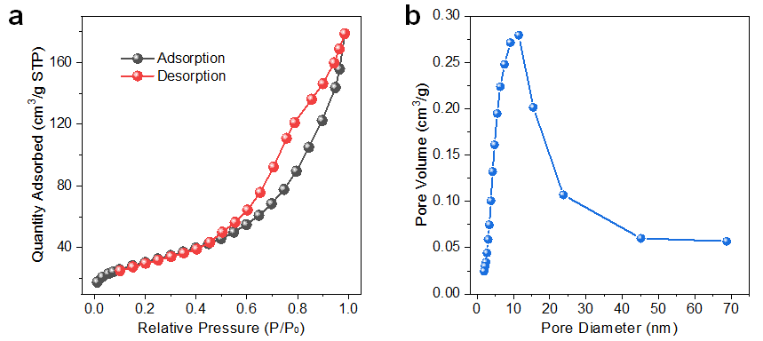
Supplementary Figure 9. a Nitrogen adsorption-desorption isotherm and b the pore size distribution profile of 2 wt.% RuNi sample.

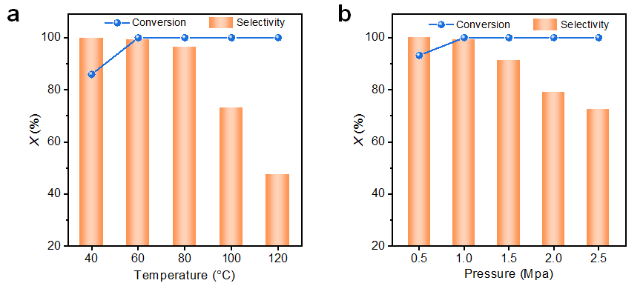
Supplementary Figure 10. Correlation between catalytic performance of 0.4 wt.% RuNi (SAA) sample and reaction conditions: 4-nitrostyrene conversion and 4-aminostyrene selectivity as function of a reaction temperature and b H₂ pressure, respectively.
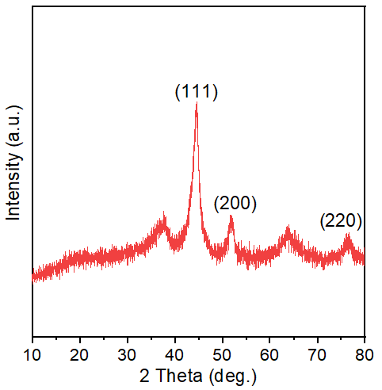
Supplementary Figure 11. XRD pattern of the used 0.4 wt.% RuNi catalyst after 5 cycle times.

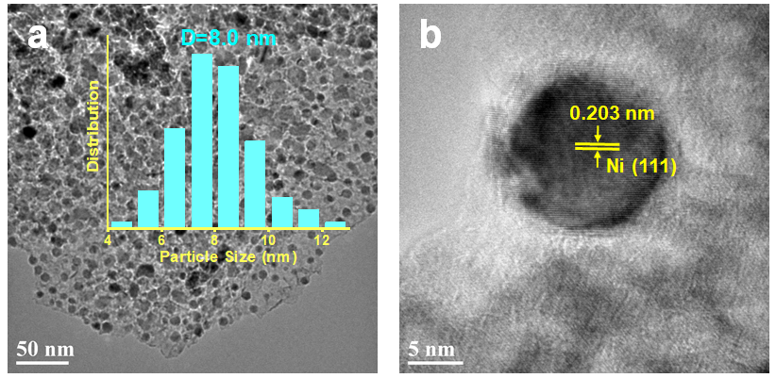
Supplementary Figure 12. a TEM image with corresponding particle size distribution and b HRTEM lattice fringe image of 0.4 wt.% RuNi catalyst after 5 cycle times.

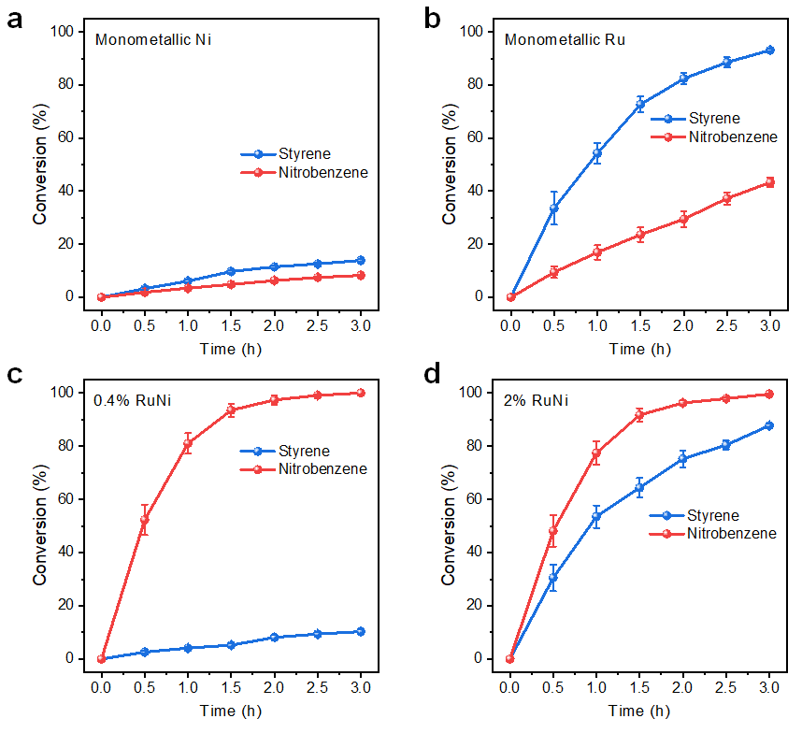
Supplementary Figure 13. Catalytic performance of a monometallic Ni, b monometallic Ru, c 0.4 wt.% and d 2 wt.% RuNi catalyst, toward the hydrogenation of nitrobenzene and styrene mixture (1:1), which possesses a single nitro group and a single C=C group, respectively. Reaction conditions: 0.5 mmol of nitrobenzene and 0.5 mmol of styrene; 8 ml of solvent (ethanol); 0.02 g of catalyst; 1 Mpa of H₂, 60 °C, 3 h.

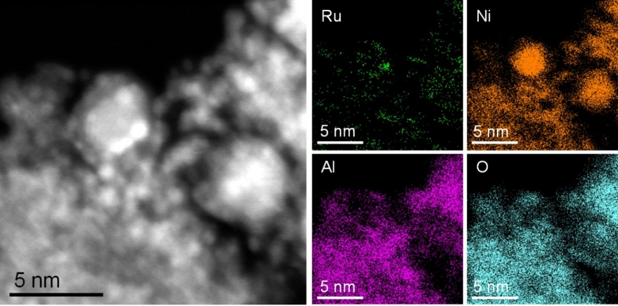
Supplementary Figure 14. HAADF-STEM image and corresponding elemental EDS mapping of 2 wt.% RuNi sample.
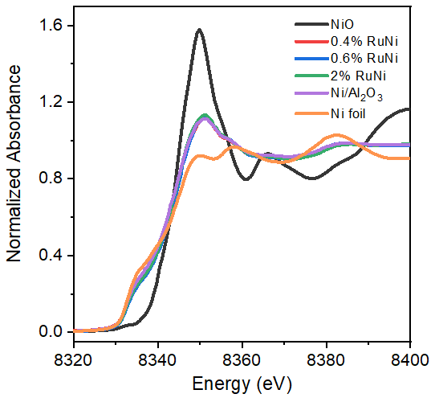
Supplementary Figure 15. In situ Ni K-edge XANES spectra of Ni/Al₂O₃, 0.4 wt.%, 0.6 wt.%, 2 wt.% RuNi samples, with Ni foil, NiO as reference samples.

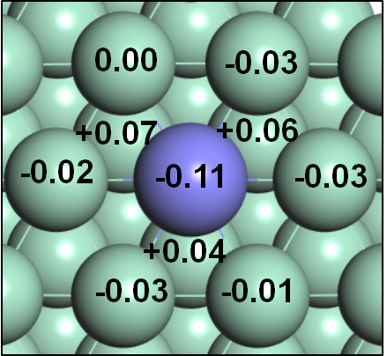
Supplementary Figure 16. Bader charge analysis of pristine RuNi SAA (111) surface. The numbers stand for the amount of charge carried by corresponding atoms, which reveal that isolated Ru atom carries negative charges from sub-surface Ni atoms. Ru, violet; Ni, green.

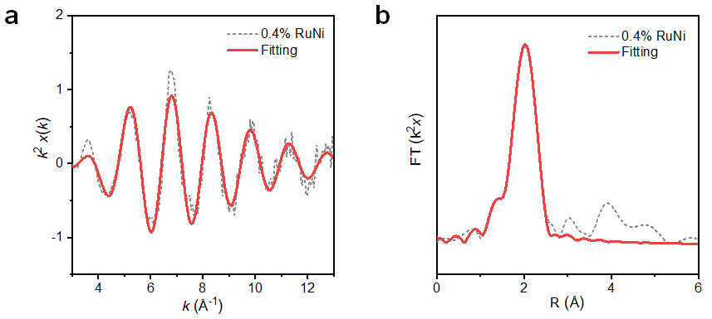
Supplementary Figure 17. Fourier−transform EXAFS fitting spectrum of 0.4 wt.% RuNi sample at k-space and R-space, respectively.

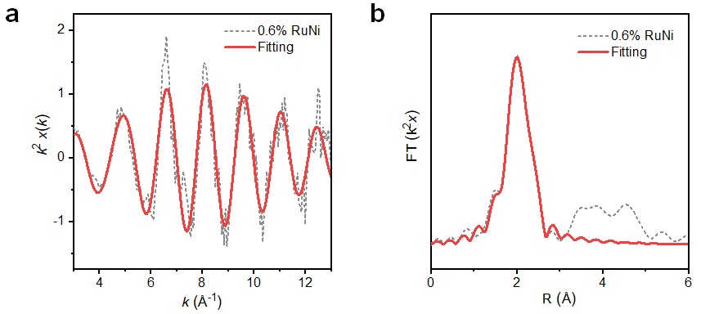
Supplementary Figure 18. Fourier−transform EXAFS fitting spectrum of 0.6 wt.% RuNi sample at k-space and R-space, respectively.

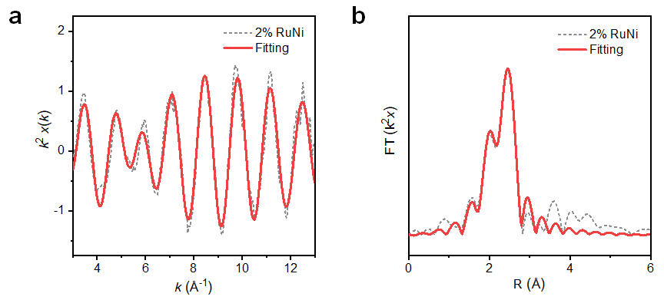
Supplementary Figure 19. Fourier−transform EXAFS fitting spectrum of 2 wt.% RuNi sample at k-space and R-space, respectively.

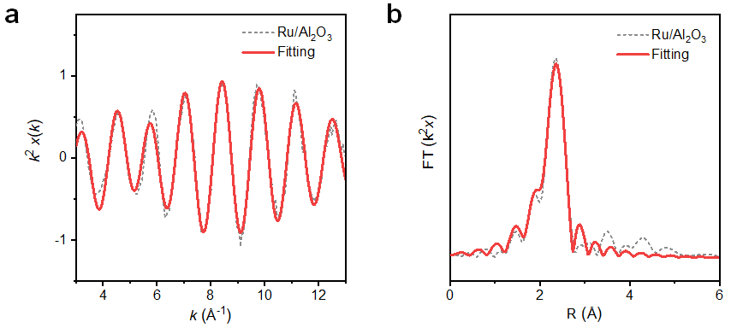
Supplementary Figure 20. Fourier−transform EXAFS fitting spectrum of Ru/Al₂O₃ sample at k-space and R-space, respectively.

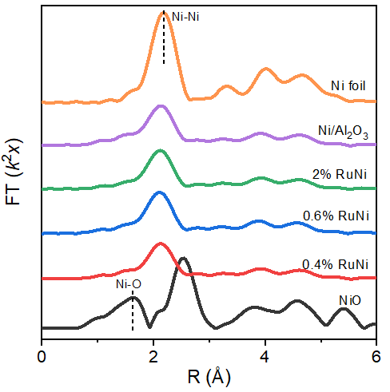
Supplementary Figure 21. In situ Ni K-edge EXAFS Fourier−transform spectra of Ni/Al₂O₃, 0.4 wt.%, 0.6 wt.%, 2 wt.% RuNi samples, and corresponding Ni foil, NiO references.

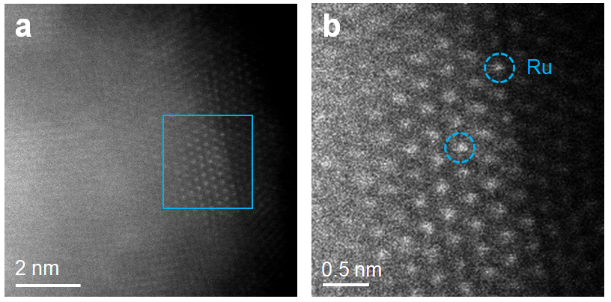
Supplementary Figure 22. a Aberration-correction HAADF–STEM image, and b corresponding enlarged image of the used 0.4 wt.% RuNi sample after 5 catalytic cycles.

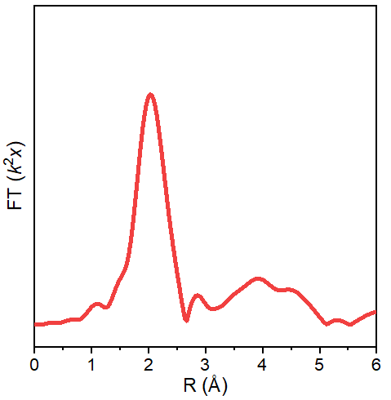
Supplementary Figure 23. Ru K-edge EXAFS Fourier−transform spectrum of the used 0.4 wt.% RuNi sample after 5 catalytic cycles.

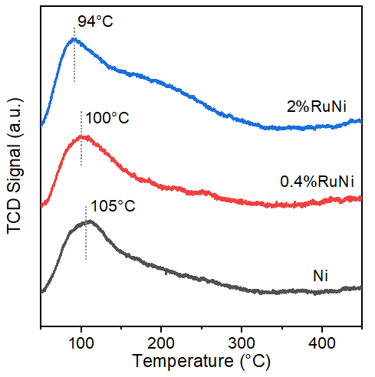
Supplementary Figure 24. H₂-TPD profiles of monometallic Ni, 0.4 wt.% RuNi (SAA), and 2 wt.%RuNi, respectively.

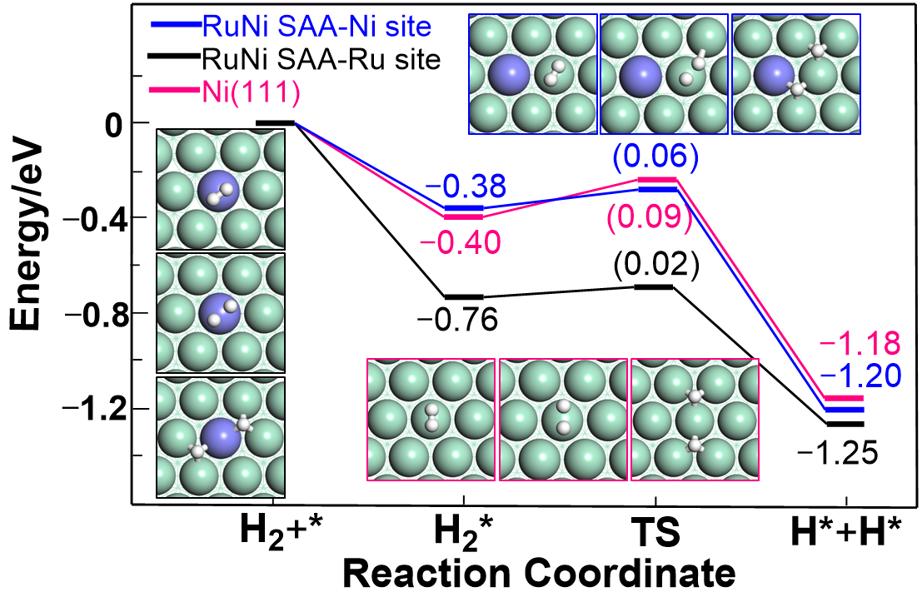
Supplementary Figure 25. Potential energy profiles for H₂ dissociation pathways on Ni (111) and RuNi SAA (111) surface, respectively.

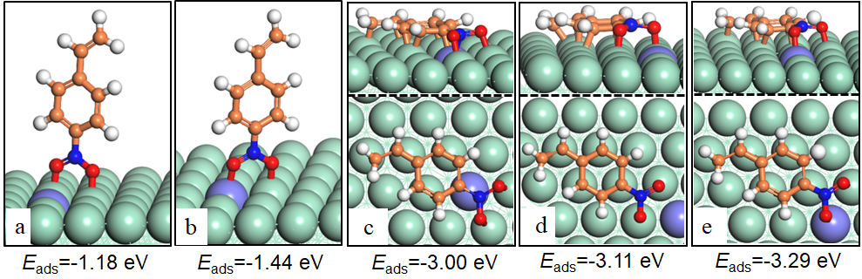
Supplementary Figure 26. Proposed adsorption configurations and corresponding adsorption energies of 4-nitrostyrene on RuNi SAA (111) surface. Ru, violet; Ni, green; C, orange; O, red; N, blue; H, white.

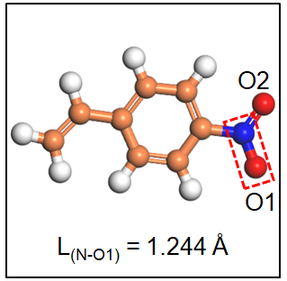
Supplementary Figure 27. Molecular structure of gaseous 4-nitrostyrene, with the labeled bond length of N−O1 (L_{(N−O1)}).

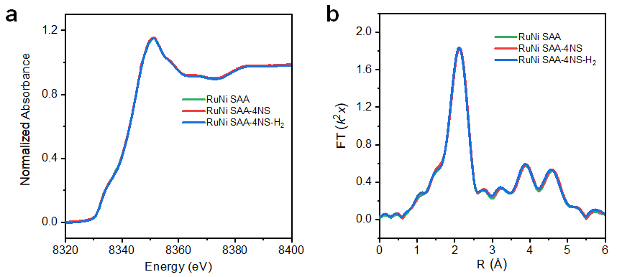
Supplementary Figure 28. a In situ normalized XANES and b phase correction EXAFS Fourier–transform spectra at Ni K-edge for the 0.4 wt.% RuNi SAA sample in the cases of 4-NS adsorption (RuNi SAA–4NS), and hydrogenation reaction stage (RuNi SAA–4NS–H₂).

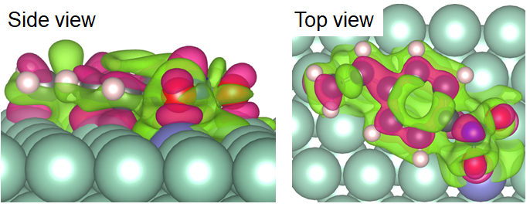
Supplementary Figure 29. Charge density difference of 4-nitrostyrene adsorbed on the surface of RuNi SAA (111). The green and red contours represent electron accumulation and depletion, respectively.

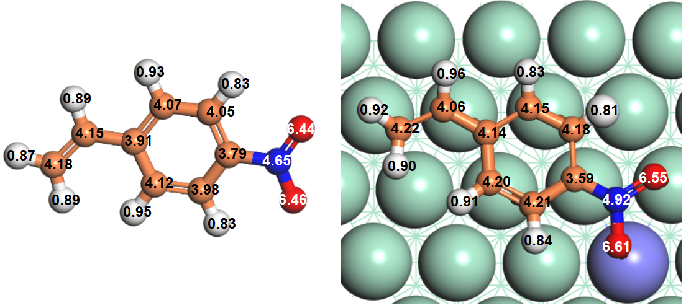
Supplementary Figure 30. Bader charge of gaseous 4-nitrostyrene molecule and 4-nitrostyrene adsorbed on RuNi SAA (111) surface. The numbers represent the electron number carried by the outermost layer of atoms.

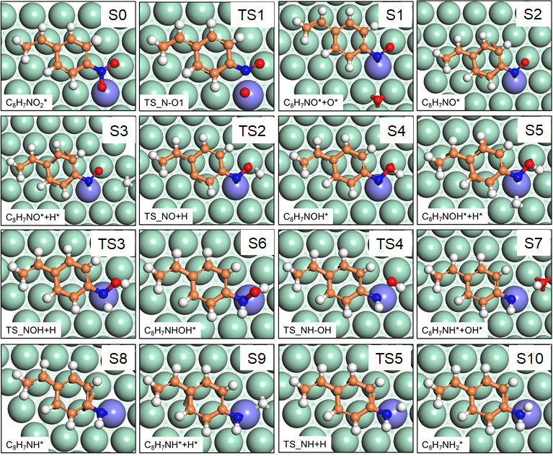
Supplementary Figure 31. Geometric structures of the elementary step for 4-nitrostyrene hydrogenation to 4-aminostyrene on the surface of RuNi SAA (111).

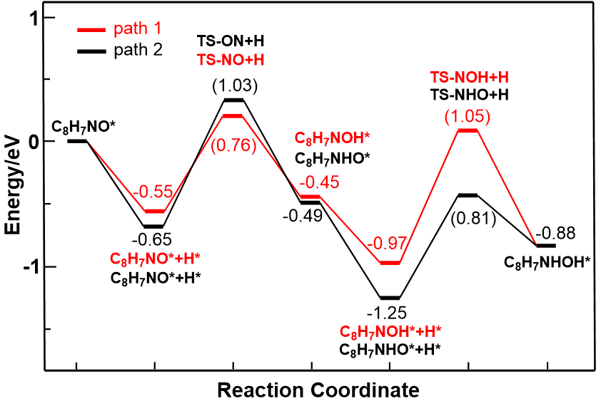
Supplementary Figure 32. Potential energy profiles of proposed reaction pathway for the intermediate hydrogenation (from C₈H₇NO* to C₈H₇NHOH*). Path 1: active H atom preferentially attacks the O atom in C₈H₇NO*; Path 2: active H atom hydrogenates N atom firstly.

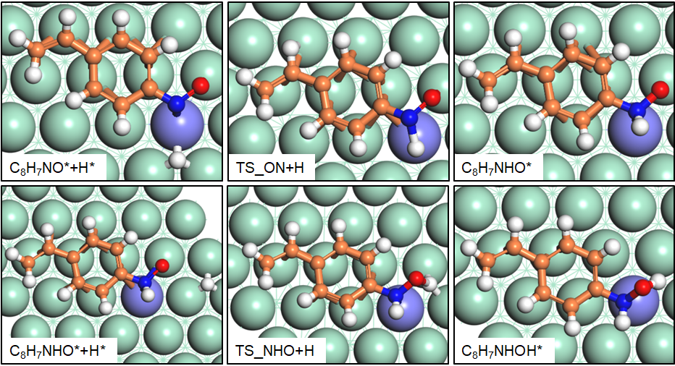
Supplementary Figure 33. Geometric structures of the elementary step for the intermediate hydrogenation (from C₈H₇NO* to C₈H₇NHOH*) via path 2.

Supplementary Tables
Supplementary Table 1. Physicochemical parameters of various samples
Sample | BET surface area ª (m²∙g⁻¹) | Mean pore size ª (nm) | Ru species content ^{b}  (wt.%) | Ni species content ^{b}  (wt.%) | Mean metal particle size ^{c}  (nm)
Ni/Al₂O₃ | 182.5 | 6.2 | − | 23.8 | 7.9
0.1% RuNi | 159.0 | 6.5 | 0.07 | 24.4 | 7.7
0.2% RuNi | 134.3 | 7.6 | 0.16 | 23.2 | 8.3
0.4% RuNi | 141.6 | 8.3 | 0.29 | 23.5 | 8.0
0.6% RuNi | 150.9 | 7.5 | 0.45 | 22.7 | 7.9
0.8% RuNi | 139.3 | 7.9 | 0.61 | 23.0 | 8.2
1% RuNi | 119.8 | 7.5 | 0.73 | 22.6 | 7.8
2% RuNi | 116.9 | 8.1 | 1.52 | 22.1 | 8.1
ª Specific surface area and mean pore size were determined by BET measurements. ^{b} Contents of metal Ru and Ni were measured by ICP–AES. ^{c} Mean metal particle size of Ni was determined by TEM images.

Supplementary Table 2. Comparison results on catalytic performance toward 4-nitrostyrene hydrogenation to 4-aminostyrene
Entry | Catalyst | Time | Tem. | P_{H2} | Con. | Sel. | TOF | Reference
Entry | Catalyst | (h) | (°C) | (MPa) | (%) | (%) | (h⁻¹) | Reference
1 | 0.1% RuNi SAA | 3 | 60 | 1 | 100 | >99 | 4287 | This work
2 | 0.2% RuNi SAA | 3 | 60 | 1 | 100 | >99 | 4271 | This work
3 | 0.4% RuNi SAA | 3 | 60 | 1 | 100 | >99 | 4293 | This work
4 | Pd/Ti₃SiC₂ | 24 | 140 | 2.5 | 100 | 93 | 4700 | 10
5 | PtTW1 | 0.06 | 80 | 1 | 80 | 66 | 1880 | 11
6 | Co_{0.23}-Ru_{0.77} | 12 | 25 | 0.3 | 97 | 99 | 32 | 12
7 | RhIn/SiO₂ | 2 | 75 | 0.1 | 99 | 93 | 25 | 13
8 | Pt@MFI | 13 | 80 | 2 | 100 | 83 | 16 | 14
9 | Au/TiO₂/UVM-7 | 24 | 140 | 2.5 | 30 | 94 | 3.3 | 15
10 | Co/N-C | 3 | 100 | 1 | >99 | 97 | 1.9 | 16
11 | Ni-Fe/SiO₂ | 4.5 | 70 | 0.1 | 98 | 95 | 11 | 17
12 | Ir₁Mo₁/TiO₂ | 1 | 120 | 2 | 100 | >96 | − | 18
13 | Pd nanosheets | 0.1 | 25 | 1 | 100 | 0 | − | 19
14ª | Pd₁₃Pb₉ | 1 | 90 | − | 99 | 96 | − | 20
15^{b} | Pt₁/Fe₂O₃ | 0.3 | 60 | 0.3 | 98.6 | 98 | 3809 | 21
16^{b} | Pt₁/Ni | 2 | 40 | 0.3 | 97 | 99 | 1800 | 22
17^{b} | 0.08%Pt/FeO_{x} | 0.83 | 40 | 0.3 | 96.5 | 98.6 | 1514 | 23
18^{b} | Co-N-C | 2 | 80 | 1 | 80.3 | 97.8 | 9.6 | 24
ª A catalytic transfer hydrogenation reaction without using H₂. ^{b} 3-nitrostyrene was used as reactant.

Supplementary Table 3. Catalytic performance toward chemoselective hydrogenation of various nitroarenes over 0.4% RuNi SAA catalyst
Entry | Reactant | Product | Con. (%) | Sel. (%)
1 |  |  | 100 | 100
2 |  |  | 100 | 98
3 |  |  | 100 | 99
4 |  |  | 99 | 96
5 |  |  | 100 | 95
Reaction conditions: 1 mmol of reactant; 8 ml of solvent (ethanol); 0.02 g of catalyst (0.4% RuNi SAA); 1 Mpa of H₂, 60 °C, 3 h.

Supplementary Table 4. Curve-fitting results of Ru K-edge EXAFS spectra for various samples
Sample | Shell | R (Å) ª | CN ^{b} | σ² (10³ Å²) ^{c} | ΔE₀ (eV) ^{d} | R factor (%)
Ru-foil | Ru–Ru | 2.67(±0.01) | 12 | 3.5 | 2.27 | 0.8
RuO₂ | Ru–O | 1.97(±0.01) | 6 | 2.3 | 3.72 | 0.7
0.4% RuNi | Ru–Ni | 2.47(±0.01) | 5.4 | 7.4 | 3.90 | 0.5
0.6% RuNi | Ru–Ni | 2.52(±0.01) | 5.8 | 6.8 | 8.50 | 0.7
0.6% RuNi | Ru–Ru | 2.62(±0.02) | 2.2 | 5.5 | 8.50 | 0.7
2% RuNi | Ru–Ni | 2.47(±0.04) | 2.5 | 8.0 | 4.41 | 0.8
2% RuNi | Ru–Ru | 2.65(±0.01) | 6.7 | 4.2 | 4.41 | 0.8
Ru/Al₂O₃ | Ru–Ru | 2.63(±0.01) | 6.2 | 5.6 | 2.52 | 1.2
Ru/Al₂O₃ | Ru–O | 2.07(±0.1) | 2.9 | 9.2 | 2.52 | 1.2
ª R: bond distance; ^{b} CN: coordination number; ^{c} σ²: Debye-Waller factor; ^{d} ΔE₀: the inner potential correction. The accuracies of the above parameters were estimated as follows: CN, ±20%; R, ±1%; σ², ±20%; ΔE₀, ± 20%. The data ranges used for data fitting in k space (Δk) and R space (ΔR) are 2.5−12.0 Å⁻¹ and 1.0−3.0 Å, respectively.

References:
1. Ravel, B. & Newville, M. ATHENA, ARTEMIS, HEPHAESTUS: data analysis for X-ray absorption spectroscopy using IFEFFIT. J. Synchrotron Radiat. 12, 537–541 (2005).
2. Funke, H., Chukalina, M. & Scheinost, A. C. A new FEFF-based wavelet for EXAFS data analysis. J. Synchrotron Radiat. 14, 426–432 (2007).
3. Kresse, G. & Furthmüller, J. Efficiency of ab-initio total energy calculations for metals and semiconductors using a plane-wave basis set. Comput. Mater. Sci. 6, 15–50 (1996).
4. Kresse, G. & Furthmüller, J. Efficient iterative schemes for ab initio total-energy calculations using a plane-wave basis set. Phys. Rev. B: Condens. Matter Mater. Phys. 54, 11169–11186 (1996).
5. Perdew, J. P., Burke, K. & Ernzerhof, M. Generalized gradient approximation made simple. Phys. Rev. Lett. 77, 3865–3868 (1996).
6. Grimme, S., Antony, J., Ehrlich, S. & Krieg, H. A consistent and accurate ab initio parametrization of density functional dispersion correction (DFT-D) for the 94 elements H-Pu. J. Chem. Phys. 132, 154104 (2010).
7. Blöchl, P. E. Projector augmented-wave method. Phys. Rev. B: Condens. Matter Mater. Phys. 50, 17953–17979 (1994).
8. Kresse, G. & Joubert, D. From ultrasoft pseudopotentials to the projector augmented-wave method. Phys. Rev. B: Condens. Matter Mater. Phys. 59, 1758–1775 (1999).
9. Yang, J., Lv, C., Guo, Y. & Wang, G. A DFT+U study of acetylene selective hydrogenation on oxygen defective anatase (101) and rutile (110) TiO₂ supported Pd₄ cluster. J. Chem. Phys. 136, 104107 (2012).
10. Trandafir, M. M. et al. Highly efficient ultralow Pd loading supported on MAX phases for chemoselective hydrogenation. ACS Catal. 10, 5899–5908 (2020).
11. Carrus, M. et al. Increased conversion and selectivity of 4-nitrostyrene hydrogenation to 4-aminostyrene on Pt nanoparticles supported on titanium-tungsten mixed oxides. Appl. Catal. A 519, 130−138 (2016).
12. Mao, J. et al. Rational control of the selectivity of a ruthenium catalyst for hydrogenation of 4-nitrostyrene by strain regulation. Angew. Chem. Int. Ed. 56, 11971–11975 (2017).
13. Furukawa, S., Takahashi, K. & Komatsu, T. Well-structured bimetallic surface capable of molecular recognition for chemoselective nitroarene hydrogenation. Chem. Sci. 7, 4476−4484 (2016).
14. Gu, J. et al. Platinum nanoparticles encapsulated in MFI zeolite crystals by a two-step dry gel conversion method as a highly selective hydrogenation catalyst. ACS Catal. 5, 6893−6901 (2015).
15. Trandafir, M. M., Moragues, A., Amorós, P. & Parvulescu, V. I. Selective hydrogenation of nitroderivatives over Au/TiO₂/UVM-7 composite catalyst. Catal. Today 355, 893–902 (2020).
16. Wang, X. & Li, Y. Chemoselective hydrogenation of functionalized nitroarenes using MOF-derived Co-based catalysts. J. Mol. Catal. A-Chem. 420, 56–65(2016).
17. Miyazaki, M., Ariyama, K., Furukawa, S., Takayama, T. & Komatsu, T. Chemoselective hydrogenation of nitroarenes using Ni-Fe alloy catalysts at ambient pressure. ChemistrySelect 6, 5538–5544 (2021).
18. Fu, J. et al. Synergistic effects for enhanced catalysis in a dual single-atom catalyst. ACS Catal. 11, 1952–1961 (2021).
19. Yang, N. et al. Amorphous/crystalline hetero-phase Pd nanosheets: one-pot synthesis and highly selective hydrogenation reaction. Adv. Mater. 30, 1803234 (2018).
20. Furukawa, S., Yoshida, Y. & Komatsu, T. Chemoselective hydrogenation of nitrostyrene to aminostyrene over Pd- and Rh-based intermetallic compounds. ACS Catal. 4, 1441–1450 (2014).
21. Ren, Y. et al. Unraveling the coordination structure-performance relationship in Pt₁/Fe₂O₃ single-atom catalyst. Nat. Commun. 10, 4500 (2019).
22. Peng, Y. et al. Pt single atoms embedded in the surface of Ni nanocrystals as highly active catalysts for selective hydrogenation of nitro compounds. Nano Lett. 18, 3785–3791 (2018).
23. Wei, H. et al. FeO_{x}-supported platinum single-atom and pseudo-single-atom catalysts for chemoselective hydrogenation of functionalized nitroarenes. Nat. Commun. 5, 5634 (2014).
24. Li, M. et al. Origin of the activity of Co-N-C catalysts for chemoselective hydrogenation of nitroarenes. ACS Catal. 11, 3026–3039 (2021).

