Supplementary Information – Spatially Referenced Watershed Models for the Red-Assiniboine River Basin Using Bayesian and Frequentist Parameter Estimation Methods: A Critical Binational Comparison

^{a,b} E. Agnes Blukacz-Richards (ORCID – 0000-0002-0014-3461)
^{a,b} Felix Ouellet (ORCID – 0009-0004-7293-5048)
^{b} Alex Neumann (ORCID – 0000-0003-1590-8516)
^{c} Dale M. Robertson (ORCID – 0000-0001-6799-0596)
^{d} Glenn A. Benoy (ORCID – 0000-0001-6530-7220)
^{b} George Arhonditsis (ORCID – 0000-0001-5359-8737)
^{c} David A. Saad (ORCID – 0000-0001-6559-6181)

ª Environment and Climate Change Canada, Burlington, Ontario L7S 1A1, Canada
^{b} Department of Physical & Environmental Sciences, University of Toronto, Toronto, Ontario M1C 1A4, Canada
^{c} U.S. Geological Survey, Madison, Wisconsin 53726, USA
^{d} International Joint Commission, Ottawa, Ontario K1P 6K6, Canada

*Corresponding authors: E-mail: Agnes.Richards@ec.gc.ca, Tel: +1 416-399-1841

E-mail: Felix.Ouellet@ec.gc.ca, Tel: +1 905-570-7489

E-mail: dzrobert@usgs.gov, Tel: +1 608-852-7551

E-mail: Alex.Gudimov@utoronto.ca, Tel: +1 416-876-1417

Appendix S1. SPARROW (Spatially Referenced Regression on Watershed Attributes) model
In this study, we used the standard SPARROW framework that separates the nutrient fate and transport within a watershed context into three conceptual processes, which ultimately describe the loading downstream: 1) nutrient export from different sources and land uses, 2) land-to-water delivery, and 3) nutrient attenuation rates during their transportation through streams and reservoirs ¹. SPARROW estimates mean annual nutrient flux F_{i} (µ in natural logarithmic space) in a headwater sub-watershed i with the following governing equation:
$$μ_{i} = ln\left(F_{i}\right)=\left[ln\left\{\sum_{j=1}^{J_{i}}{(\left(\sum_{n=1}^{N_{c}}{β_{n}S_{n,j}}\right)R_{i,j}^{lwd}+β_{SC} T L Q_{bool}+β_{PT}S_{PT}+F_{QA})H_{i,j}^{R}}\right\}\right]+ε_{i}$$ | (3)
where the subscripts i and j refer to monitored stations with tributary measurements and upstream reach catchments, respectively. For each water quality station i, mean annual TP load was estimated using Fluxmaster ²; for details see Jenkinson and Benoy ³. For each scenario calibrated using the Bayesian approach, the number of area sources N is denoted by the vector [N₁, N₂,…, N_{c}]. Scenarios 1, 2, and 3 have five sources: agricultural sources, forests/wetlands, stream channels, WWTPs, and Qu’Appelle River. For Scenarios 4, 7, and 5, one source was added in each case for a total of six sources, where agricultural sources are split into fertilizers and manure for Scenarios 4 and 7, and forests/wetlands were split into forests and wetlands for Scenario 5. For Scenario 6, one source was added, which was urban area, for a total of six sources. For Scenario 8, one source was added for a total of six sources, where agricultural sources were split into being located in Canada and the United States (U.S.). For Scenario 9, two sources are added for a total of seven sources, which corresponds to the combination of splits of Scenarios 7 and 8. [J₁, J₂,…, J_{i}] refers to the total number of stream reaches in monitored station catchments i; ε_{i} represents a random and normally distributed error term. $β_{n}$ is the export coefficient from a particular nutrient area source n (agriculture, agriculture fertilizer, agriculture manure, agriculture manure – Canada, stream channels…); S_{n} is a measurable quantity for the nutrient area source n, such as the area occupied by a specific land cover, or fertilizer and manure inputs to agricultural areas. $β_{SC}$ represents the export coefficient for stream channels, where $L$ represents the length of the stream, $T$ selects only stream elements (not reservoirs), and $Q_{bool}$ is a boolean that selects stream flows between 0.03 m³/s and 0.21 m³/s. $β_{PT}$ is the export coefficient of wastewater treatment plants, and $S_{PT}$ is the wastewater treatment plant input load. $F_{QA}$ is the point source for the Qu’Appelle River, expressed as a load.

The catchment transfer function $R_{i,j}^{lwd}$ accounts for the land-to-water delivery process at the catchment scale, which can be modulated by a suite of factors (or land-surface characteristics) associated with drainage, such as catchment slope, areal extent of wetlands, soil hydraulic conductivity, precipitation, and soil bulk density:
$$R_{i,j}^{lwd}= e^{\left(α(Z_{j}-Avg(Z_{j}))\right)}$$ | (4)
where Z refers to a measurable quantity of a factor, α represents the land-to-water delivery coefficient for a factor, which is represented by precipitation in our model.
The attenuation in connected reservoirs and lakes $H_{i,j}^{R}$ followed:
 | $$H_{i,j}^{R}=\prod_{j=1}^{j}{\frac{1}{\left(1+\frac{k_{R}}{V_{h_{i} }}\right)}}$$ | (5)
Where instances of j included in multiplication were only applicable to reaches on the path of catchment j to water quality station, and where $V_{h }$represents hydraulic load (annual outflow rate divided by the surface lake/reservoir area, m/yr); k_{R} refers to the first order rate coefficient for net in-lake total phosphorus (TP) settling (m/yr).
Nutrient loading accumulation in nested station catchments is estimated by adding upstream loading ⁴. During typical model calibration, downstream loads are computed after all upstream simulated loads are replaced with their measured loads to prevent errors from propagating downstream ¹. This may overestimate the “true” performance of the model compared to if the model completely simulated all of the loads ^{5,6}. In this study in all Bayesian simulations, we used the “unconditioned” approach to estimate nutrient loading in downstream nested station catchments, $F_{i}^{*}$, with simulated loading inputs $F_{i}$ from upstream station catchments:
$$μ_{i}=ln\left(F_{i}^{*}\right)=\left[ln\left\{\sum_{j=1}^{J_{i}}{(\left(\sum_{n=1}^{N_{c}}{β_{n}S_{n,j}}\right)R_{i,j}^{lwd}+β_{SC} T L Q_{bool}+β_{PT}S_{PT}+F_{QA})H_{i,j}^{R}}+\left(\sum_{i=1}^{U_{i}}{F_{i}}\right)H_{i}^{R}\right\}\right]+ε_{i}$$ | (6)
where U_{i} is a number of upstream monitored station catchments, which flow into the station catchment i. $H_{i}^{R}$ is delivery fraction between the upstream and downstream water quality stations. $F_{i}^{*}$ and $F_{i}$ are referred to as ${Load}_{SPARROWi}$ in the manuscript.

Appendix S2. Calibration results in log scale.

Table S1. Model Fit RMSE, R², and DIC values for all scenarios. RMSE percent differences (representing improvement) for Scenarios 2-9 are calculated in comparison with Scenario 1.
Scenario | Description | RMSE (Calibrated)  Value Diff. |  | RMSE (Predicted)  Value Diff. |  | R² (Calibrated)  Value | R² (Predicted)  Value | DIC  Value
Scenario 1 | Benoy et al. ⁷ | 0.489 |  | 0.648 |  | 0.915 | 0.858
Scenario 2 | Variability on WWTPs | 0.329 | 33% | 0.572 | 12% | 0.964 | 0.890 | 154.2
Scenario 3a-MARB | Priors from MARB | 0.325 | 34% | 0.639 | 1% | 0.965 | 0.863 | 163.0
Scenario 3b-MI | Priors from Bayesian SPARROW | 0.333 | 32% | 0.573 | 12% | 0.963 | 0.890 | 155.7
Scenario 3c-Extr | Priors from Non-Bayesian SPARROW (Extremes) | 0.335 | 31% | 0.564 | 13% | 0.962 | 0.893 | 154.5
Scenario 3d-FS | Priors from Non-SPARROW Field Studies | 0.331 | 32% | 0.577 | 11% | 0.963 | 0.888 | 154.3
Scenario 4 | Split Fertilizers vs Manure | 0.331 | 32% | 0.556 | 14% | 0.964 | 0.897 | 152.5
Scenario 5 | Split Forests vs Wetlands | 0.332 | 32% | 0.574 | 11% | 0.964 | 0.890 | 153.0
Scenario 6 | Addition of Urban | 0.321 | 34% | 0.604 | 7% | 0.966 | 0.879 | 156.7
Scenario 7 | Scenario 3d-FS & Scenario 4 | 0.333 | 32% | 0.562 | 13% | 0.963 | 0.895 | 153.5
Scenario 8 | Scenario 3d-FS & Country Hierarchy (Agr. Inputs) | 0.346 | 29% | 0.568 | 12% | 0.960 | 0.893 | 156.0
Scenario 9 | Scenario 7 & Country Hierarchy (Manure) | 0.347 | 29% | 0.555 | 14% | 0.960 | 0.899 | 151.7

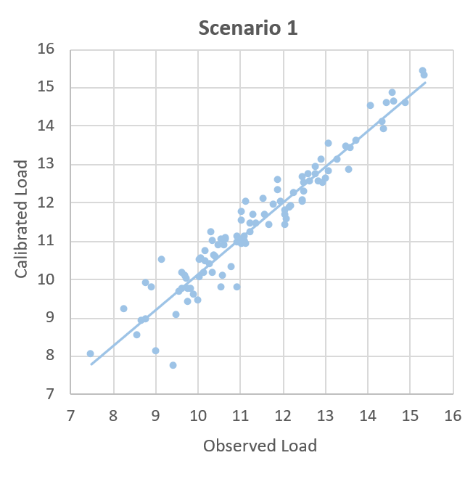 | 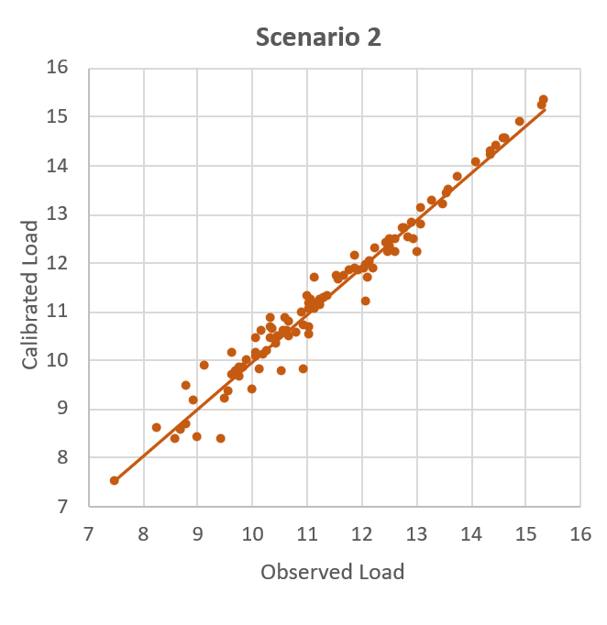 | 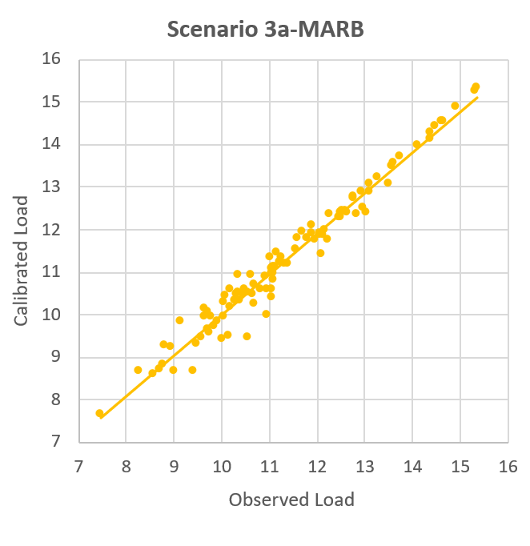
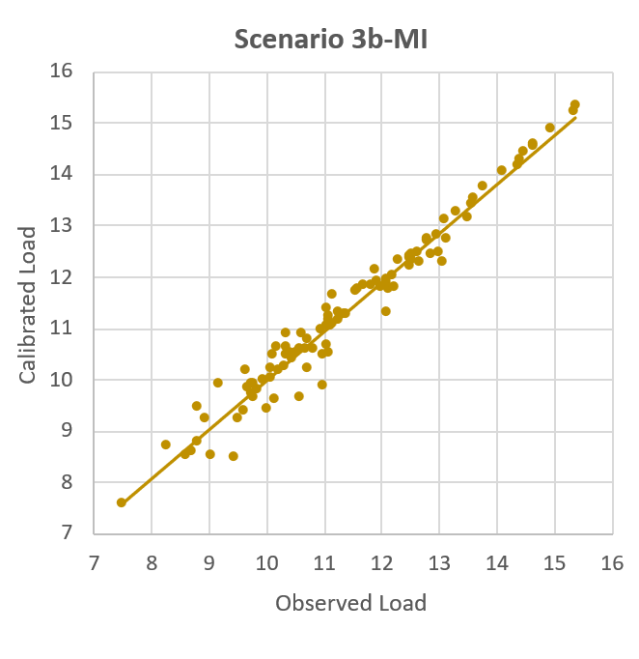 | 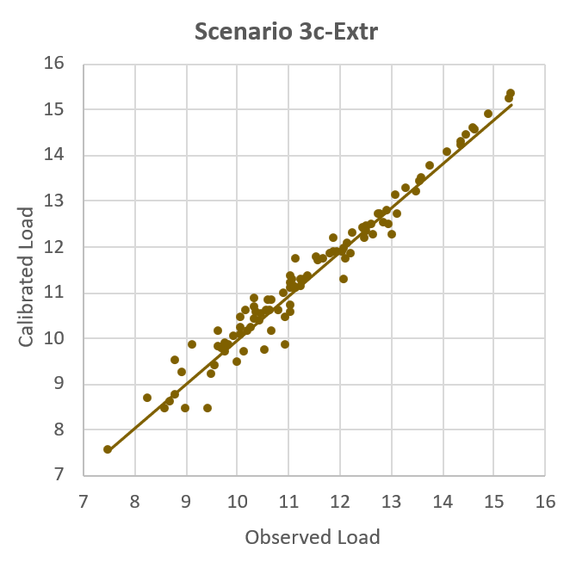 | 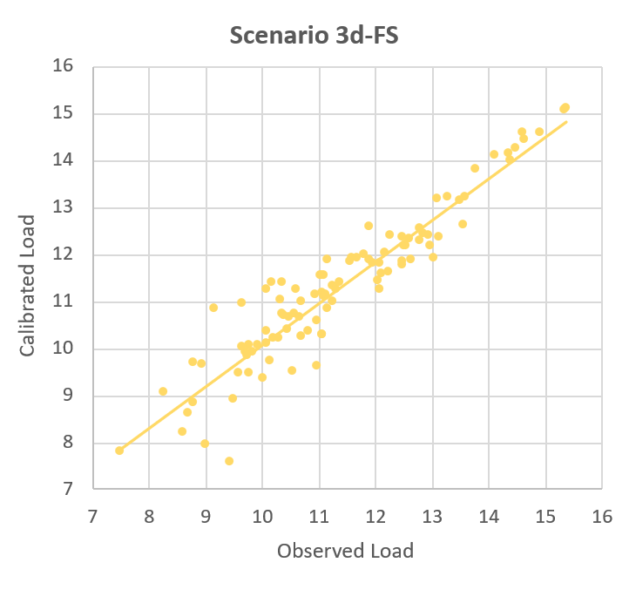
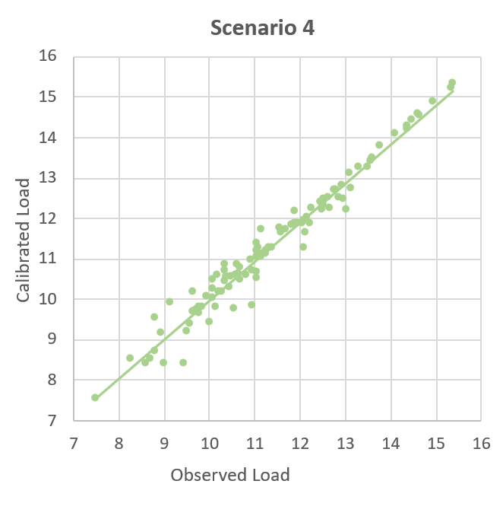 | 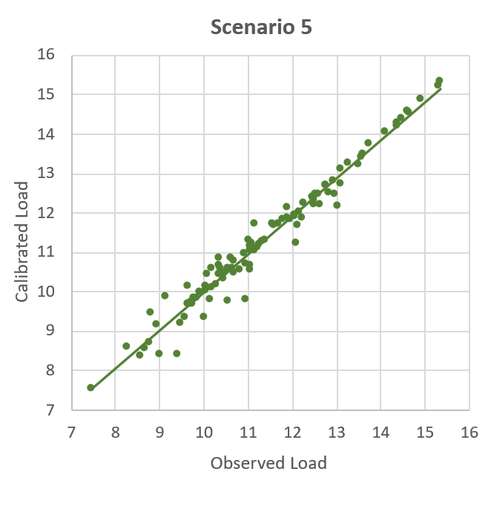 | 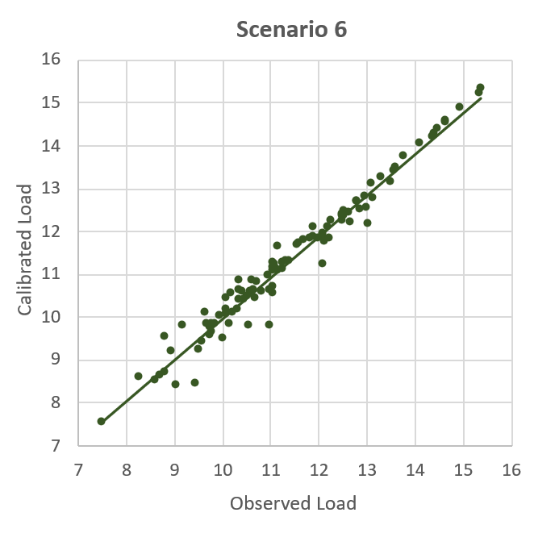
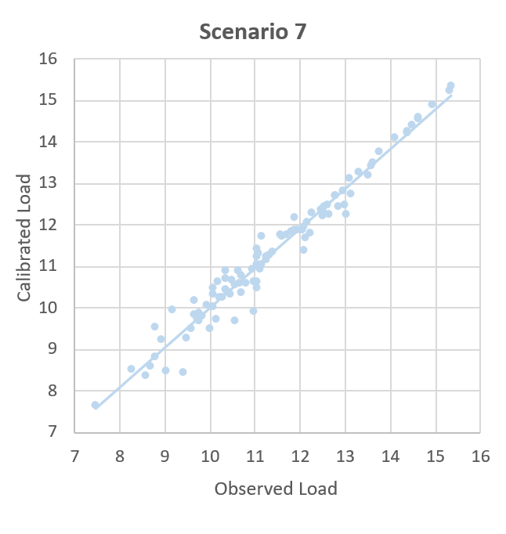 | 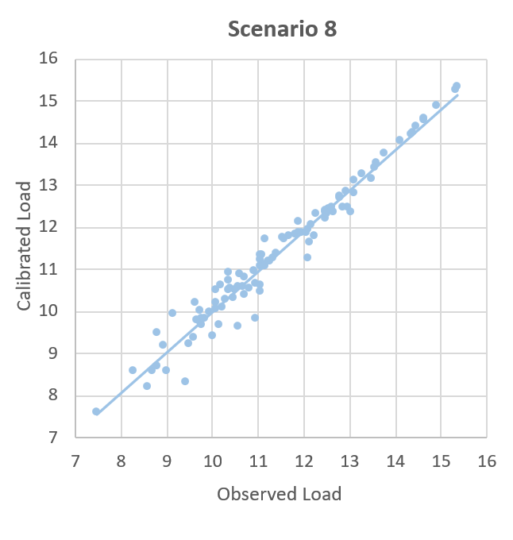 | 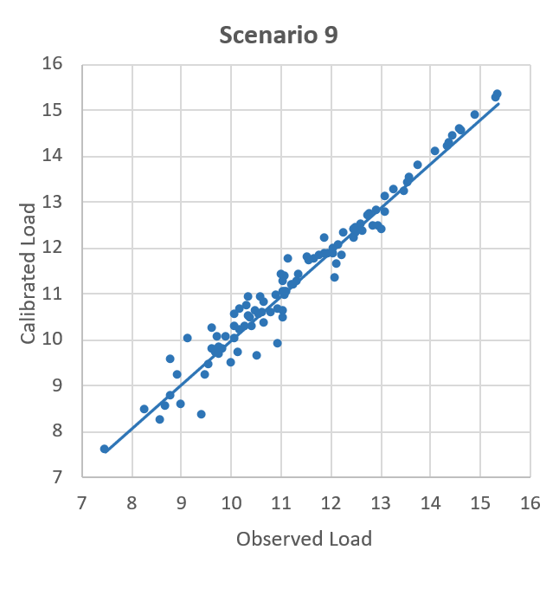
Figure S1. Calibration of loads – Benoy et al. ⁷ model (Scenario 1) and Bayesian main scenarios (Scenarios 2-9).

Table S2. Observed vs calibrated loads (kg/yr) for Scenario 1, and the four key scenarios.
SPARROW ID | Station Catchment ID | Observed Load | Scenario 1 Cal. Load | Scenario 2 Cal. Load | Scenario 3d-FS Cal. Load | Scenario 4 Cal. Load | Scenario 8 Cal. Load
62906 | 1 | 5,941 | 7,479 | 5,464 | 5,763 | 5,146 | 5,417
62792 | 2 | 34,123 | 39,728 | 32,600 | 33,910 | 30,850 | 31,430
62659 | 3 | 1,767 | 3,164 | 1,959 | 2,146 | 1,988 | 2,068
62617 | 4 | 68,782 | 55,371 | 64,020 | 65,720 | 63,390 | 64,050
62457 | 5 | 7,516 | 18,071 | 10,110 | 10,670 | 10,090 | 10,330
62437 | 6 | 17,478 | 17,570 | 19,420 | 20,110 | 19,120 | 19,230
62412 | 7 | 76,599 | 96,472 | 78,330 | 80,620 | 76,220 | 76,070
62081 | 8 | 182,359 | 105,039 | 123,900 | 128,900 | 121,100 | 119,400
62004 | 9 | 145,573 | 229,565 | 145,100 | 145,300 | 144,300 | 142,900
69251 | 10 | 264,024 | 166,661 | 236,600 | 236,000 | 237,100 | 244,000
69020 | 11 | 12,355 | 2,326 | 4,639 | 4,679 | 4,788 | 4,263
68621 | 12 | 308,015 | 280,137 | 214,100 | 216,400 | 215,700 | 236,200
68543 | 13 | 455,645 | 311,572 | 213,400 | 213,700 | 216,000 | 247,000
68143 | 14 | 13,247 | 8,743 | 10,110 | 11,030 | 10,200 | 10,470
67406 | 15 | 22,195 | 12,849 | 12,840 | 13,520 | 13,470 | 13,050
66912 | 16 | 38,052 | 17,653 | 18,760 | 17,430 | 18,770 | 16,770
66893 | 17 | 62,911 | 54,845 | 39,690 | 38,630 | 39,500 | 36,990
66888 | 18 | 62,587 | 63,135 | 45,580 | 43,940 | 44,740 | 42,530
66271 | 19 | 17,330 | 12,395 | 16,130 | 16,330 | 16,140 | 16,390
65229 | 20 | 16,570 | 24,128 | 17,690 | 17,770 | 17,220 | 17,740
65221 | 21 | 18,643 | 16,993 | 19,470 | 19,290 | 18,640 | 19,350
65193 | 22 | 23,490 | 23,372 | 23,920 | 23,930 | 23,440 | 23,990
65190 | 23 | 43,584 | 65,974 | 50,890 | 51,330 | 51,090 | 51,160
66157 | 24 | 82,302 | 117,586 | 81,260 | 80,650 | 82,520 | 80,430
65171 | 25 | 62,691 | 55,811 | 65,660 | 67,150 | 65,910 | 66,550
65041 | 26 | 133,100 | 157,344 | 142,700 | 143,900 | 142,100 | 142,300
65016 | 27 | 191,335 | 145,388 | 178,000 | 179,900 | 177,700 | 176,700
64915 | 28 | 271,161 | 219,535 | 233,900 | 238,000 | 234,000 | 232,200
64911 | 29 | 428,174 | 273,066 | 279,300 | 280,500 | 271,600 | 268,600
64574 | 30 | 6,598 | 19,908 | 13,840 | 13,350 | 15,130 | 13,800
64545 | 31 | 20,388 | 15,063 | 23,260 | 22,830 | 25,080 | 22,830
64540 | 32 | 49,244 | 30,305 | 40,400 | 39,870 | 41,500 | 39,450
63575 | 33 | 61,609 | 127,572 | 88,030 | 91,320 | 92,200 | 88,520
64248 | 34 | 57,284 | 17,988 | 19,290 | 20,370 | 20,130 | 19,450
63487 | 35 | 145,076 | 297,614 | 192,100 | 194,800 | 200,700 | 191,200
61081 | 36 | 38,648 | 61,979 | 41,160 | 39,910 | 40,300 | 40,670
61069 | 37 | 32,430 | 40,525 | 43,110 | 39,690 | 40,230 | 40,010
61002 | 38 | 66,065 | 59,692 | 76,840 | 67,130 | 69,370 | 69,490
60999 | 39 | 66,493 | 68,194 | 72,430 | 67,740 | 69,430 | 68,960
60271 | 40 | 172,389 | 134,984 | 149,600 | 145,300 | 149,700 | 141,600
60997 | 41 | 55,450 | 66,497 | 60,200 | 57,900 | 58,890 | 59,360
60206 | 42 | 274,716 | 268,804 | 265,100 | 256,500 | 262,800 | 258,400
60182 | 43 | 258,367 | 320,516 | 258,000 | 248,900 | 257,000 | 246,100
59638 | 44 | 202,322 | 151,052 | 150,400 | 141,800 | 149,900 | 139,300
59602 | 45 | 299,412 | 346,923 | 274,000 | 266,600 | 278,400 | 266,900
60174 | 46 | 379,031 | 281,631 | 294,000 | 275,800 | 292,600 | 277,300
59573 | 47 | 725,368 | 711,022 | 587,000 | 552,000 | 606,900 | 549,000
59570 | 48 | 486,020 | 752,227 | 508,600 | 499,600 | 516,500 | 499,200
59556 | 49 | 587,049 | 501,165 | 584,000 | 581,300 | 591,900 | 577,400
59077 | 50 | 156,005 | 166,673 | 146,600 | 145,300 | 148,500 | 148,100
59073 | 51 | 69,379 | 166,985 | 131,100 | 130,800 | 133,400 | 134,300
59052 | 52 | 938,444 | 826,348 | 975,200 | 977,700 | 998,300 | 966,100
58159 | 53 | 30,745 | 76,665 | 45,380 | 45,040 | 46,180 | 46,760
57848 | 54 | 175,504 | 120,797 | 159,900 | 160,500 | 160,400 | 159,100
57847 | 55 | 103,419 | 178,404 | 135,400 | 133,300 | 139,200 | 136,000
57839 | 56 | 1,753,564 | 1,104,999 | 1,609,000 | 1,595,000 | 1,615,000 | 1,585,000
57537 | 57 | 6,529 | 7,783 | 6,281 | 6,793 | 6,537 | 6,457
57291 | 58 | 176,498 | 89,971 | 79,880 | 87,170 | 85,940 | 81,320
57257 | 59 | 1,326,990 | 2,039,085 | 1,371,000 | 1,367,000 | 1,433,000 | 1,346,000
57168 | 60 | 1,724,903 | 1,366,327 | 1,528,000 | 1,529,000 | 1,540,000 | 1,490,000
57167 | 61 | 1,917,699 | 2,157,984 | 1,851,000 | 1,848,000 | 1,864,000 | 1,825,000
56869 | 62 | 14,361 | 16,280 | 12,410 | 13,460 | 13,000 | 12,570
56847 | 63 | 23,459 | 37,063 | 27,360 | 30,220 | 29,980 | 28,550
56540 | 64 | 26,822 | 35,651 | 26,310 | 27,950 | 28,510 | 25,830
55756 | 65 | 35,812 | 53,636 | 38,270 | 41,700 | 41,780 | 39,260
55305 | 66 | 2,255,472 | 2,254,632 | 2,128,000 | 2,140,000 | 2,154,000 | 2,091,000
54198 | 67 | 25,247 | 25,818 | 19,630 | 18,330 | 19,650 | 17,310
54062 | 68 | 42,048 | 53,317 | 43,480 | 42,880 | 43,530 | 41,880
53575 | 69 | 2,209,305 | 2,869,000 | 2,198,000 | 2,200,000 | 2,249,000 | 2,193,000
53560 | 70 | 3,005,922 | 2,212,409 | 2,945,000 | 2,928,000 | 2,938,000 | 2,920,000
51912 | 71 | 87,491 | 96,641 | 85,100 | 89,710 | 84,330 | 91,320
51726 | 72 | 62,884 | 101,196 | 73,350 | 76,900 | 74,160 | 78,530
51724 | 73 | 64,419 | 63,199 | 79,760 | 83,320 | 81,340 | 86,510
50647 | 74 | 8,184 | 3,360 | 4,703 | 5,115 | 4,632 | 5,667
48920 | 75 | 16,743 | 22,268 | 17,750 | 19,030 | 17,990 | 24,250
34261 | 76 | 75,773 | 74,338 | 68,830 | 71,360 | 69,210 | 74,230
32553 | 77 | 43,516 | 63,545 | 38,800 | 33,420 | 38,120 | 33,700
31396 | 78 | 57,026 | 57,692 | 48,440 | 44,420 | 48,610 | 46,090
28909 | 79 | 263,378 | 173,859 | 212,000 | 208,000 | 207,700 | 208,700
22936 | 80 | 29,210 | 33,224 | 27,460 | 28,650 | 27,470 | 30,110
22710 | 81 | 350,829 | 348,687 | 327,700 | 329,200 | 327,600 | 331,600
22261 | 82 | 492,785 | 377,384 | 362,500 | 358,000 | 354,300 | 367,900
21854 | 83 | 414,766 | 506,285 | 374,300 | 375,700 | 371,400 | 381,000
17386 | 84 | 15,405 | 25,739 | 17,310 | 20,360 | 16,970 | 18,960
10445 | 85 | 30,971 | 60,818 | 35,230 | 35,650 | 35,580 | 37,660
10115 | 86 | 9,375 | 37,022 | 20,390 | 20,330 | 21,560 | 21,900
9196 | 87 | 5,349 | 5,116 | 4,557 | 4,431 | 4,631 | 3,866
9010 | 88 | 15,242 | 16,962 | 26,590 | 26,450 | 27,590 | 28,040
8542 | 89 | 23,767 | 38,482 | 35,150 | 35,870 | 36,400 | 36,720
8530 | 90 | 40,308 | 23,915 | 53,140 | 54,010 | 53,790 | 55,020
8035 | 91 | 3,856 | 10,236 | 5,640 | 5,777 | 5,215 | 5,461
7994 | 92 | 26,240 | 46,338 | 41,180 | 41,870 | 41,890 | 43,060
7985 | 93 | 30,997 | 26,666 | 53,910 | 55,920 | 55,250 | 56,490
7382 | 94 | 118,435 | 90,386 | 132,000 | 140,400 | 129,500 | 136,500
7292 | 95 | 106,587 | 120,720 | 121,100 | 128,300 | 121,200 | 124,900
1964 | 96 | 210,785 | 212,498 | 218,500 | 219,700 | 215,800 | 226,500
807 | 97 | 802,425 | 689,216 | 741,700 | 745,100 | 743,200 | 765,000
702 | 98 | 353,610 | 410,826 | 332,500 | 336,400 | 331,900 | 344,600
433 | 99 | 775,108 | 378,638 | 680,100 | 681,200 | 666,400 | 685,400
222 | 100 | 4,505,002 | 4,974,967 | 4,217,000 | 4,243,000 | 4,277,000 | 4,333,000
104 | 101 | 4,649,398 | 4,547,900 | 4,557,000 | 4,574,000 | 4,566,000 | 4,598,000

Appendix S3. Priors vs posteriors.

Table S3. Characteristics of Parameters prior probability distributions for SPARROW parameters in Red-Assiniboine River Basin (RARB) with descriptions, units, means, standard deviations (S.D.), and interpretations. Interpretation column shows that 90% of the probability lies between the two values shown.

Parameters/ Priors |  | Units | Mean | S.D. |  | Interpretation
Sources (β_{FM}): Fertilizers and Manure
Scenario 1 ⁷ | Fraction |  | 0.011 |  | 0.004 |  | 0.005 - 0.018
Scenario 2 ⁷ | Fraction |  | 0.011 |  | 0.004 |  | 0.005 - 0.018
Scenario 3a-MARB ⁸ | Fraction |  | 0.027 |  | 0.005 |  | 0.019 - 0.035
Scenario 3b-MI† ^{4,7–9} | Fraction |  | 0.026 |  | 0.005 |  | 0.018 - 0.034
Scenario 3c-Extr‡ ^{4,7–9} | Fraction |  | 0.050 |  | 0.050 |  | 0.003 - 0.040
Scenario 3d-FS§ ^{10,11} | Fraction |  | 0.050 |  | 0.030 |  | 0.011 - 0.100
Scenario 4-Fertilizers ⁷  -Manure ⁷ | Fraction  Fraction |  | 0.011  0.011 |  | 0.004  0.004 |  | 0.005 - 0.018  0.005 - 0.018
Scenario 5 ⁷ | Fraction |  | 0.011 |  | 0.004 |  | 0.005 - 0.018
Scenario 6 ⁷ | Fraction |  | 0.011 |  | 0.004 |  | 0.005 - 0.018
Scenario 7-Fertilizers§ ^{10,11}  -Manure§ ^{10,11} | Fraction  Fraction |  | 0.050  0.050 |  | 0.030  0.030 |  | 0.011 - 0.100  0.011 - 0.100
Scenario 8 -Canada§ ^{10,11}  -U.S.^{§ 10,11} | Fraction  Fraction |  | 0.050  0.050 |  | 0.030  0.030 |  | 0.011 - 0.100  0.011 - 0.100
Scenario 9-Fertilizers§ ^{10,11}  -Manure-Canada§ ^{10,11}  -Manure-U.S.§ ^{10,11} | Fraction  Fraction  Fraction |  | 0.050  0.050  0.050 |  | 0.030  0.030  0.030 |  | 0.011 - 0.100  0.011 - 0.100  0.011 - 0.100

Sources (β_{FW}): Forests and Wetlands
Scenario 1 ⁷ | kg/km²/yr | 6.02 | 3.2 | 1 - 11
Scenario 2 ⁷ | kg/km²/yr | 6.02 | 3.2 | 1 - 11
Scenario 3a-MARB ⁸ | kg/km²/yr | 4.22 | 1.3 | 2 - 6
Scenario 3b-MI ¹² | kg/km²/yr | 6.00 | 4.3 | 1 - 13
Scenario 3c-Extr^{‡ 7,8} | kg/km²/yr | 10.00 | 10.0 | 2 - 27
Scenario 3d-FS ¹³ | kg/km²/yr | 7.18 | 3.8 | 2 - 14
Scenario 4 ⁷ | kg/km²/yr | 6.02 | 3.2 | 1 - 11
Scenario 5-Forests ⁷  -Wetlands ⁷ | kg/km²/yr  kg/km²/yr | 6.02  6.02 | 3.2  3.2 | 1 - 11  1 - 11
Scenario 6 ⁷ | kg/km²/yr | 6.02 | 3.2 | 1 - 11
Scenario 7 ¹³ | kg/km²/yr | 7.18 | 3.8 | 2 - 14
Scenario 8 ¹³ | kg/km²/yr | 7.18 | 3.8 | 2 - 14
Scenario 9 ¹³ | kg/km²/yr | 7.18 | 3.8 | 2 - 14

Sources (β_{U}): Urban Areas including cottages and roads
Scenario 6 ⁸ | kg/km²/yr | 103 | 23 | 65 - 141

Parameters/ Priors | Units | Mean |  | S.D. |  | Interpretation
Sources (β_{SC}): Stream Channels
Scenario 1 ⁷ | kg/m/yr |  | 0.070 |  | 0.04 | 0.02 - 0.14
Scenario 2 ⁷ | kg/m/yr |  | 0.070 |  | 0.04 | 0.02 - 0.14
Scenario 3a-MARB ⁸ | kg/m/yr |  | 0.093 |  | 0.02 | 0.06 - 0.13
Scenario 3b-MI† ^{7,8} | kg/m/yr |  | 0.081 |  | 0.03 | 0.03 - 0.13
Scenario 3c-Extr^{‡ 7,8} | kg/m/yr |  | 0.200 |  | 0.20 | 0.03 - 0.54
Scenario 3d-FS§ ^{7,8} | kg/m/yr |  | 0.082 |  | 0.02 | 0.05 - 0.11
Scenario 4 ⁷ | kg/m/yr |  | 0.070 |  | 0.04 | 0.02 - 0.14
Scenario 5 ⁷ | kg/m/yr |  | 0.070 |  | 0.04 | 0.02 - 0.14
Scenario 6 ⁷ | kg/m/yr |  | 0.070 |  | 0.04 | 0.02 - 0.14
Scenario 7^{§ 7,8} | kg/m/yr |  | 0.082 |  | 0.02 | 0.05 - 0.11
Scenario 8^{§ 7,8} | kg/m/yr |  | 0.082 |  | 0.02 | 0.05 - 0.11
Scenario 9§ ^{7,8} | kg/m/yr |  | 0.082 |  | 0.02 | 0.05 - 0.11

Sources (β_{PT}): Wastewater Treatment Plants
Scenario 1 ⁷ | Fraction | 1.000 | – | –
Scenario 2 ⁷ | Fraction | 1.000 | 0.06 | 0.9 - 1.1
Scenario 3a-MARB ⁸ | Fraction | 1.000 | 0.19 | 0.7 - 1.4
Scenario 3b-MI ^{14,15} | Fraction | 1.000 | 0.30 | 0.5 - 1.5
Scenario 3c-Extr ⁷ | Fraction | 1.000 | 1.00 | 0.2 - 2.7
Scenario 3d-FS ⁷ | Fraction | 1.000 | 0.06 | 0.9 - 1.1
Scenario 4 ⁷ | Fraction | 1.000 | 0.06 | 0.9 - 1.1
Scenario 5 ⁷ | Fraction | 1.000 | 0.06 | 0.9 - 1.1
Scenario 6 ⁷ | Fraction | 1.000 | 0.06 | 0.9 - 1.1
Scenario 7 ⁷ | Fraction | 1.000 | 0.06 | 0.9 - 1.1
Scenario 8 ⁷ | Fraction | 1.000 | 0.06 | 0.9 - 1.1
Scenario 9 ⁷ | Fraction | 1.000 | 0.06 | 0.9 - 1.1

Land-to-water delivery (a_{PPT})
Scenario 1 ⁷ | mm/yr | 0.0093 | 0.002 | 0.006 - 0.013
Scenario 2 ⁷ | mm/yr | 0.0093 | 0.002 | 0.006 - 0.013
Scenario 3a-MARB ⁸ | mm/yr | 0.0020 | 0.001 | 0.001 - 0.004
Scenario 3b-MI^{† 7,8} | mm/yr | 0.0060 | 0.002 | 0.003 - 0.009
Scenario 3c-Extr^{‡ 7,8} | mm/yr | 0.0100 | 0.010 | 0.002 - 0.027
Scenario 3d-FS^{§ 7,8} | mm/yr | 0.0055 | 0.003 | 0.001 - 0.010
Scenario 4 ⁷ | mm/yr | 0.0093 | 0.002 | 0.006 - 0.013
Scenario 5 ⁷ | mm/yr | 0.0093 | 0.002 | 0.006 - 0.013
Scenario 6 ⁷ | mm/yr | 0.0093 | 0.002 | 0.006 - 0.013
Scenario 7^{§ 7,8} | mm/yr | 0.0055 | 0.003 | 0.001 - 0.010
Scenario 8^{§ 7,8} | mm/yr | 0.0055 | 0.003 | 0.001 - 0.010
Scenario 9^{§ 7,8} | mm/yr | 0.0055 | 0.003 | 0.001 - 0.010

Losses in reservoirs (k_{R})
Scenario 1 ⁷ | m/yr | 5.73 | 2.6 | 2 - 10
Scenario 2 ⁷ | m/yr | 5.73 | 2.6 | 2 - 10
Scenario 3a-MARB ⁸ | m/yr | 16.77 | 3.3 | 11 - 22
Scenario 3b-MI ¹² | m/yr | 12.84 | 4.8 | 5 - 21
Scenario 3c-Extr‡ ^{4,7–9} | m/yr | 20.00 | 20.0 | 3 - 54
Scenario 3d-FS^{§ 4,7–9,16} | m/yr | 8.42 | 4.3 | 2 - 16
Scenario 4 ⁷ | m/yr | 5.73 | 2.6 | 2 - 10
Scenario 5 ⁷ | m/yr | 5.73 | 2.6 | 2 - 10
Scenario 6 ⁷ | m/yr | 5.73 | 2.6 | 2 - 10
Scenario 7^{§ 4,7–9,16} | m/yr | 8.42 | 4.3 | 2 - 16
Scenario 8^{§ 4,7–9,16} | m/yr | 8.42 | 4.3 | 2 - 16
Scenario 9^{§ 4,7–9,16} | m/yr | 8.42 | 4.3 | 2 - 16
Binational Great Lakes ⁴; Binational RARB ⁷; Mississippi/Atchafalaya (MARB) ⁸; MRB3 (USA Laurentian Great Lakes) ⁹; Northern Great Plains streams ¹⁰; MANAGE DB (JAWRA) ¹¹; Bay of Quinte ¹²; Manitoba streams ¹³; Georgian Bay ^{14,15}; Northern Great Plains surface waters ¹⁶; § Based on distributions from published values; † Average of published values; ‡ Extreme values based on published values.
Table S4. Posteriors: Comparison of the posterior SPARROW parameter estimates for Red-Assiniboine River Basin (RARB).

Parameters/ Posteriors |  | Units | Mean |  | S.D. |  | Interpretation
Sources (β_{FM}): Fertilizers and Manure |  |  |  |  |  |  |  | % of TP is exported
Scenario 1 | Fraction |  |  | 0.011 |  | 0.004 |  | 1.1%
Scenario 2 | Fraction |  |  | 0.010 |  | 0.001 |  | 1.0%
Scenario 3a-MARB | Fraction |  |  | 0.015 |  | 0.002 |  | 1.5%
Scenario 3b-MI | Fraction |  |  | 0.013 |  | 0.002 |  | 1.3%
Scenario 3c-Extr | Fraction |  |  | 0.012 |  | 0.002 |  | 1.2%
Scenario 3d-FS | Fraction |  |  | 0.009 |  | 0.001 |  | 0.9%
Scenario 4-Fertilizers  -Manure | Fraction  Fraction |  |  | 0.012  0.005 |  | 0.002  0.003 |  | 1.2%  0.5%
Scenario 5 | Fraction |  |  | 0.010 |  | 0.002 |  | 1.0%
Scenario 6 | Fraction |  |  | 0.008 |  | 0.002 |  | 0.8%
Scenario 7-Fertilizers  -Manure | Fraction  Fraction |  |  | 0.011  0.003 |  | 0.002  0.003 |  | 1.1%  0.3%
Scenario 8 -Canada  -U.S. | Fraction  Fraction |  |  | 0.014  0.008 |  | 0.003  0.002 |  | 1.4%  0.8%
Scenario 9-Fertilizers  -Manure-Canada  -Manure-U.S. | Fraction  Fraction  Fraction |  |  | 0.010  0.035  0.002 |  | 0.002  0.020  0.002 |  | 1.0%  3.5%  0.2%

Sources (β_{FW}): Forests and Wetlands |  |  |  | kg of TP is exported per km² per year
Scenario 1 | kg/km²/yr | 6.02 | 3.2 | 6
Scenario 2 | kg/km²/yr | 6.65 | 1.8 | 7
Scenario 3a-MARB | kg/km²/yr | 5.56 | 1.0 | 6
Scenario 3b-MI | kg/km²/yr | 8.39 | 2.2 | 8
Scenario 3c-Extr | kg/km²/yr | 8.86 | 2.8 | 9
Scenario 3d-FS | kg/km²/yr | 7.31 | 2.0 | 7
Scenario 4 | kg/km²/yr | 6.83 | 1.7 | 7
Scenario 5-Forests  -Wetlands | kg/km²/yr  kg/km²/yr | 5.40  7.14 | 2.7  2.0 | 5  7
Scenario 6 | kg/km²/yr | 6.35 | 1.9 | 6
Scenario 7 | kg/km²/yr | 7.33 | 1.9 | 7
Scenario 8 | kg/km²/yr | 6.52 | 1.9 | 7
Scenario 9 | kg/km²/yr | 6.63 | 1.8 | 7

Sources (β_{U}): Urban Areas including cottages and roads |  |  |  | kg of TP is exported per km² per year
Scenario 6 | kg/km²/yr | 65 | 22 | 65

Parameters/ Posteriors |  | Units | Mean |  | S.D. |  | Interpretation
Sources (β_{SC}): Stream Channels |  |  |  |  |  |  |  | TP export per linear unit of stream per year
Scenario 1 | kg/m/yr |  |  | 0.070 |  | 0.04 |  | 0.07
Scenario 2 | kg/m/yr |  |  | 0.030 |  | 0.02 |  | 0.03
Scenario 3a-MARB | kg/m/yr |  |  | 0.067 |  | 0.02 |  | 0.07
Scenario 3b-MI | kg/m/yr |  |  | 0.029 |  | 0.02 |  | 0.03
Scenario 3c-Extr | kg/m/yr |  |  | 0.029 |  | 0.02 |  | 0.03
Scenario 3d-FS | kg/m/yr |  |  | 0.062 |  | 0.02 |  | 0.06
Scenario 4 | kg/m/yr |  |  | 0.023 |  | 0.02 |  | 0.02
Scenario 5 | kg/m/yr |  |  | 0.031 |  | 0.02 |  | 0.03
Scenario 6 | kg/m/yr |  |  | 0.027 |  | 0.02 |  | 0.03
Scenario 7 | kg/m/yr |  |  | 0.056 |  | 0.02 |  | 0.06
Scenario 8 | kg/m/yr |  |  | 0.059 |  | 0.02 |  | 0.06
Scenario 9 | kg/m/yr |  |  | 0.053 |  | 0.01 |  | 0.05

Sources (β_{PT}): Wastewater Treatment Plants |  |  |  | Percentage (%) of TP from WWTP is exported
Scenario 1 | Fraction | 1.000 | – | 100.00%
Scenario 2 | Fraction | 0.992 | 0.06 | 99.19%
Scenario 3a-MARB | Fraction | 0.997 | 0.20 | 99.70%
Scenario 3b-MI | Fraction | 0.791 | 0.29 | 79.06%
Scenario 3c-Extr | Fraction | 0.496 | 0.40 | 49.61%
Scenario 3d-FS | Fraction | 0.992 | 0.06 | 99.16%
Scenario 4 | Fraction | 0.991 | 0.06 | 99.12%
Scenario 5 | Fraction | 0.990 | 0.06 | 99.02%
Scenario 6 | Fraction | 0.991 | 0.06 | 99.06%
Scenario 7 | Fraction | 0.990 | 0.06 | 99.00%
Scenario 8 | Fraction | 0.990 | 0.06 | 99.02%
Scenario 9 | Fraction | 0.988 | 0.06 | 98.77%

Land-to-water delivery (a_{PPT}) |  |  |  | Precipitation enhanced TP delivery by %
Scenario 1 | mm/yr | 0.0093 | 0.002 | 44%
Scenario 2 | mm/yr | 0.0091 | 0.001 | 42%
Scenario 3a-MARB | mm/yr | 0.0052 | 0.001 | 14%
Scenario 3b-MI | mm/yr | 0.0073 | 0.001 | 27%
Scenario 3c-Extr | mm/yr | 0.0084 | 0.001 | 36%
Scenario 3d-FS | mm/yr | 0.0090 | 0.001 | 41%
Scenario 4 | mm/yr | 0.0093 | 0.001 | 44%
Scenario 5 | mm/yr | 0.0092 | 0.001 | 43%
Scenario 6 | mm/yr | 0.0083 | 0.001 | 35%
Scenario 7 | mm/yr | 0.0093 | 0.001 | 44%
Scenario 8 | mm/yr | 0.0102 | 0.001 | 54%
Scenario 9 | mm/yr | 0.0103 | 0.001 | 56%

Losses in reservoirs (k_{R}) |  |  |  | TP settles at about X m/year
Scenario 1 | m/yr | 5.73 | 2.6 | 6
Scenario 2 | m/yr | 8.42 | 1.9 | 8
Scenario 3a-MARB | m/yr | 18.48 | 2.7 | 18
Scenario 3b-MI | m/yr | 15.10 | 3.3 | 15
Scenario 3c-Extr | m/yr | 15.06 | 5.4 | 15
Scenario 3d-FS | m/yr | 12.22 | 2.8 | 12
Scenario 4 | m/yr | 8.40 | 1.9 | 8
Scenario 5 | m/yr | 8.26 | 1.9 | 8
Scenario 6 | m/yr | 8.30 | 1.9 | 8
Scenario 7 | m/yr | 12.16 | 2.8 | 12
Scenario 8 | m/yr | 13.33 | 3.0 | 13
Scenario 9 | m/yr | 13.04 | 2.9 | 13

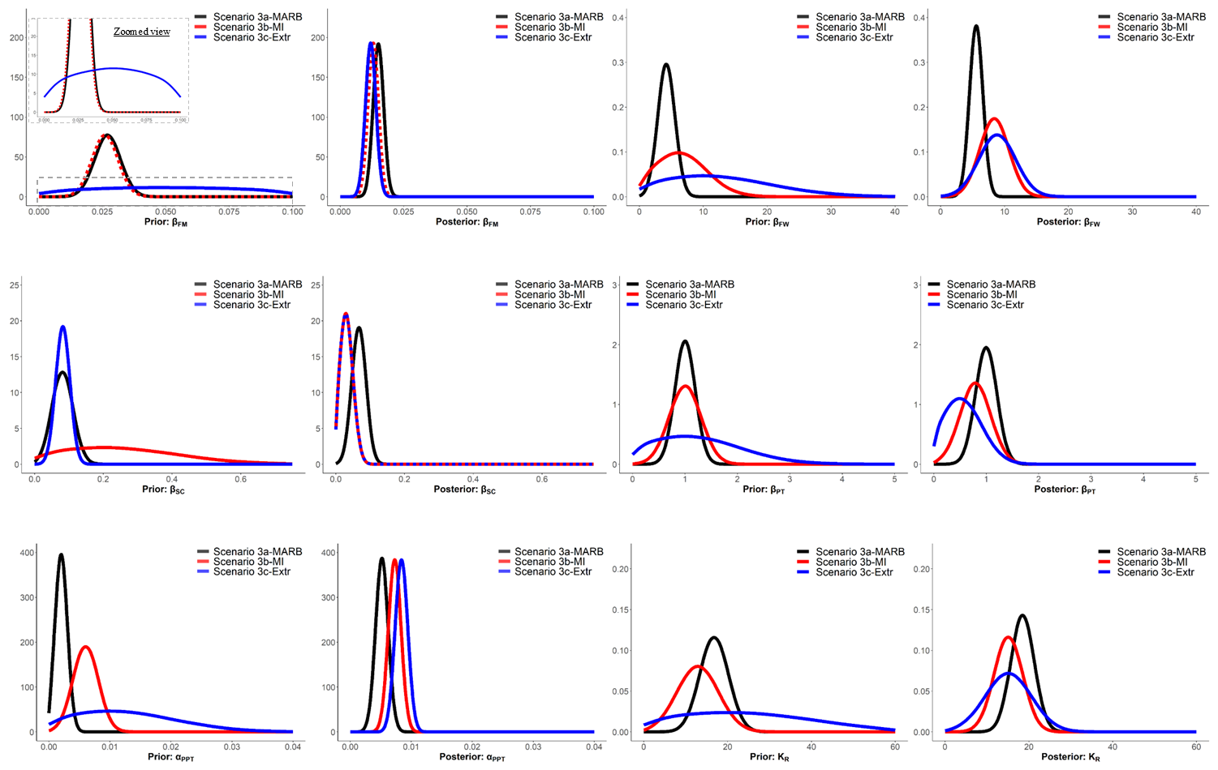
Figure S2. Probability density plots for parameter priors and posteriors of Scenarios 3a-MARB, 3b-MI, and 3c-Extr.
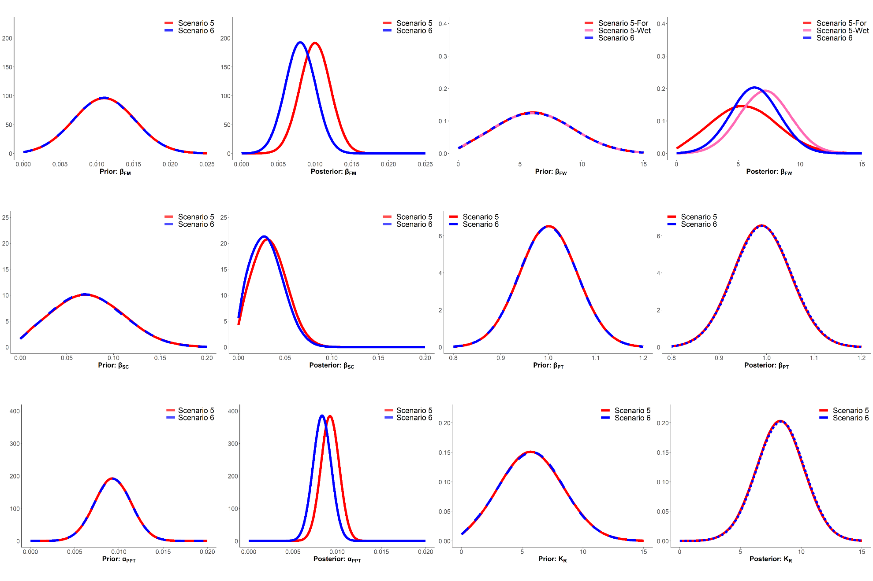
Figure S3. Probability density plots for parameter priors and posteriors of Scenarios 5 and 6.
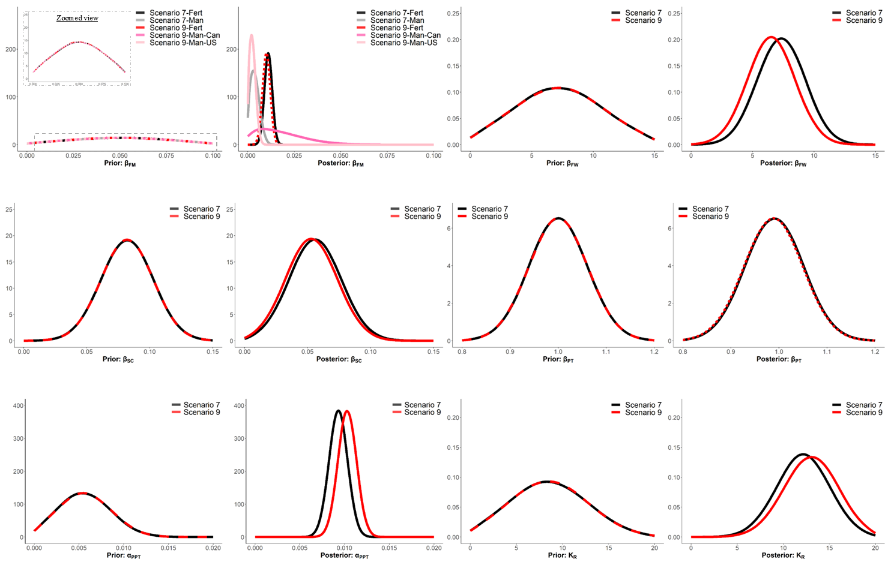
Figure S4. Probability density plots for parameter priors and posteriors of Scenarios 7 and 9.

Appendix S4. Tables of Loads and Yields for all non-key scenarios.
Table S5. Summary of loads and yields per major basin, province /state, and country for non-key scenarios.
 |  | Aggregated  (Non-Decayed)  TP Load (MT/yr) |  |  | Delivered Aggregated  TP Load (MT/yr) |  |  | Aggregated TP  Yield (kg/km²) |  |  | Delivered Aggregated  TP Yield (kg/km²) |  |  | TP Delivery  Fraction
 |  | Scen 3a-MARB | Scen 3b-MI | Scen 3c-Extr | Scen 3a-MARB | Scen 3b-MI | Scen 3c-Extr | Scen 3a-MARB | Scen 3b-MI | Scen 3c-Extr | Scen 3a-MARB | Scen 3b-MI | Scen 3c-Extr | Scen 3a-MARB | Scen 3b-MI | Scen 3c-Extr
Major  (River)  Basin | Red | 5,283 | 4,992 | 4,828 | 4,222 | 3,991 | 3,810 | 43.0 | 40.7 | 39.3 | 34.4 | 32.5 | 31.0 | 0.80 | 0.80 | 0.79
Major  (River)  Basin | Souris | 841 | 603 | 518 | 182 | 141 | 122 | 15.4 | 11.1 | 9.5 | 3.3 | 2.6 | 2.2 | 0.22 | 0.23 | 0.24
Major  (River)  Basin | Assiniboine | 1,082 | 825 | 716 | 362 | 286 | 241 | 25.4 | 19.4 | 16.8 | 8.5 | 6.7 | 5.6 | 0.33 | 0.35 | 0.34
Province  /State | Manitoba | 2,738 | 2,249 | 1,955 | 2,028 | 1,711 | 1,476 | 45.7 | 37.6 | 32.7 | 33.9 | 28.6 | 24.7 | 0.74 | 0.76 | 0.75
Province  /State | North Dakota | 2,062 | 1,832 | 1,756 | 1,483 | 1,379 | 1,336 | 29.7 | 26.4 | 25.3 | 21.4 | 19.9 | 19.2 | 0.72 | 0.75 | 0.76
Province  /State | Minnesota | 1,548 | 1,684 | 1,769 | 1,144 | 1,222 | 1,263 | 34.0 | 37.0 | 38.9 | 25.1 | 26.8 | 27.7 | 0.74 | 0.73 | 0.71
Province  /State | Saskatchewan | 791 | 582 | 507 | 85 | 76 | 67 | 18.1 | 13.3 | 11.6 | 1.9 | 1.7 | 1.5 | 0.11 | 0.13 | 0.13
Province  /State | South Dakota | 67 | 74 | 76 | 26 | 30 | 31 | 49.0 | 53.7 | 55.2 | 18.9 | 21.6 | 22.3 | 0.39 | 0.40 | 0.40
Country | Canada | 3,529 | 2,831 | 2,462 | 2,113 | 1,787 | 1,543 | 34.1 | 27.3 | 23.8 | 20.4 | 17.3 | 14.9 | 0.60 | 0.63 | 0.63
Country | US | 3,677 | 3,589 | 3,600 | 2,653 | 2,630 | 2,629 | 31.6 | 30.8 | 30.9 | 22.8 | 22.6 | 22.6 | 0.72 | 0.73 | 0.73
RARB |  | 7,206 | 6,420 | 6,063 | 4,766 | 4,417 | 4,172 | 32.8 | 29.2 | 27.6 | 21.7 | 20.1 | 19.0 | 0.66 | 0.69 | 0.69

 |  | Aggregated  (Non-Decayed)  TP Load (MT/yr) |  | Delivered Aggregated  TP Load (MT/yr) |  | Aggregated TP  Yield (kg/km²) |  | Delivered Aggregated  TP Yield (kg/km²) |  | TP Delivery  Fraction
 |  | Scen 5 | Scen 6 | Scen 5 | Scen 6 | Scen 5 | Scen 6 | Scen 5 | Scen 6 | Scen 5 | Scen 6
Major  (River)  Basin | Red | 4,725 | 4,759 | 3,916 | 3,934 | 38.5 | 38.8 | 32.0 | 32.1 | 0.83 | 0.83
Major  (River)  Basin | Souris | 460 | 473 | 128 | 135 | 8.4 | 8.7 | 2.4 | 2.5 | 0.28 | 0.29
Major  (River)  Basin | Assiniboine | 681 | 656 | 277 | 273 | 16.0 | 15.4 | 6.5 | 6.4 | 0.41 | 0.42
Province  /State | Manitoba | 1,971 | 1,871 | 1,601 | 1,519 | 33.0 | 31.3 | 26.7 | 25.4 | 0.81 | 0.81
Province  /State | North Dakota | 1,678 | 1,773 | 1,333 | 1,392 | 24.1 | 25.6 | 19.2 | 20.0 | 0.79 | 0.79
Province  /State | Minnesota | 1,680 | 1,750 | 1,262 | 1,316 | 36.9 | 38.5 | 27.8 | 29.0 | 0.75 | 0.75
Province  /State | Saskatchewan | 465 | 432 | 90 | 85 | 10.6 | 9.9 | 2.1 | 2.0 | 0.19 | 0.20
Province  /State | South Dakota | 72 | 64 | 34 | 30 | 52.8 | 47.0 | 25.1 | 21.8 | 0.48 | 0.46
Country | Canada | 2,436 | 2,303 | 1,691 | 1,604 | 23.5 | 22.2 | 16.3 | 15.5 | 0.69 | 0.70
Country | US | 3,430 | 3,586 | 2,630 | 2,738 | 29.5 | 30.9 | 22.6 | 23.5 | 0.77 | 0.76
RARB |  | 5,866 | 5,888 | 4,322 | 4,342 | 26.6 | 26.8 | 19.6 | 19.7 | 0.74 | 0.74

 |  | Aggregated  (Non-Decayed)  TP Load (MT/yr) |  | Delivered Aggregated  TP Load (MT/yr) |  | Aggregated TP  Yield (kg/km²) |  | Delivered Aggregated  TP Yield (kg/km²) |  | TP Delivery  Fraction
 |  | Scen 7 | Scen 9 | Scen 7 | Scen 9 | Scen 7 | Scen 9 | Scen 7 | Scen 9 | Scen 7 | Scen 9
Major  (River)  Basin | Red | 5,018 | 5,588 | 4,087 | 4,593 | 40.9 | 45.5 | 33.3 | 37.5 | 0.81 | 0.82
Major  (River)  Basin | Souris | 514 | 578 | 128 | 138 | 9.4 | 10.6 | 2.4 | 2.5 | 0.25 | 0.24
Major  (River)  Basin | Assiniboine | 757 | 864 | 282 | 325 | 17.8 | 20.3 | 6.6 | 7.6 | 0.37 | 0.38
Province  /State | Manitoba | 2,092 | 2,840 | 1,642 | 2,257 | 35.0 | 47.5 | 27.4 | 37.7 | 0.79 | 0.79
Province  /State | North Dakota | 1,894 | 1,813 | 1,472 | 1,415 | 27.2 | 26.1 | 21.1 | 20.3 | 0.78 | 0.78
Province  /State | Minnesota | 1,724 | 1,730 | 1,281 | 1,274 | 37.9 | 38.1 | 28.1 | 28.0 | 0.74 | 0.74
Province  /State | Saskatchewan | 522 | 590 | 78 | 84 | 11.9 | 13.5 | 1.8 | 1.9 | 0.15 | 0.14
Province  /State | South Dakota | 58 | 57 | 25 | 25 | 42.2 | 41.8 | 18.4 | 18.0 | 0.44 | 0.43
Country | Canada | 2,614 | 3,430 | 1,720 | 2,341 | 25.2 | 33.2 | 16.6 | 22.6 | 0.66 | 0.68
Country | US | 3,676 | 3,600 | 2,778 | 2,715 | 31.6 | 31.0 | 23.8 | 23.3 | 0.76 | 0.75
RARB |  | 6,290 | 7,030 | 4,498 | 5,056 | 28.6 | 32.0 | 20.4 | 23.0 | 0.72 | 0.72

Appendix S5. Delivered aggregated yields maps per sub-sub-drainage area for all non-key scenarios.
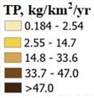 | 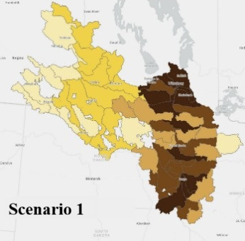 | 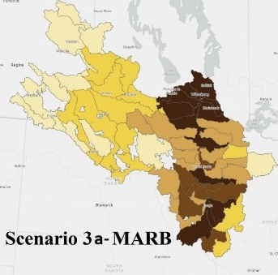 | 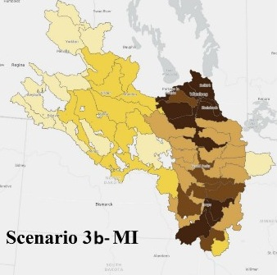 | 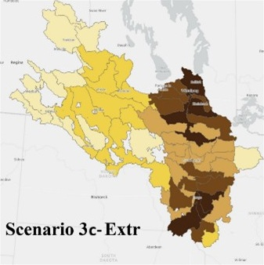
 |  | 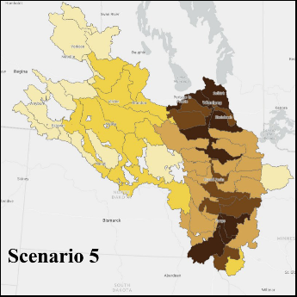 | 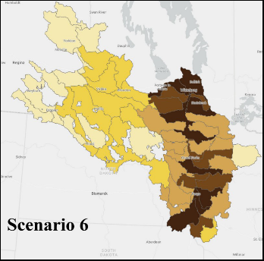
 |  | 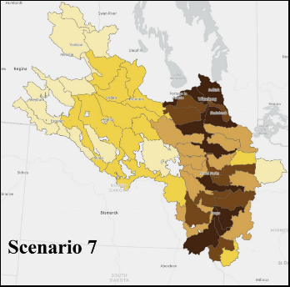 | 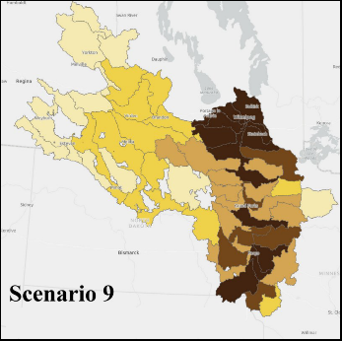

Figure S5. Delivered aggregated yields for sub-sub-drainage areas for non-key scenarios.

Appendix S6. Hotspots – Canada then US – Yields per Sub-Sub-Drainage Area (kg/km²/yr).
Table S6. Canadian delivered yield hotspot values (kg/km²/yr). Rows sorted using Scenario 8.
Major Basin | Sub-Sub-Drainage Area | Scenario 1 | Scenario 2 | Scenario 3d-FS | Scenario 4 | Scenario 8
Red | Lower Red | 89.5 | 87.3 | 86.8 | 88.2 | 97.6
Red | Rat and Tourond | 62.8 | 58.1 | 56.8 | 51.3 | 82.6
Red | Upper Red (Canada) | 65.2 | 59.4 | 58.7 | 62.9 | 71.6
Red | Seine | 47.0 | 43.0 | 41.6 | 37.4 | 59.4
Assiniboine | Lower Assiniboine - Mouth | 51.2 | 48.8 | 49.7 | 49.1 | 58.4
Red | Morris | 47.5 | 40.5 | 42.0 | 43.3 | 58.4
Red | La Salle | 43.3 | 37.4 | 38.3 | 39.5 | 52.6
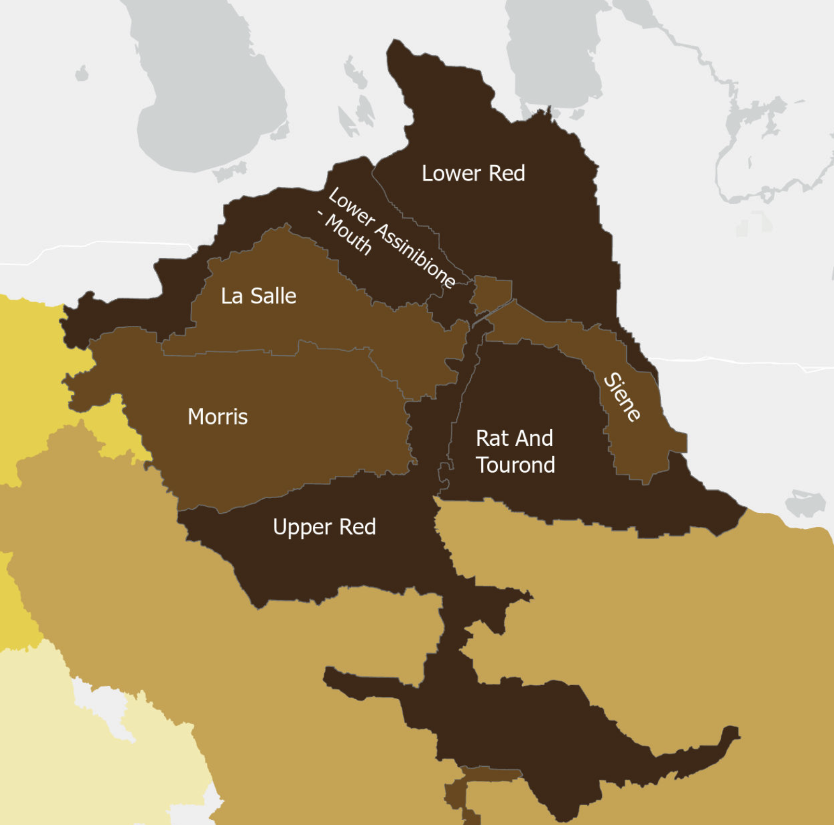
Figure S6. Canadian delivered yield hotspot map. Color rendering uses average yield across four key scenarios where darker brown is higher yield.
Table S7. U.S. delivered yield hotspot values (kg/km²/yr). Rows sorted using Scenario 8.
Major Basin | Sub-Sub-Drainage Area | Scenario 1 | Scenario 2 | Scenario 3d-FS | Scenario 4 | Scenario 8
Red | Upper Red (US) | 96.8 | 89.8 | 89.3 | 93.0 | 90.3
Red | Buffalo | 69.3 | 61.8 | 60.7 | 61.5 | 62.9
Red | Western Wild Rice | 66.9 | 58.8 | 55.1 | 62.6 | 55.6
Red | Sandhill-Wilson | 50.3 | 44.9 | 46.5 | 48.0 | 45.0
Red | Eastern Wild Rice | 45.2 | 39.9 | 39.7 | 40.2 | 40.4
Red | Bois De Sioux | 35.2 | 40.4 | 39.0 | 42.5 | 38.8
Red | Elm-Marsh | 44.0 | 37.7 | 38.2 | 42.0 | 36.8
Red | Grand Marais-Red | 40.3 | 35.0 | 36.1 | 37.0 | 34.1
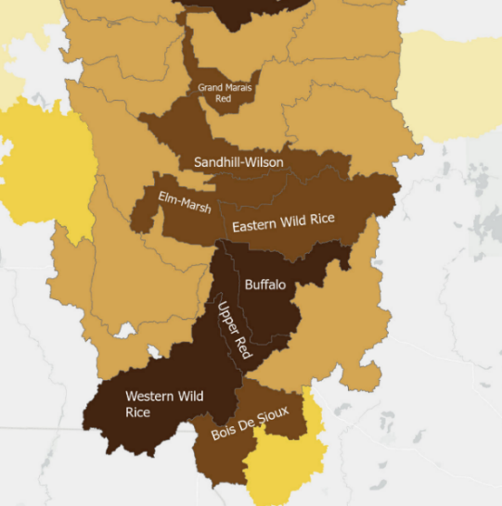
Figure S7. U.S. delivered yield hotspot map. Color rendering uses average yield across four key scenarios where darker brown is higher yield.
References:
1. Smith, R. A., Schwarz, G. E. & Alexander, R. B. Regional interpretation of water-quality monitoring data. Water Resour. Res. 33, 2781–2798 (1997).
2. Schwarz, G. E., Hoos, A. B., Alexander, R. B. & Smith, R. A. The SPARROW surface water-quality model: theory, application and user documentation. (2006).
3. Jenkinson, R. & Benoy, G. Red-Assiniboine Basin SPARROW model development technical document. National Research Council of Canada, Ottawa, ON 65 (2015).
4. Robertson, D. M. et al. Phosphorus and nitrogen transport in the binational Great Lakes basin estimated using SPARROW watershed models. J. Am. Water Resour. Assoc https://doi.org/10.1111/1752-1688.12792 (2019) doi:10.1111/1752-1688.12792.
5. Qian, S. S., Reckhow, K. H., Zhai, J. & McMahon, G. Nonlinear regression modeling of nutrient loads in streams: A Bayesian approach. Water Resources Research 41, 2005WR003986 (2005).
6. Wellen, C., Kamran-Disfani, A.-R. & Arhonditsis, G. B. Evaluation of the current state of distributed watershed nutrient water quality modelling. Environ. Sci. Technol. 49, 3278–3290 (2015).
7. Benoy, G. A., Jenkinson, R. W., Robertson, D. M. & Saad, D. A. Nutrient delivery to Lake Winnipeg from the Red—Assiniboine River Basin – A binational application of the SPARROW model. Canadian Water Resources Journal / Revue canadienne des ressources hydriques 41, 429–447 (2016).
8. Robertson, D. M. & Saad, D. A. SPARROW models used to understand nutrient sources in the Mississippi/Atchafalaya River Basin. Journal of Environmental Quality 42, 1422–1440 (2013).
9. Robertson, D. M. & Saad, D. A. Nutrient inputs to the Laurentian Great Lakes by source and watershed estimated using SPARROW watershed Models. JAWRA J. Am. Water Resour. Assoc 47, 1011–1033 (2011).
10. Rattan, K., Blukacz-Richards, E., Yates, A., Culp, J. & Chambers, P. Hydrological variability affects particulate nitrogen and phosphorus in streams of the Northern Great Plains. Journal of Hydrology: Regional Studies 21, 110–125 (2019).
11. Harmel, R. D. et al. Updates to the MANAGE database to facilitate regional analyses of nutrient runoff. Agricultural & Env. Letters 7, e20095 (2022).
12. Kim, D.-K. et al. A Bayesian approach for estimating phosphorus export and delivery rates with the SPAtially Referenced Regression On Watershed attributes (SPARROW) model. Ecol. Inform 37, 77–91 (2017).
13. Bourne, A., Armstrong, N. & Jones, G. A preliminary estimate of total nitrogen and total phosphorus loading to streams in Manitoba, Canada. https://www.gov.mb.ca/sd/pubs/water/lakes-beaches-rivers/nutrient_loading_report_2002-04_november_2002.pdf (2002).
14. Neumann, A., Blukacz-Richards, E. A., Saha, R., Alberto Arnillas, C. & Arhonditsis, G. B. A Bayesian hierarchical spatially explicit modelling framework to examine phosphorus export between contrasting flow regimes. Journal of Great Lakes Research S0380133022002301 (2022) doi:10.1016/j.jglr.2022.10.003.
15. Neumann, A., Blukacz-Richards, E. A., Yao, H., James, A. L. & Arhonditsis, G. B. An ensemble of Bayesian SPARROW models for the Precambrian Shield in the eastern Georgian Bay drainage basin, Ontario, Canada. Journal of Great Lakes Research 47, 1671–1688 (2021).
16. Baulch, H. M. et al. Soil and water management: opportunities to mitigate nutrient losses to surface waters in the Northern Great Plains. Environ. Rev. 27, 447–477 (2019).

