Bi-analyte demonstration of non-resonant, single-molecule SERS with isolated lithographic
enhancement structures.
Xin Jin, Hui Xia and S. R. J. Brueck
Daisy Genomics, Inc. 5901 Indian School Road, Albuquerque, NM 87110
Supplementary Information
Spectra before baseline subtraction:
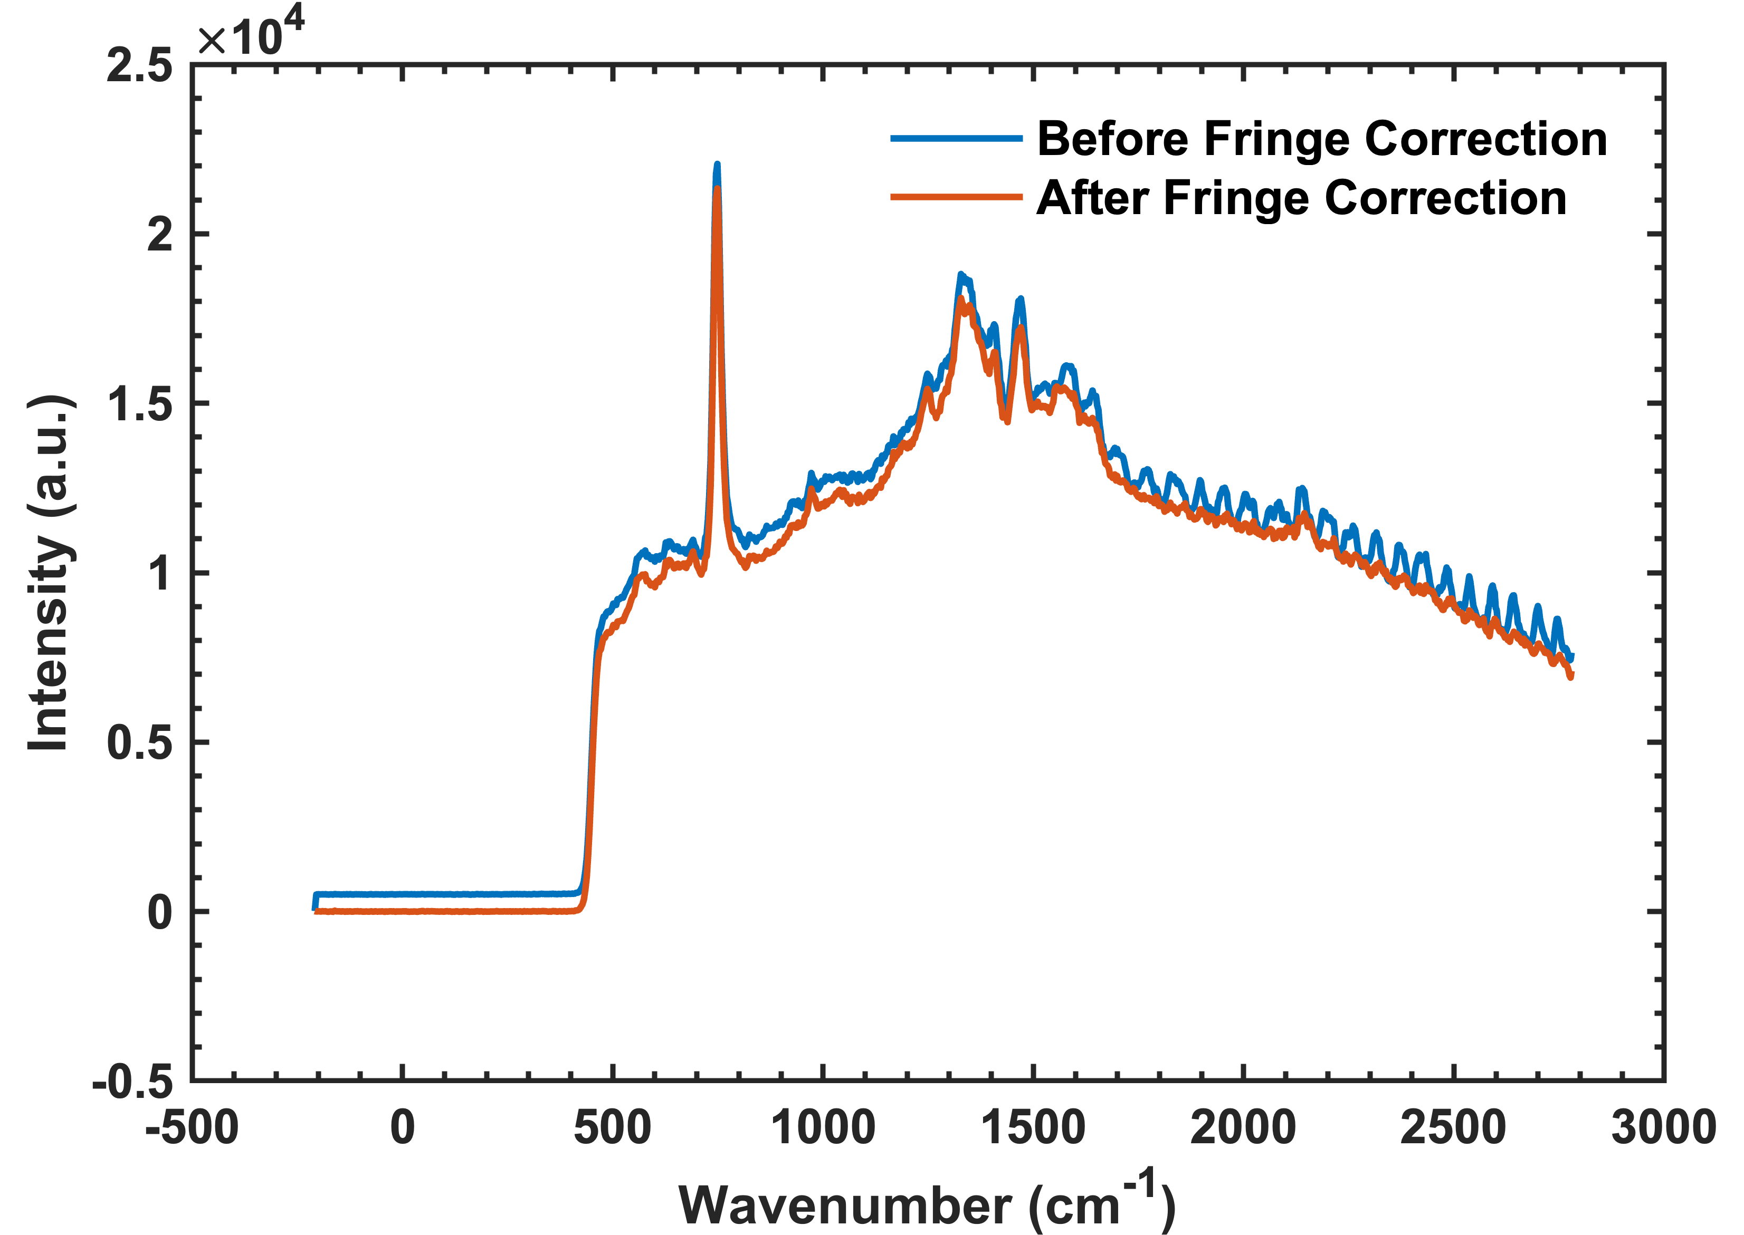
Fig. S.1. Adenine monolayer spectrum before baseline subtraction. The sharp cut-on at ~ 500 cm⁻¹ shift is due to the long-pass filter used to eliminate reflected excitation light. The blue spectrum includes thin film effects from the thinned silicon detector. The red spectrum is after removal of the thin-film fringing.
Calibration of bulk Raman spectra:
The evaluation of the SERS enhancement factor by calibrating against a bulk Raman measurement is given by:
$EF\sim \frac{N_{b}*C_{s}}{N_{s}*C_{b}} ,$ Eq. S1
where N_{b} (N_{s}) is the number of molecules contributing to the bulk (single molecule) Raman signal and C_{b} (C_{s}) is the appropriate Cts/(mW.s). C_{b} and C_{s} are measured and N_{s} = 1. We follow the procedure discussed in detail by Le Ru et al.. The basic concept is to replace the complex volume defined by the convolution of the excitation Gaussian beam propagation and the collection optical paths with an equivalent cylindrical volume with the transverse dimensions set by the excitation spot size at focus and the depth obtained by an empirical measurement of the vertical displacement of a planar source. For the planar source we take a silicon wafer as a reflector. We do not use the Si Raman signal since the penetration depth of 633 nm excitation into silicon is ~ 3 μm which is on the same order of magnitude as the measured collection depth. Fig. S.2 shows the measured reflectance as the silicon wafer is lowered from the focal plane. A disadvantage of using the excitation beam reflectance is that attenuation is required to avoid camera saturation and stray excitation light impinging on the entrance slits can become an issue. For our measurements 50- and 100-μm slits gave comparable results, for larger slit widths the scattering clearly impacted the results. For these measurements the signal was integrated over 10 pixels (13 μm pixels), ~ an effective 130 μm exit slit width. The dashed curve in Fig. S.2 is a Lorentzian fit to the data, giving a collection depth of d ~ 13 μm. The spot size was w₀ ~ 0.5 μm, so the collection volume was $πw_{0}^{2}d \sim$10.2 μm³. For a concentration of 0.1 mol/liter (~ 6x10⁷ molecules/mm³) this gives N_{b} ~ 6x10⁸ molecules contributing to the bulk measurement and an enhancement factor of ~ 1.2x10¹⁰. The Raman spectrum at focus is shown in Fig. S.3.

Fig. S.2. Reflected signal vs. vertical displacement of Si mirror at focal plane. Both 50- and 100-μm slit widths provide similar results implying that measurement is not affected strongly by slit width.
Fig. S.3. Bulk Raman measurement of adenine in water.
Adenine monolayer spectrum on ‘best’ enhancement structure
As noted in the methods section, there was significant variability between fabrication runs. Figure S.4 shows based line subtracted spectra of adenine and cytosine monolayers on samples from the same fabrication run. (average of 50 spectra across sample, 30 s integration time, 80 mW laser power).
Figure S.3. Spectra for monolayers of adenine and cytosine (offset for clarity). The ring breathing spectral peaks at 743 cm-1 shift (A) and at 807 cm-1 shift (C) were used for the bi-analyte study. Average of 50 spectra across the sample for each spectrum, laser power was 80 mW and integration time was 30 s.
The single molecule results were taken from a ‘better’ fabrication run. Fig. S.4 shows the signal from an adenine monolayer on a sample from the same run as the single molecule results. The normalized signal intensity for the adenine ring breathing mode at a 743 cm-1 shift of ~ 7500 cts/(mW.s) was used for evaluating the number of molecules contributing to the monolayer signal by comparison with the single molecule results.
Fig. S.4. Adenine monolayer signal on a sample from the same fabrication run as the SM-SERS results.

E.C. Le Ru, E. Blackie, M. Myer and P.G. Etchegoin, Supporting information for “SERS enhancement factors: a comprehensive review,” J. Phys. Chem. C111, 13794 (2007). [DOI: 10.1021/jp0687908]

